**Department of Electrical and Computer Engineering**

**North South University**



**Senior Design Project**

**Unsupervised Graph Network Discrimination**

**Name: Zahin Ahmed ID # 1711020042**

**Name: Mahmud Elahi Akhter ID # 1721498042**

**Faculty Advisor:**

**Dr. Mohammad Ashrafuzzaman Khan**

**Assistant Professor**

**Department of ECE**

**Summer 2020**

**LETTER OF TRANSMITTAL**

**APPROVAL**

**DECLARATION**

**ACKNOWLEDGEMENT**

**ABSTRACT**

Table of Contents

CHAPTER 1: INTRODUCTION 10

1.1 Scope of this Article 11

1.2 Organization of article 11

1.3 Motivation 11

CHAPTER 2: LITERATURE REVIEW 13

CHAPTER 3: DATASETS 15

3.1 Social Networks 16

3.1.1 Ego Networks (Facebook and Twitter) 16

3.1.2 Page to Page Networks (Facebook) 16

3.1.3 Twitch 16

3.1.4 Last.fm 16

3.2 Collaboration Networks 17

3.3 Citation Networks 17

3.4 Co-purchase Networks 17

3.5 Communication Networks 17

3.6 Internet P2P Networks 18

3.7 Ground Truth Networks 18

3.8 Signed Networks 18

CHAPTER 4: CENTRALITIES 20

4.1 Initial Analysis 21

4.2 Final Centralities 22

CHAPTER 5: ABLATION STUDY 25

5.1 Model 1 26

5.2 Model 2 26

5.3 Model 3 26

5.4 Model 4 26

5.5 Model 5 27

5.6 Model 6 27

5.7 Model 7 28

5.8 Model 8 28

5.9 Model 9 29

CHAPTER 6: RESULTS & ANALYSIS 31

6.1 P2P-Gnutella04 dataset 32

6.1.1 Boxplot and Correlation plots 32

6.1.2 PCA 33

6.1.3 t-SNE and K-means on t-SNE 34

6.1.4 K-means on PCA 56

6.1.5 UMAP and K-means on UMAP 60

6.1.6 Sammon’s mapping 64

6.1.7 DBSCAN 66

6.2 CA-HepPh dataset 69

6.2.1 Boxplot and Correlation plots 69

6.2.2 PCA 70

6.2.3 t-SNE and K-means on t-SNE 70

6.2.4 K-means on PCA 88

6.2.5 UMAP and K-means on UMAP 92

6.2.6 Sammon’s mapping 95

6.2.7 DBSCAN 97

CHAPTER 5: CONCLUSION AND FUTURE WORK 100

REFERENCES 102

# CHAPTER 1: INTRODUCTION

## Scope of this Article

In recent years, network analysis techniques have evolved(Chen et al., 2019; Williamson & Tec, 2019) in proportion to the rapid growth of real world networks. Much research has been done on networks such as social networks (Bródka et al., 2011; Culotta & Cutler, 2016), communication networks (Mccallum, 2007), citation networks etc. As time progresses, these networks become bigger and more complex, consequently holding vast amounts of interesting information which can be used for various purposes. Network analysis techniques include, but are not limited to, using random graph models to capture or derive the properties of real world networks (Williamson & Tec, 2019), subgraph isomorphism (Cordella et al., 2004), graph simulation etc. A significant portion of the research conducted on networks has been on centralities (Newman, 2010) to deduce, “which” are the more important nodes in the graph i.e.. central nodes or nodes that propagate most information, and how traffic flows through them. In turn, calculated centralities of various network graphs have been used in many other research fields as well. For example, analyzing social networks, such as tweet classification (Hussain & Islam, 2016), detecting political discussion practices (Miller et al., 2015) and many other such applications (Cohn et al., 2019; Rossman et al., 2010; Yang & Liu, 2008); has involved the generation of multiple centralities. Centralities have also been used in analyzing road traffic networks, such as finding road network patterns (Zhang et al., 2011), tourism management (Lee et al., 2013) etc.. Another important application of centrality measurements is in analyzing biological networks, as can be seen in (Bell et al., 1999; Joyce et al., 2010; Narayanan, 2005; Park & Kim, 2009).

Centralities such as Degree, Closeness, Betweenness, Crossclique, Pagerank, etc. have all been proposed and developed (Crucitti et al., 2006) over the years to answer “Which node is the most influential?” in various different applications (Landherr et al., 2010). “Significance” or “importance” of nodes varies from one context to another. For example, in some cases, it is essential to identify which node(s) propagate more information locally or globally in a graph(Newman, 2010), whereas in other cases, detecting the central node(s) might be of more value (Chiu et al., 2016). Centralities can, therefore, be seen as features/characteristics of a graph; thus, it is possible to discriminate between networks based on their centrality values (Wang & Krim, 2012)

## 1.2 Organization of article

## 1.3 Motivation

In this paper, our main concern is “What information can we extract from a given, unknown graph of a network?” Calculating various centralities from a graph is possible, but this raises the question of what can be concluded from this information? Is it possible to discriminate between types of networks based on only the centrality values of their nodes? Or, Can unsupervised learning techniques applied to unknown graphs produce meaningful context about the network in question? Being able to find meaningful insights about an unidentified network has many practical uses, such as deducing, whether it is a criminal network or not, or if the network was part of a successful political campaign, or whether the network is an ego network of a socially influential person.

# CHAPTER 2: LITERATURE REVIEW

Lit review starts here

# CHAPTER 3: DATASETS

The datasets we have collected belong to the following categories: Social Networks, Citation Networks, Collaboration Networks, Product Co-purchase Networks, Communication networks, Internet P2P networks, Ground Truth Networks and Signed Networks. The description of each network are given below.

## 3.1 Social Networks

### 3.1.1 Ego Networks (Facebook and Twitter)

The Ego networks are essentially networks centered around one particular node. Such networks are formed by taking one node, and finding all the vertices that are directly connected to it while also finding the connections between those vertices. We have used two ego networks, namely the “Ego-Facebook” dataset which contains 4039 nodes and 88233 edges as it combines 10 ego networks, and “Ego-Twitter” dataset which contains 81306 nodes and 2420765 edges. The Facebook ego networks were collected by Facebook users willingly using an app and twitter information was collected using web crawlers.

### 3.1.2 Page to Page Networks (Facebook)

Another type of network is formed between pages instead of account-holders. The “Gemsec-Facebook” datasets consist of networks of 8 different categories- Artists (50515 nodes and 819306 edges), Athletes (13866 nodes and 86858 edges), Company (14113 nodes and 52310 edges), Government (7057 nodes and 89455 edges), New sites (27917 nodes and 206259 edges), Politicians (5908 nodes and 41729 edges), Public figures (11565 nodes and 67114 edges), and Tv shows (3892 nodes and 17262 edges). Each individual dataset consist of verified Facebook pages of that category, and edges exist between pages that like each other.

### 3.1.3 Twitch

Twitch is a website on which people can livestream, and it is used mostly by gamers. The “Musae-twitch” datasets consists of 6 networks – DE (9498 nodes and 153138 edges), ENGB (7126 nodes and 35324 edges), ES (4648 nodes and 59382 edges), FR (6549 nodes and 112666 edges), PTBR (1912 nodes and 31299 edges), RU (4385 nodes and 37304 edges) - divided by the languages used by the streamers. The edges represent friendships between the streamers. The data was collected on May 2018.

### 3.1.4 Last.fm

Last.fm is a website that has been providing music services since 2003. The “Feather-lastfm-social” dataset contains a social network of LastFM users which was collected in March 2020. The nodes represent users residing in Asian countries and edges represent mutual follow relationships. It has 7624 nodes and 27806 edges.

## 3.2 Collaboration Networks

The Arxiv collaboration networks were collected from the e-print arXiv websites. The edges represent collaborations between authors, so if one author collaborated with another an undirected edge exists between them. The data consists of papers published between January 1993 to April 2003. The “Ca-AstroPH” dataset has 18772 nodes and 396160 edges, and represents collaborations in papers of the Astro Physics category. The “Ca-HepPH” dataset has 12008 nodes and 237010 edges, and represents collaborations in papers of the High Energy Physics - Phenomenology category.

## 3.3 Citation Networks

The Arxiv citation networks were also collected from the e-print arXiv database. These datasets represent which papers cite each other within this database, and if one paper cites another, a directed edge is drawn from the former to the latter. Information regarding cited papers that do no exist within the database is not present in the networks. The data is collected from papers published between January 1993 and April 2003. The “cit-HepPH” dataset contains 34546 nodes and 421577 edges and consists of papers submitted to the High Energy Physics- Phenomenology category. The “cit-HepTH” dataset contains 27770 nodes and 352807 edges and consists of papers submitted to the High Energy Physics- Theory category.

## 3.4 Co-purchase Networks

The Amazon product co-purchasing networks were collected by crawling the website and collecting information from the “Customers Who Bought This Item Also Bought” feature. A directed edge exists from one product to another if the former is frequently bought companying the latter. The “Amazon0302” dataset was collected on 2nd March 2003 and has 262111 nodes and 1234876 edges. The “Amazon0601” dataset was collected on 1st June 2003 and has 403394 nodes and 3387388 edges.

## 3.5 Communication Networks

Communication networks can be constructed by collecting email data from institutes. Such networks are the “Email-EuAll” and “Email-enron” networks. “Email-EuAll” has 265214 nodes and 420045 edges, and was collected from an European institute from October 2003 to May 2005. The nodes represent email address and a directed edge signifies that source node sent at least one email to target node. “Email-enron” has 36692 nodes and 367662 edges and was collected, and made public, from the Enron Corporation when it was being investigated. This network is undirected and contains an edge between nodes if any email was exchanged between them.

## 3.6 Internet P2P Networks

The hosts in a peep-to-peer sharing system also form networks. Such networks were constructed from the Gnutella file sharing network by taking 9 snapshots across a few days in August 2002. The ones used in this research are : “P2p-Gnutella04” (10876 nodes and 39994 edges) which was collected on 4th August, “p2p-Gnutella30”( 36682 nodes and 88328 edges) which was collected on 30th August, “p2p-Gnutella31” (62586 nodes and 147892 edges) which was taken on 31st August.

## 3.7 Ground Truth Networks

A network with ground-truth communities available aid in research as they provide a basis for comparison when communities are detected or identified using any algorithm. Such a networks can be constructed from the data available at the DBLP computer science bibliography website. The “Com-DBLP” dataset has 317080 edges and 1049865 nodes and it represents a network of authors. The nodes represent authors and an edge exists between two nodes if they have published at least one paper together.

## 3.8 Signed Networks

Unlike other social networks where edges between nodes only signify the existence of a relation, but not the nature, signed networks are able to convey both this information. Such a network is the “Soc-sign-Slashdot090221” which has 82140 nodes and 549201 edges and shows whether two connected nodes are friends or foes. However, in this research the sign is not taken into account. The network was collected in February 2009.

The following table shows the details of each dataset, sorted in order of increasing nodes:

|  |  |  |  |  |  |
| --- | --- | --- | --- | --- | --- |
| **Dataset name** | **Nodes** | **Edges** | **Average Degree** | **Graph Density** | **Graph Transitivity** |
| musae-Twitch-PTBR | 1912 | 31299 | 32.73953975 | 0.008561595 | 0.130980962 |
| Gemsec-Facebook-Tv shows | 3892 | 17262 | 8.870503597 | 0.001139582 | 0.590643566 |
| Ego-Facebook | 4039 | 88233 | 43.69051745 | 0.005408581 | 0.519189302 |
| musae-Twitch-RU | 4385 | 37304 | 17.01436716 | 0.001940065 | 0.048648019 |
| musae-Twitch-ES | 4648 | 59382 | 25.55163511 | 0.00274867 | 0.084234875 |
| Gemsec-Facebook-Politician | 5908 | 41729 | 14.12626947 | 0.00119552 | 0.301073736 |
| musae-Twitch-FR | 6549 | 112666 | 34.40708505 | 0.002626896 | 0.054128273 |
| Gemsec-Facebook-Government | 7057 | 89455 | 25.35213263 | 0.00179624 | 0.223768822 |
| musae-Twitch-ENGB | 7126 | 35324 | 9.914117317 | 0.00069563 | 0.042433249 |
| Feather-lastfm | 7624 | 27806 | 7.294333683 | 0.00047838 | 0.178622548 |
| musae-Twitch-DE | 9498 | 153138 | 32.24636766 | 0.001697535 | 0.046470889 |
| p2p-Gnutella04 | 10876 | 39994 | 7.354542111 | 0.000338109 | 0.005402029 |
| Gemsec-Facebook-Public figure | 11565 | 67114 | 11.60639862 | 0.00050179 | 0.166564488 |
| CA-HepPh | 12008 | 237010 | 39.47534977 | 0.00164371 | 0.659477009 |
| Gemsec-Facebook-Athletes edges | 13866 | 86858 | 12.52819847 | 0.00045176 | 0.129227029 |
| Gemsec-Facebook-Company | 14113 | 52310 | 7.413023454 | 0.000262631 | 0.153198695 |
| CA-AstroPh | 18772 | 396160 | 42.20754315 | 0.001124215 | 0.318001581 |
| Musae-Facebook | 22470 | 171002 | 15.22047174 | 0.000338684 | 0.232321437 |
| Cit-HepTh | 27770 | 352807 | 25.40921858 | 0.000457494 | 0.119569073 |
| Gemsec-Facebook-New sites | 27917 | 206259 | 14.77658774 | 0.000264652 | 0.113984782 |
| Cit-HepPh | 34546 | 421577 | 24.4067041 | 0.000353249 | 0.145656674 |
| p2p-Gnutella30 | 36682 | 88328 | 4.815876997 | 6.56E-05 | 0.005163701 |
| Email-Enron | 36692 | 367662 | 20.04044478 | 0.00027309 | 0.085310796 |
| Deezer-RO | 41773 | 125826 | 6.024274053 | 7.21E-05 | 0.075266704 |
| Deezer-HU | 47538 | 222887 | 9.377214018 | 9.86E-05 | 0.092924018 |
| Gemsec-Facebook-Artist edges | 50515 | 819306 | 32.43812729 | 0.000321074 | 0.05349711 |
| Deezer-HR | 54573 | 498202 | 18.25818628 | 0.000167282 | 0.11463005 |
| p2p-Gnutella31 | 62586 | 147892 | 4.726040968 | 3.78E-05 | 0.003872019 |
| Ego-Twitter | 81306 | 2420765 | 59.5470199 | 0.000366191 | 0.170572209 |
| soc-sign-Slashdot090221 | 82140 | 549201 | 13.37231556 | 8.14E-05 | 0.023617547 |
| Amazon0302 | 262111 | 1234876 | 9.422542358 | 1.80E-05 | 0.236082716 |
| Email-EUAll | 265214 | 420045 | 3.167592963 | 5.97E-06 | 0.004106431 |
| com-DBLP | 317080 | 1049865 | 6.622082755 | 1.04E-05 | 0.306377952 |
| Amazon0312 | 400727 | 3200440 | 15.97316877 | 1.99E-05 | 0.16048945 |
| Amazon0601 | 403394 | 3387388 | 16.79443918 | 2.08E-05 | 0.165622114 |

# CHAPTER 4: CENTRALITIES

## 4.1 Initial Analysis

Initially, we started off with twenty-six centralities as potential options. These were:

1. Page Rank
2. Closeness Centrality (Latora)
3. Degree Centrality
4. Eigenvector centralities
5. Kleinberg's authority centrality score
6. Kleinberg's hubscore centrality score
7. Betweenness Centrality
8. Centroid value
9. Radiality Centrality
10. ClusterRank
11. DMNC - Density of Maximum Neighborhood Component
12. Clustering coefficient
13. Lobby Index (Centrality)
14. Community Centrality
15. Leverage Centrality
16. Load Centrality
17. Subgraph centrality scores
18. Topological Coefficient
19. Diffusion Degree
20. Eccentricity Centrality
21. Geodesic K-Path Centrality
22. Stress Centrality
23. Information Centrality
24. Markov Centrality
25. Entropy Centrality
26. Local Bridging Centrality

## 4.2 Final Centralities

Upon seeing the definitions of each centrality and judging whether they are appropriate for our research, we tried calculating each centrality on a medium-sized dataset to see which were calculable within a reasonable amount of time. Finally, we selected 13 final Centralities. These were:

1. **Page Rank**

PageRank is an eigenvector-based algorithm. The score for a given vertex may be thought of as the fraction of time spent 'visiting' that vertex (measured over all time) in a random walk over the vertices (following outgoing edges from each vertex). PageRank modifies this random walk by adding to the model a probability (specified as 'alpha' in the constructor) of jumping to any vertex. If alpha is 0, this is equivalent to the eigenvector centrality algorithm; if alpha is 1, all vertices will receive the same score (1/|V|). Thus, alpha acts as a sort of score smoothing parameter.

1. **Closeness Centrality (Latora)**

"Reciprocal of the total distance from a node v to all the other nodes in a network.By definition of shortest-path distances, classic closeness centrality is ill-defined on unconnected networks.

1. **Degree Centrality**

In graph theory, the degree (or valency) of a vertex of a graph is the number of edges incident to the vertex, with loops counted twice. The maximum degree of a graph G, denoted by Δ(G), and the minimum degree of a graph, denoted by δ(G), are the maximum and minimum degree of its vertices. In a regular graph, all degrees are the same, and so we can speak of the degree of the graph. Degree centrality is a local and static metric, since it considers only the directly connected neighbors of a vertex in a static state. Nonetheless, it serves as a useful indicator of the extent of attachment of a vertex to the graph

1. **Eigenvector centralities**

A measure of importance of nodes in a network using the adjacency and eigenvector matrices. It scores the relative importance of all nodes in the network by weighting connections to highly important nodes more than connections to nodes of low importance. As graph G is undirected and loop-free, the adjacency matrix A is symmetric, and all diagonal entries are 0."

1. **Kleinberg's authority centrality score**

The authority scores of the vertices are defined as the principal eigenvector of t(A)*A, where A is the adjacency matrix of the graph. Obviously, for undirected matrices the adjacency matrix is symmetric and the two scores are the same.

1. **Kleinberg's hubscore centrality score**

The hub scores of the vertices are defined as the principal eigenvector of A*t(A), where A is the adjacency matrix of the graph.

Obviously, for undirected matrices the adjacency matrix is symmetric and the two scores are the same.

1. **Betweenness Centrality**

The Betweenness is a node centrality index. It is similar to the stress but provides a more elaborated and informative centrality index. It is calculated considering couples of nodes (v1, v2) and counting the number of shortest paths linking v1 and v2 and passing through a node n. Then, the value is related to the total number of shortest paths linking v1 and v2. Thus, a node can be traversed by only one path linking v1 and v2, but if this path is the only connecting v1 and v2 the node n will score a higher betweenness value (in the stress computation would have had a low score). Thus, a high Betweenness score means that the node, for certain paths, is crucial to maintain node connections. Notably, to know the number of paths for which the node is critical it is necessary to look at the stress. Thus, stress and Betweenness can be used to gain complementary information.

1. **DMNC - Density of Maximum Neighborhood Component**

For a node v, let N be the node number and E be the edge number of MNC(v), respectively. The score of node v, DMNC(v), is defined to be E/Nϵ for some 1≤ϵ≤2.

We may assume that the MNC has a strong community structure, such as a clique percolation in a random network"

1. **Lobby Index (Centrality)**

The l-index or lobby index of a node x is the largest integer k such that x has at least k neighbors with a degree of at least k. If x has a high lobby index, then the l-core L(x) (those neighbors which provide the index) has high connectivity (statistically higher than l(x). The authors expect that in the case of social and communication networks (some of which are also based on social networks) the lobby-index is located between the bridgeness, closeness, eigenvector and betweenness centrality

1. **Leverage Centrality**

Leverage centrality considers the degree of a node relative to its neighbors and operates under the principle that a node in a network is central if its immediate neighbors rely on that node for information. A node with negative leverage centrality is influenced by its neighbors, as the neighbors connect and interact with far more nodes. A node with positive leverage centrality, on the other hand, influences its neighbors since the neighbors tend to have far fewer connections.

1. **Eccentricity Centrality**

"The greatest distance between v and any other vertex.The eccentricity of a node in a biological network, for instance a protein signaling network, can be interpreted as the easiness of a protein to be functionally reached by all other proteins in the network. Thus, a protein with high eccentricity, compared to the average eccentricity of the network, will be more easily influenced by the activity of other proteins (the protein is subject to a more stringent or complex regulation) or, conversely could easily influence several other proteins"

1. **Information Centrality**

"Actor information centrality is a hybrid measure which relates to both path-length indices (e.g., closeness, graph centrality) and to walk-based Eigen measures (e.g., eigenvector centrality, Bonacich power). In particular, the information centrality of a given actor can be understood to be the harmonic average of the “bandwidth” for all paths originating with said individual (where the bandwidth is taken to be inversely related to path length).

1. **Local Bridging Centrality**

"The local bridging centrality was a variant of global bridging centrality which can be calculated locally requiring only limited local neighborhood graph information. Localized centrality calculations can reduce both communication and computation complexity and there are a myriad of potential applications. It is expected that the concept of localized bridging centrality can improve existing distributed relay or optimization algorithms"

# CHAPTER 5: ABLATION STUDY

To understand the effects of different categories of centrality on the results obtained by unsupervised learning algorithm (categories being community centralities and individual node importance centralities), we conducted an Ablation study. We made 9 models where different combinations of centralities were used, and the algorithms were applied on each model separately to see how the results differ and whether a specific combination of centralities aid in proving our hypothesis.

## 5.1 Model 1

All centralities.

## 5.2 Model 2

Without degree

We are removing the effects of:

* Degree

To see how degree, which signifies the connectivity of the nodes, affect the model

## 5.3 Model 3

Without community centralities and information centrality.

We are removing the effects of:

* DMNC
* Leverage
* Local Bridging
* Eccentricity
* Lobby
* Information

To see how well the model performs when only centralities that are calculated globally (WITHOUT taking neighborhood/ community into account) are used

## 5.4 Model 4

Without node centralities.

We are removing the effects of:

* Page Rank
* Closeness
* Degree
* Eigenvector
* Authority
* Hubscore
* Betweenness

To see how the model performs when global centralities are taken out of the equation and centralities that depend on neighborhood/ community are used

## 5.5 Model 5

Without eigenvector, pagerank, hubscore, authority

We are removing the effects of:

* Pagerank-
* Hubscore
* Authority

To see how the impact of “importance” amongst nodes differs from the impact of “distance” between nodes.

## 5.6 Model 6

Without betweenness, eccentricity, closeness, information

We are removing the effects of:

* Betweenness
* Eccentricity
* Closeness
* Information

To see how the impact of “distance” between nodes differs from the impact of “importance” amongst nodes.

## 5.7 Model 7

Without leverage, lobby, dmnc, local bridging, information centrality, eigenvector, closeness

We are removing the effects of:

* Leverage
* Lobby Index
* DMNC
* local bridging-
* Information centrality
* Eigenvector
* Closeness

Keeping:

* Degree
* Betweeness
* Pagerank
* Hubscore
* Authority
* Eccentricity

To see how more global information received about “centrality” of nodes with some community information impacts the model.

## 5.8 Model 8

Without degree, hubscore, authority, betweenness, information, Eccentricity, leverage

We are removing the effects of:

* Degree
* Hubscore
* Authority
* Betweenness
* Information
* Eccentricity
* Leverage

Keeping:

* Page rank
* Closeness
* Eigenvector
* DMNC
* Local Bridging
* Lobby

To see how equal proportions of community and node importance information affects the model

## 5.9 Model 9

Without Closeness, eigenvector, authority, hubscore, Betweenness, Leverage, Information Centrality,

We are removing the effects of:

* Closeness
* Eigenvector
* Authority
* Hubscore
* Betweenness
* Leverage
* Information Centrality

Keeping:

* Page Rank,
* Degree
* DMNC
* Lobby Index
* Eccentricity
* Local Bridging

To see how more information about community and some information about node importance affects the model

# CHAPTER 6: RESULTS & ANALYSIS

## 6.1 P2P-Gnutella04 dataset

### 6.1.1 Boxplot and Correlation plots

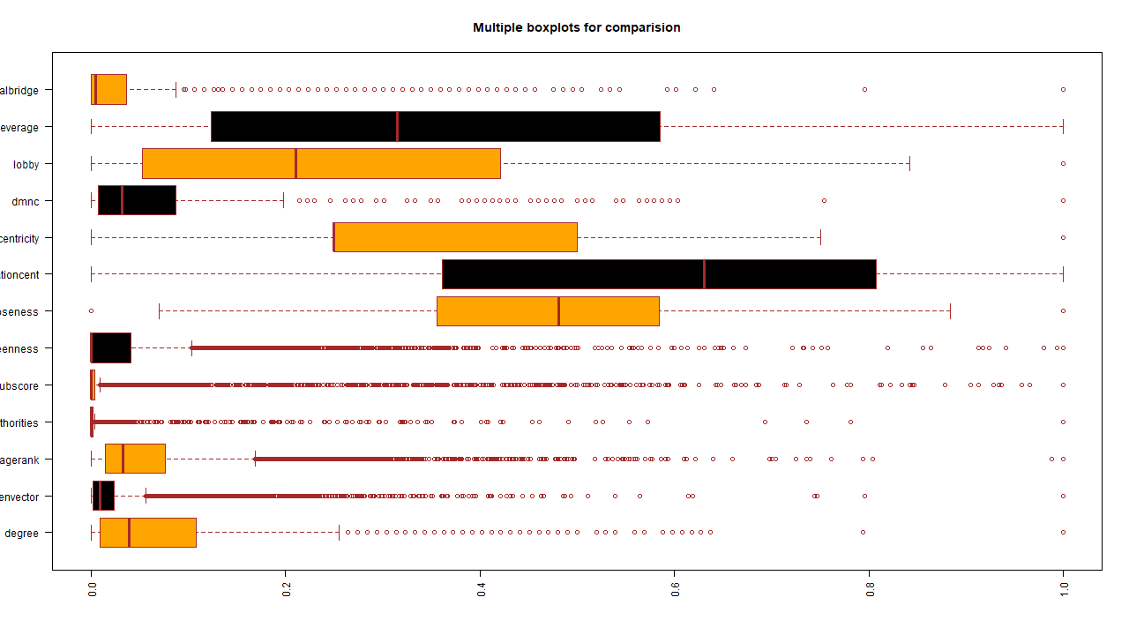

Figure 1 Boxplot

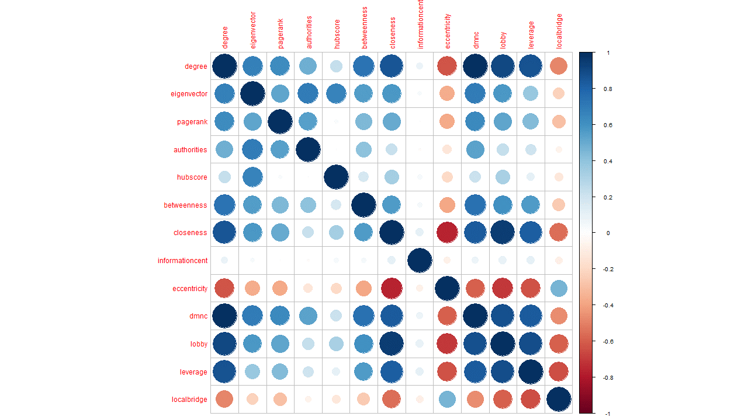

Figure 2 Correlation plot

### 6.1.2 PCA

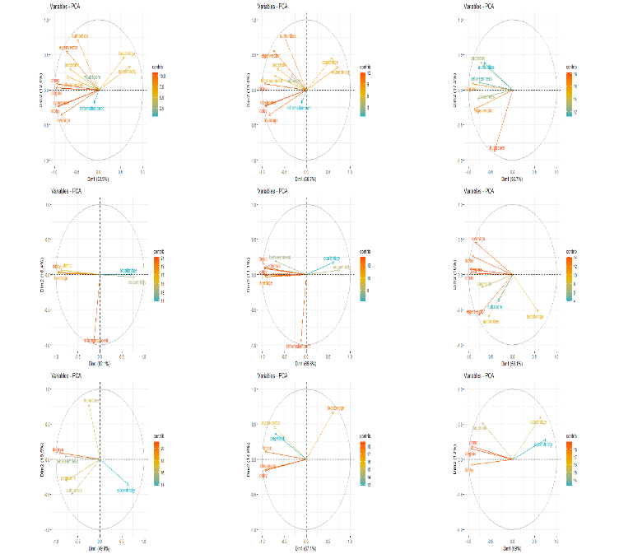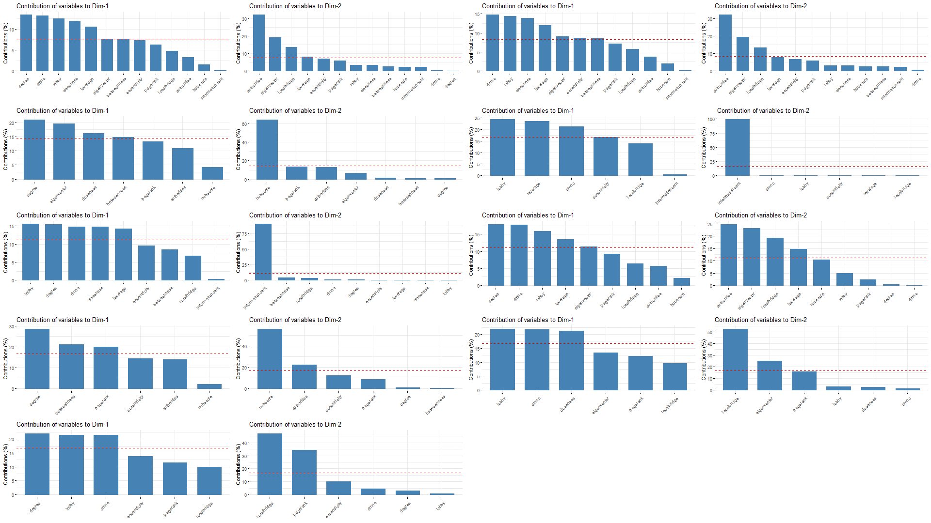

Figure 3 Principal Component Analysis (PCA) Figure 4 Dimension Contribution

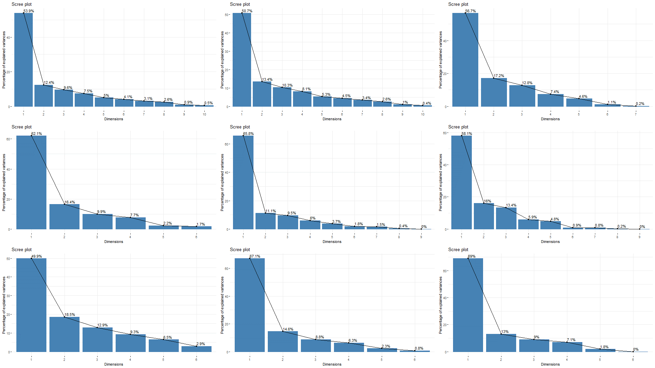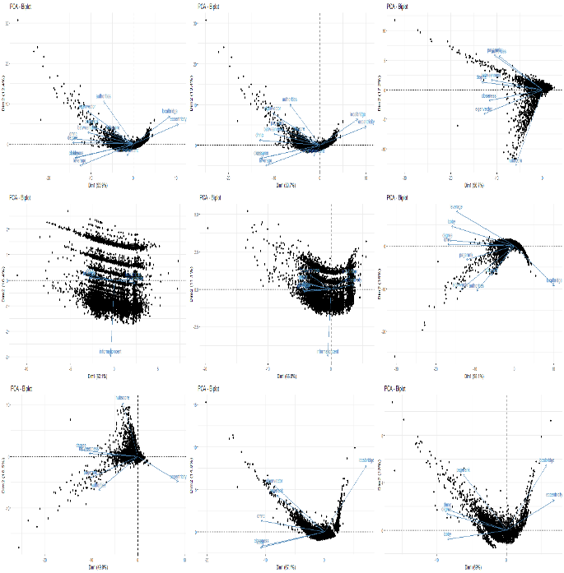

Figure 5 Scree plot Figure 6 Biplot

### 6.1.3 t-SNE and K-means on t-SNE

t-SNE Model 1:

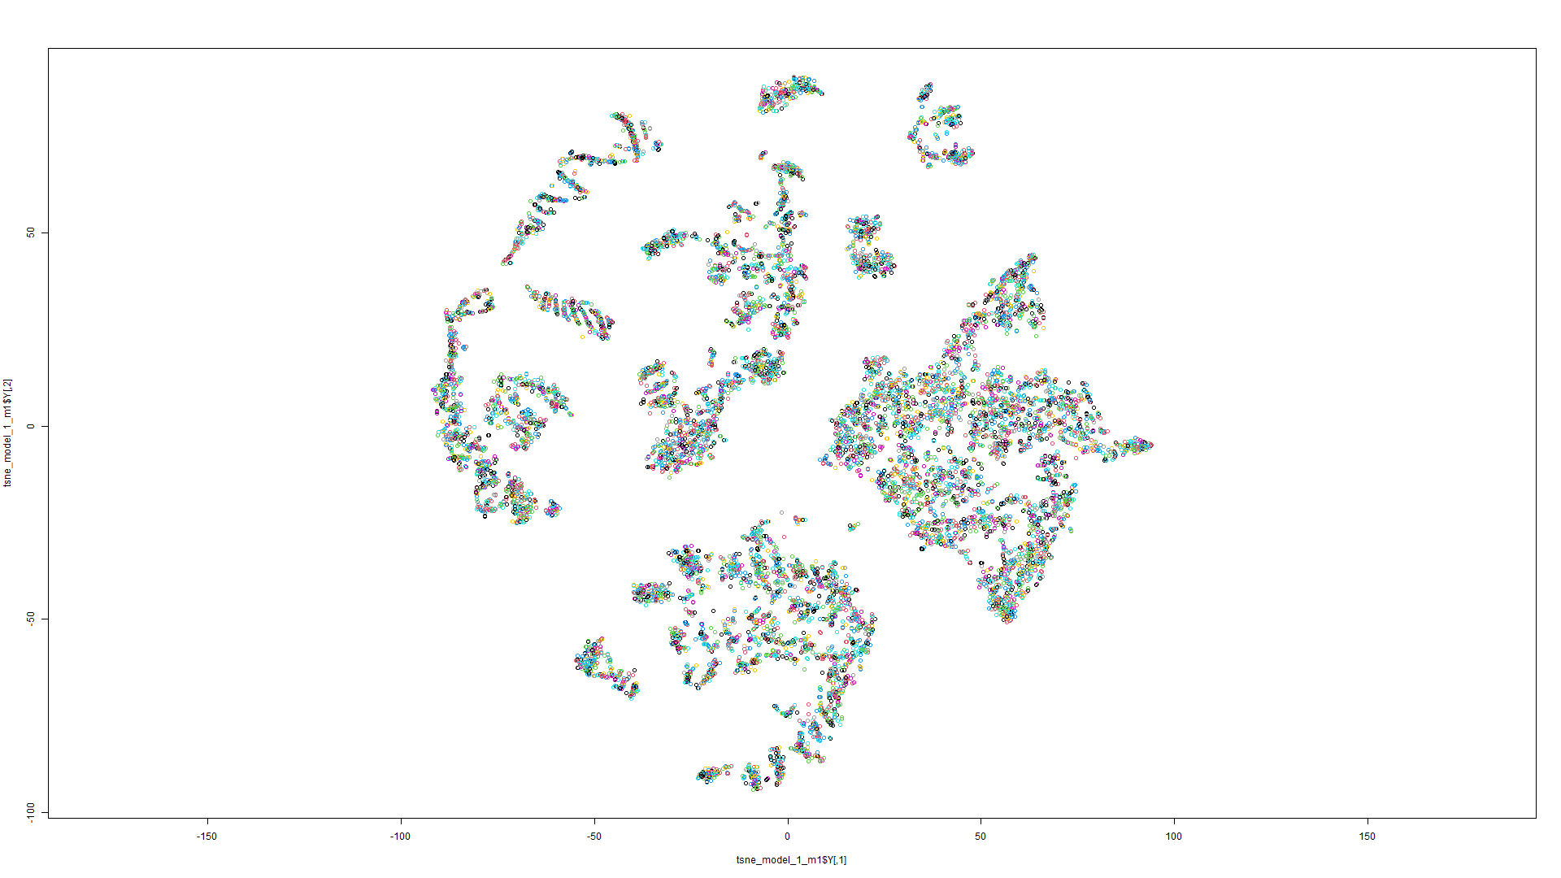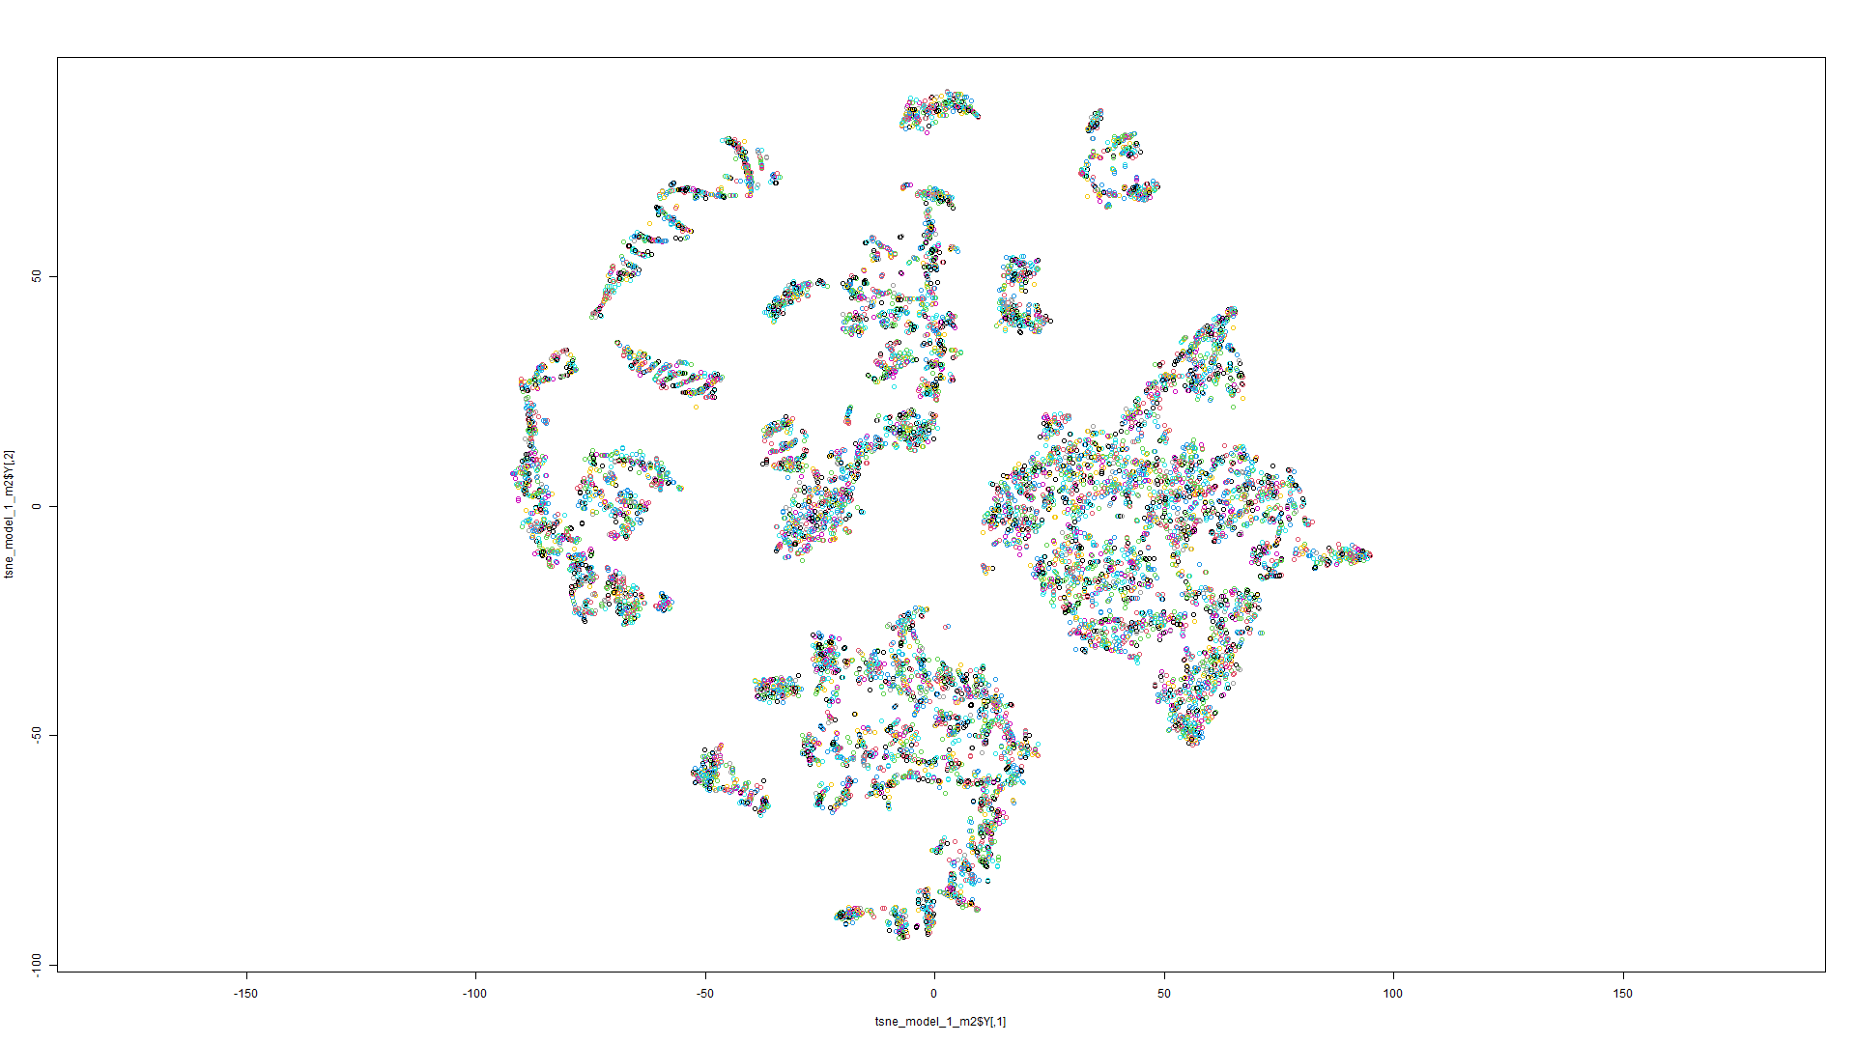

Figure 7 t-SNE on Model 1 Figure 8 t-SNE on Model 2

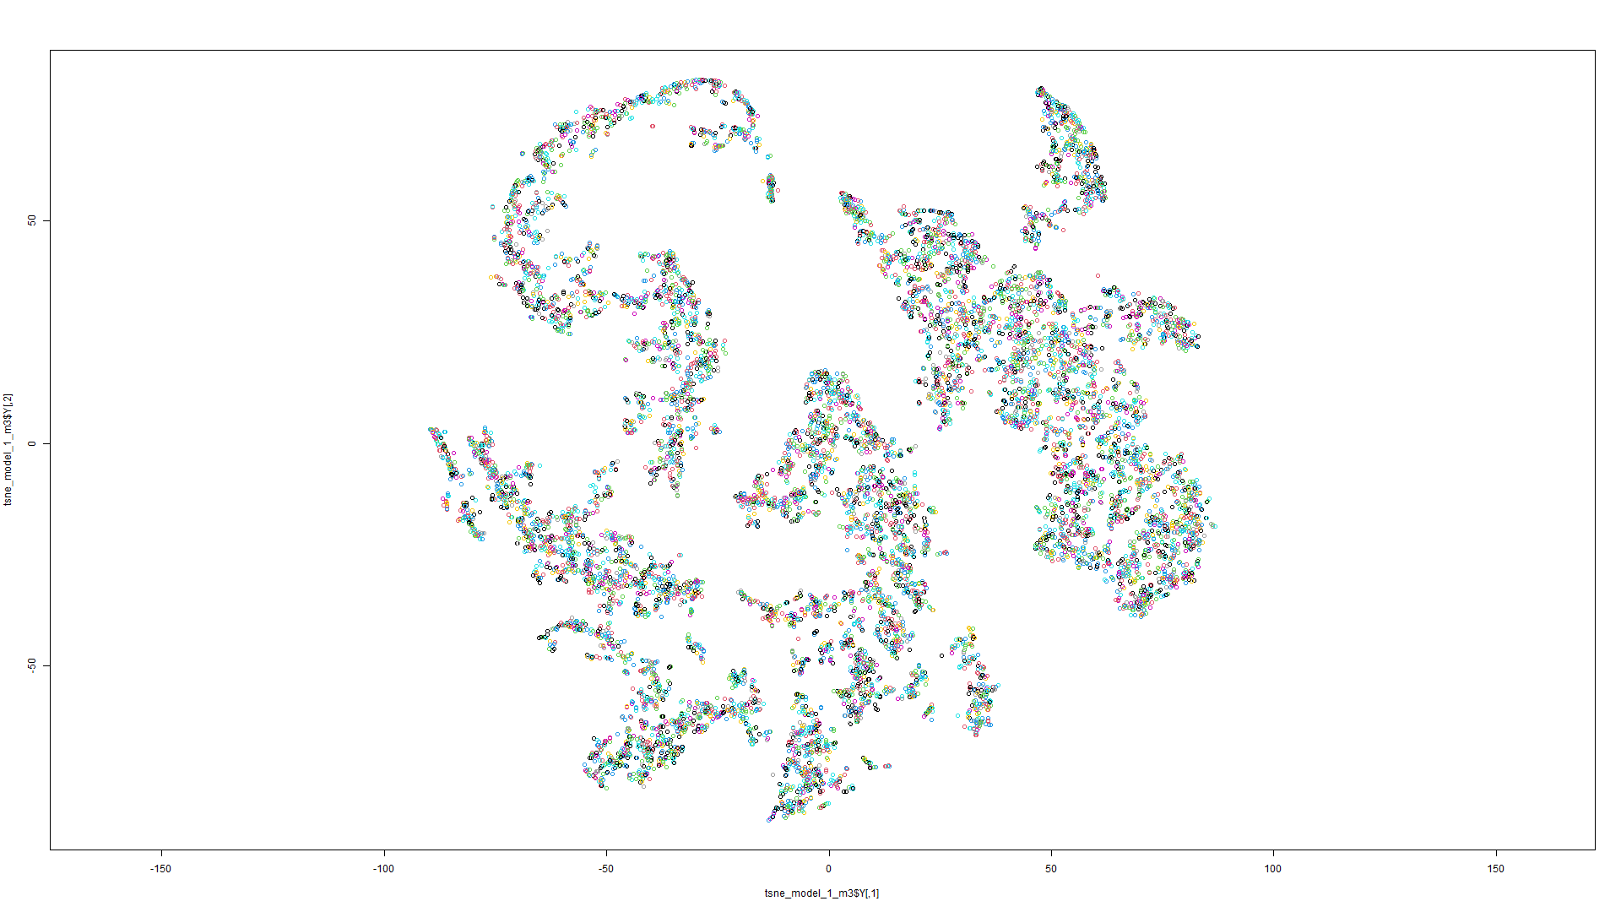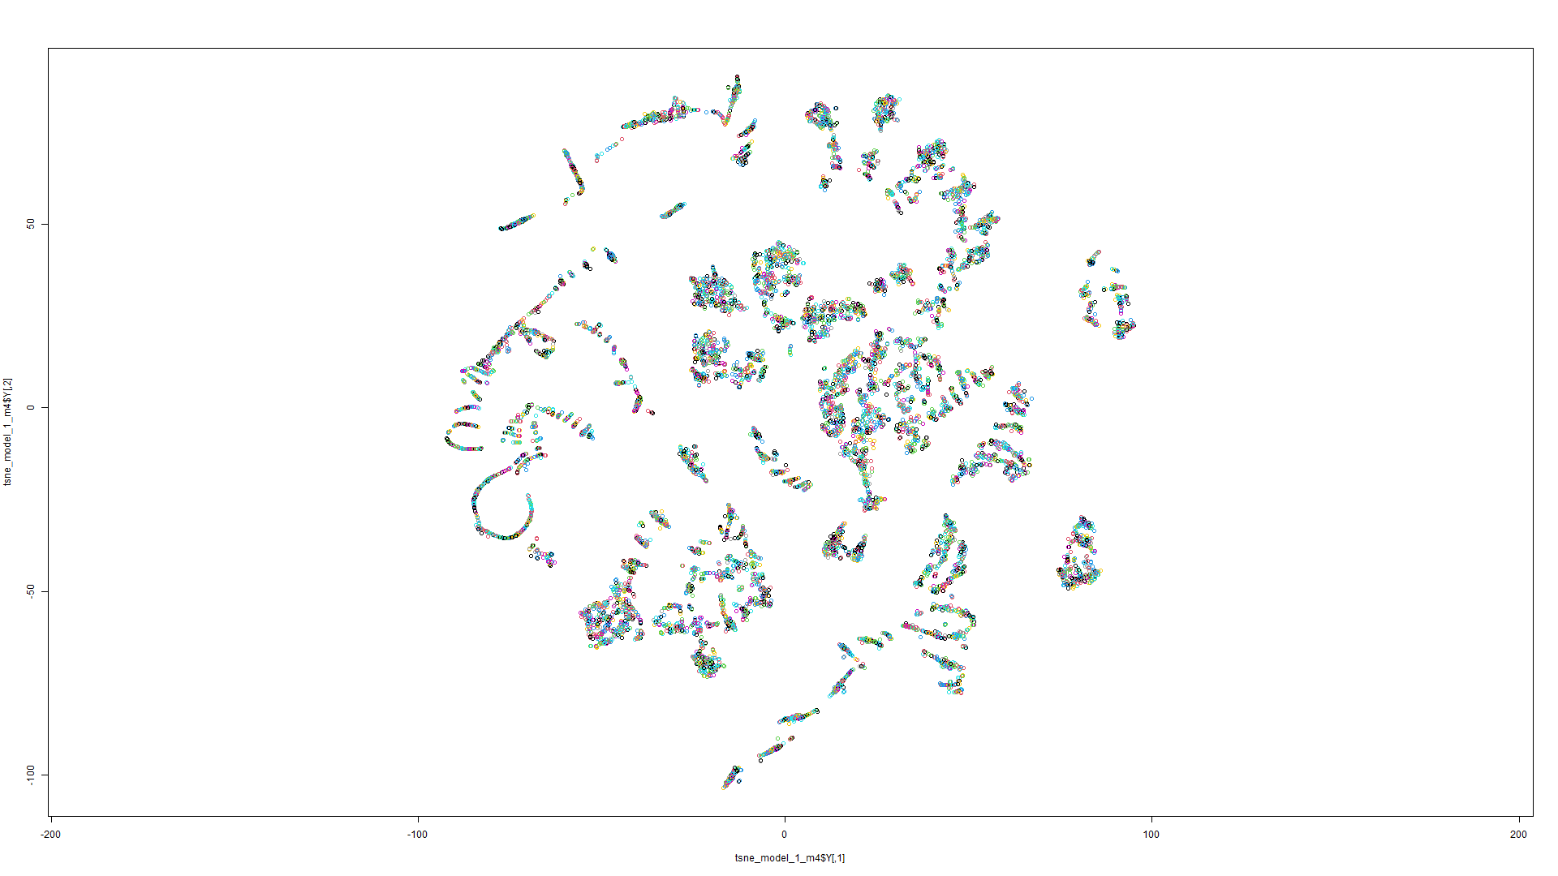

Figure 9 t-SNE on Model 3 Figure 10 t-SNE on Model 4

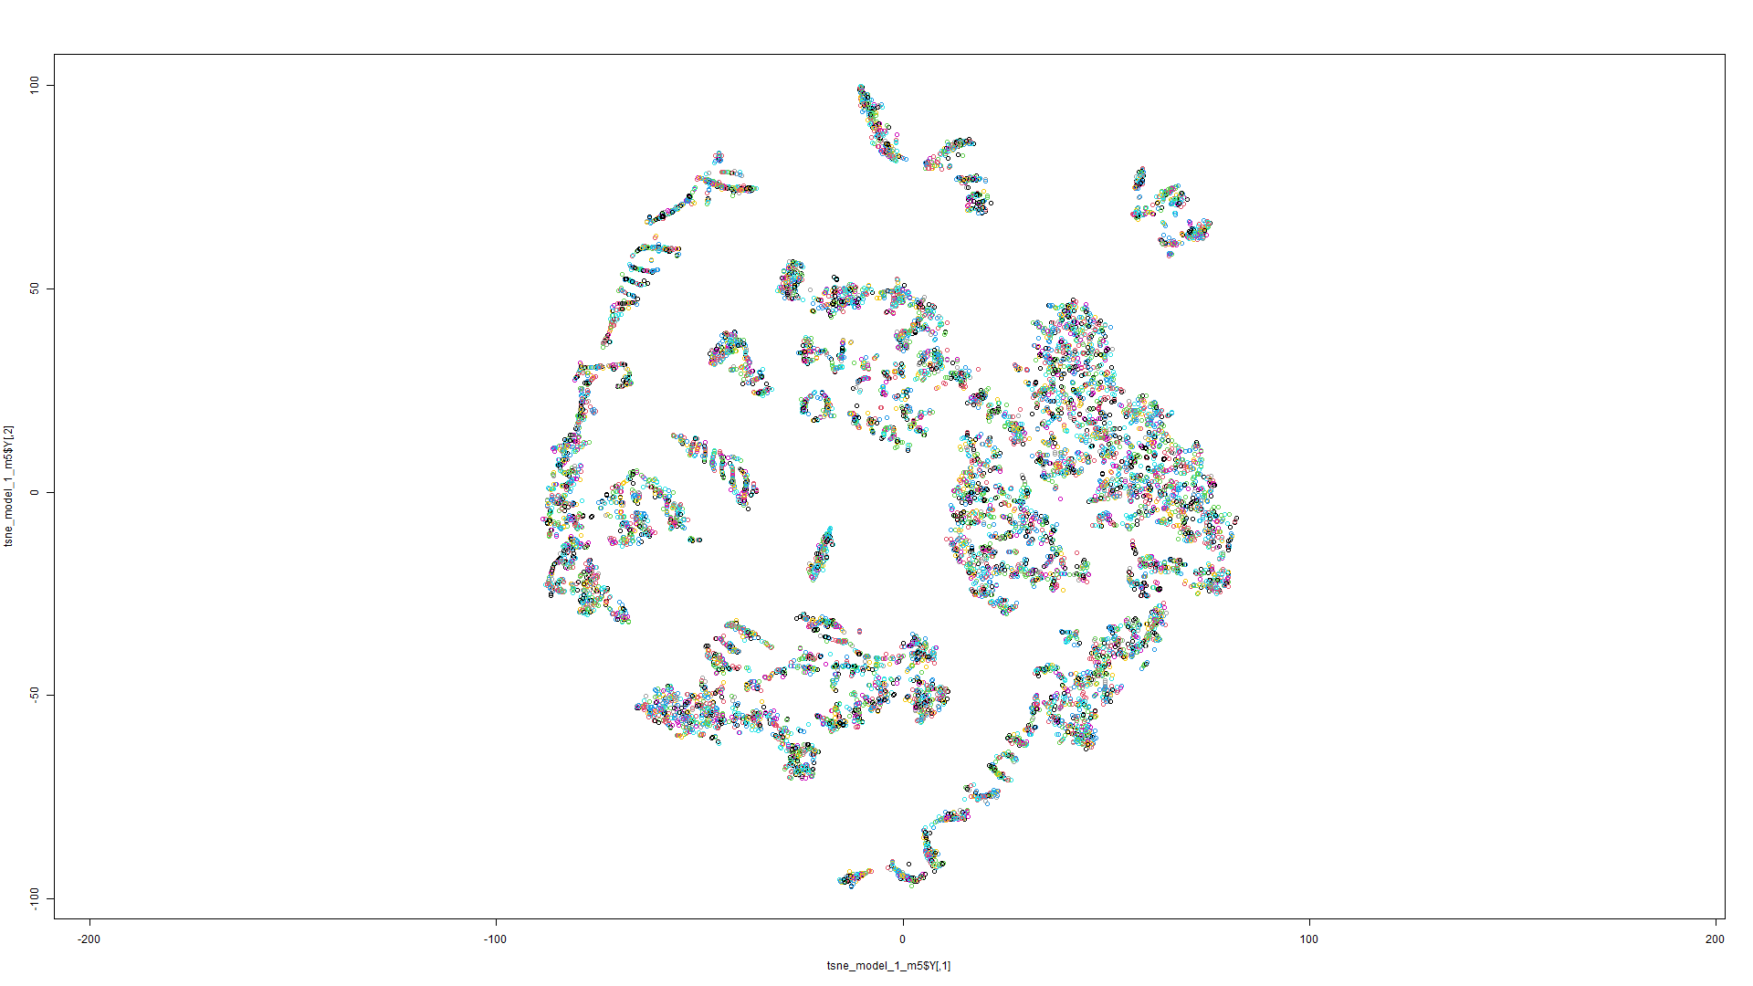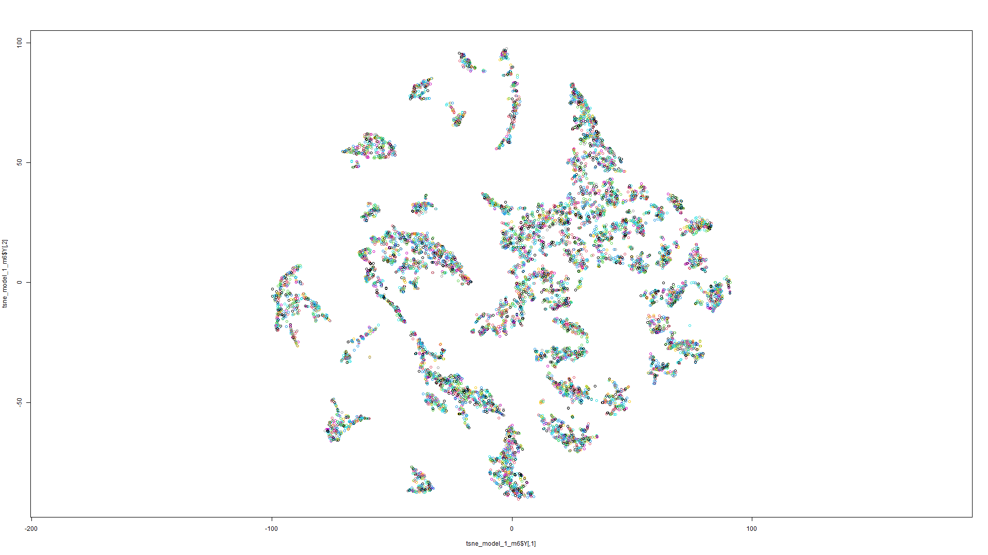

Figure 11 t-SNE on Model 5 Figure 12 t-SNE on Model 6

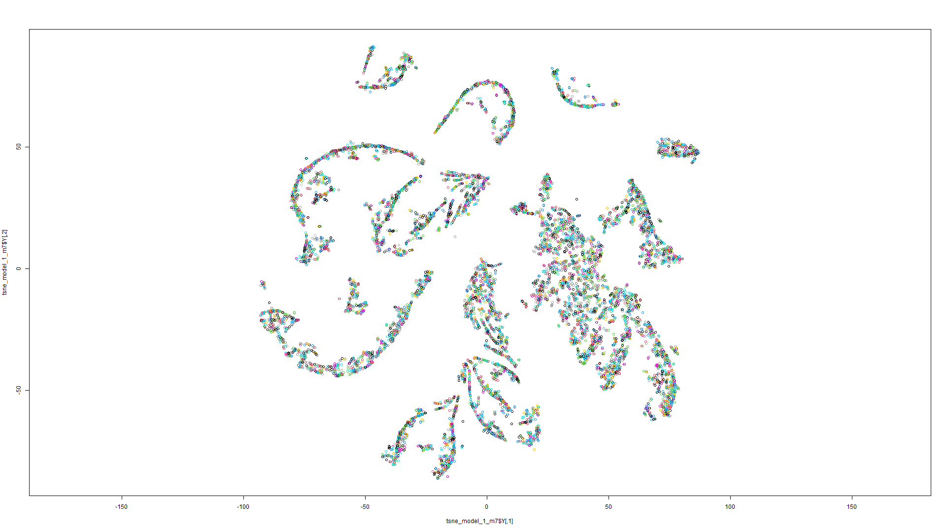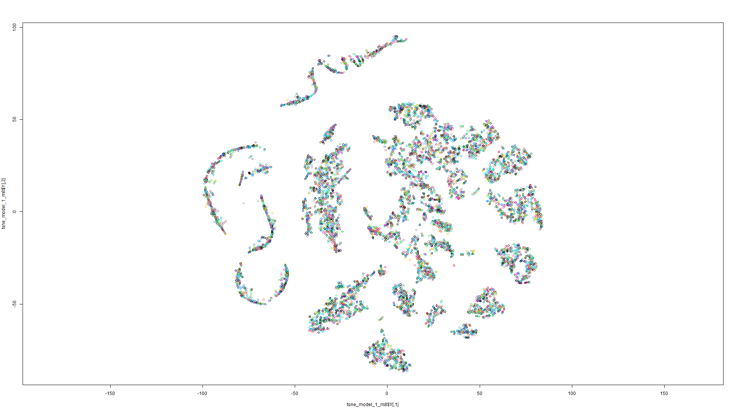

Figure 13 t-SNE on Model 7 Figure 14 t-SNE on Model 8

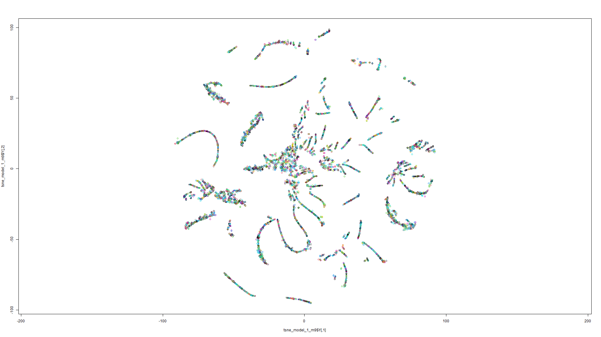

t-SNE Model 2:

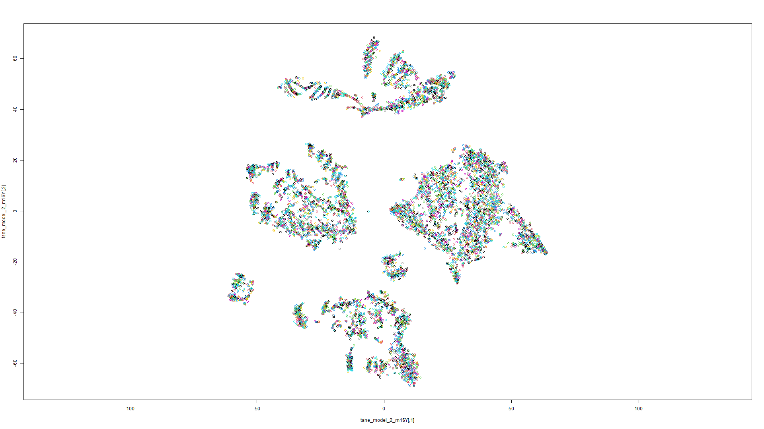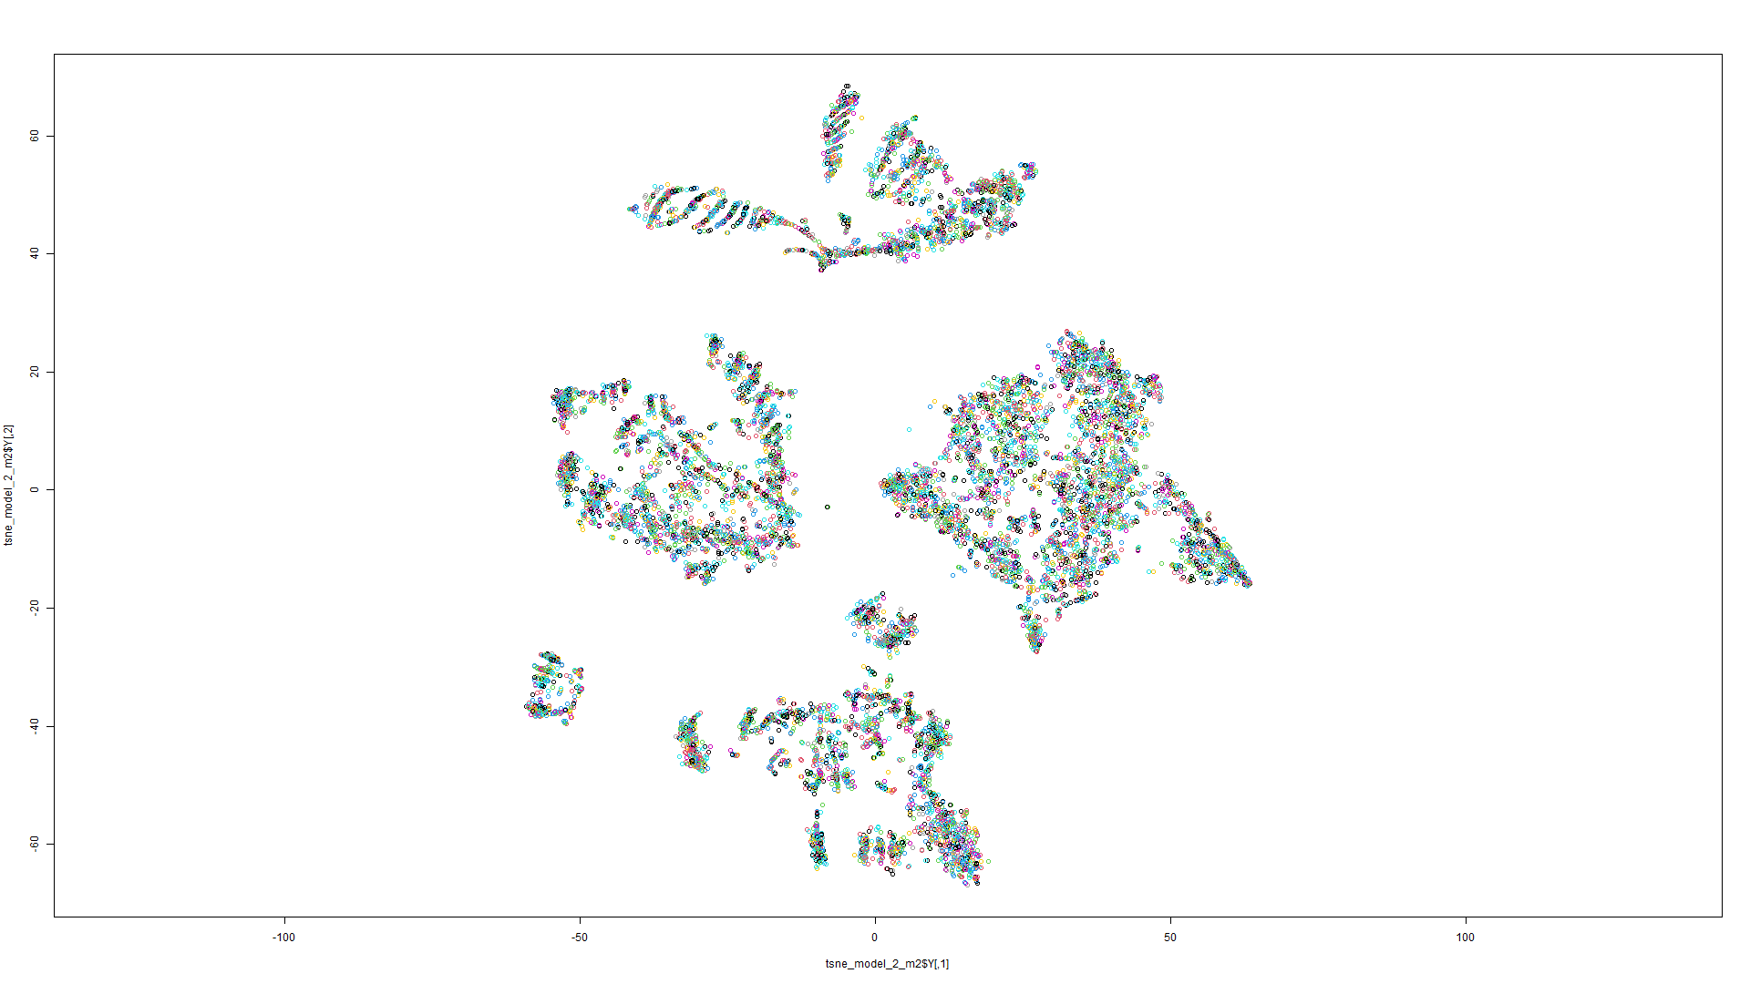

Figure 15 t-SNE on Model 1 Figure 16 t-SNE on Model 2

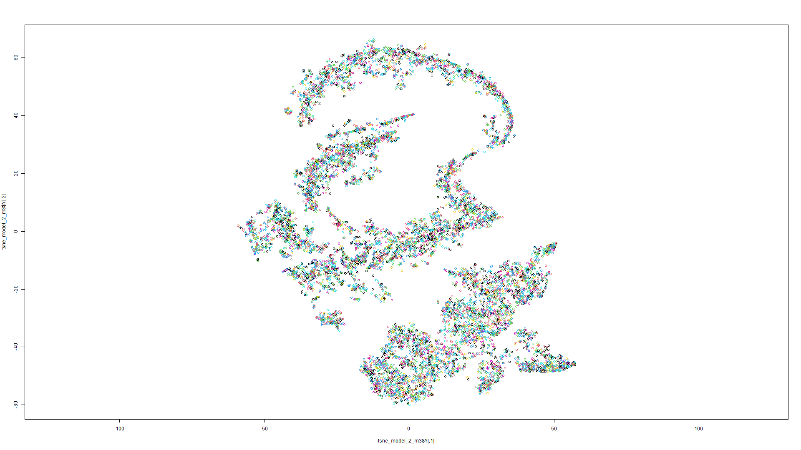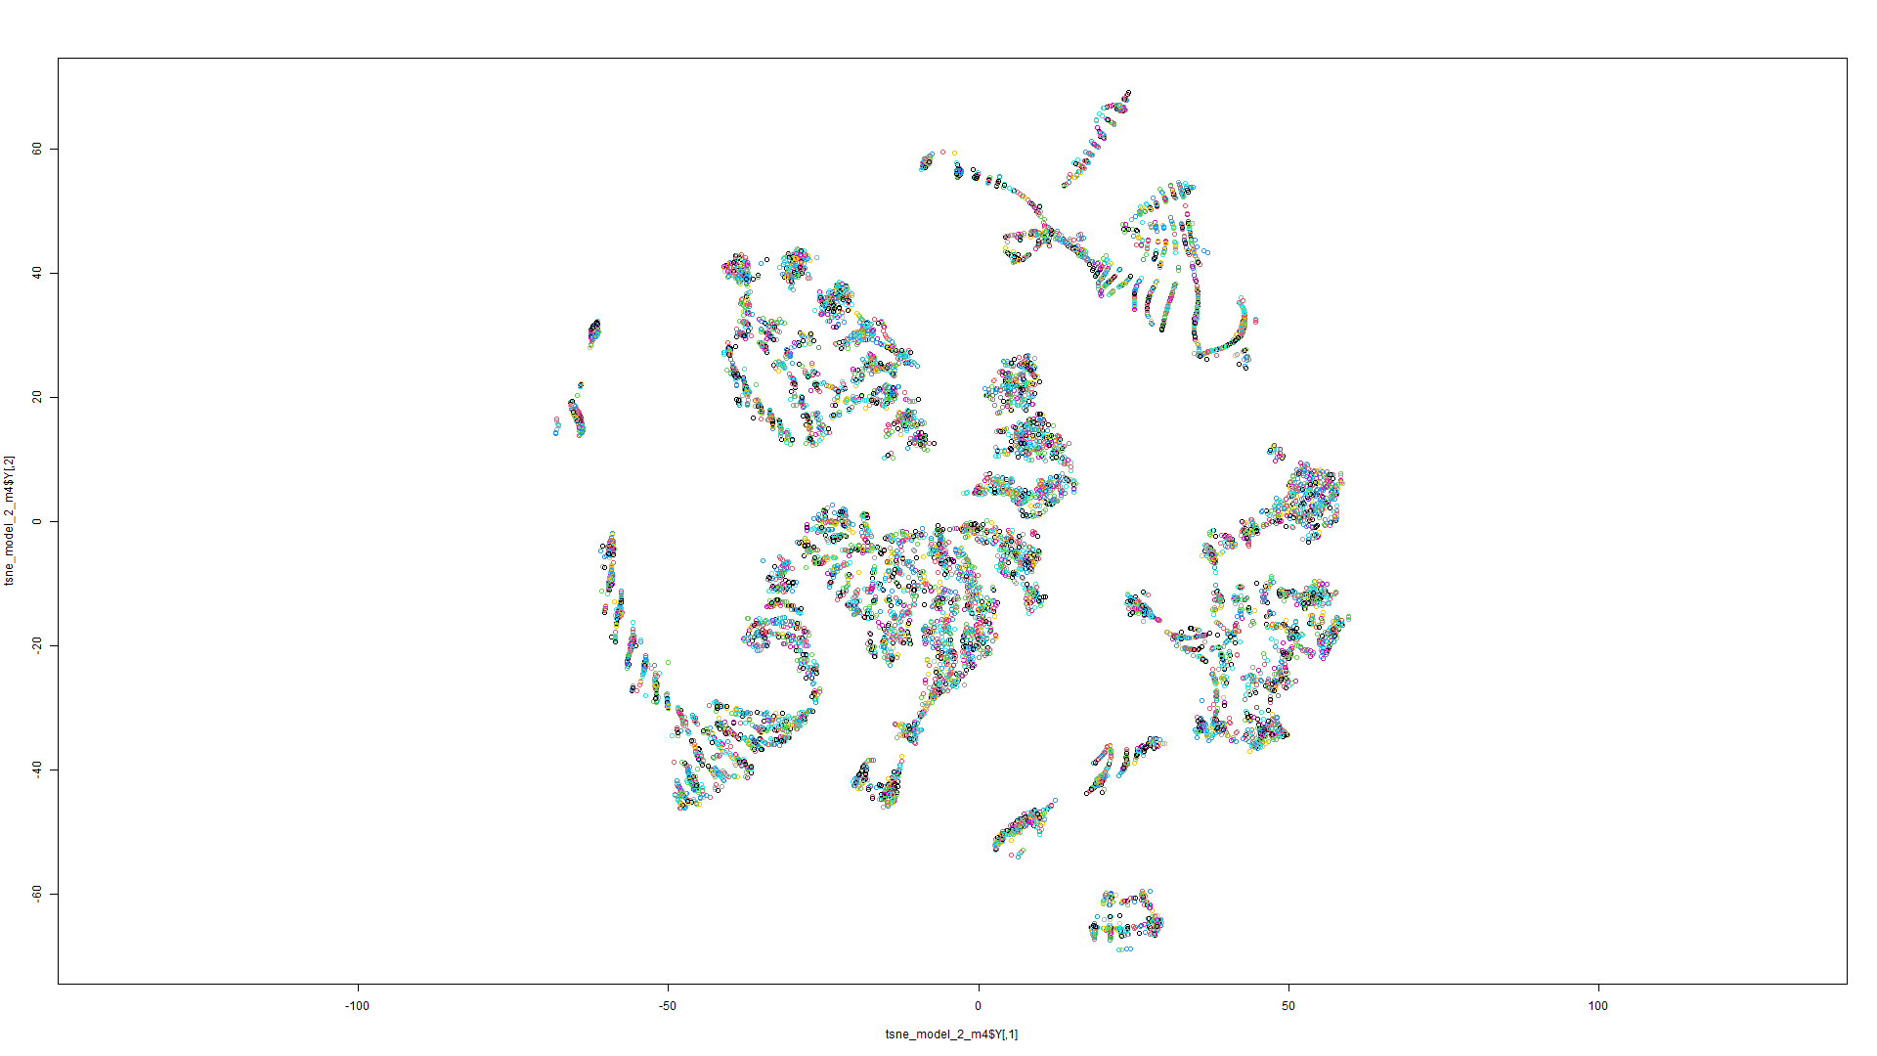

Figure 18 t-SNE on Model 3 Figure 19 t-SNE on Model 4

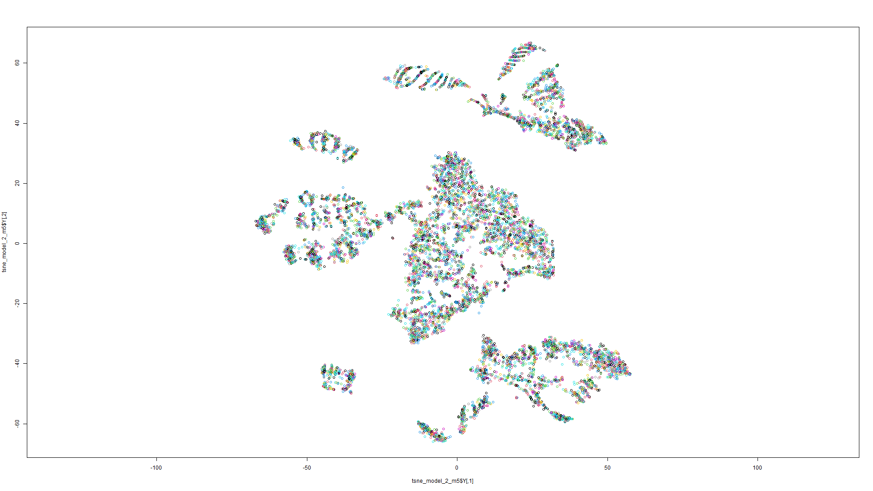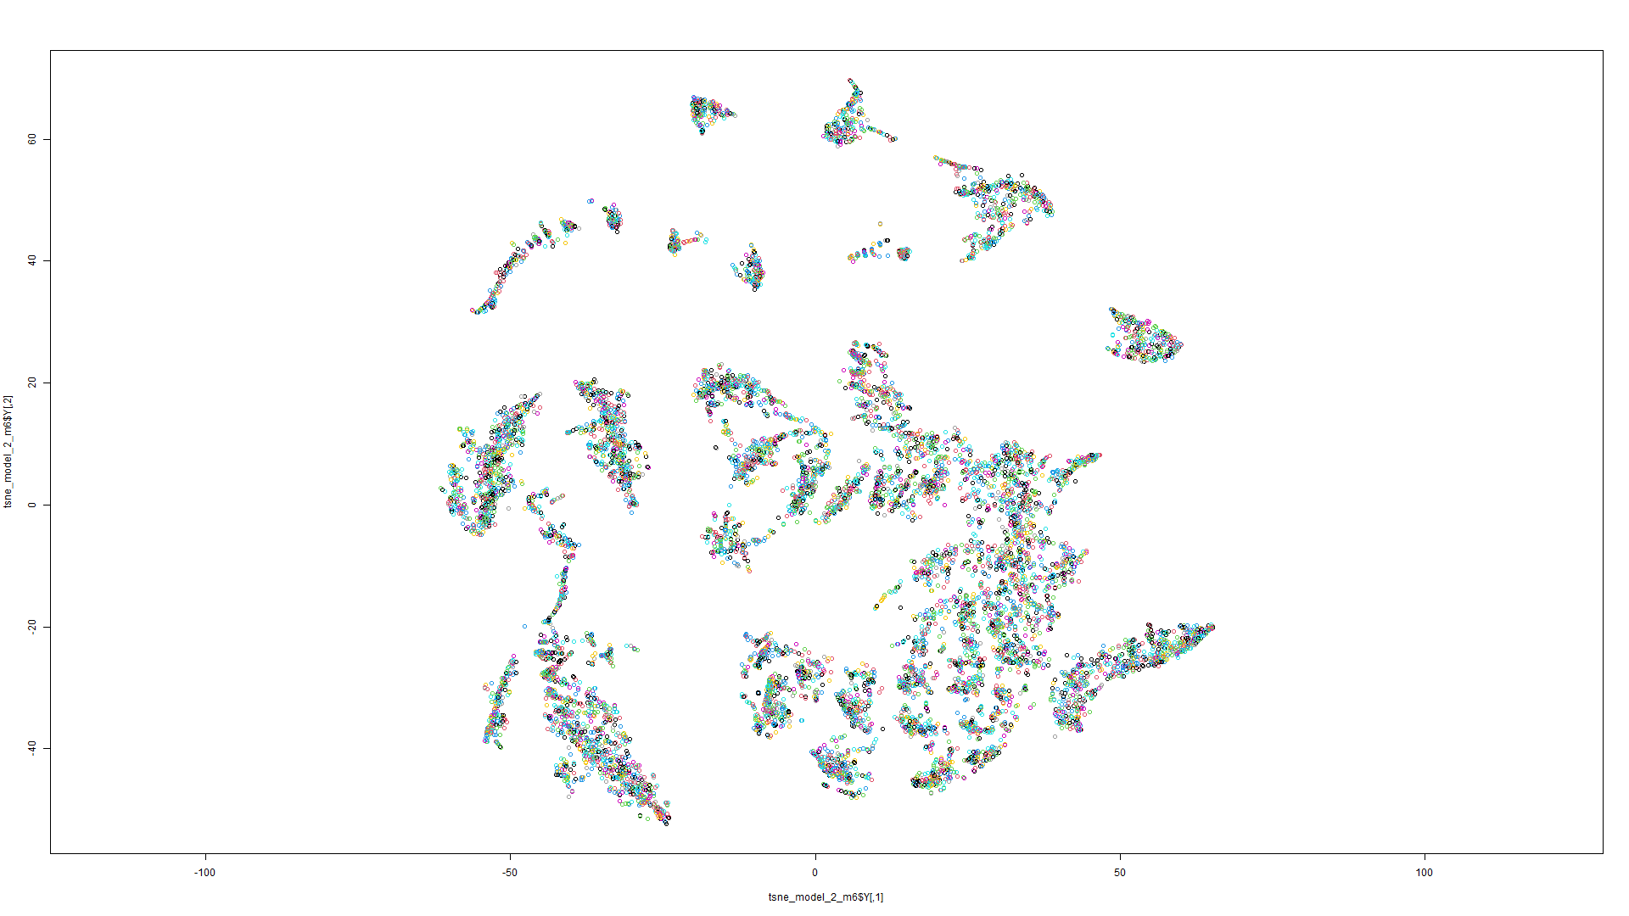

Figure 20 t-SNE on Model 5 Figure 21 t-SNE on Model 6

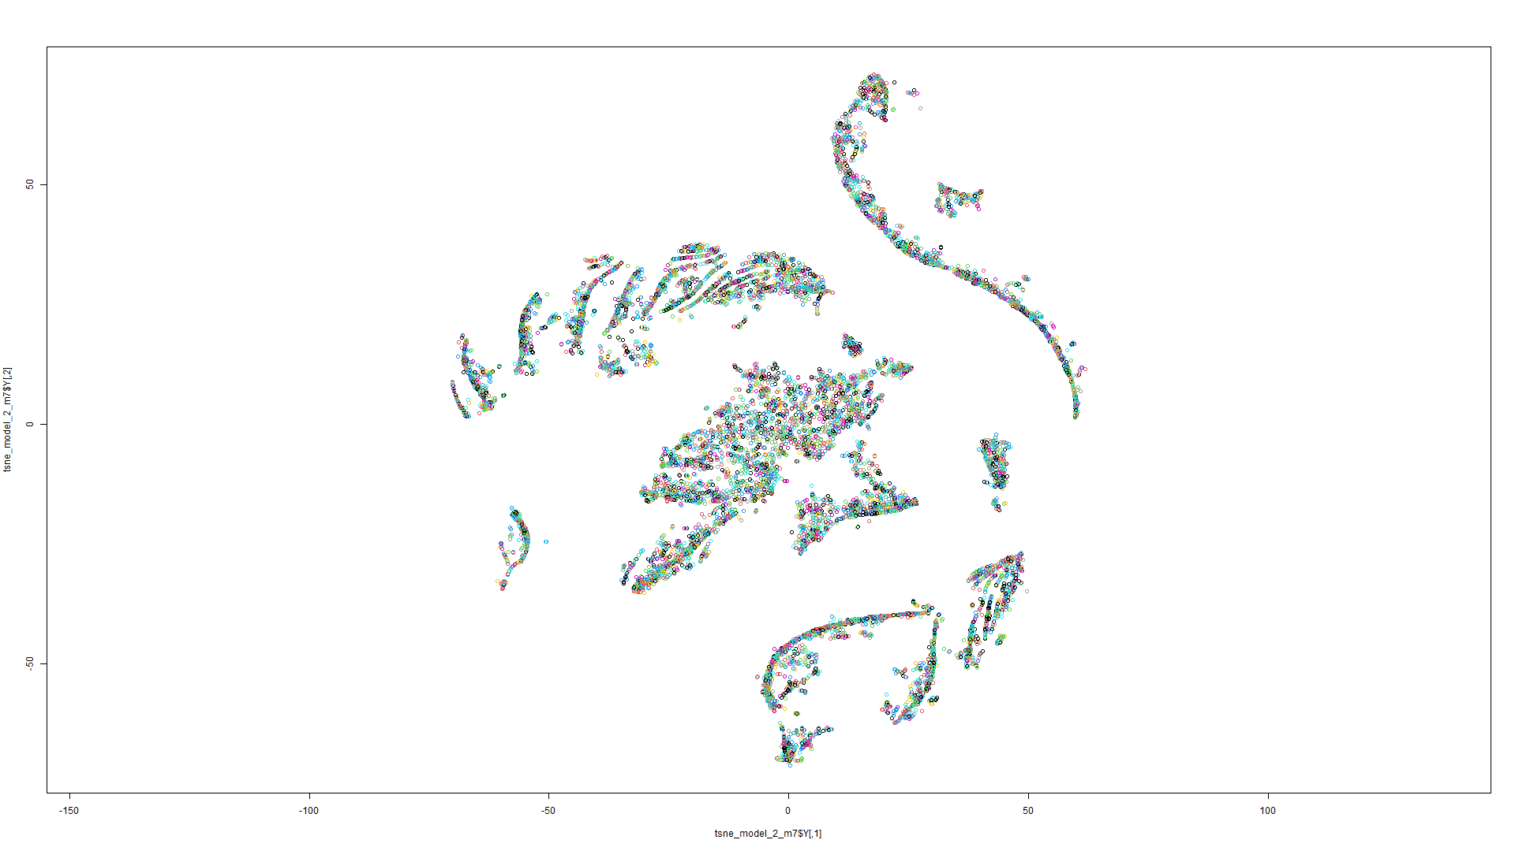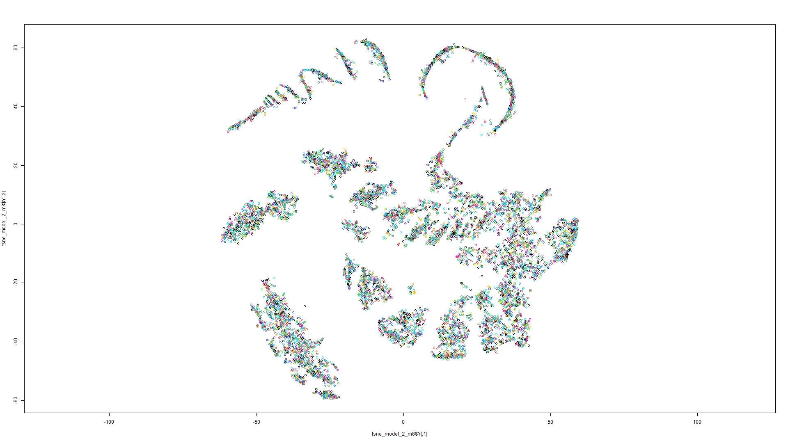

Figure 22 t-SNE on Model 7 Figure 23 t-SNE on Model 8

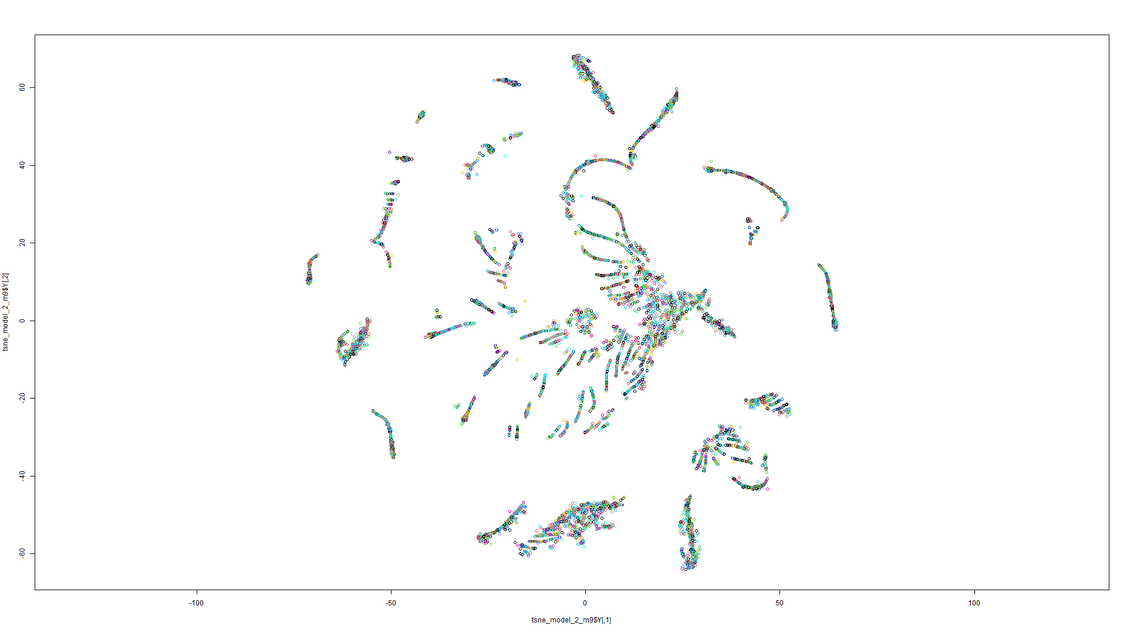

Figure 24 t-SNE on Model 9

t-SNE Model 3:

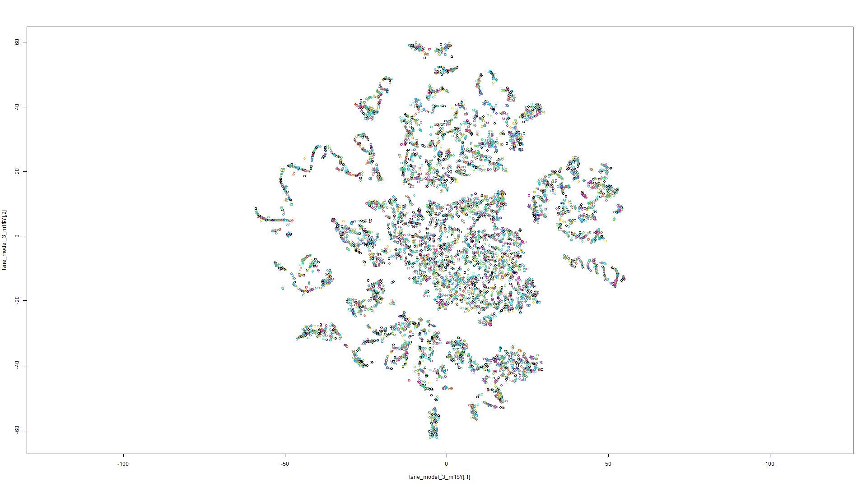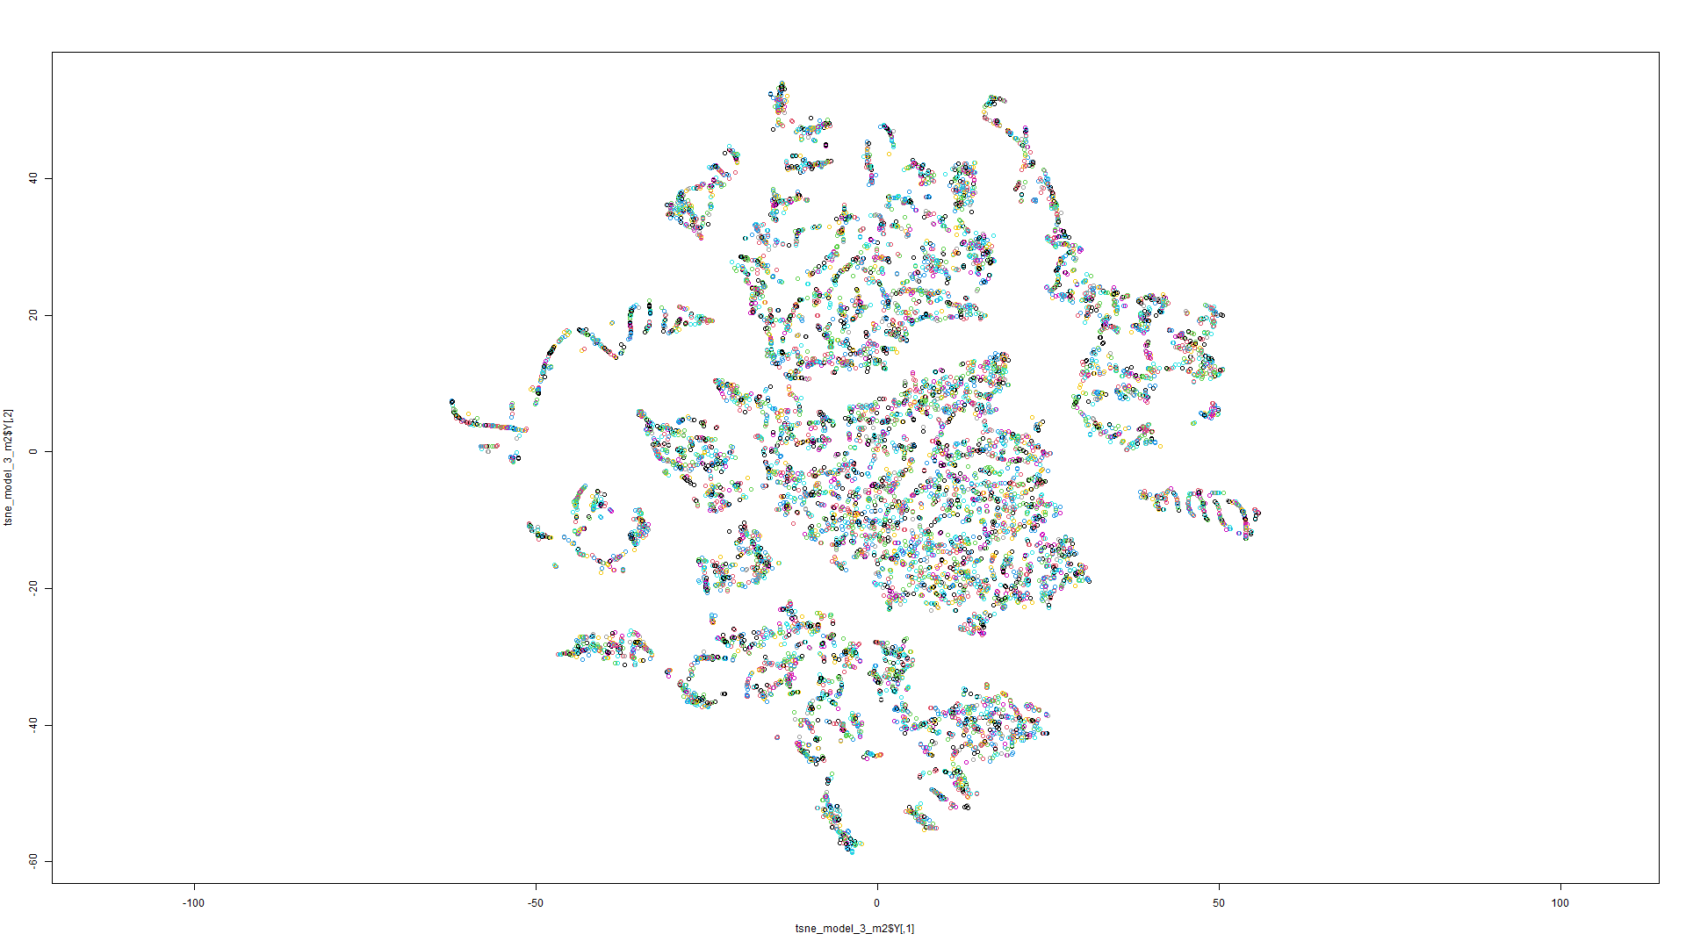

Figure 25 t-SNE on Model 1 Figure 26 t-SNE on Model 2

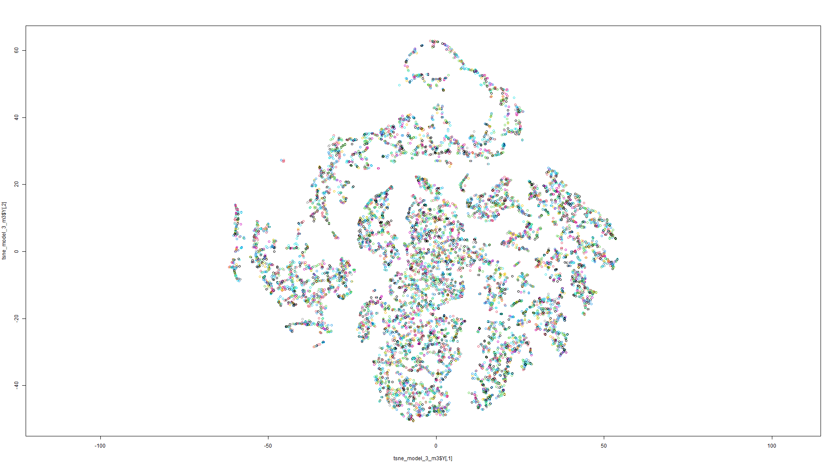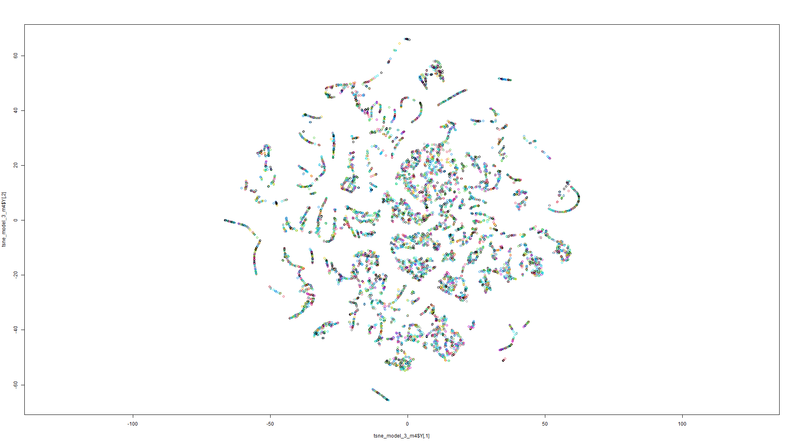

Figure 27 t-SNE on Model 3 Figure 28 t-SNE on Model 4

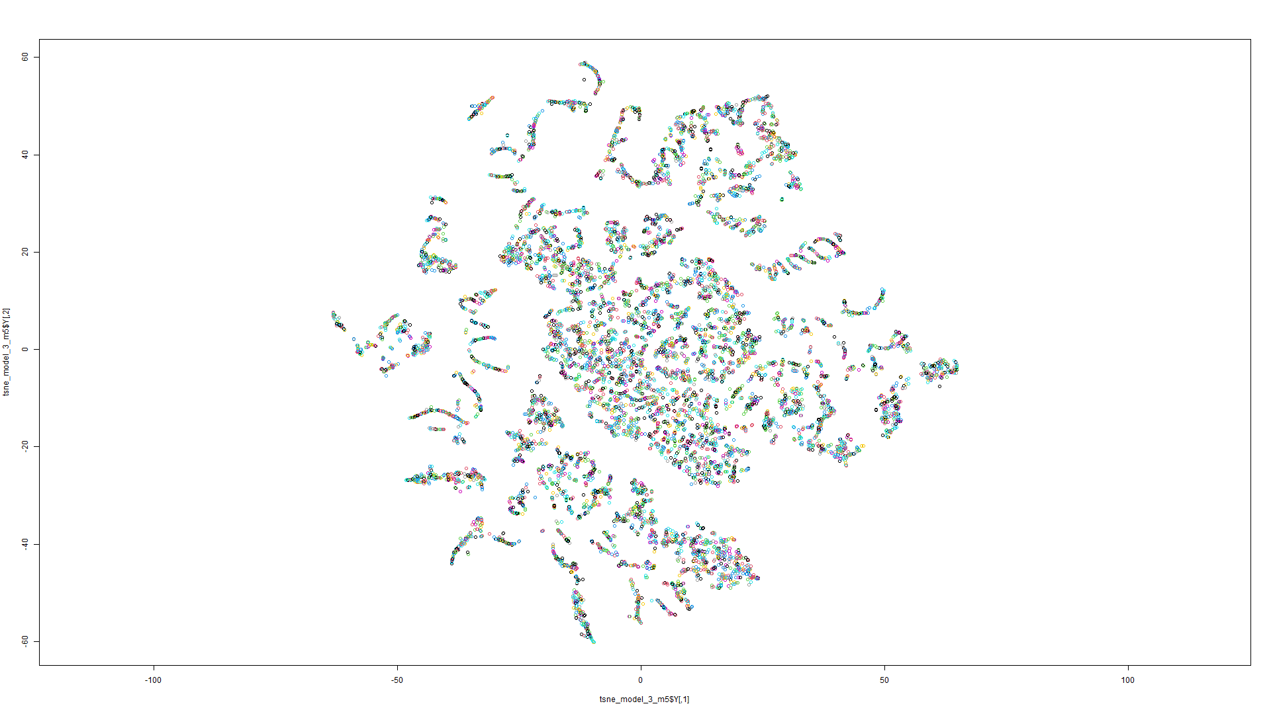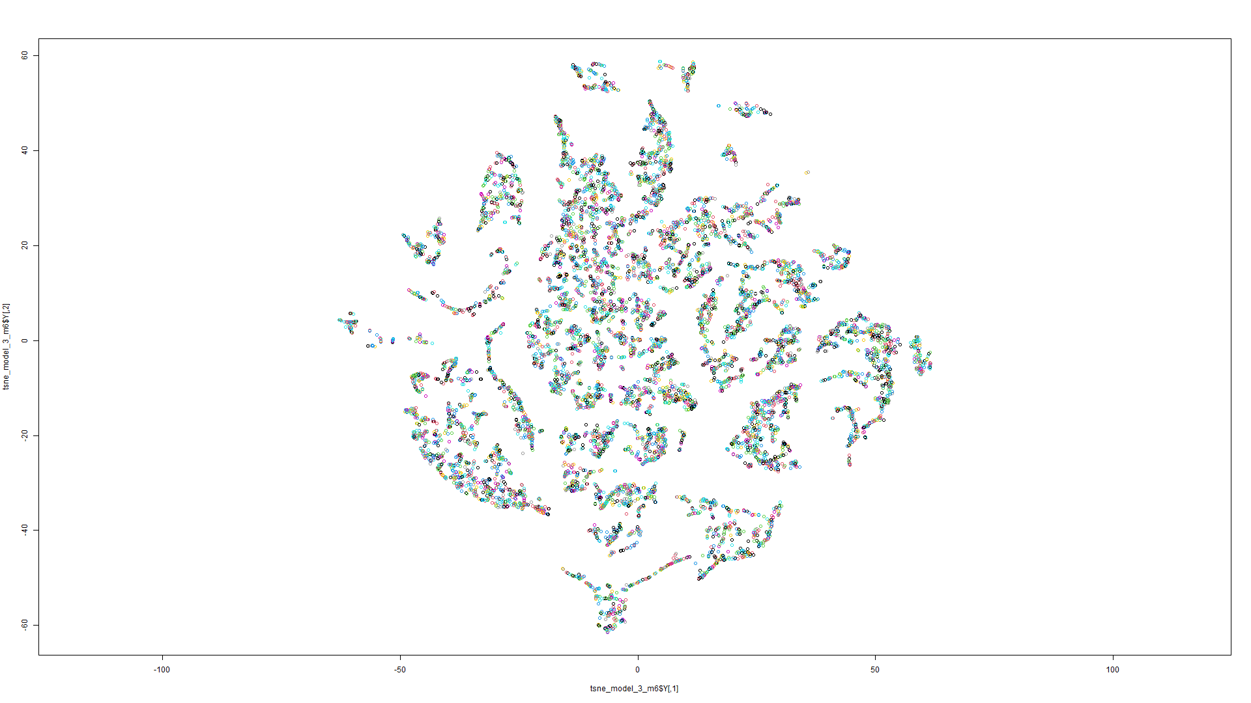

Figure 29 t-SNE on Model 5 Figure 30 t-SNE on Model 6

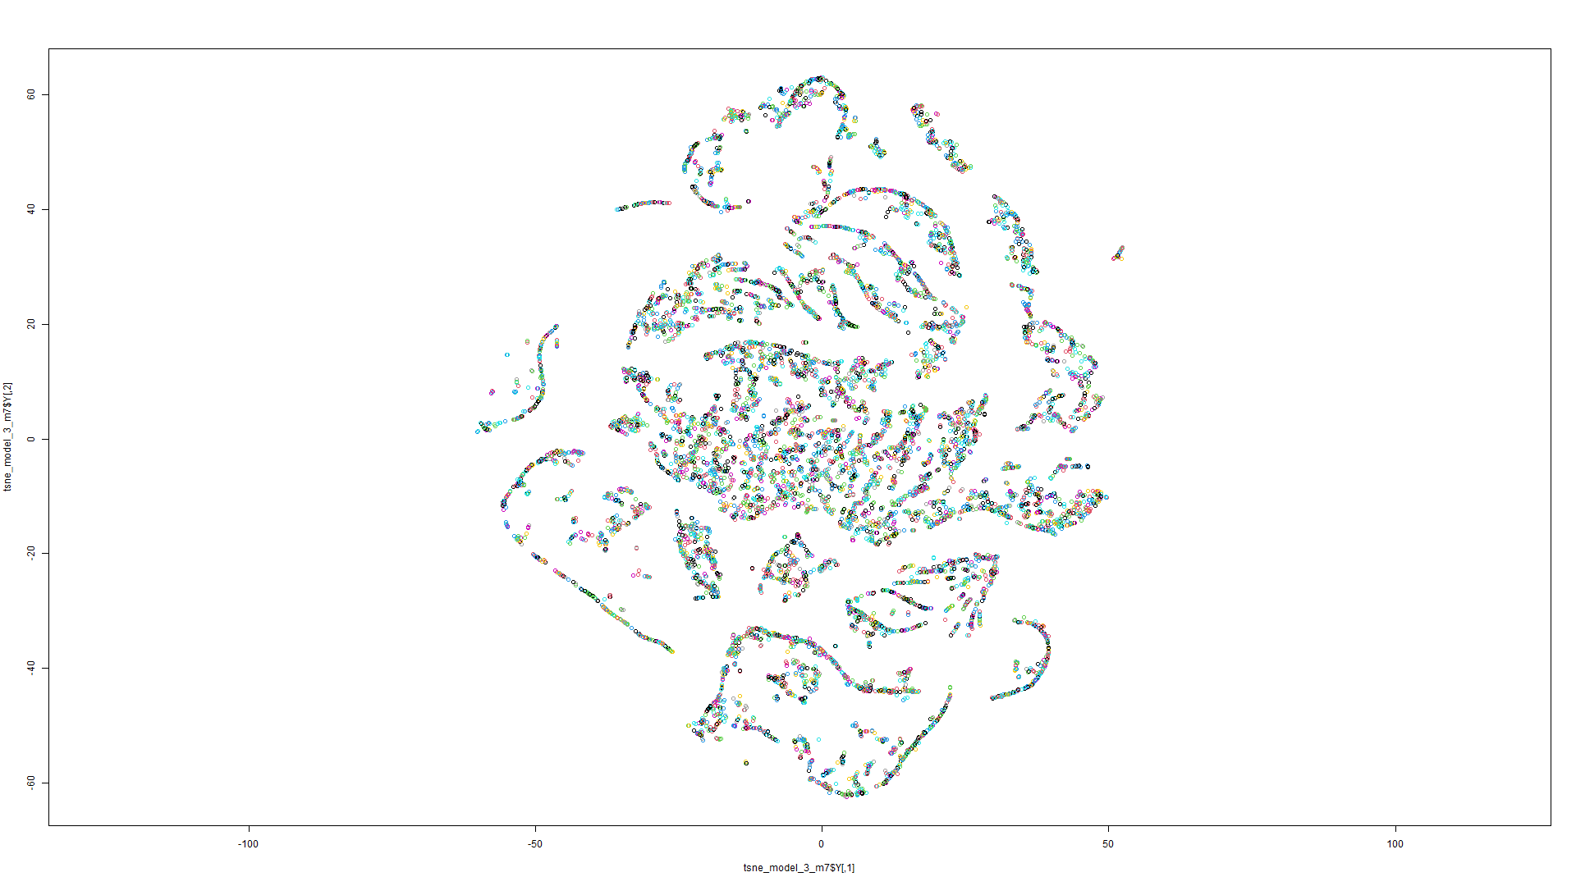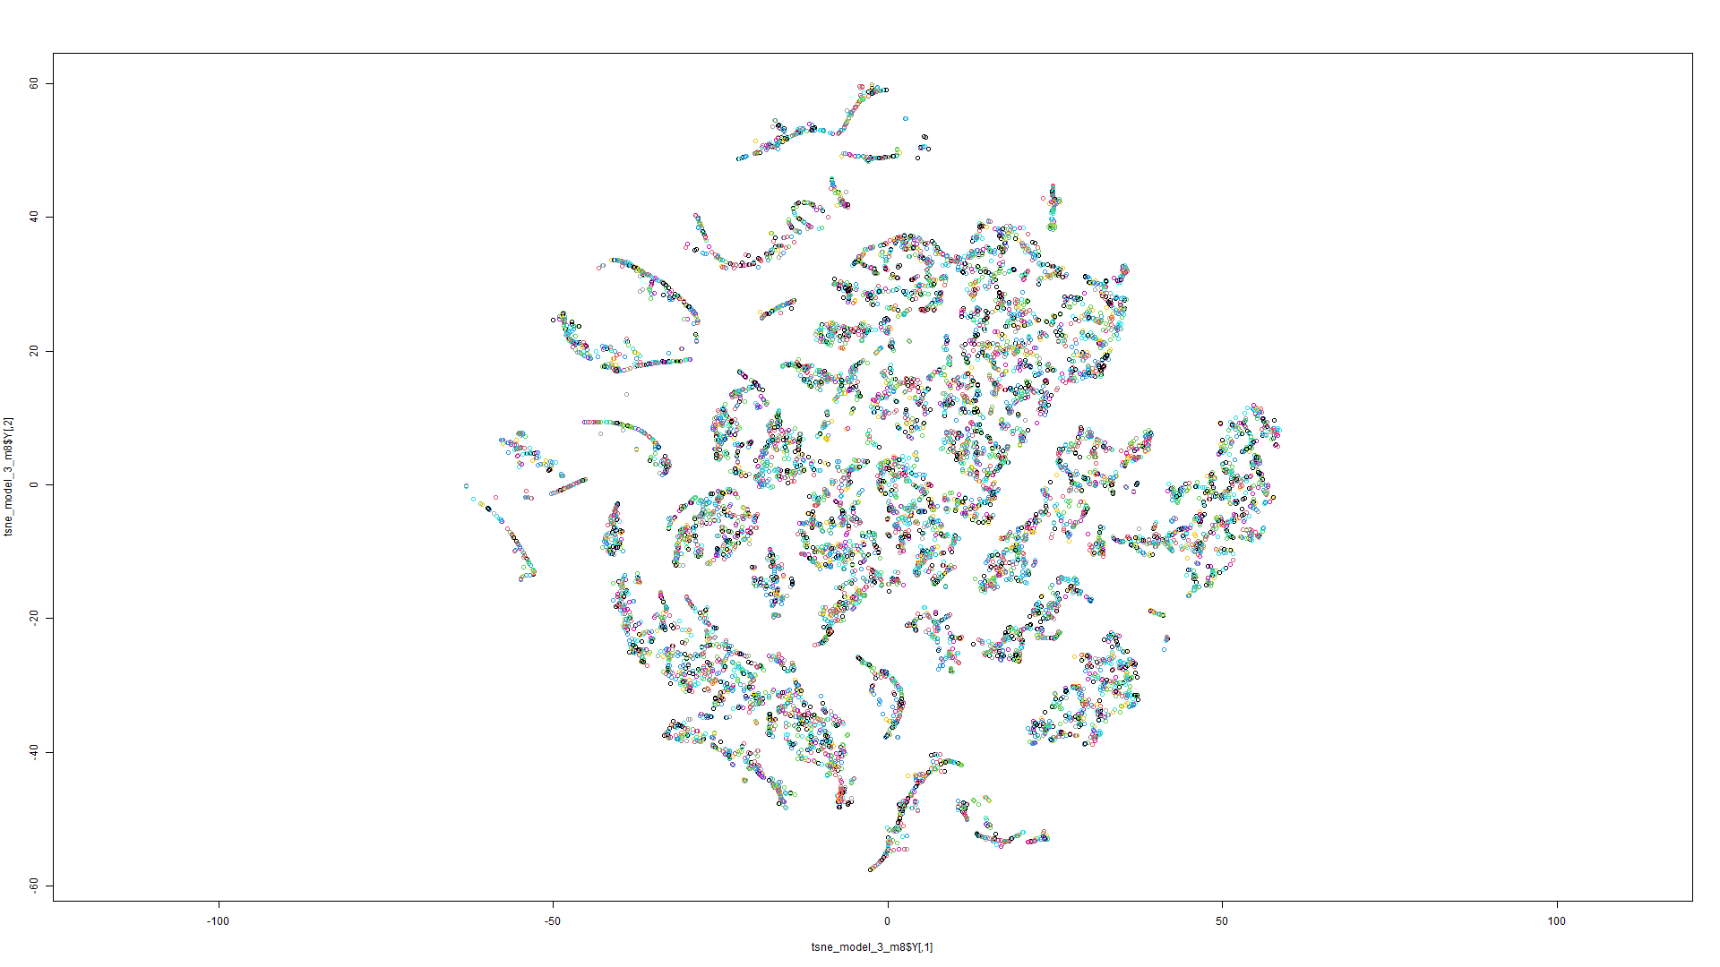

Figure 31 t-SNE on Model 7 Figure 32 t-SNE on Model 8

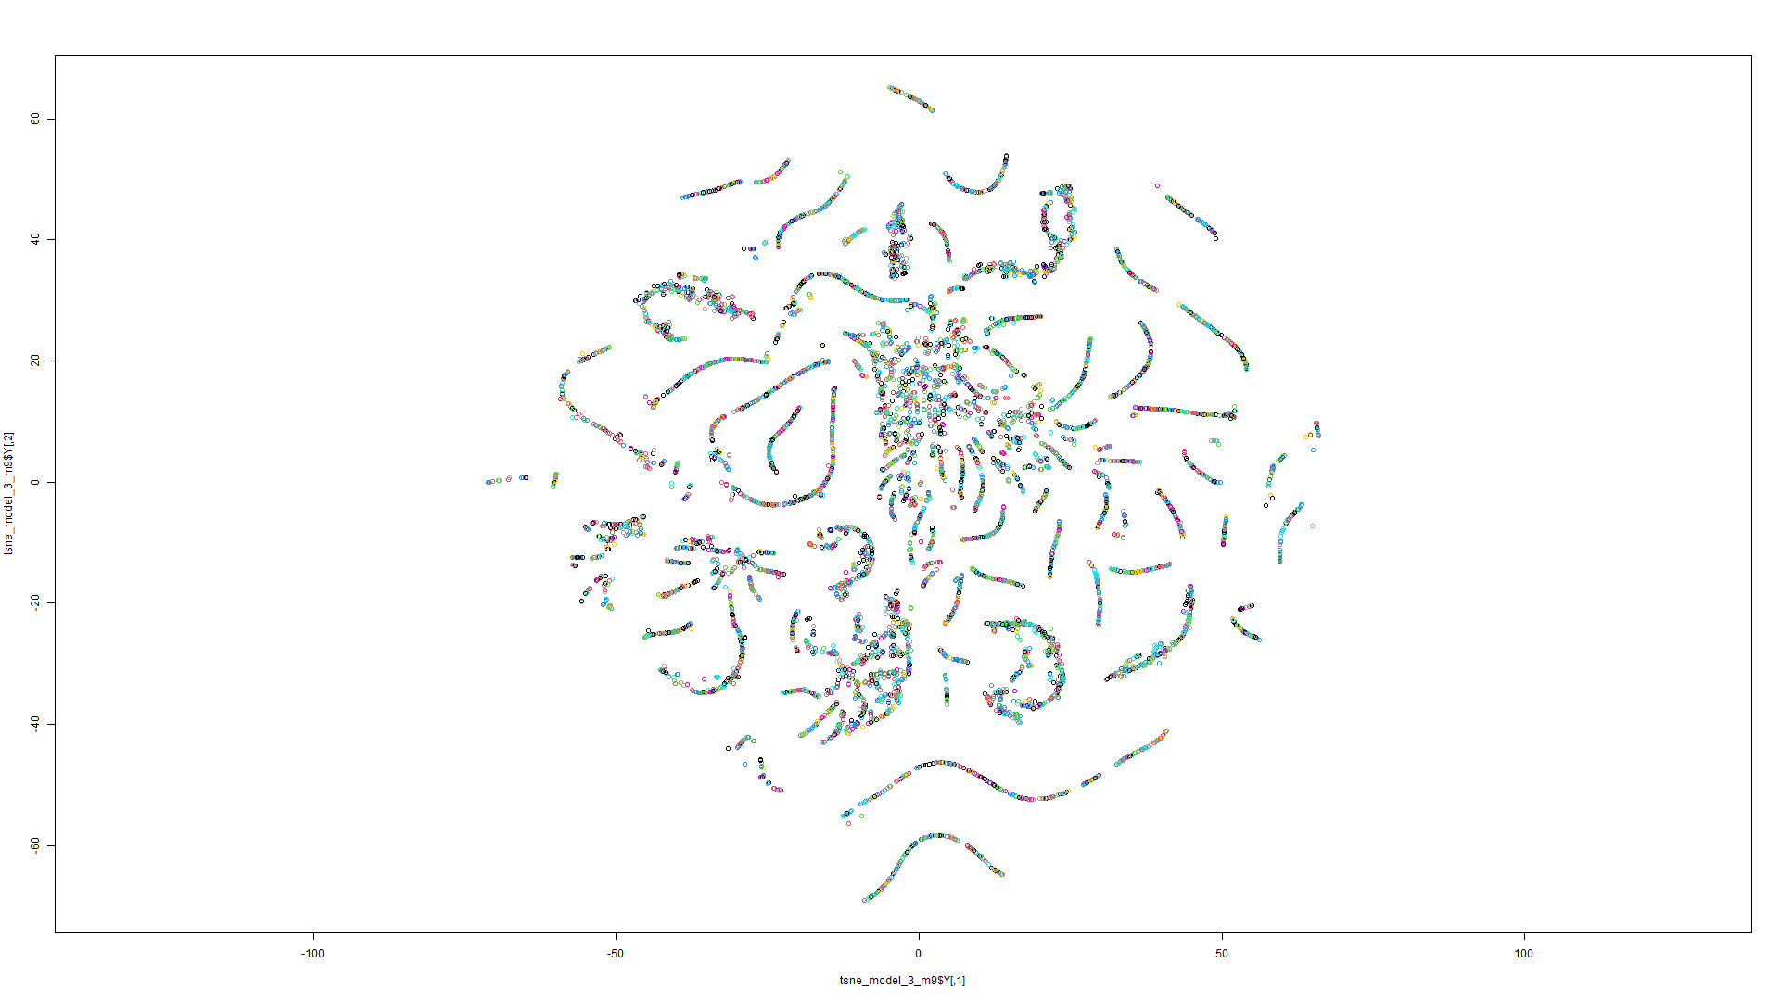

Figure 33 t-SNE on Model 9

t-SNE Model 4:

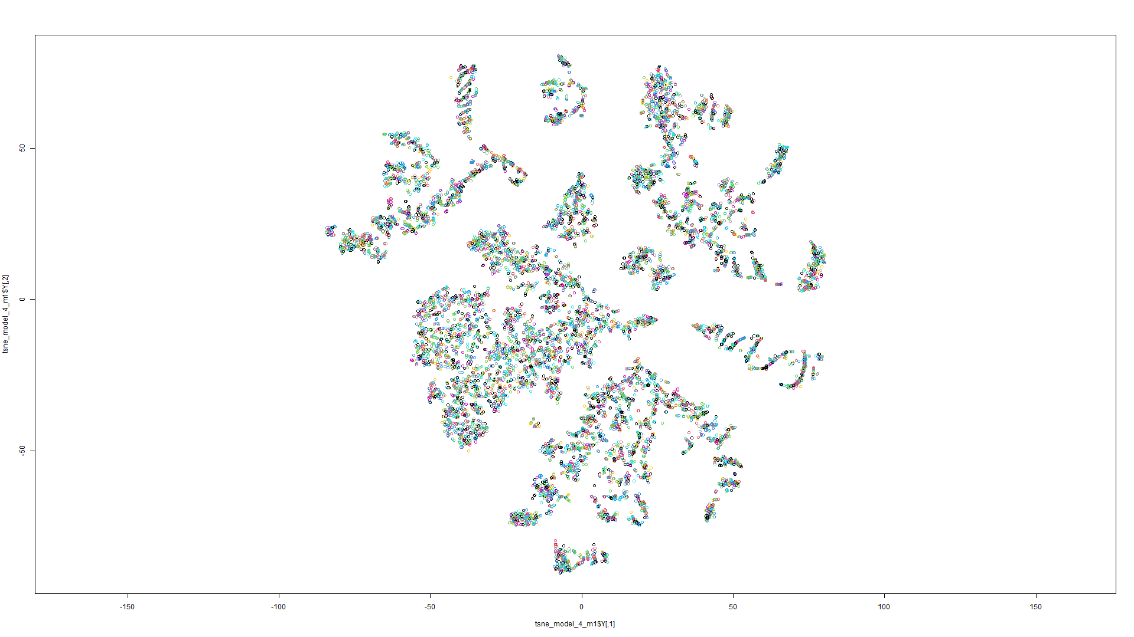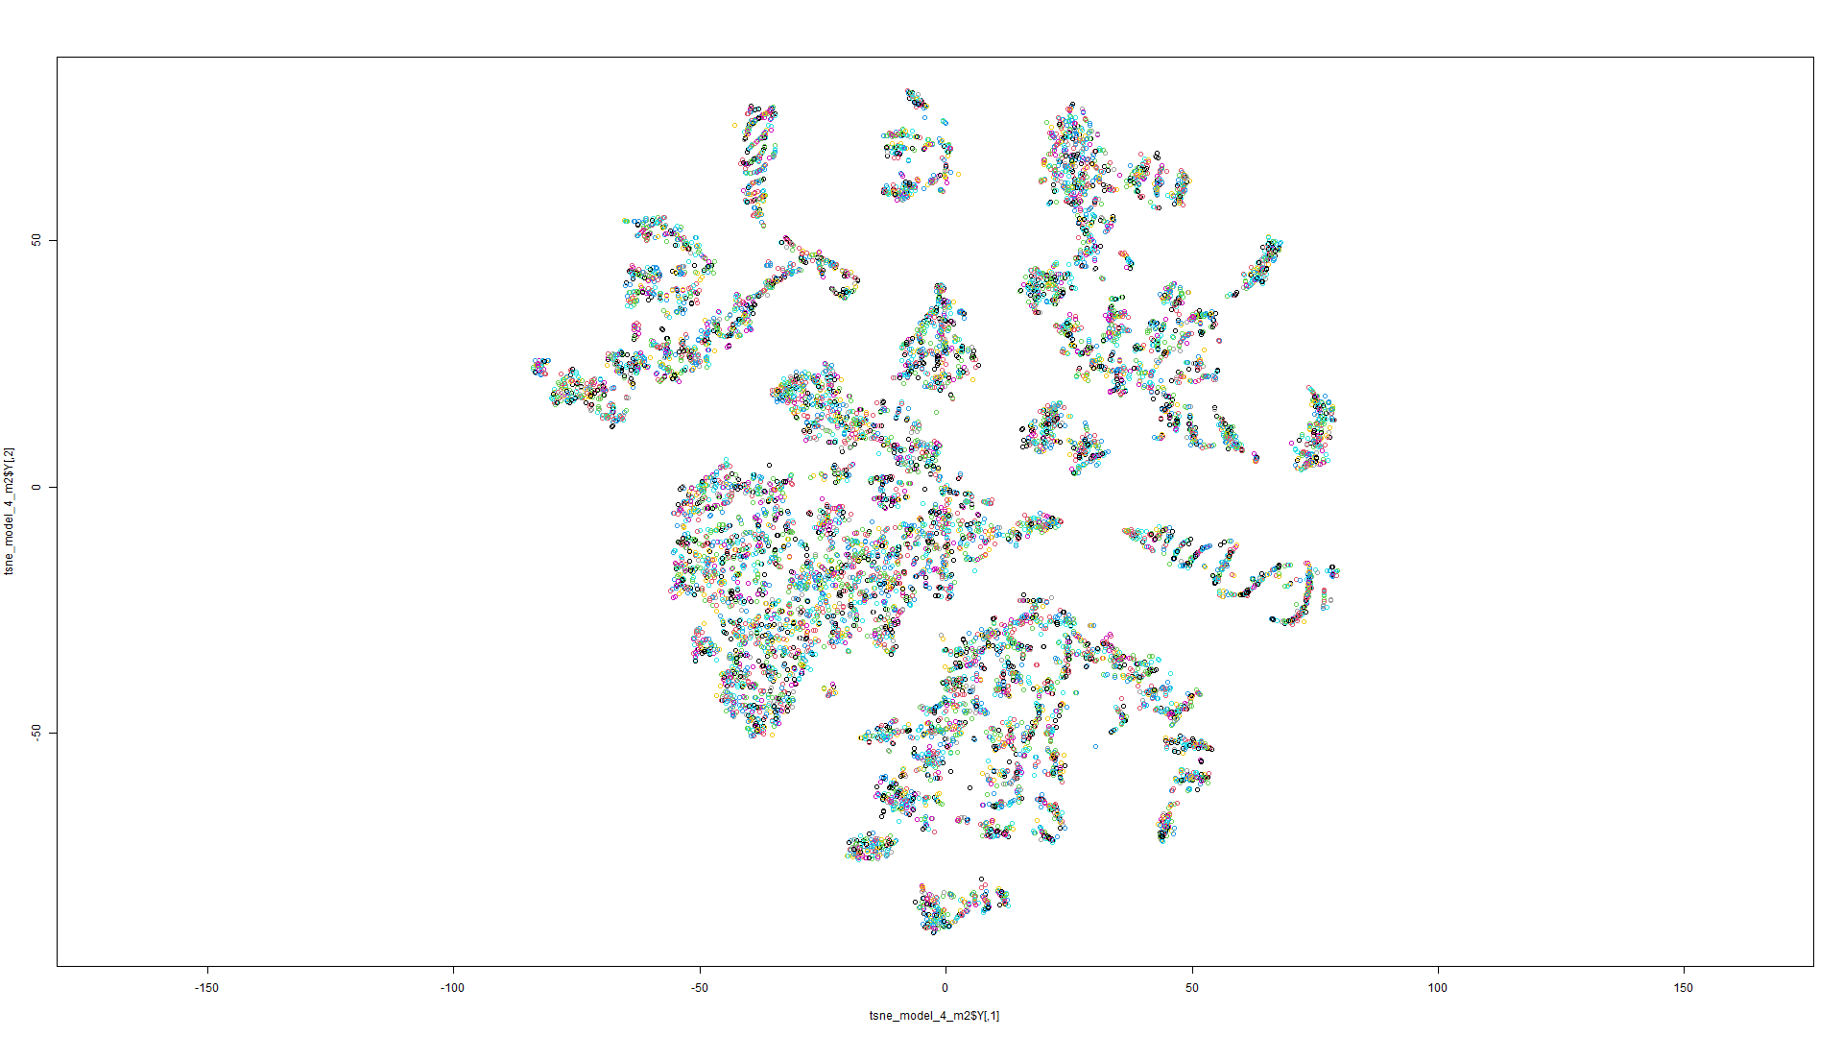

Figure 34 t-SNE on Model 1 Figure 35 t-SNE on Model 2

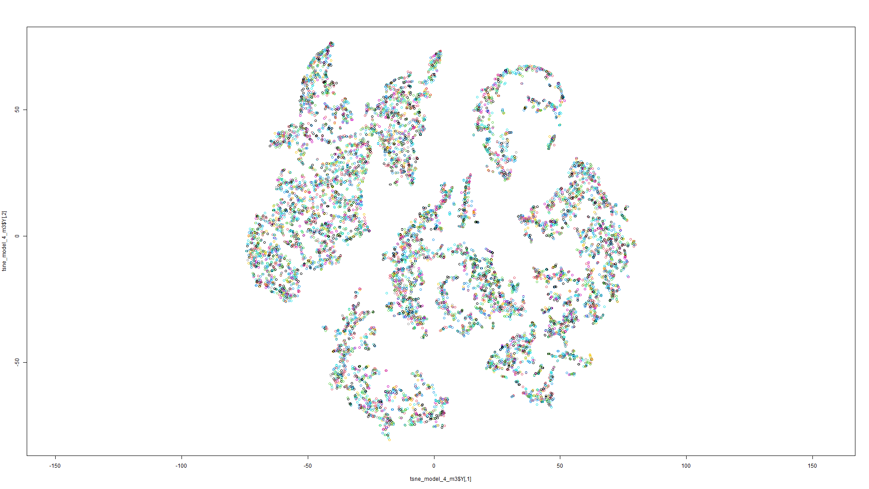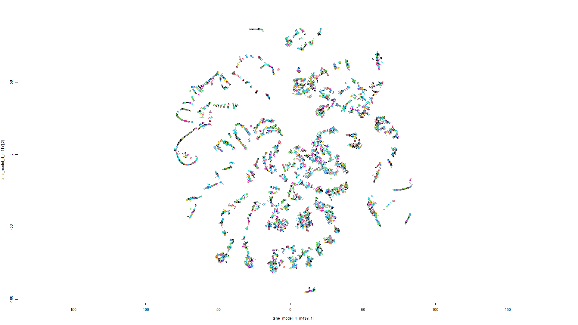

Figure 36 t-SNE on Model 3 Figure 37 t-SNE on Model 4

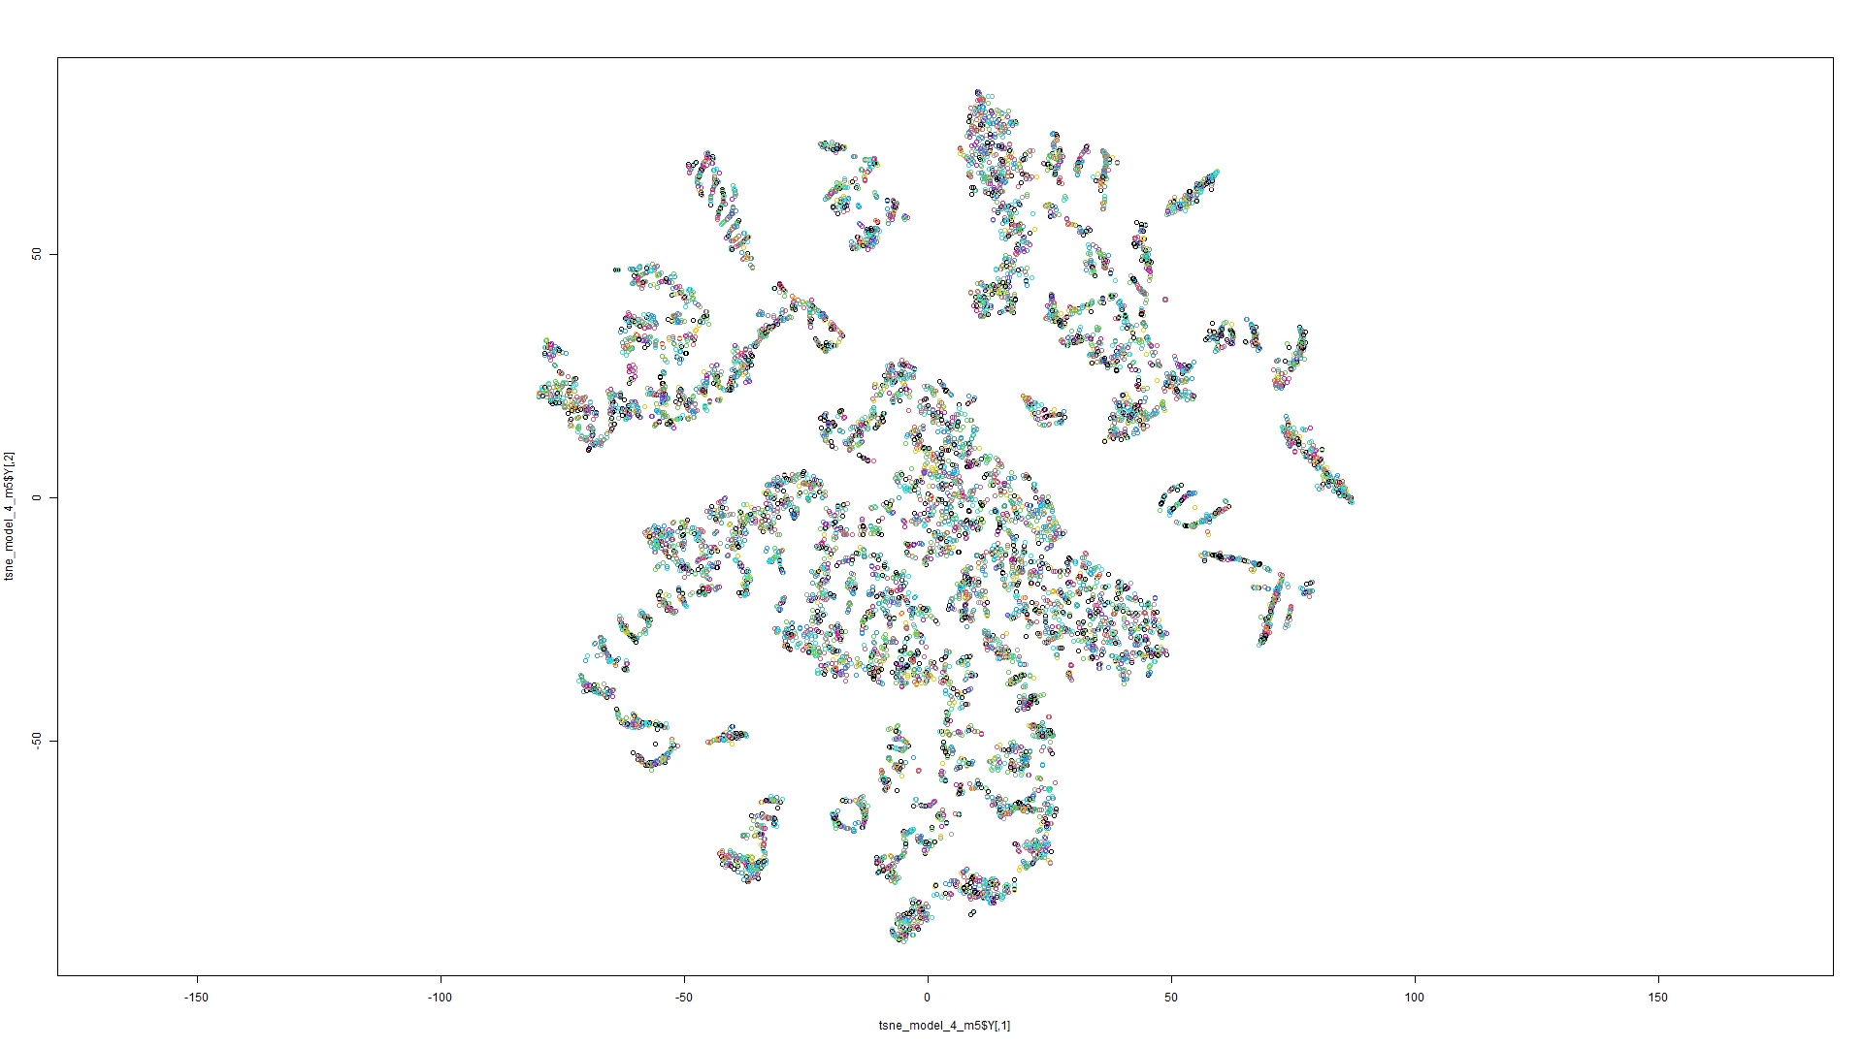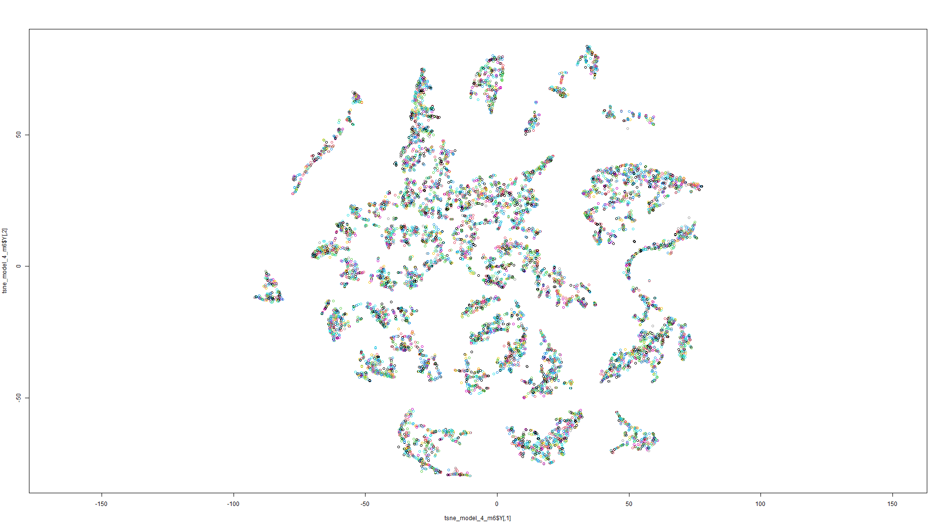

Figure 38 t-SNE on Model 5 Figure 39 t-SNE on Model 6

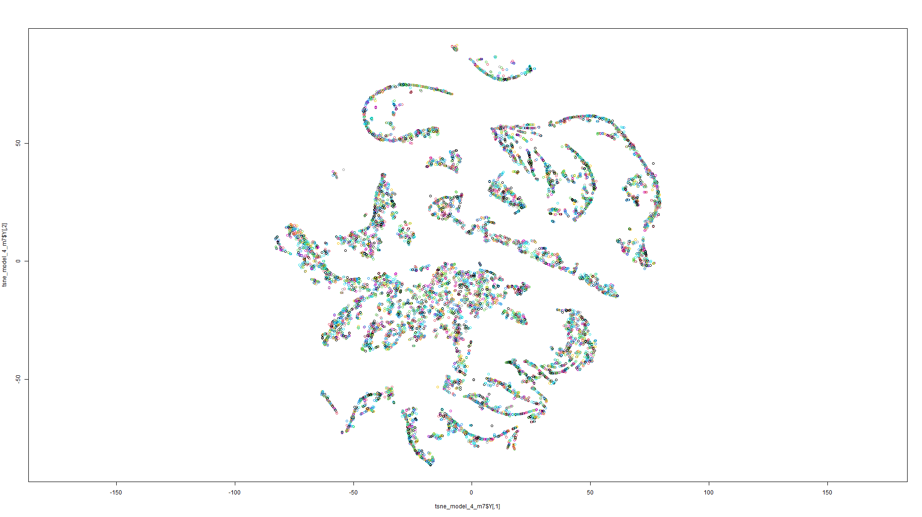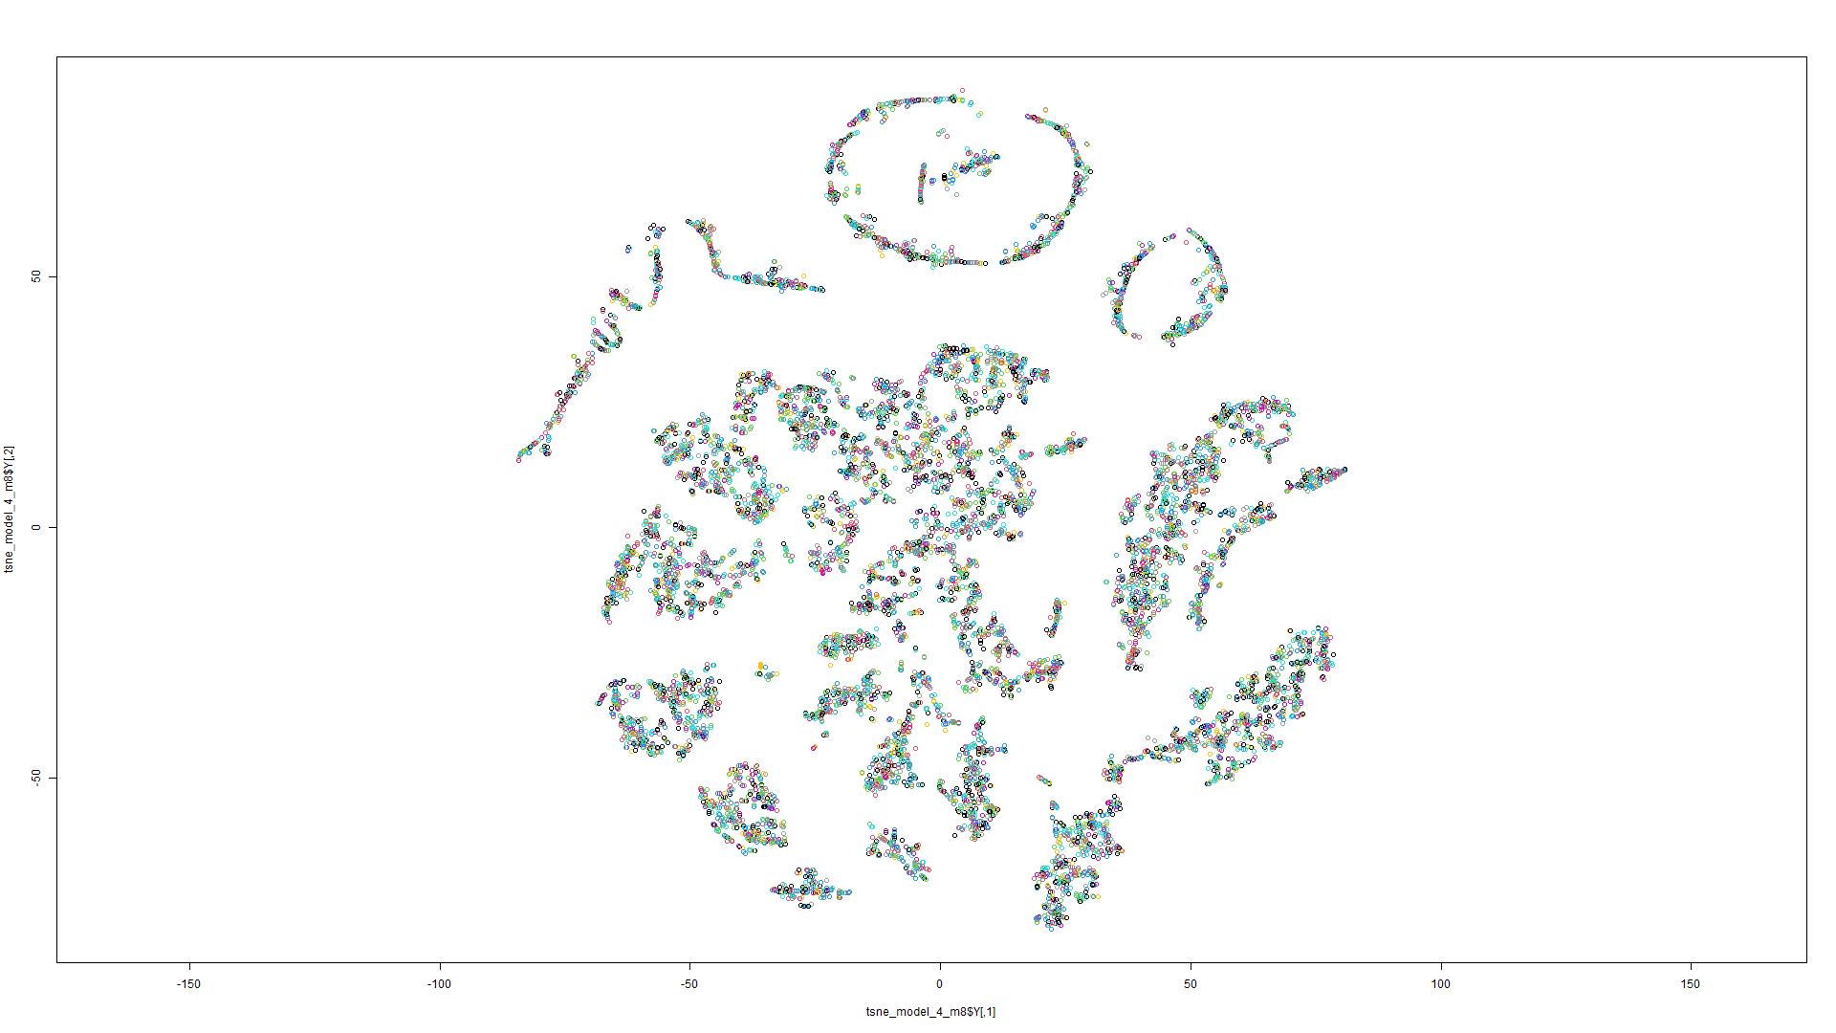

Figure 40 t-SNE on Model 7 Figure 41 t-SNE on Model 8

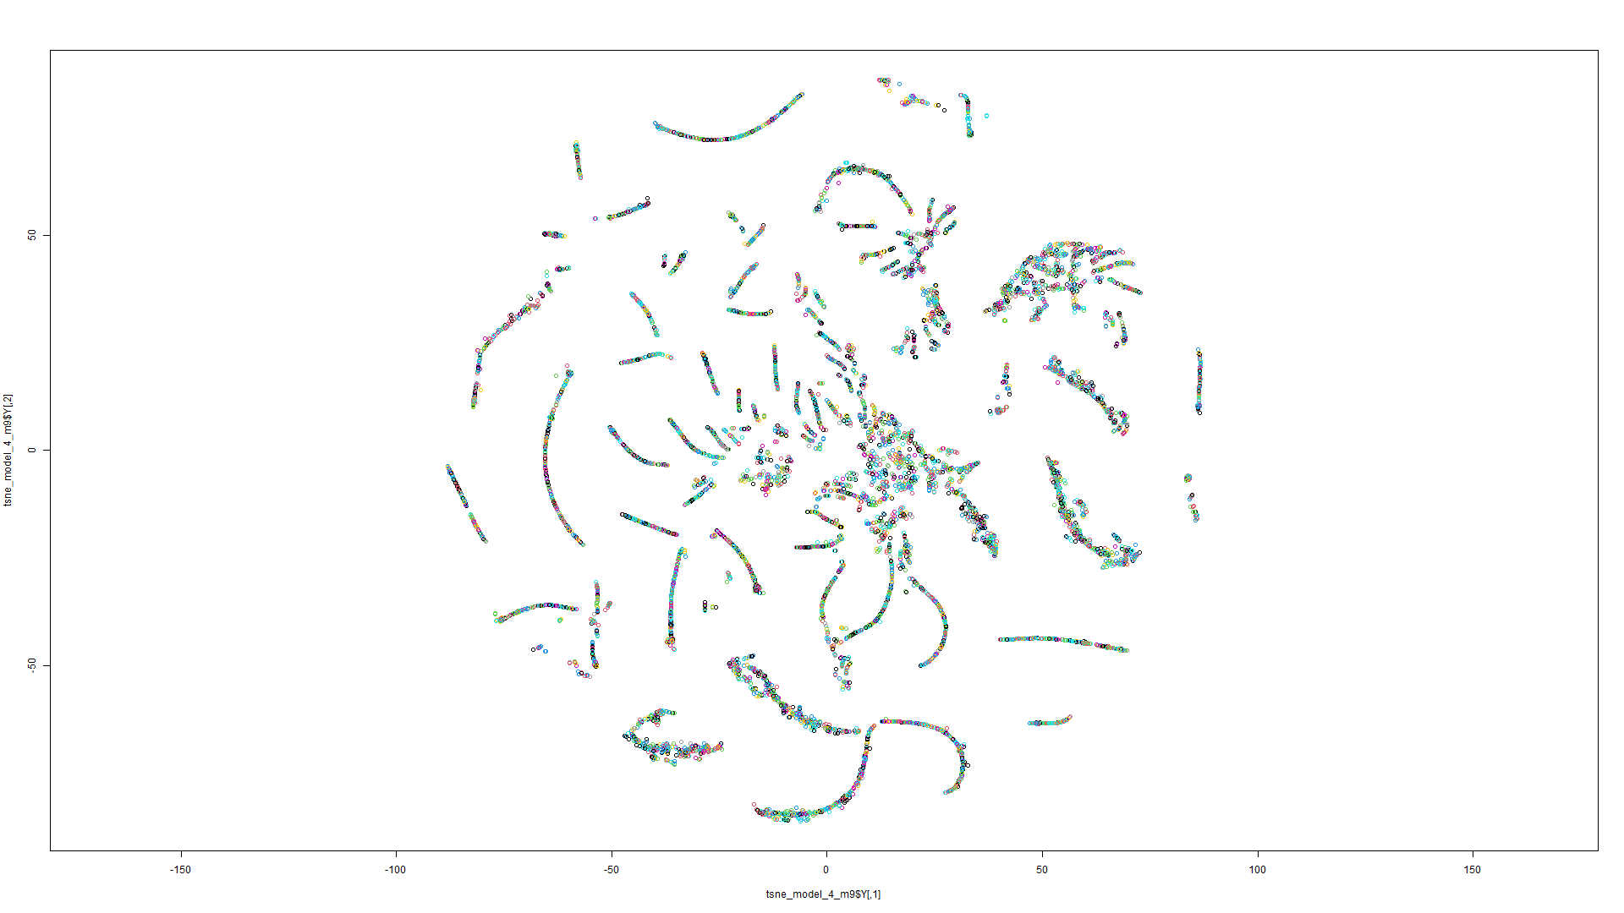

Figure 42 t-SNE on Model 9

Model 1:

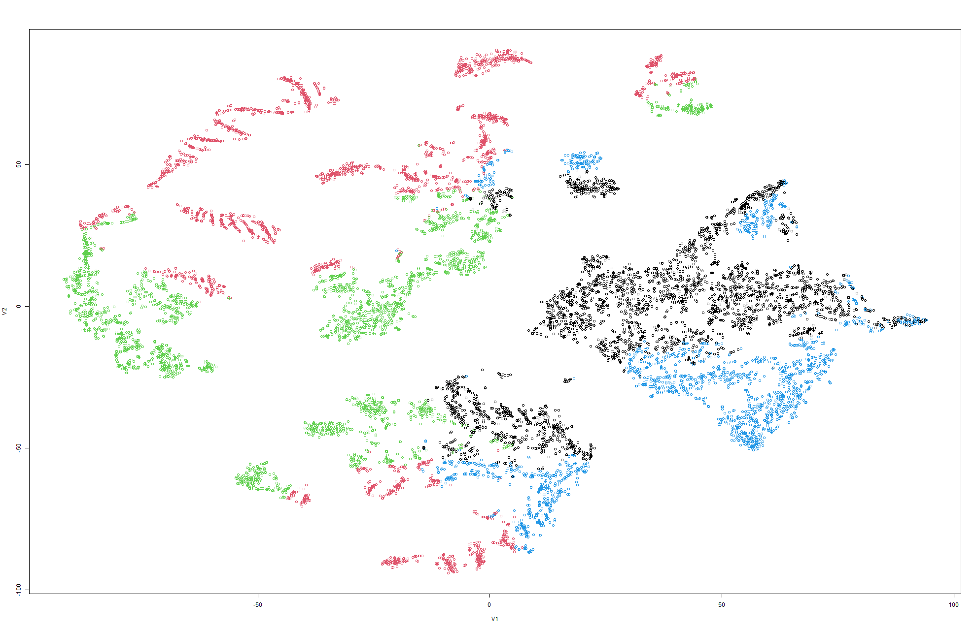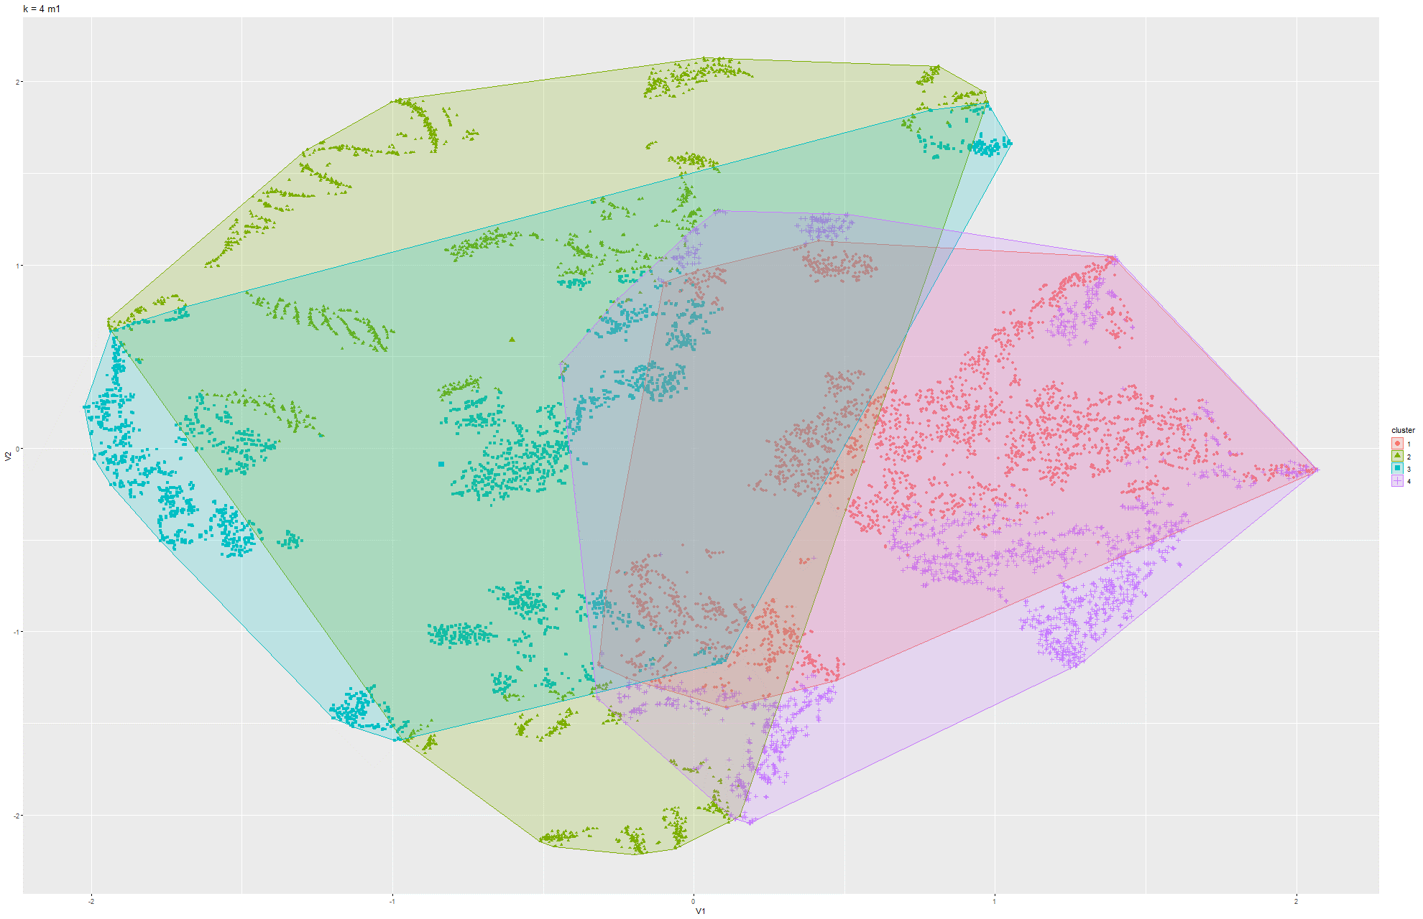

Figure 43&44 k-Means on t-SNE Model 1

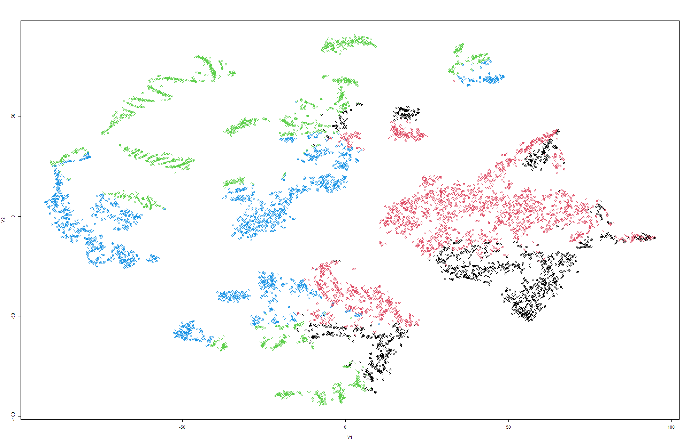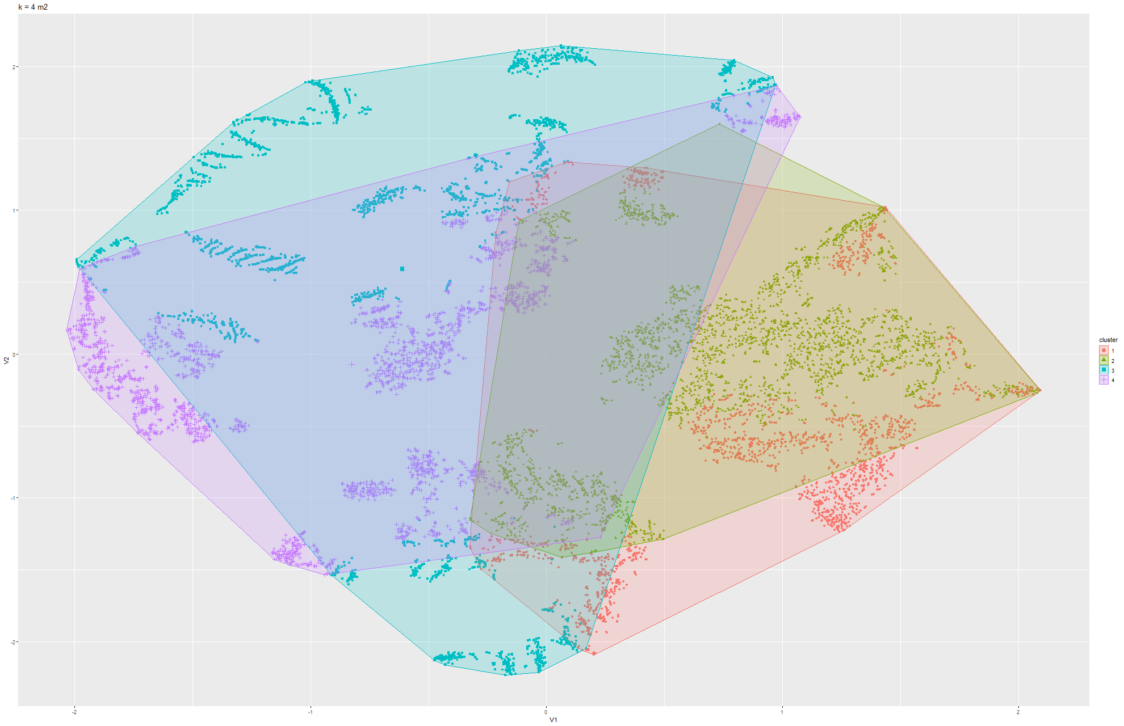

Figure 45 & 46 k-means t-SNE on Model 2

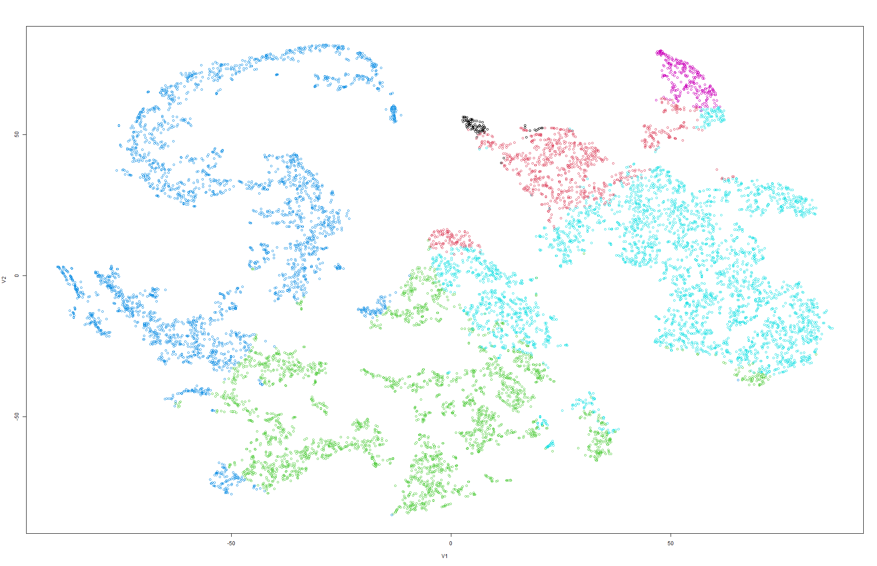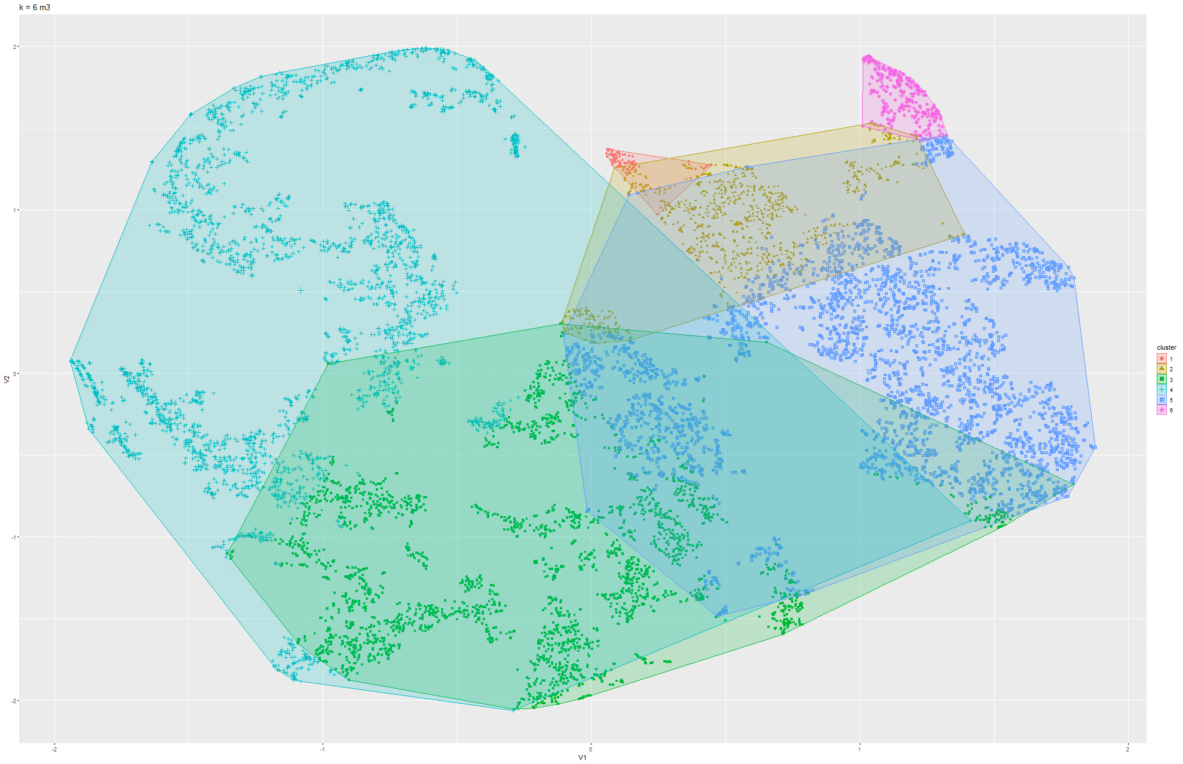

Figure 47 & 48 k-means t-SNE on Model 3

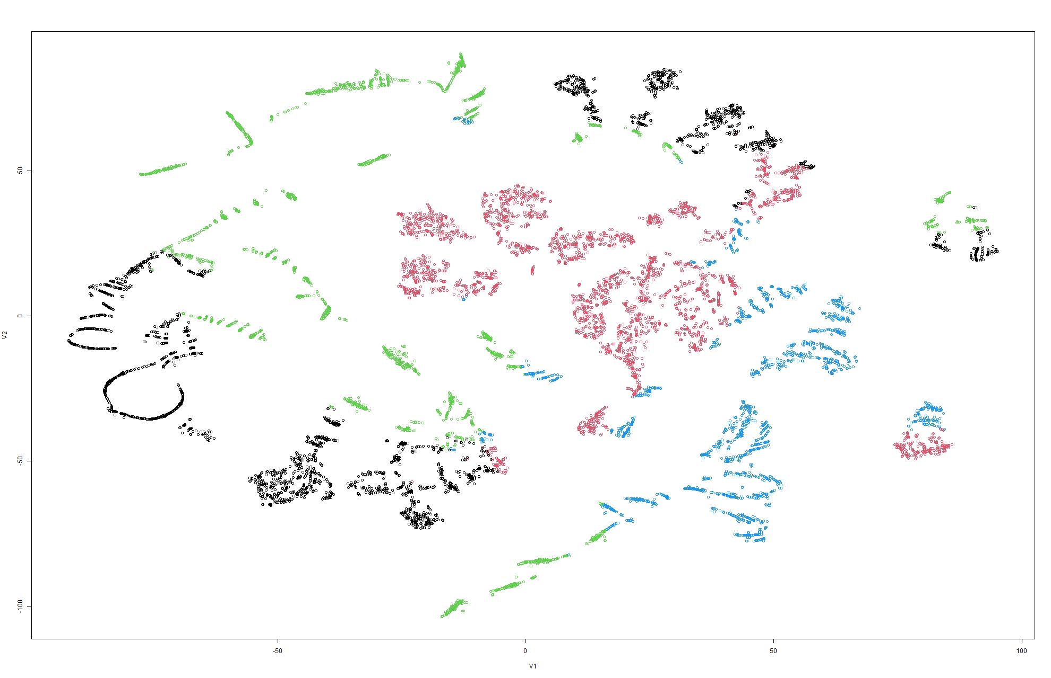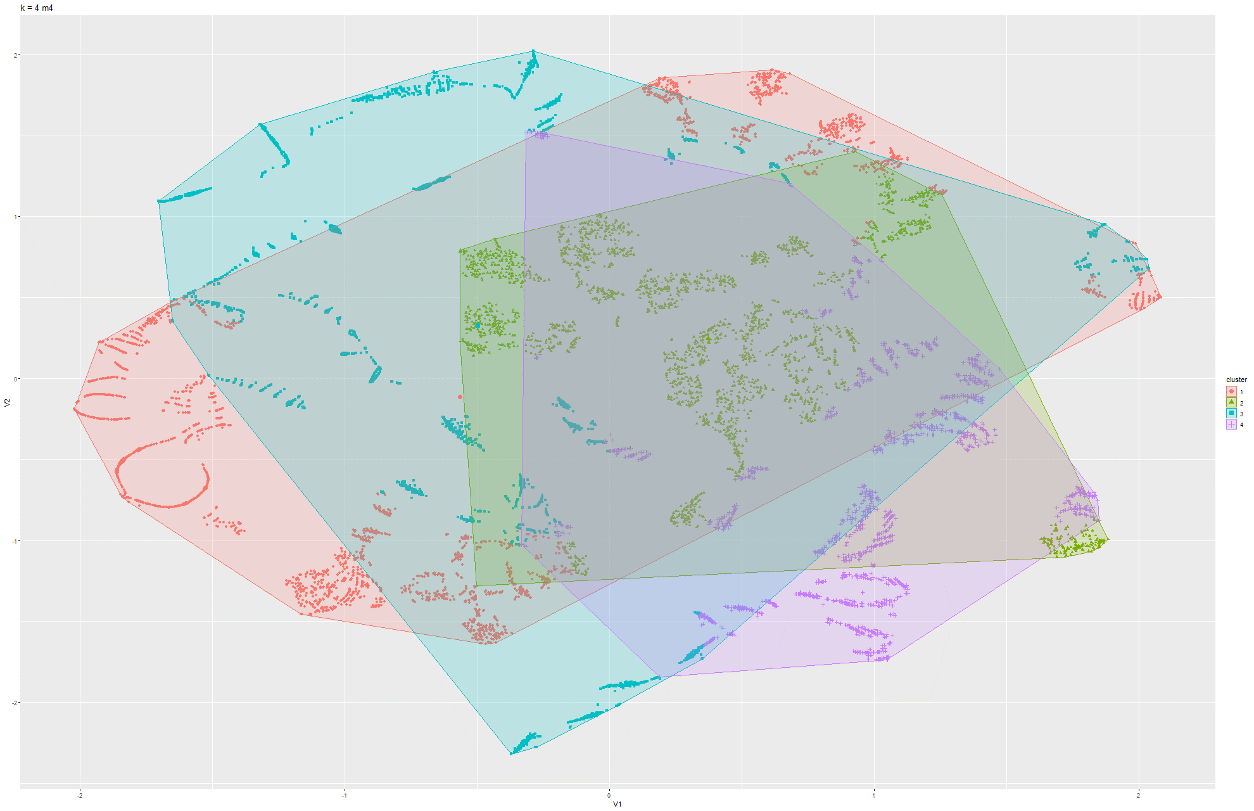

Figure 49 & 50 k-means t-SNE on Model 4

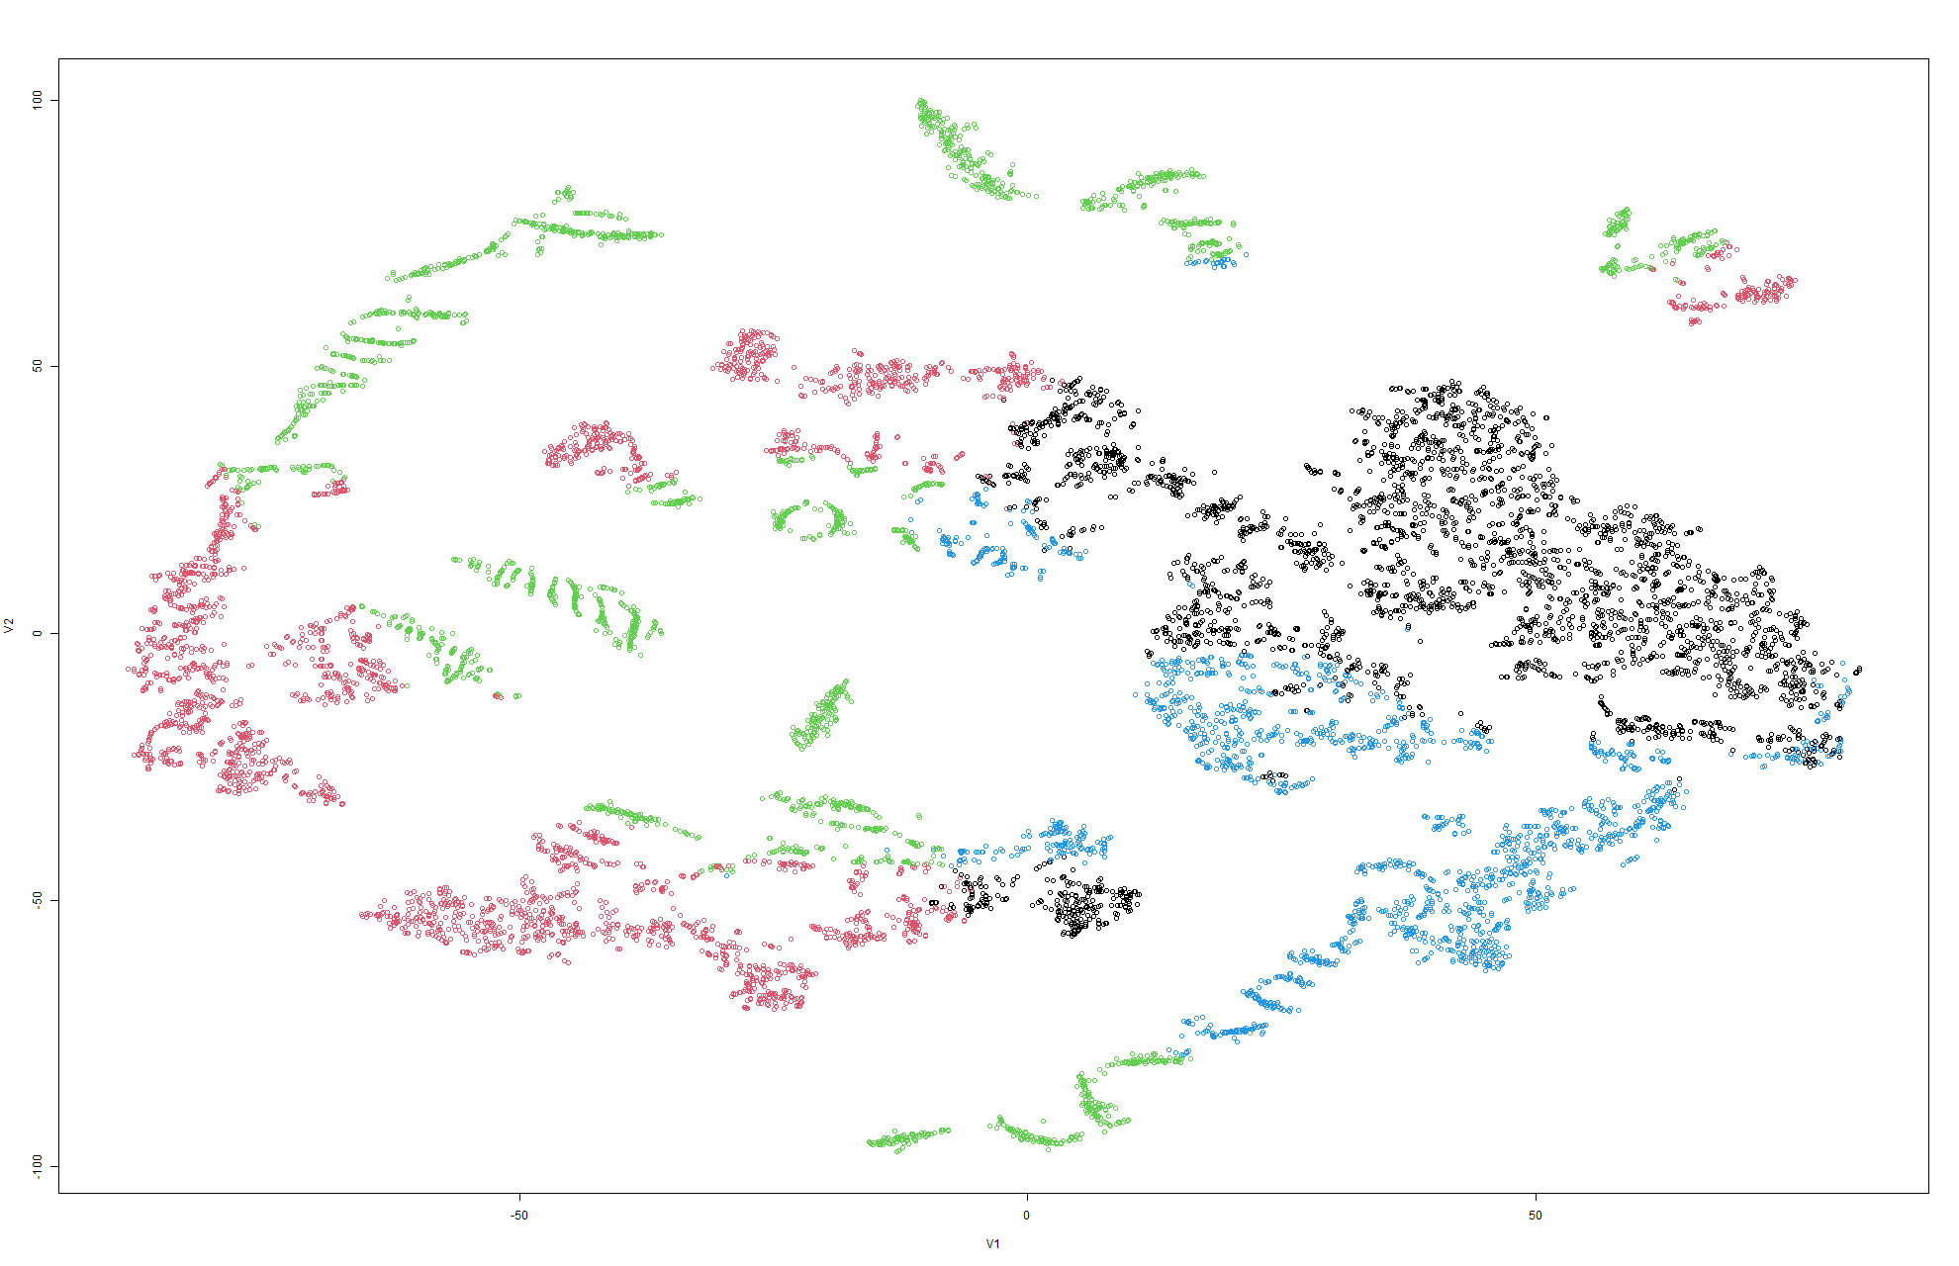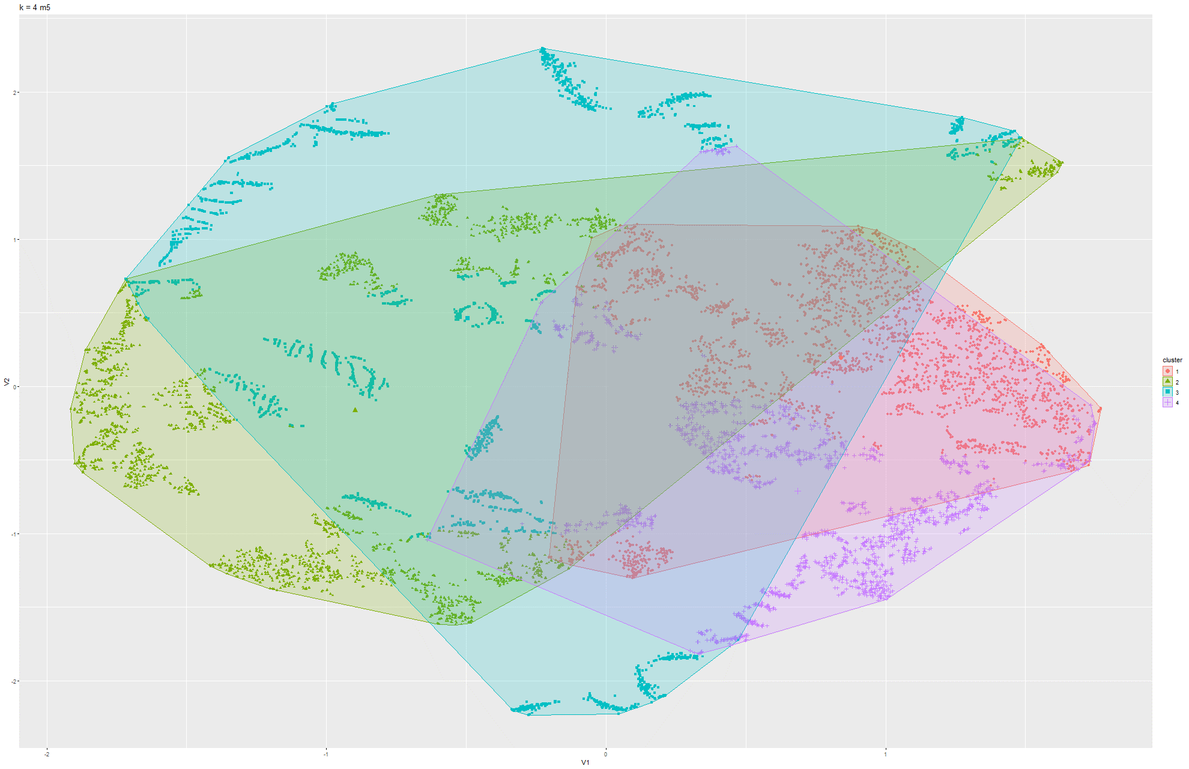

Figure 51 & 52 k-means t-SNE on Model 5

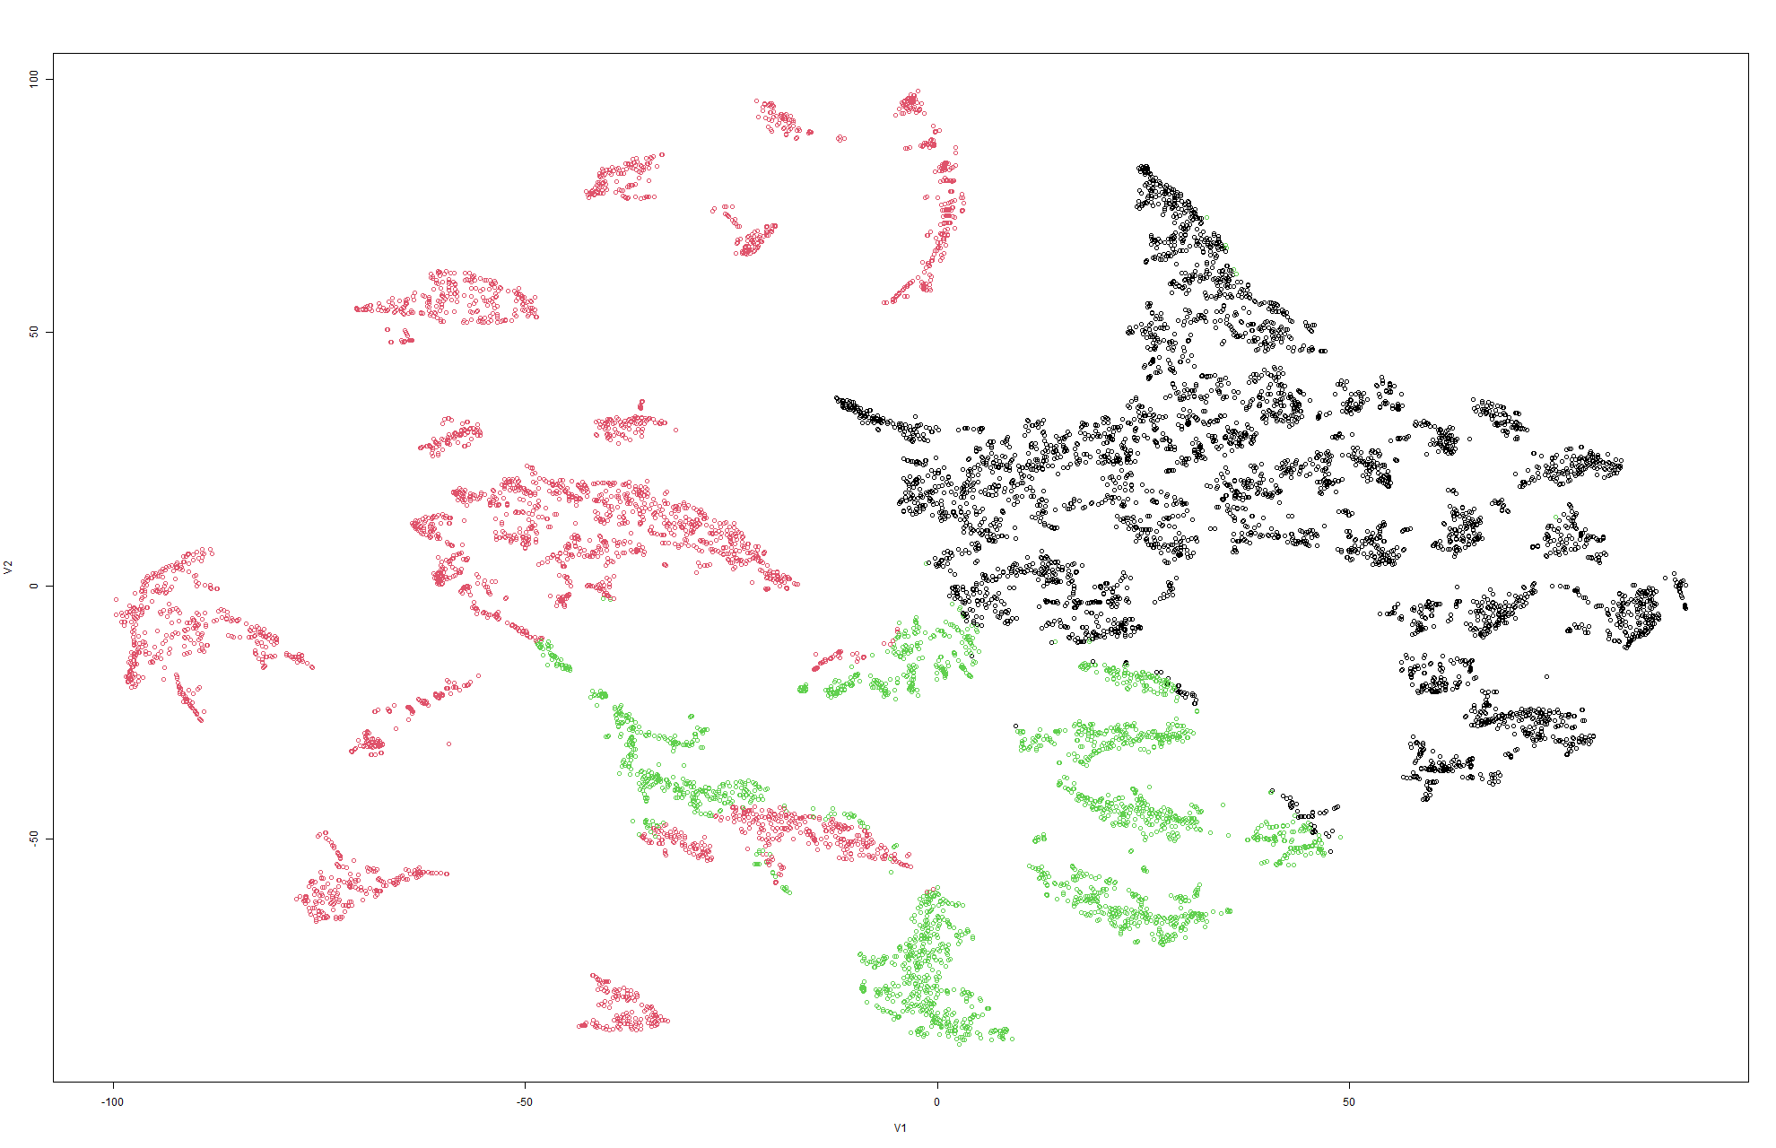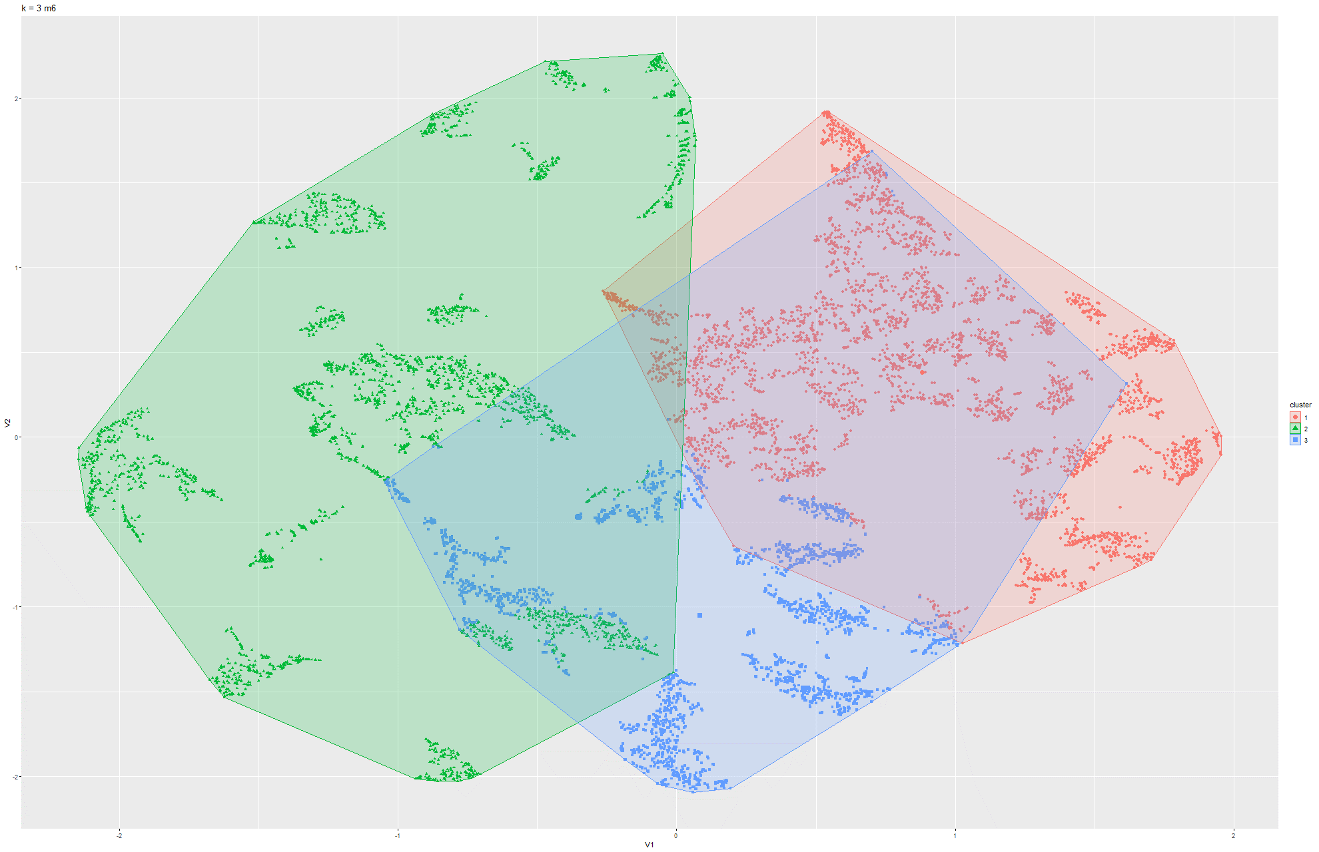

Figure 53 & 54 k-means t-SNE on Model 6

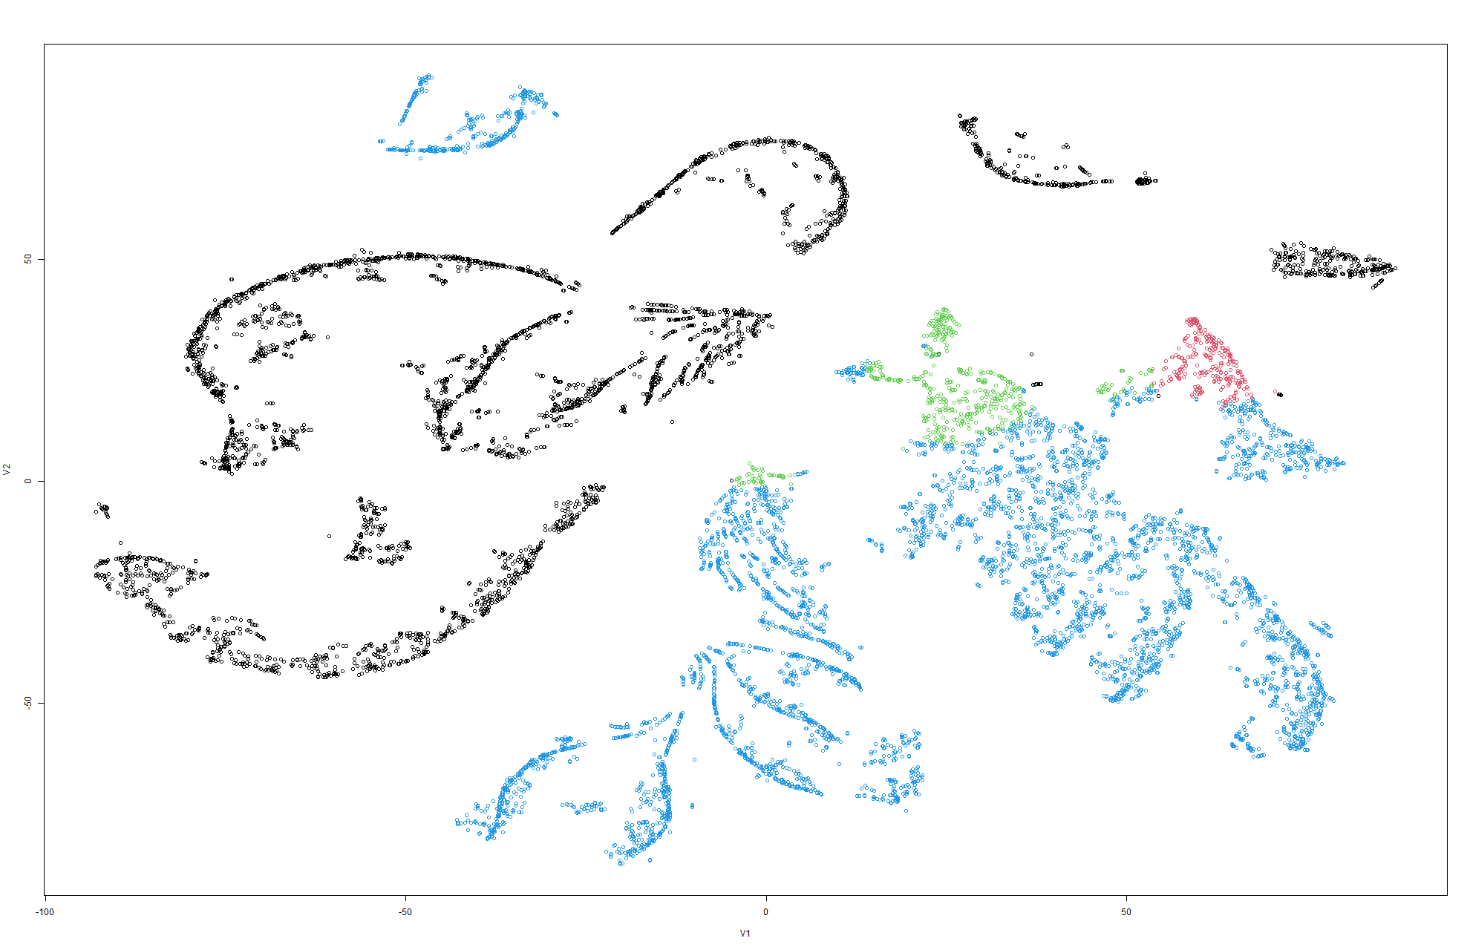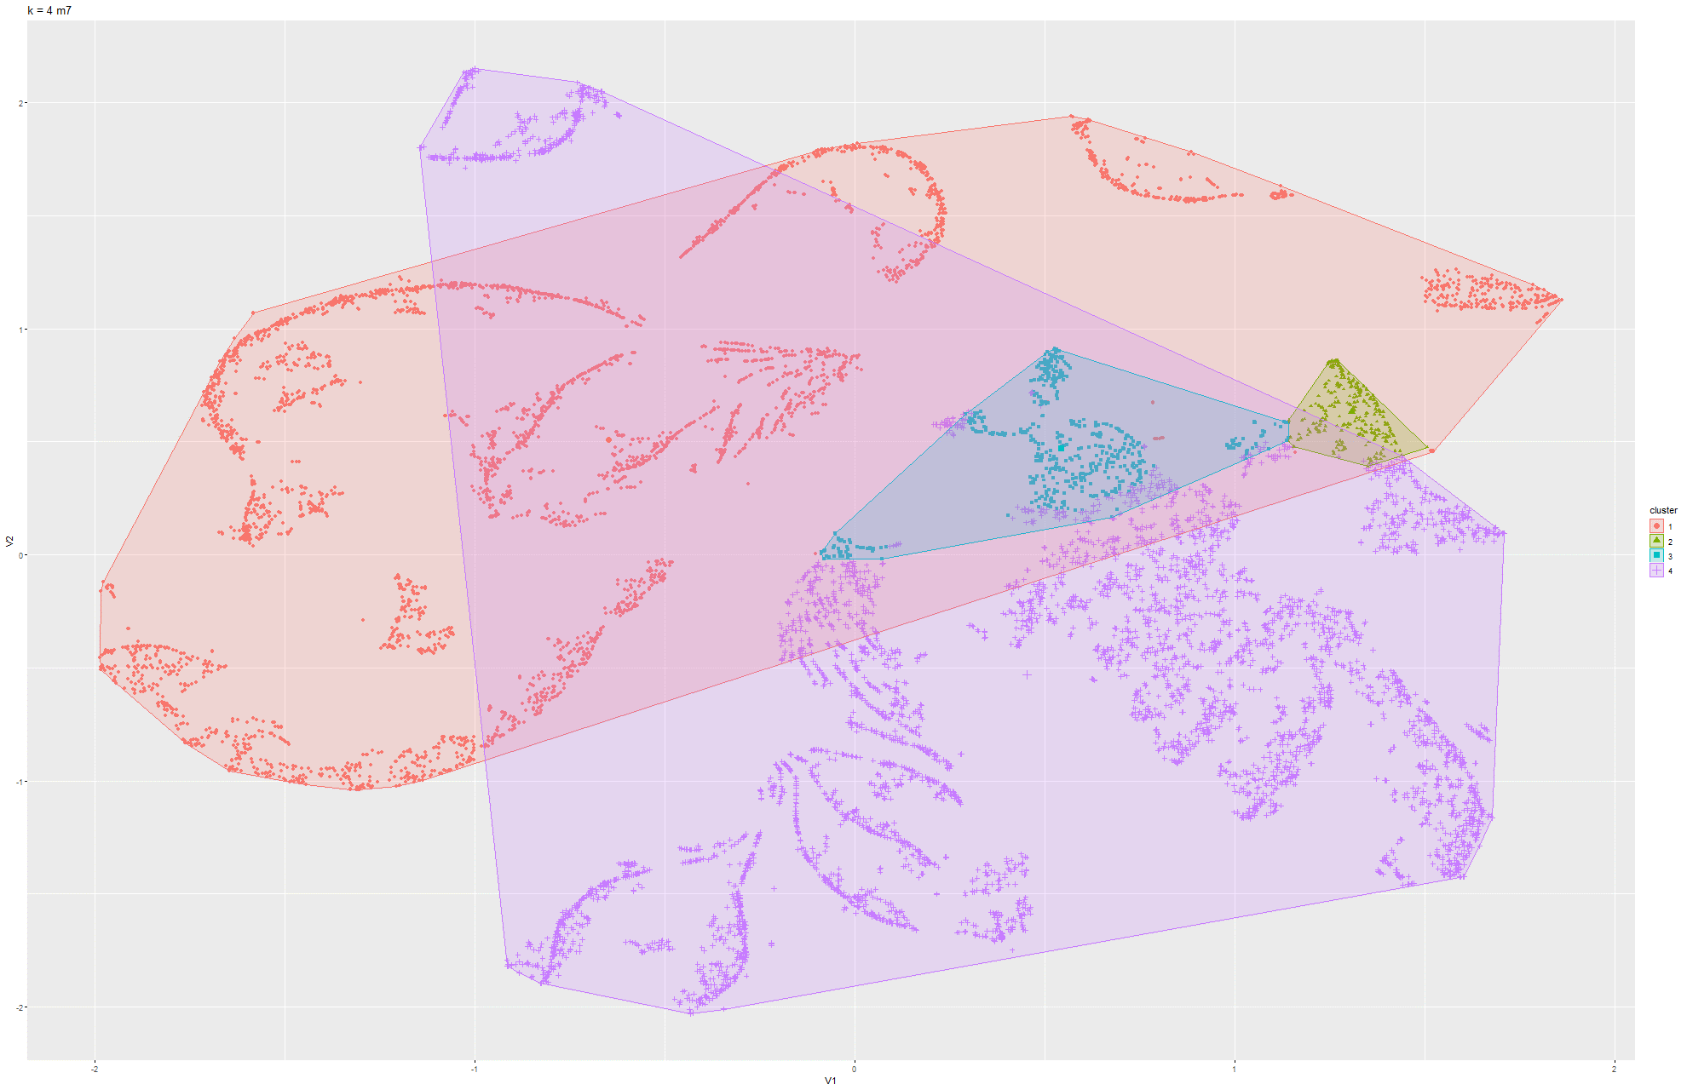

Figure 55 & 56 k-means t-SNE on Model 7

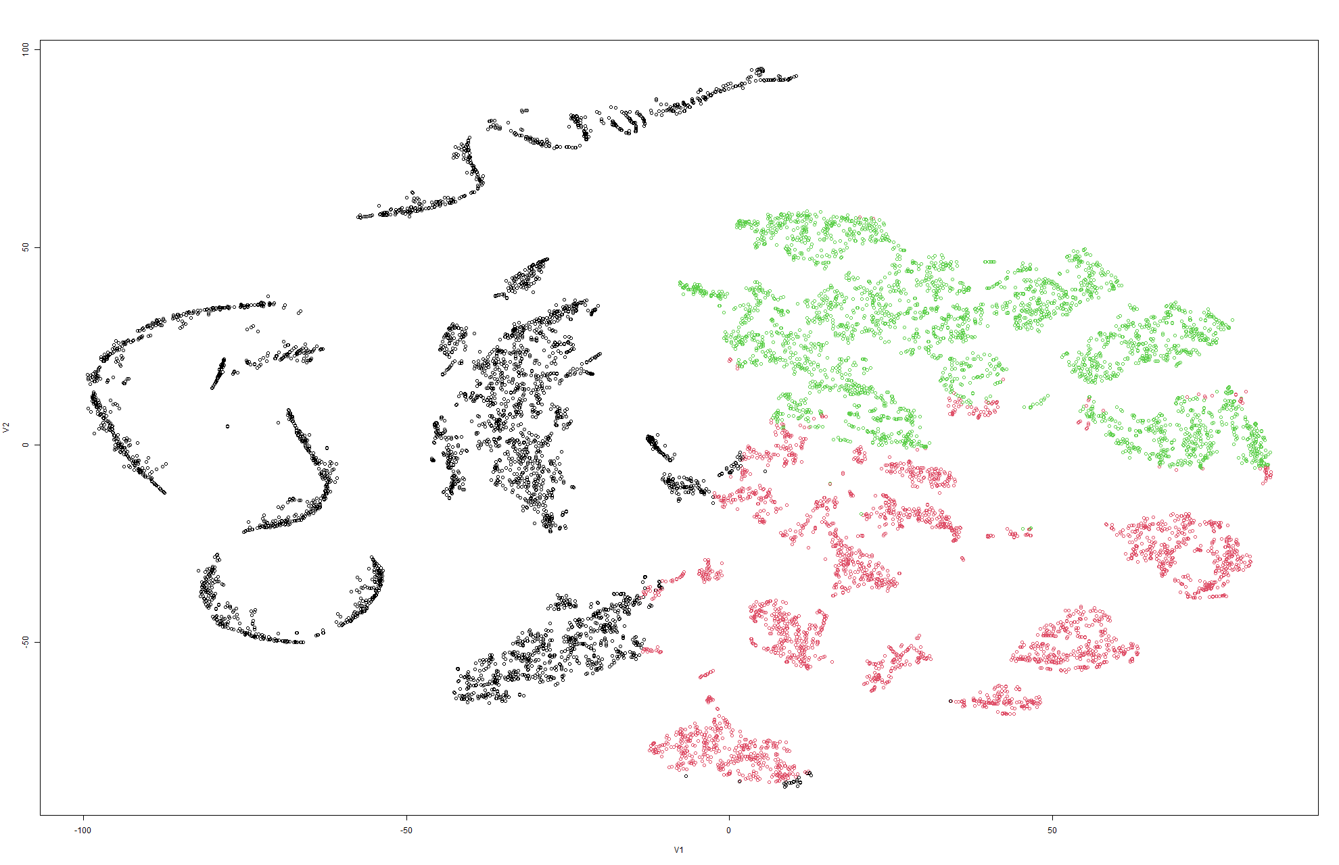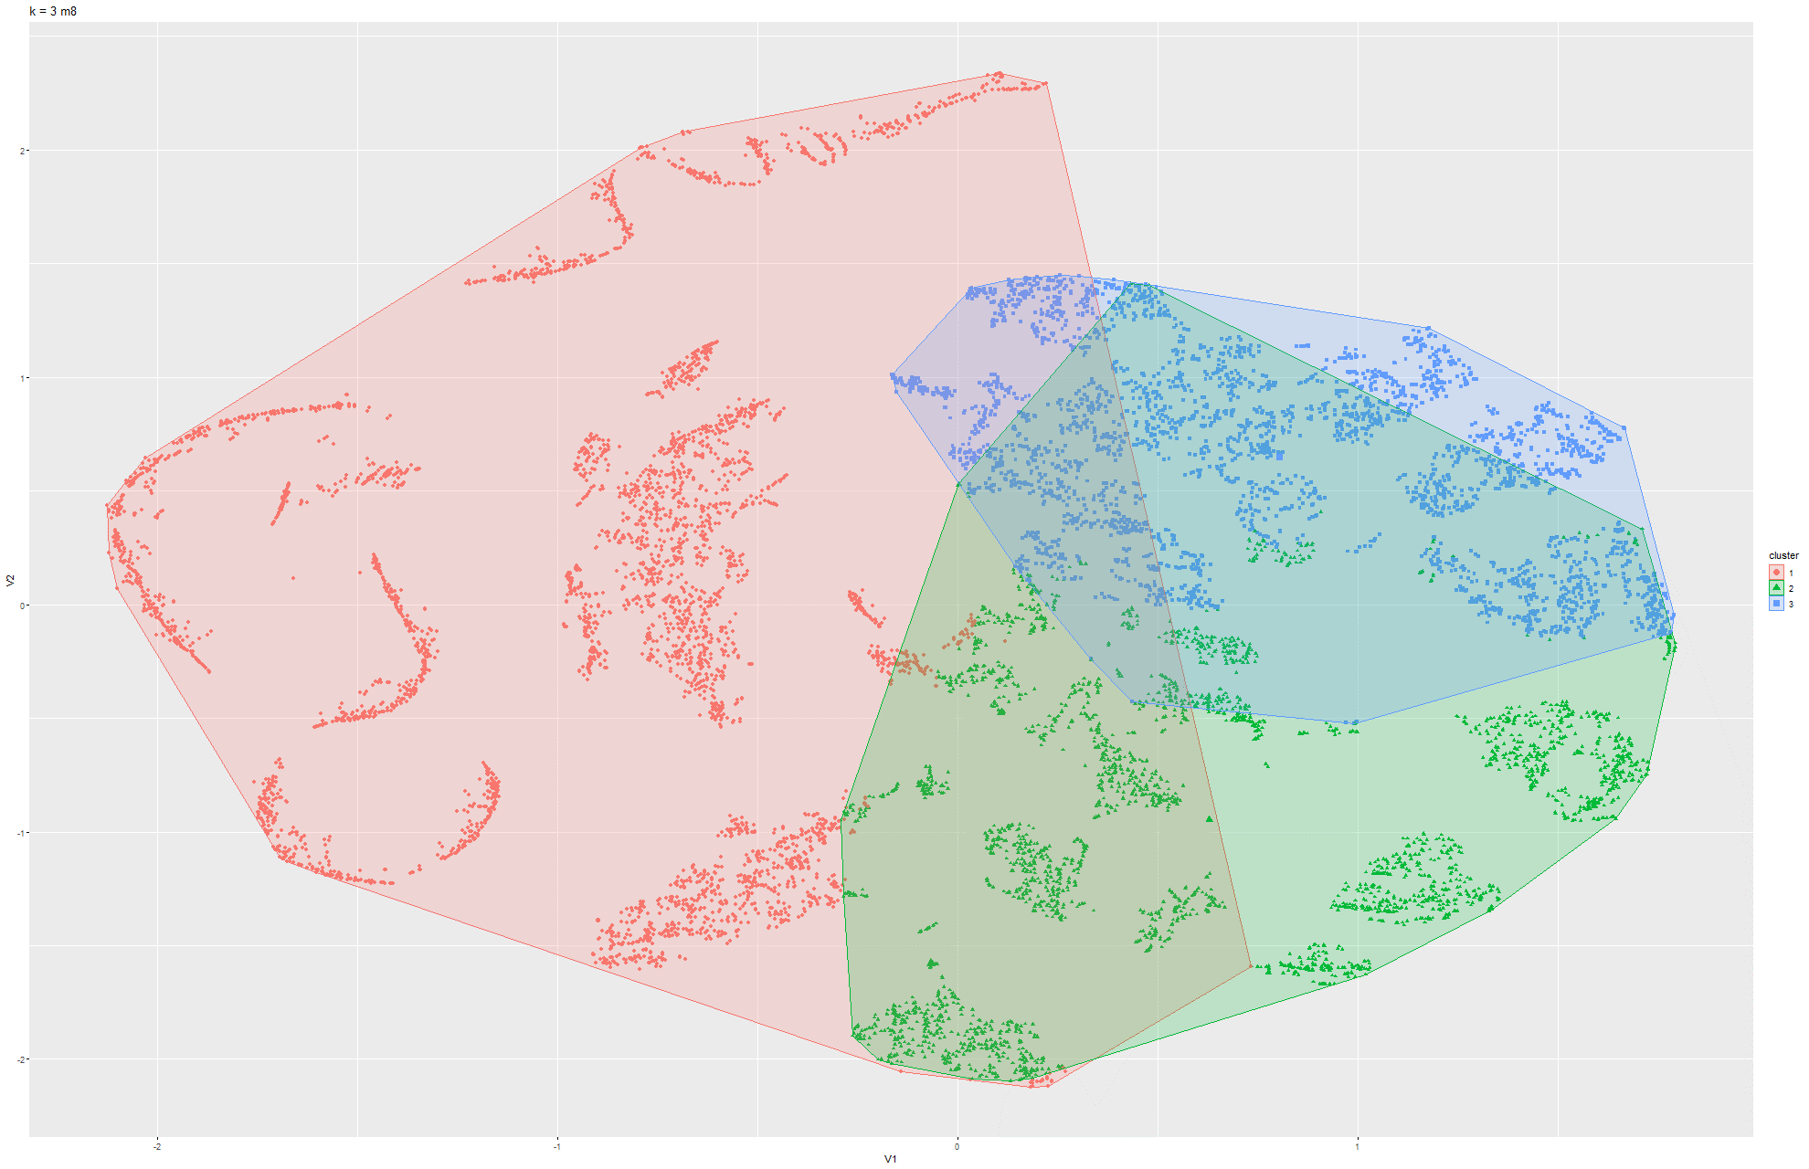

Figure 57 & 58 k-means t-SNE on Model 8

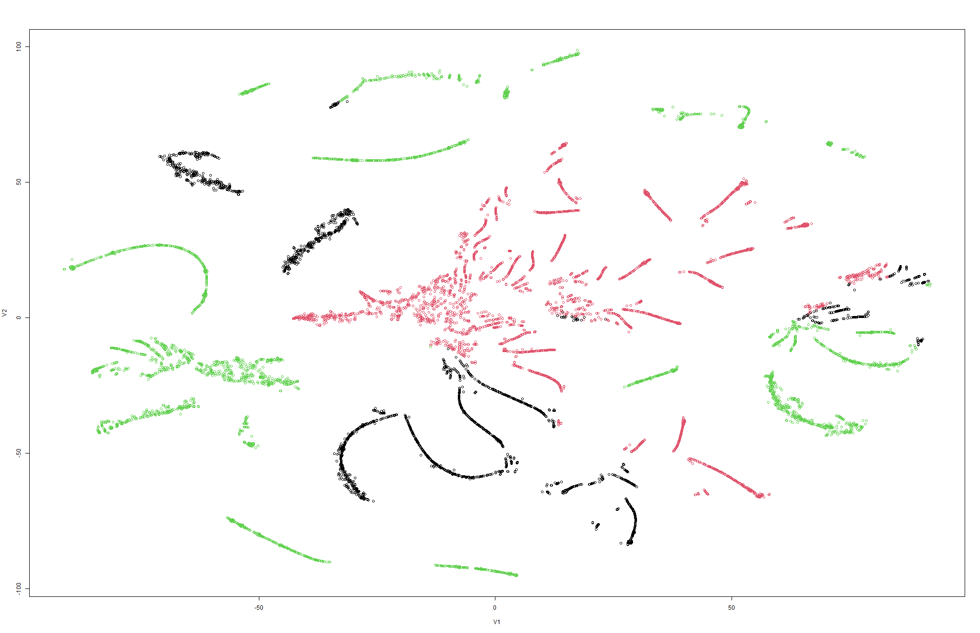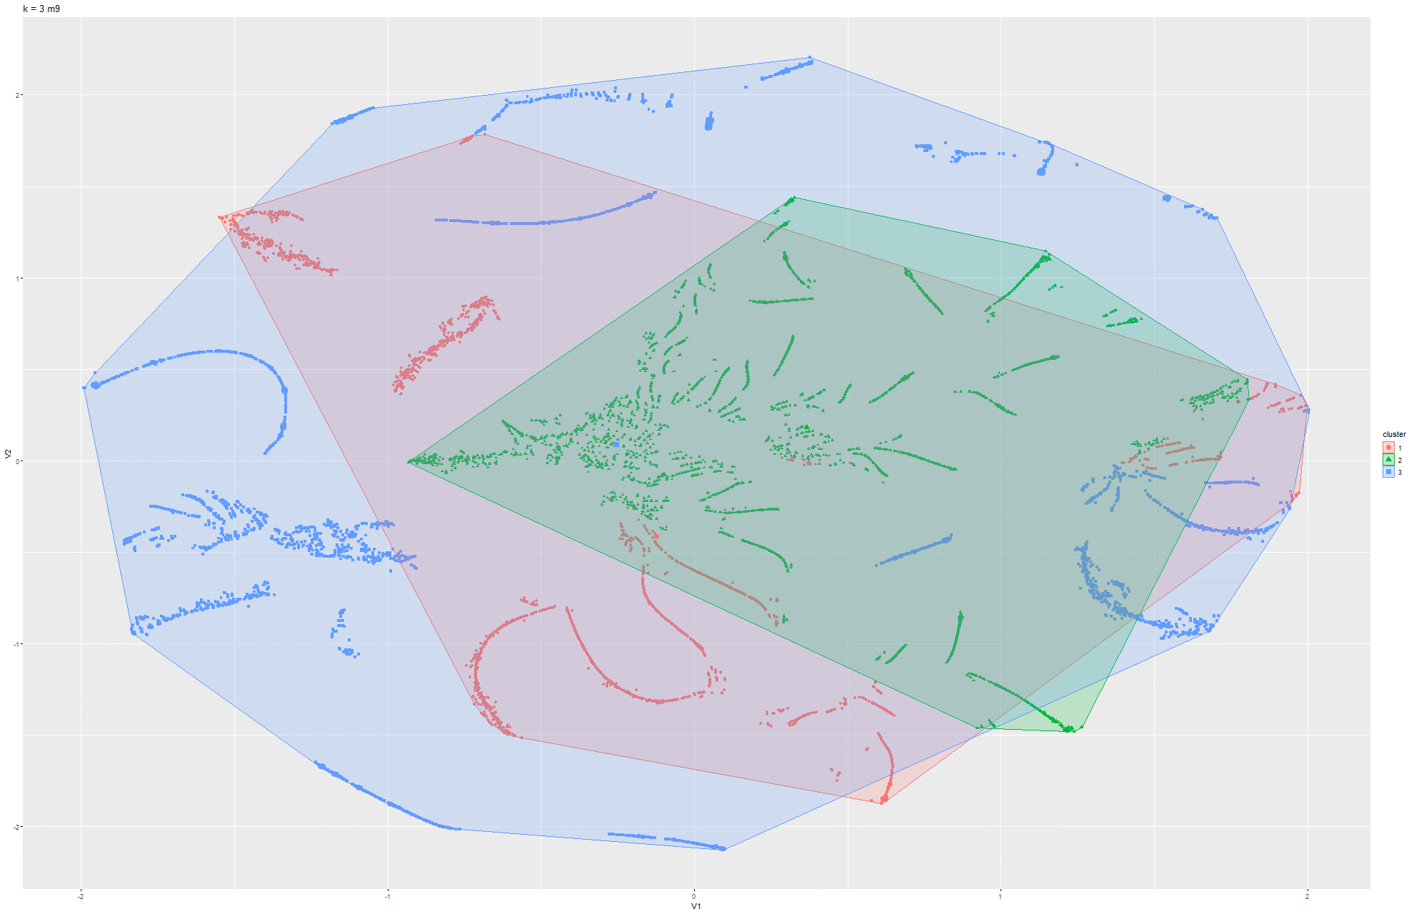

Figure 59 & 60 k-means t-SNE on Model 2

Model 2:

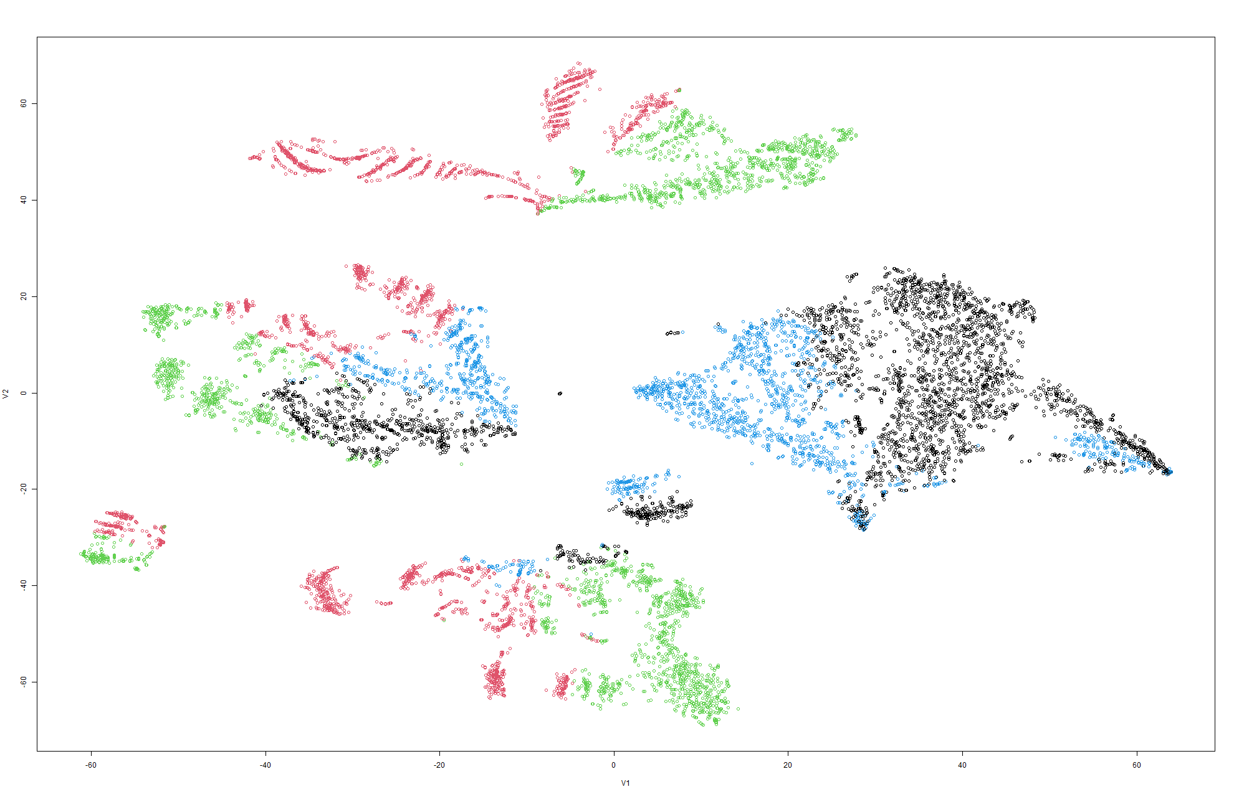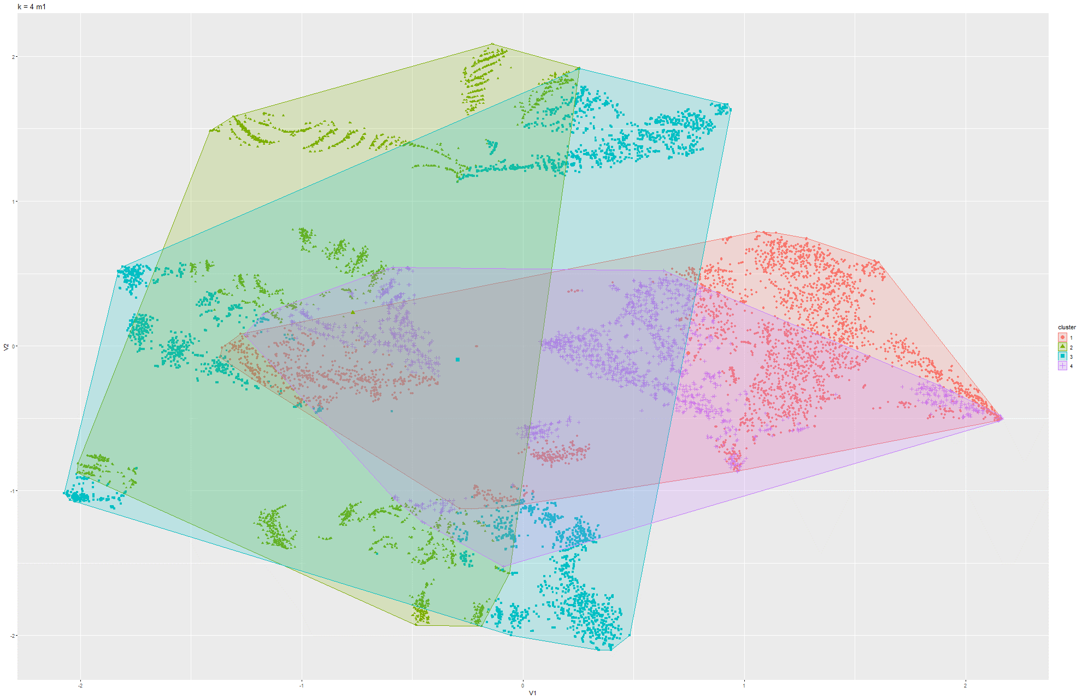

Figure 61 & 62 k-means t-SNE on Model 1

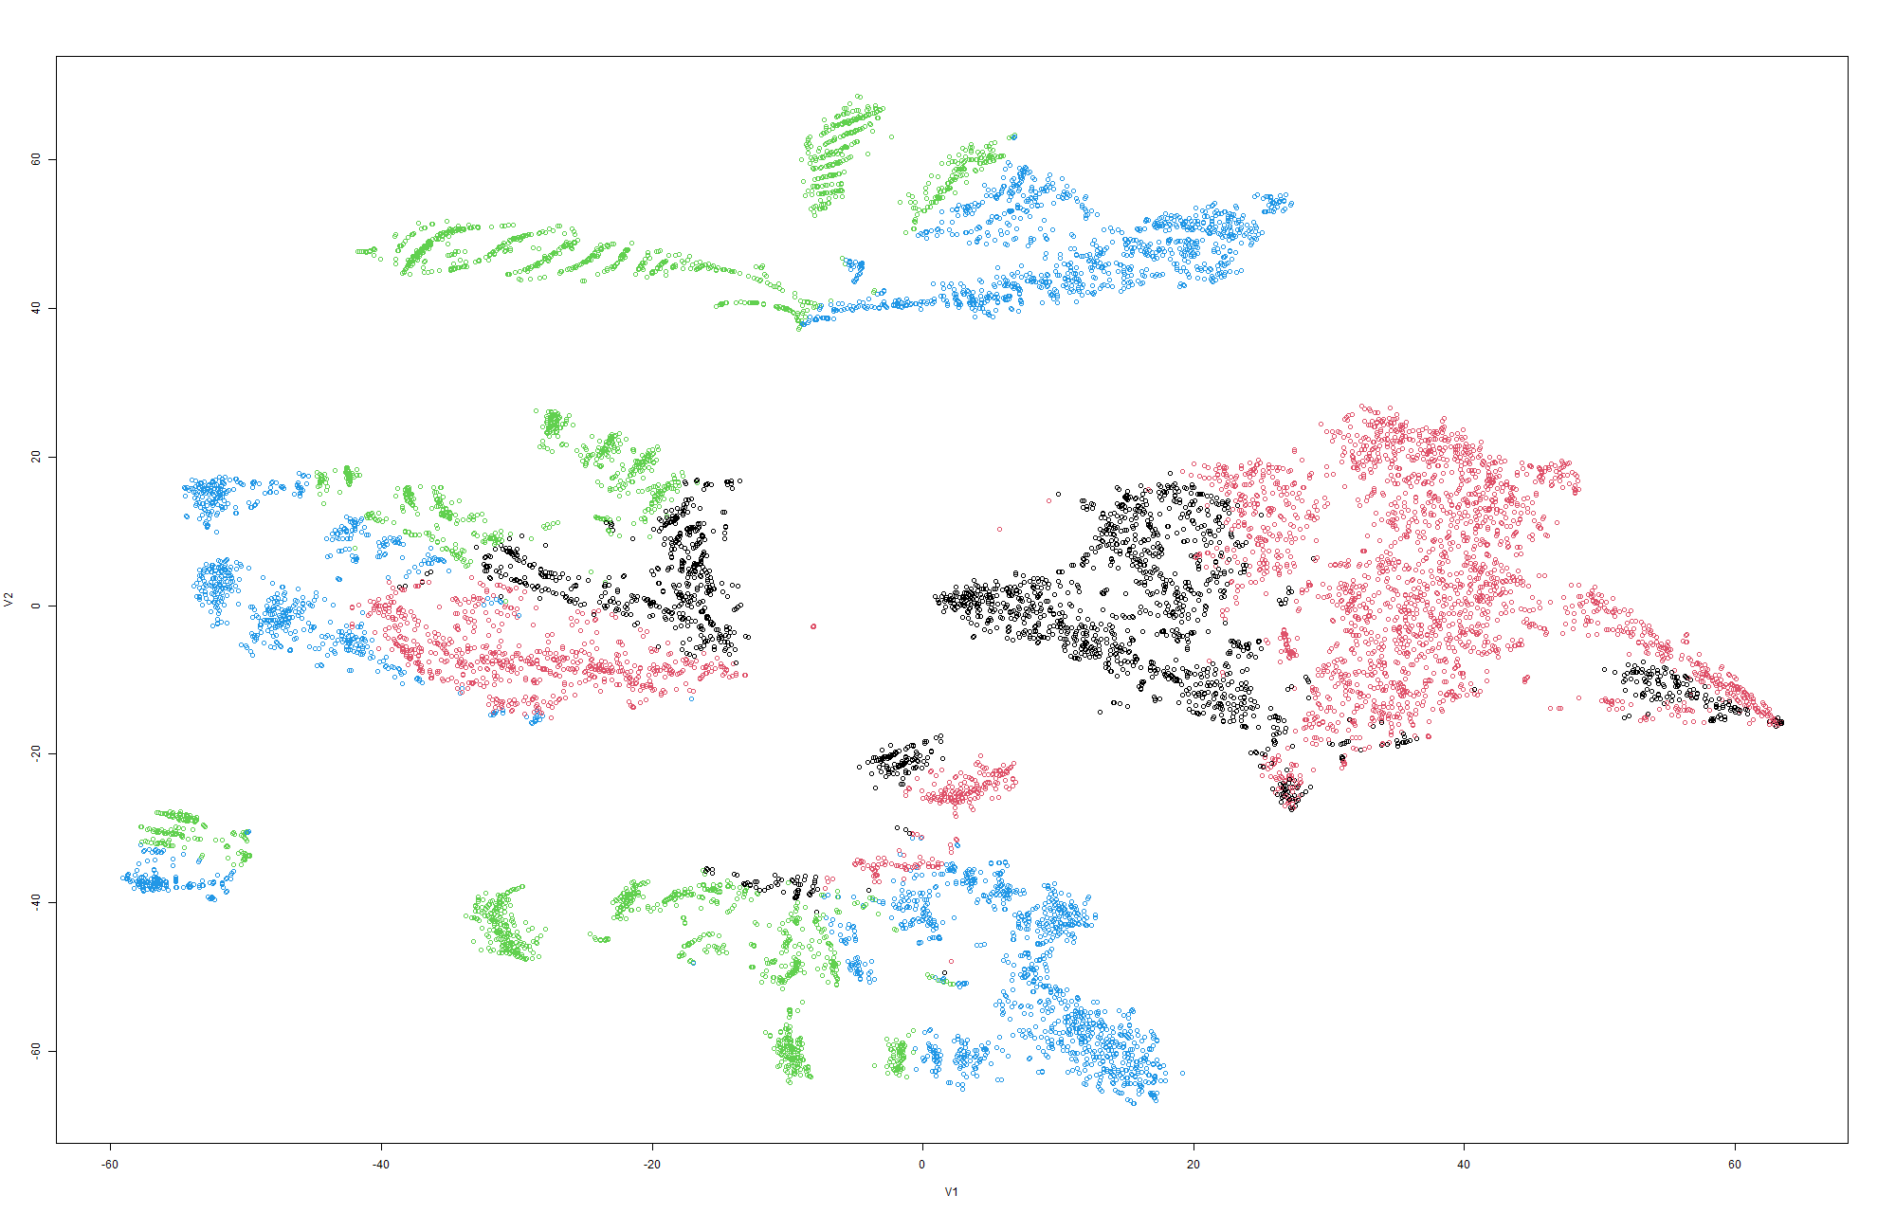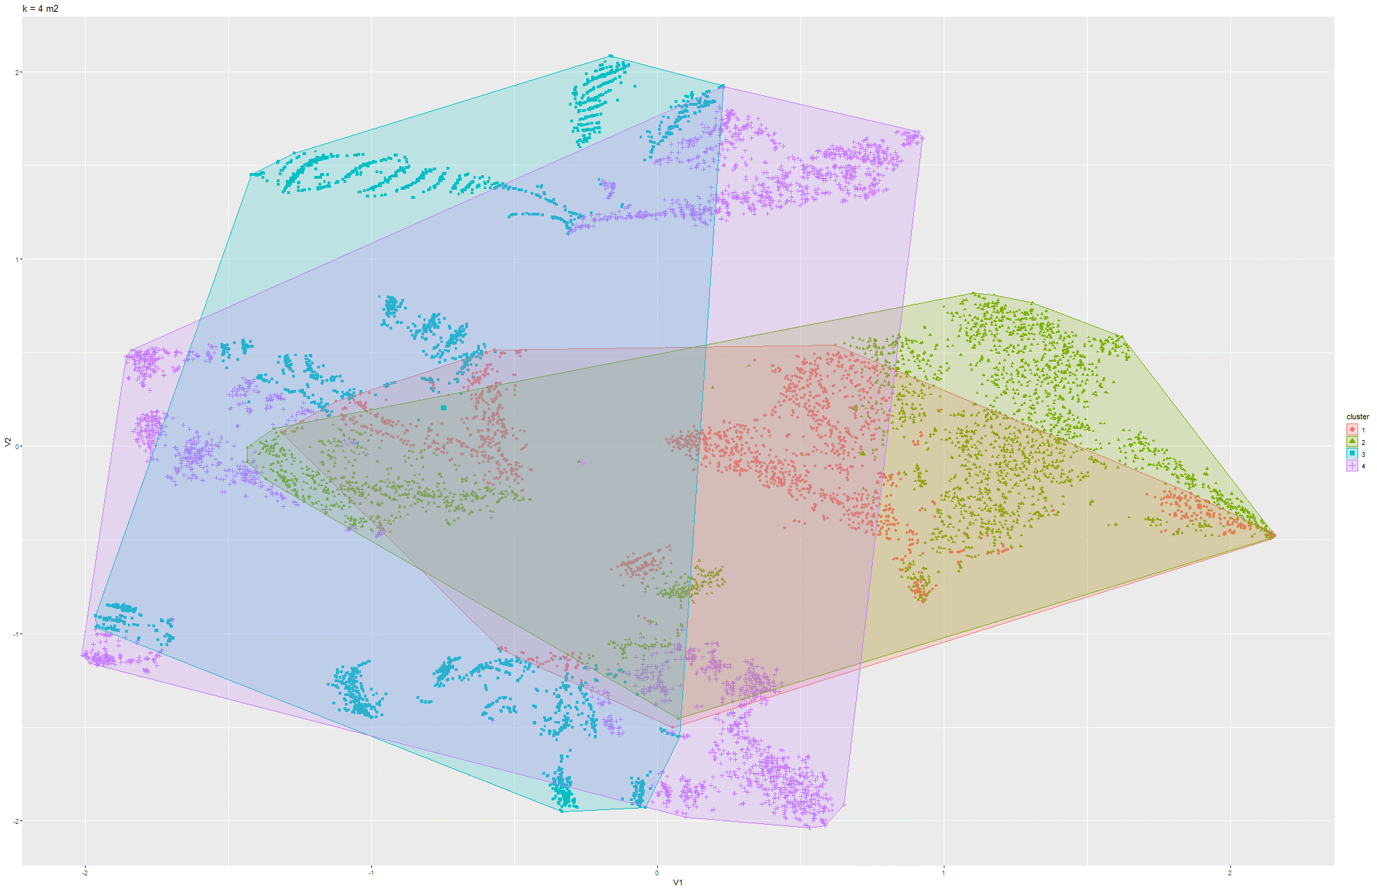

Figure 63 & 64 k-means t-SNE on Model 2

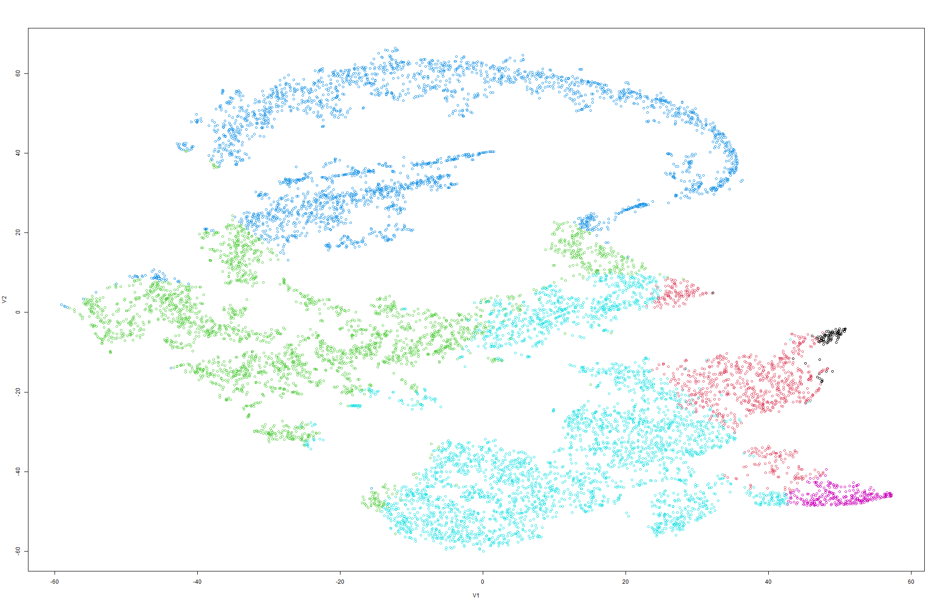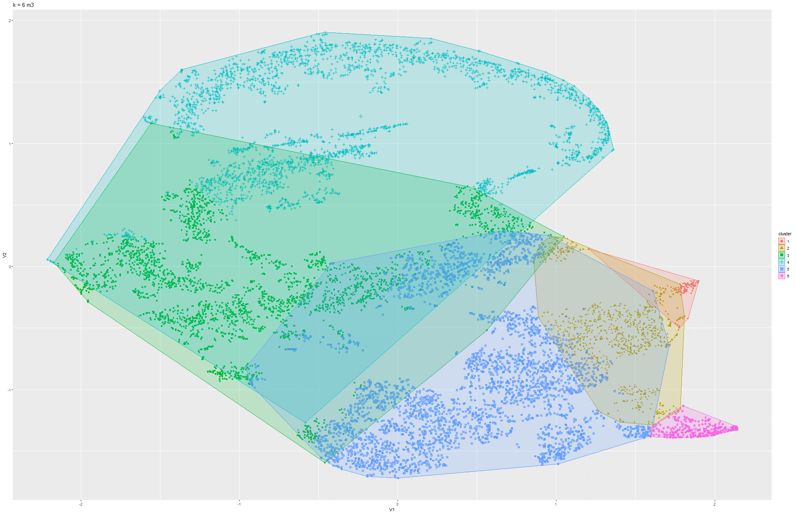

Figure 65 & 66 k-means t-SNE on Model 3

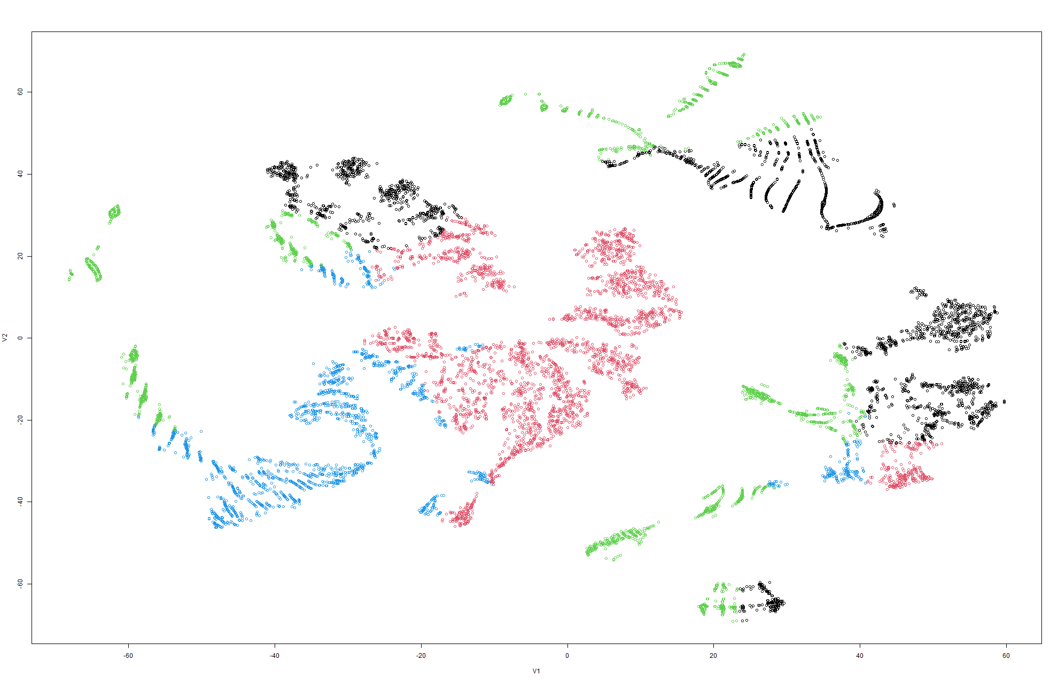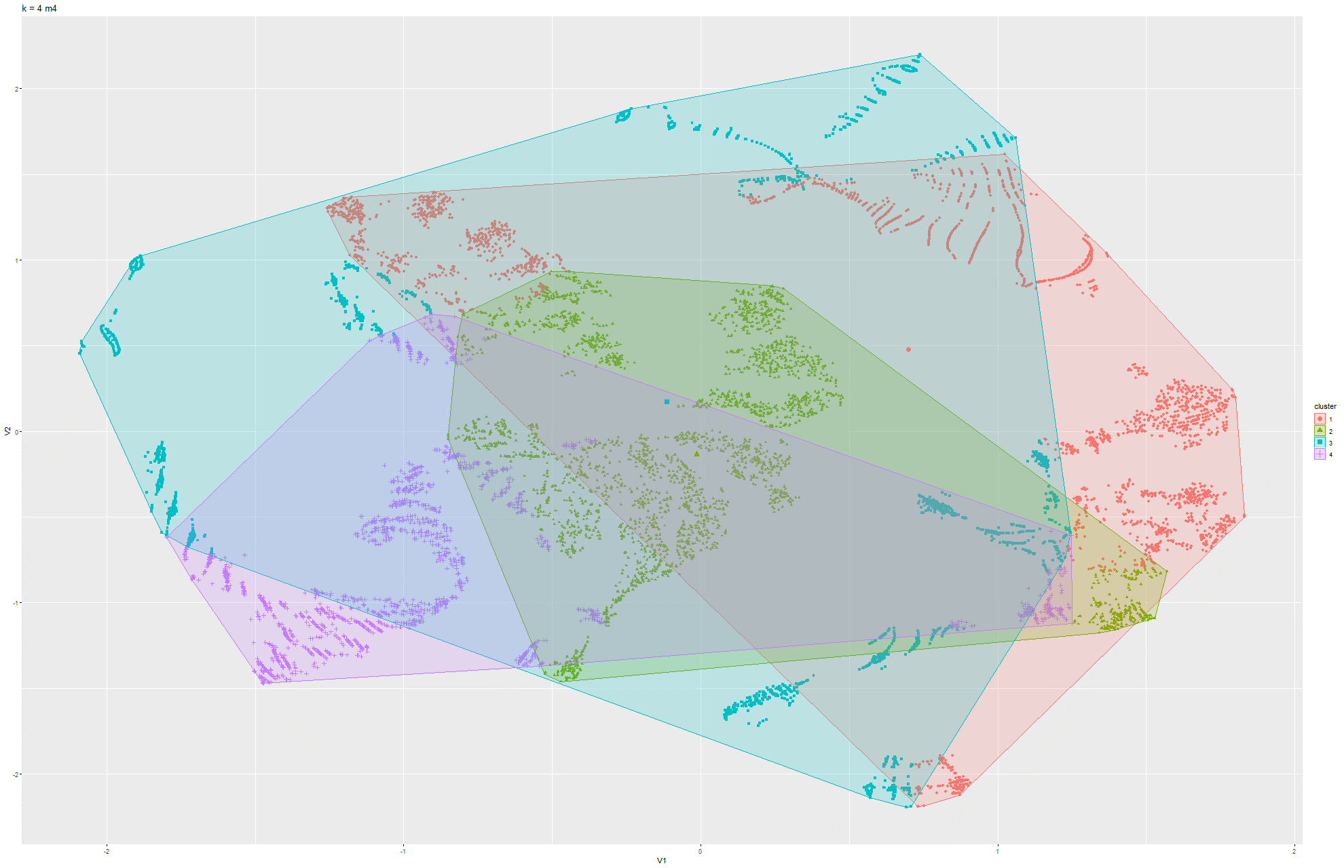

Figure 67 & 68 k-means t-SNE on Model 4

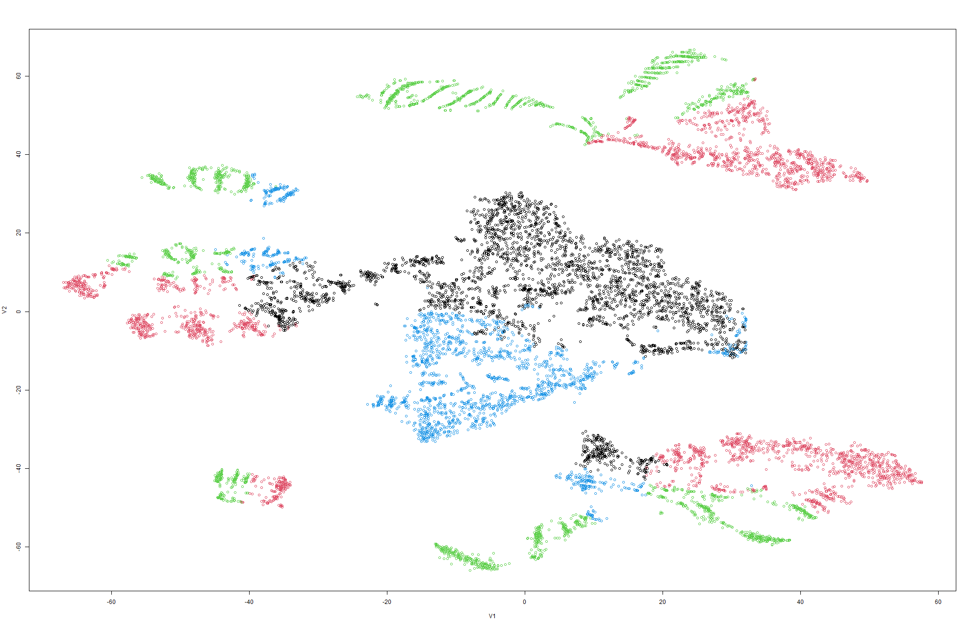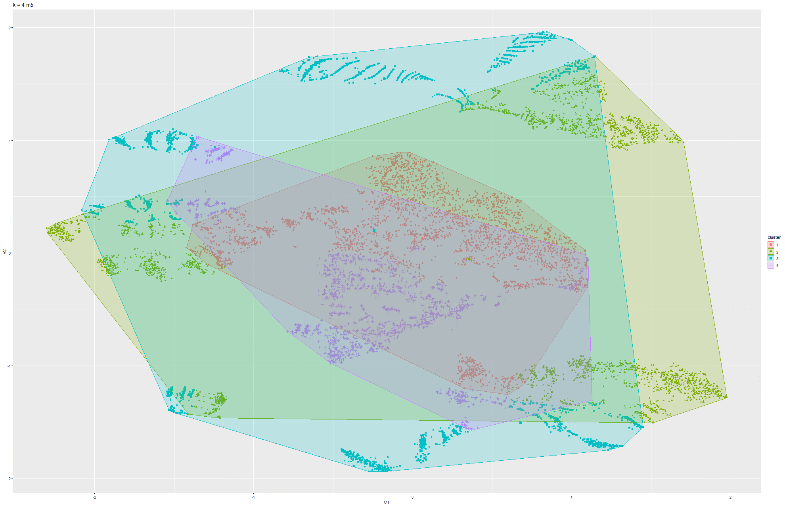

Figure 69 & 70 k-means t-SNE on Model 5

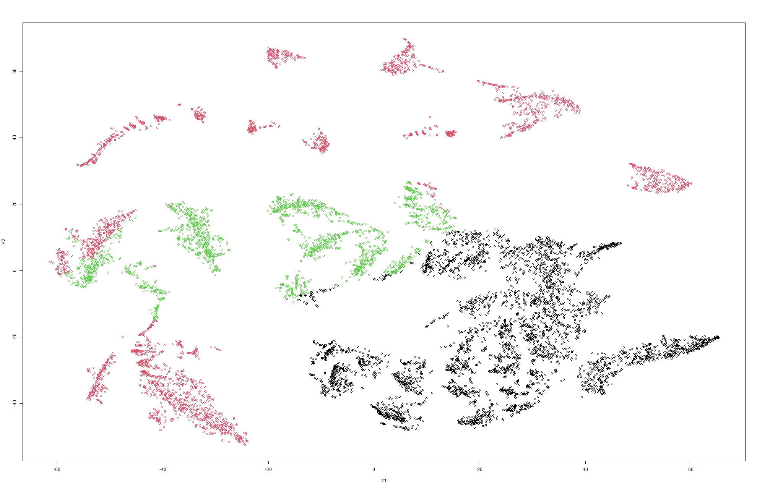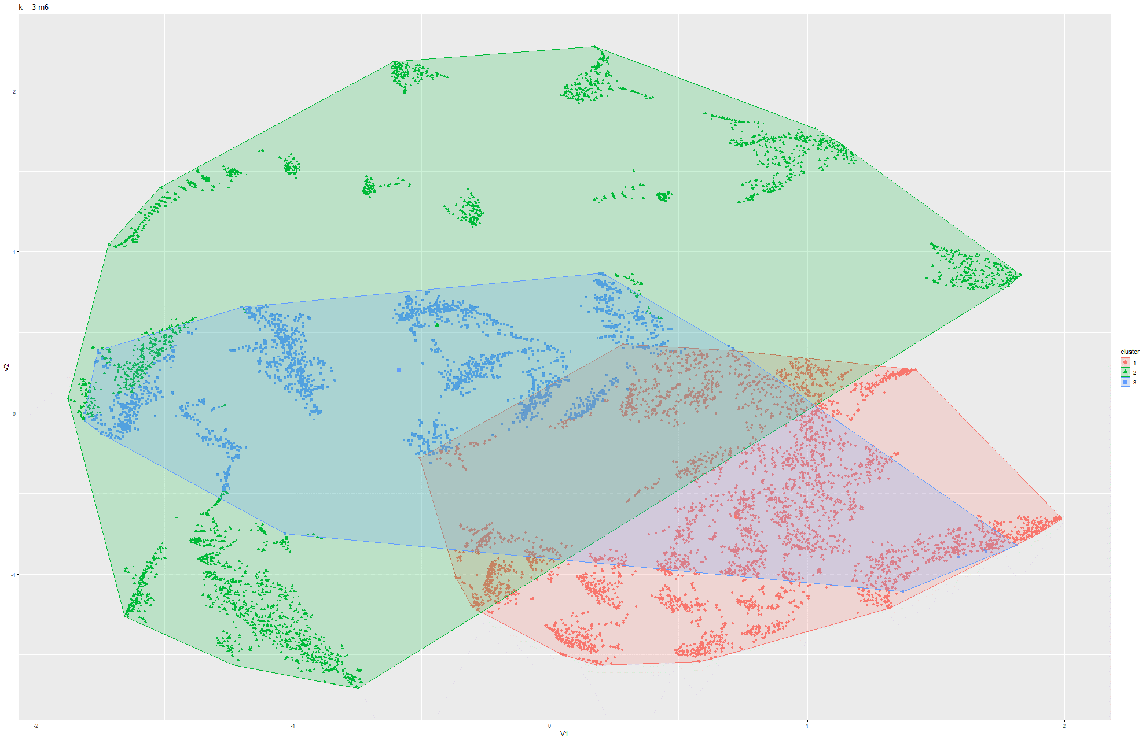

Figure 71 & 72 k-means t-SNE on Model 6

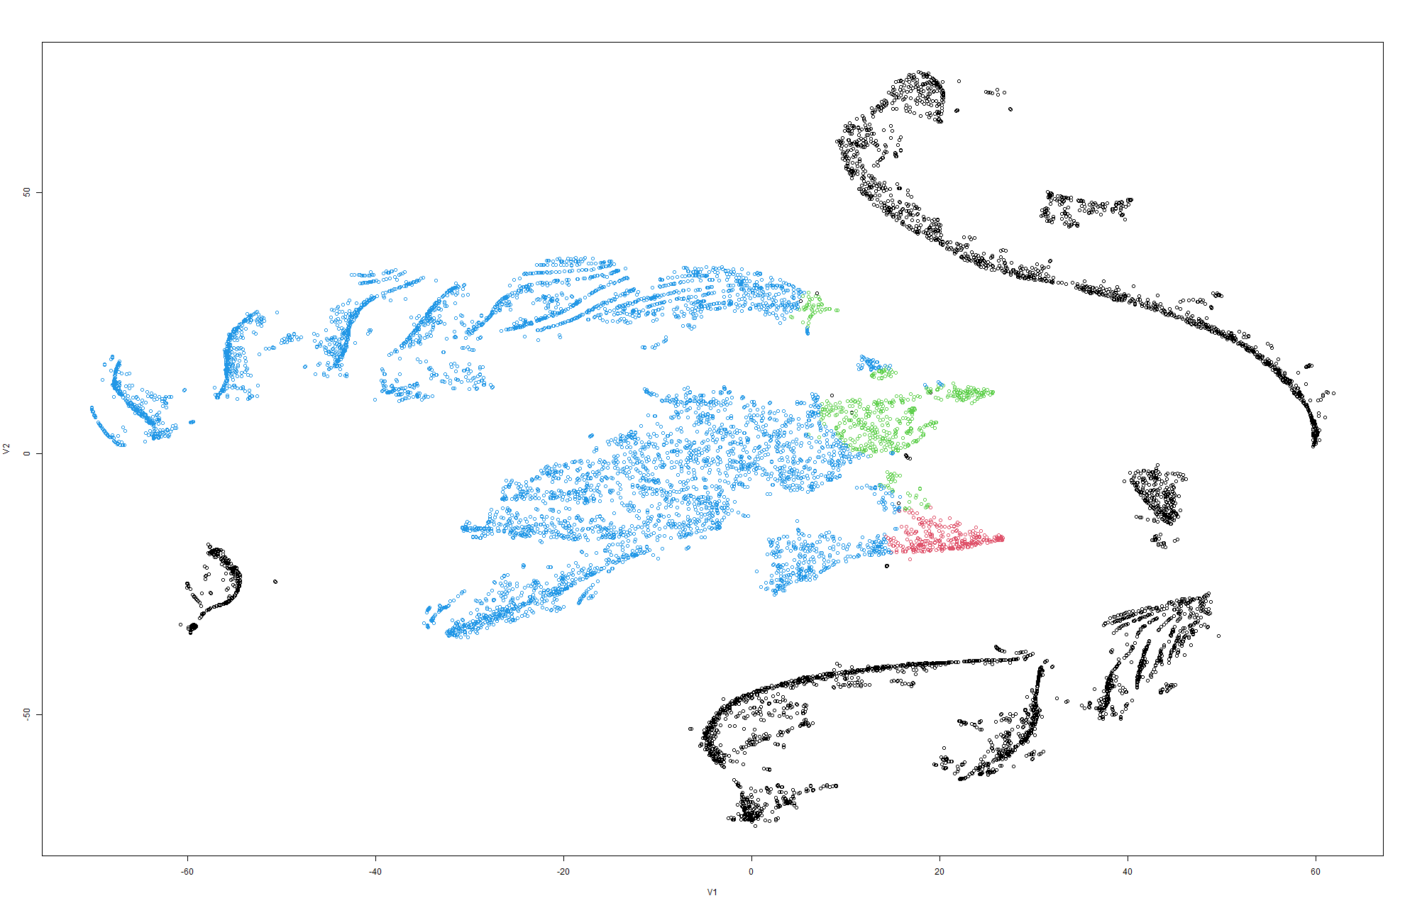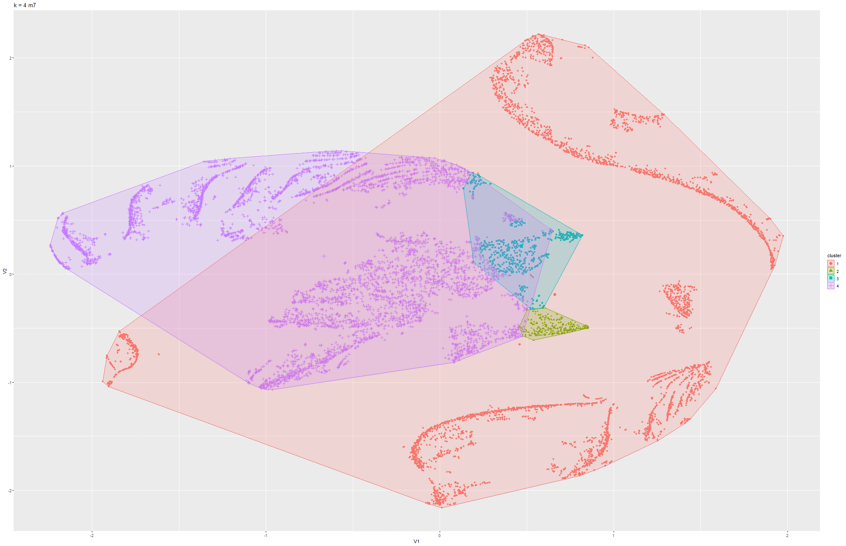

Figure 73 & 74 k-means t-SNE on Model 7

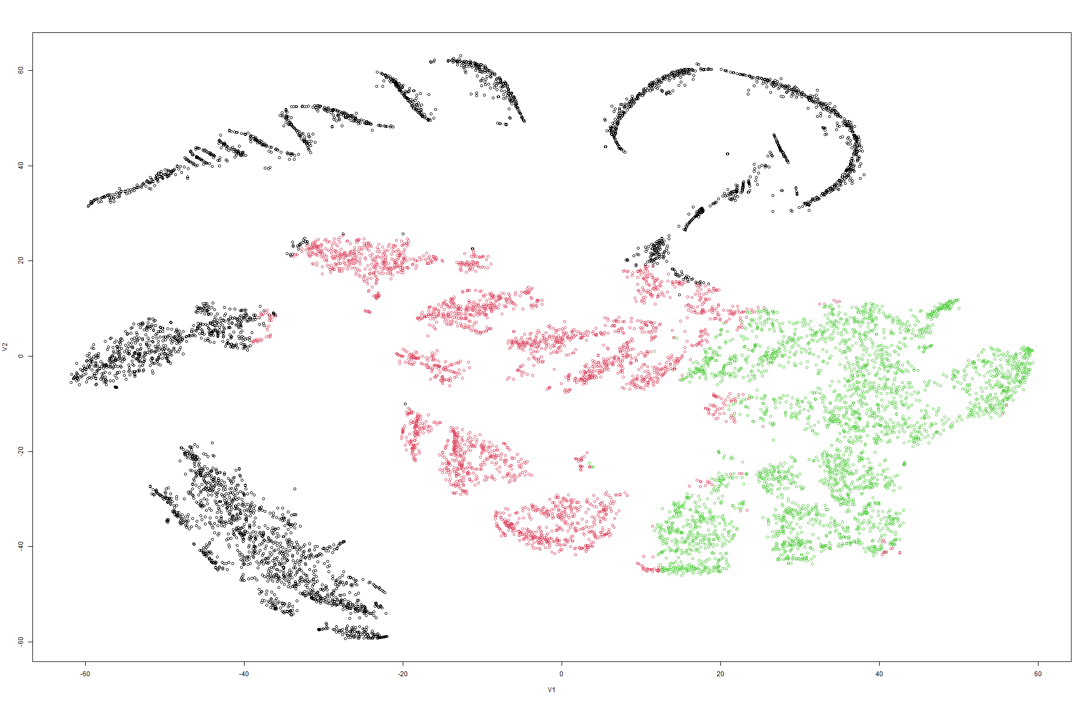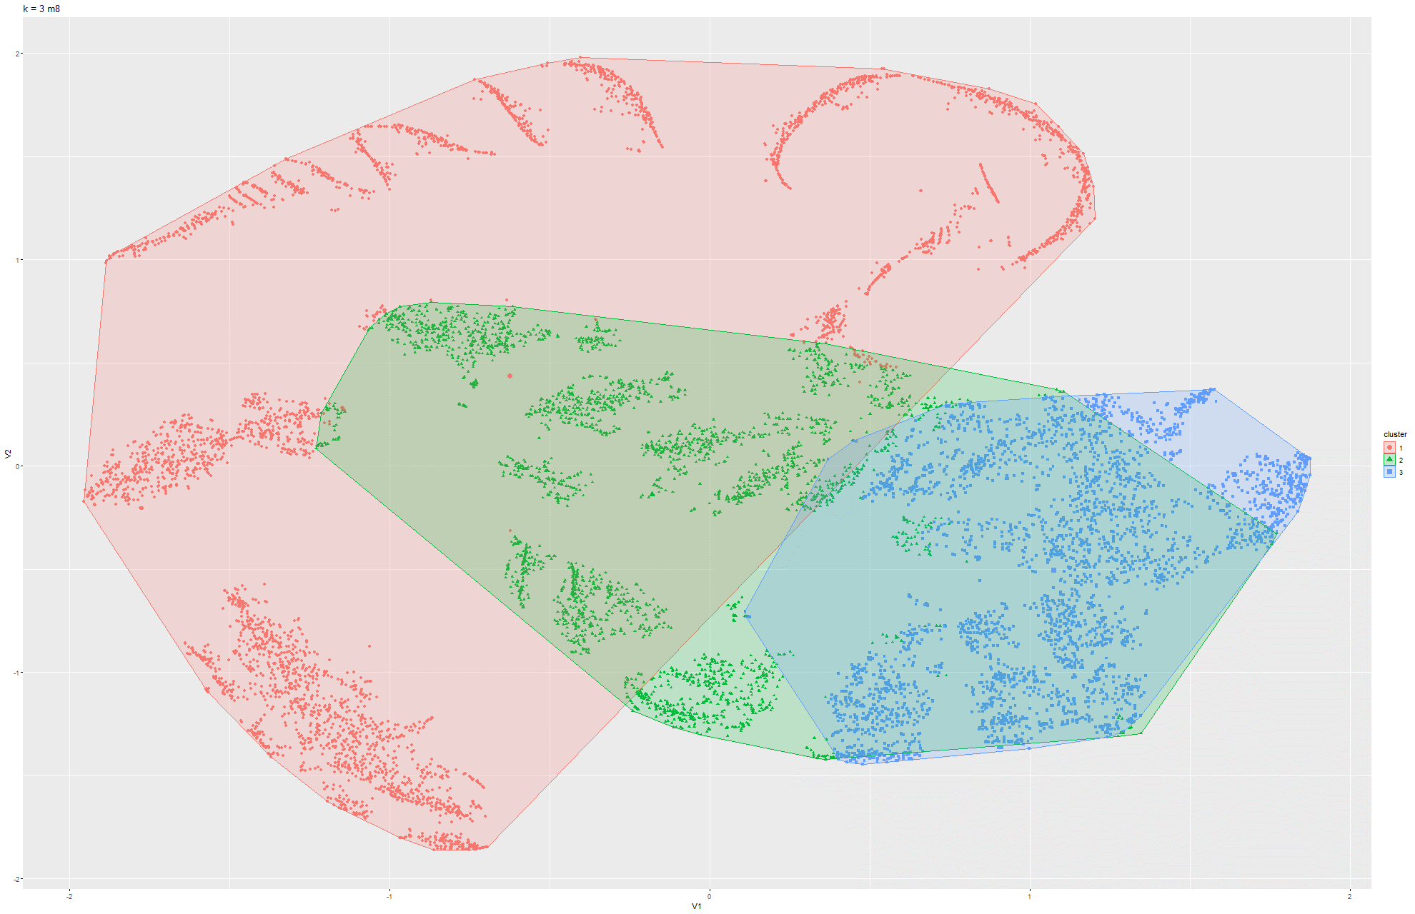

Figure 75 & 76 k-means t-SNE on Model 8

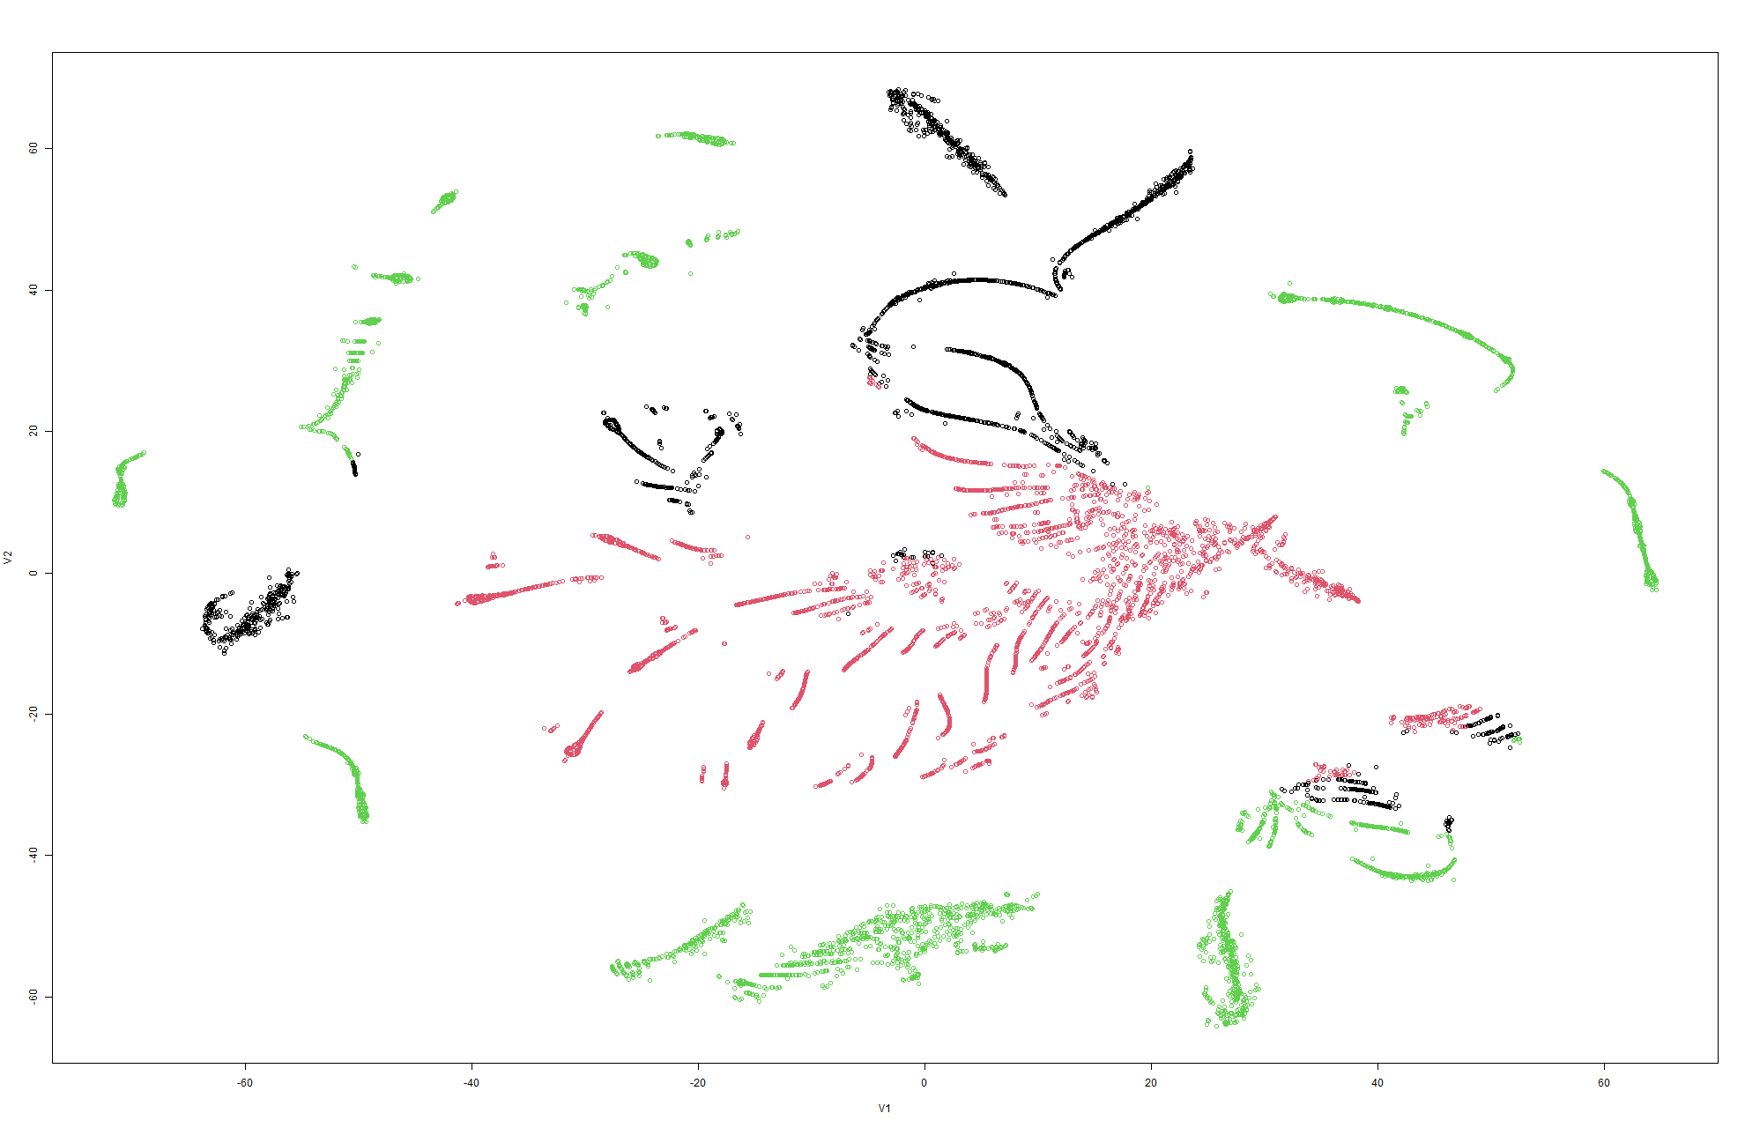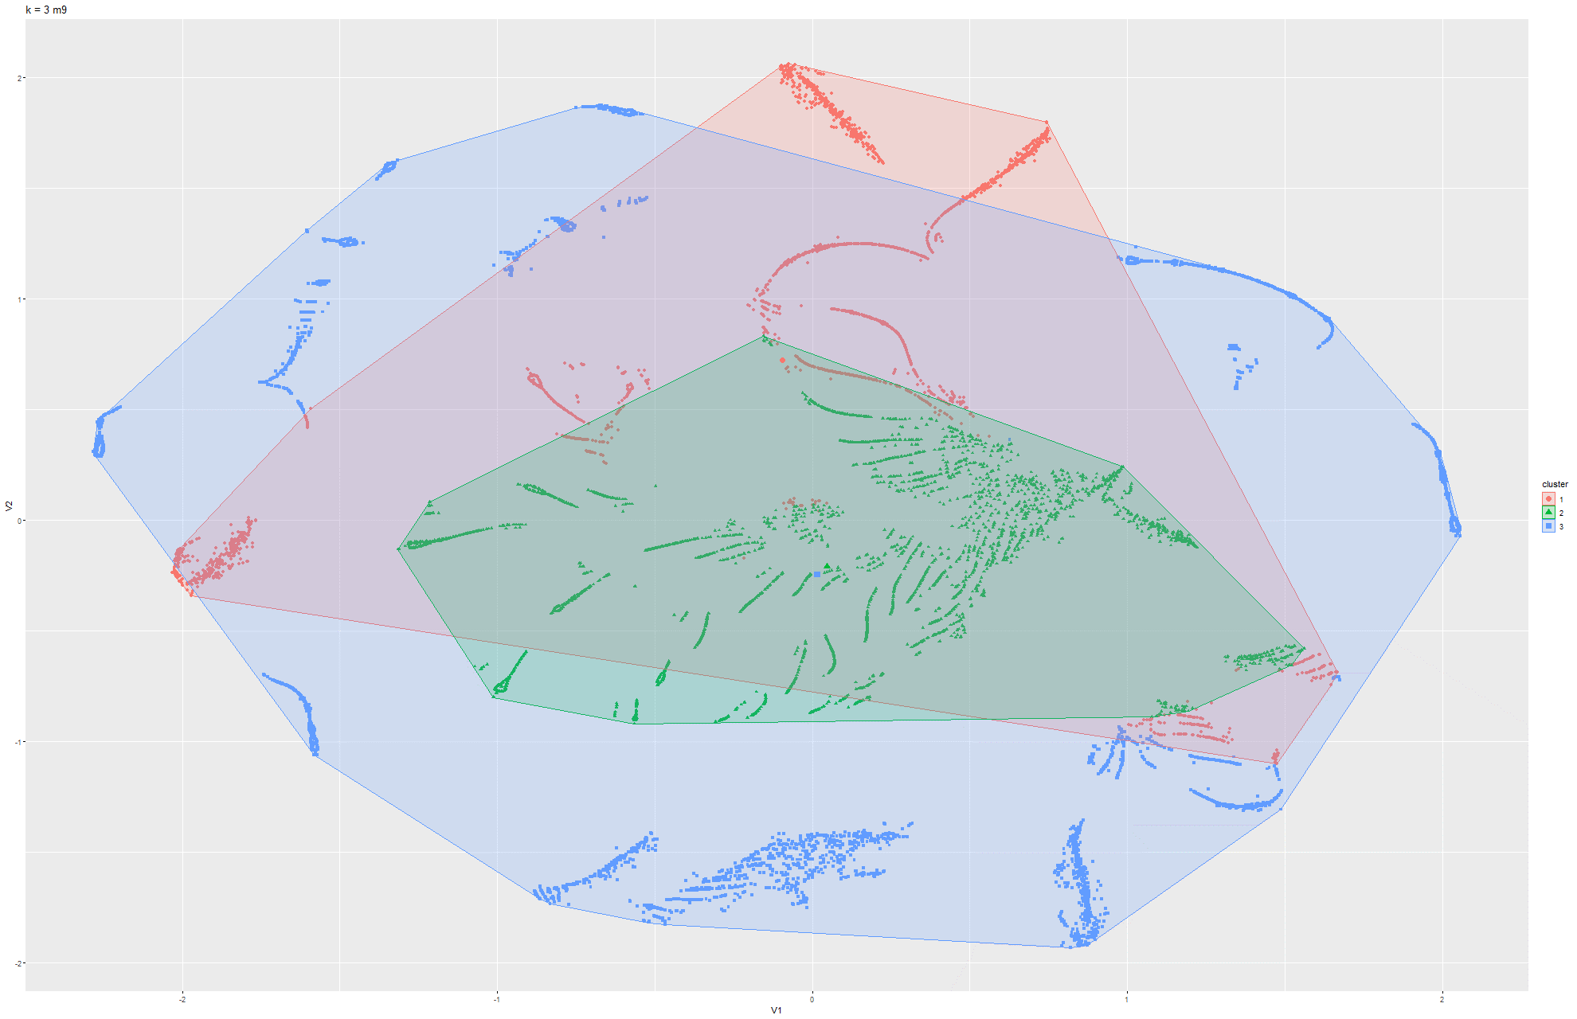

Figure 77 & 78 k-means t-SNE on Model 9

Model 3:

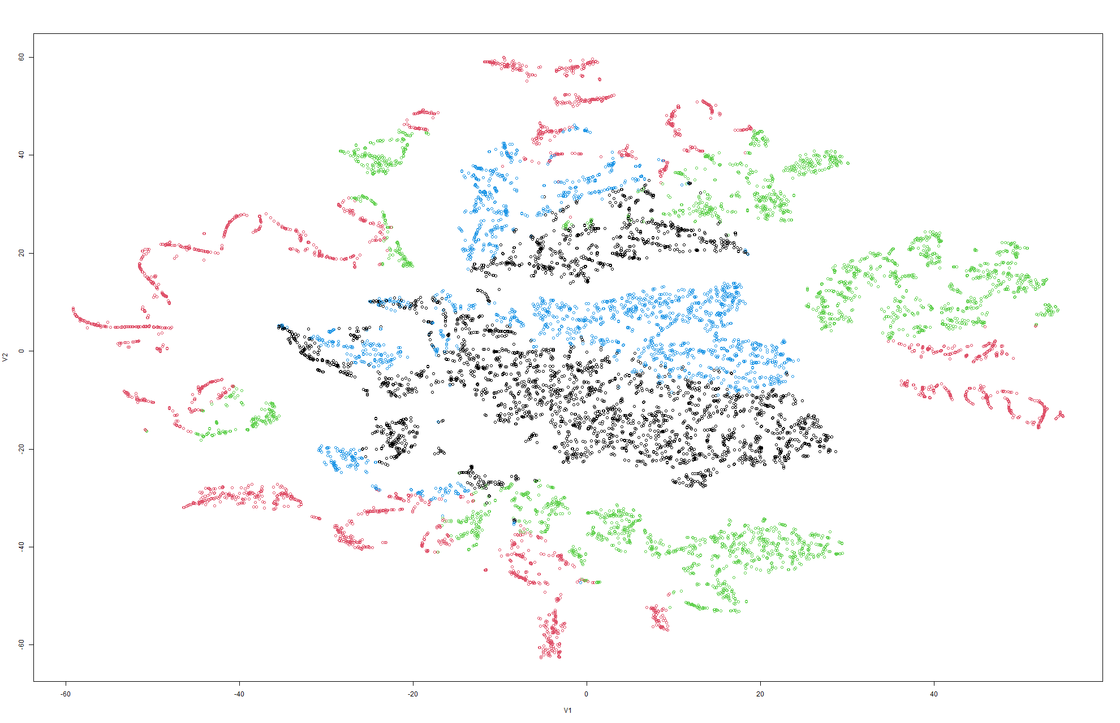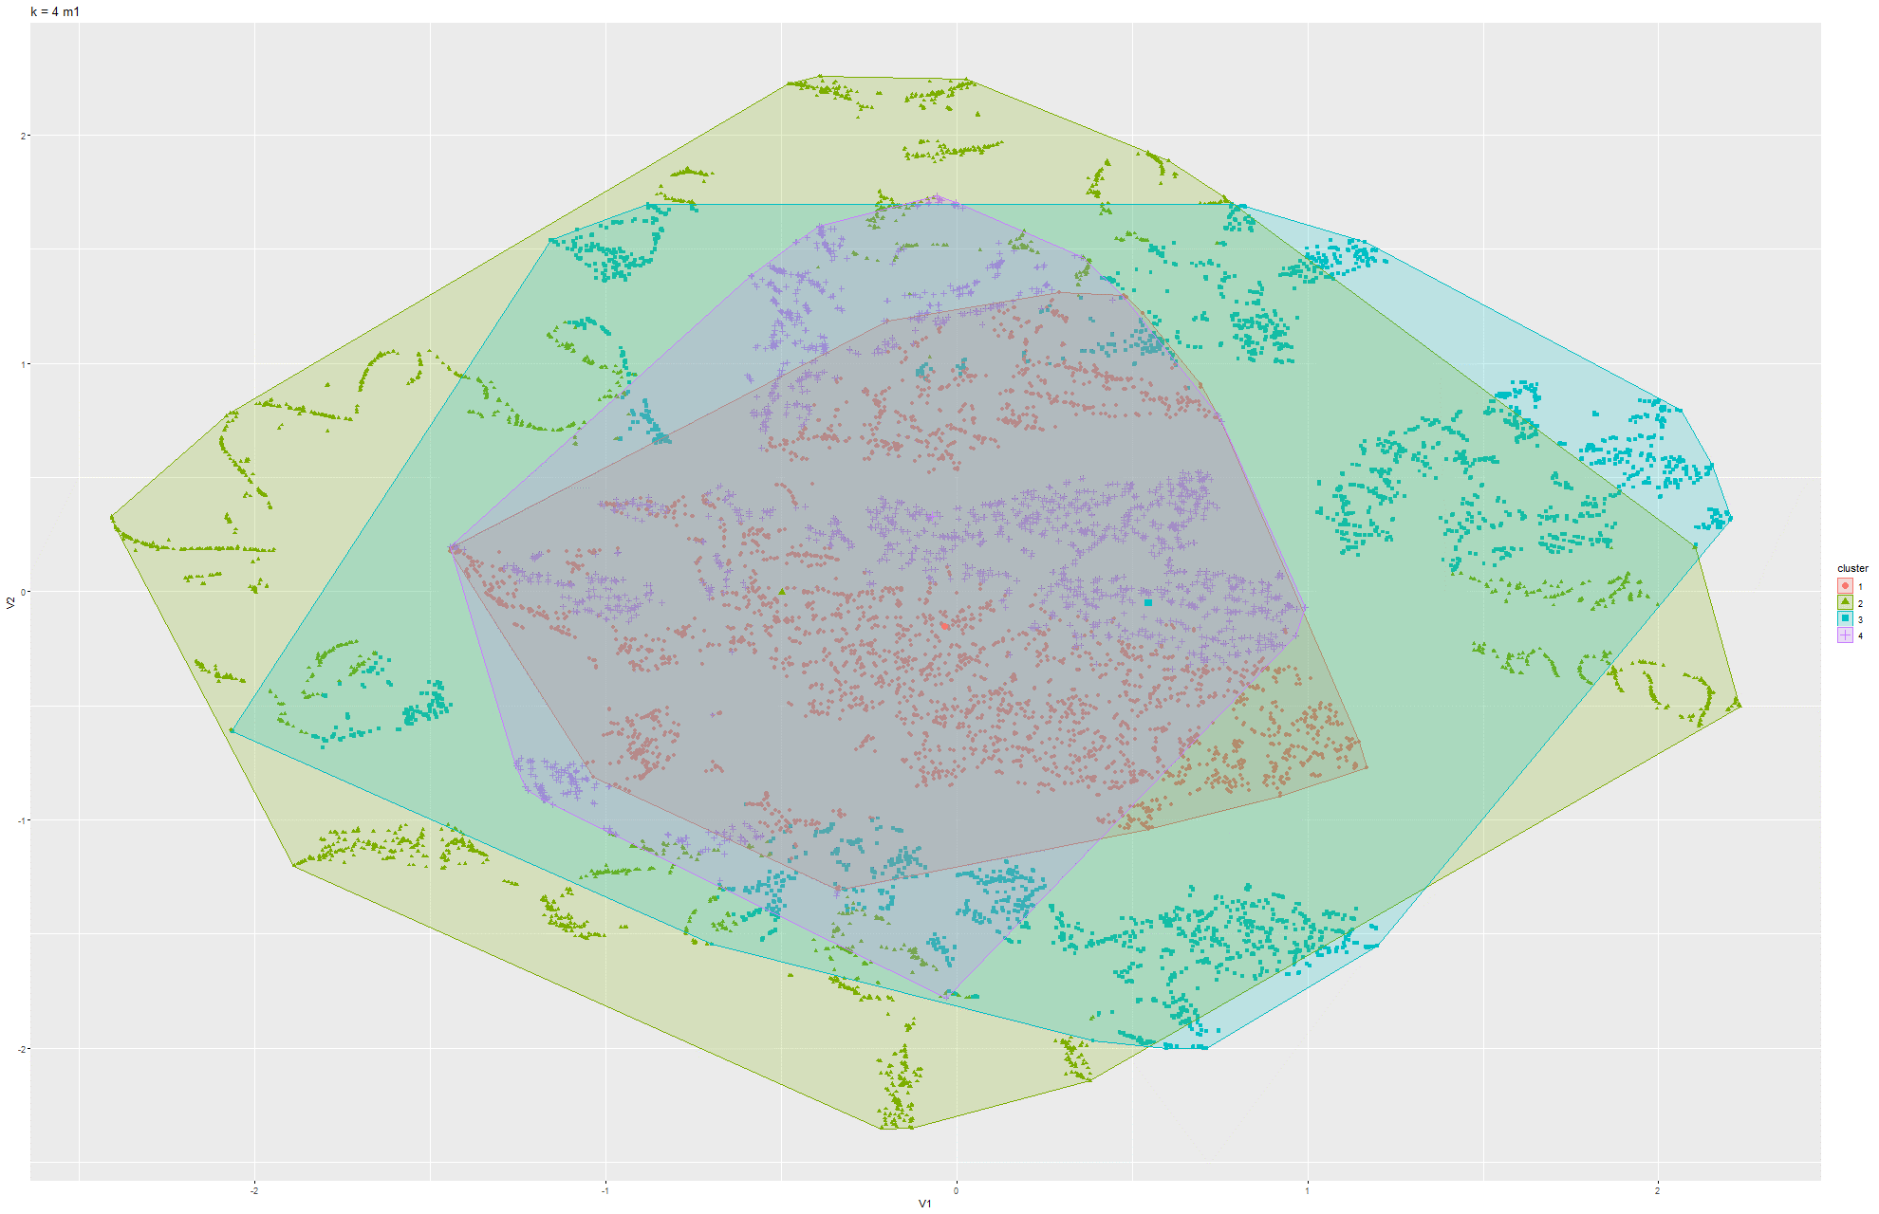

Figure 79 & 80 k-means t-SNE on Model 1

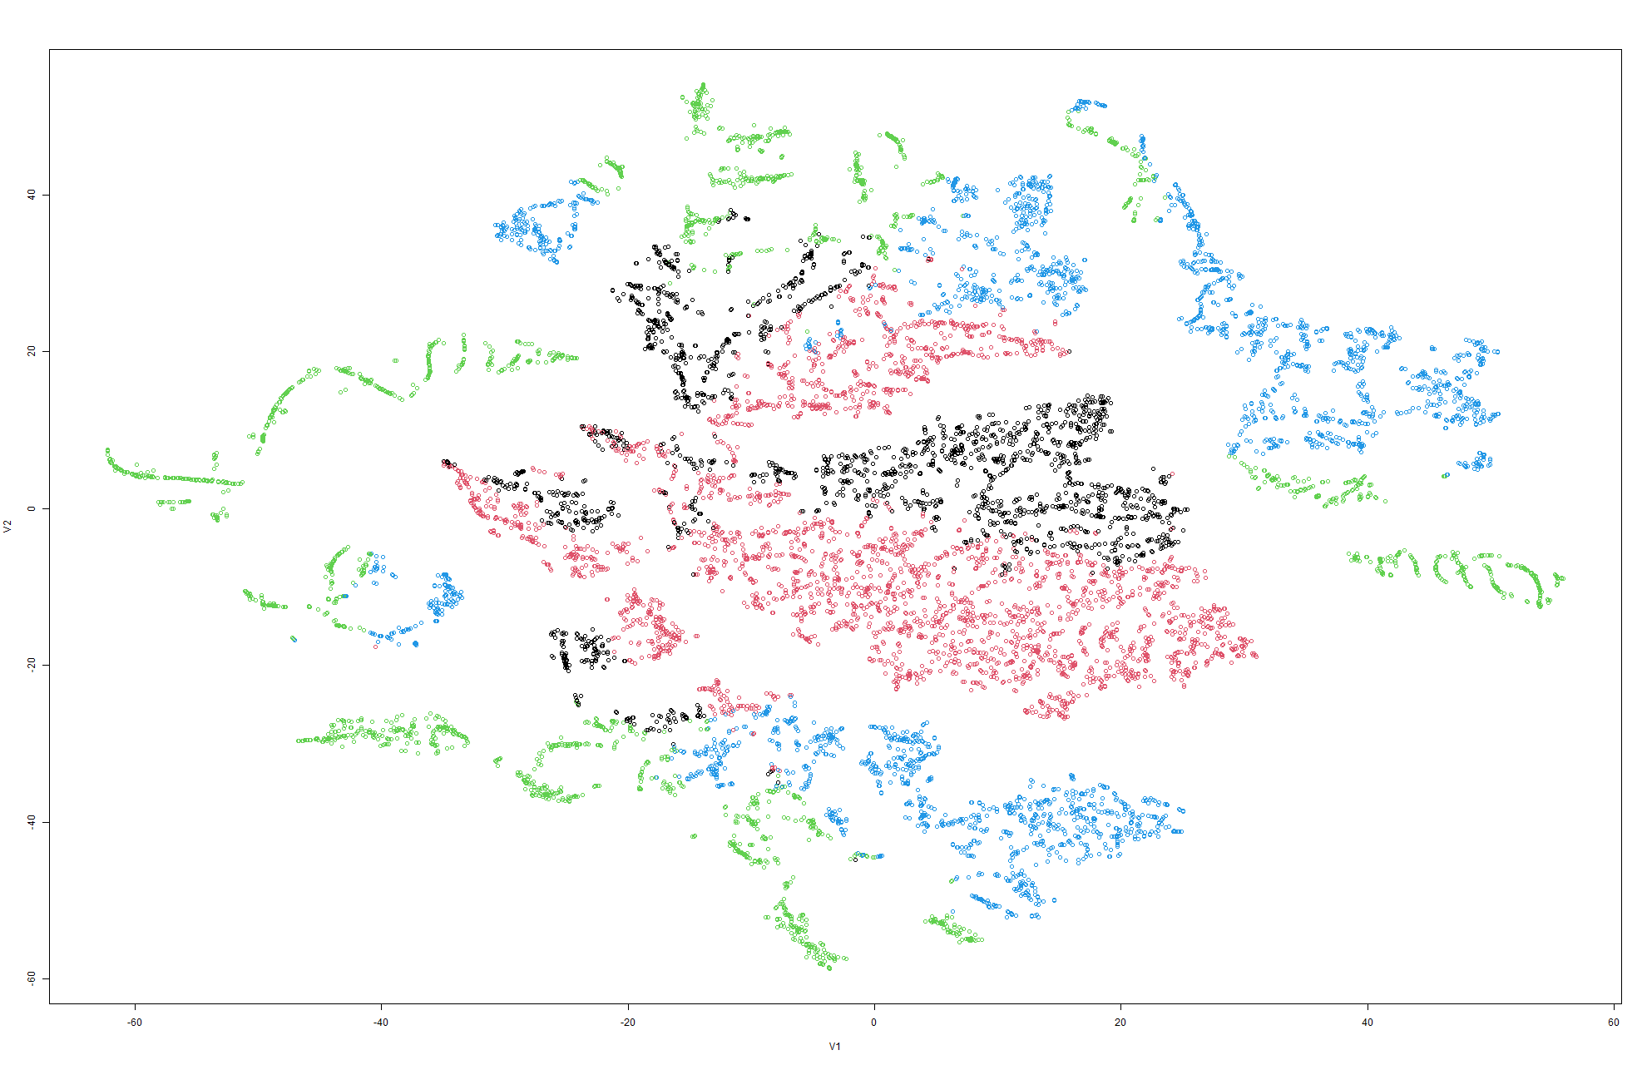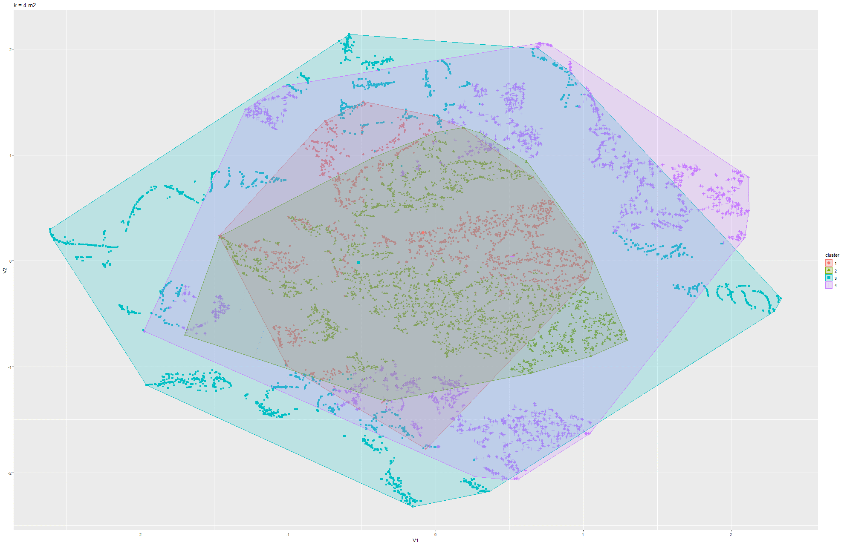

Figure 81 & 82 k-means t-SNE on Model 2

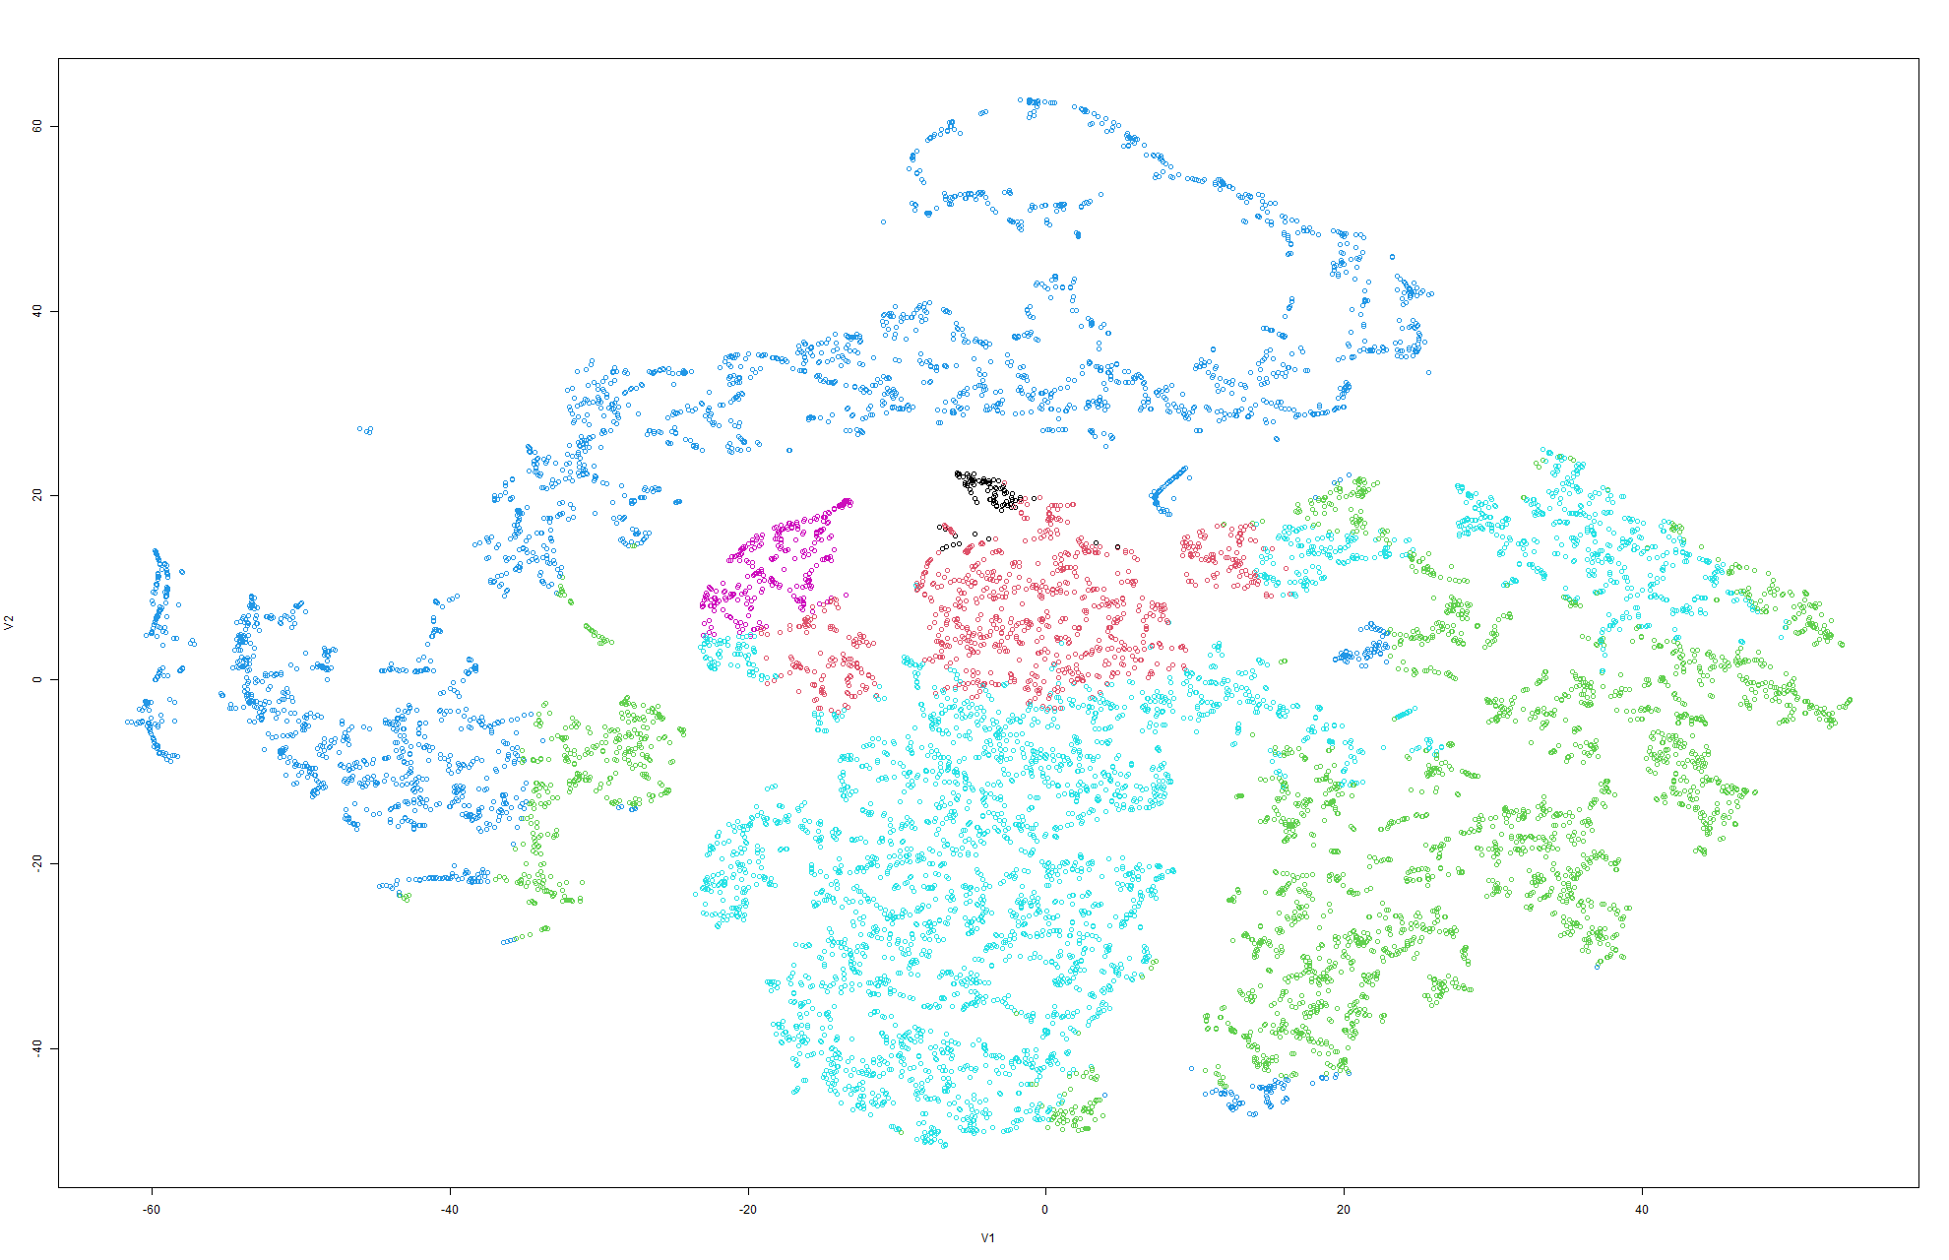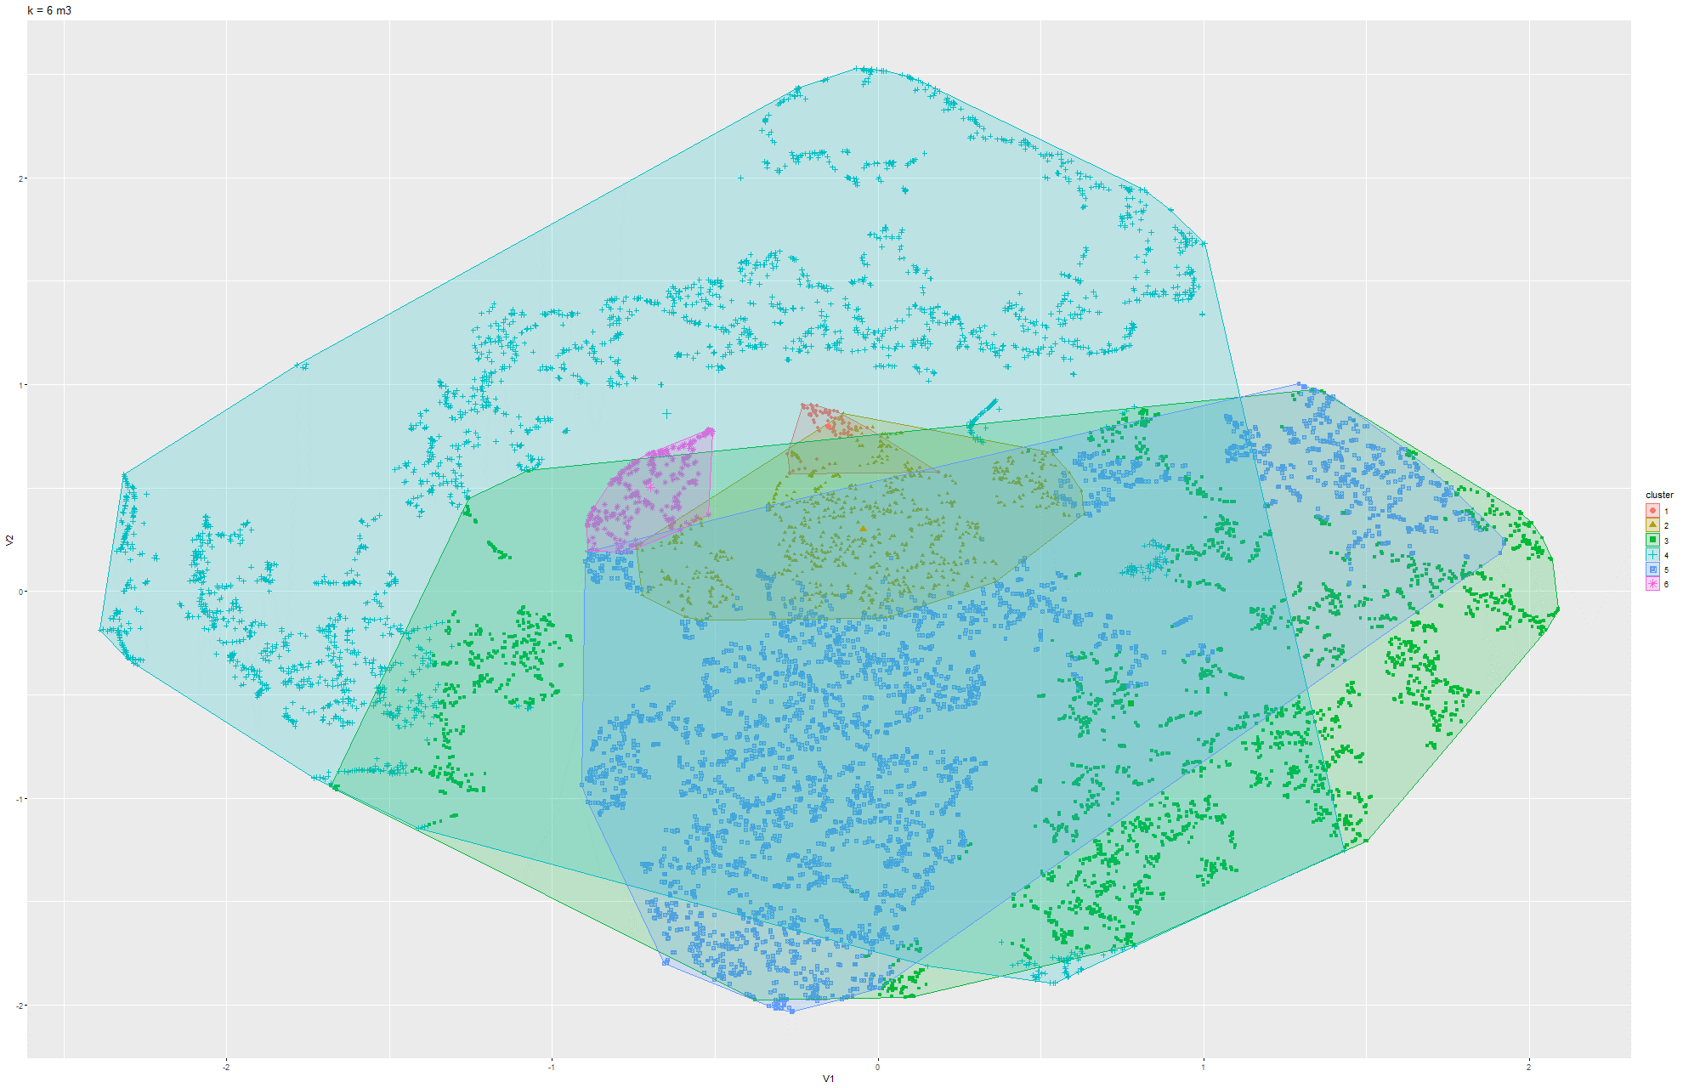

Figure 83 & 84 k-means t-SNE on Model 3

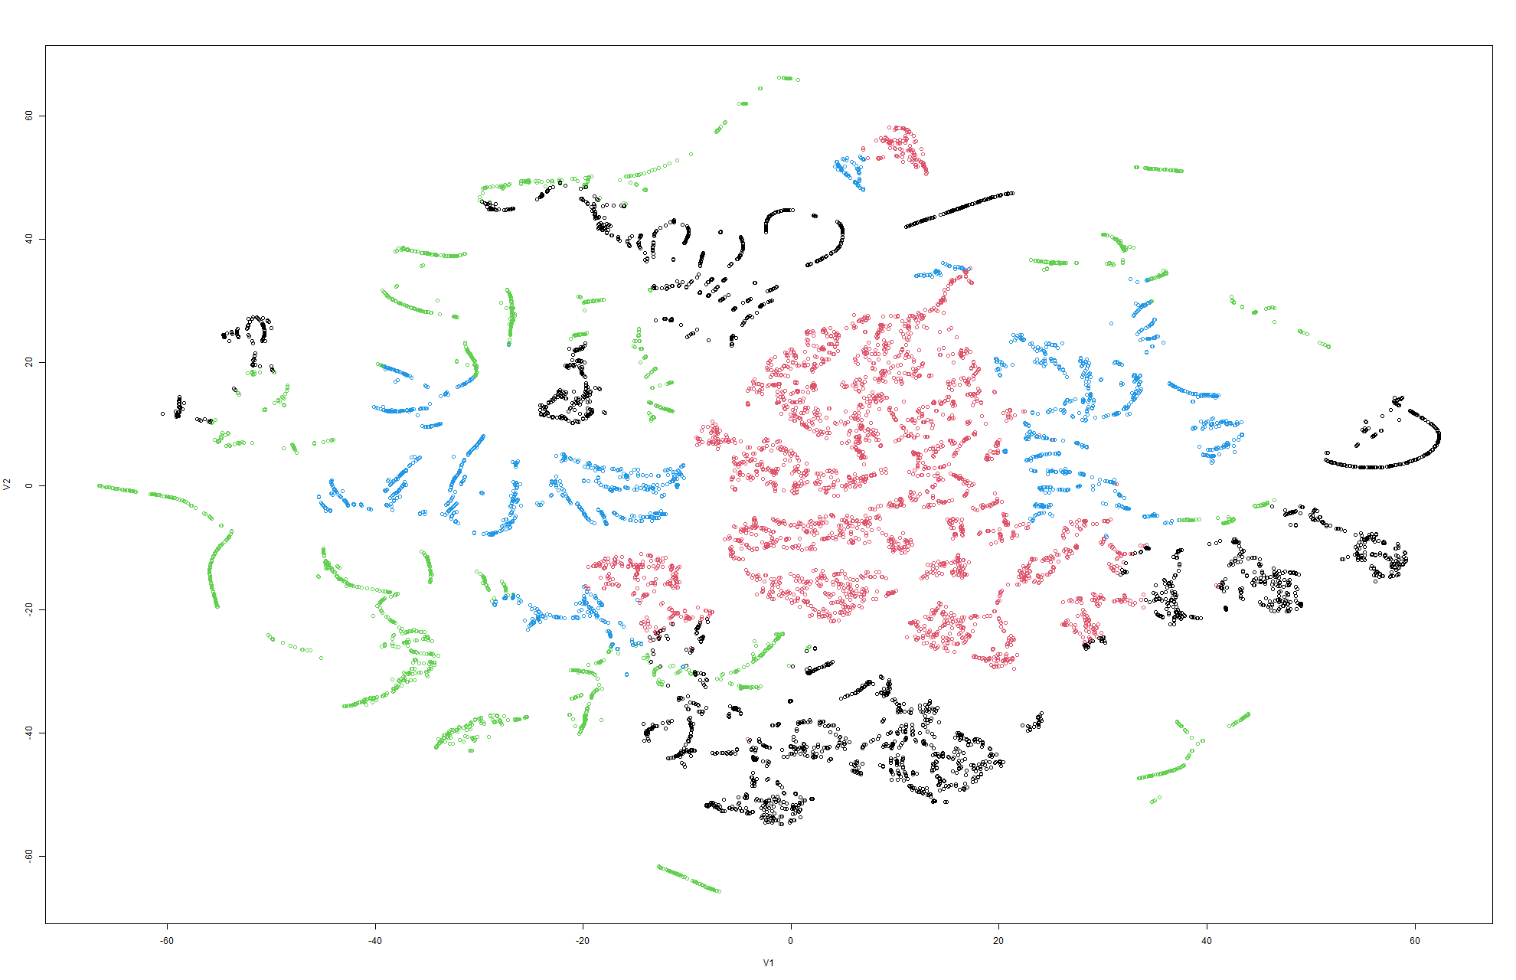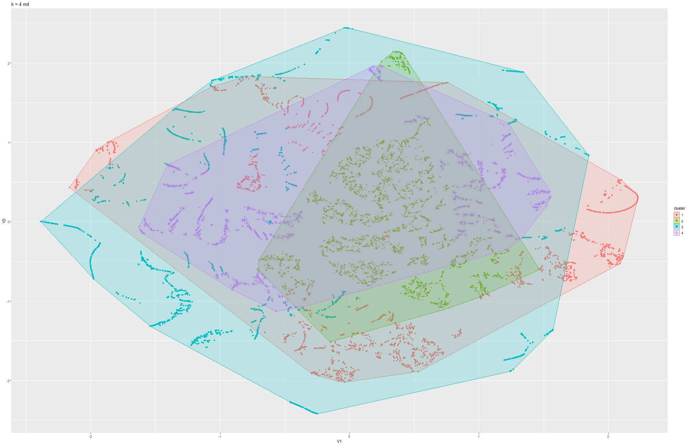Figure 85 & 86 k-means t-SNE on Model 4

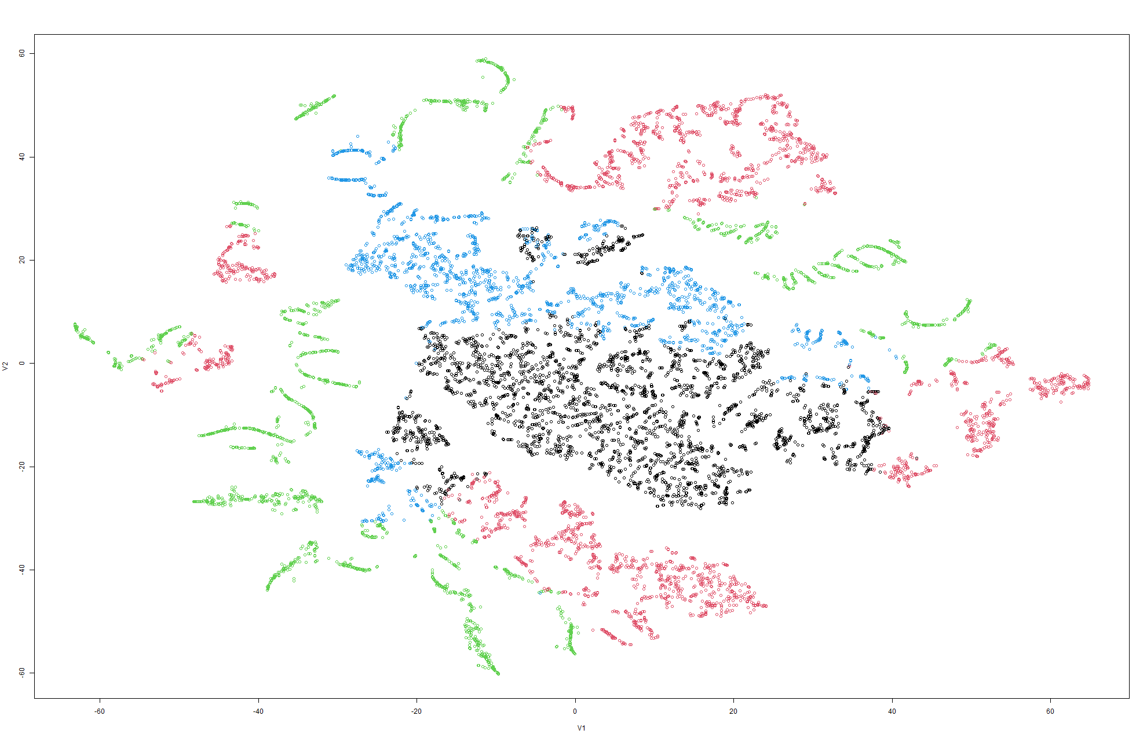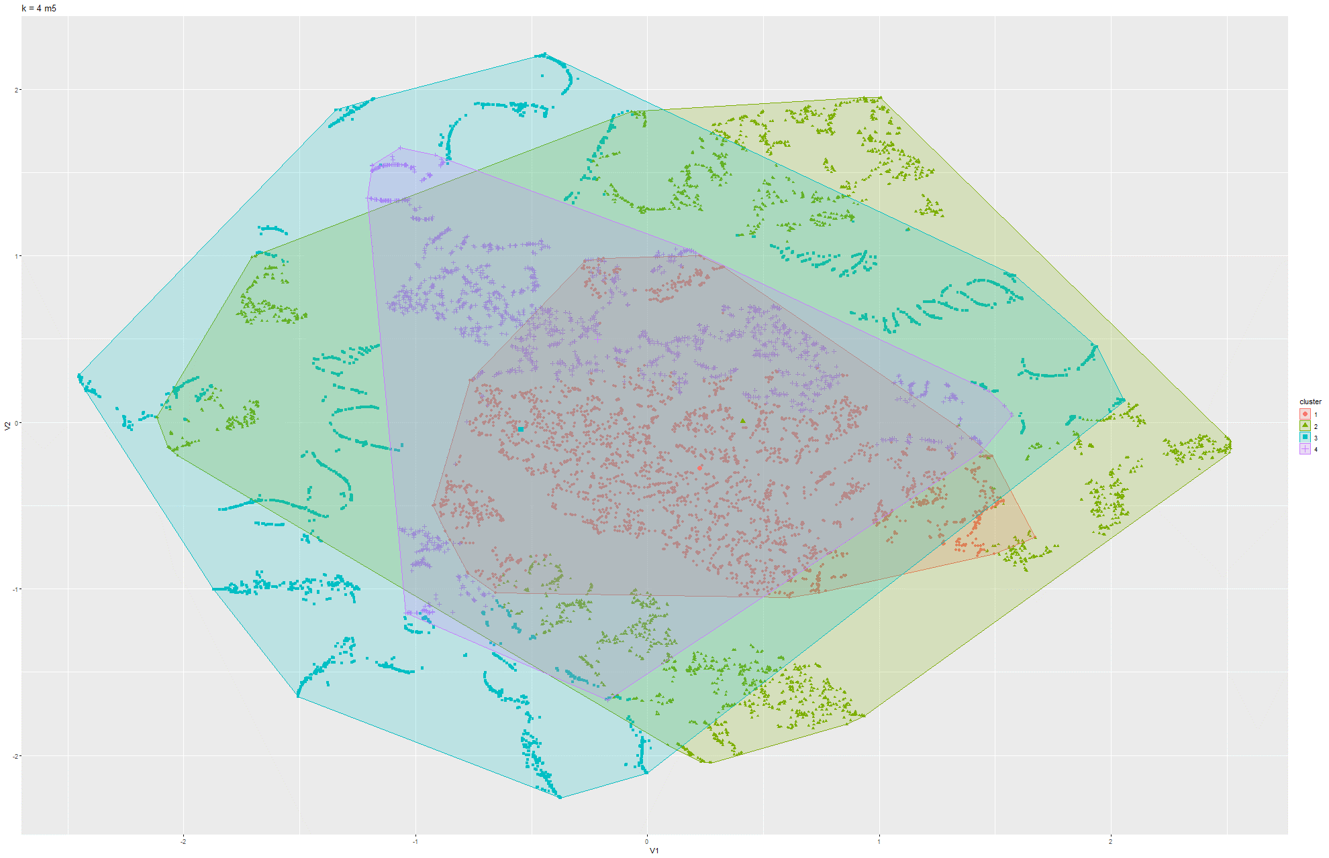Figure 87 & 88 k-means t-SNE on Model 5

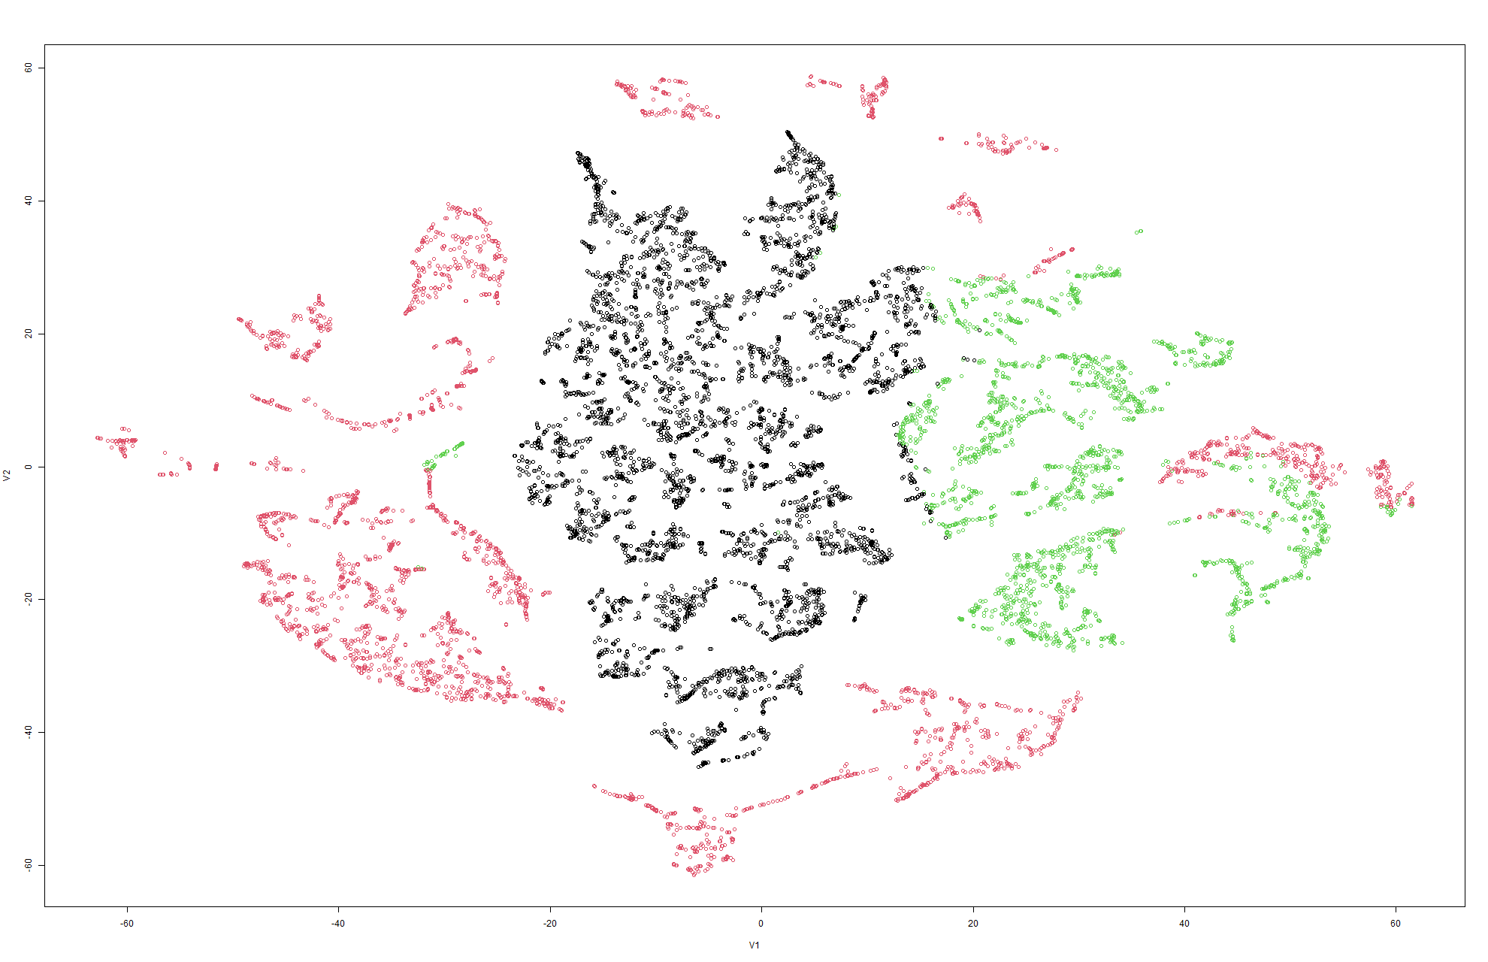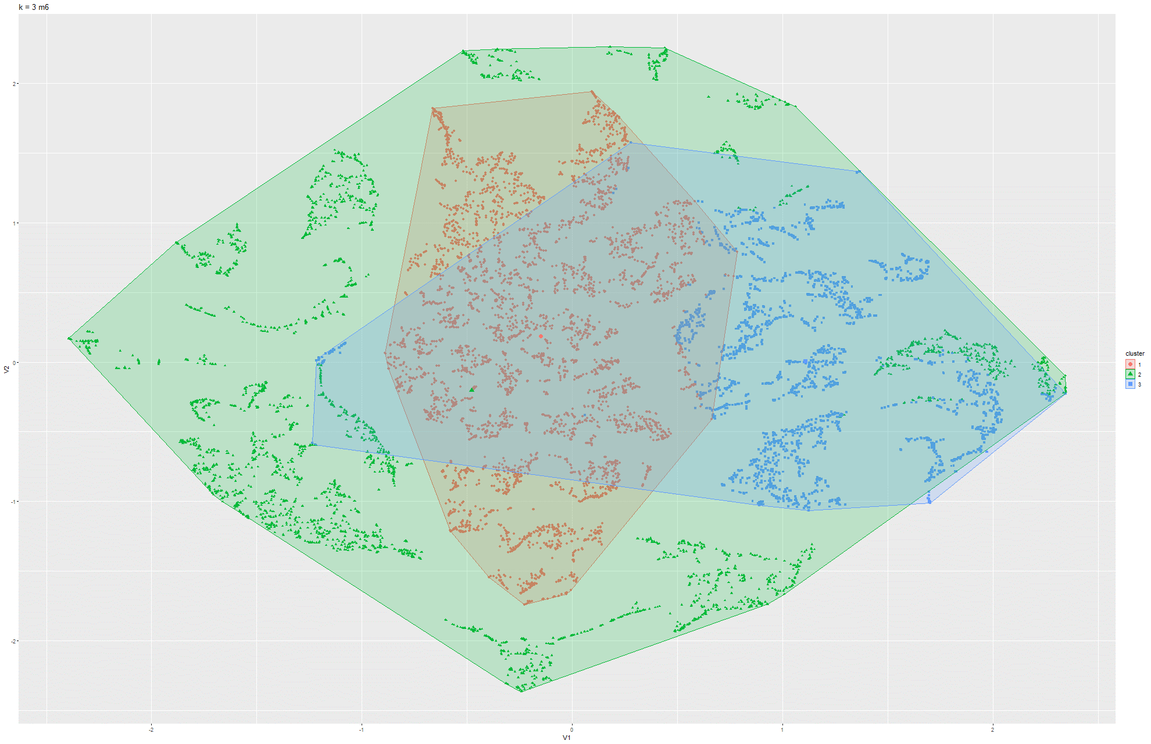Figure 89 & 90 k-means t-SNE on Model 6

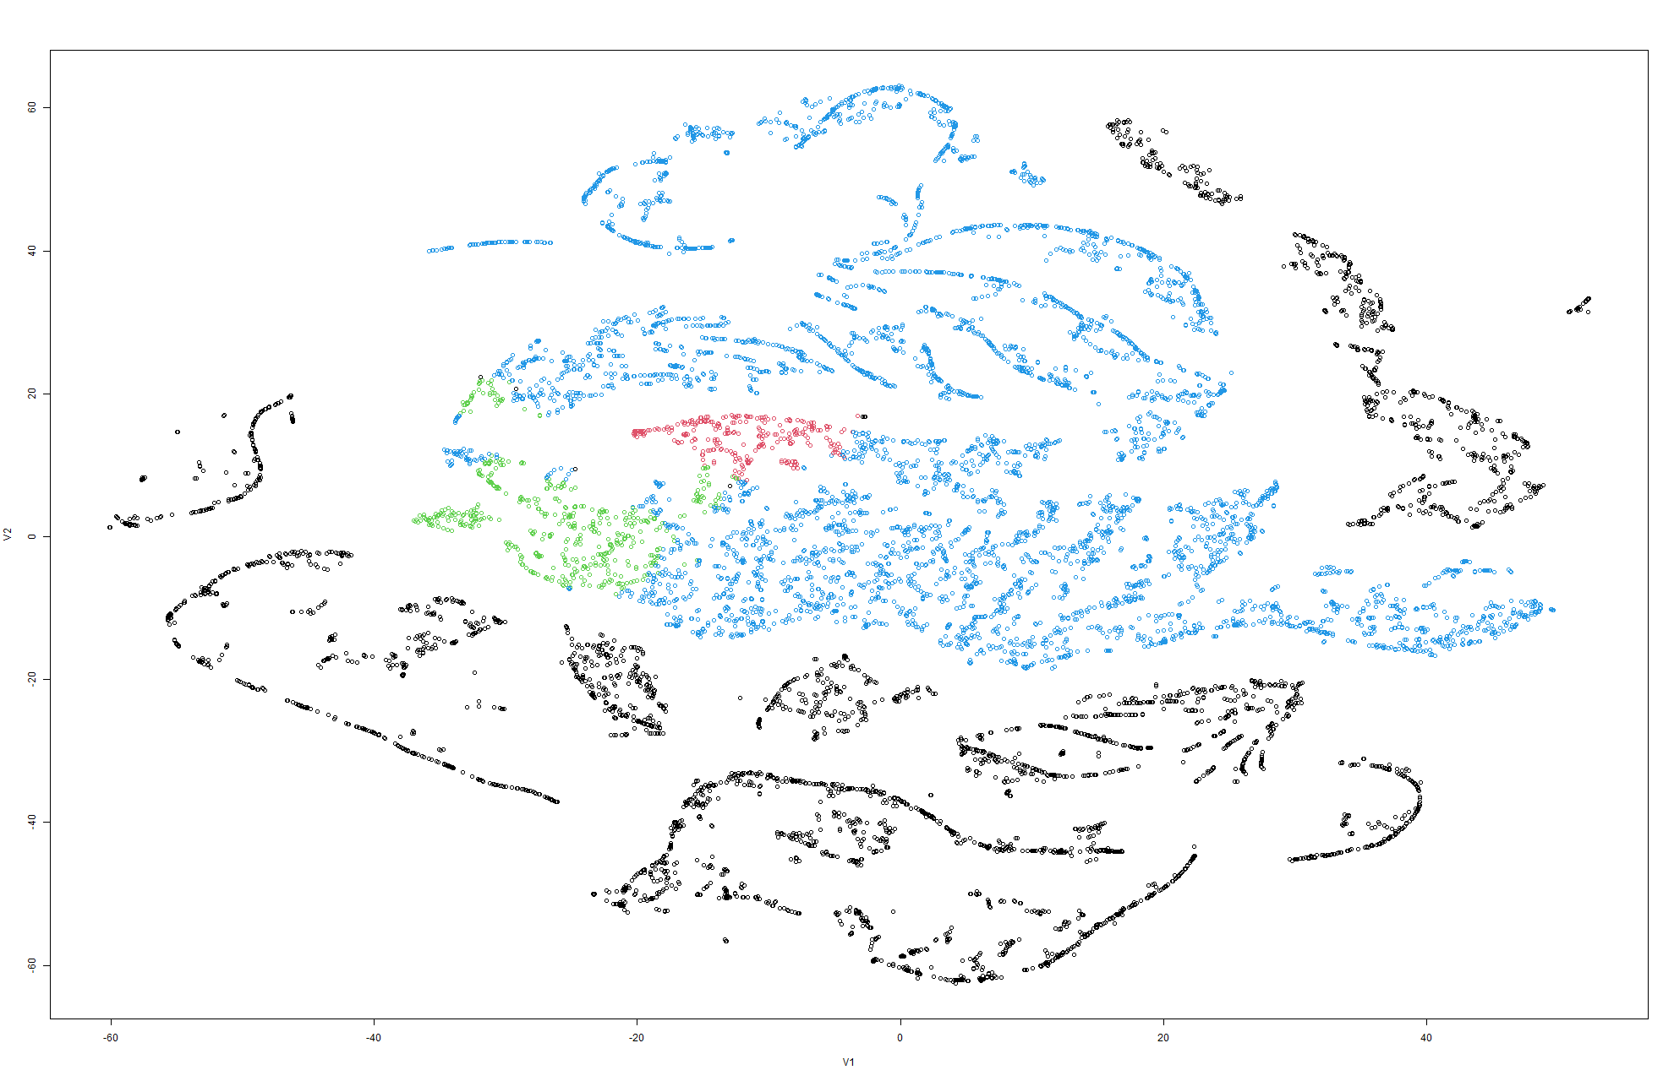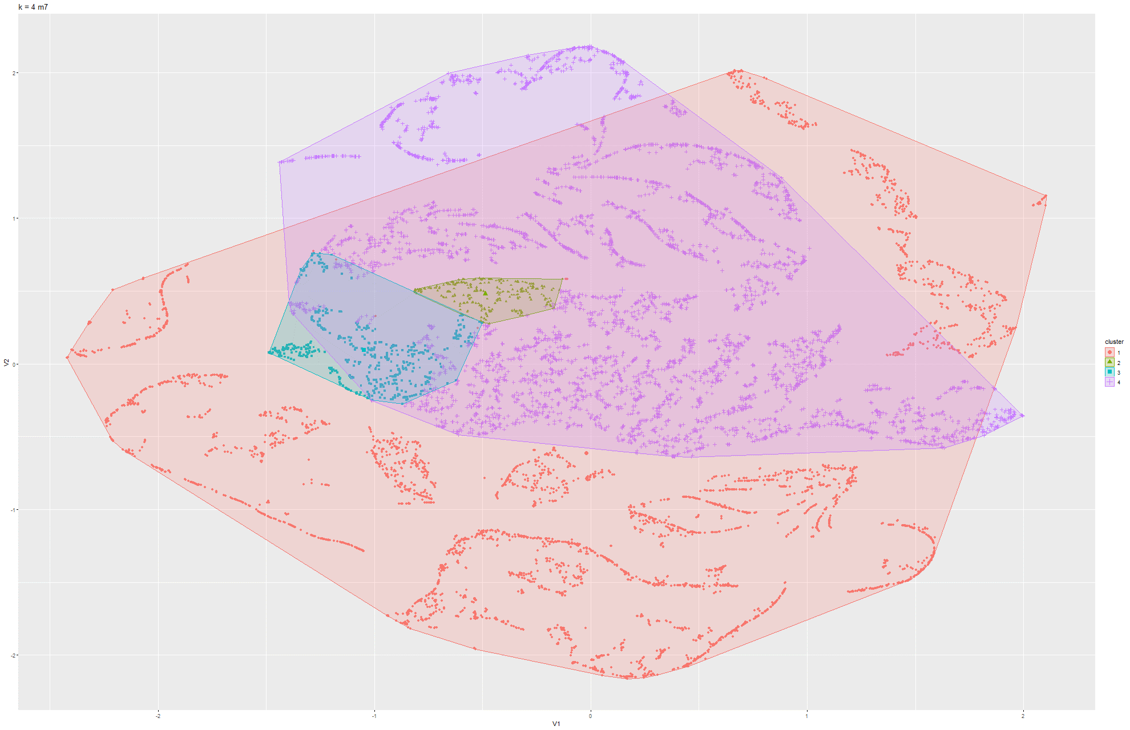Figure 91 & 92 k-means t-SNE on Model 7

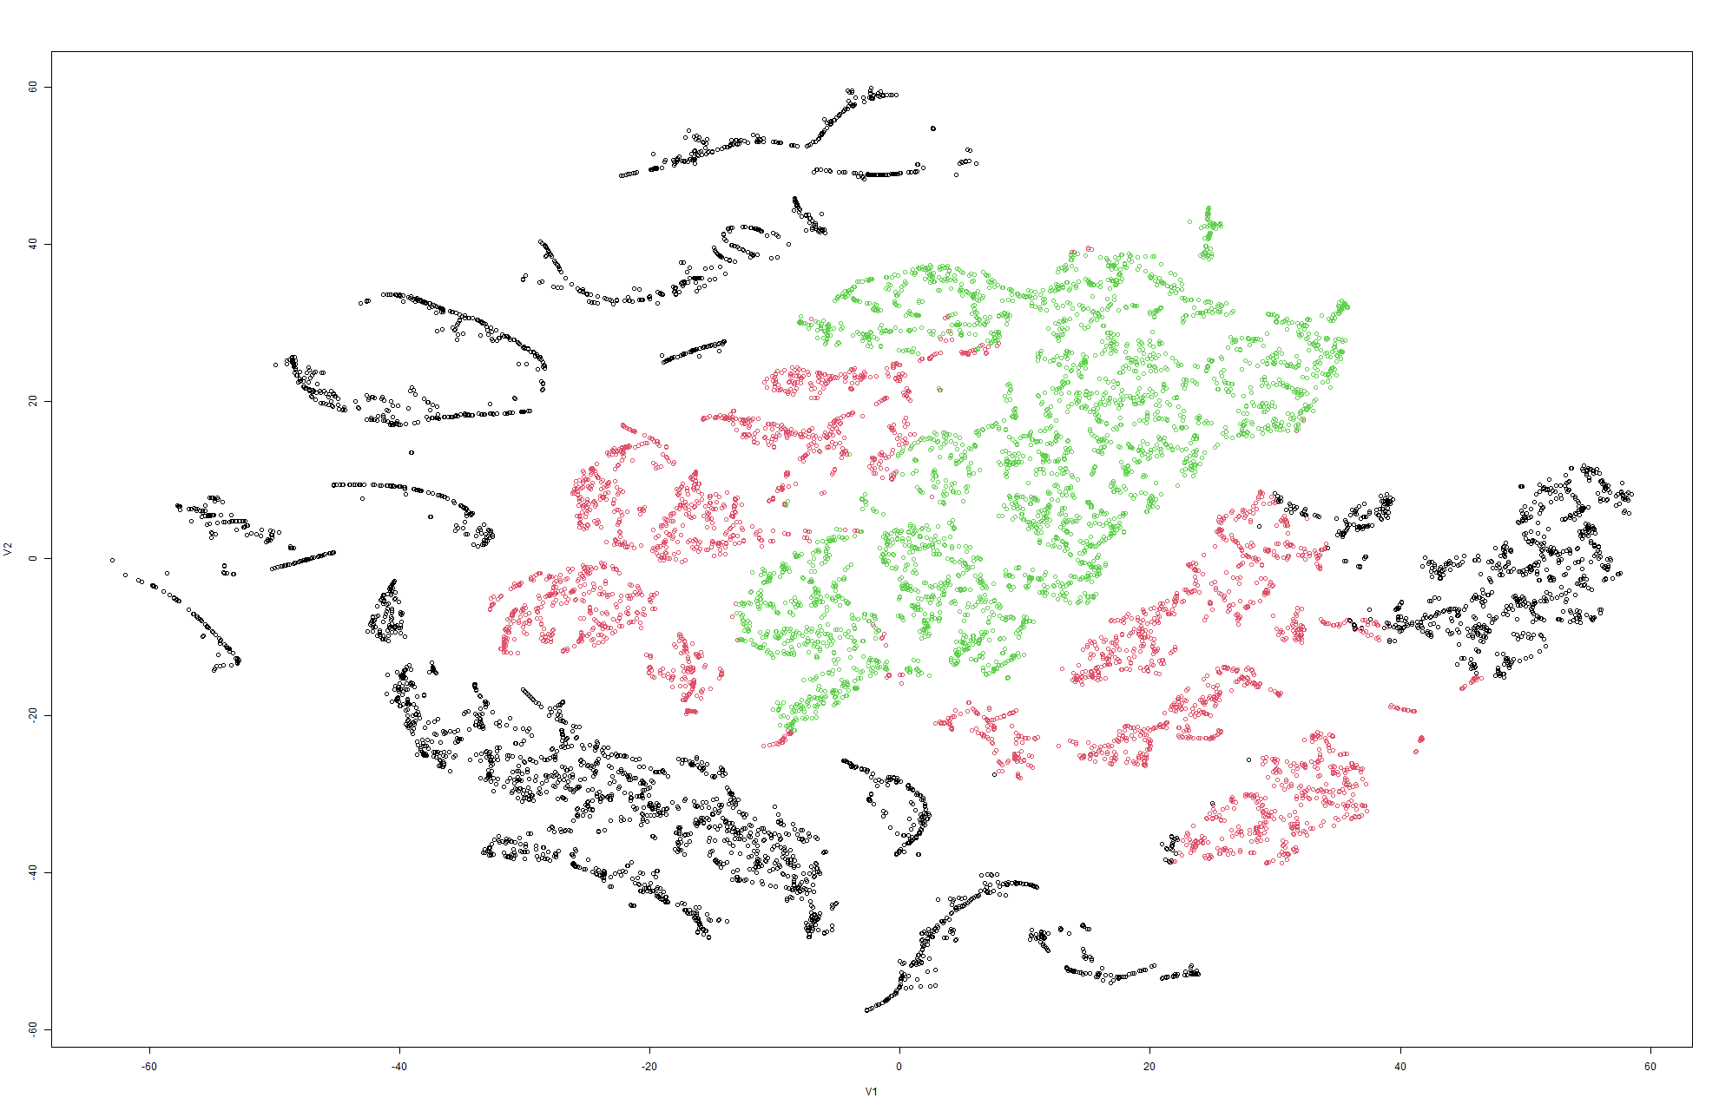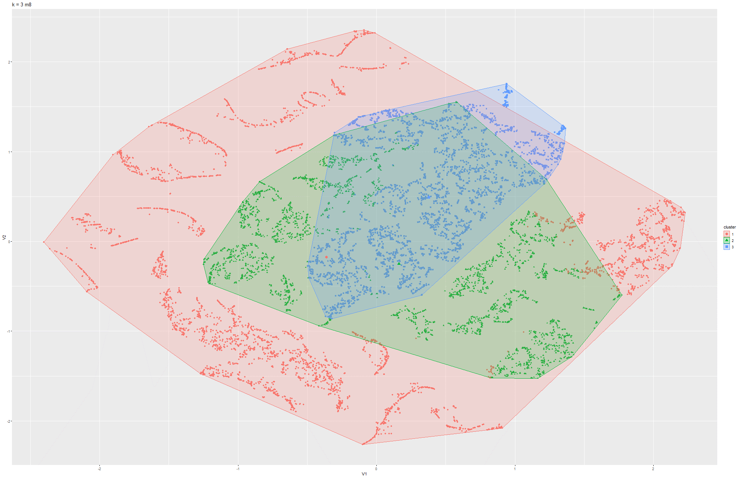Figure 93 & 94 k-means t-SNE on Model 8

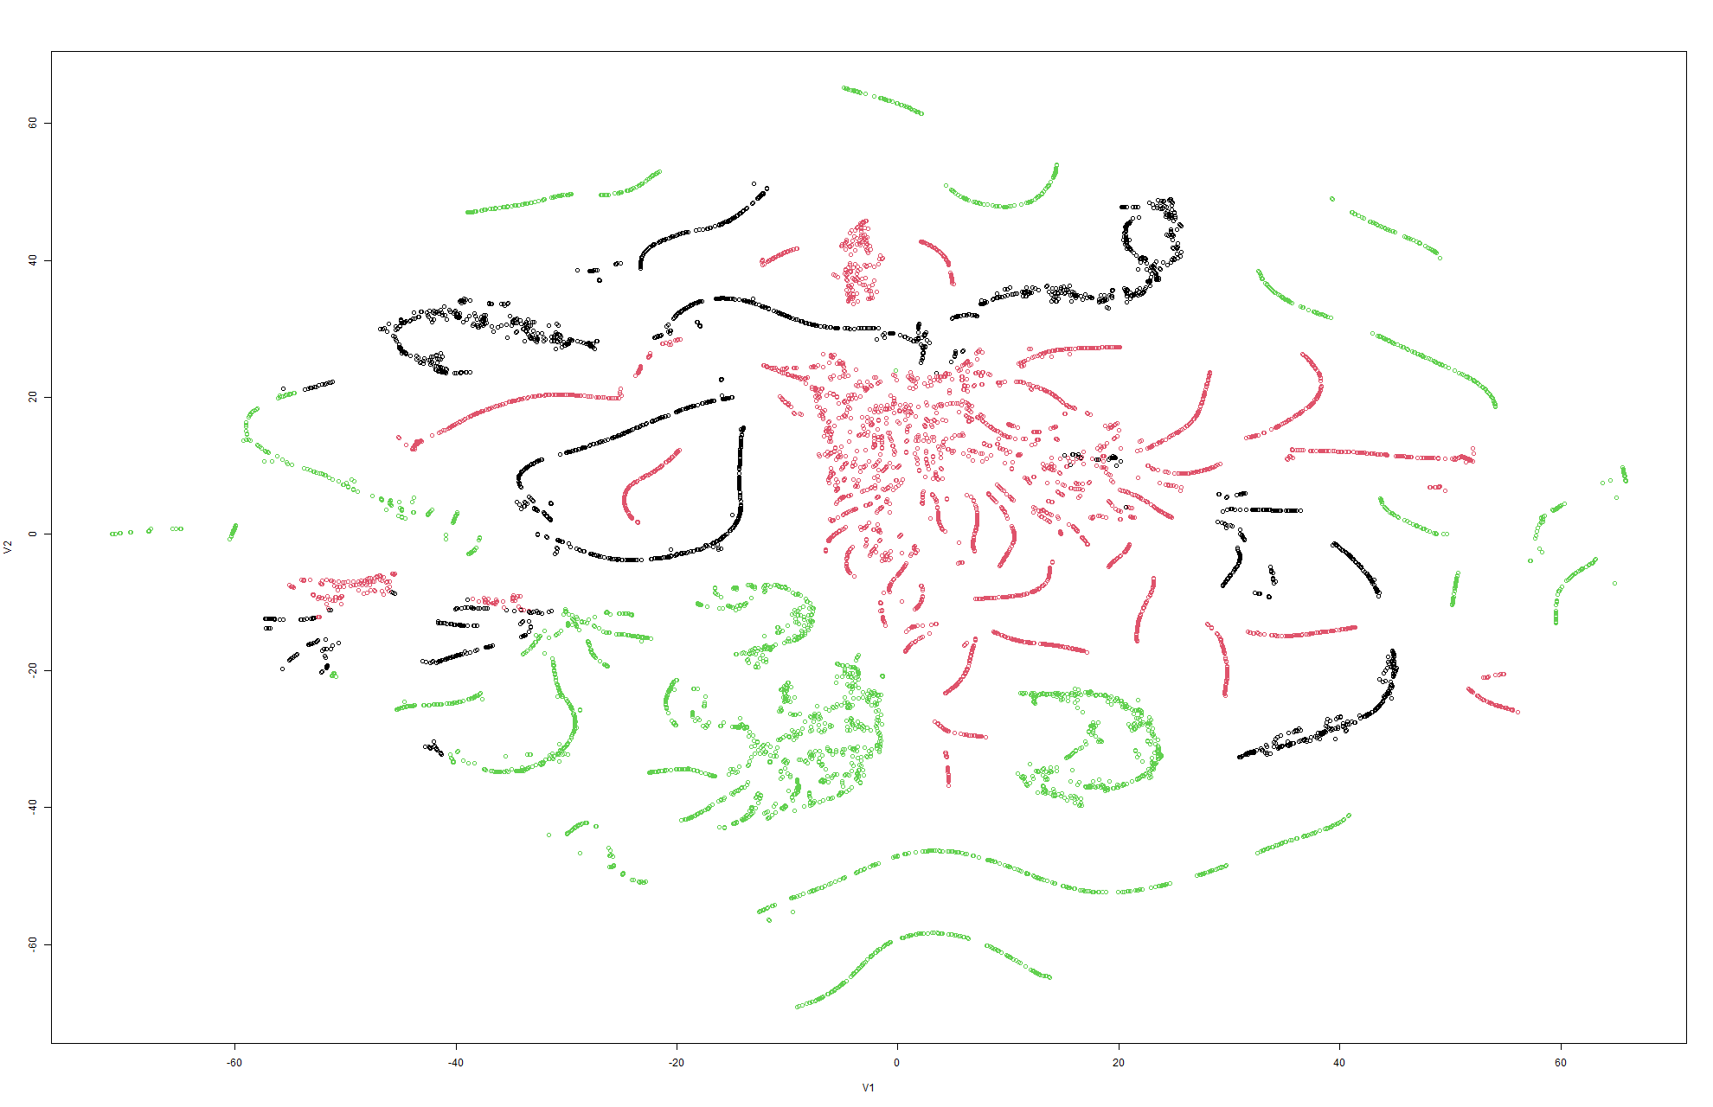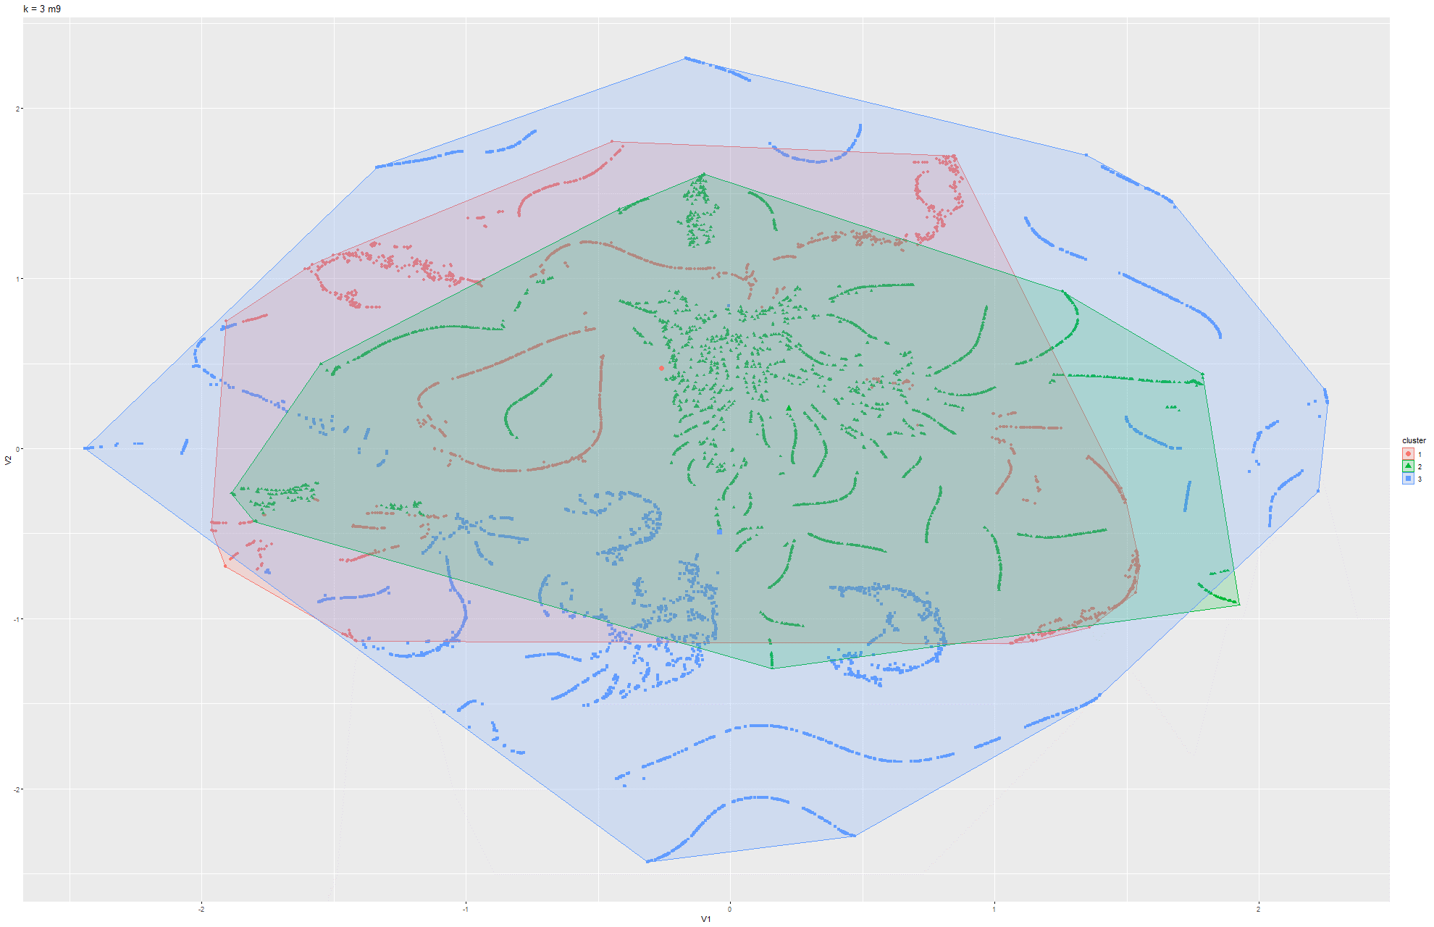Figure 95 & 96 k-means t-SNE on Model 9

Model 4:

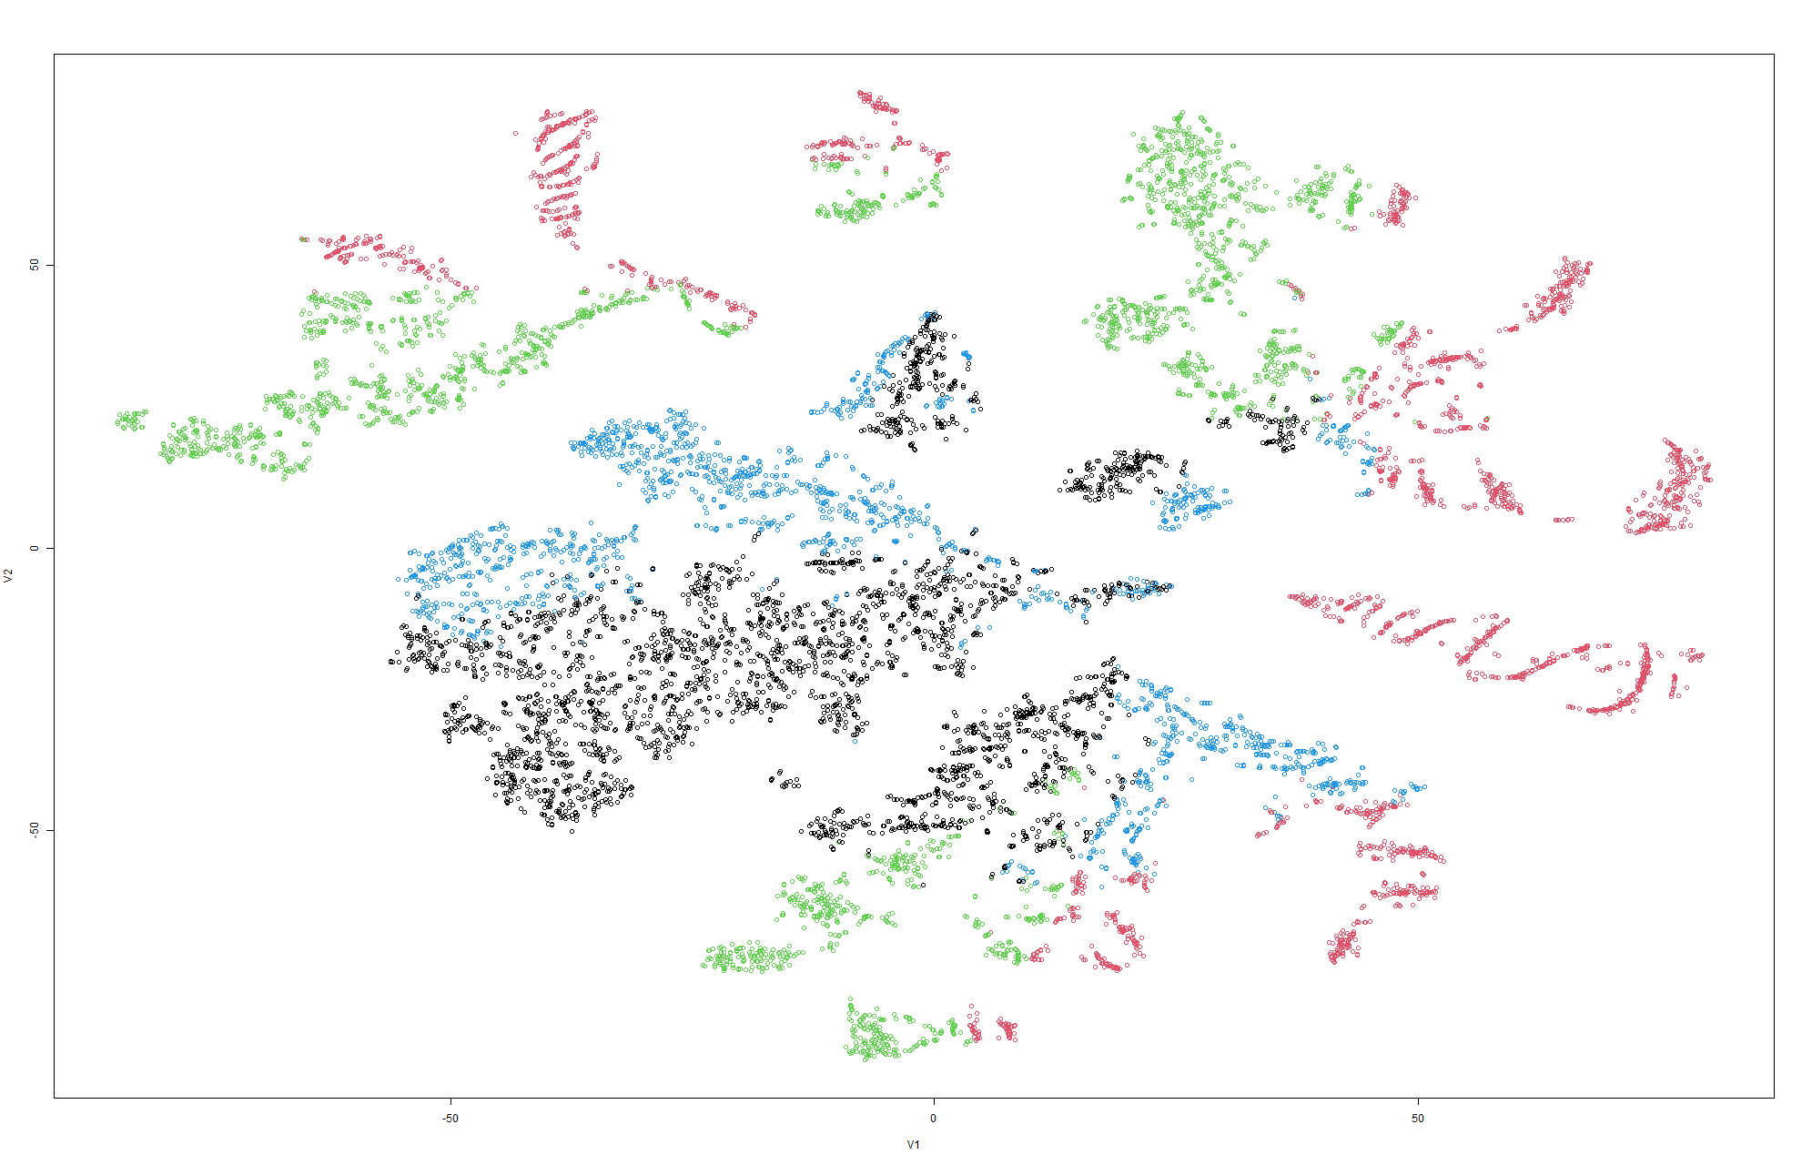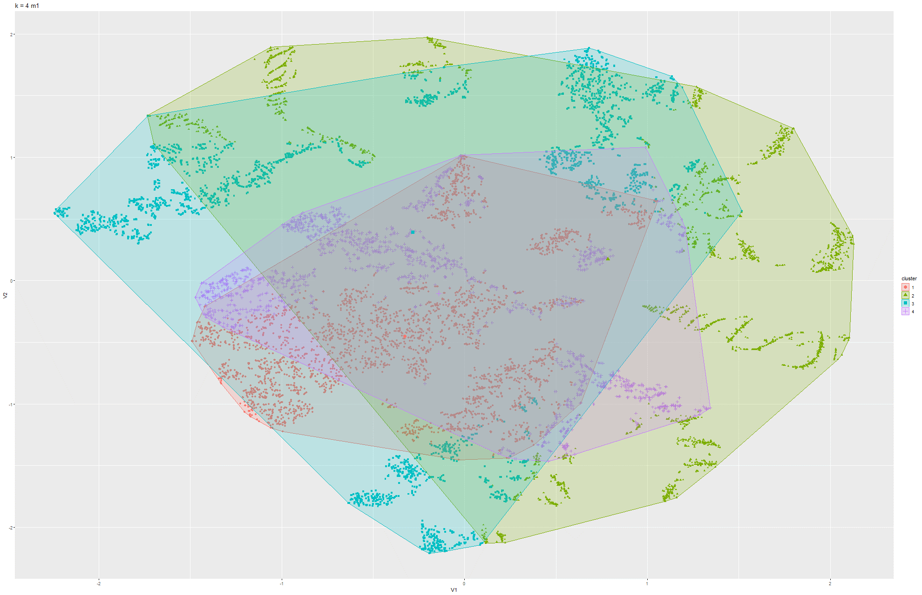Figure 97 & 98 k-means t-SNE on Model 1

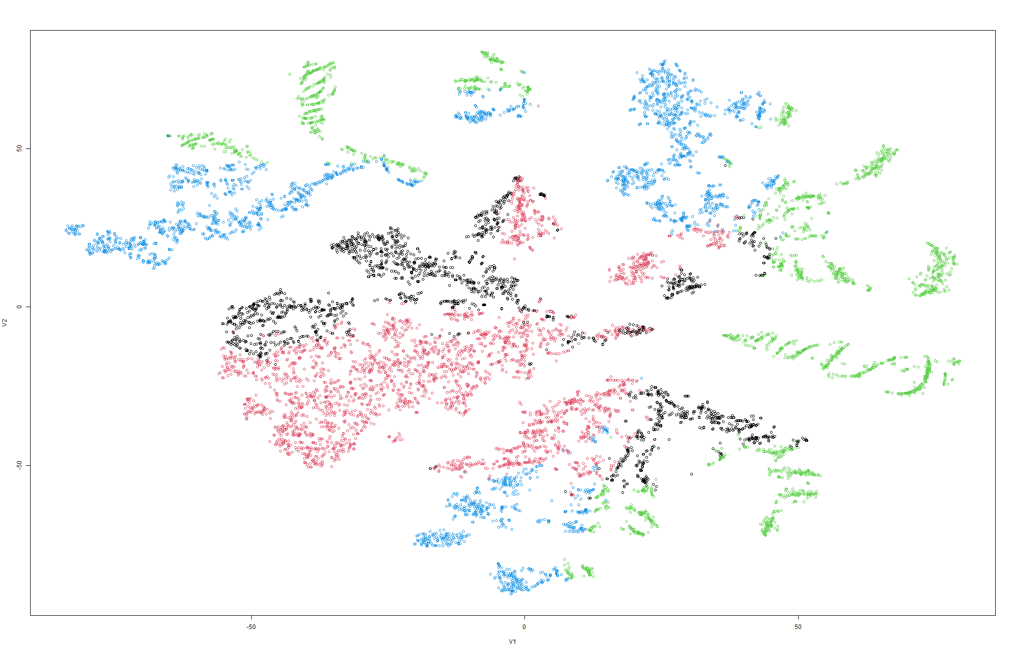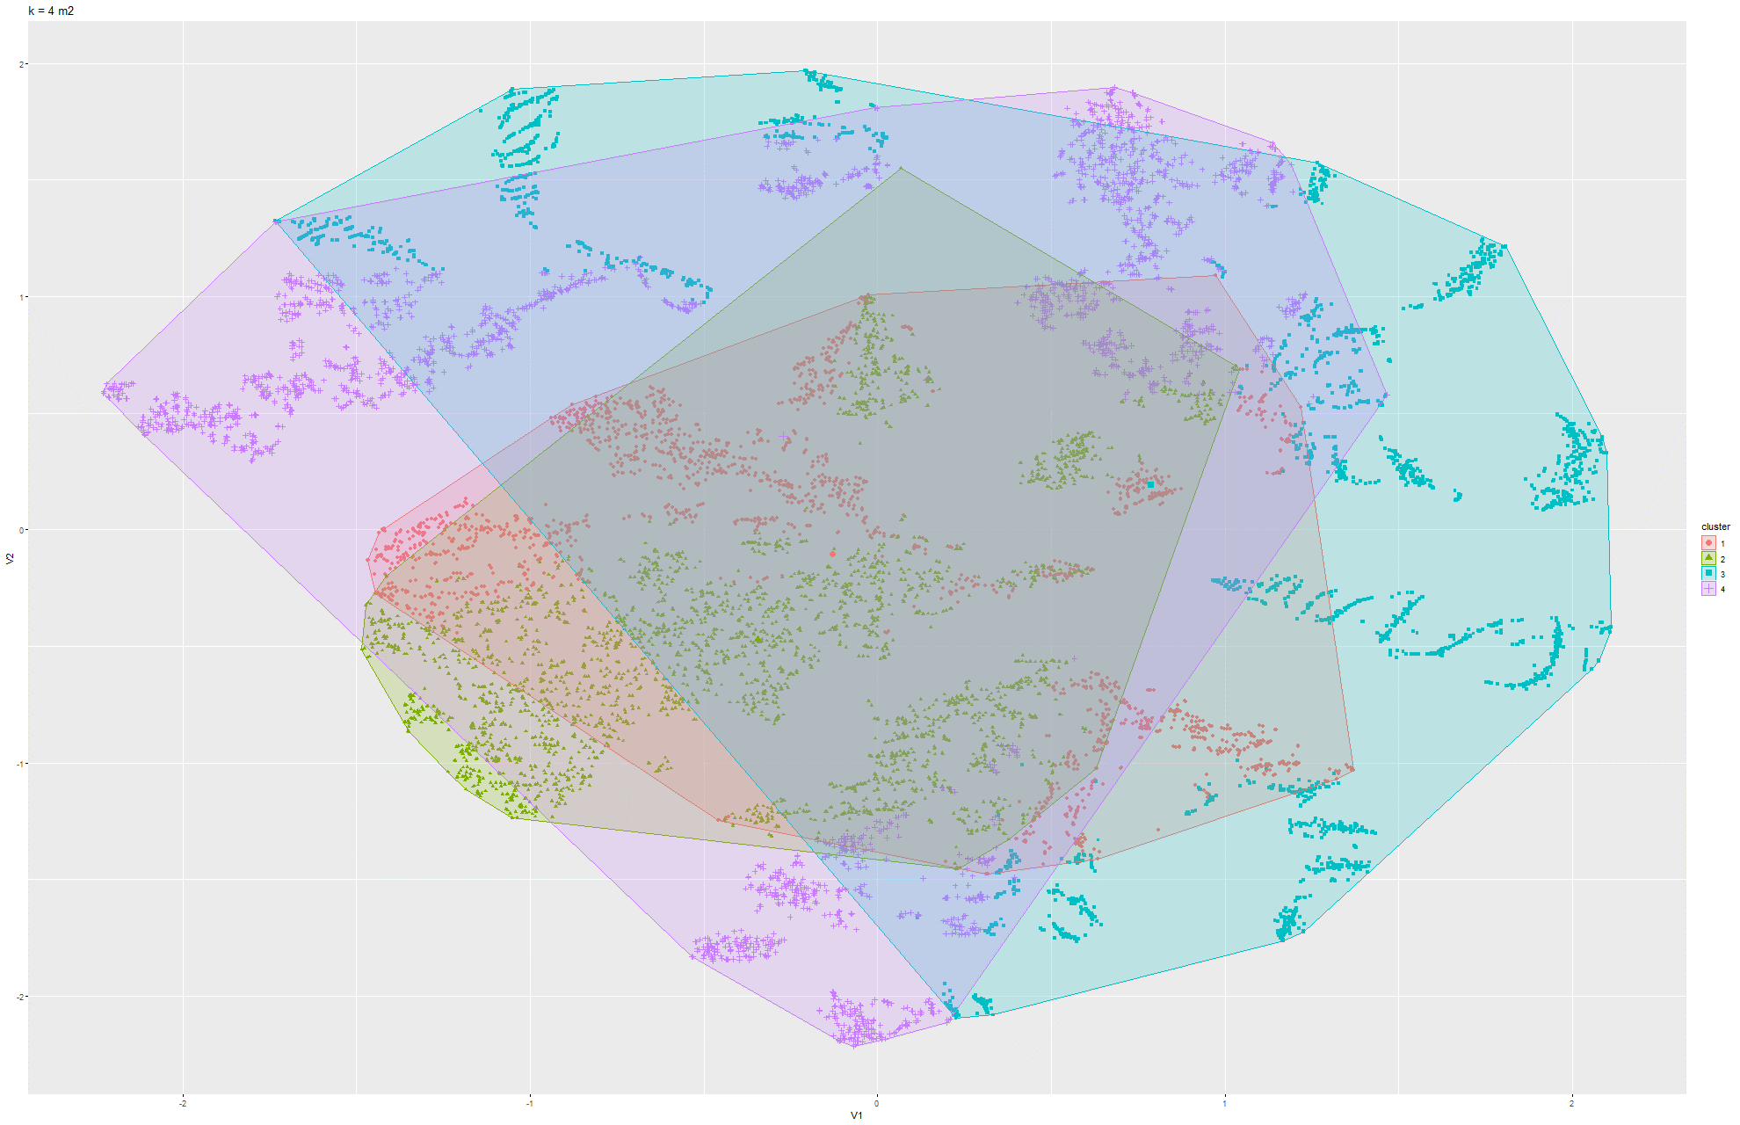Figure 99 & 100 k-means t-SNE on Model 2

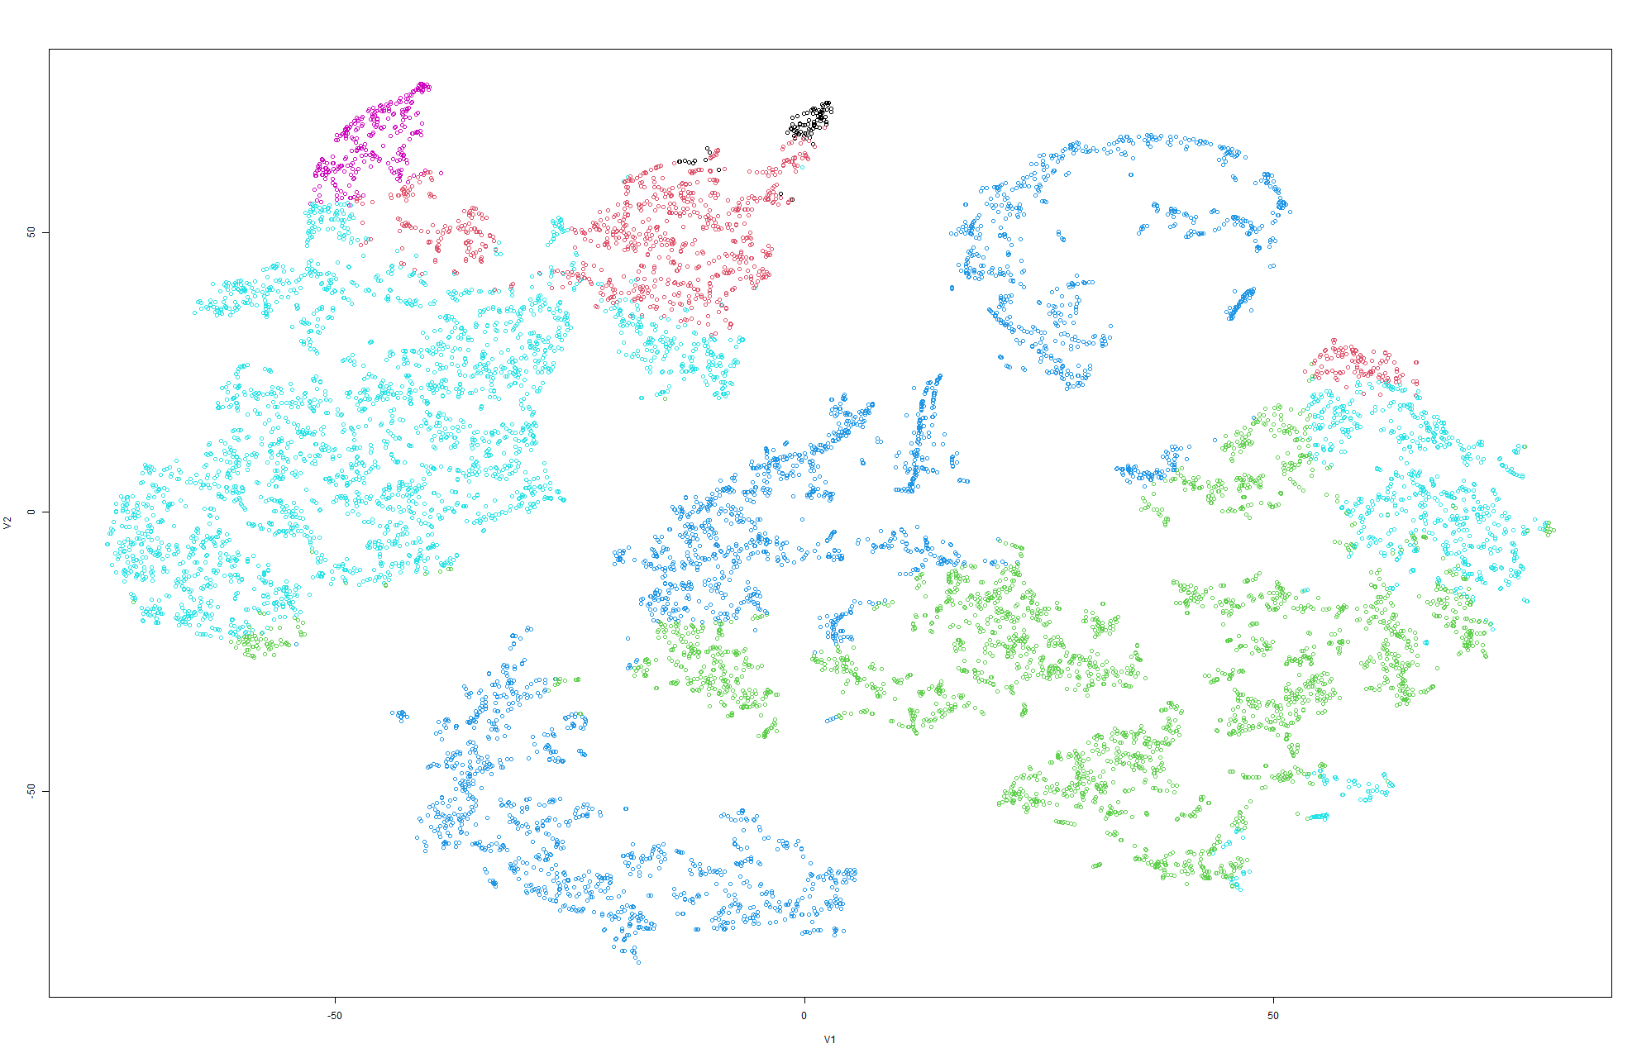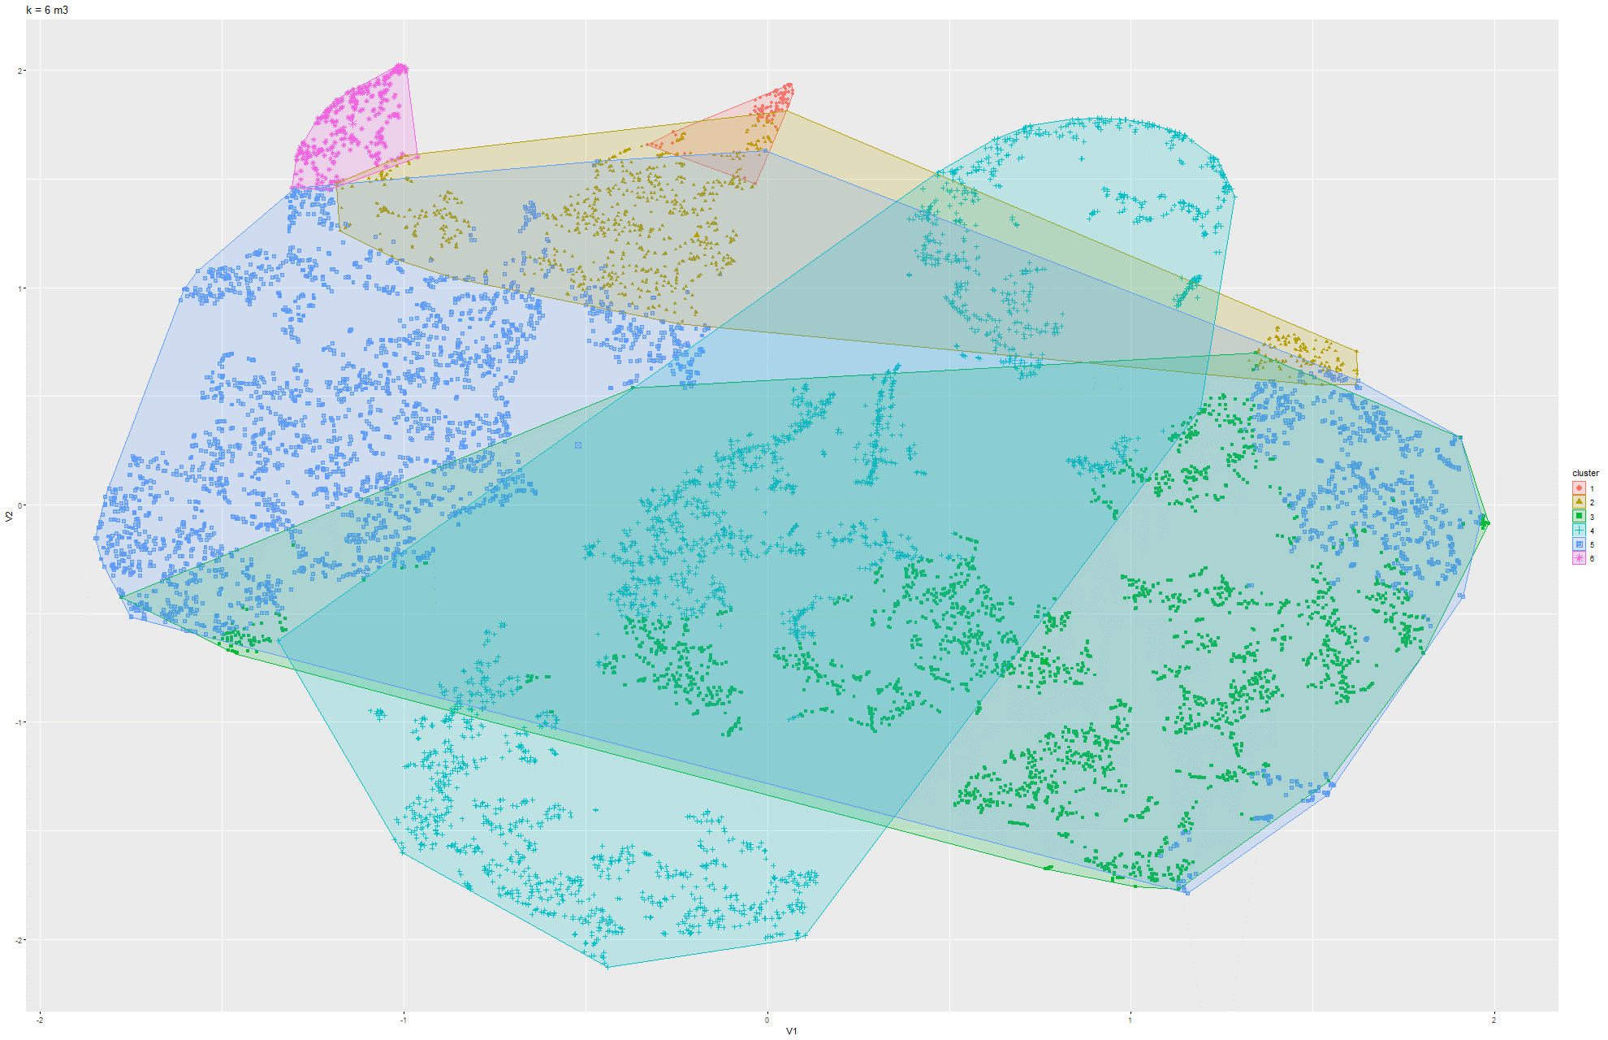Figure 101 & 102 k-means t-SNE on Model 3

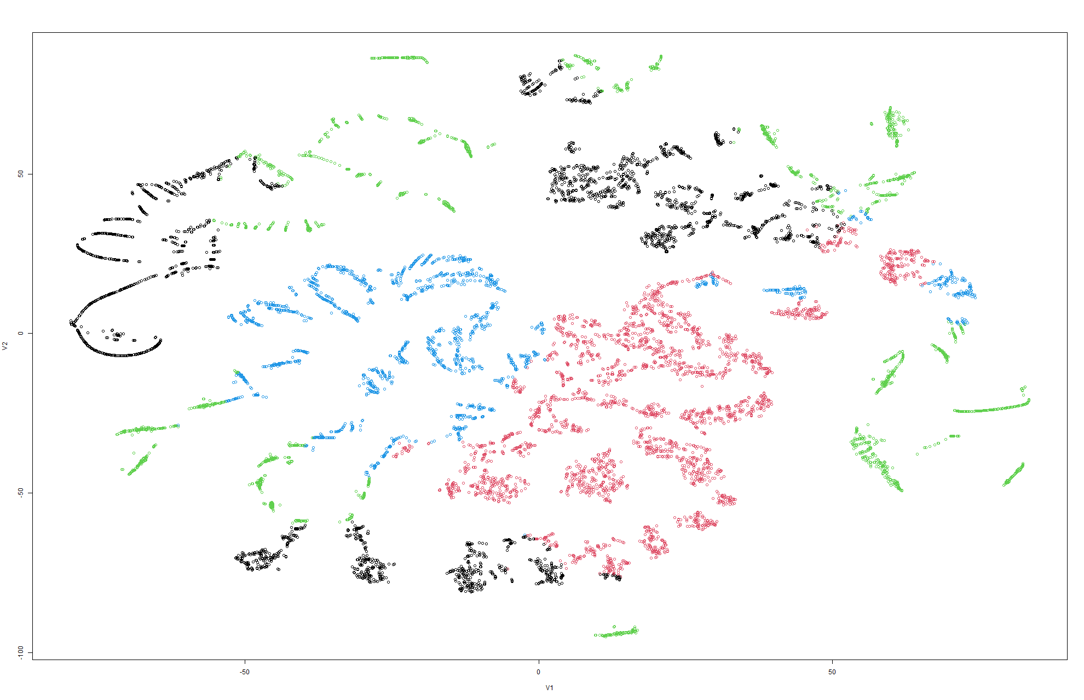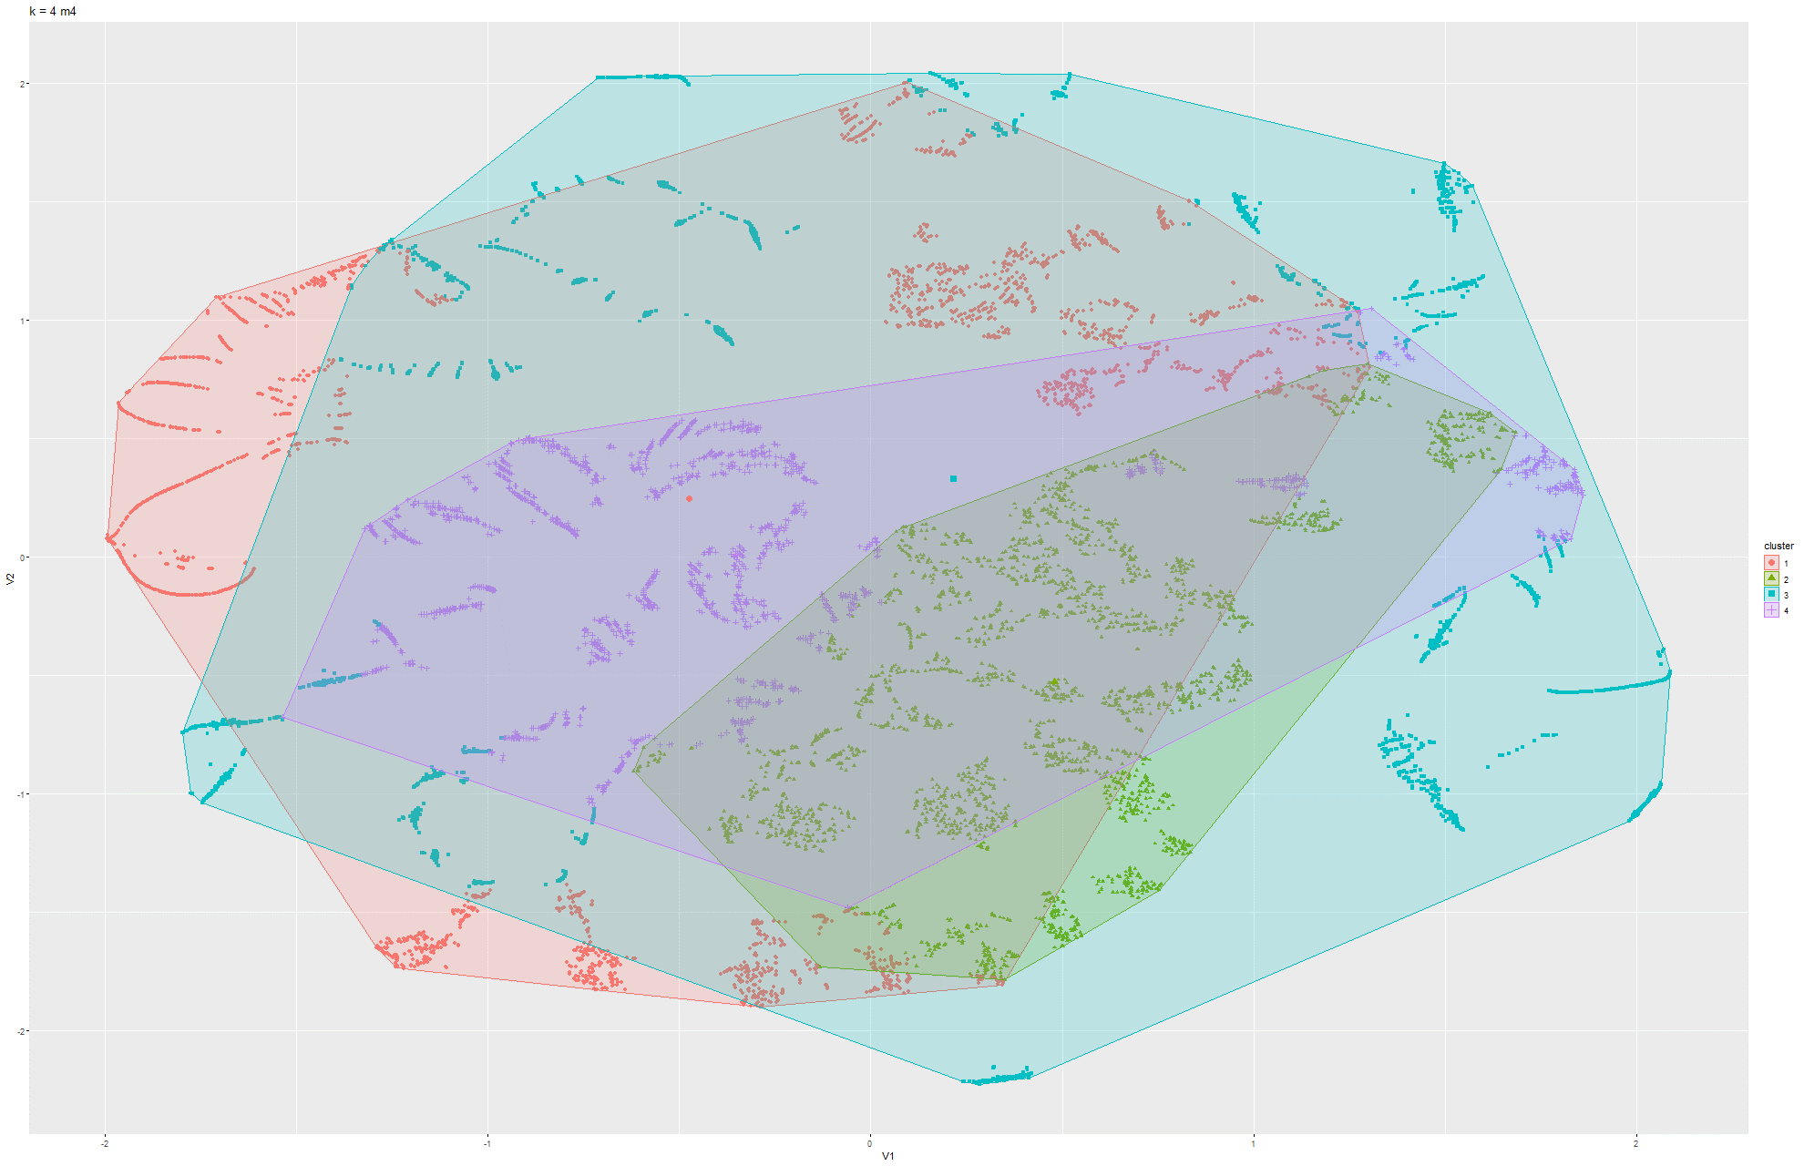Figure 103 & 104 k-means t-SNE on Model 4

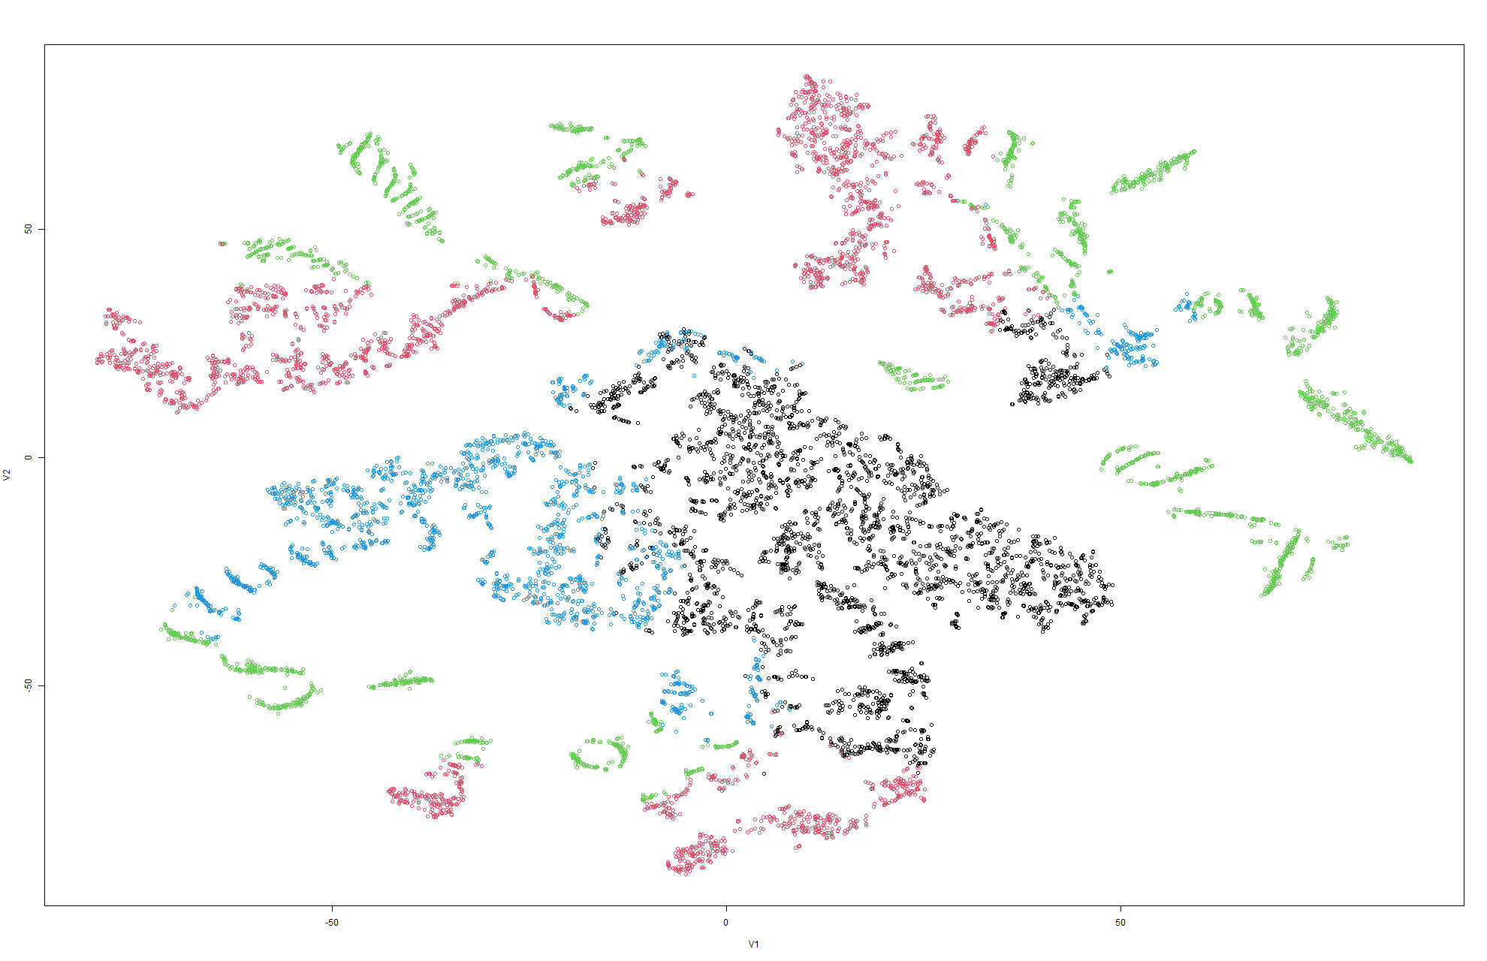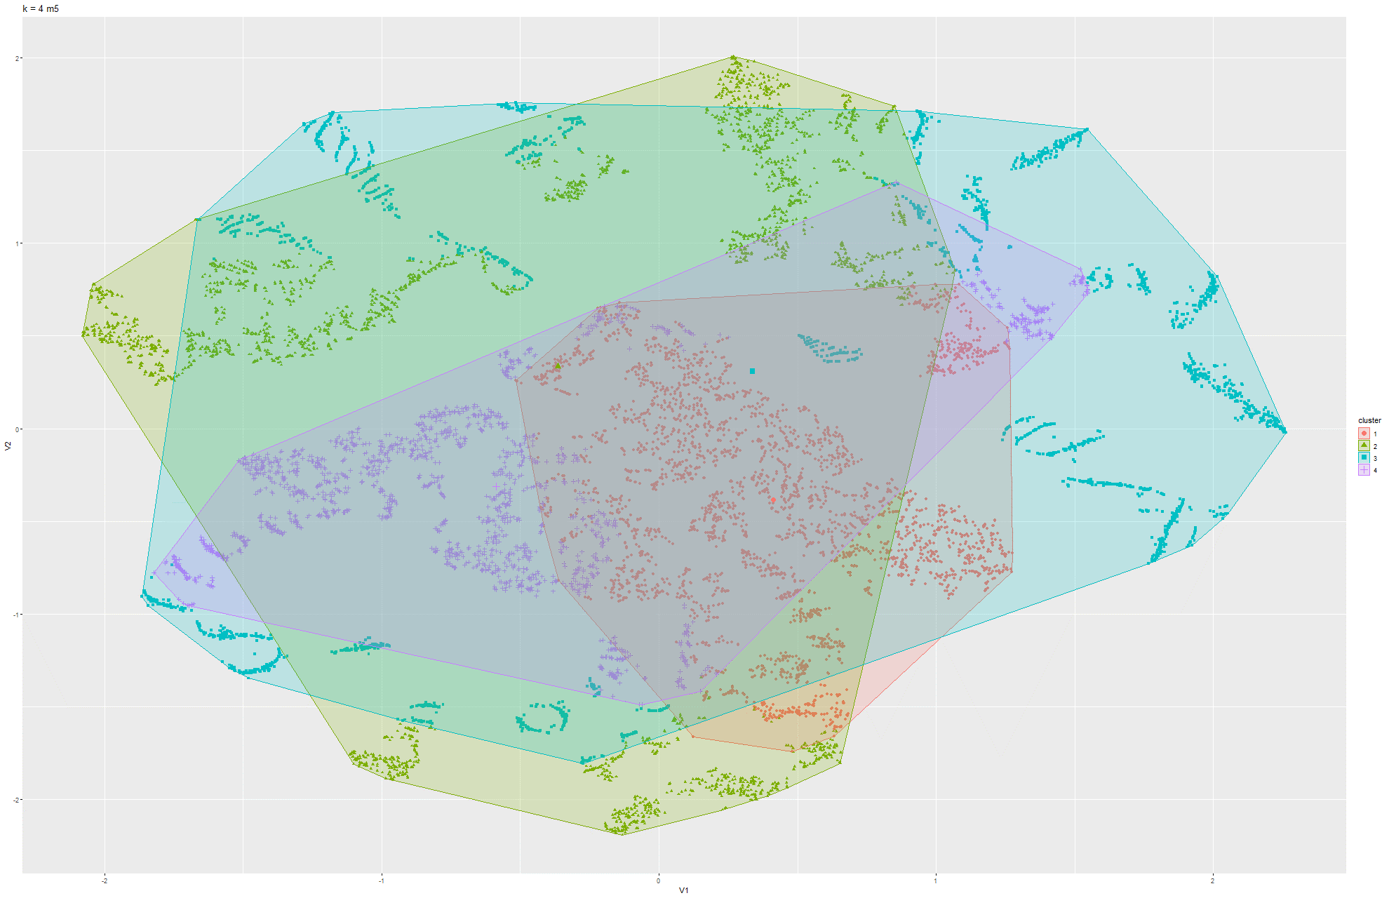Figure 105 & 106 k-means t-SNE on Model 5

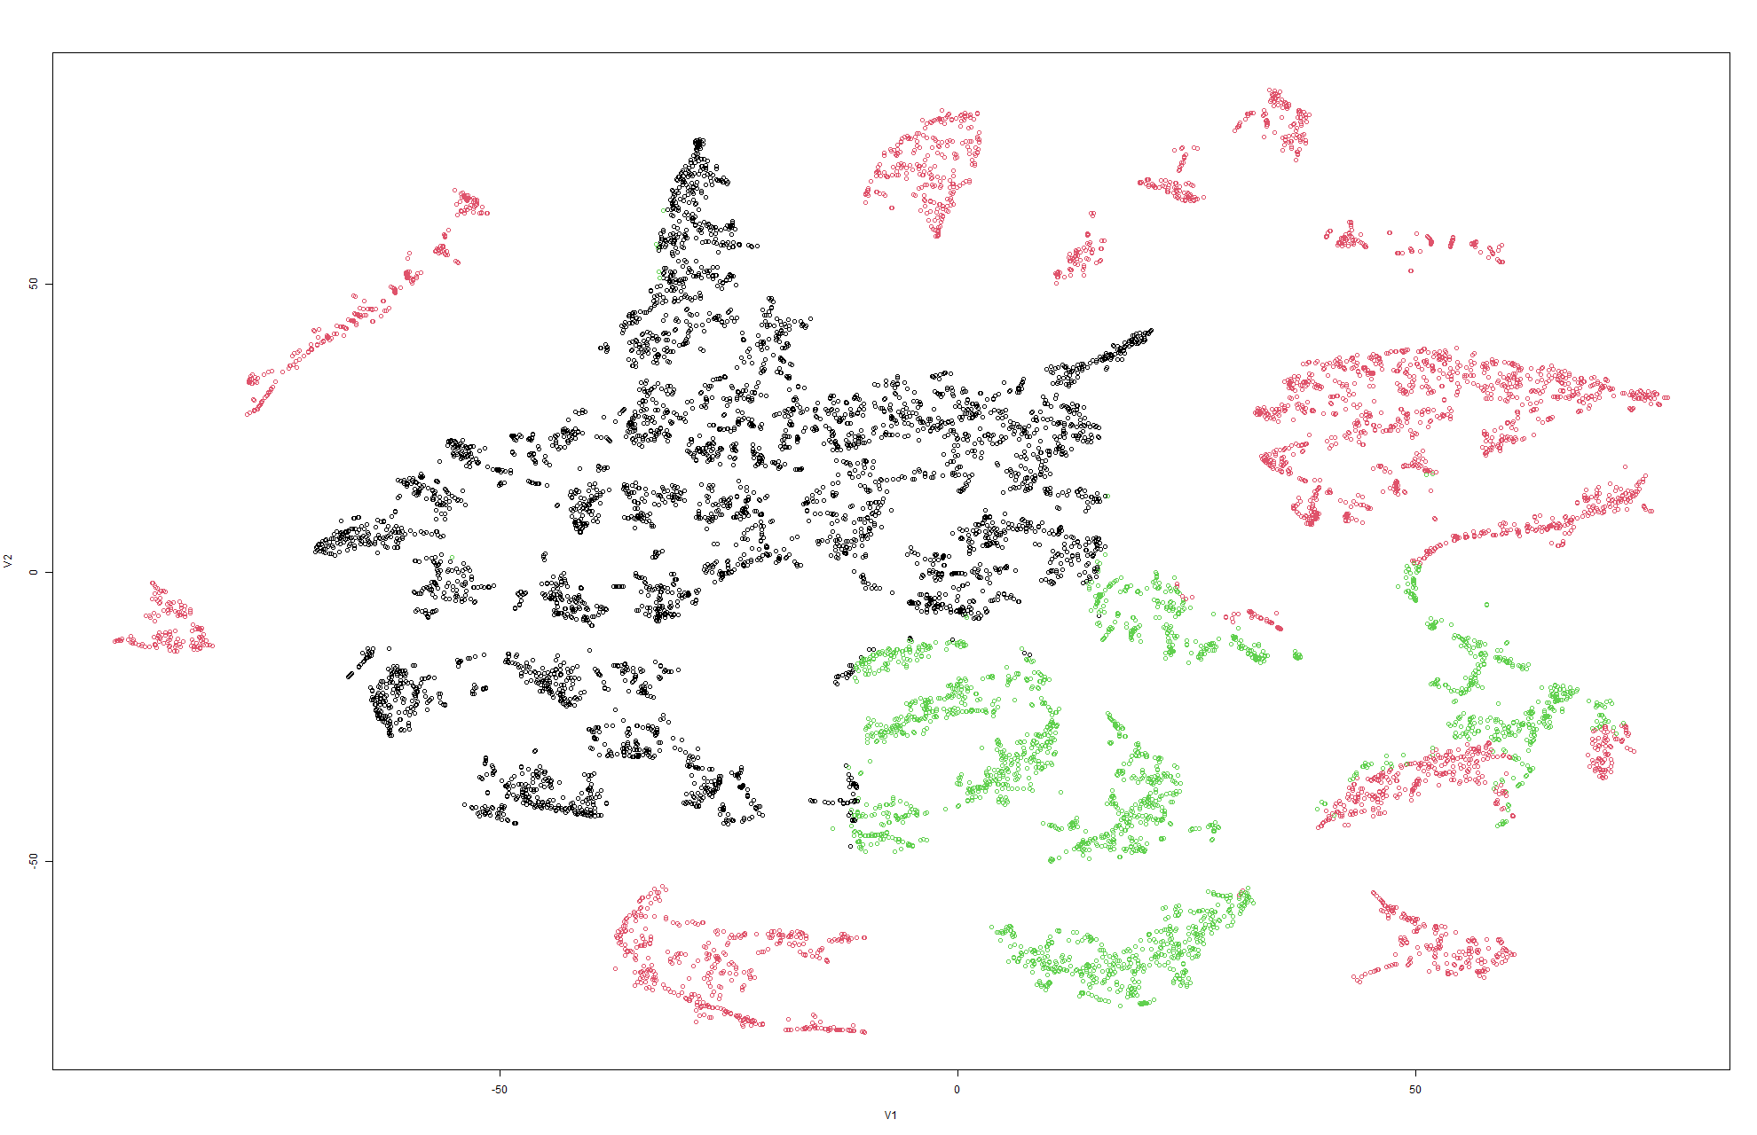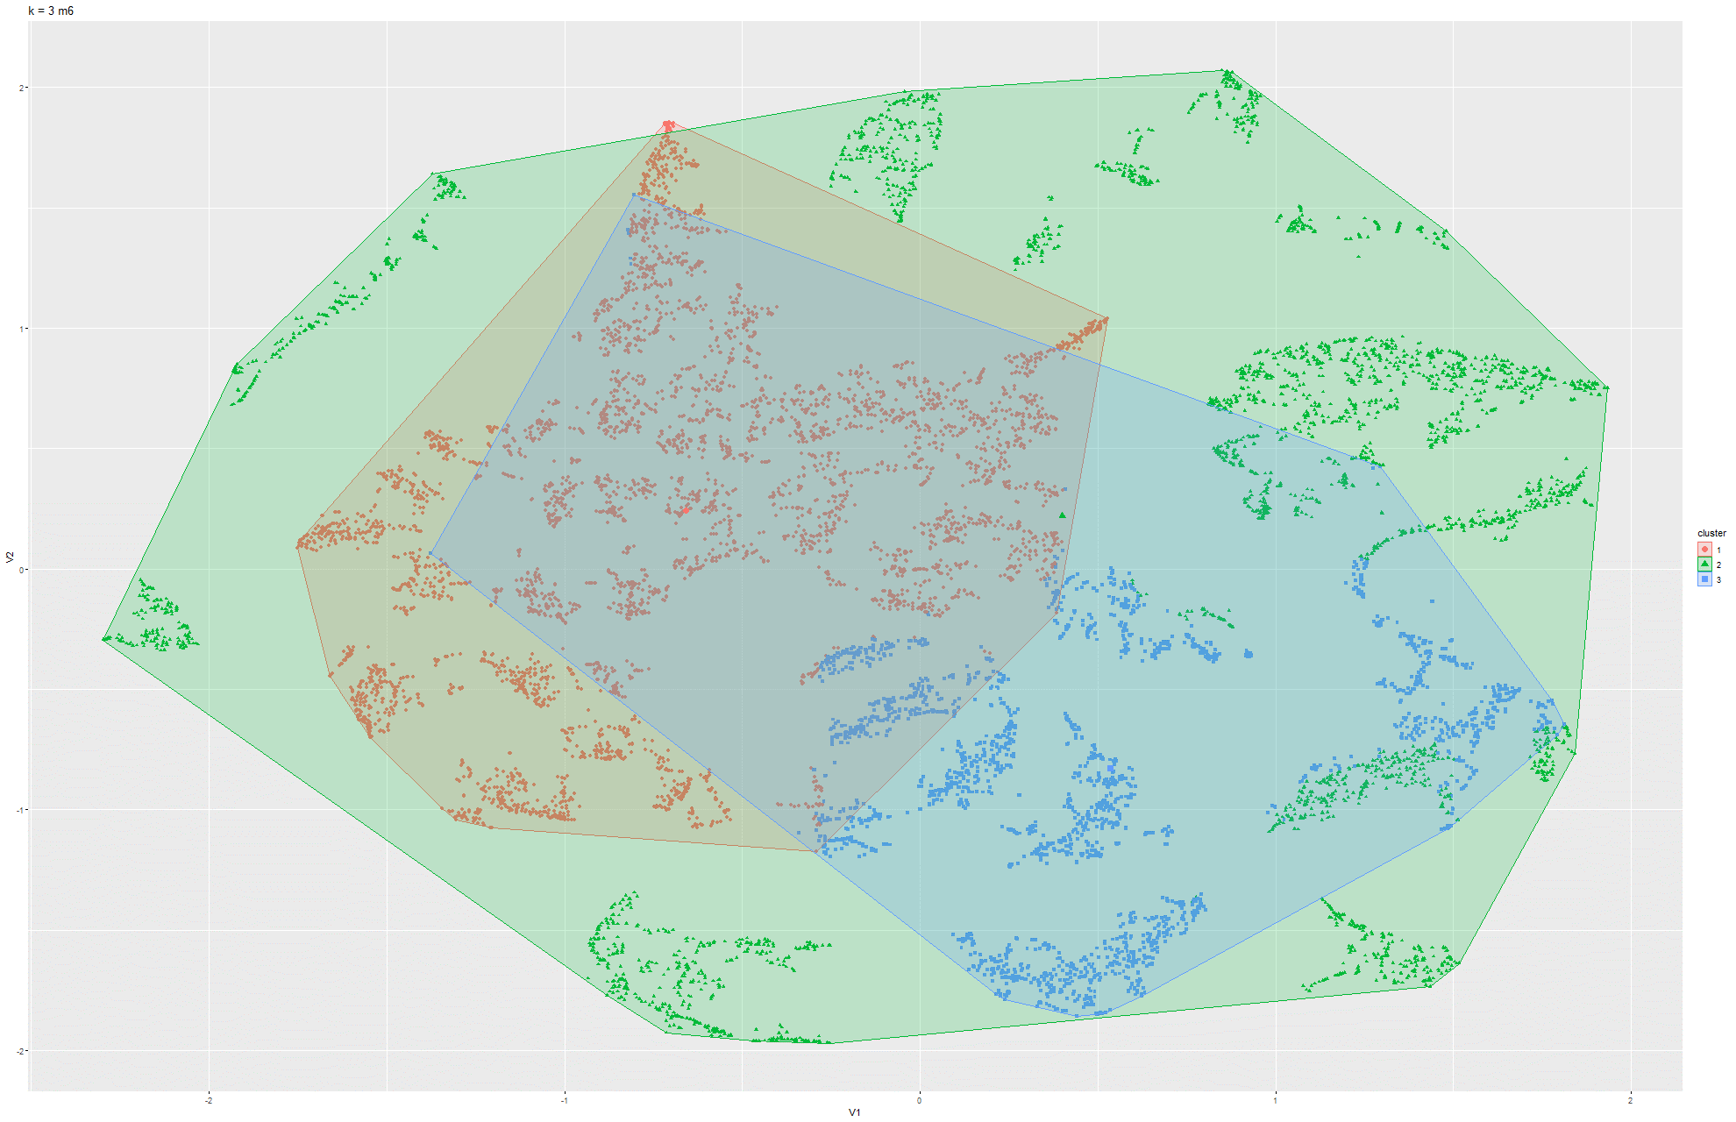Figure 107 & 108 k-means t-SNE on Model 6

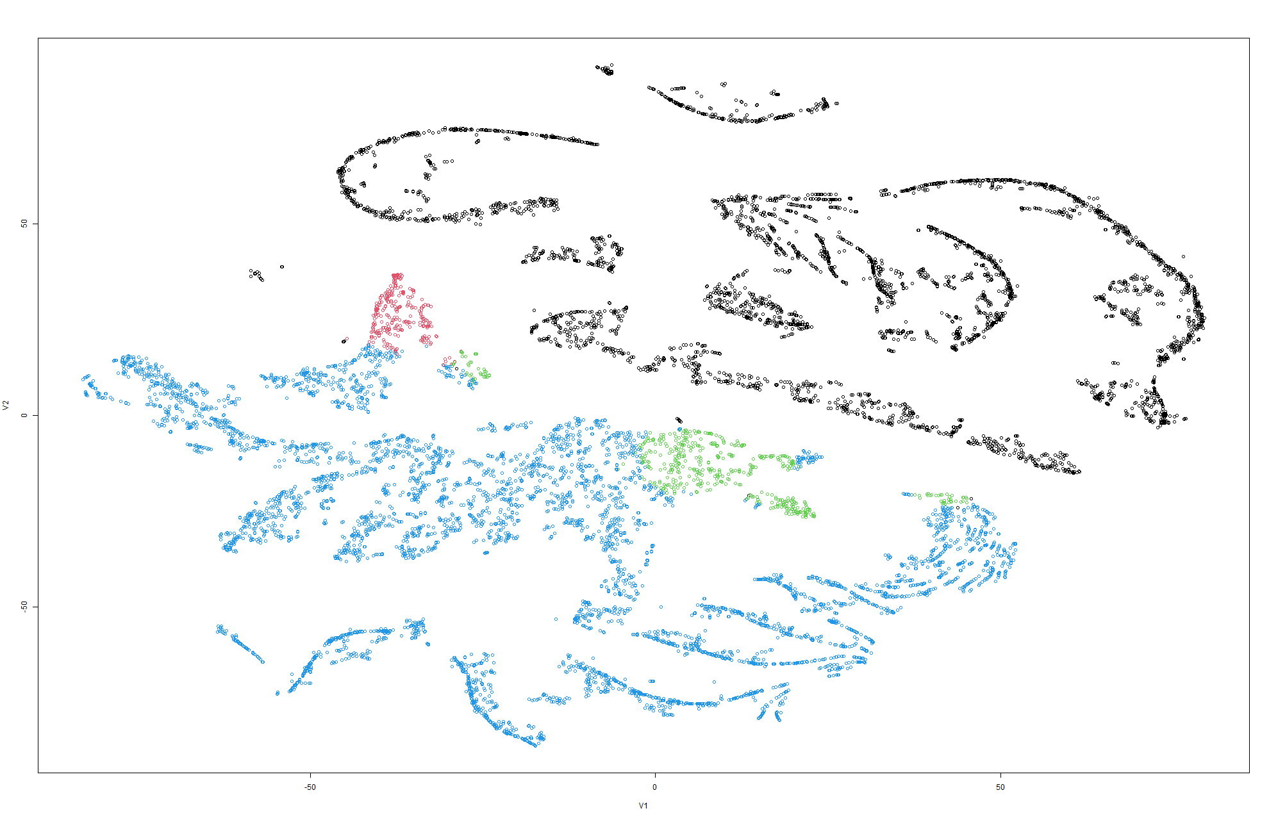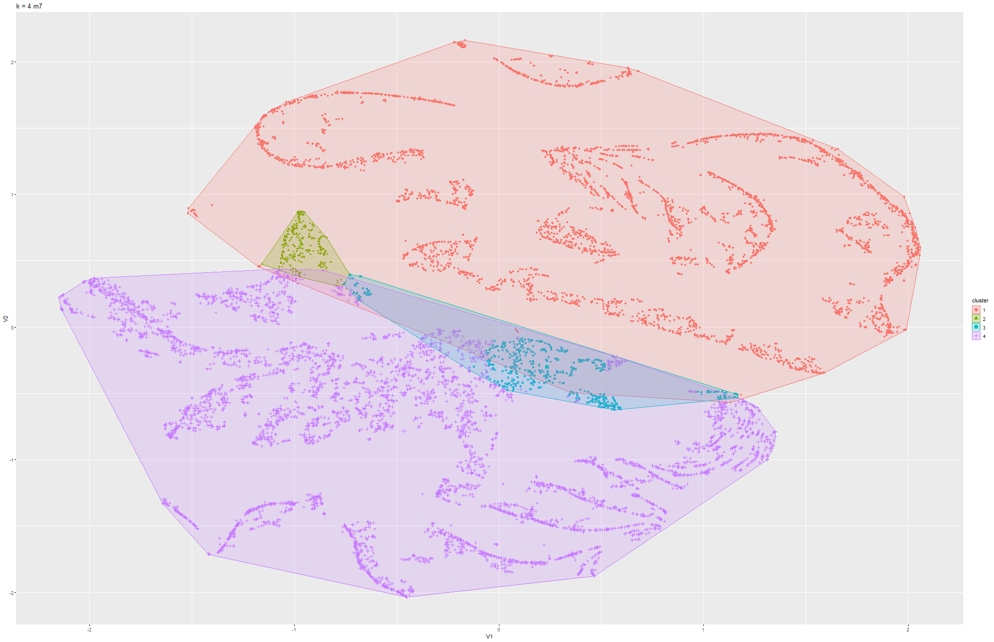Figure 109 & 110 k-means t-SNE on Model 7

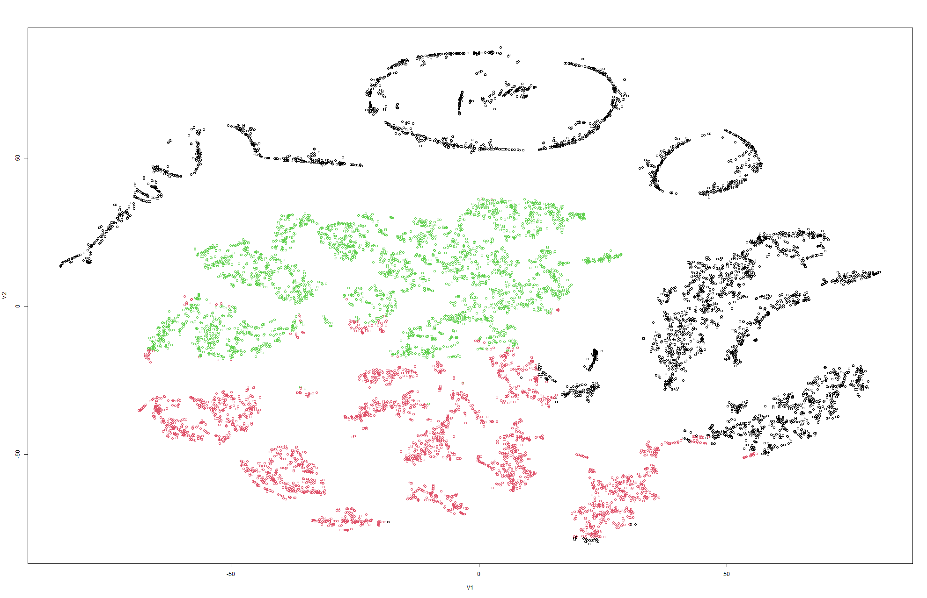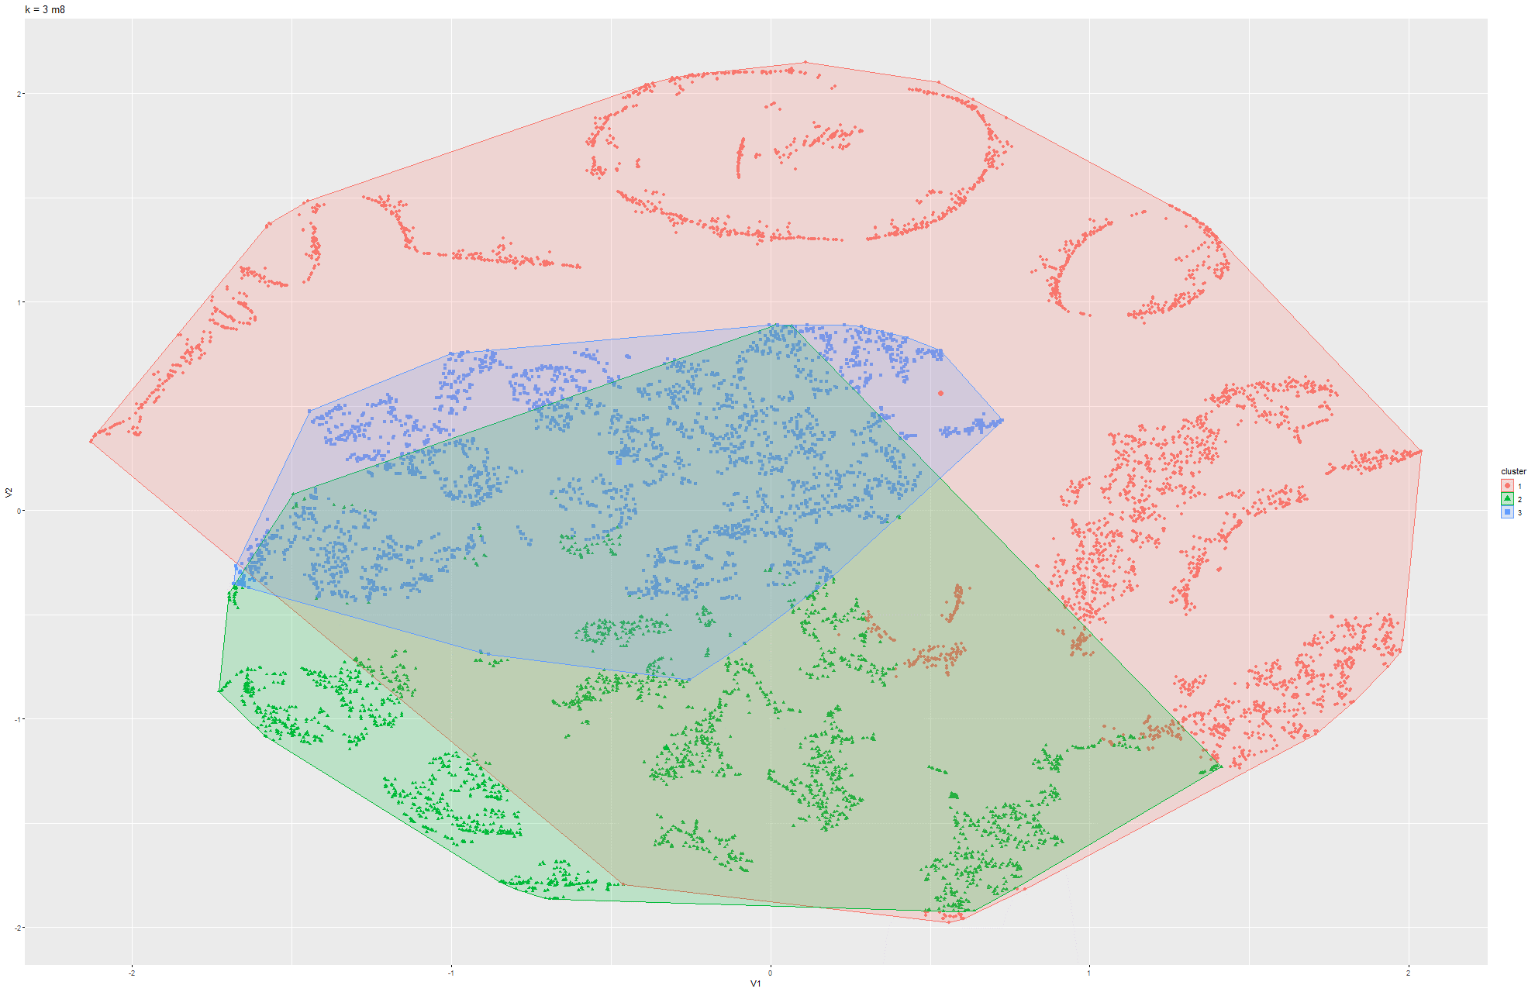Figure 111 & 112 k-means t-SNE on Model 8

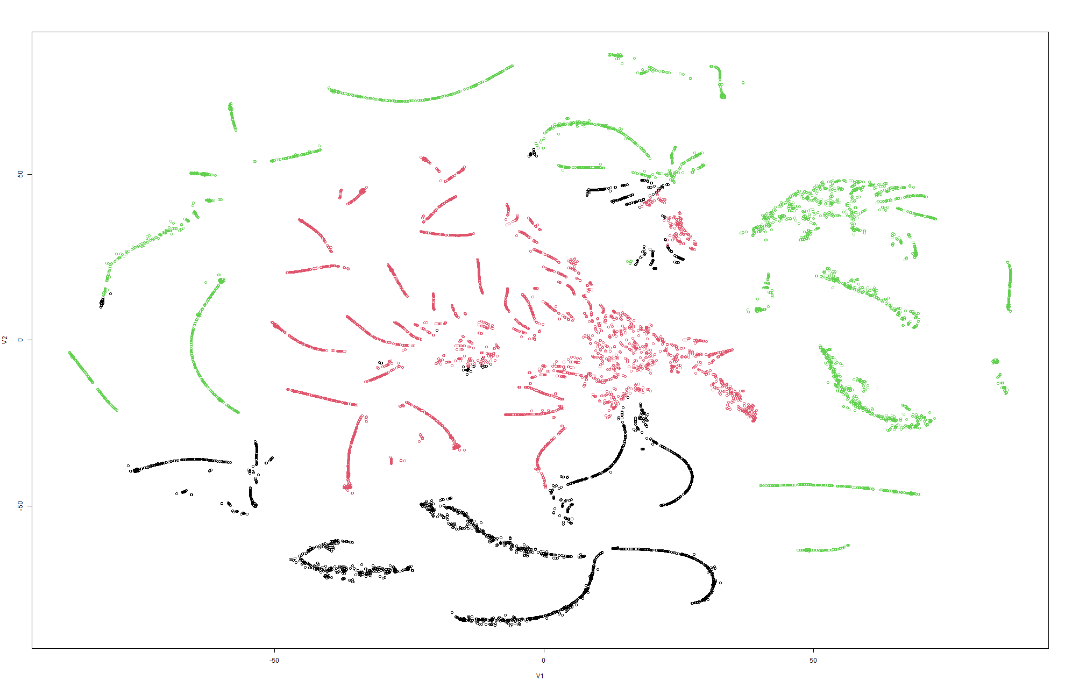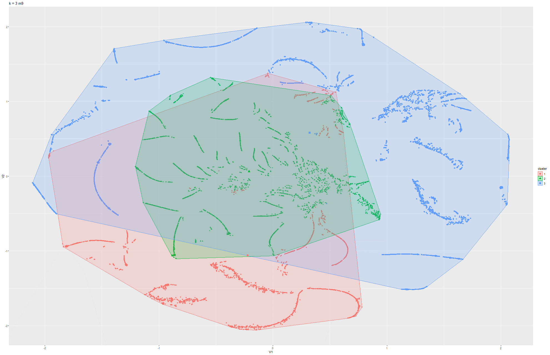Figure 113 & 114 k-means t-SNE on Model 9

### 6.1.4 K-means on PCA

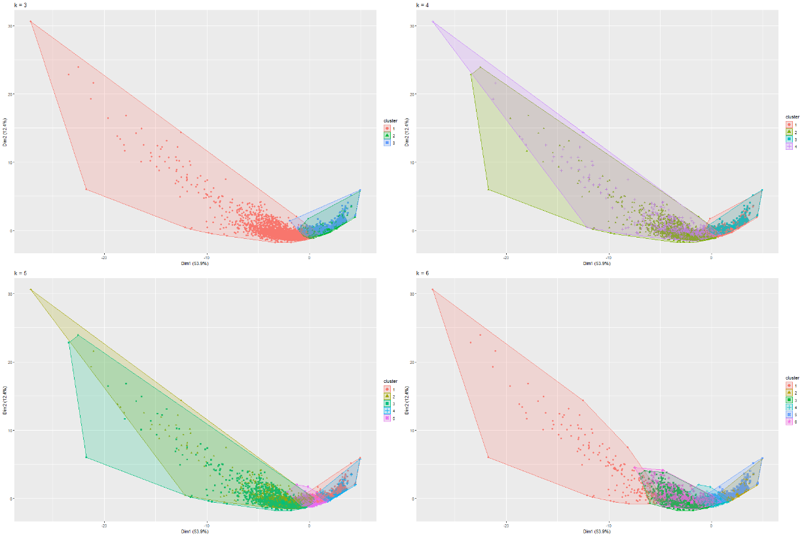

Figure 115 k-means PCA on Model 1

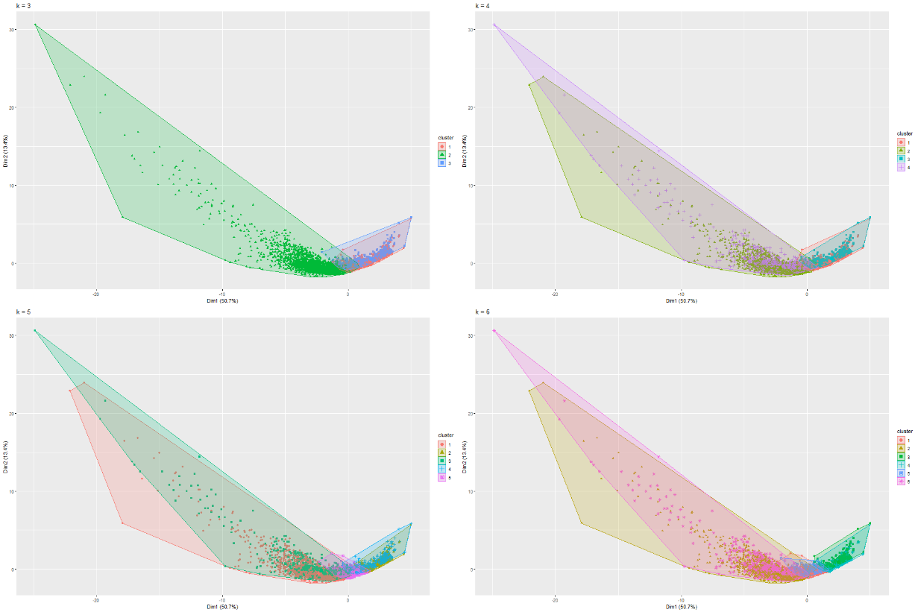

Figure 116 k-means PCA on Model 2

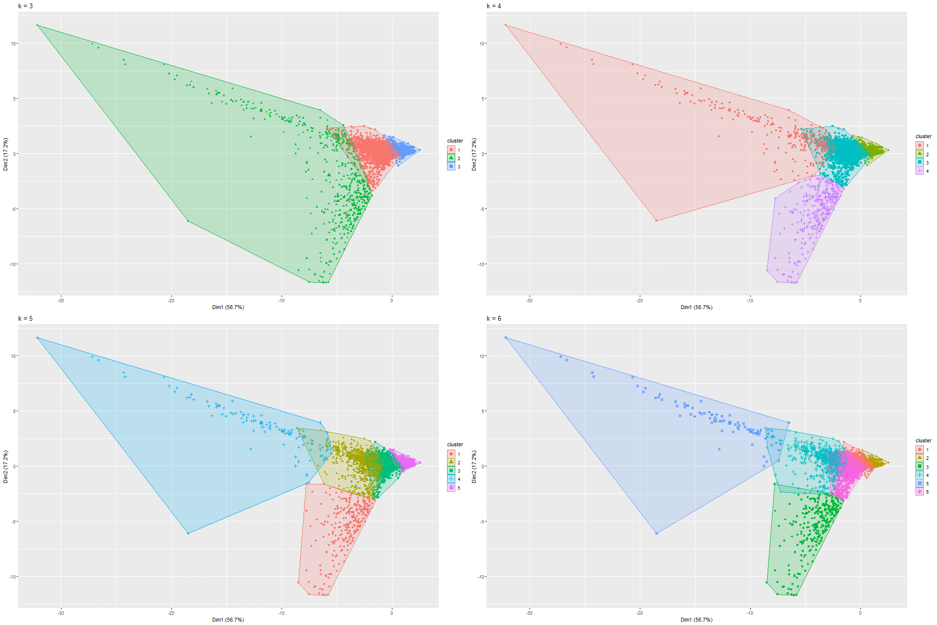

Figure 117 k-means PCA on Model 3

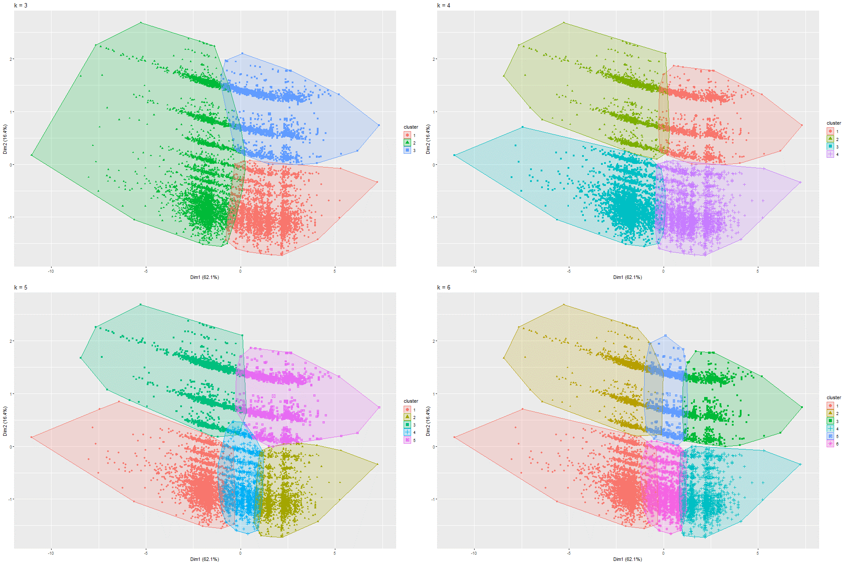

Figure 118 k-means PCA on Model 4

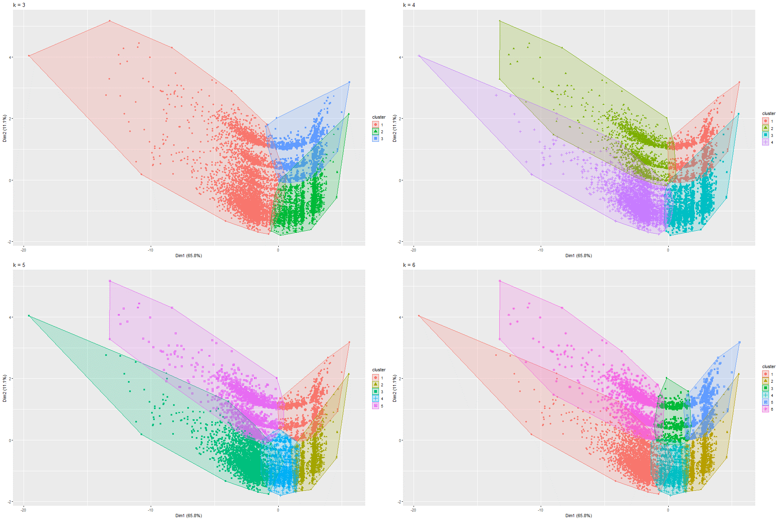

Figure 119 k-means PCA on Model 5

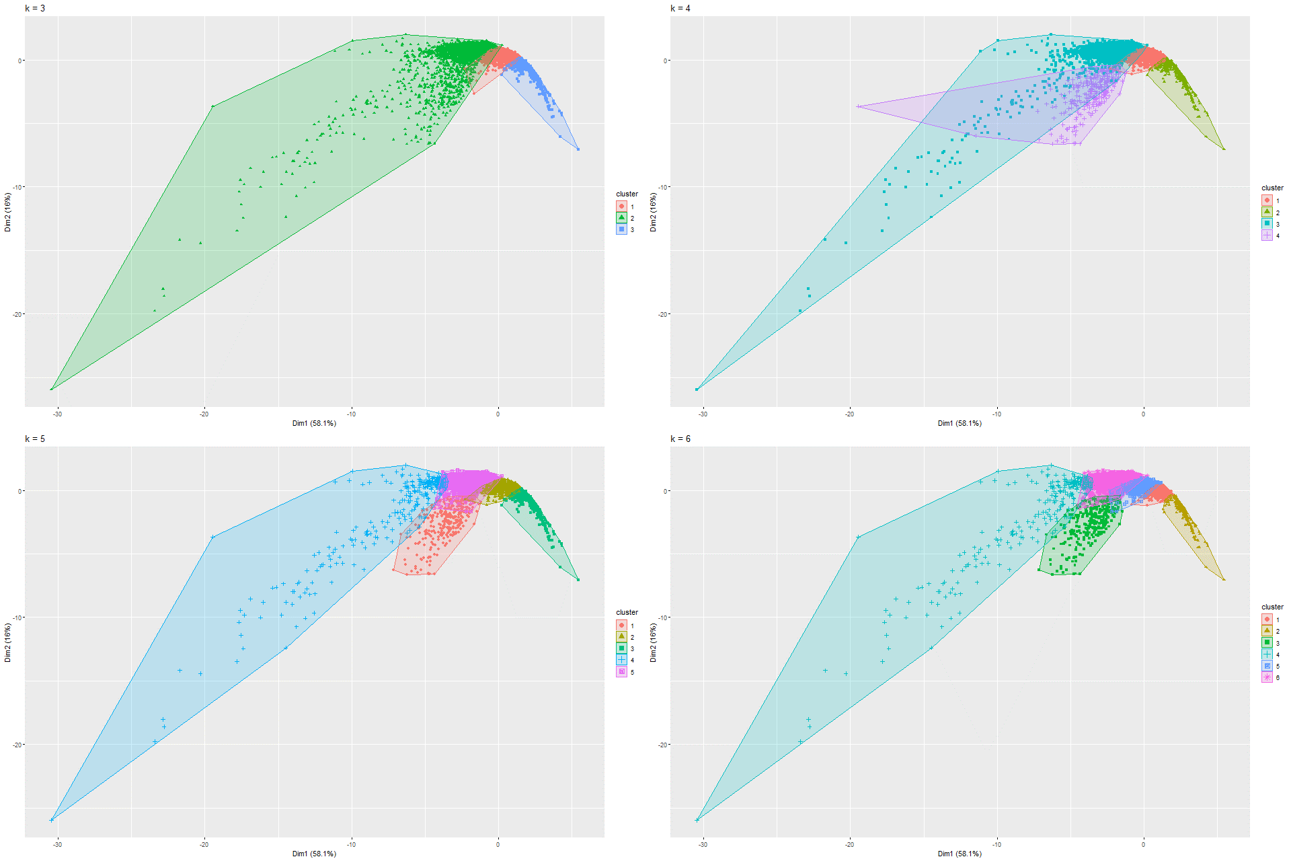

Figure 120 k-means PCA on Model 6

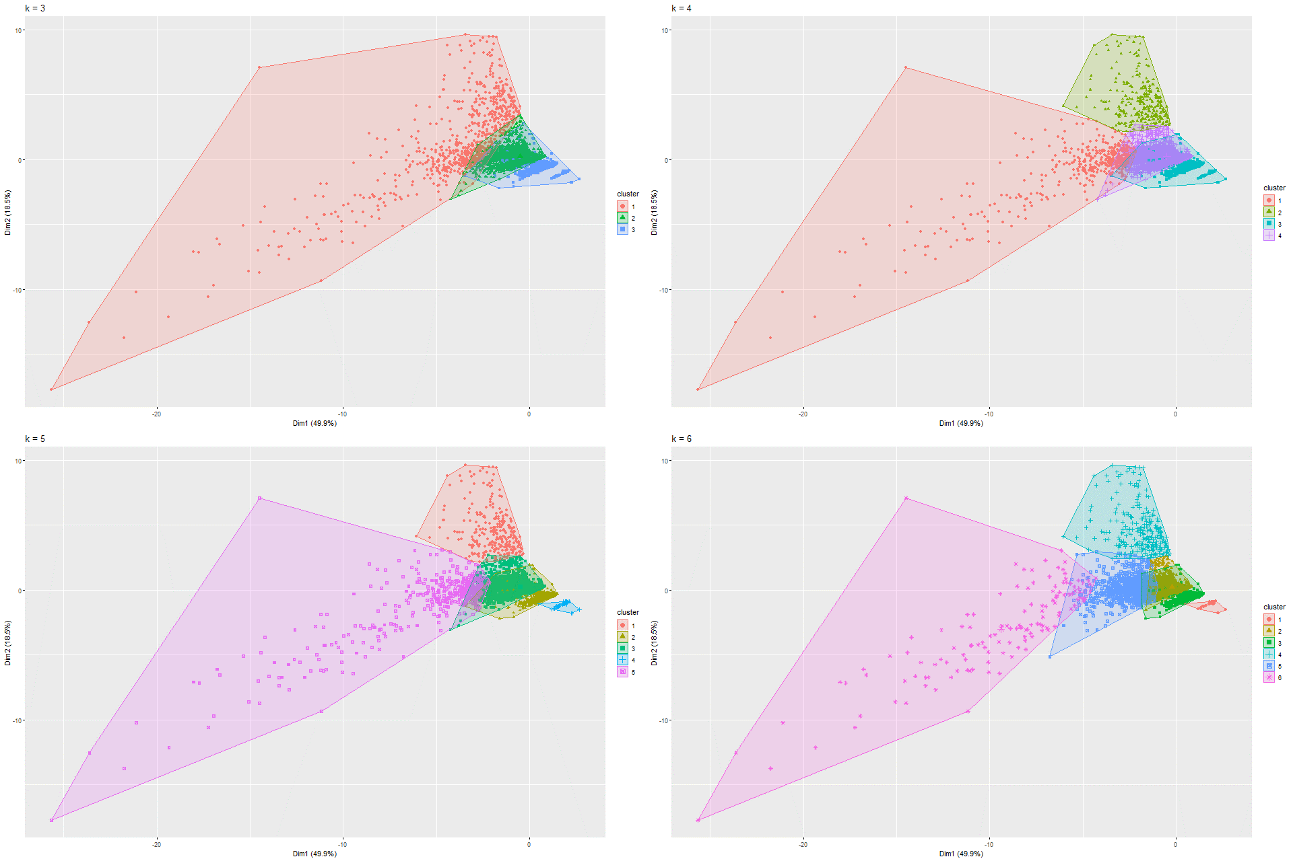

Figure 121 k-means PCA on Model 7

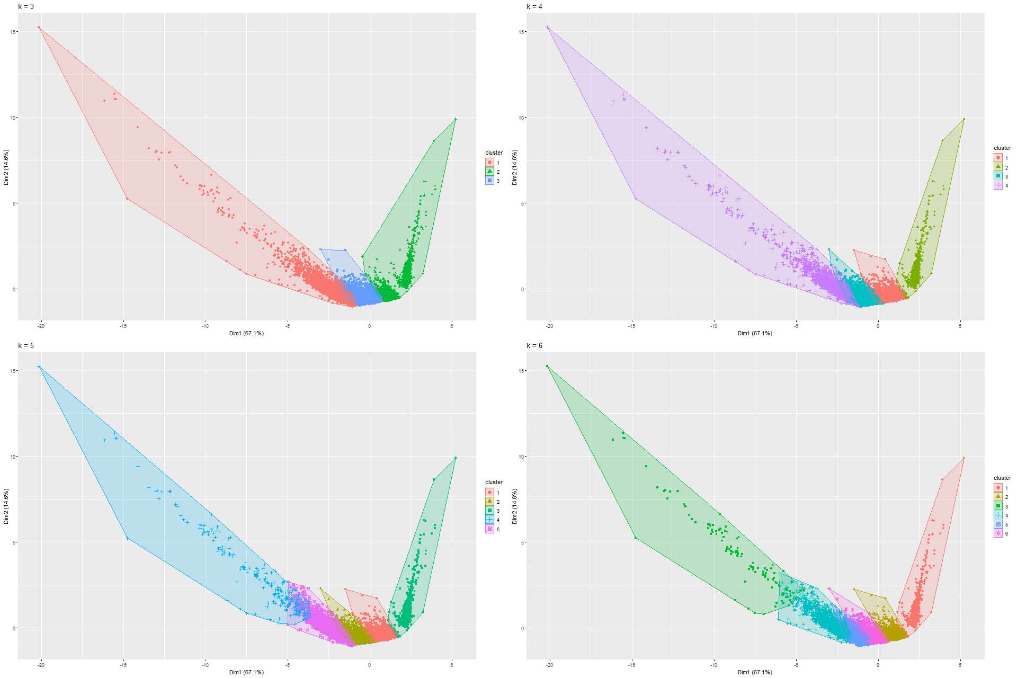

Figure 122 k-means PCA on Model 8

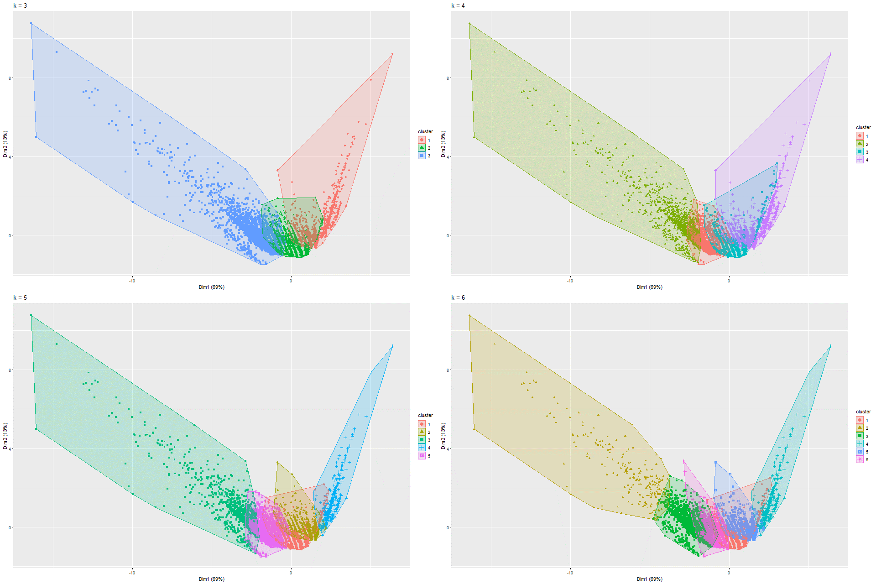

Figure 122 k-means PCA on Model 8

### 6.1.5 UMAP and K-means on UMAP

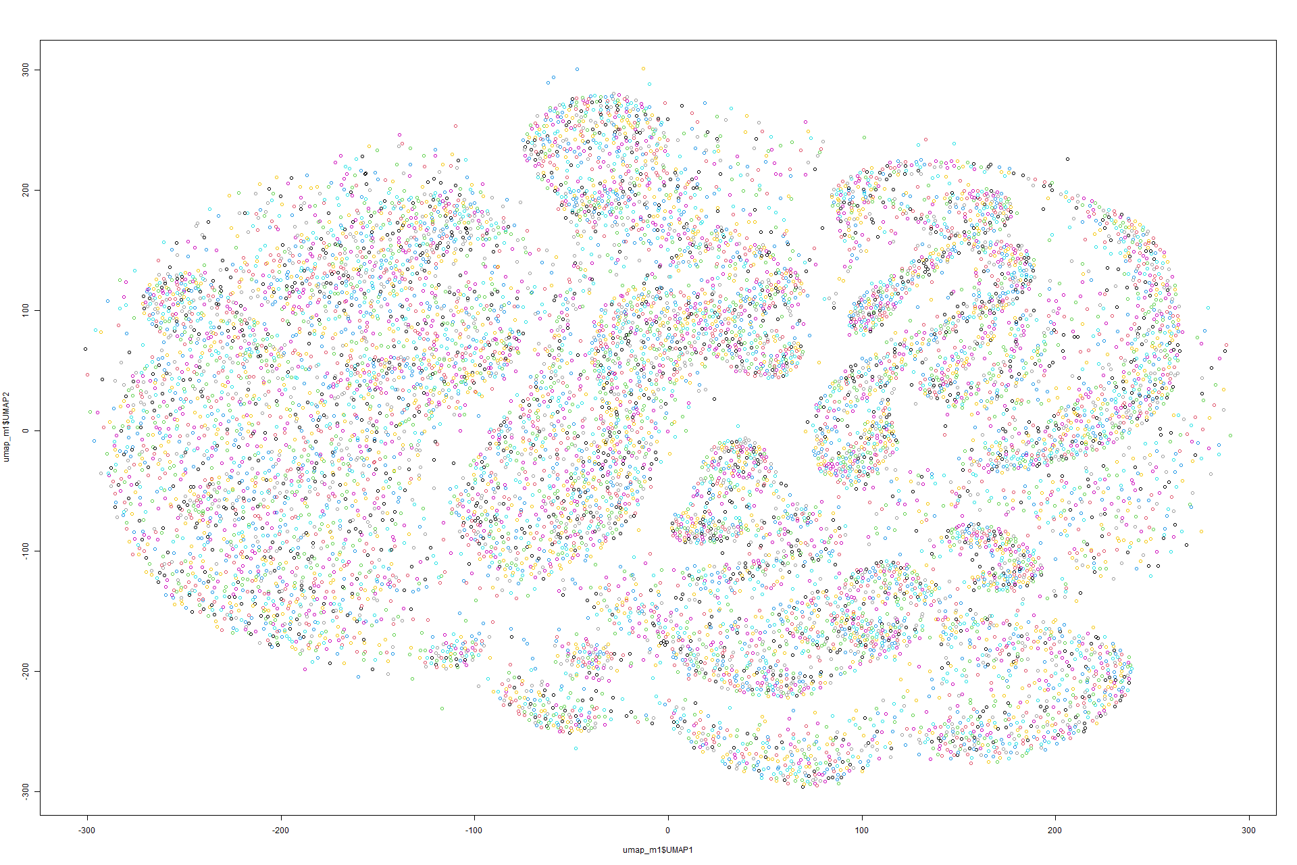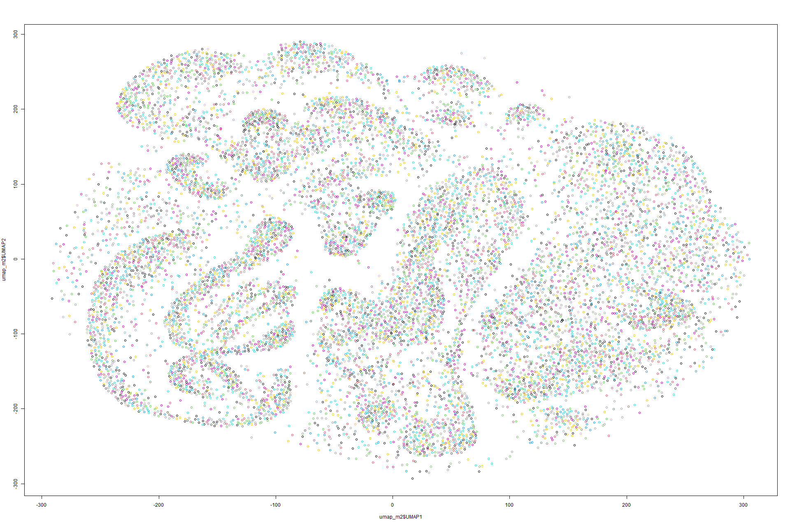Figure 123 UMAP on Model 1 Figure 124 UMAP on Model 2

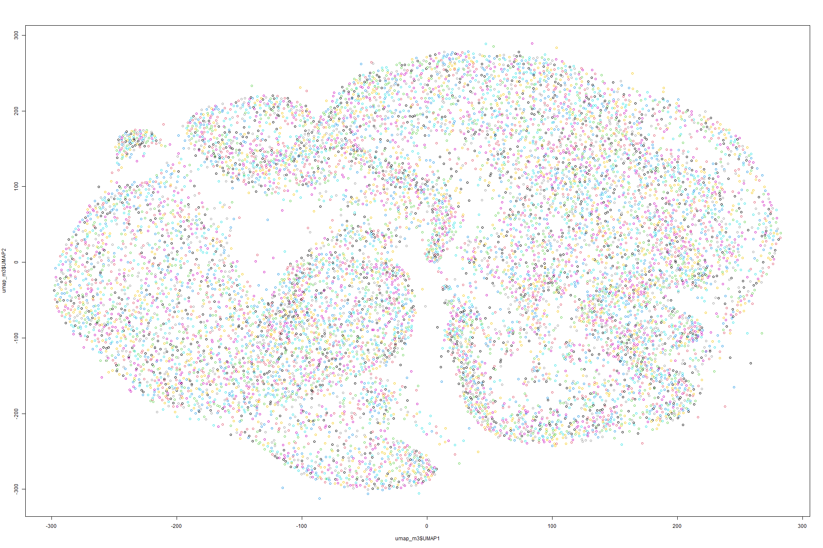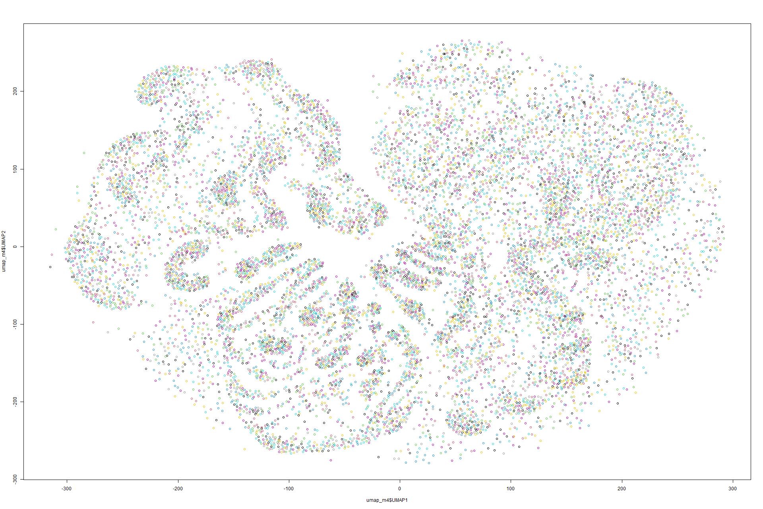

Figure 125 UMAP on Model 3 Figure 126 UMAP on Model 4

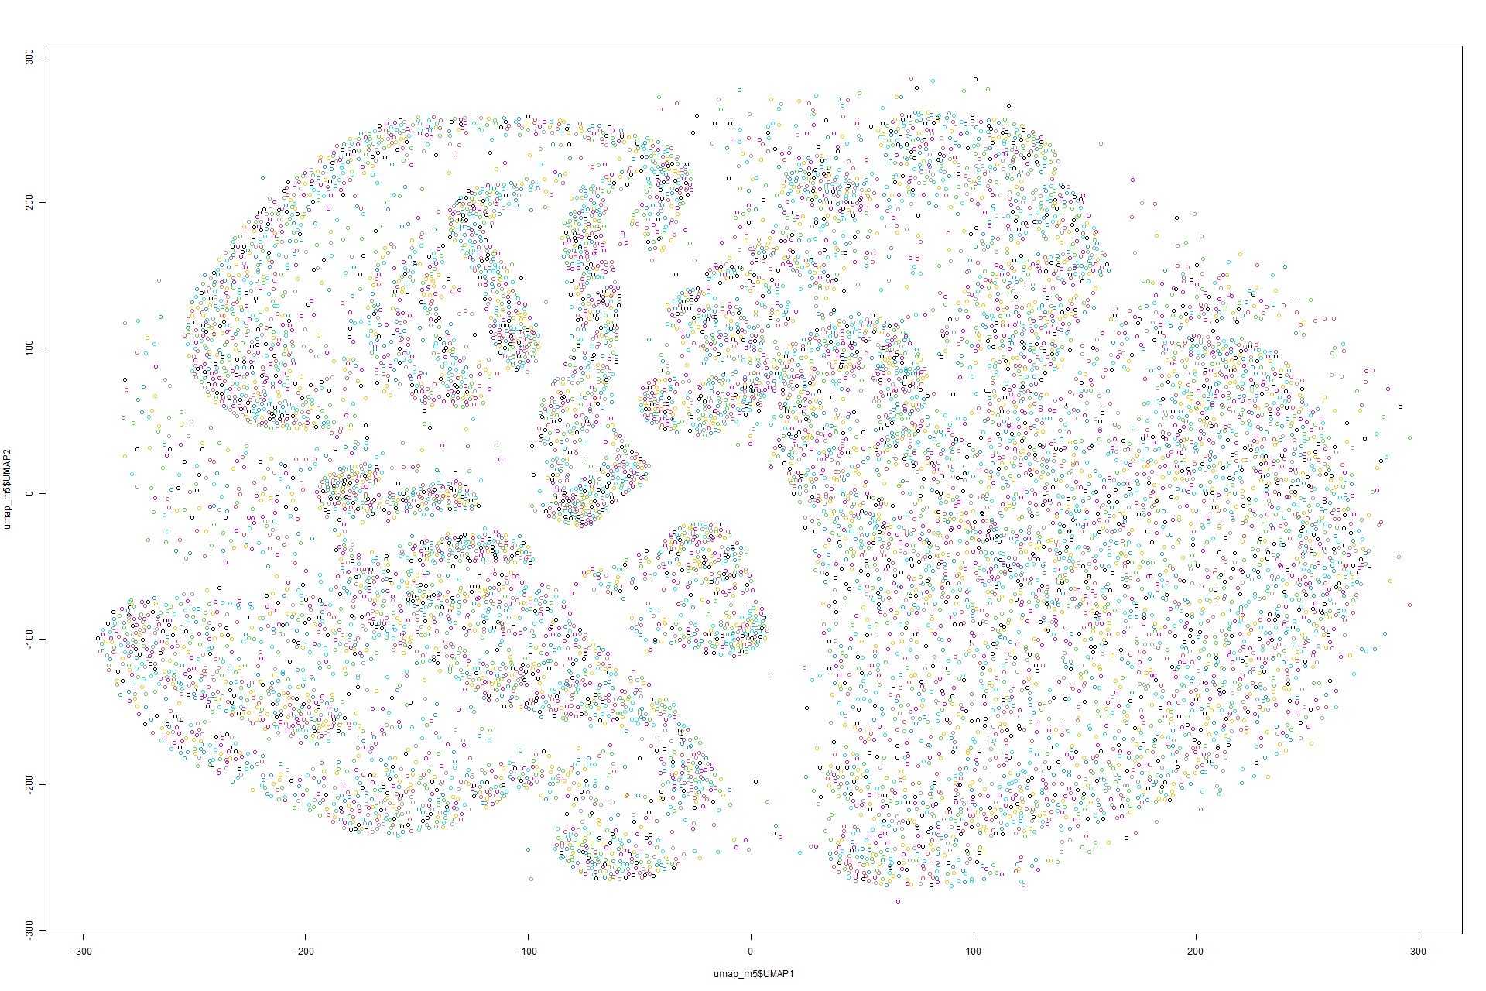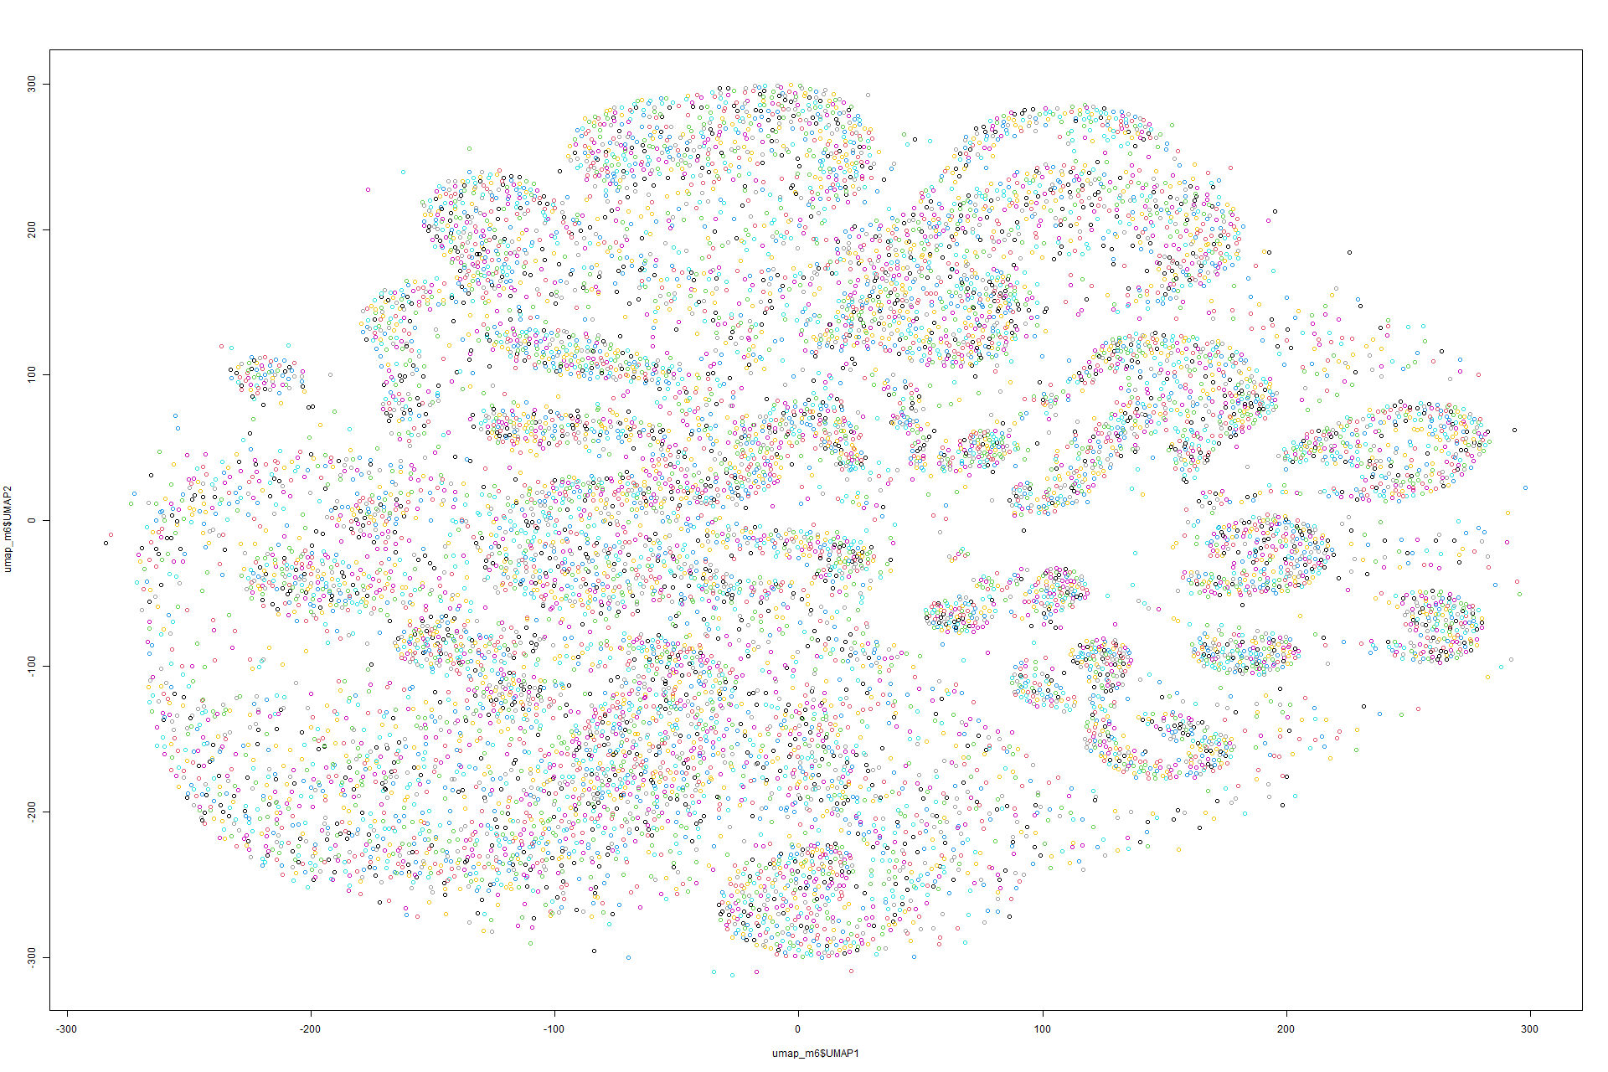

Figure 127 UMAP on Model 5 Figure 128 UMAP on Model 6

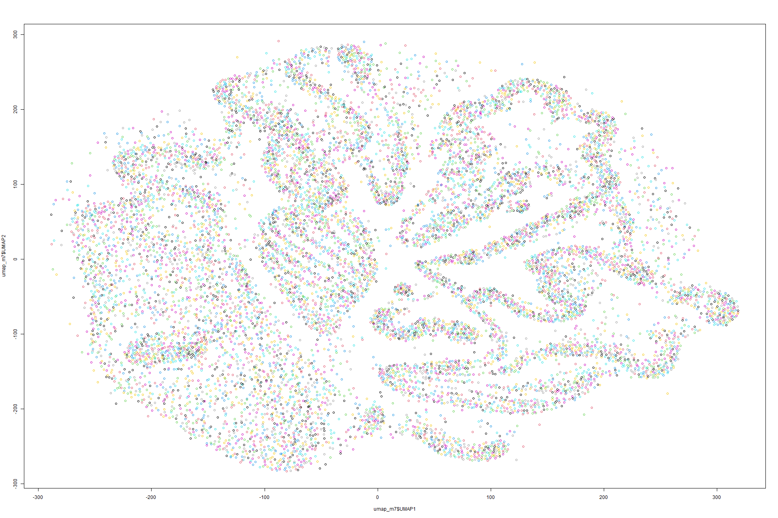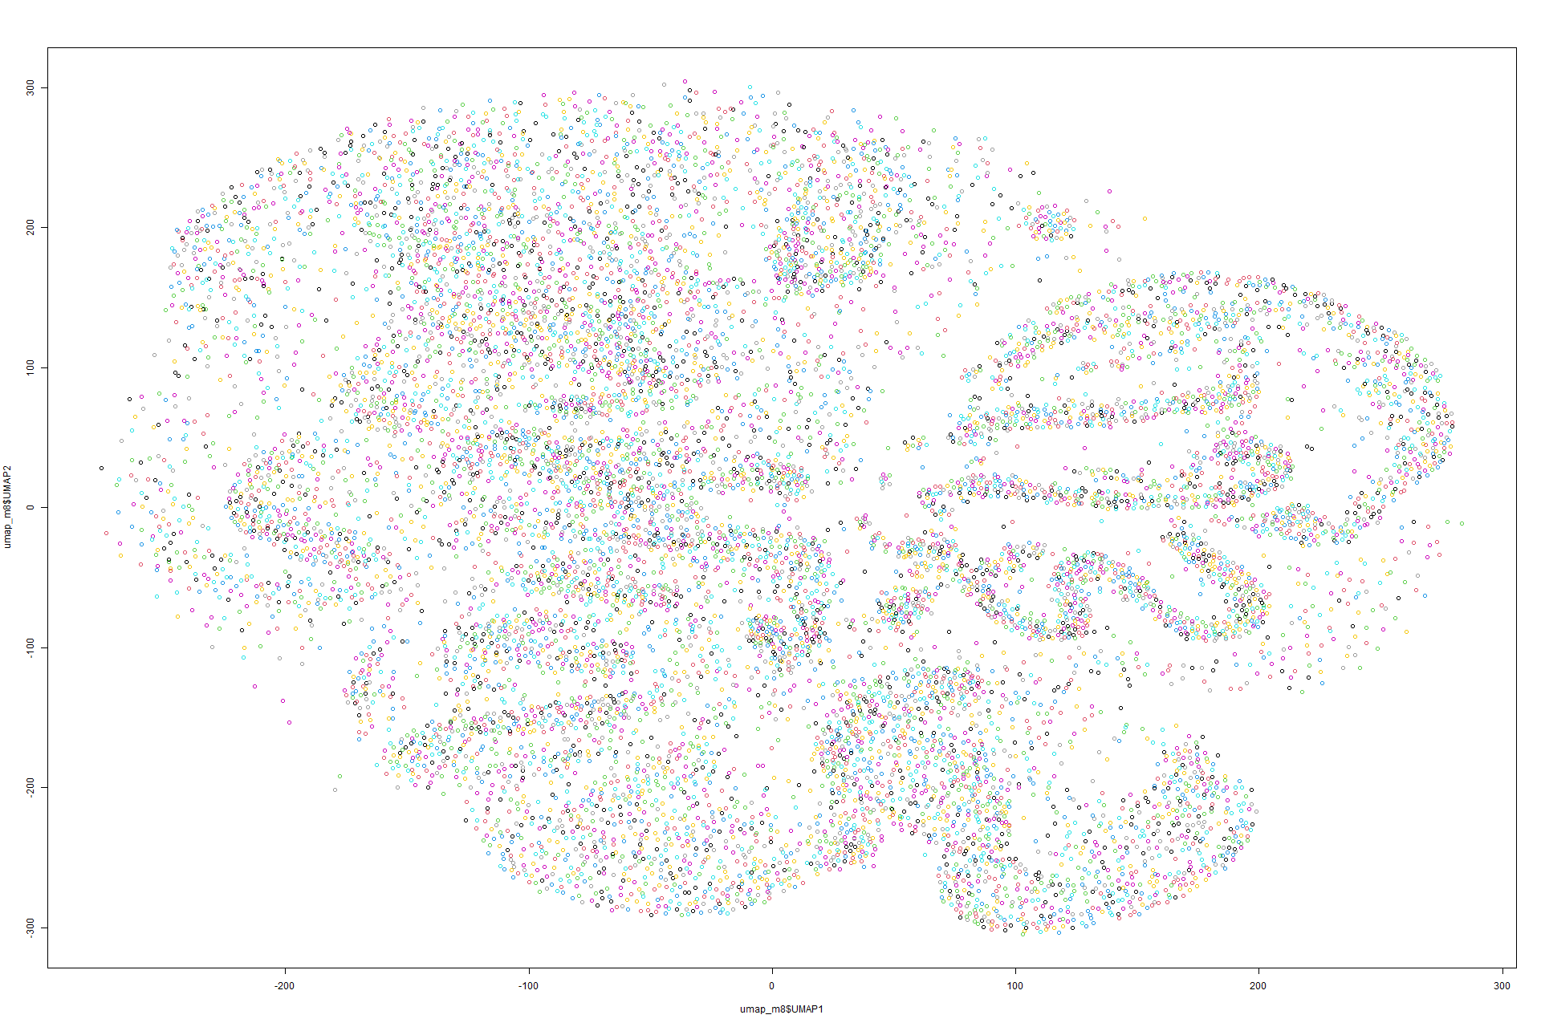

Figure 129 UMAP on Model 7 Figure 130 UMAP on Model 8

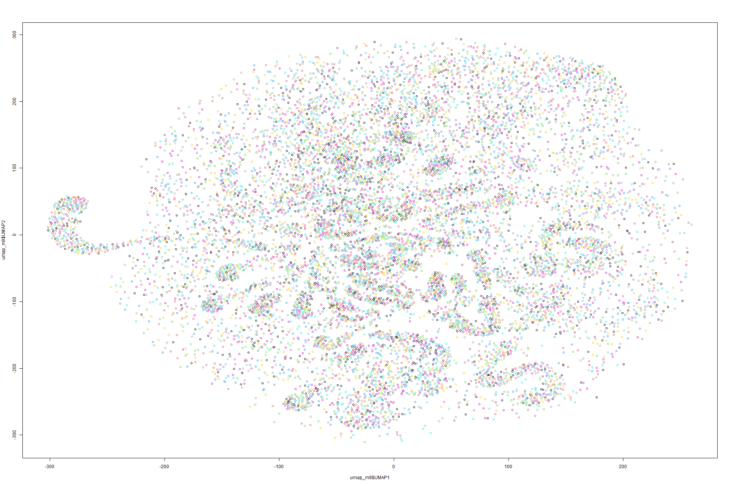

Figure 131 UMAP on Model 9

K-means on UMAP

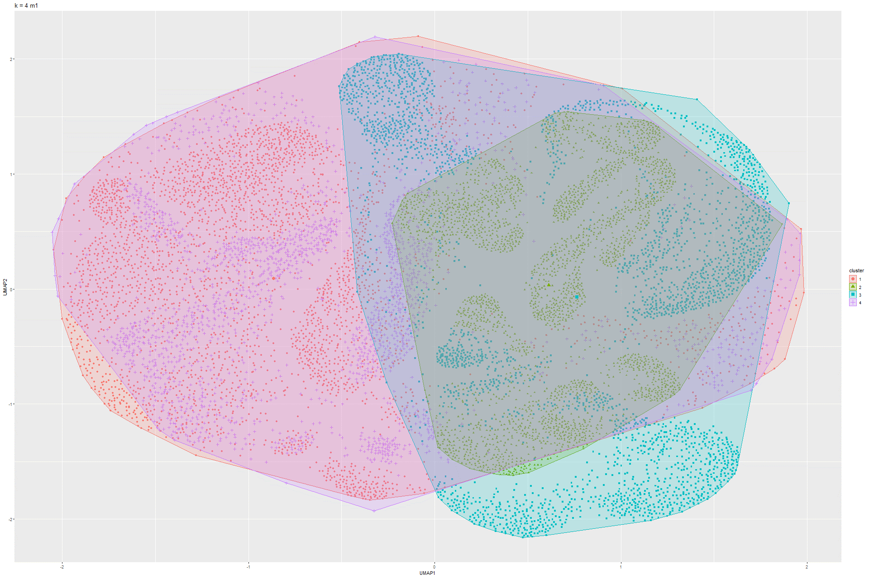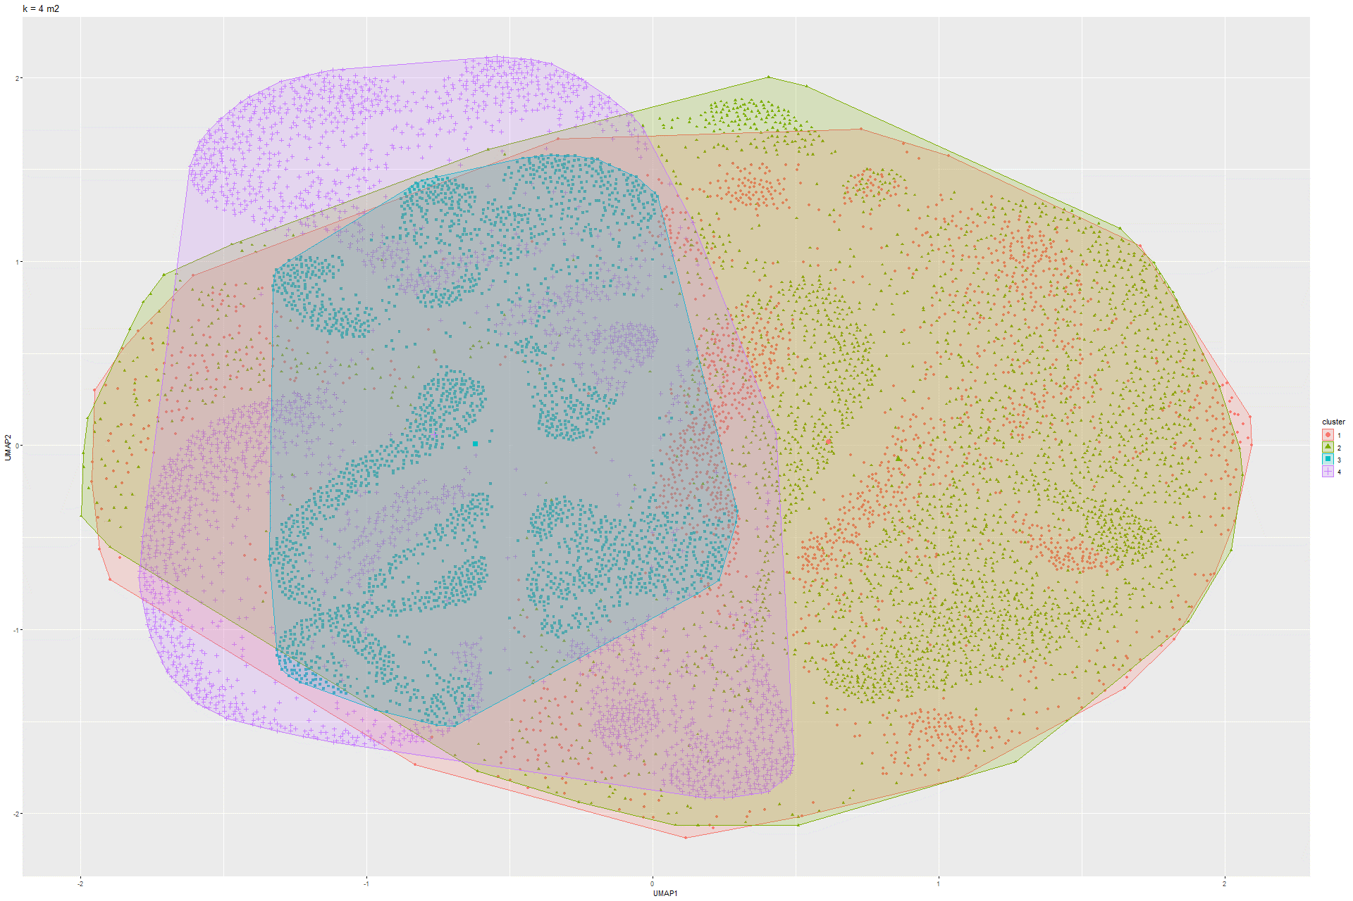Figure 132 k-Means UMAP on Model 1 Figure 133 k-Means UMAP on Model 2

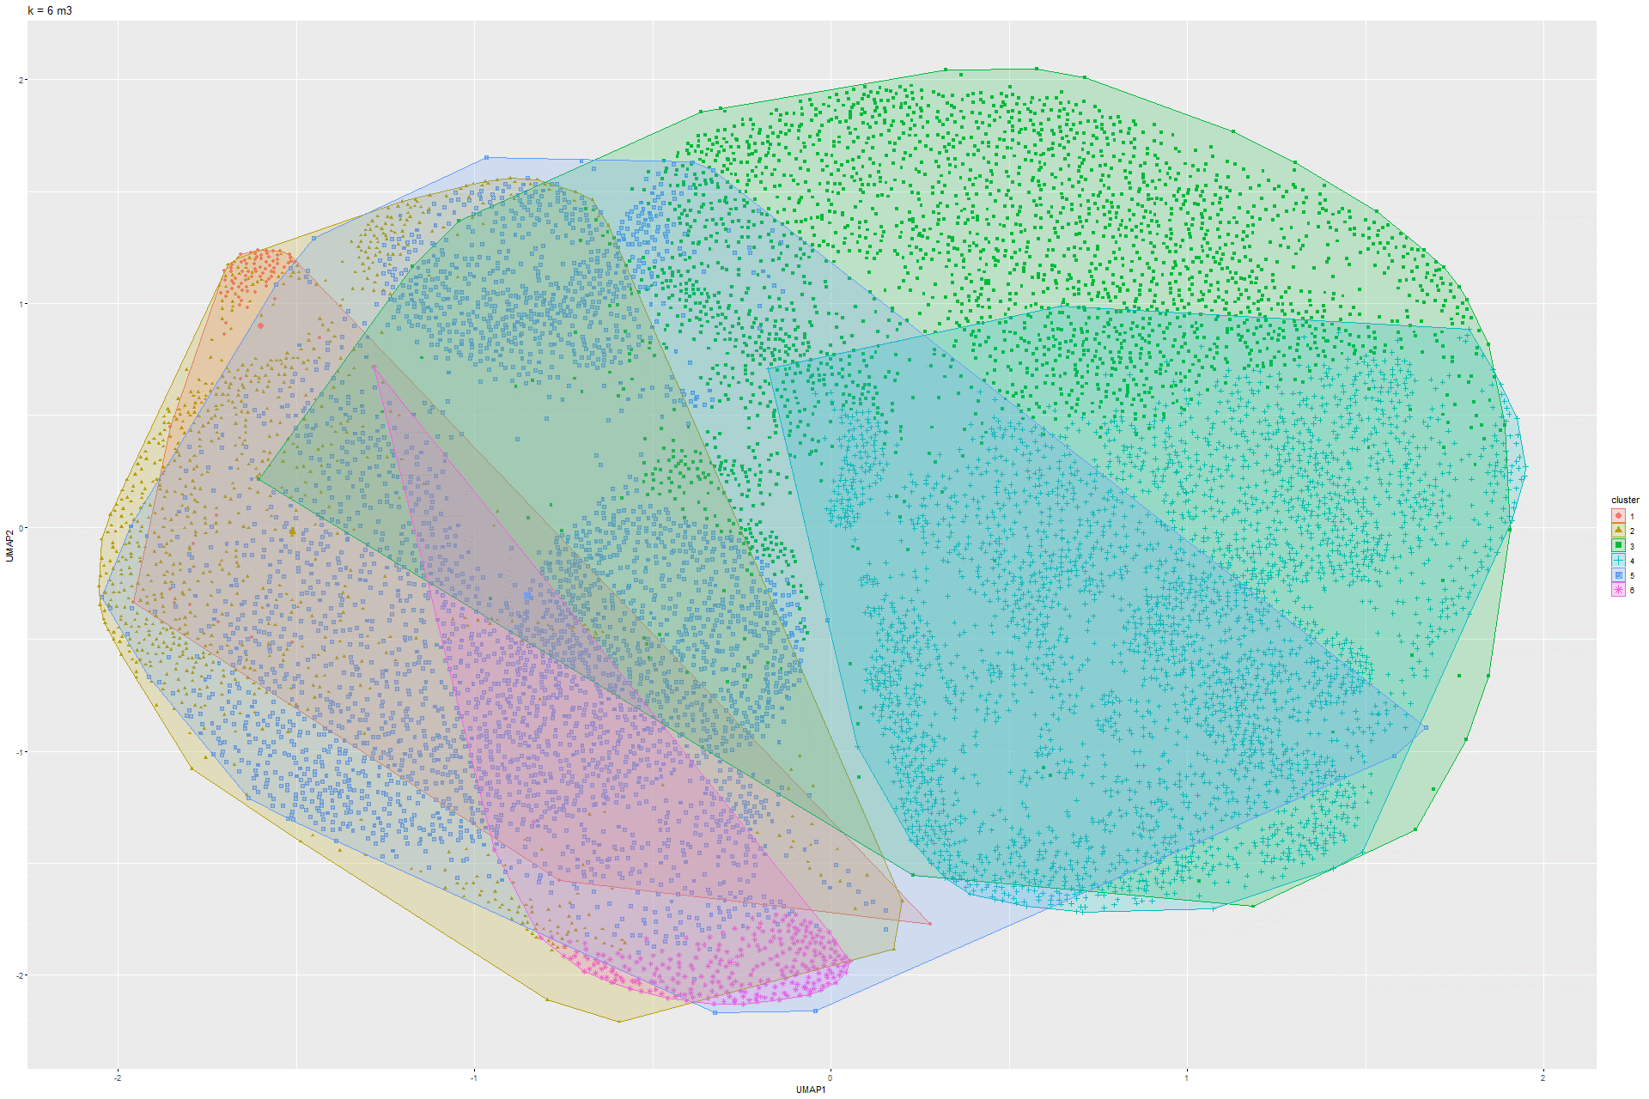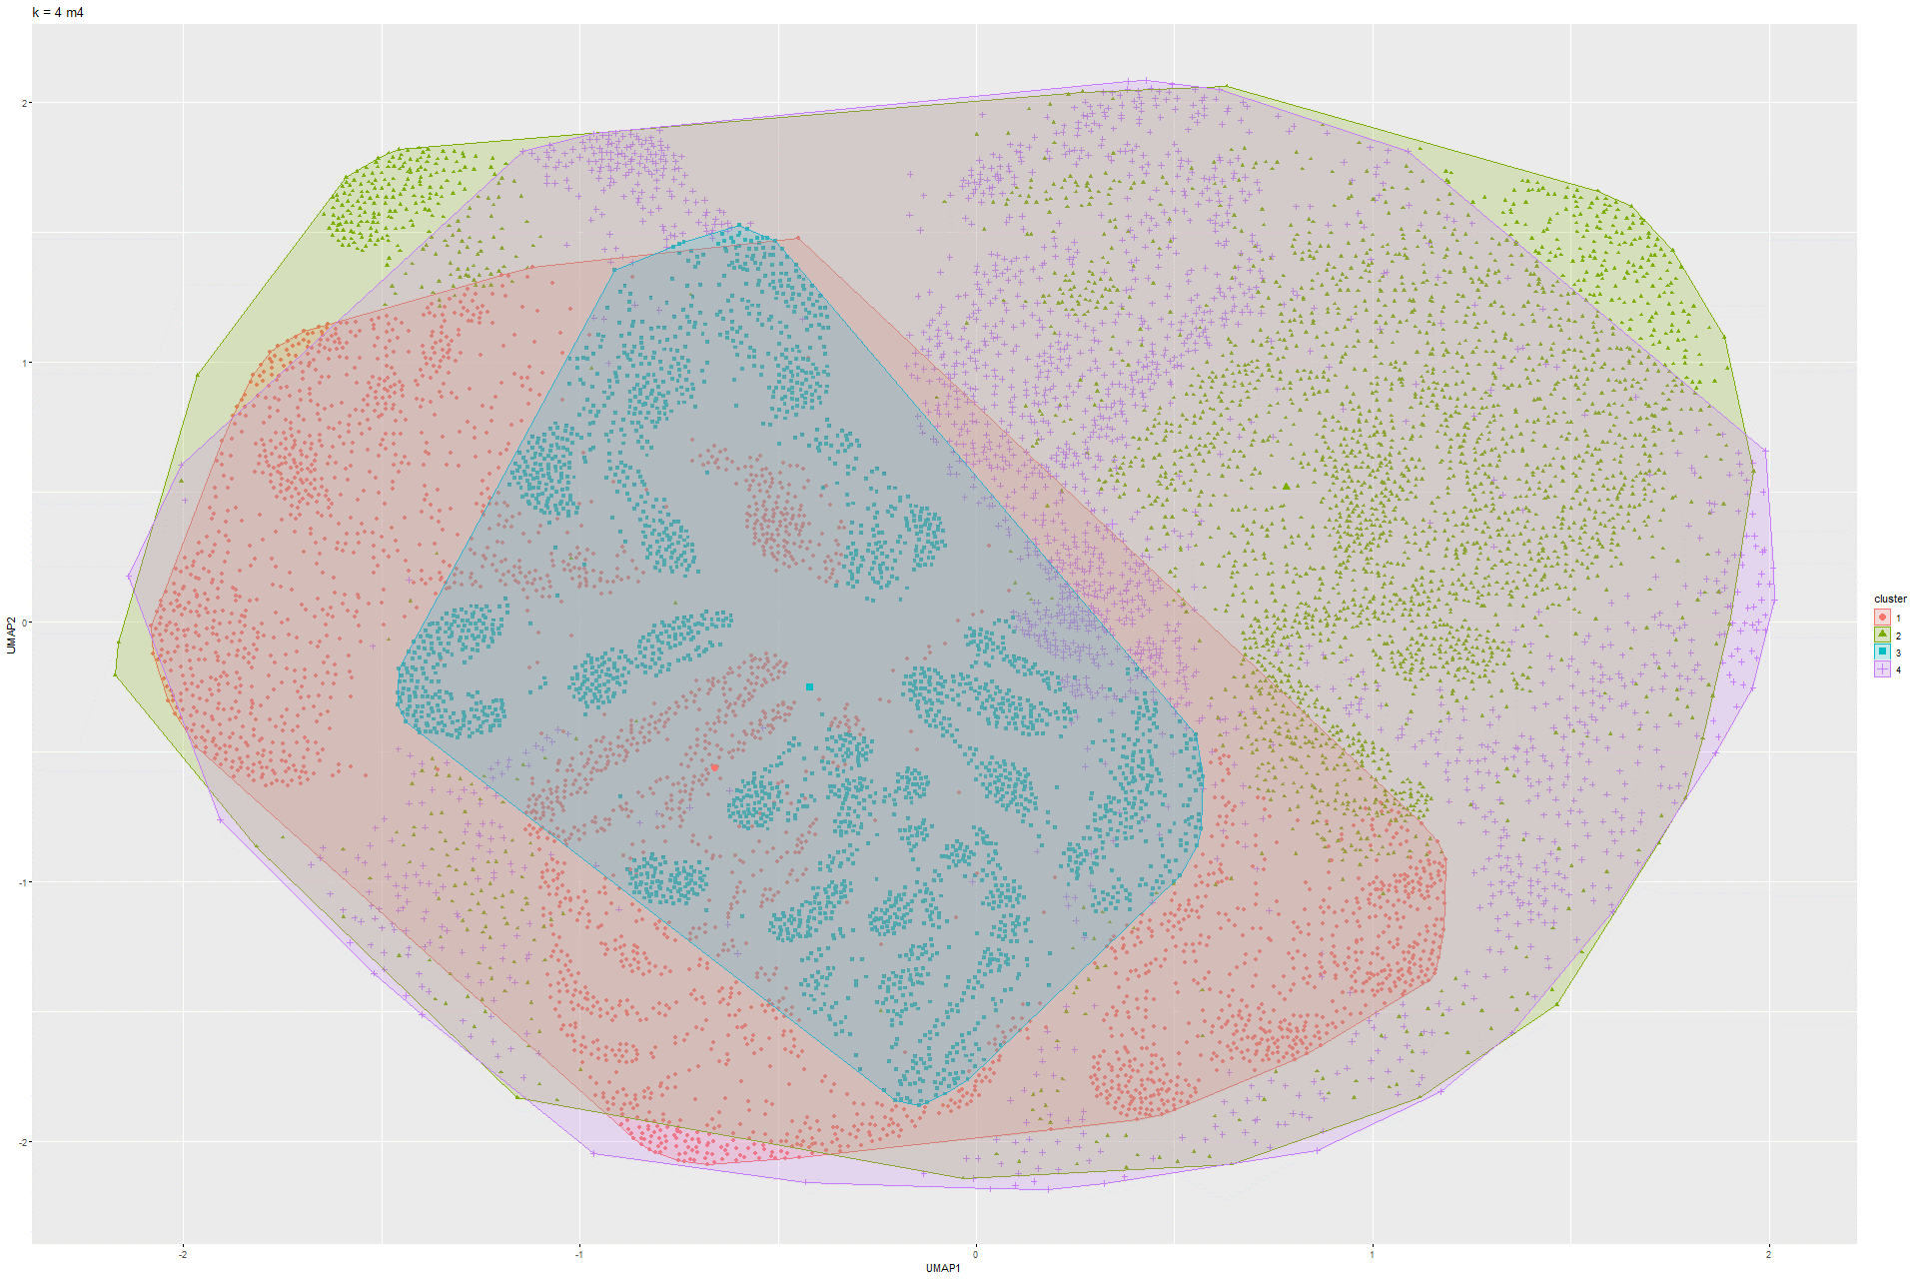Figure 134 k-Means UMAP on Model 3 Figure 135 k-Means UMAP on Model 4

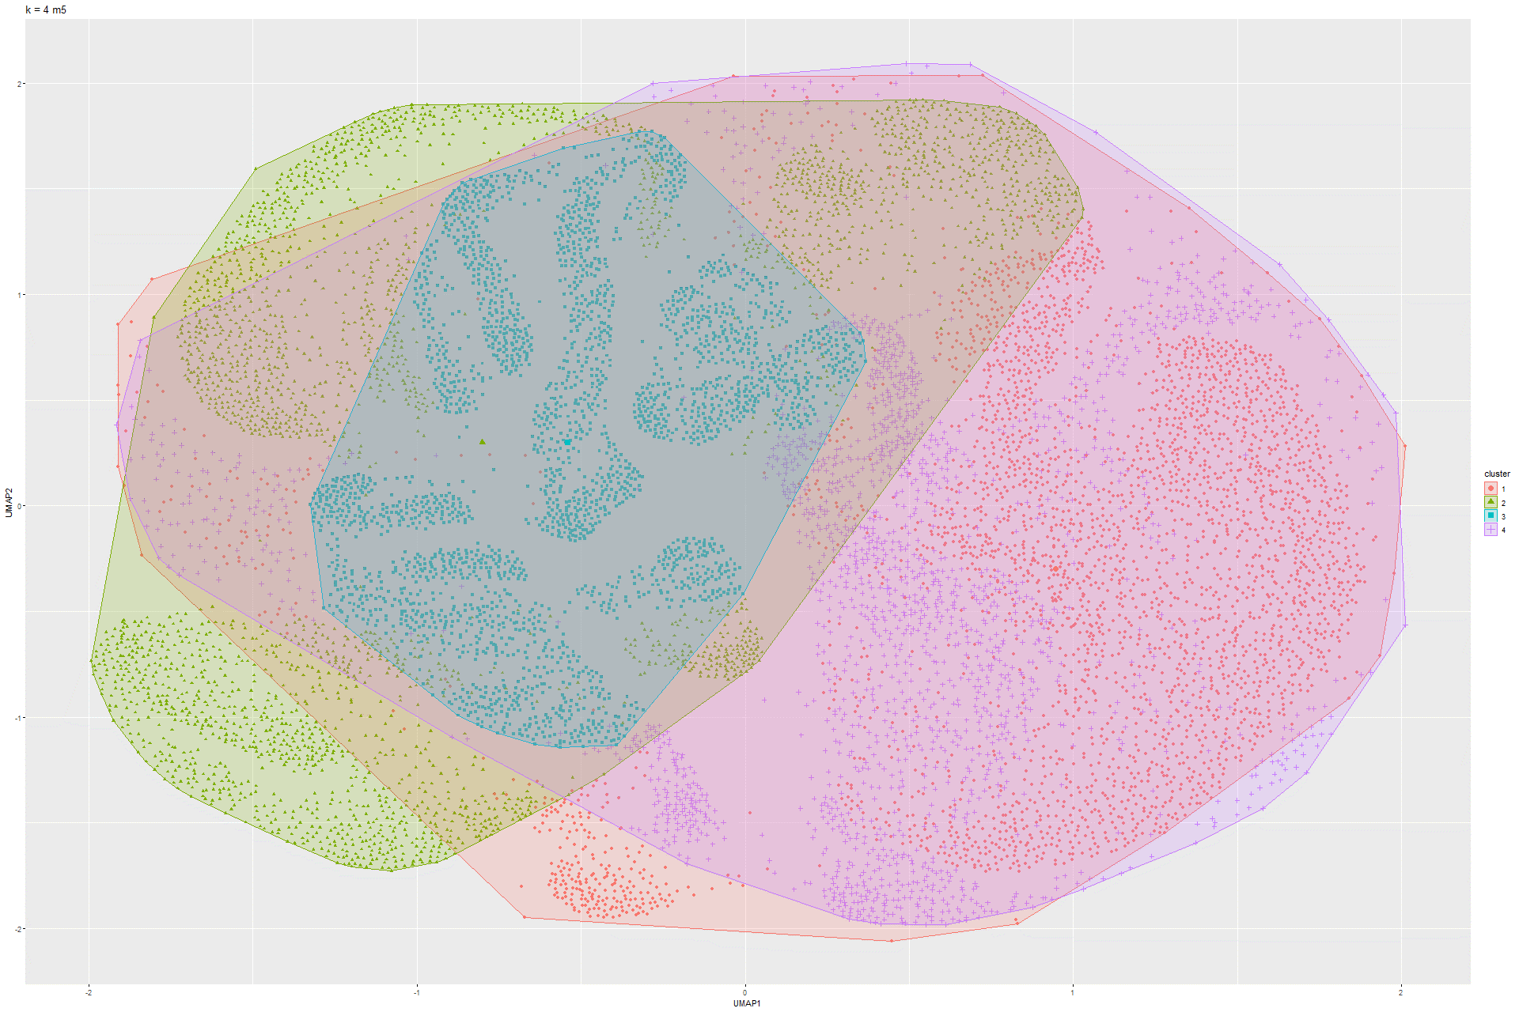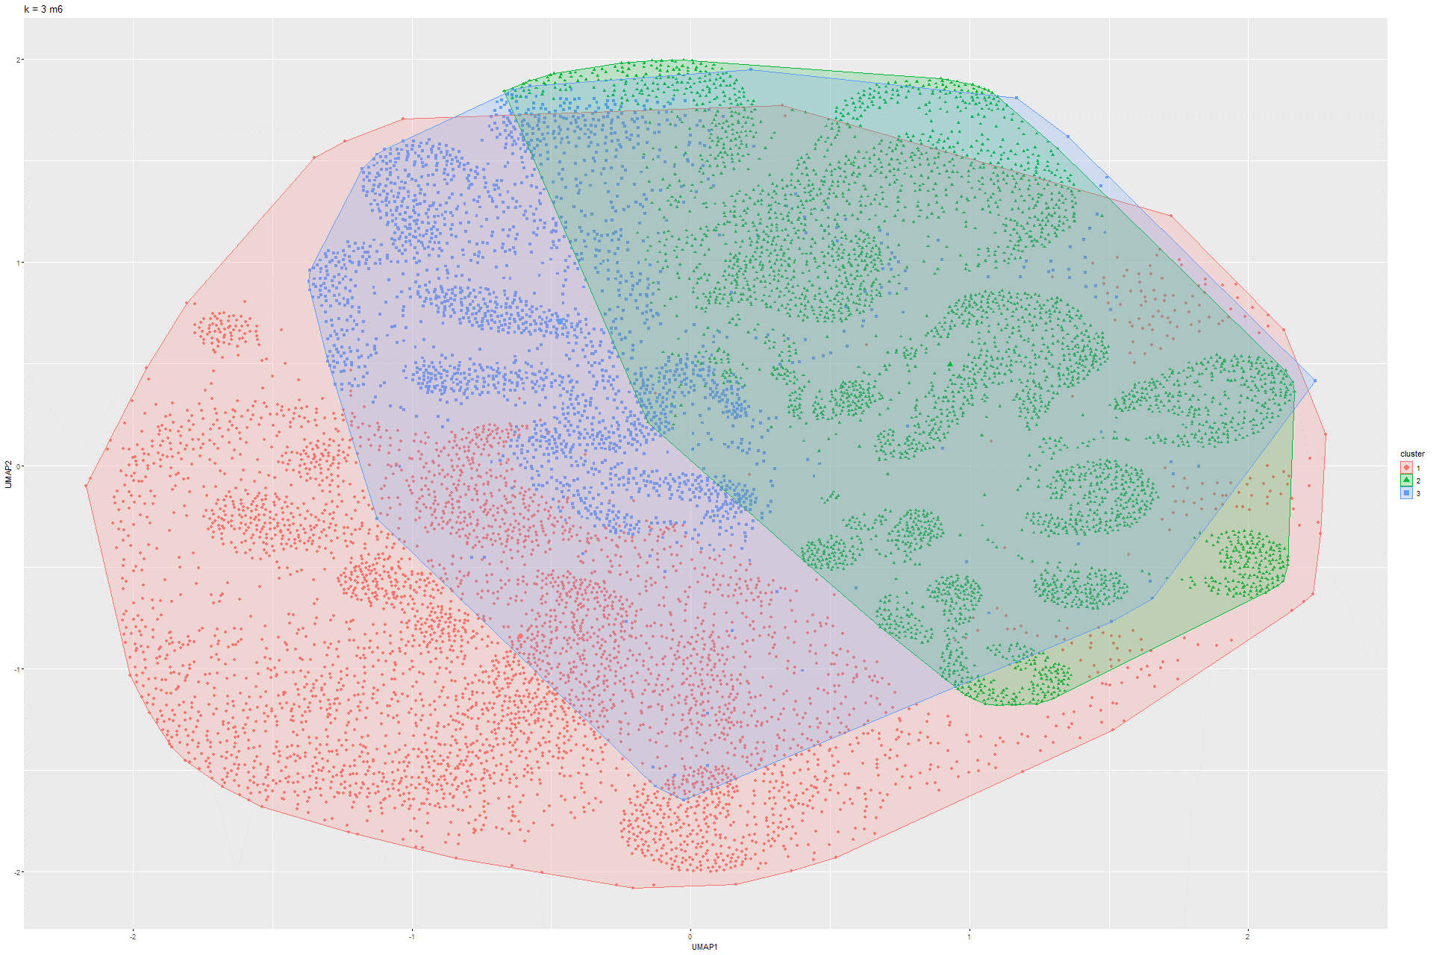Figure 136 k-Means UMAP on Model 5 Figure 137 k-Means UMAP on Model 6

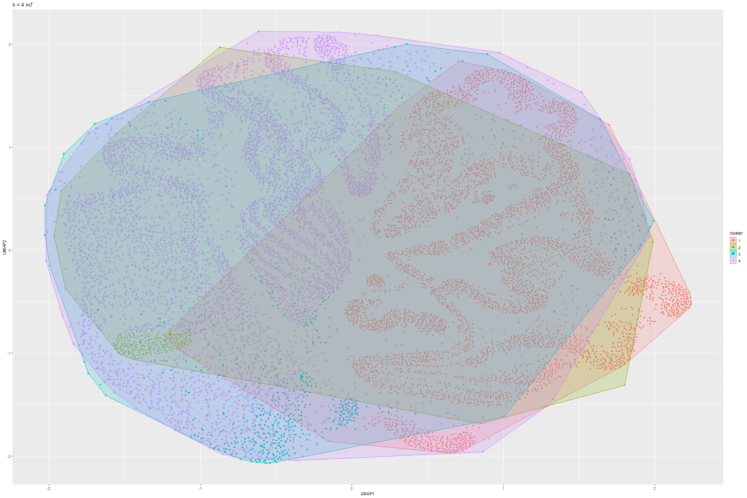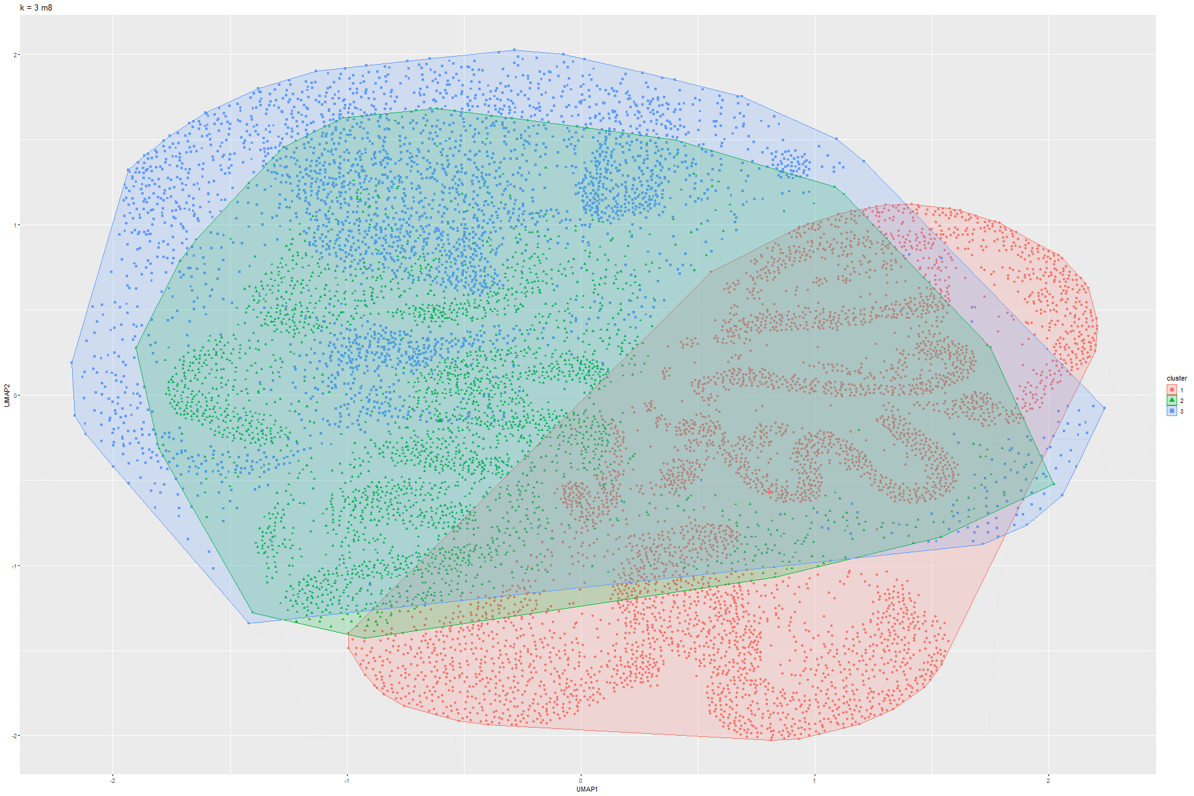Figure 138 k-Means UMAP on Model 7 Figure 139 k-Means UMAP on Model 8

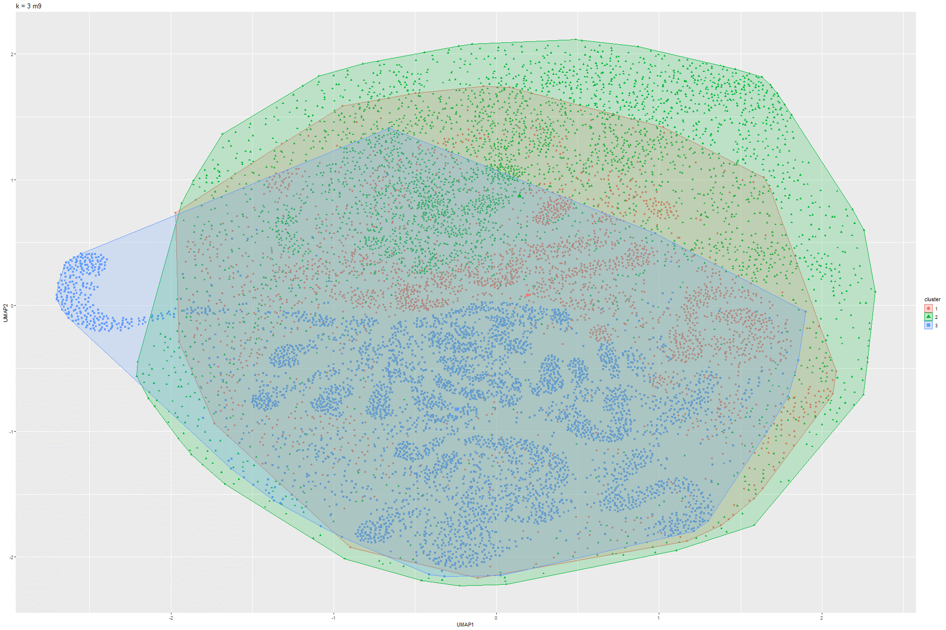

Figure 140 k-Means UMAP on Model 9

### 6.1.6 Sammon’s mapping

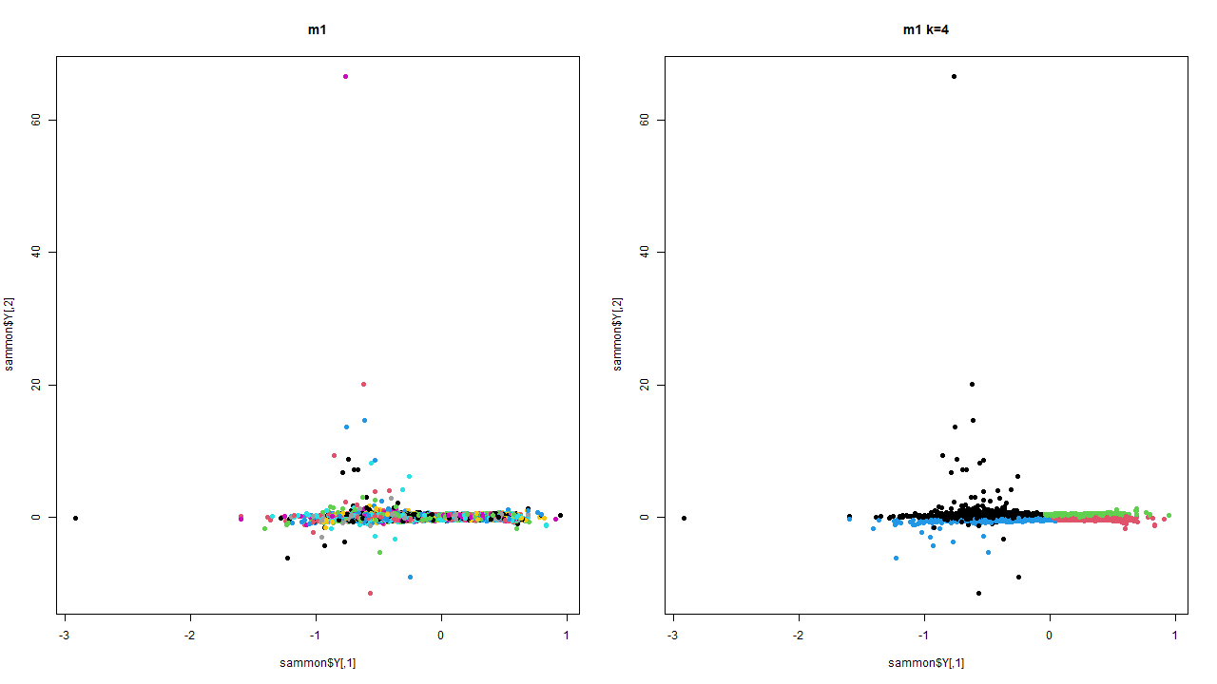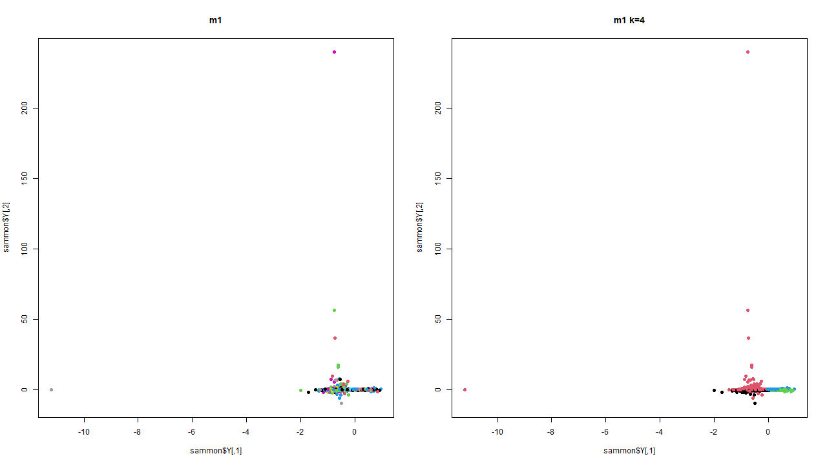Figure 141 Sammon’s mapping on Model 1 Figure 142 Sammon’s mapping on Model 2

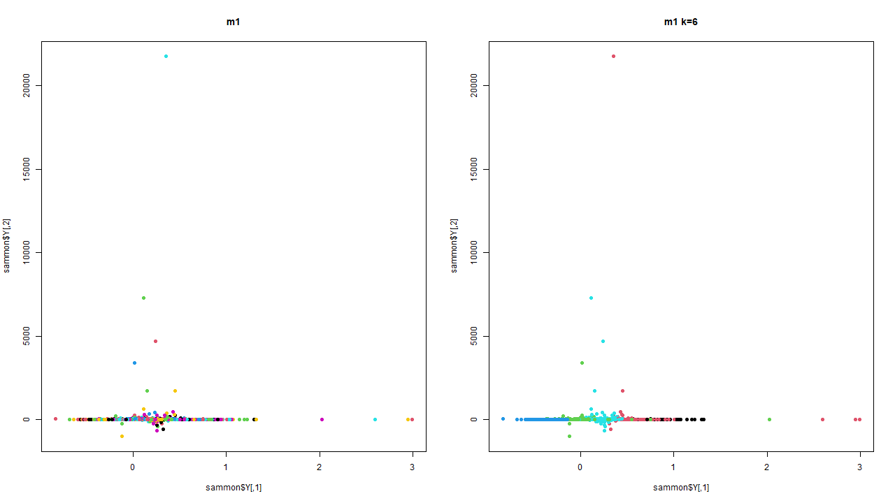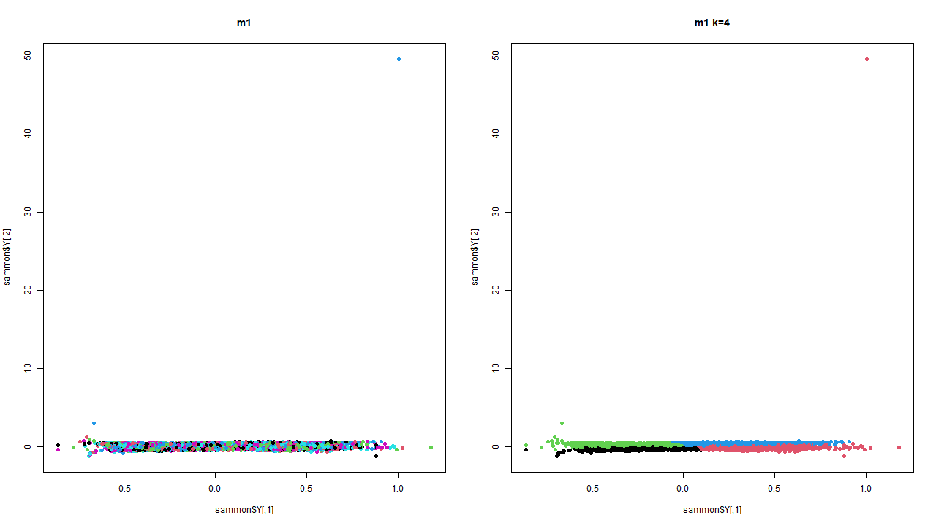Figure 143 Sammon’smapping on Model 3 Figure 144 Sammon’s mapping on Model 4

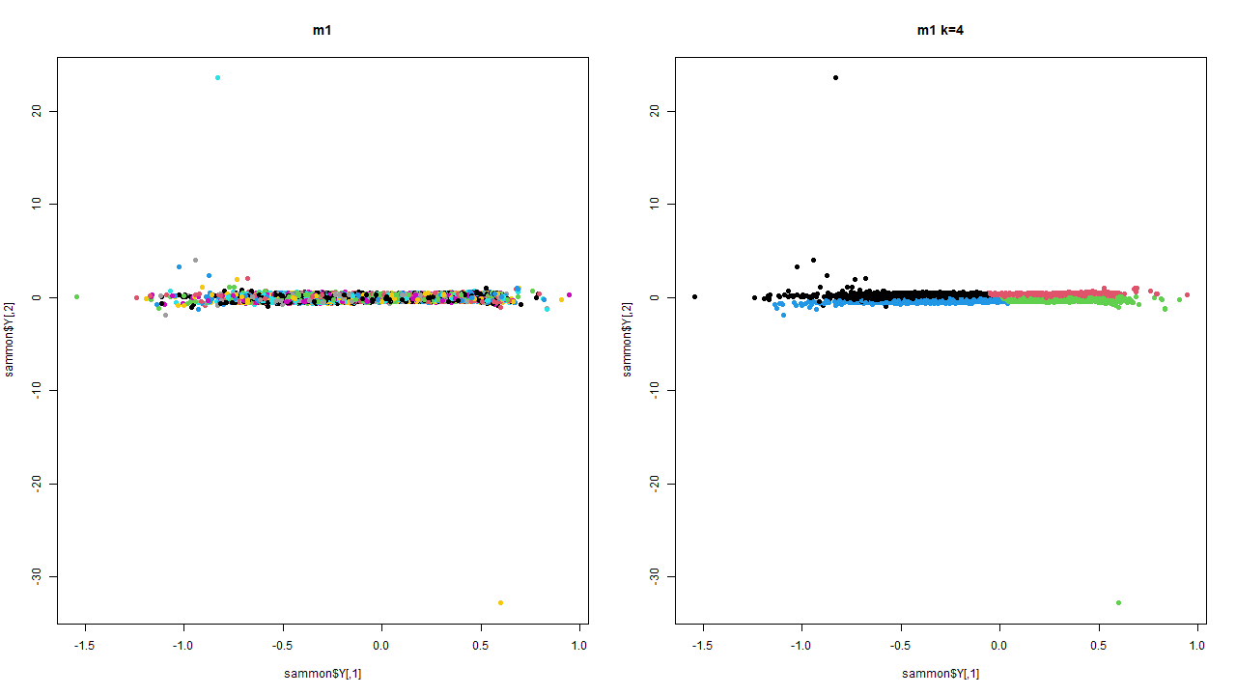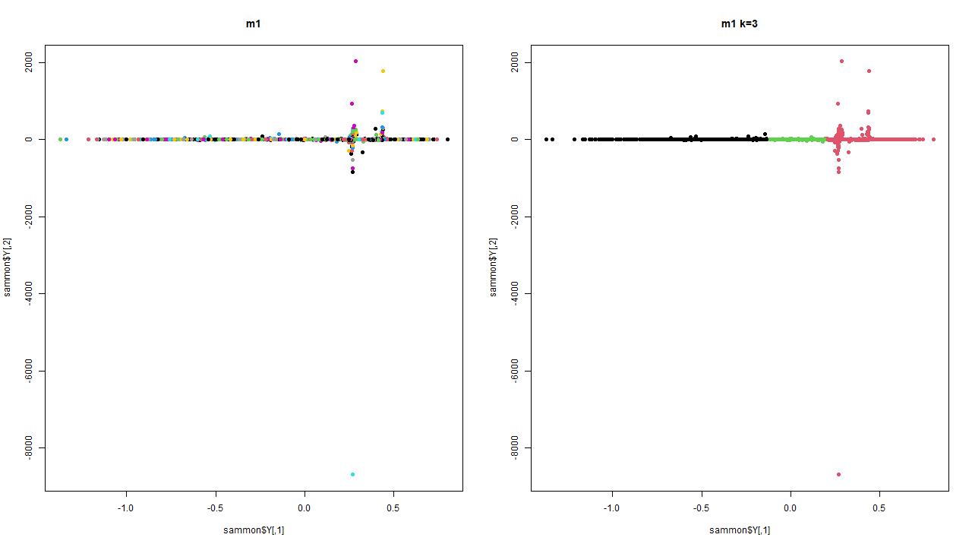Figure 145 Sammon’s mapping on Model 5 Figure 146 Sammon’s mapping on Model 6

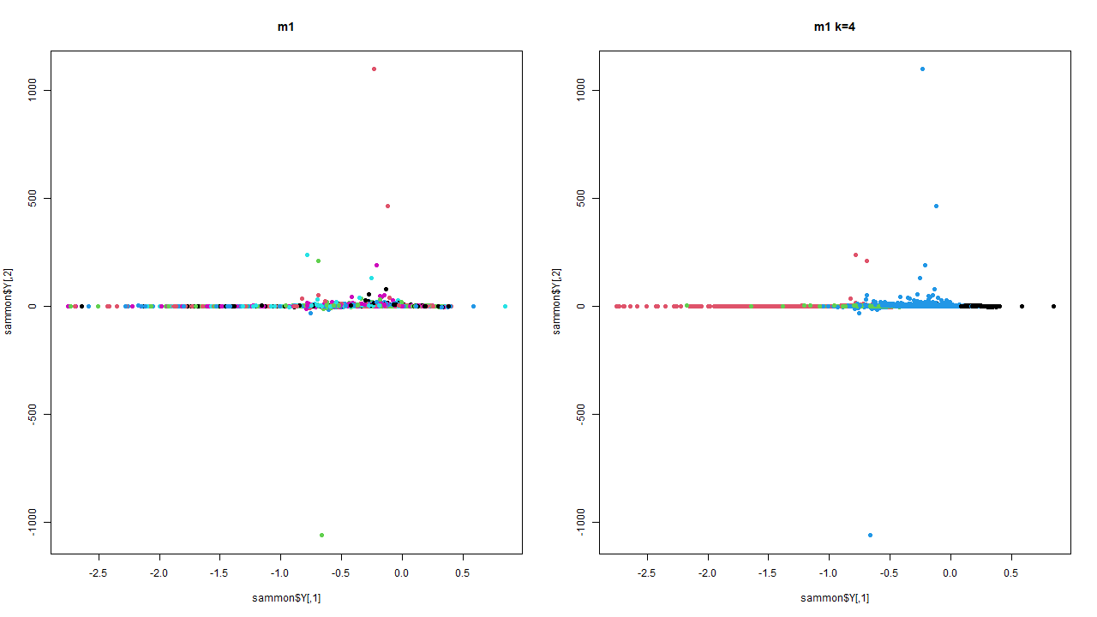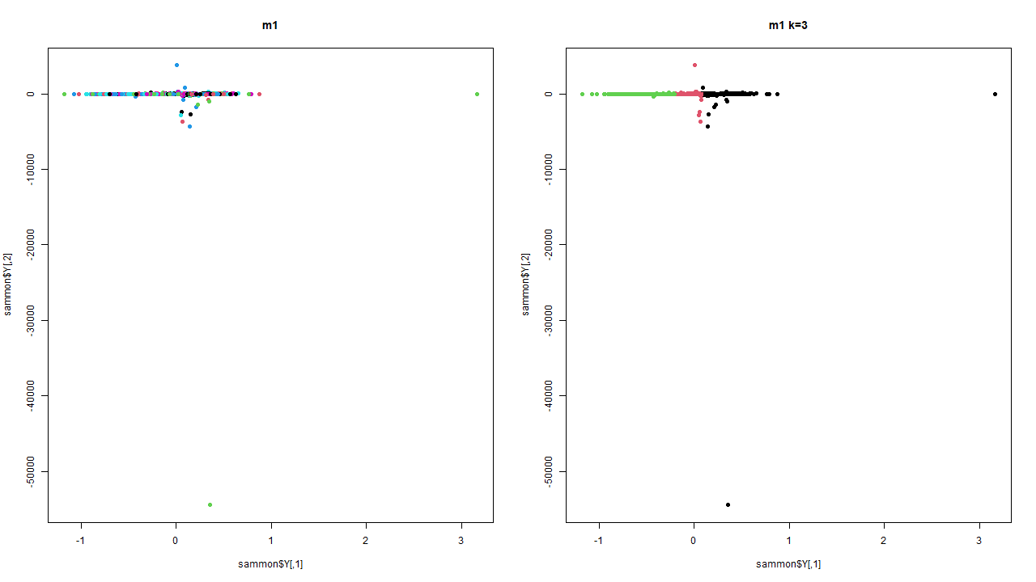Figure 147 Sammon’s mapping on Model 7 Figure 148 Sammon’s mapping on Model 8

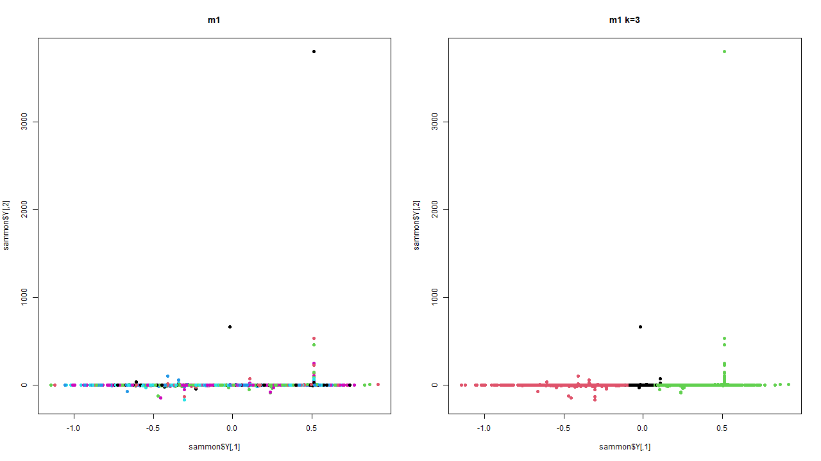

Figure 148 Sammon’s mapping on Model 9

### 6.1.7 DBSCAN

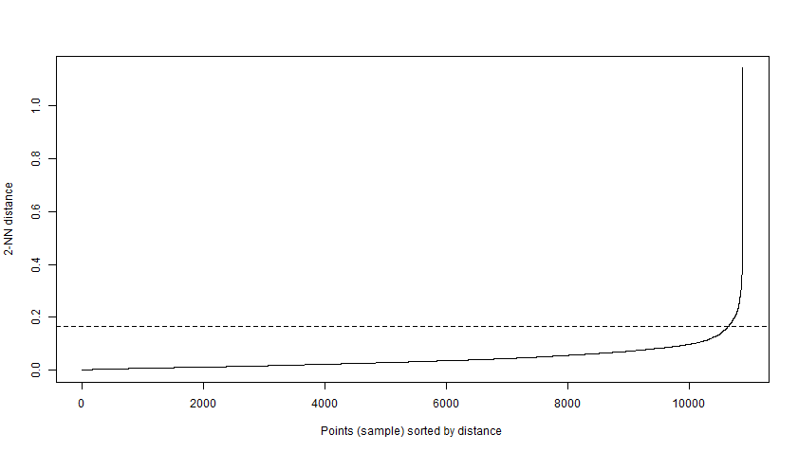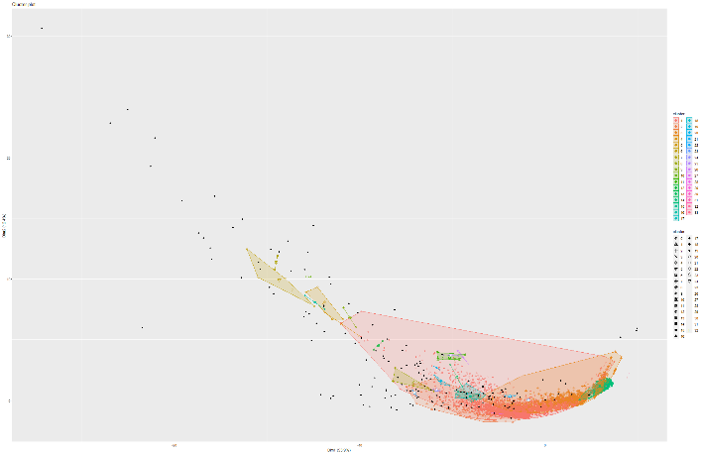Figure 149 and 150 Knee plot and DBSCAN on Model 1

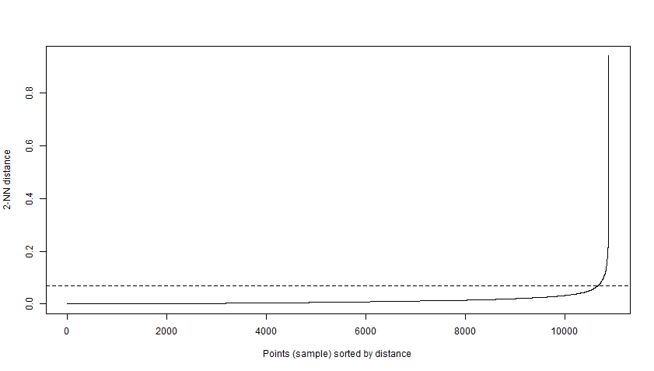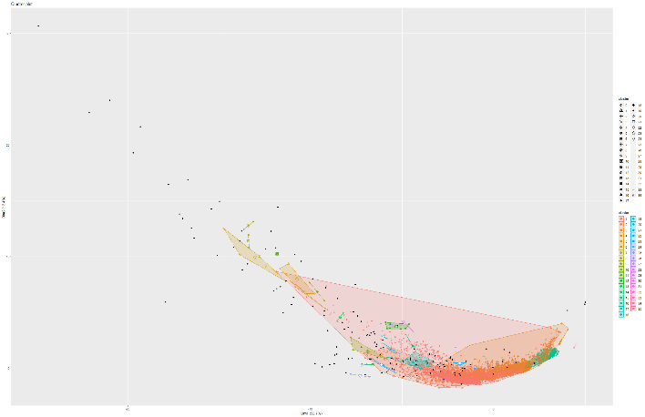Figure 151 and 152 Knee plot and DBSCAN on Model 2

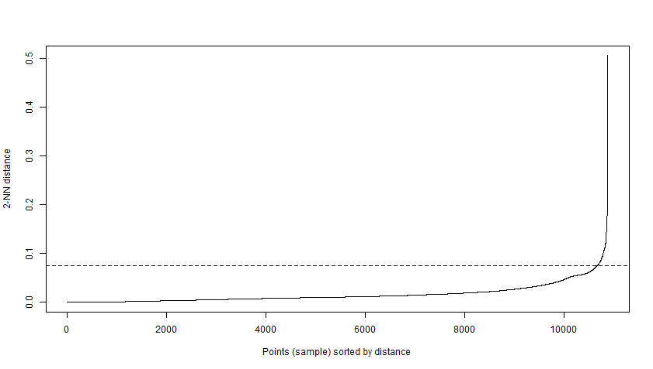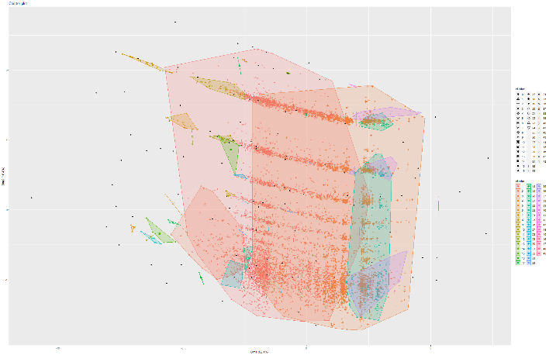Figure 153 and 154 Knee plot and DBSCAN on Model 4

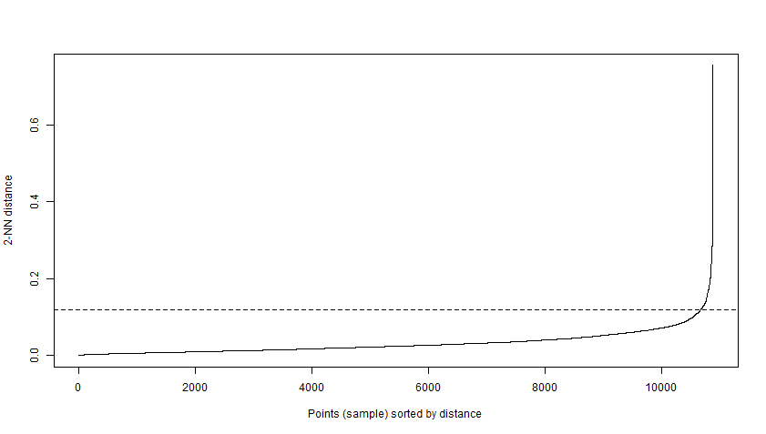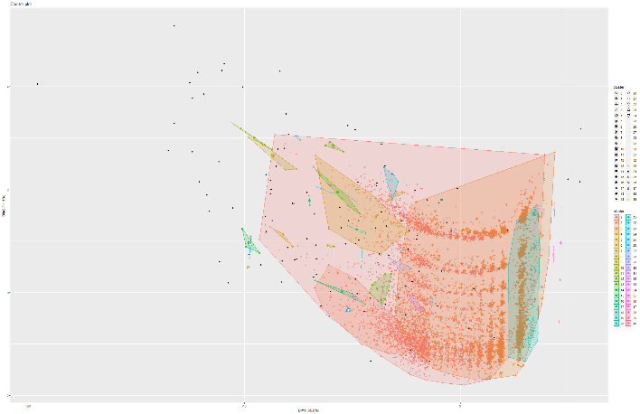Figure 155 and 156 Knee plot and DBSCAN on Model 5

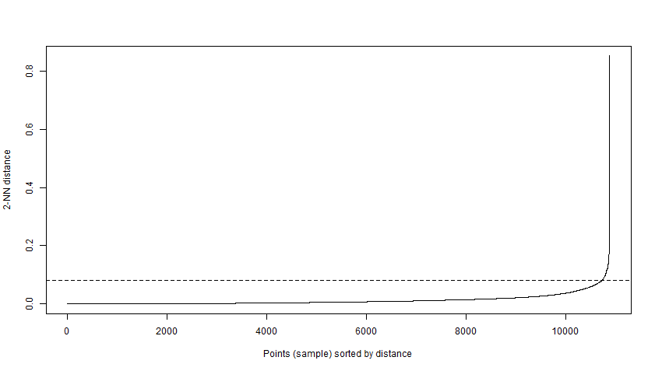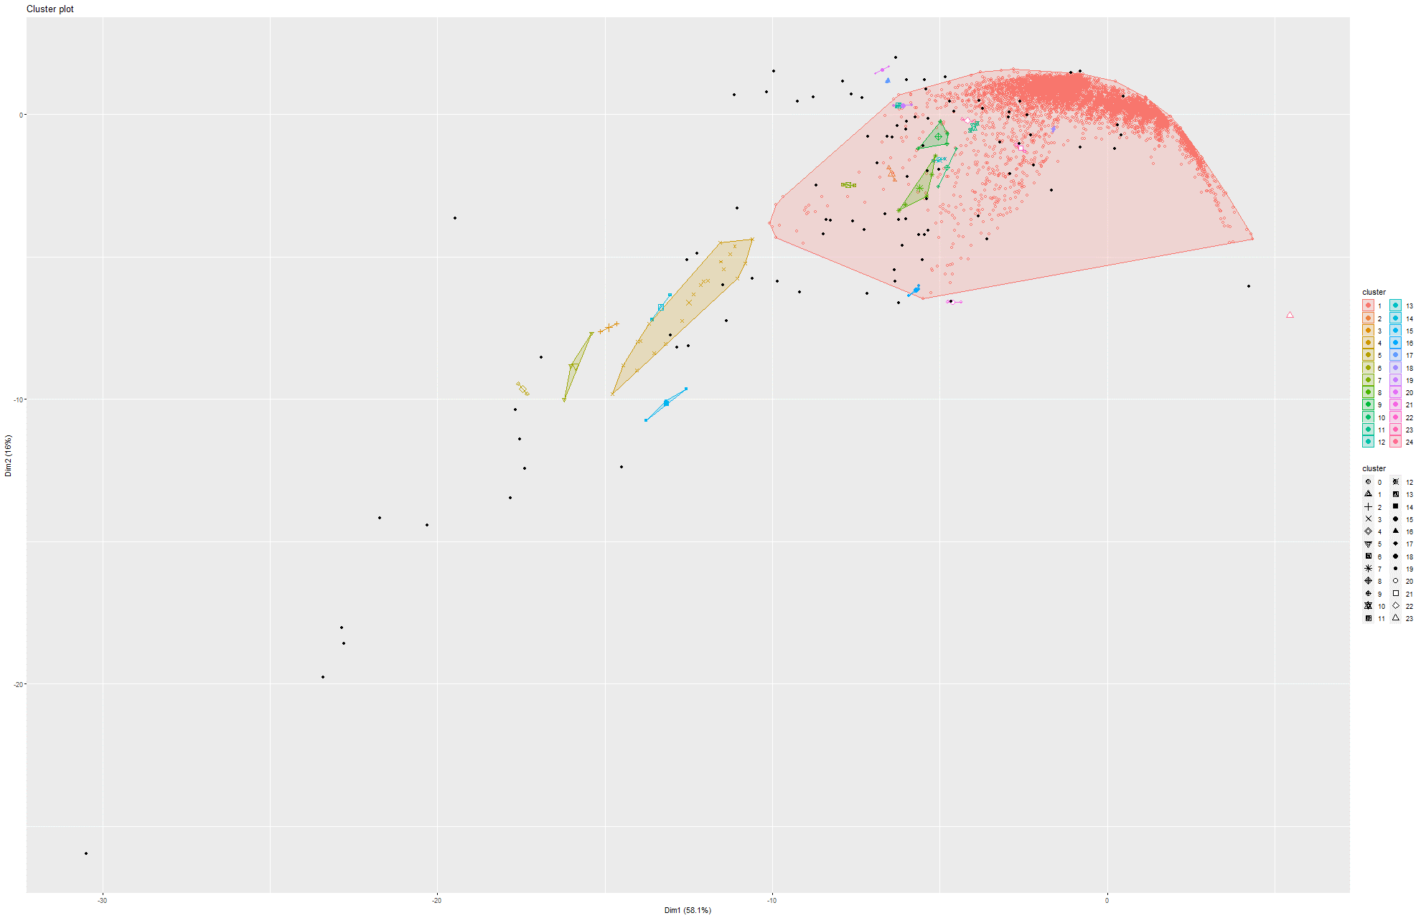Figure 157 and 158 Knee plot and DBSCAN on Model 6

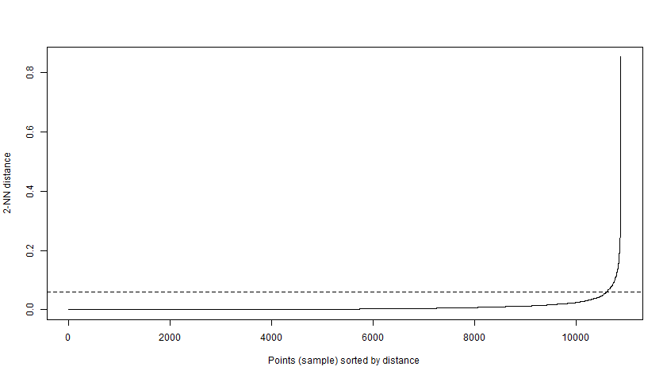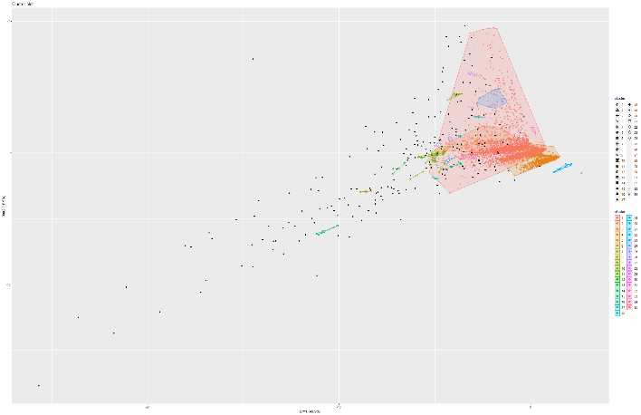Figure 159 and 160 Knee plot and DBSCAN on Model 7

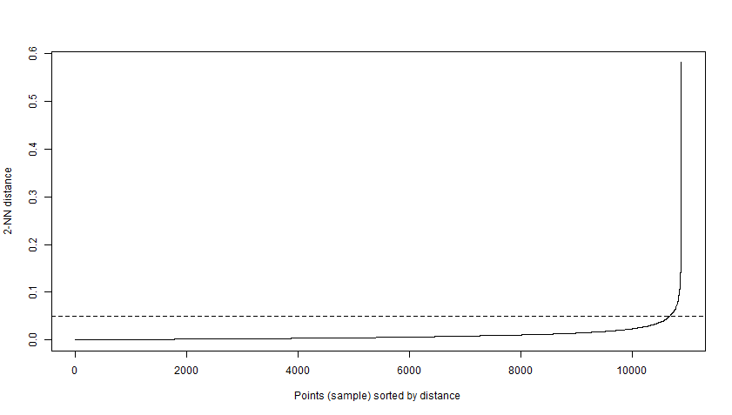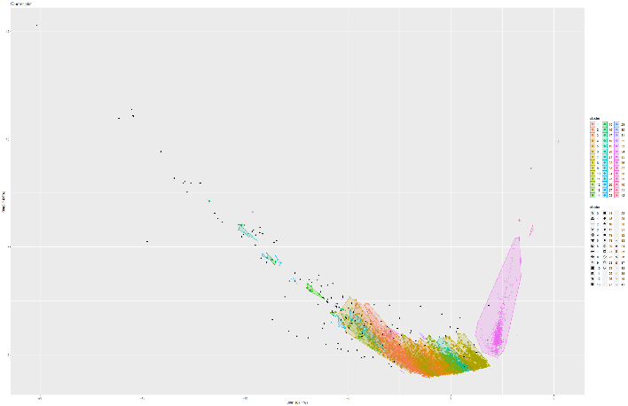Figure 161 and 162 Knee plot and DBSCAN on Model 8

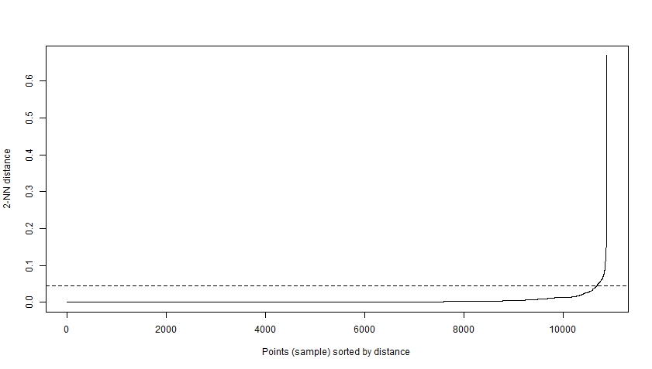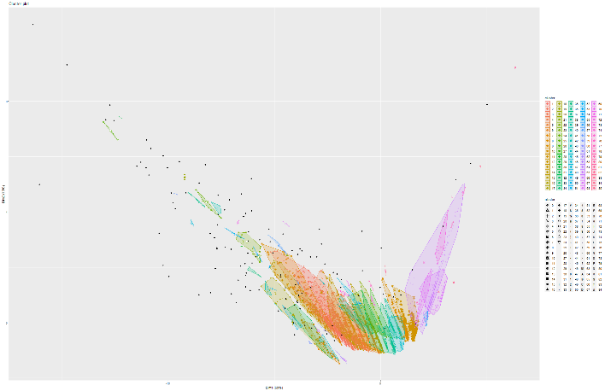Figure 163 and 164 Knee plot and DBSCAN on Model 9

## 6.2 CA-HepPh dataset

### 6.2.1 Boxplot and Correlation plots

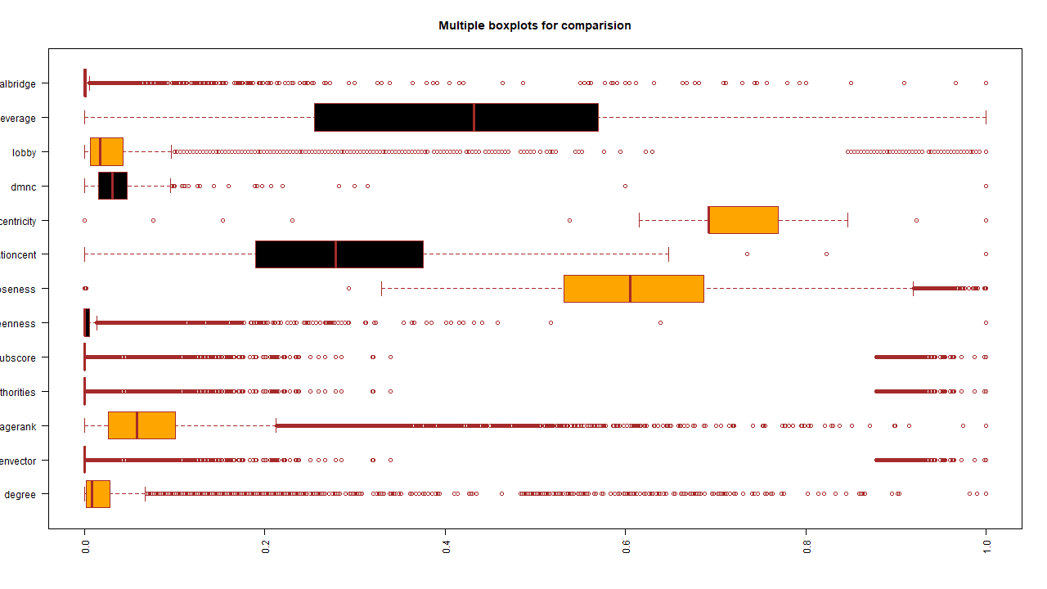Figure 165 Boxplot

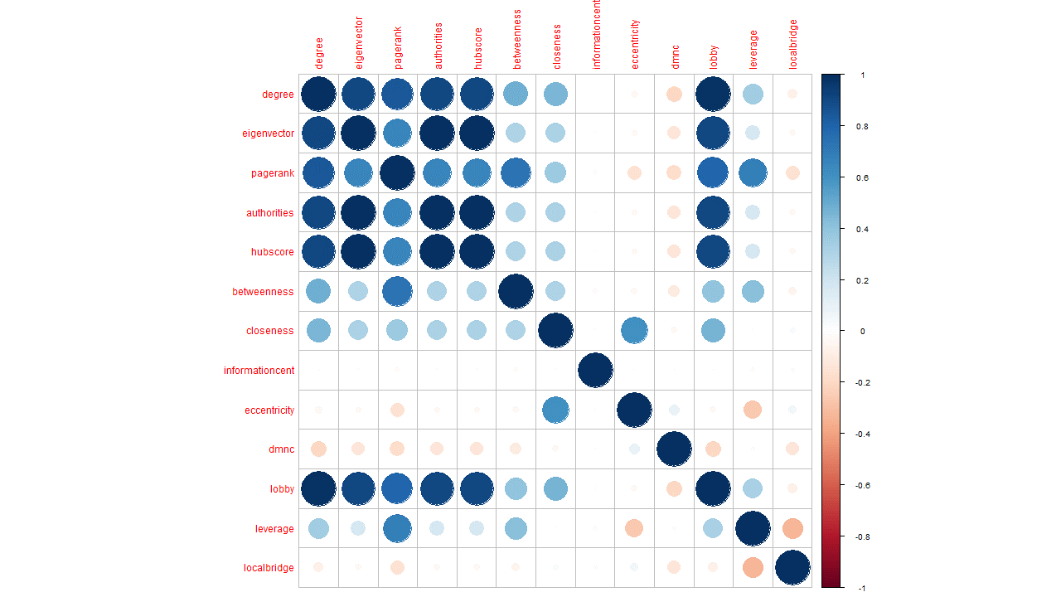

Figure 166 Correlation matrix

### 6.2.2 PCA

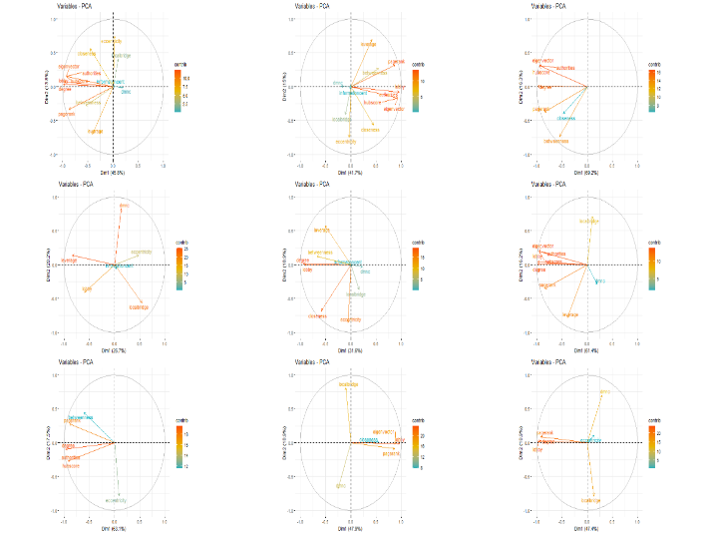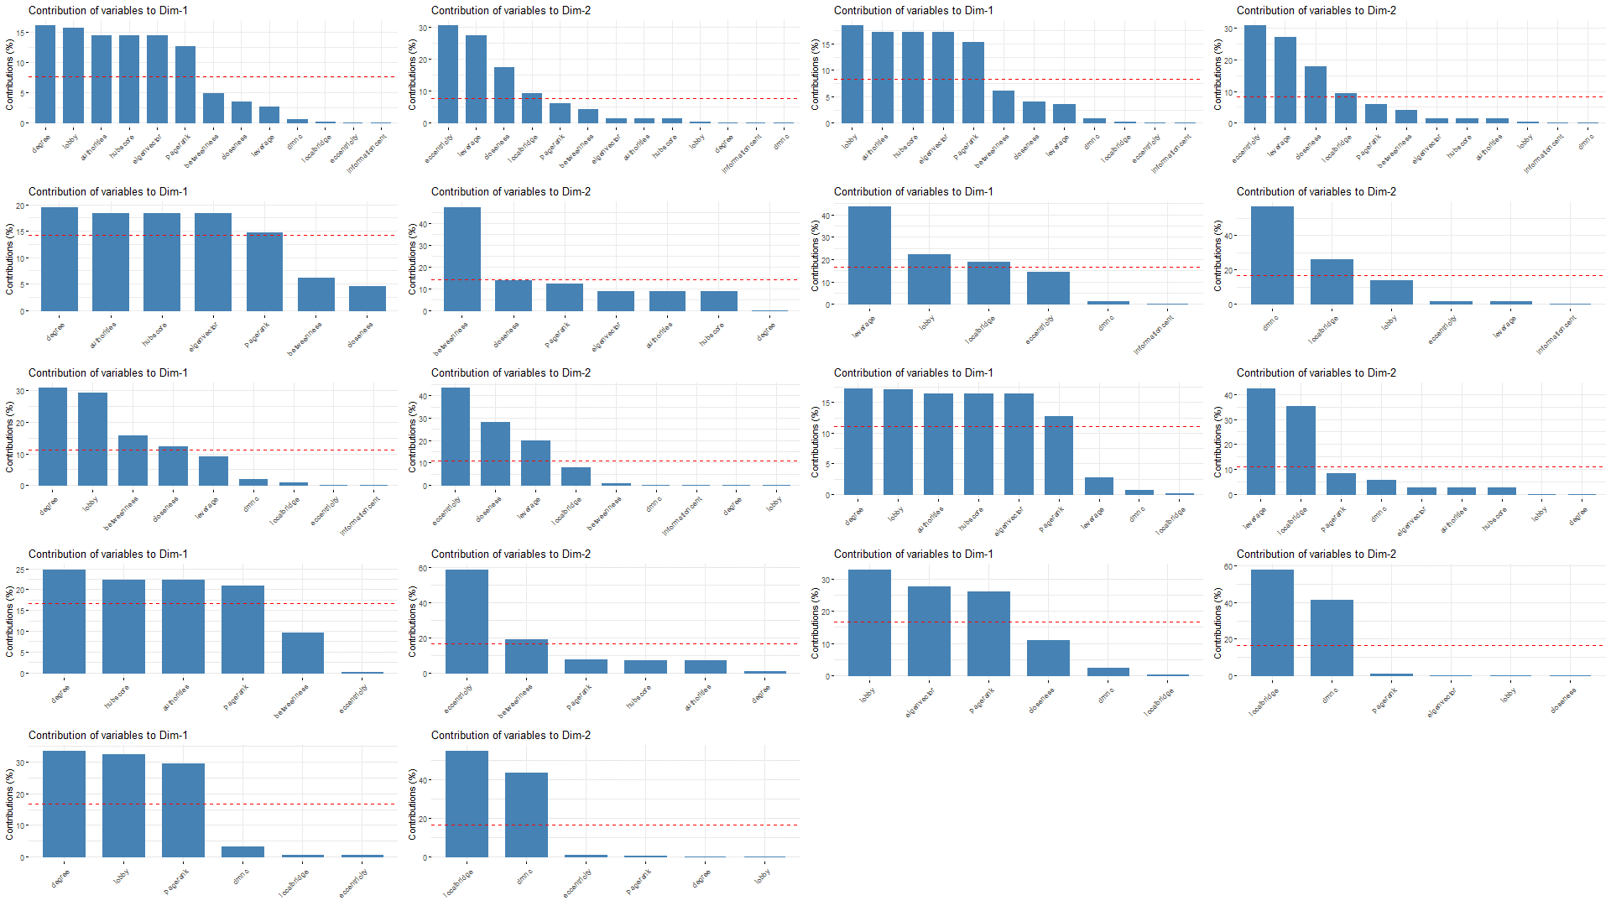Figure 167 PCA Figure 168 Dimension Contribution

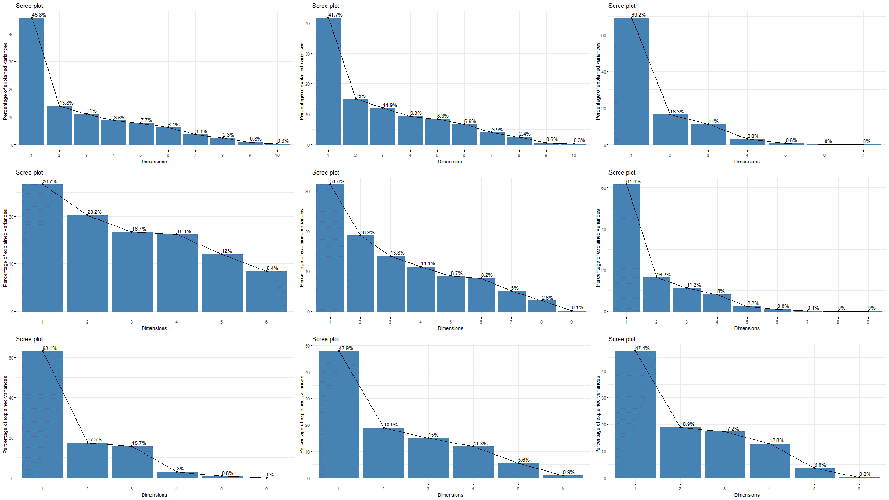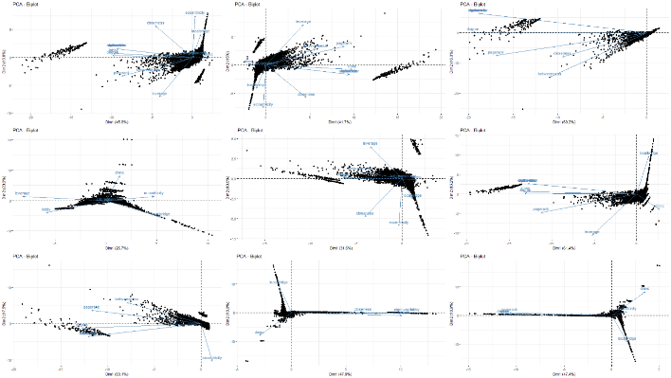Figure 169 Scree plot Figure 170 biplot

### 6.2.3 t-SNE and K-means on t-SNE

Model 1:

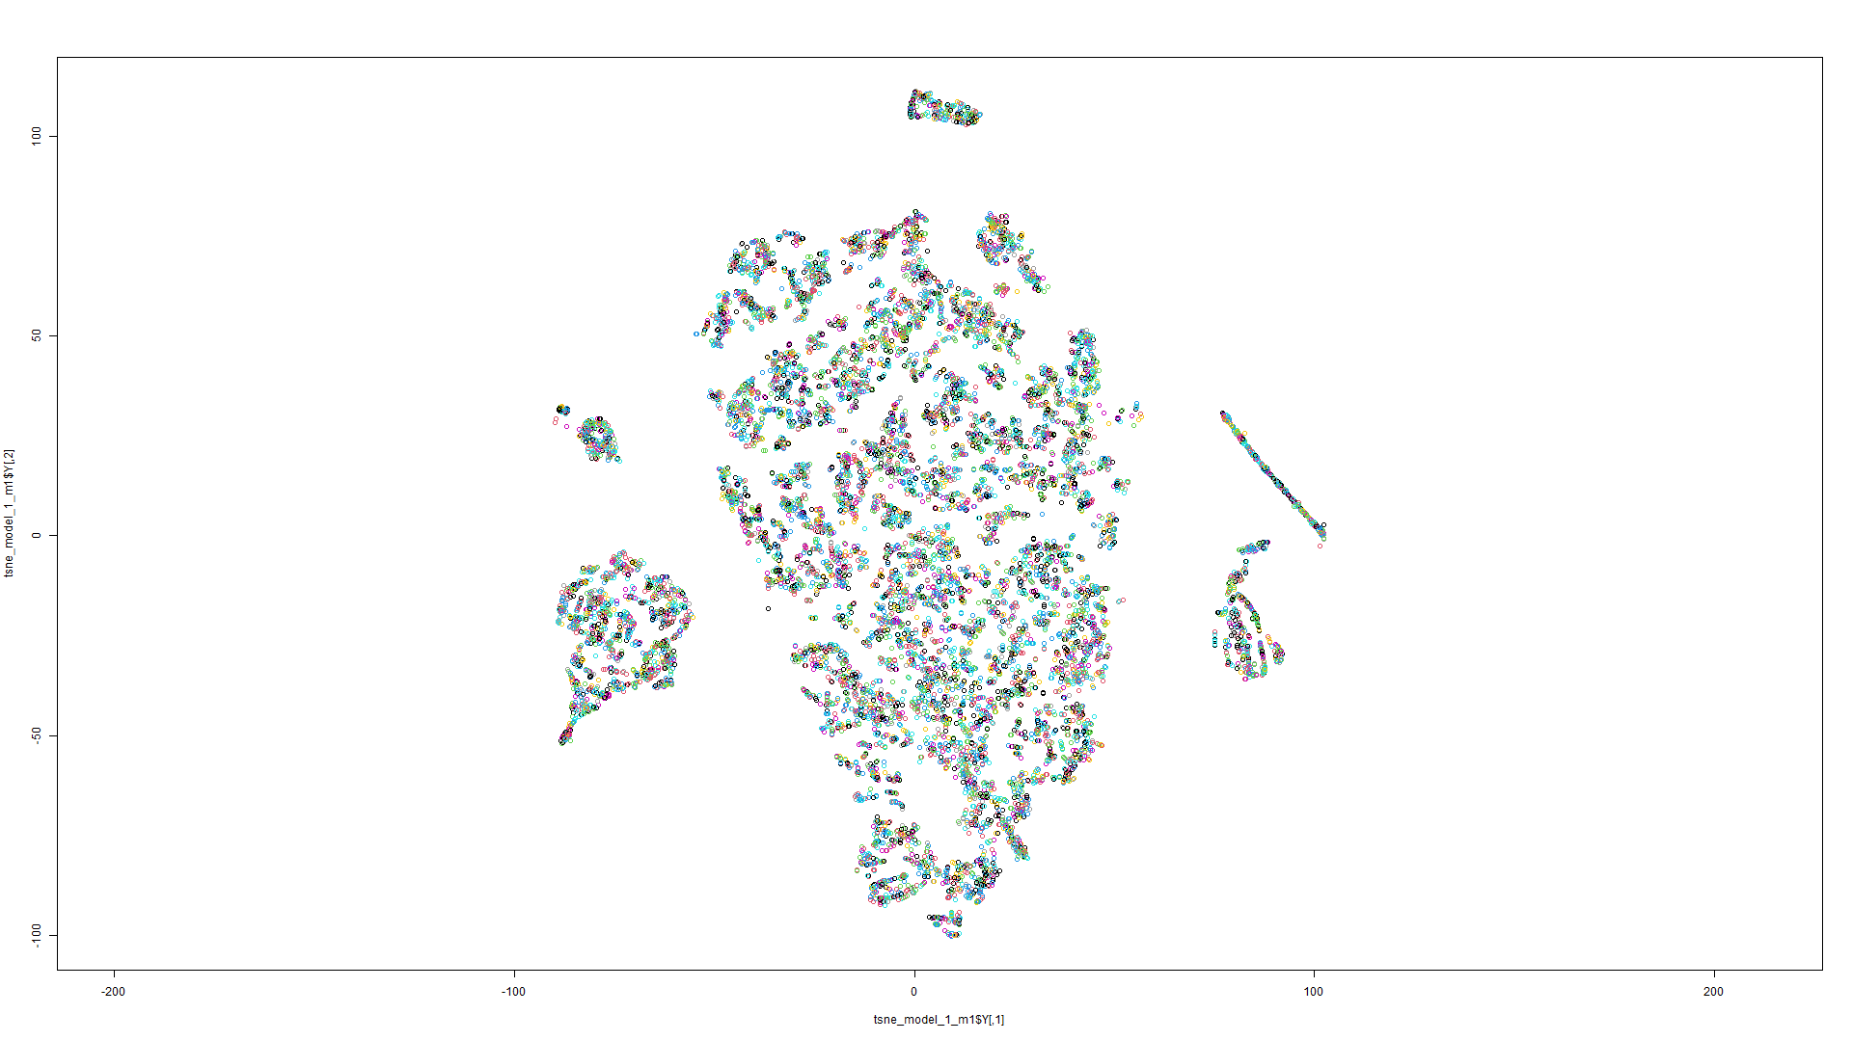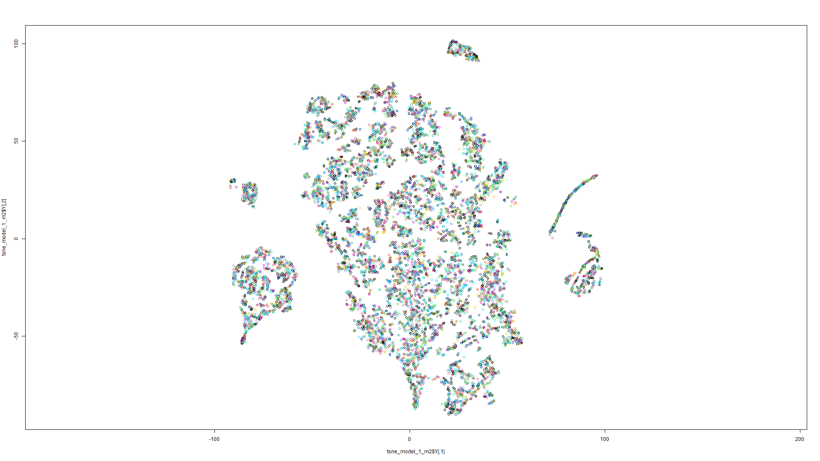

Figure 170 t-SNE on Model 1 Figure 171 t-SNE on Model 2

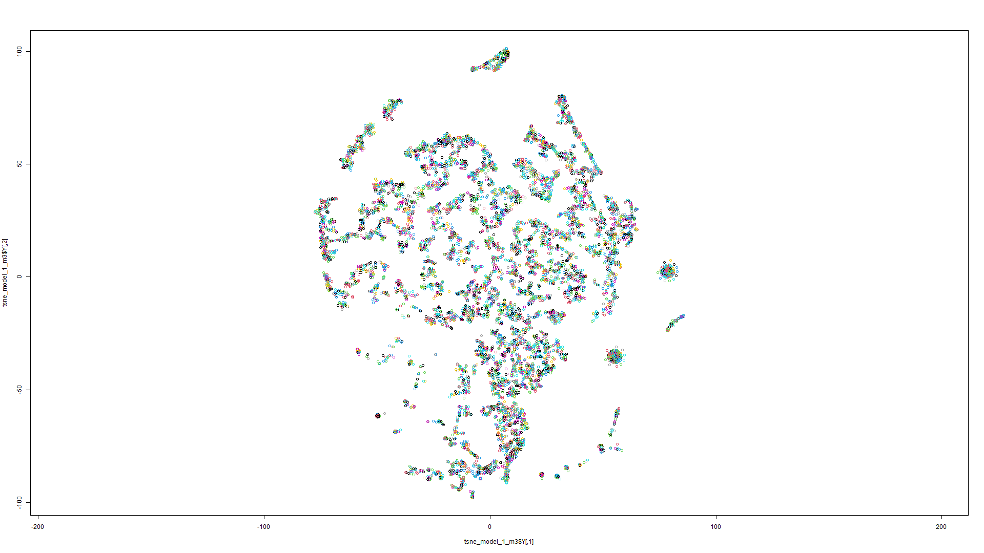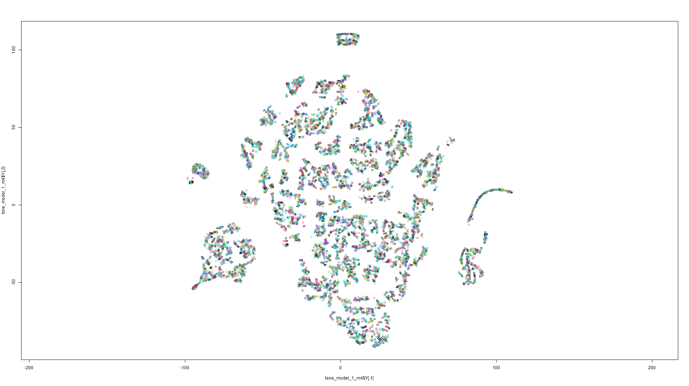Figure 172 t-SNE on Model 3 Figure 173 t-SNE on Model 4

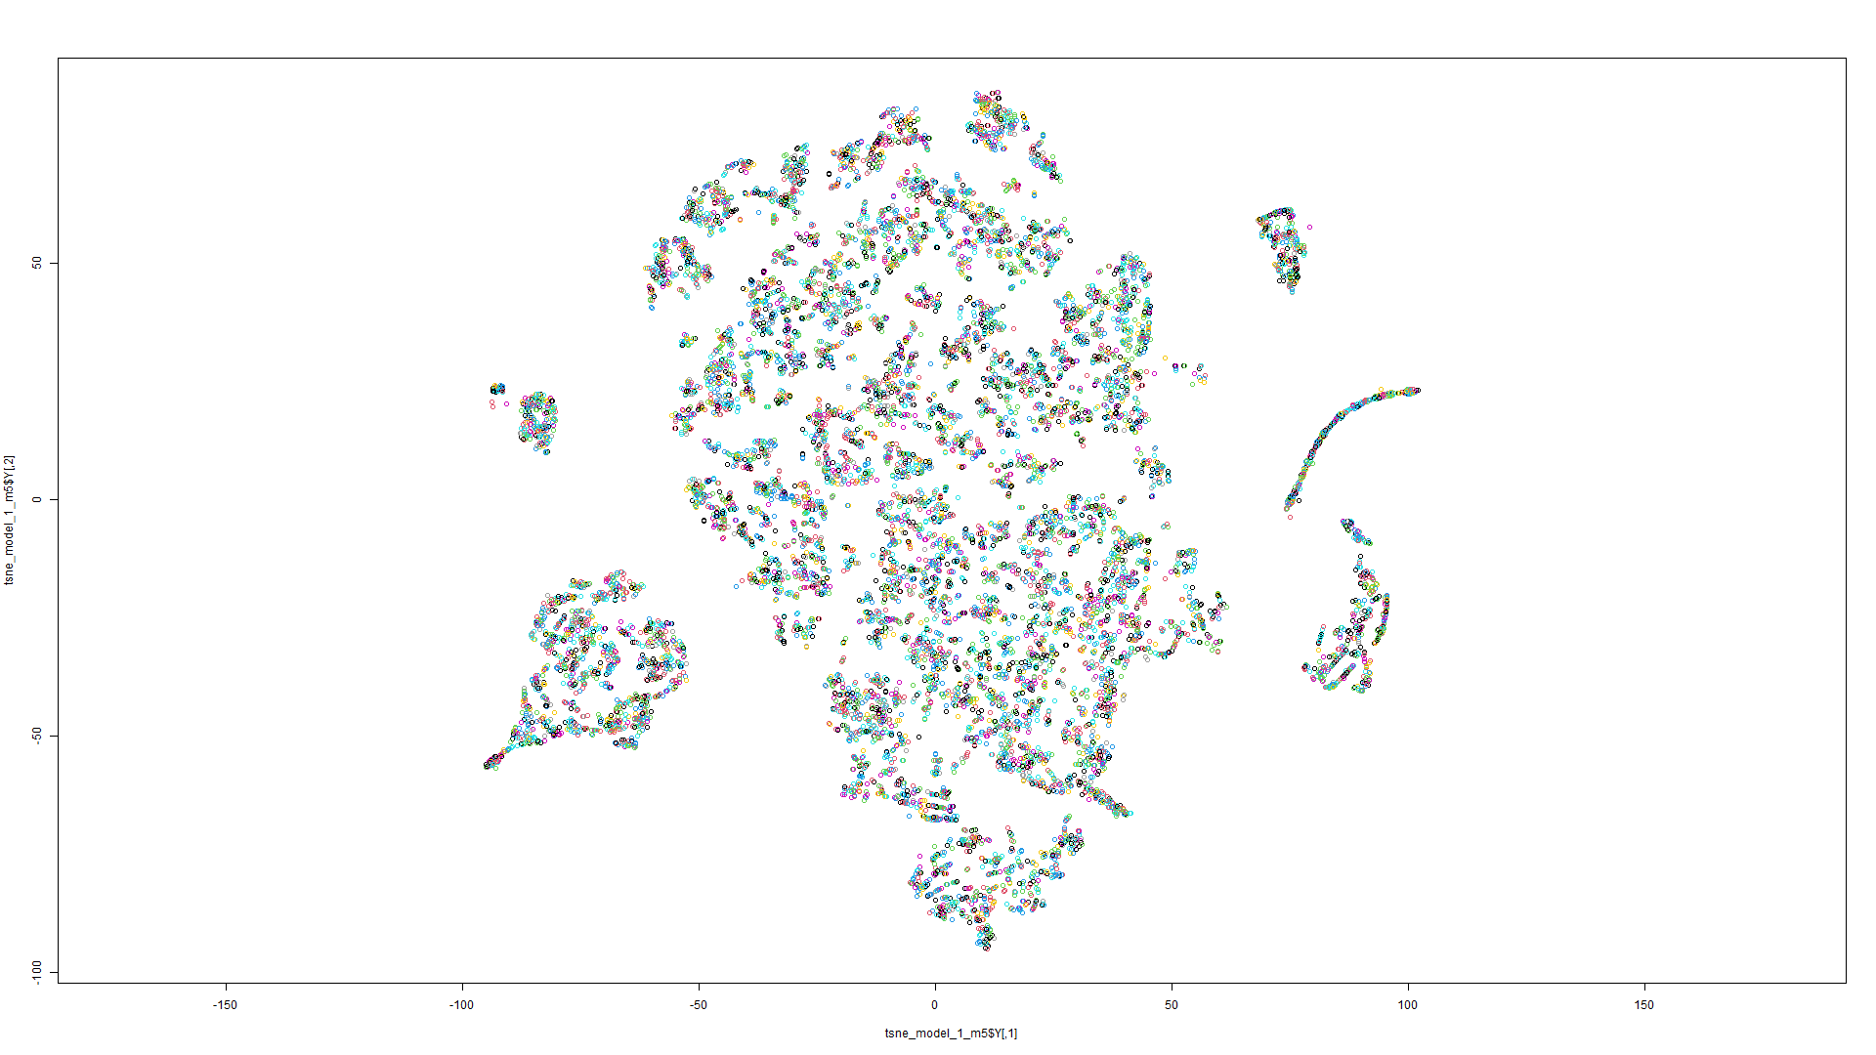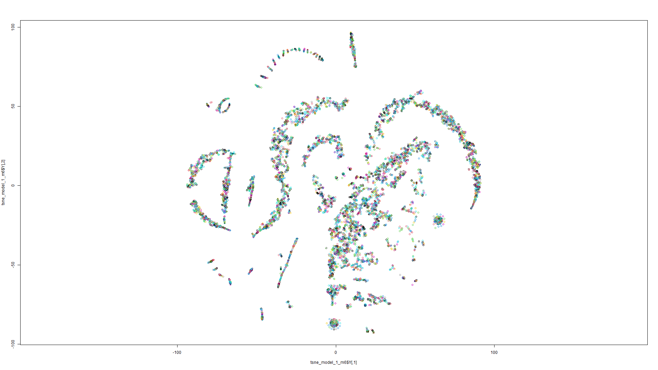Figure 174 t-SNE on Model 5 Figure 175 t-SNE on Model 6

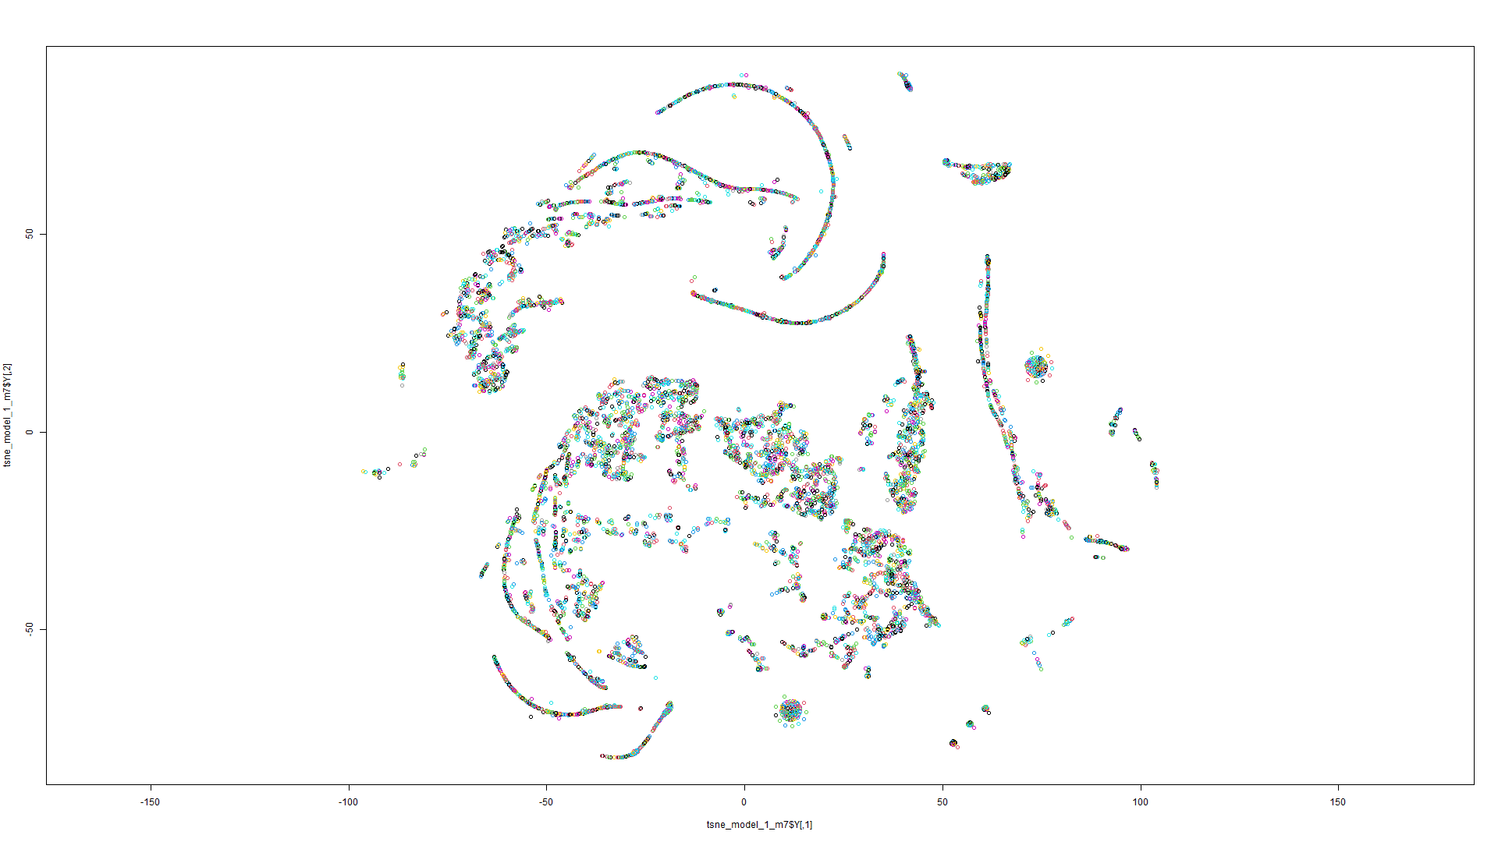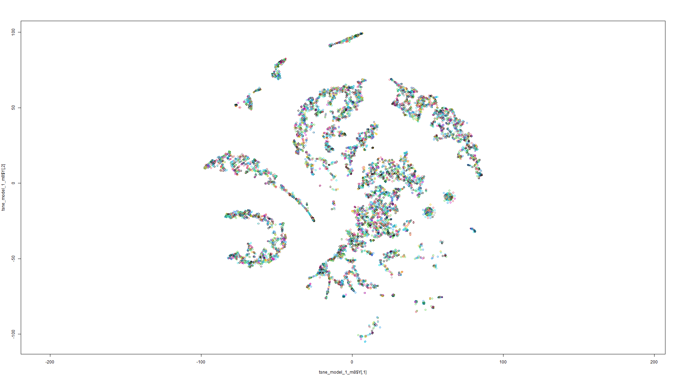Figure 176 t-SNE on Model 7 Figure 177 t-SNE on Model 8

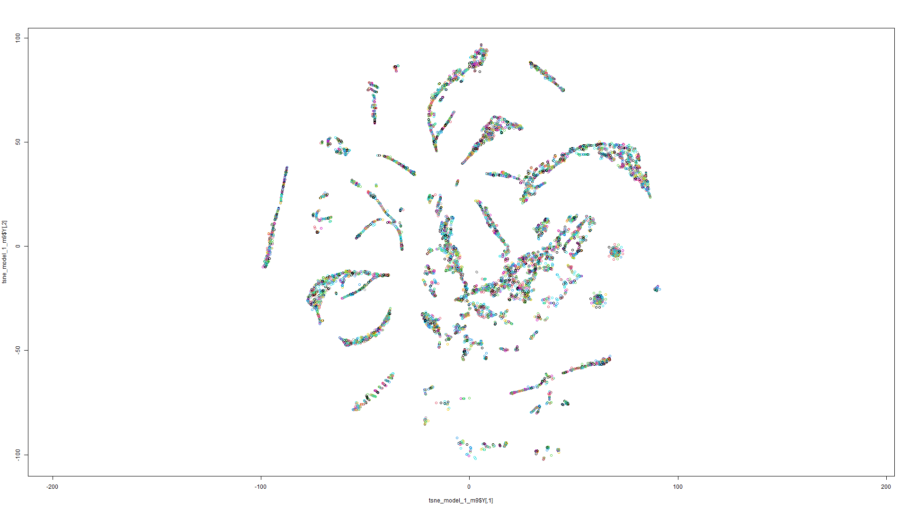

Figure 178 t-SNE on Model 9

Model 2:

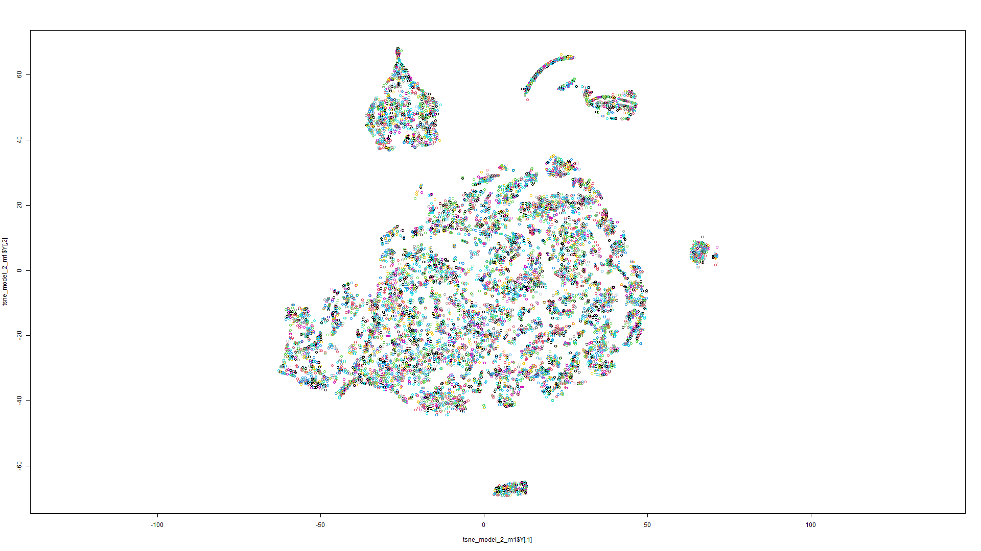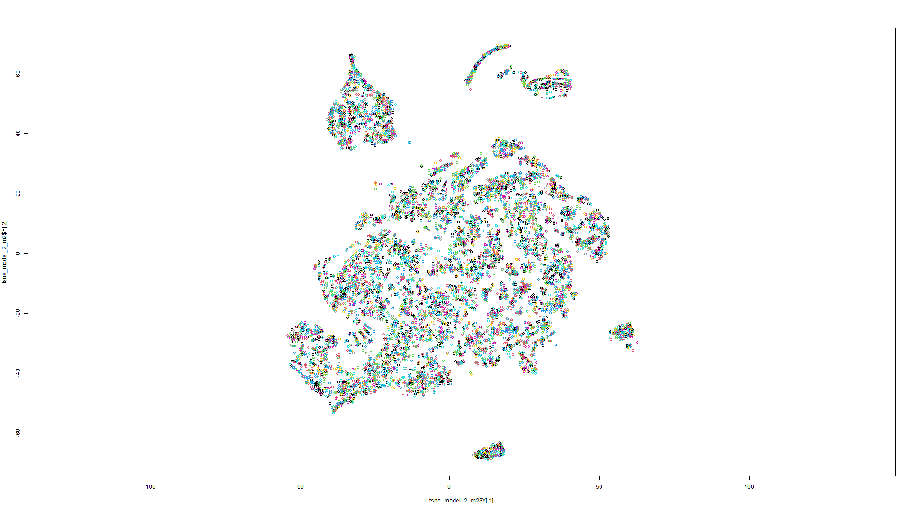Figure 179 t-SNE on Model 1 Figure 180 t-SNE on Model 2

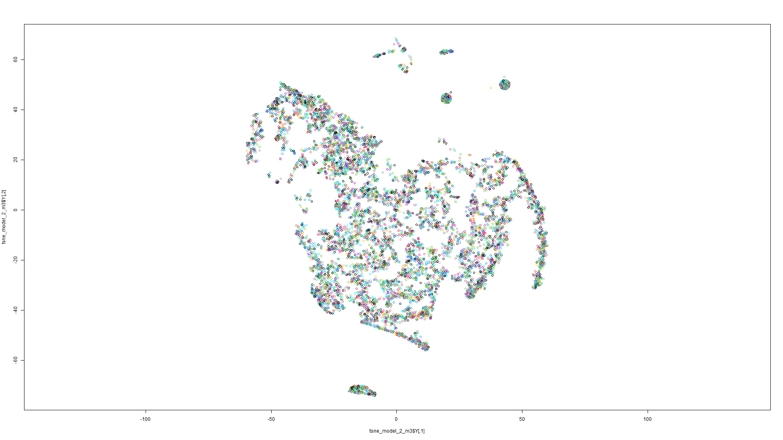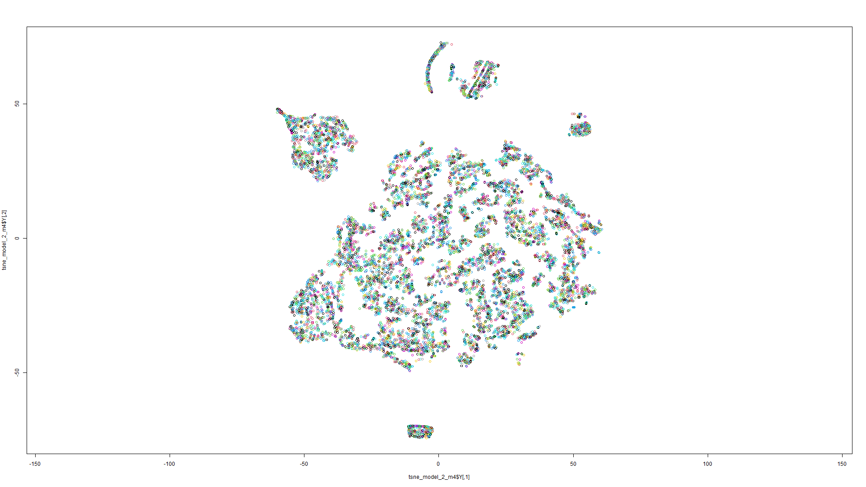Figure 181 t-SNE on Model 3 Figure 182 t-SNE on Model 4

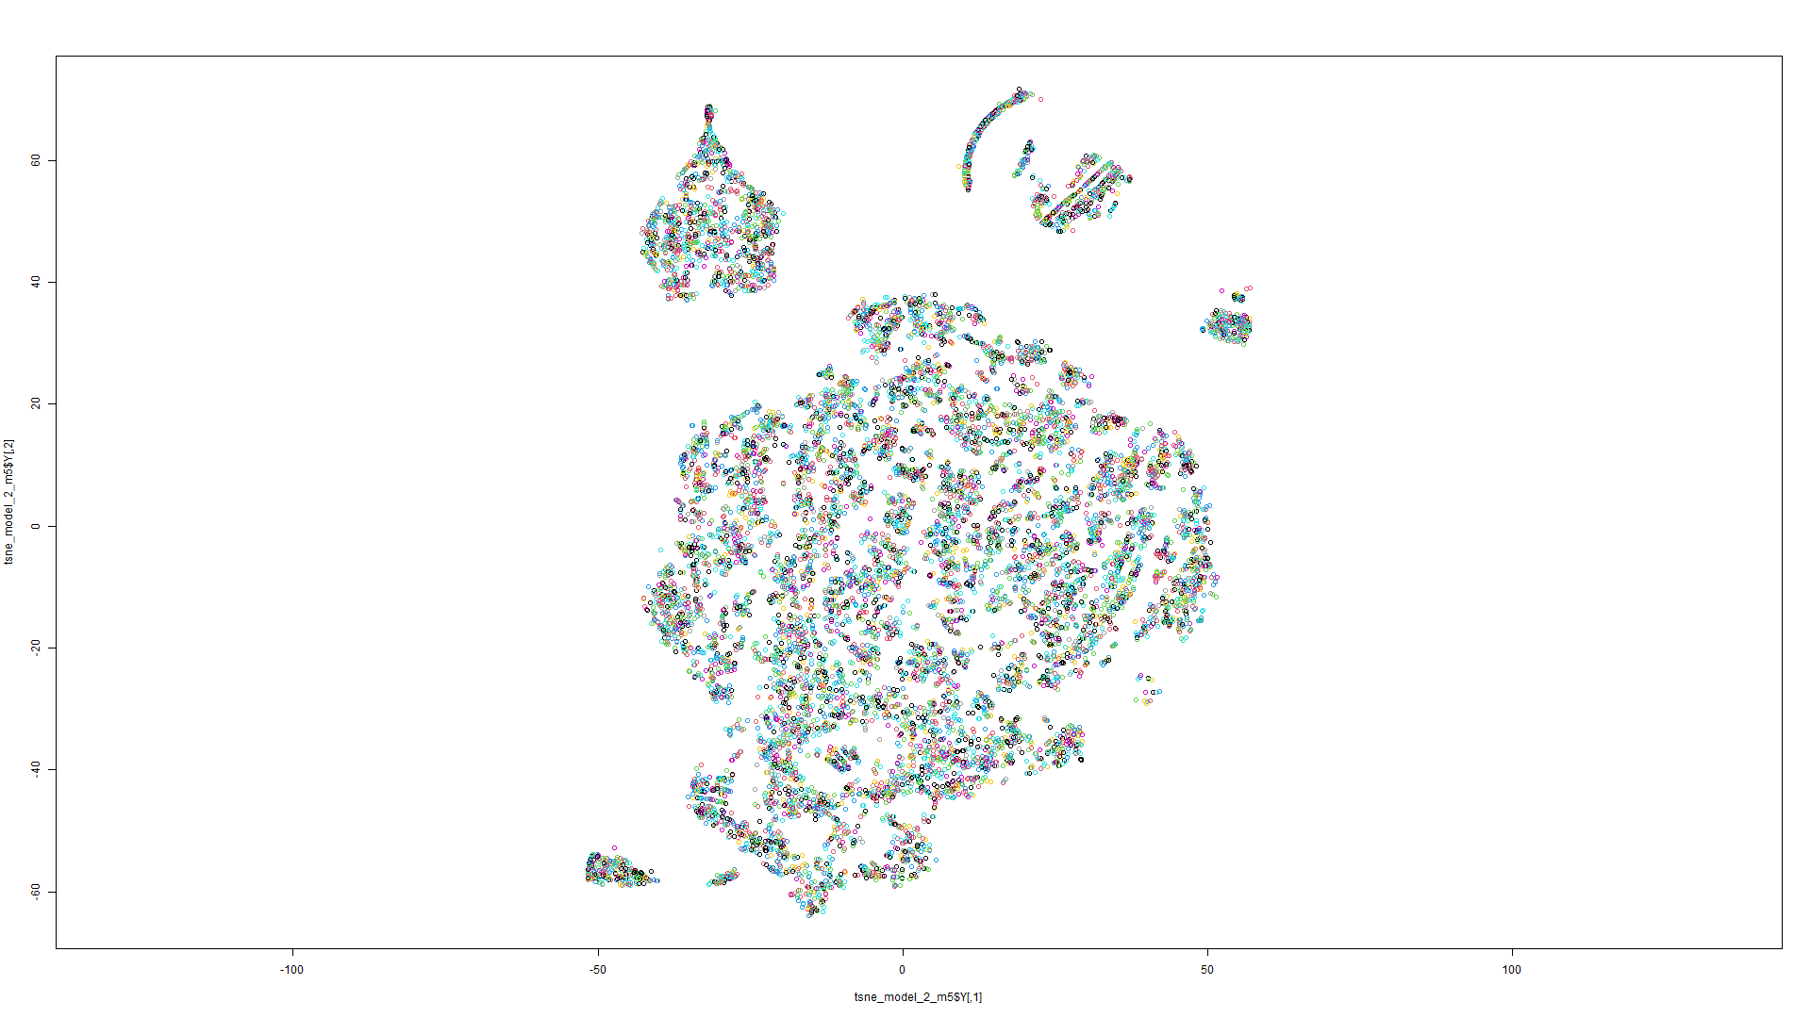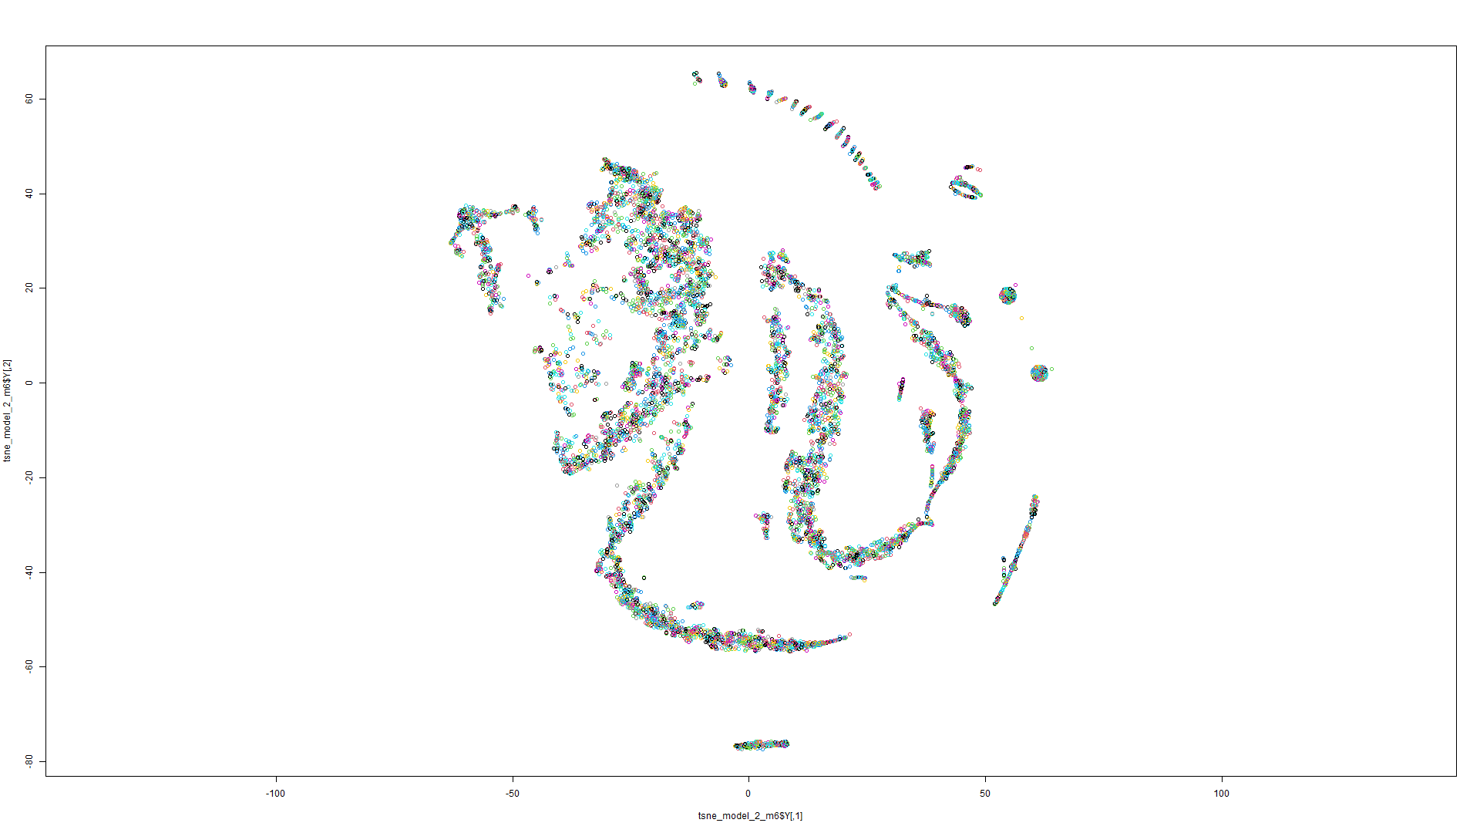Figure 183 t-SNE on Model 5 Figure 184 t-SNE on Model 6

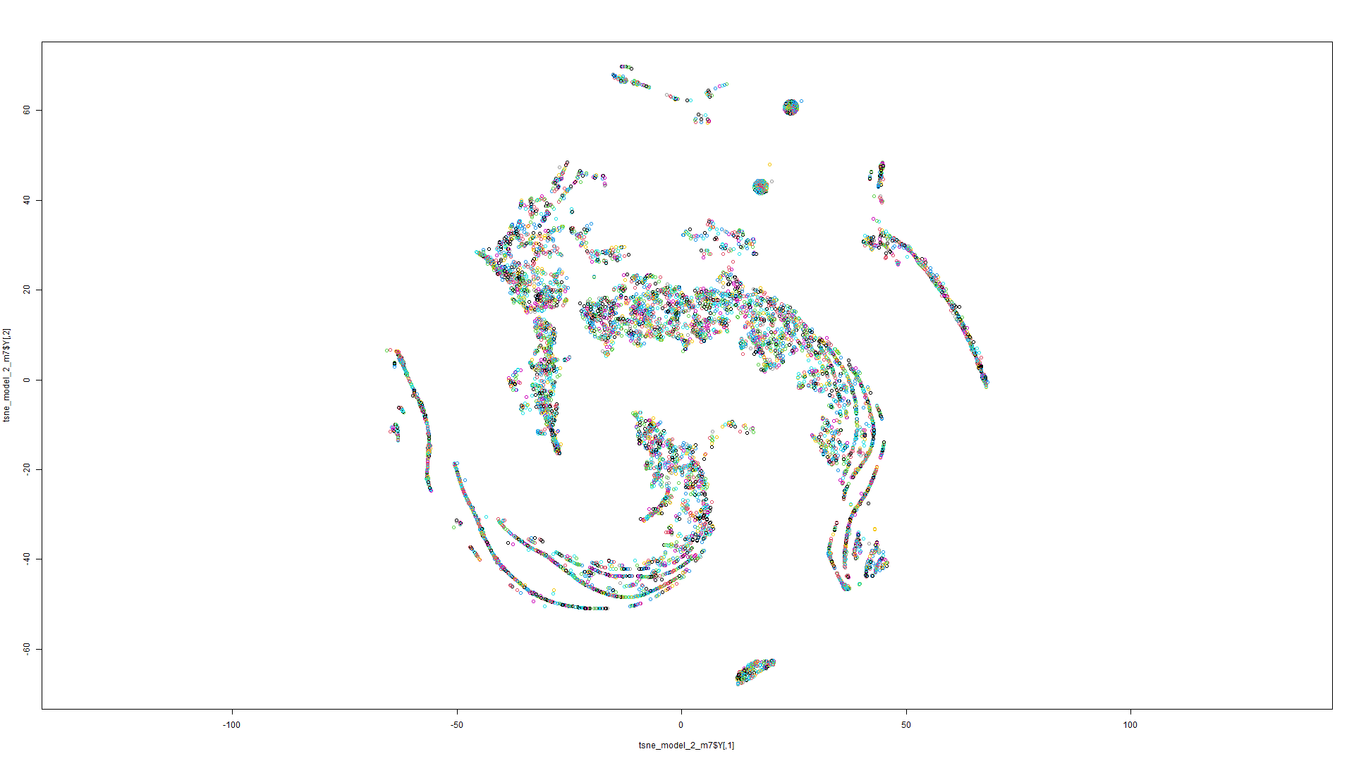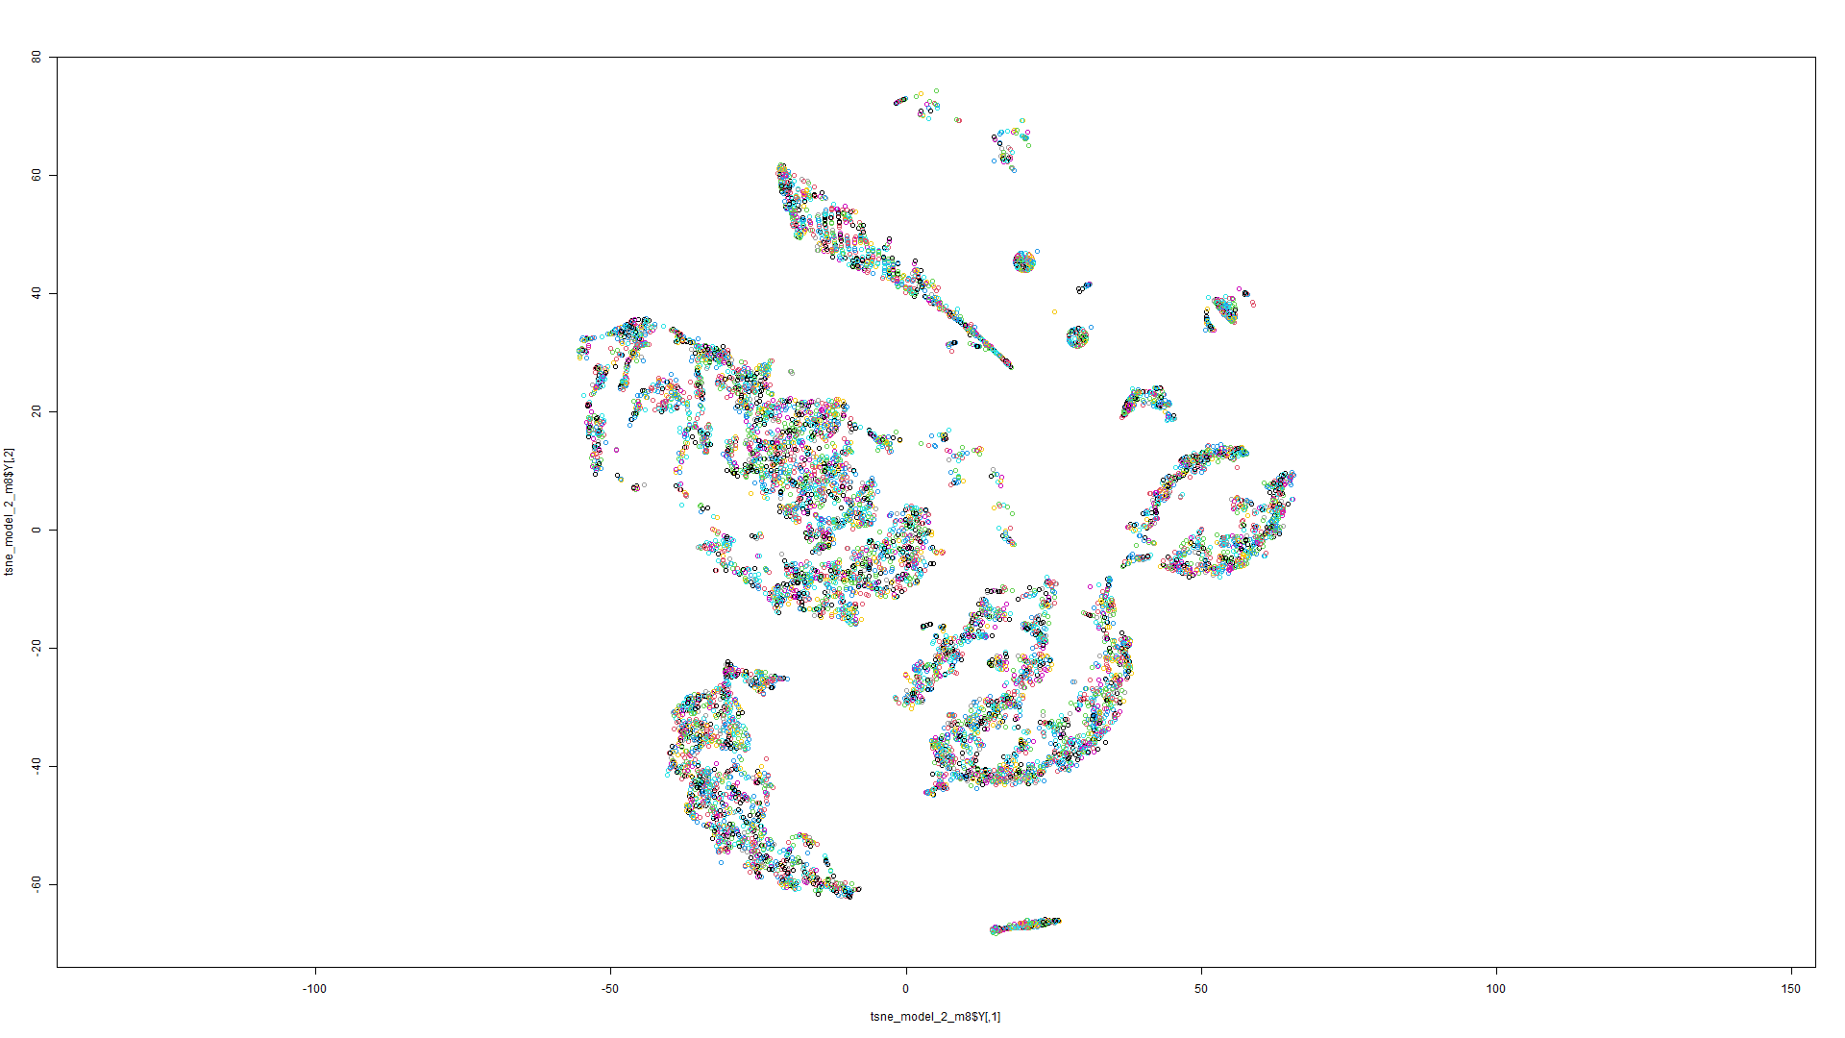Figure 185 t-SNE on Model 7 Figure 186 t-SNE on Model 8

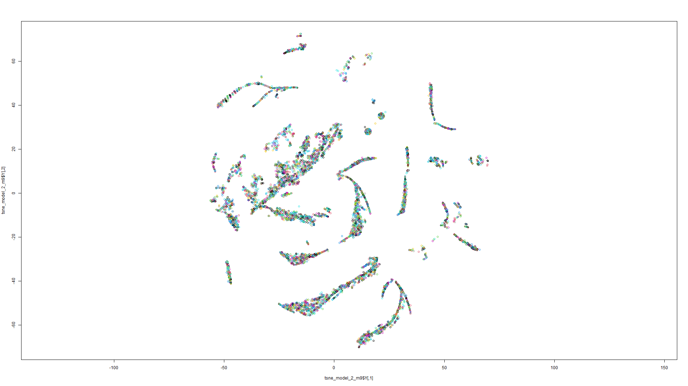

Figure 187 t-SNE on Model 9

Model 3:

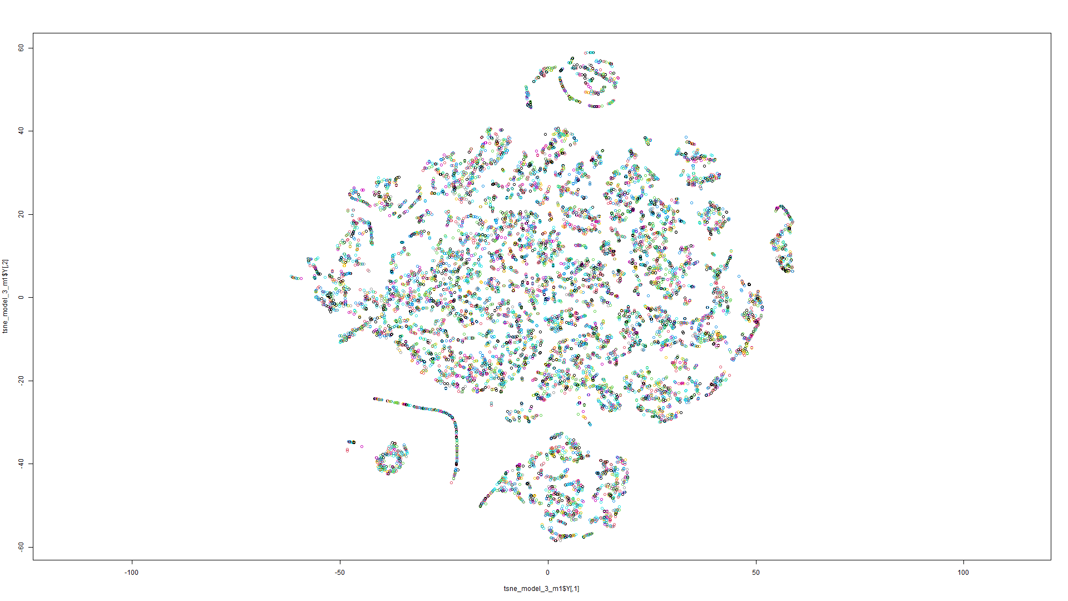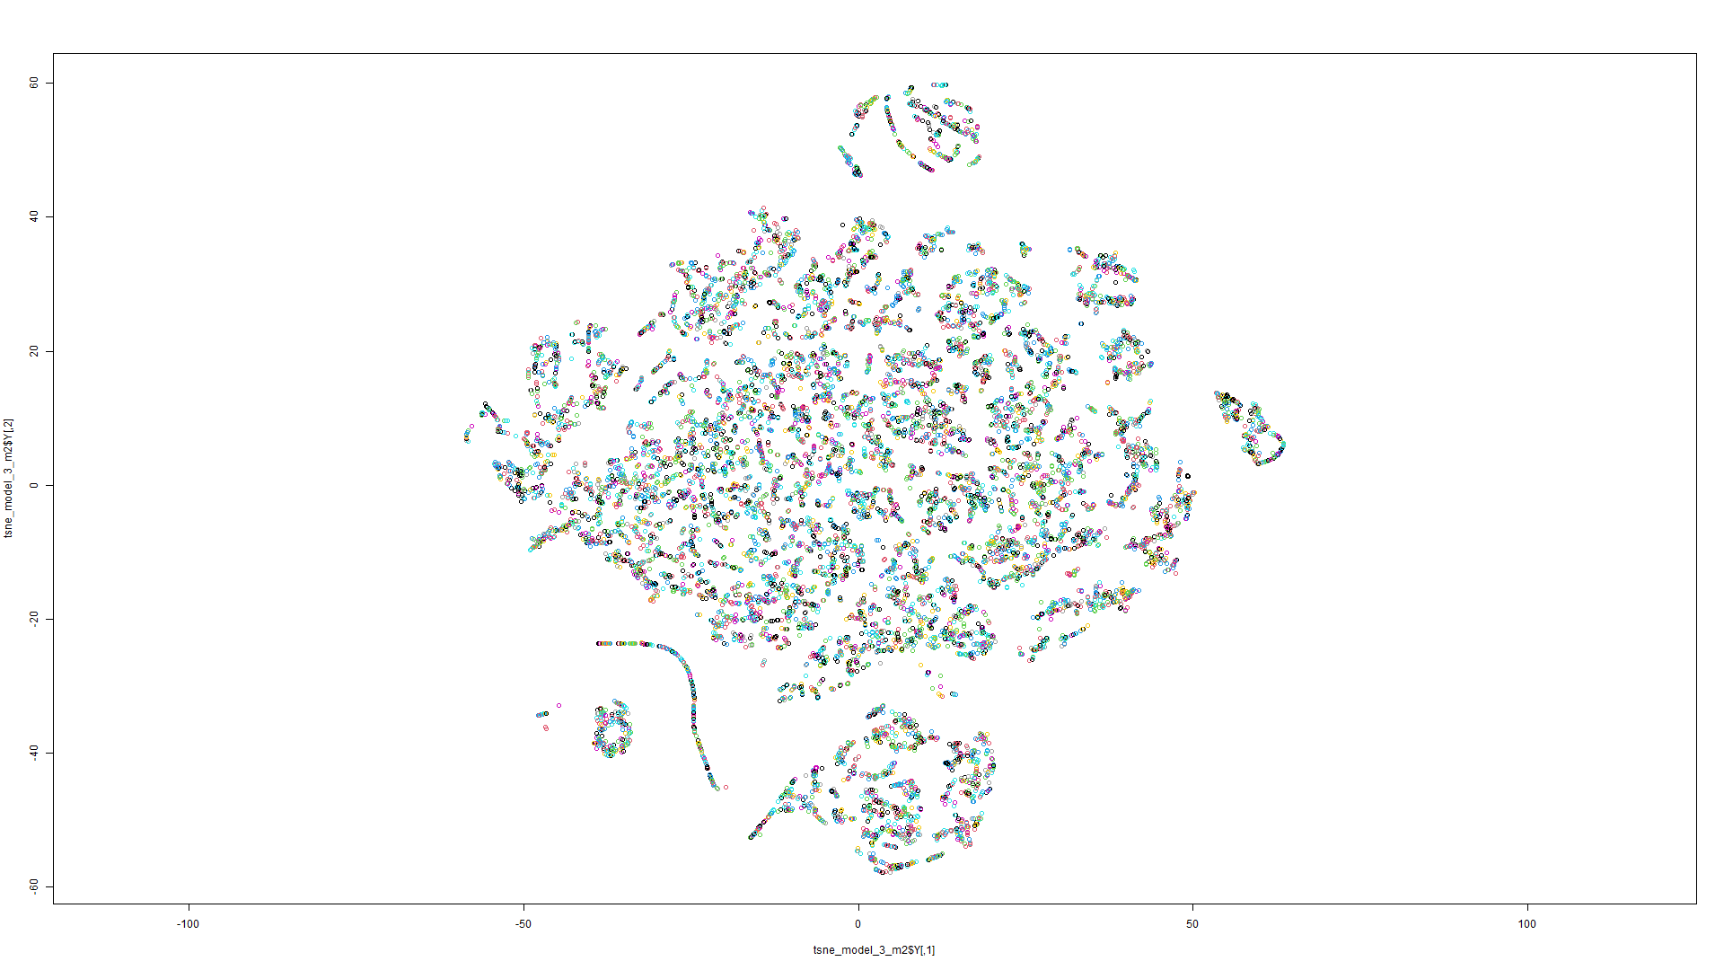Figure 188 t-SNE on Model 1 Figure 189 t-SNE on Model 2

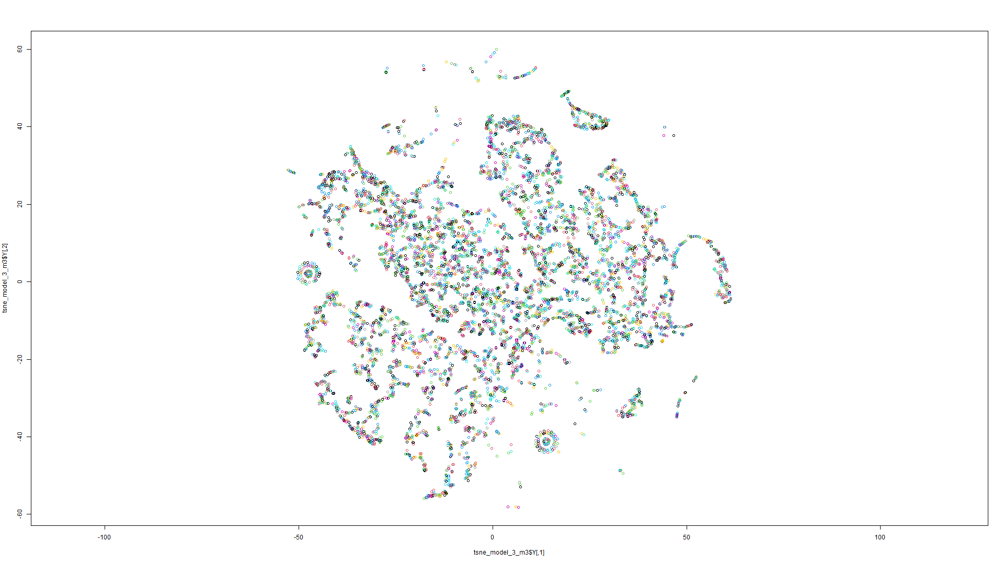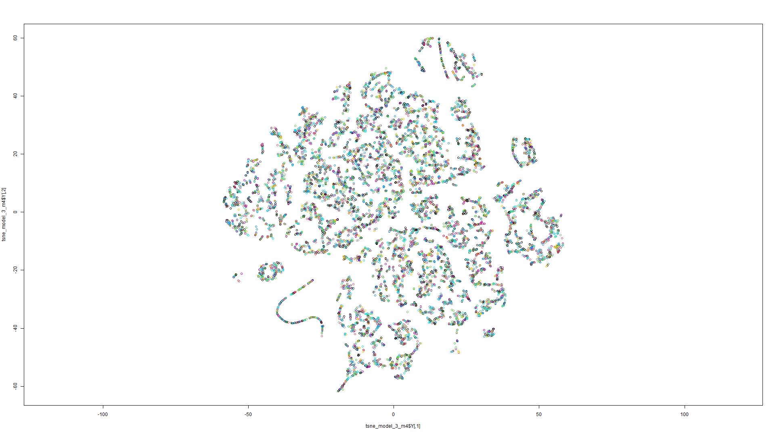Figure 190 t-SNE on Model 3 Figure 191 t-SNE on Model 4

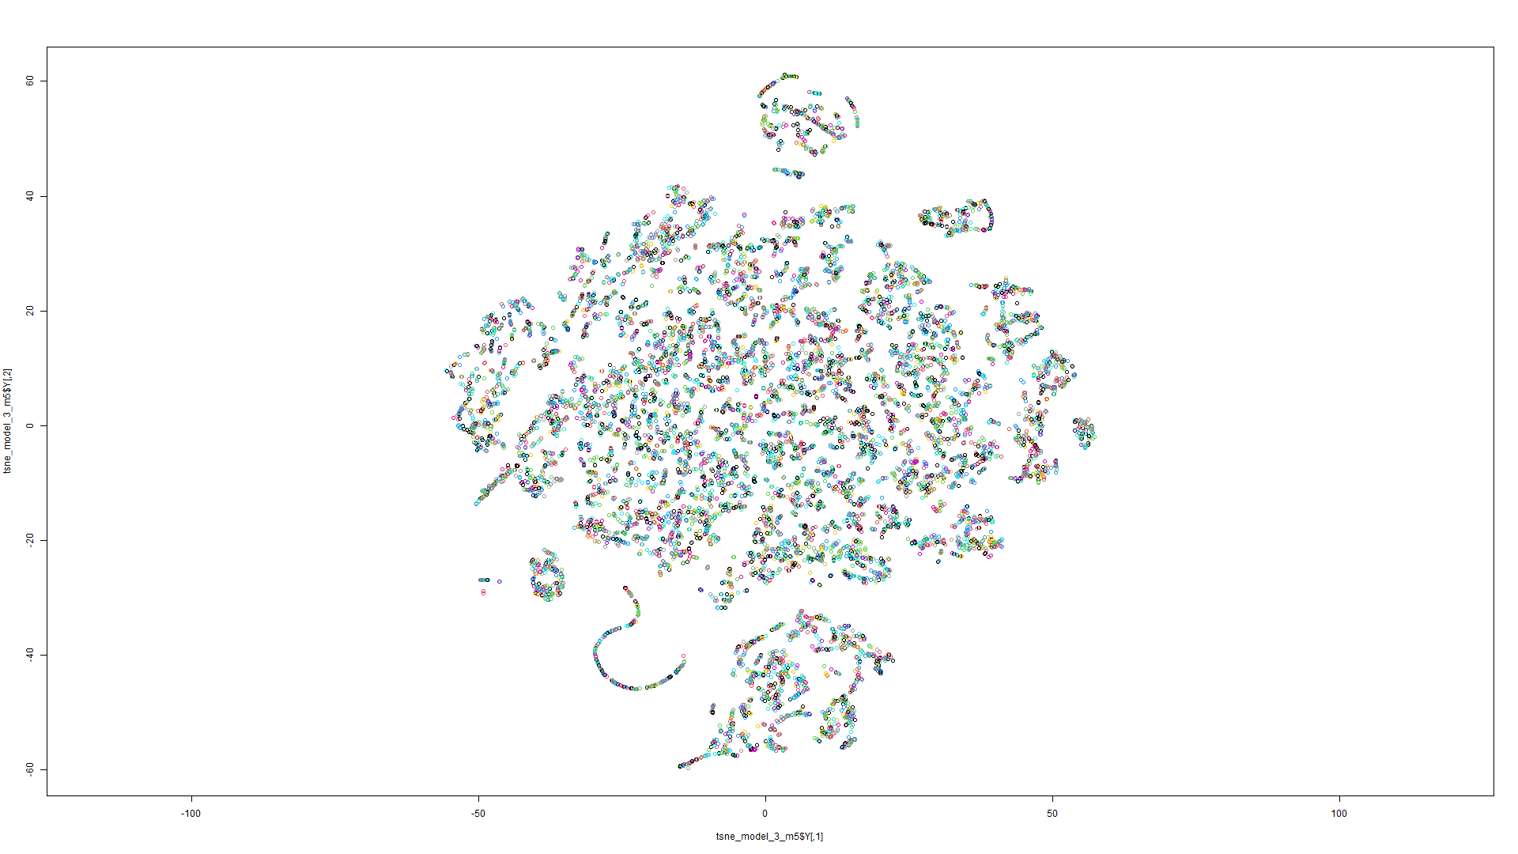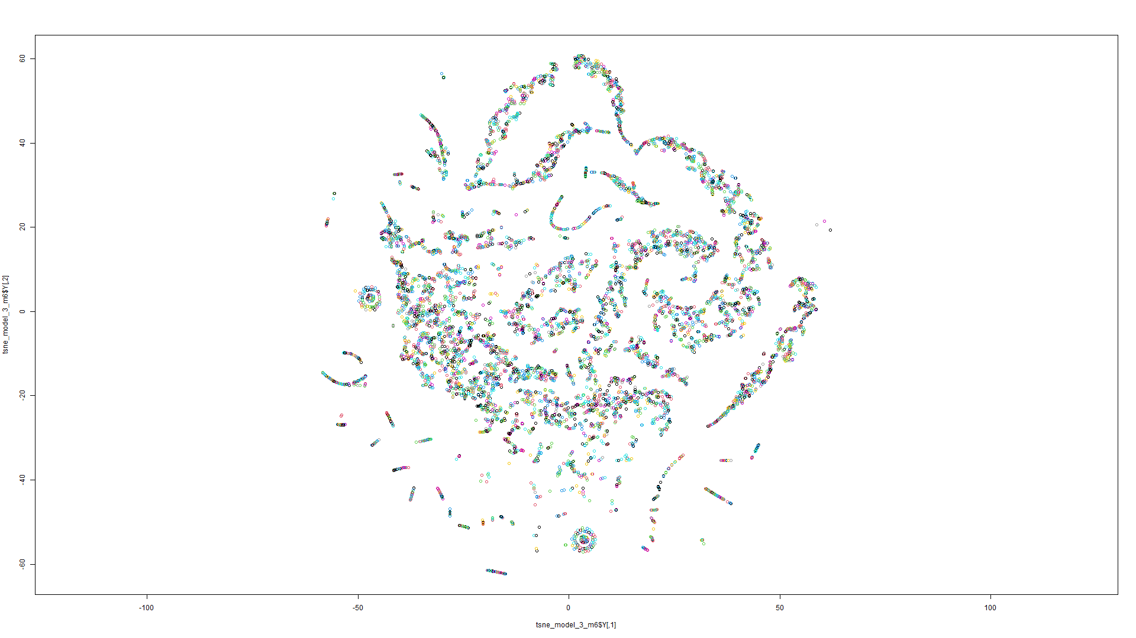Figure 192 t-SNE on Model 5 Figure 193 t-SNE on Model 6

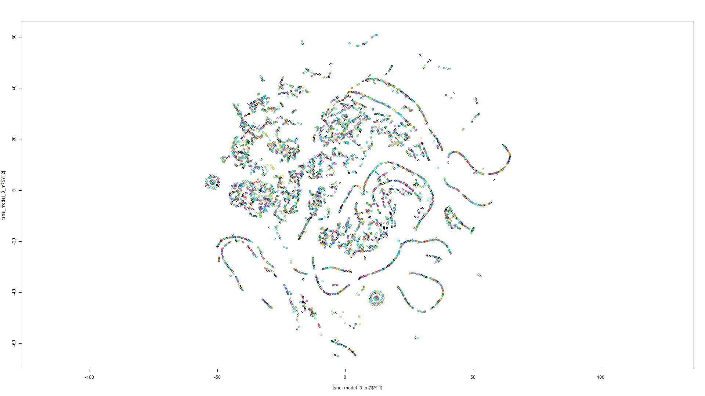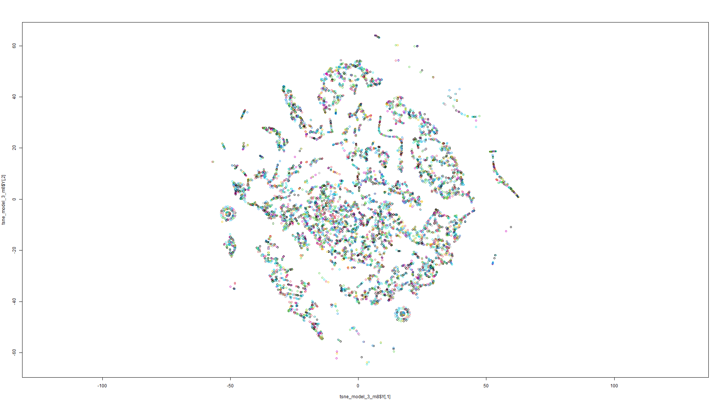Figure 194 t-SNE on Model 7 Figure 195 t-SNE on Model 8

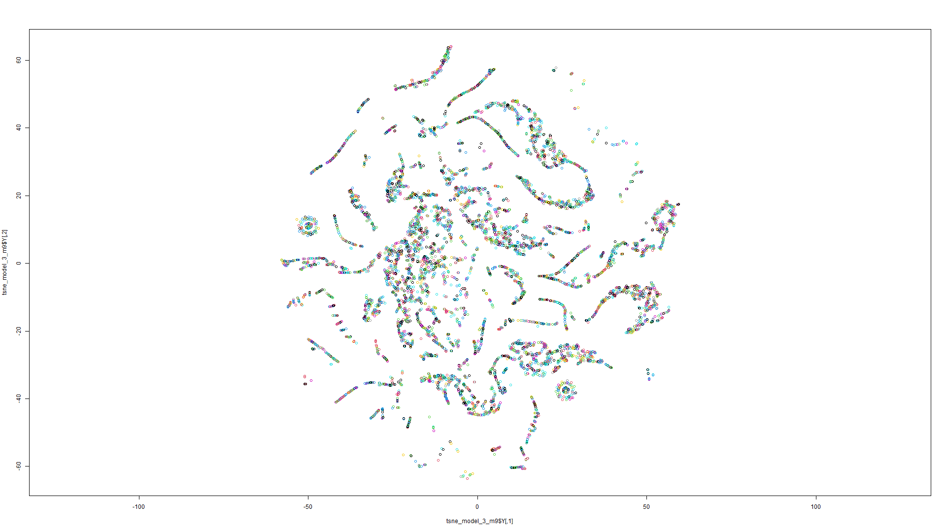

Figure 196 t-SNE on Model 9

Model 4:

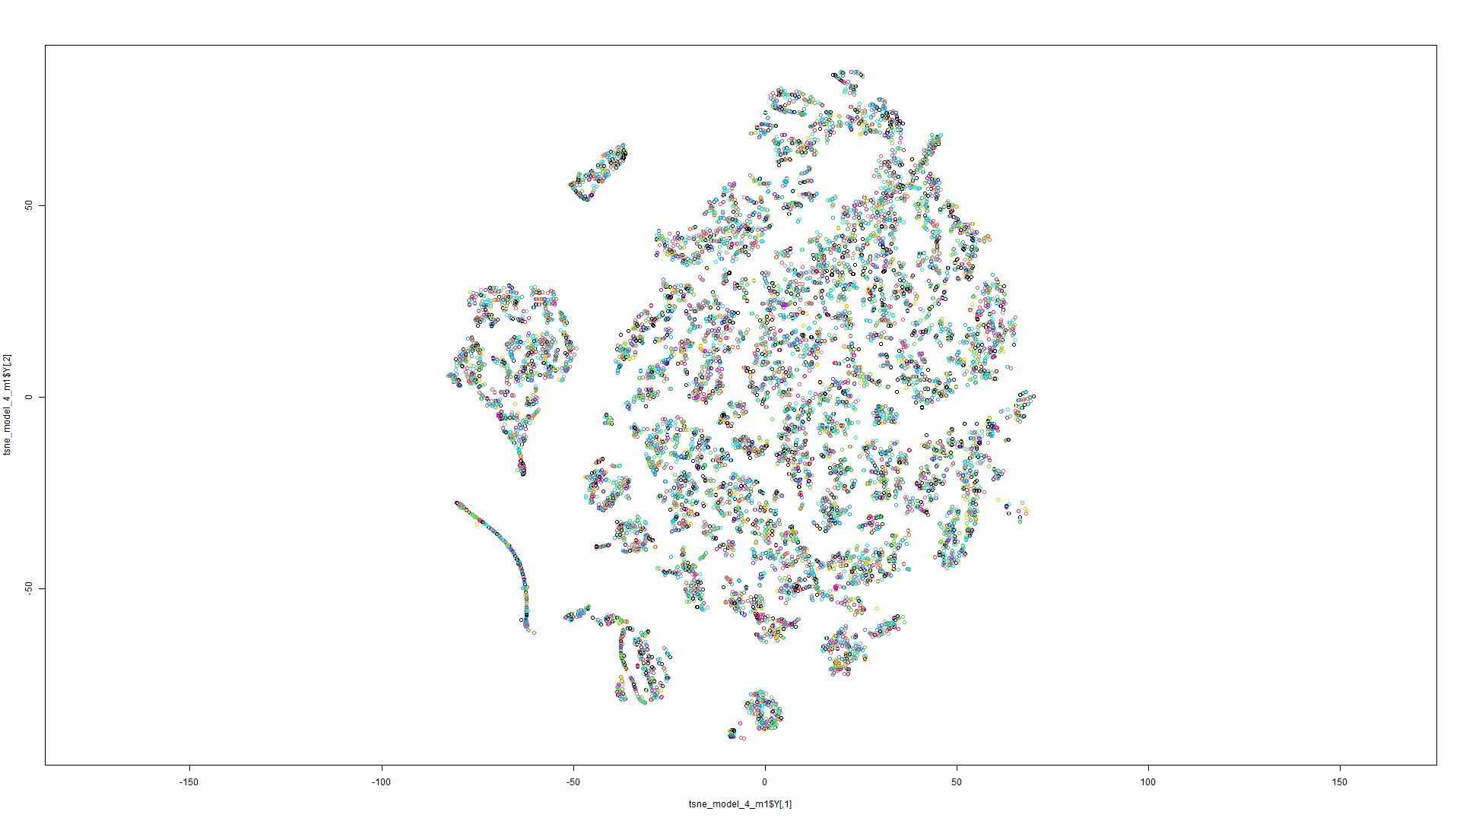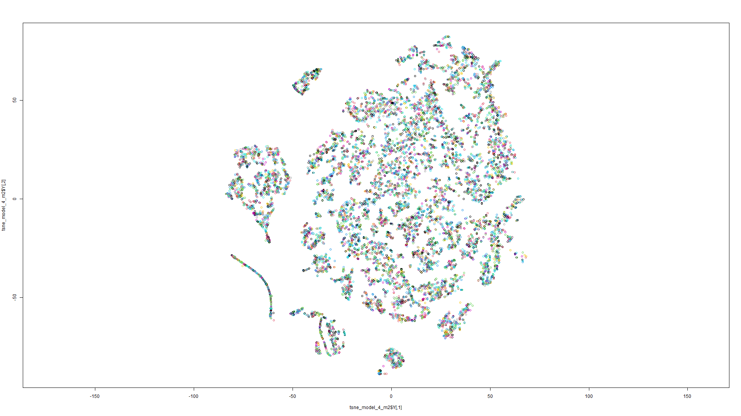Figure 197 t-SNE on Model 1 Figure 198 t-SNE on Model 2

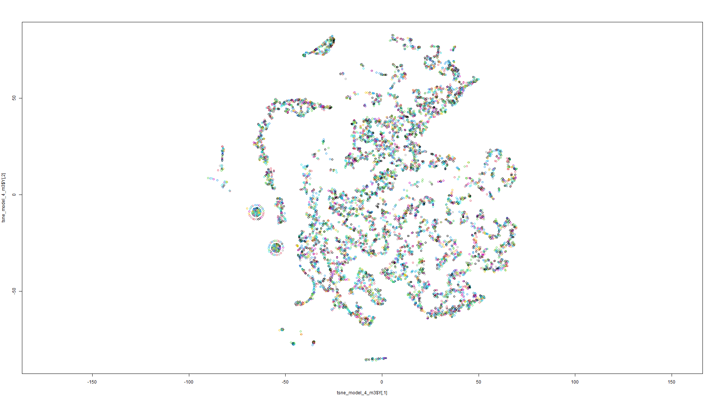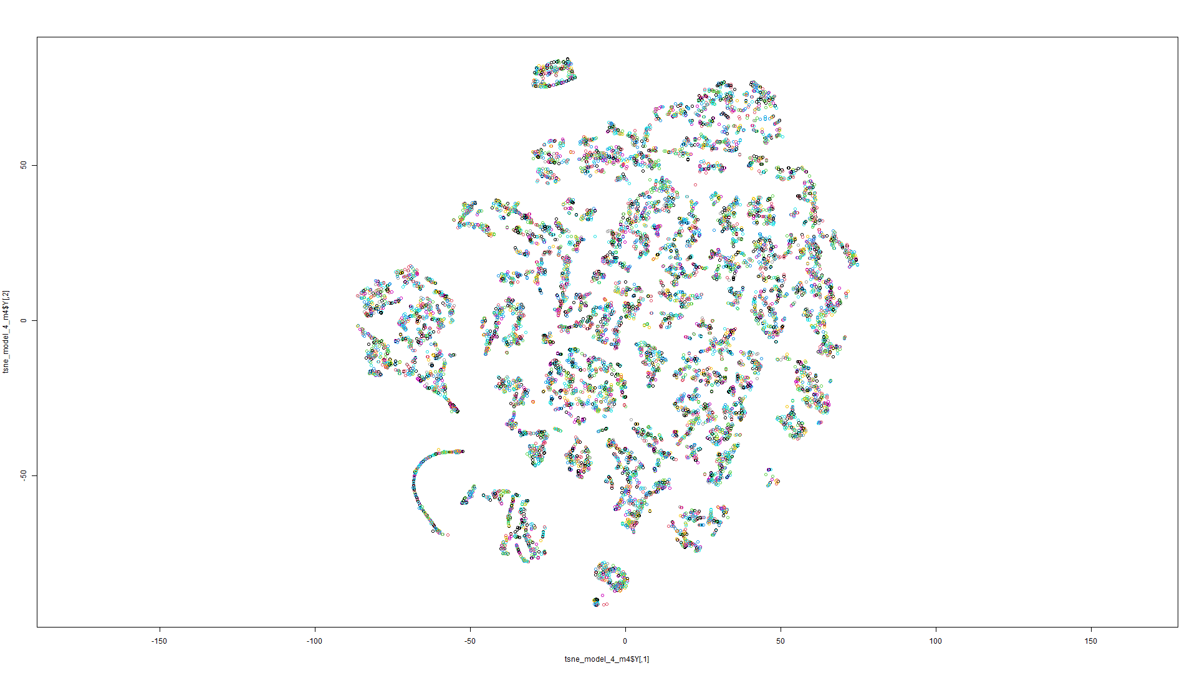Figure 199 t-SNE on Model 3 Figure 200 t-SNE on Model 4

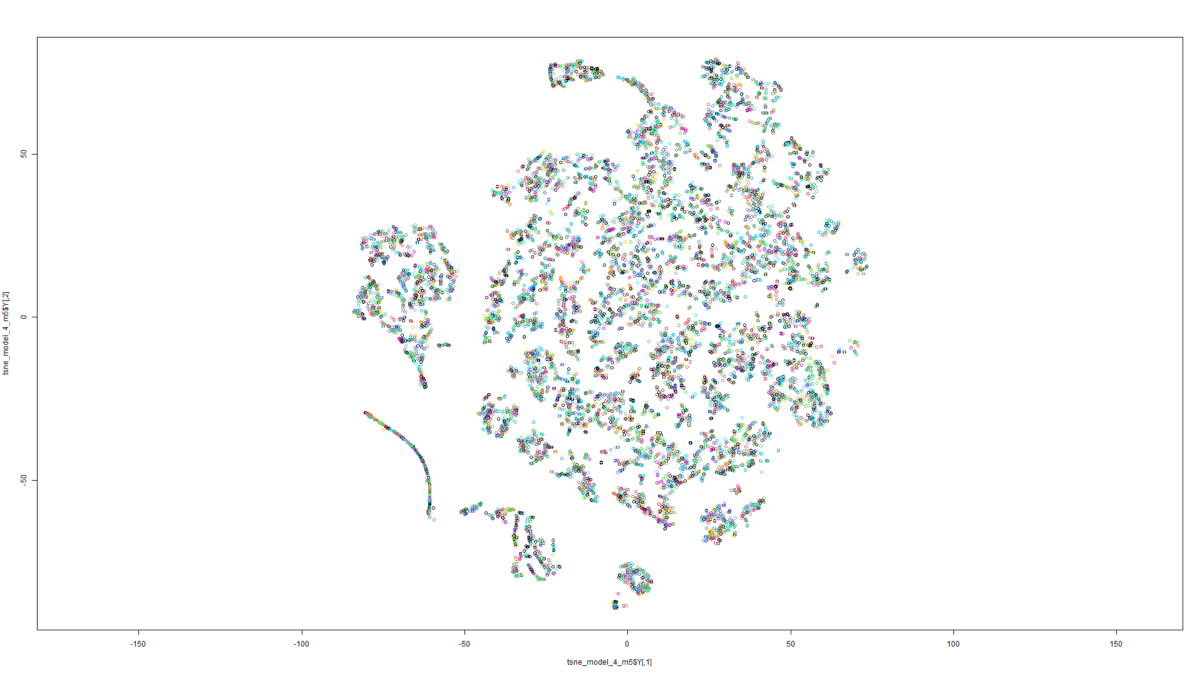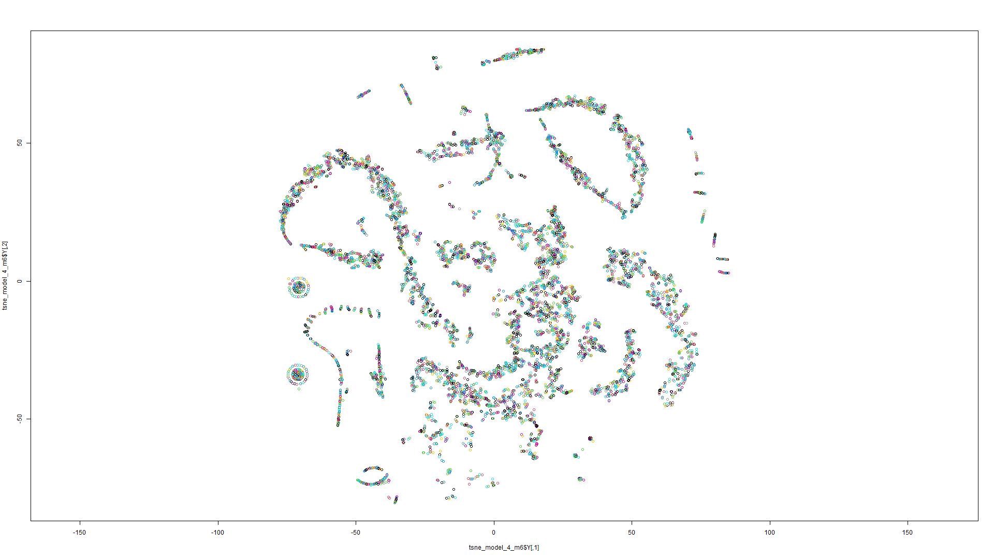Figure 201 t-SNE on Model 5 Figure 202 t-SNE on Model 6

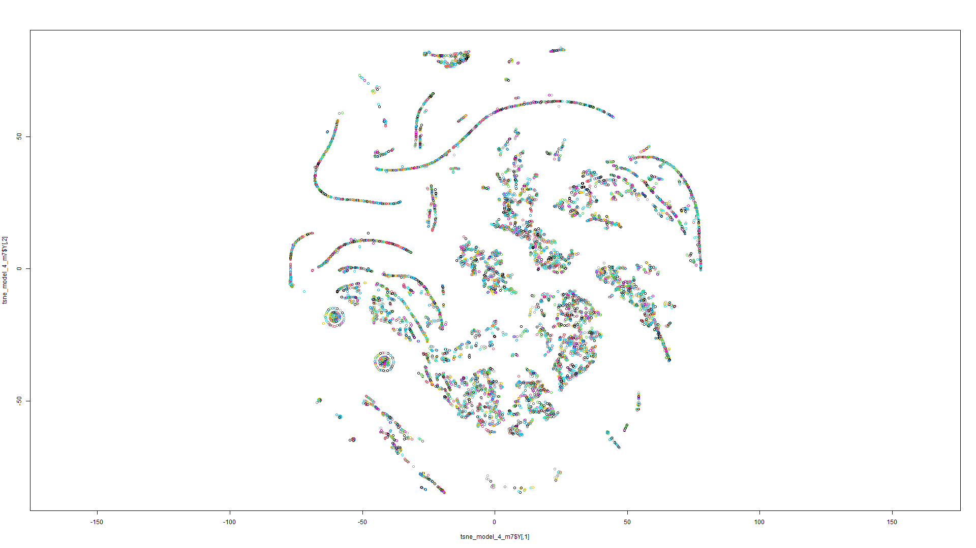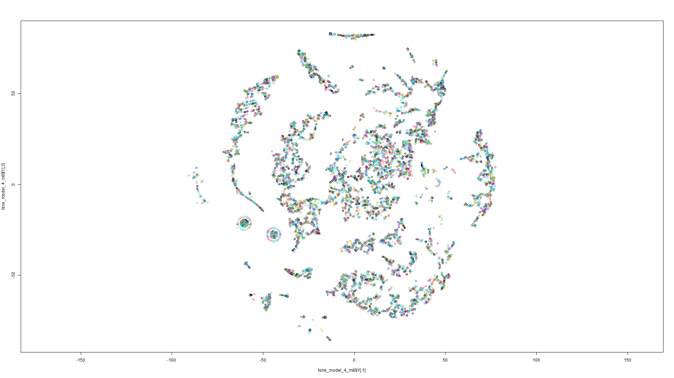Figure 203 t-SNE on Model 7 Figure 204 t-SNE on Model 8

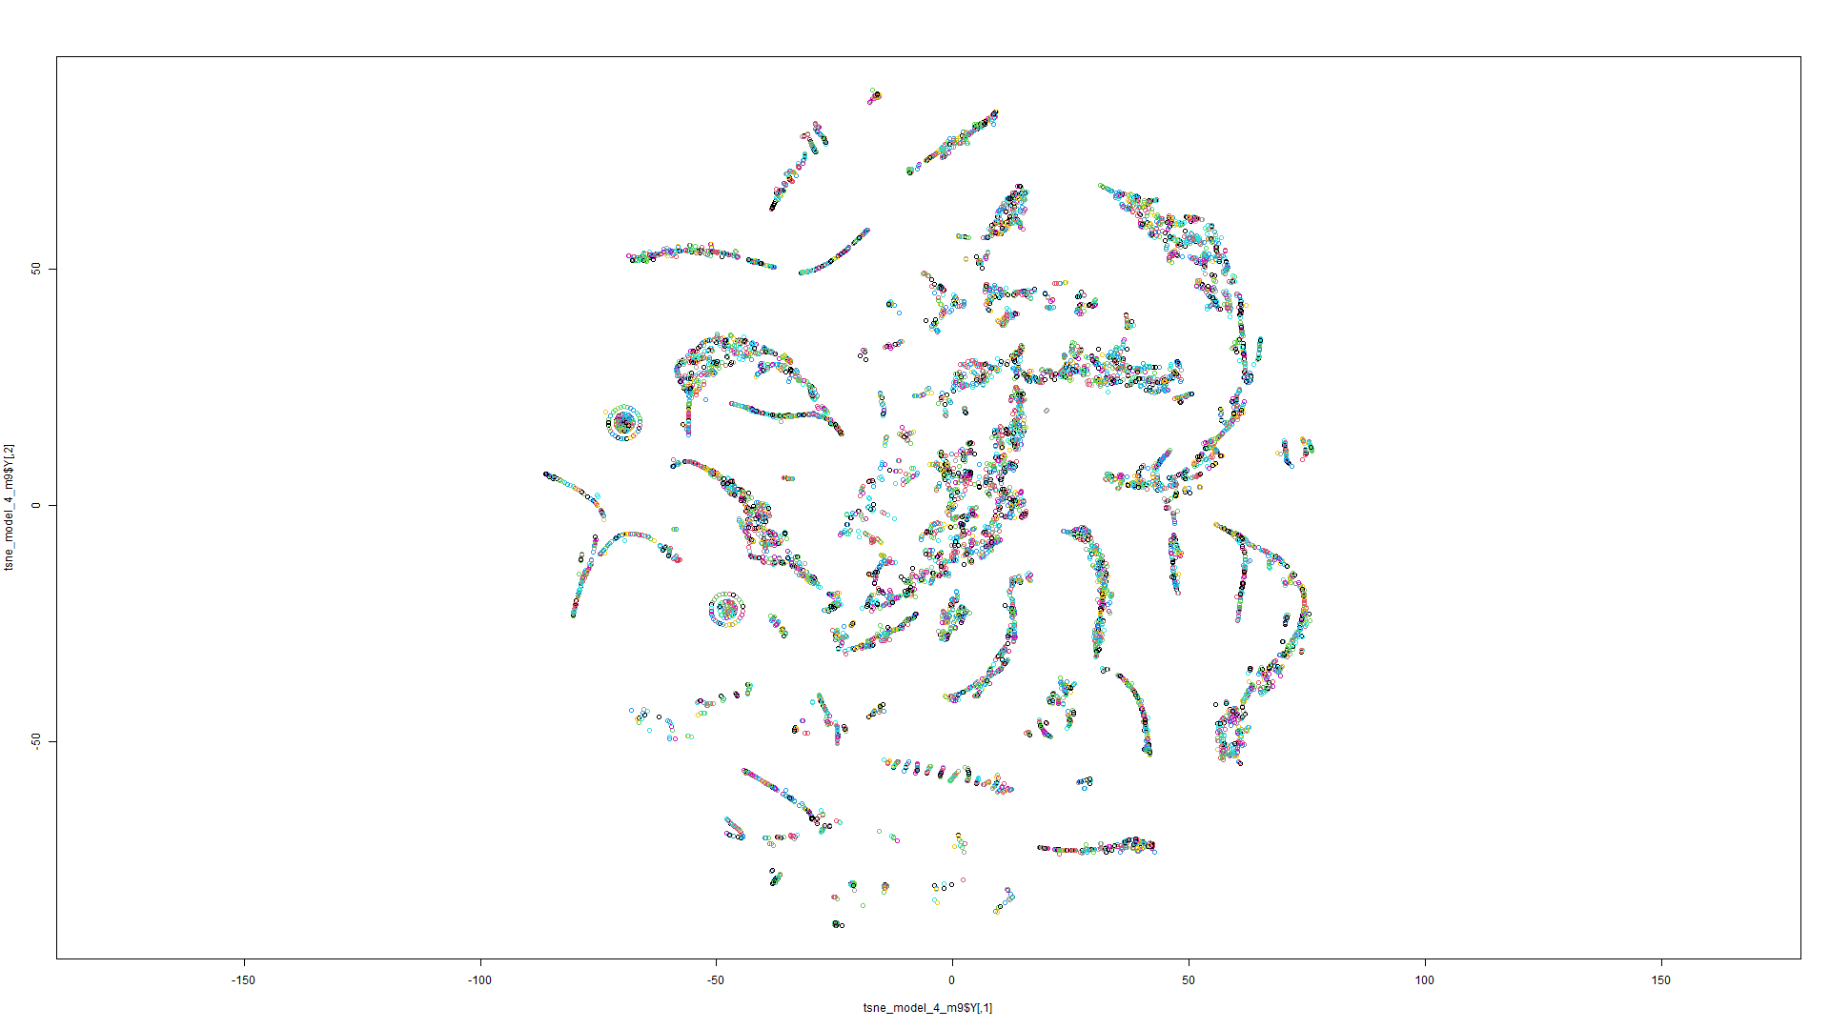

Figure 205 t-SNE on Model 9

K-means on t-SNE:

Model 1:

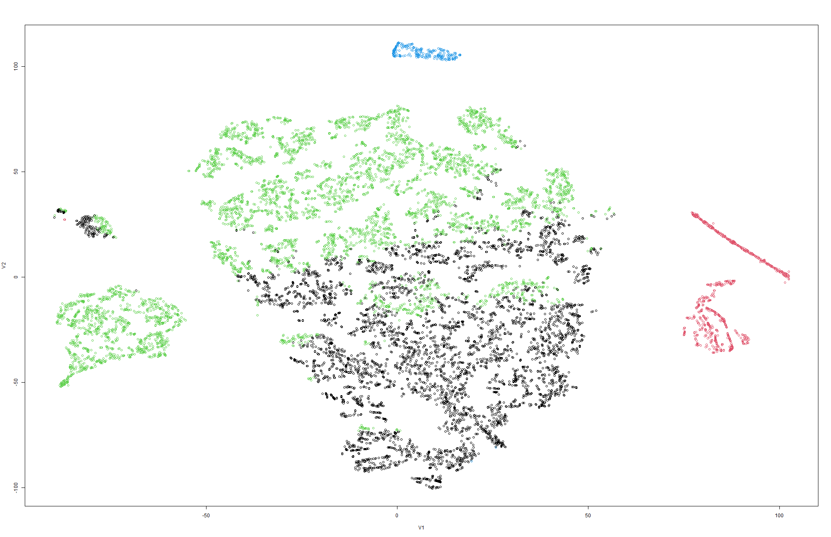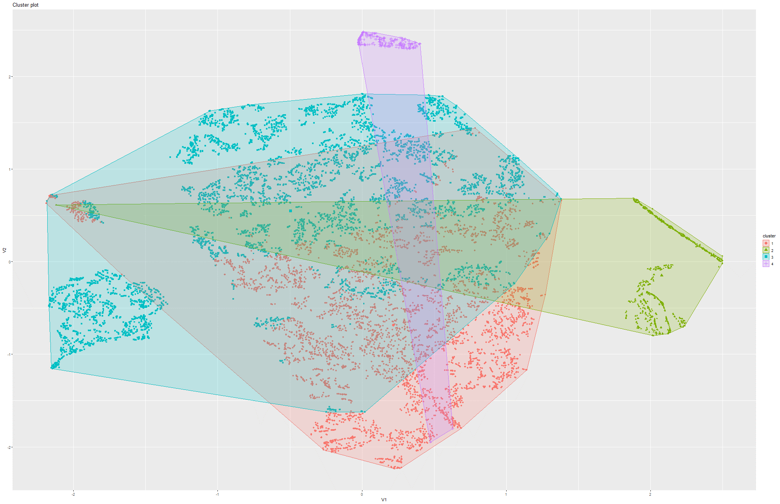Figure 206&207 k-Means on t-SNE Model 1

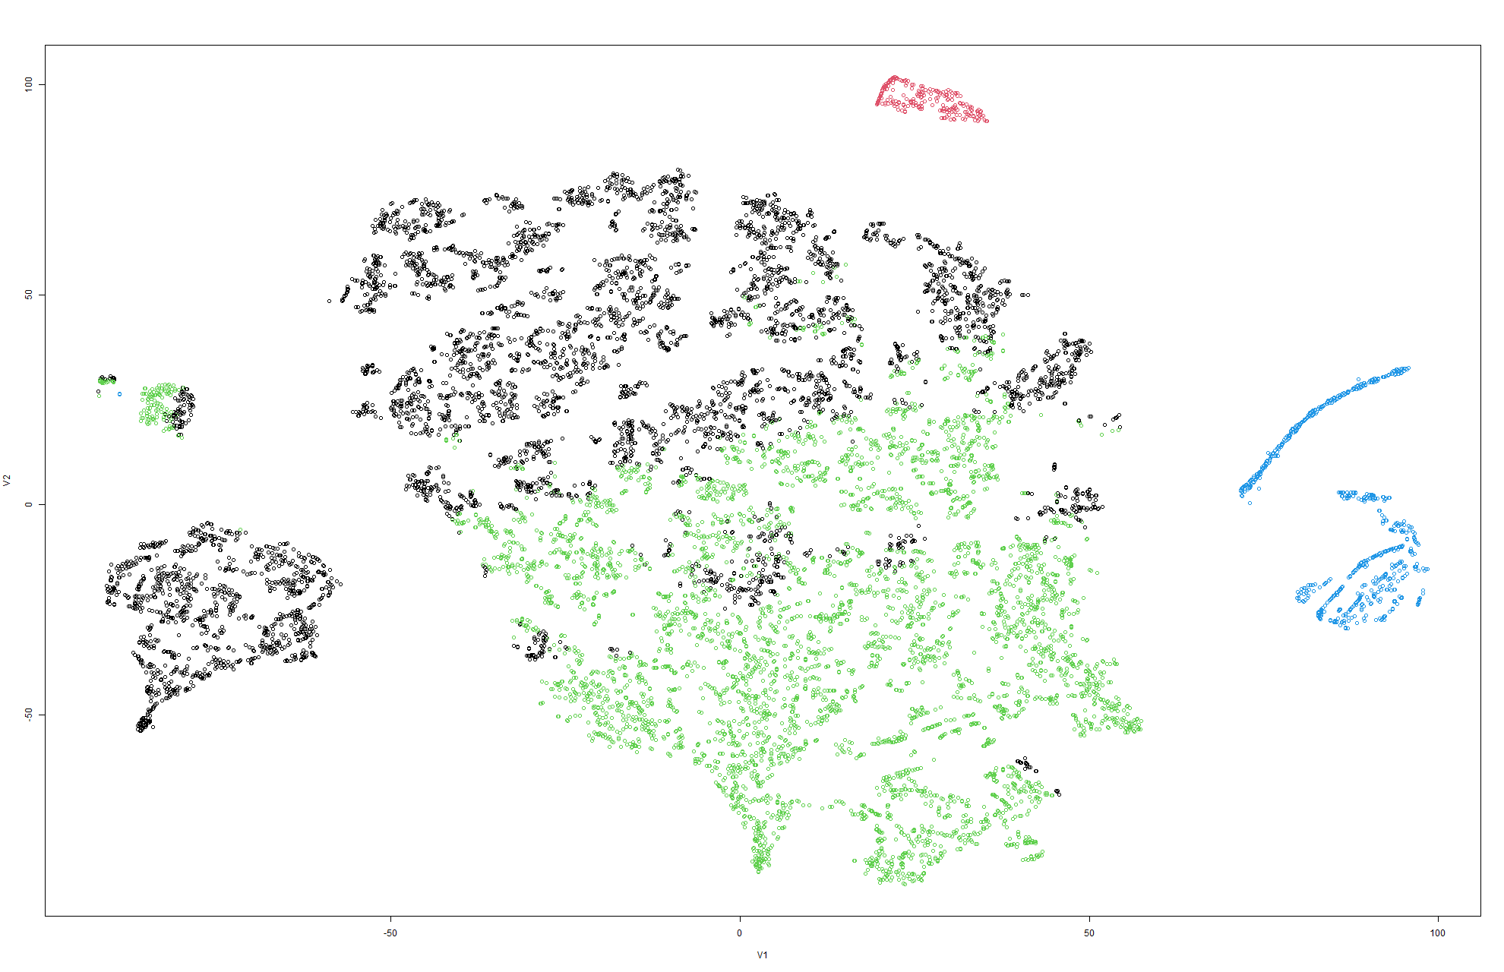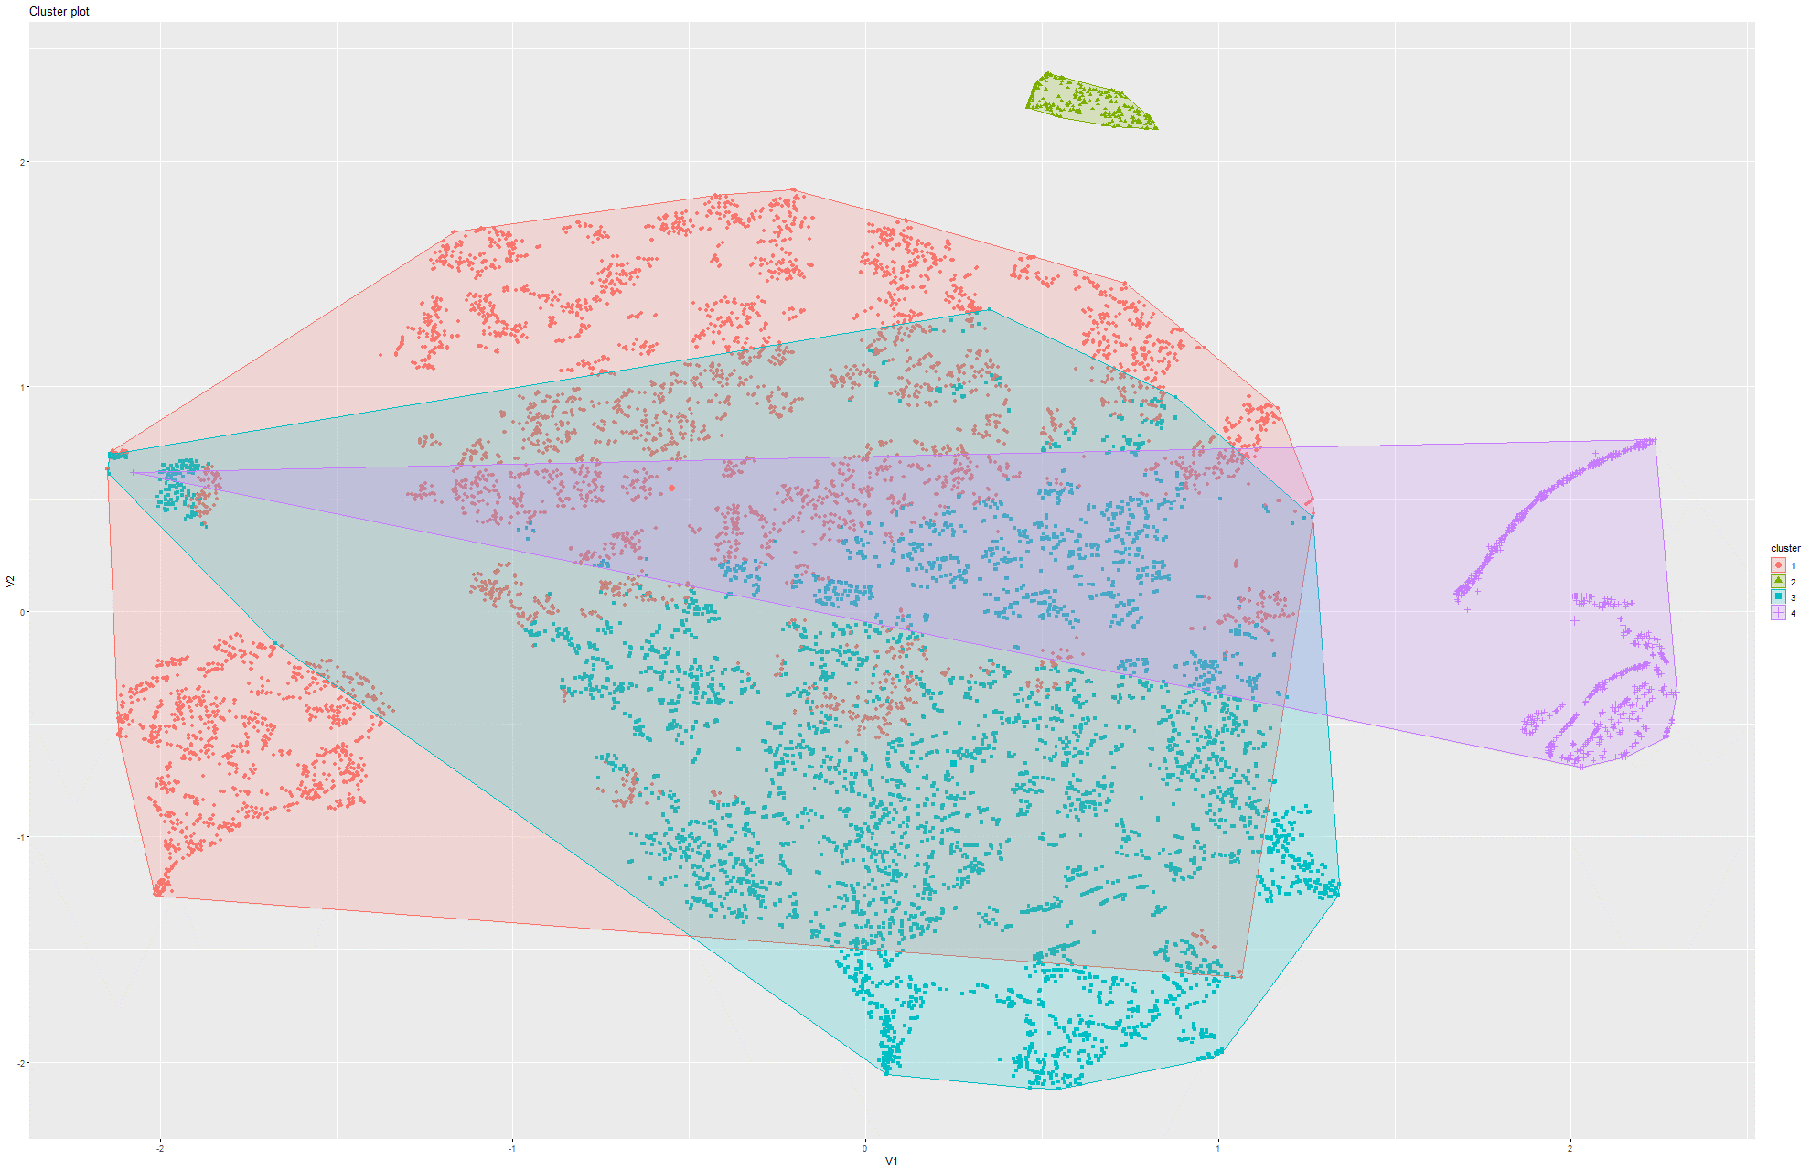Figure 208&209 k-Means on t-SNE Model 2

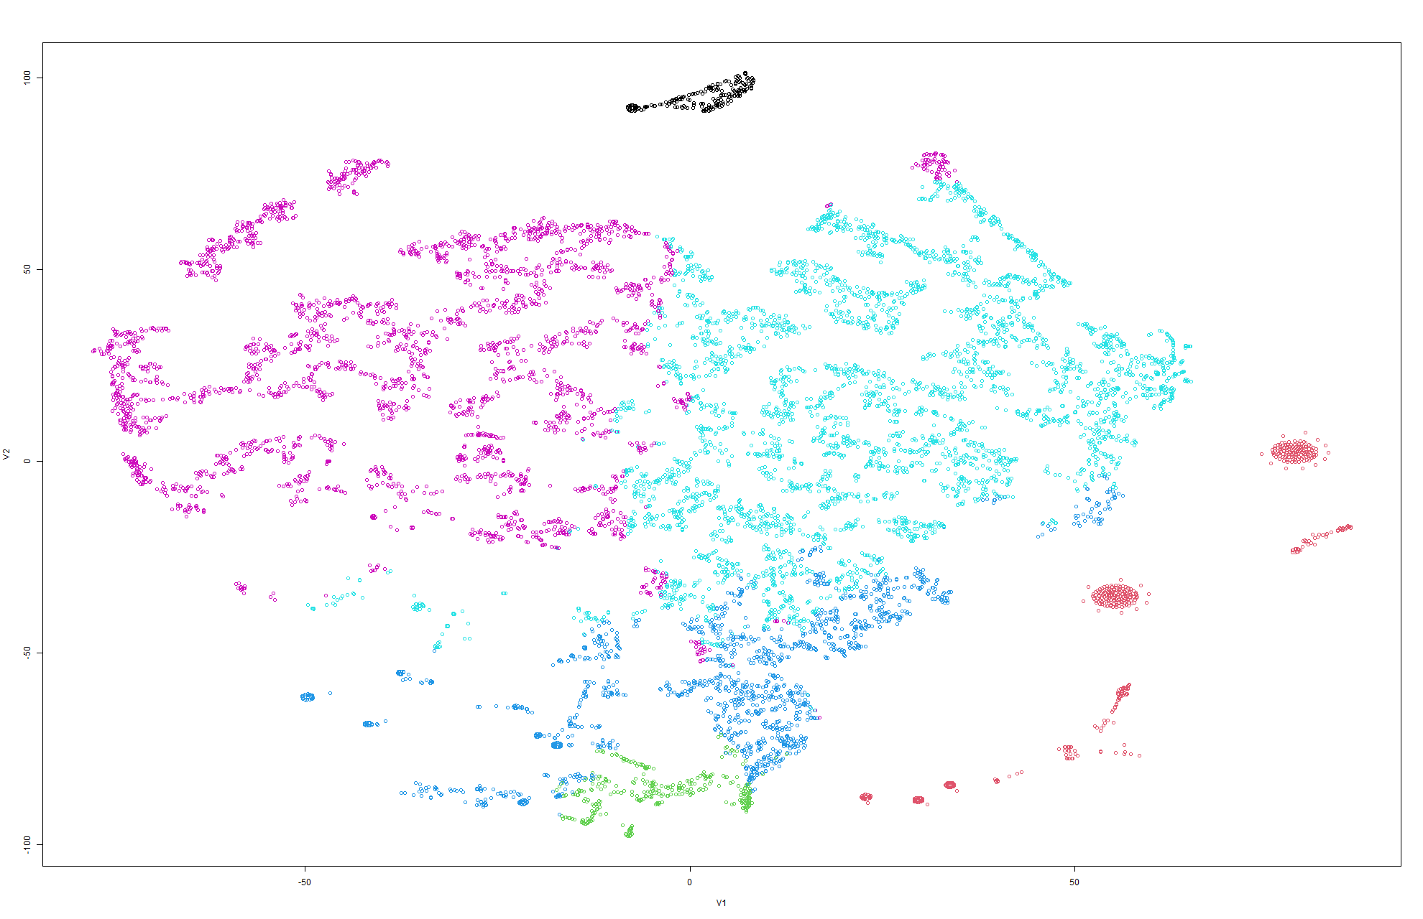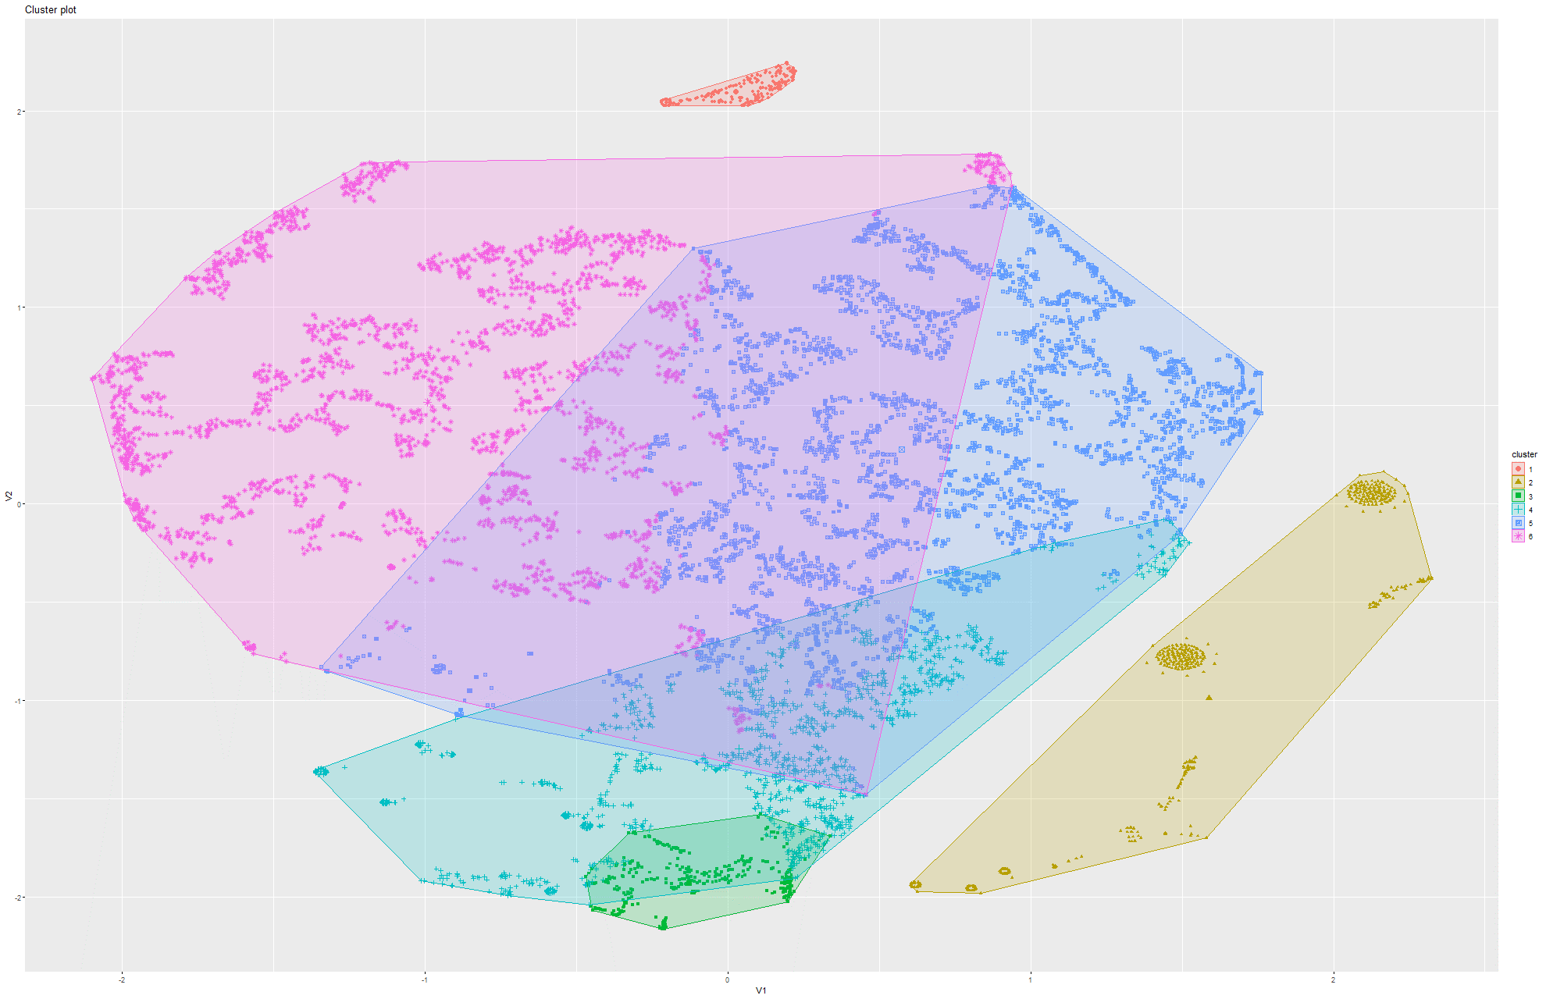Figure 210&211 k-Means on t-SNE Model 3

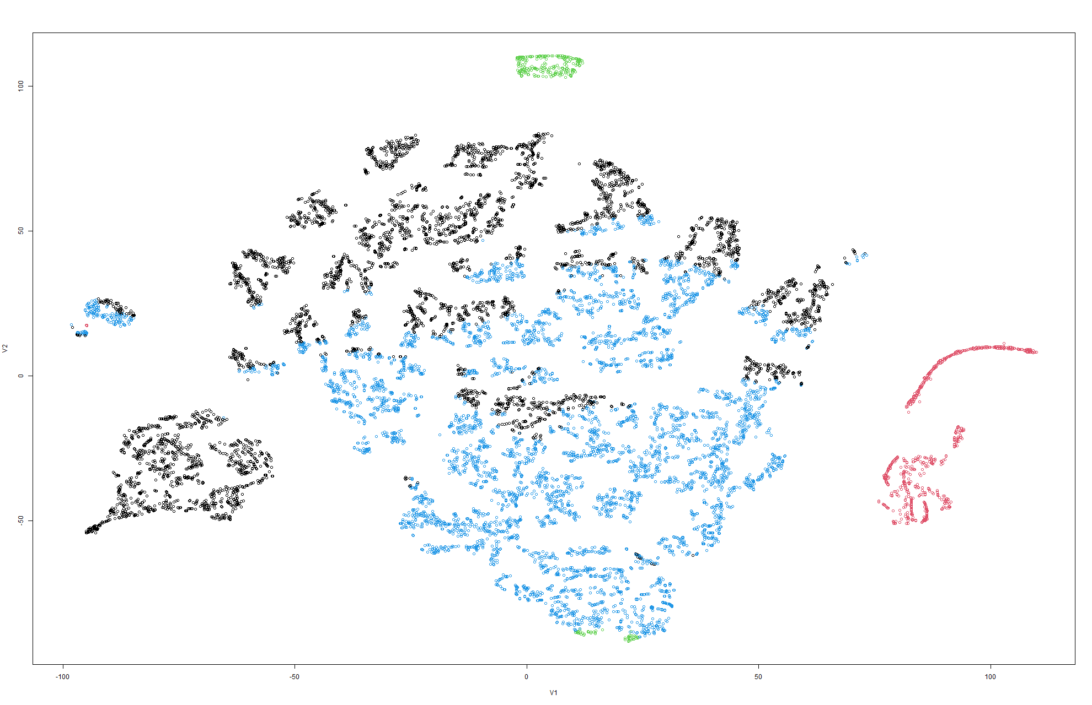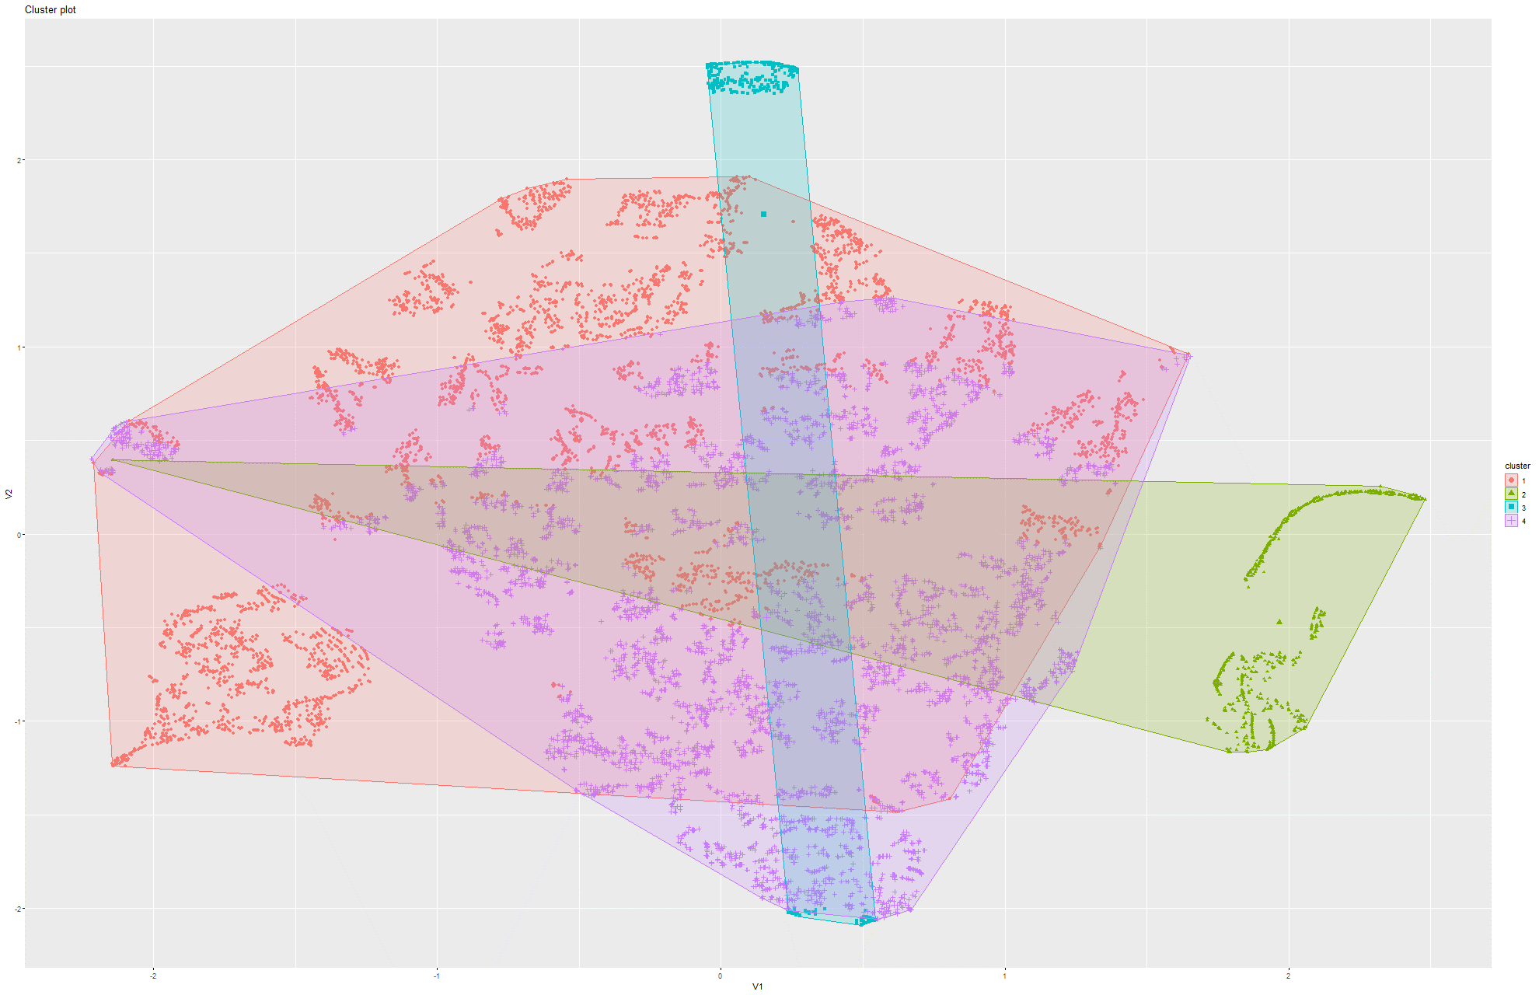Figure 212&213 k-Means on t-SNE Model 4

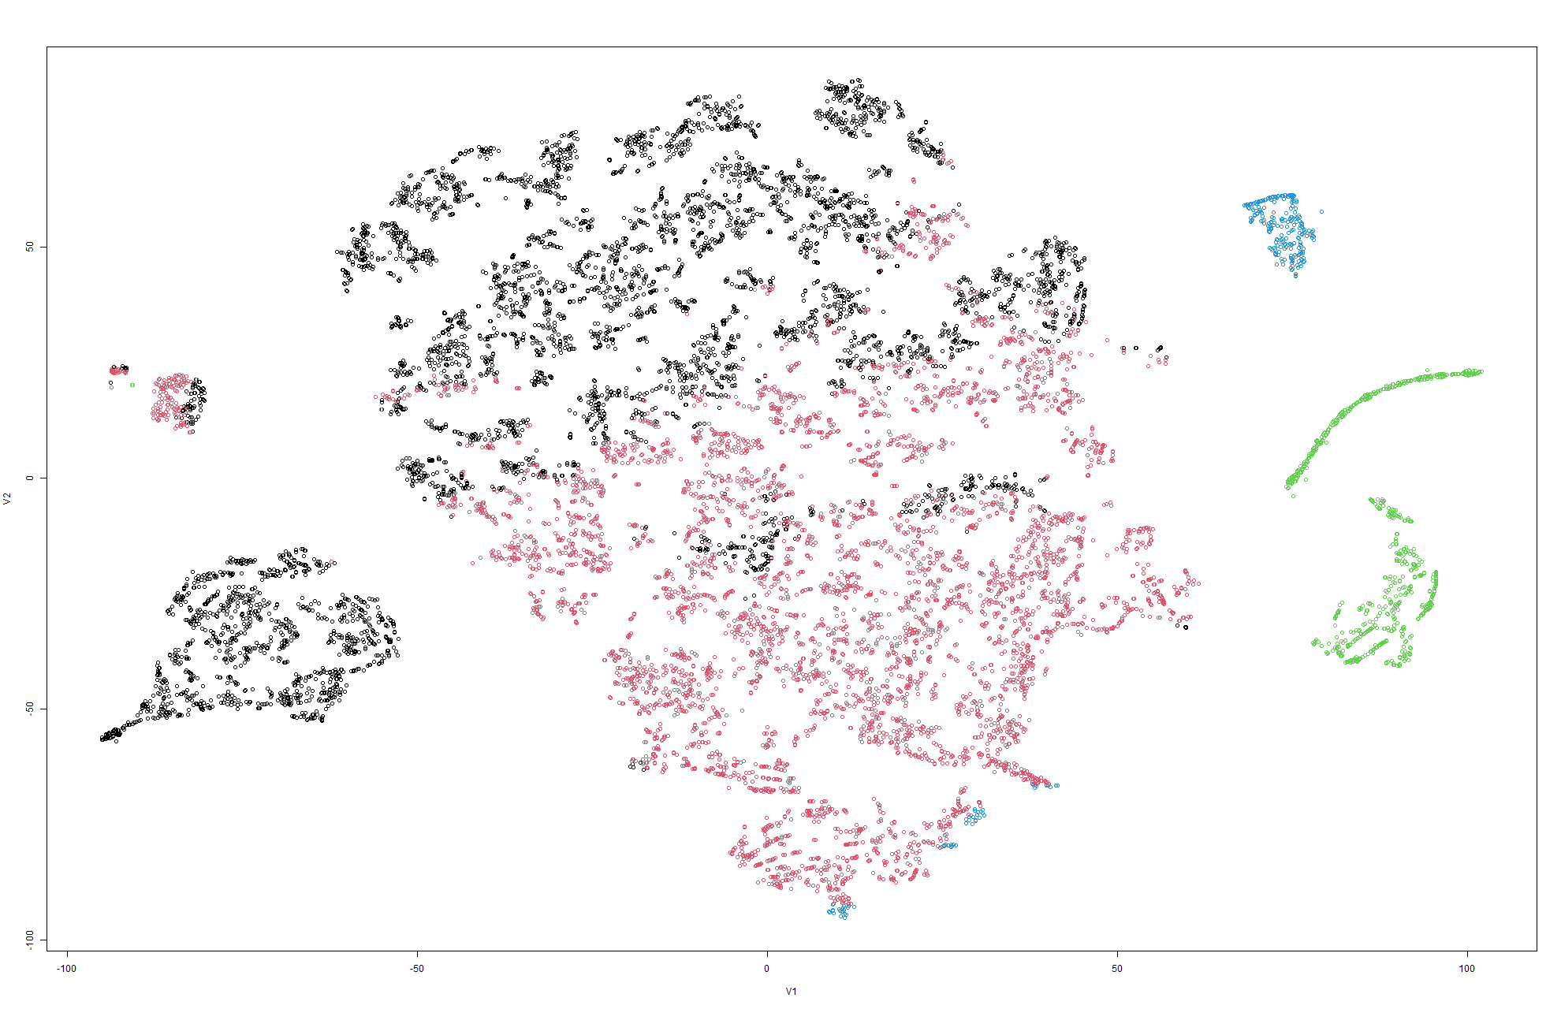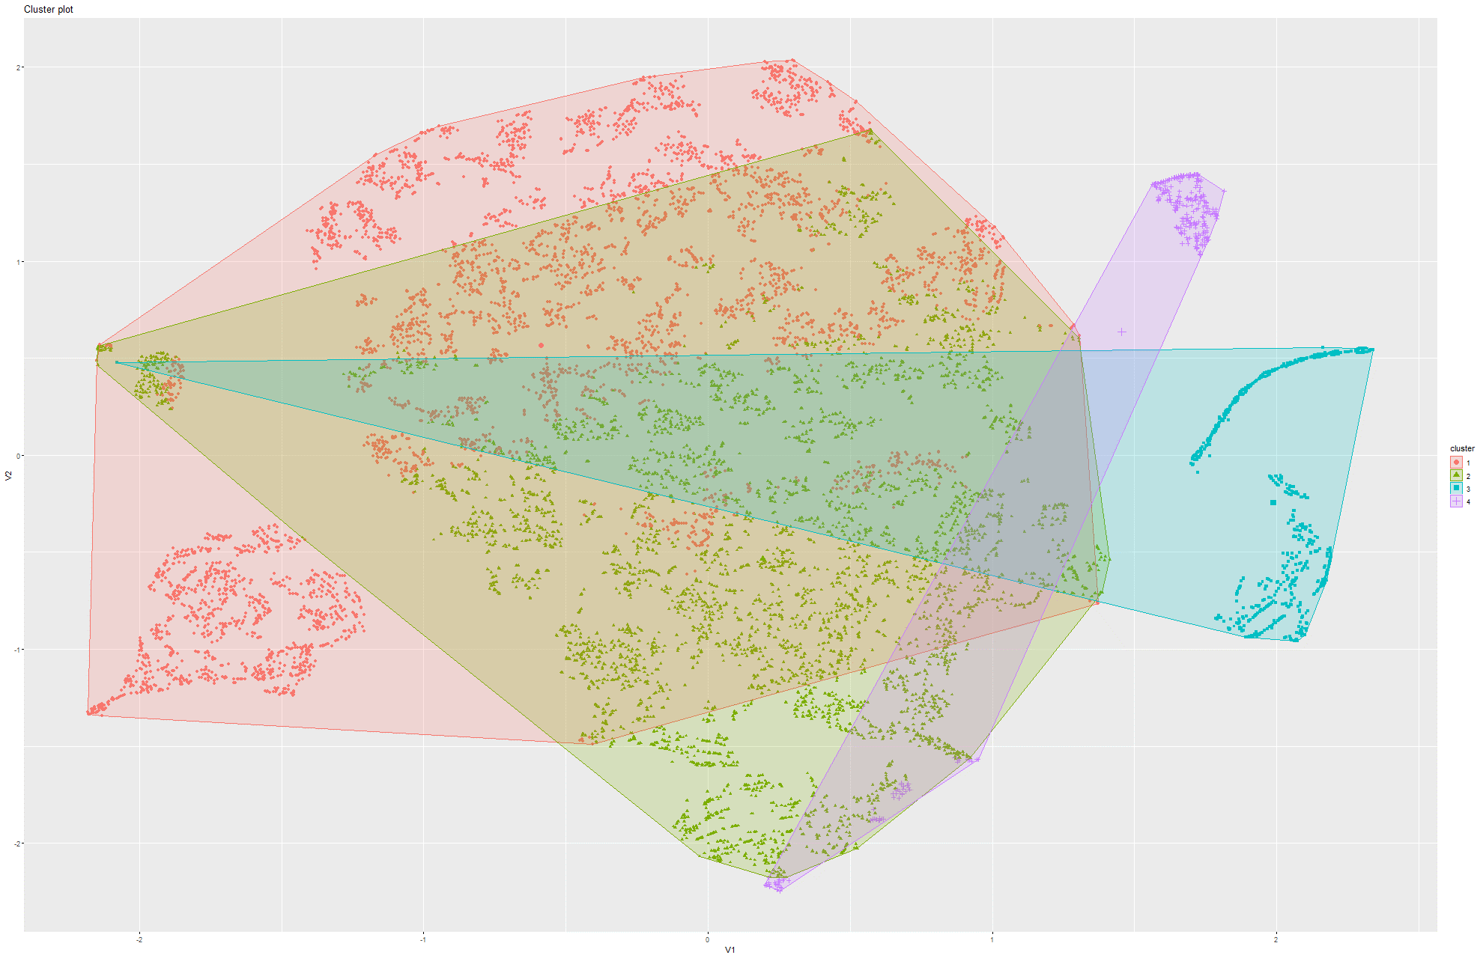Figure 214&215 k-Means on t-SNE Model 5

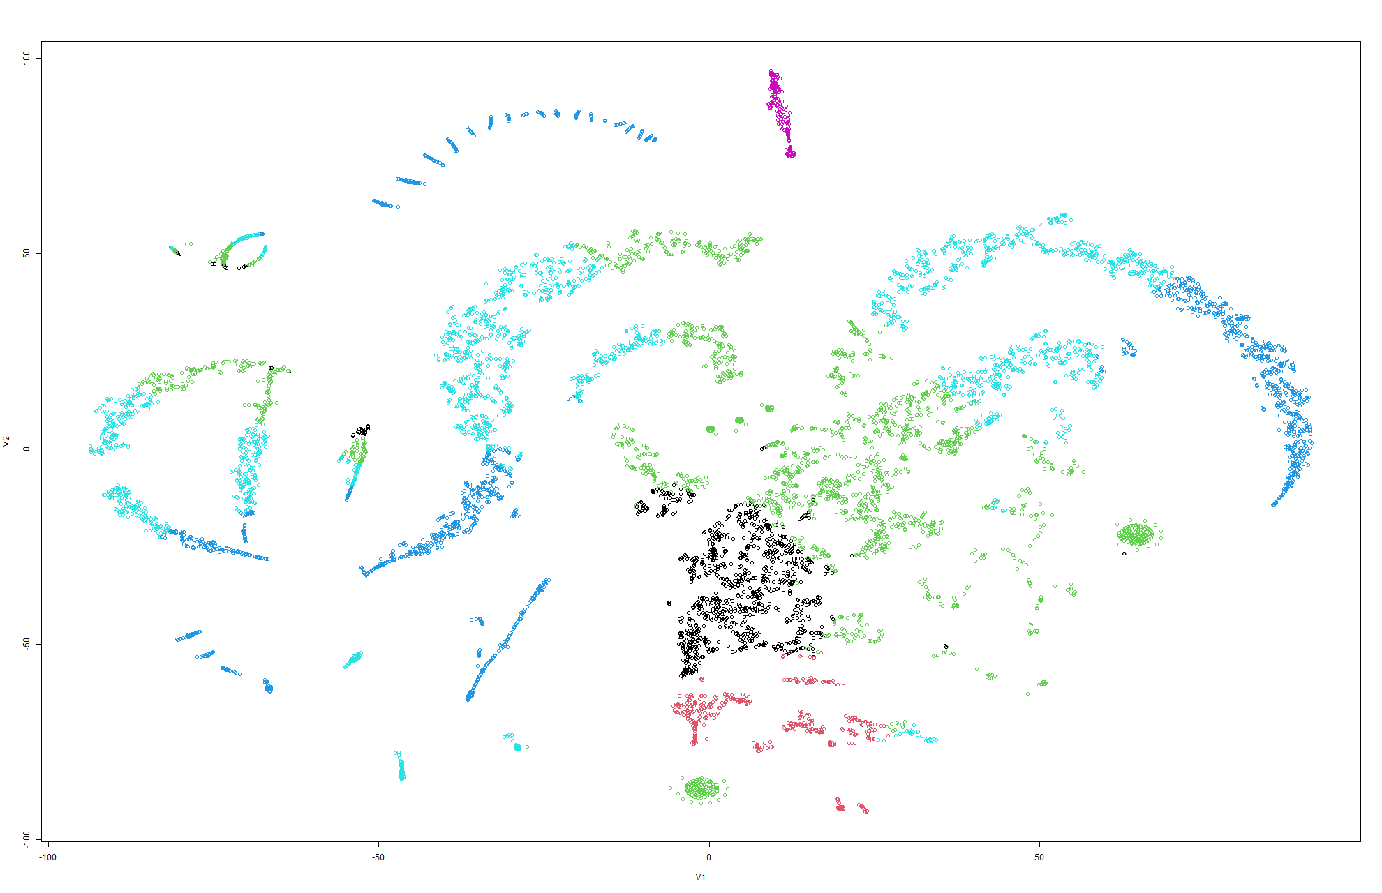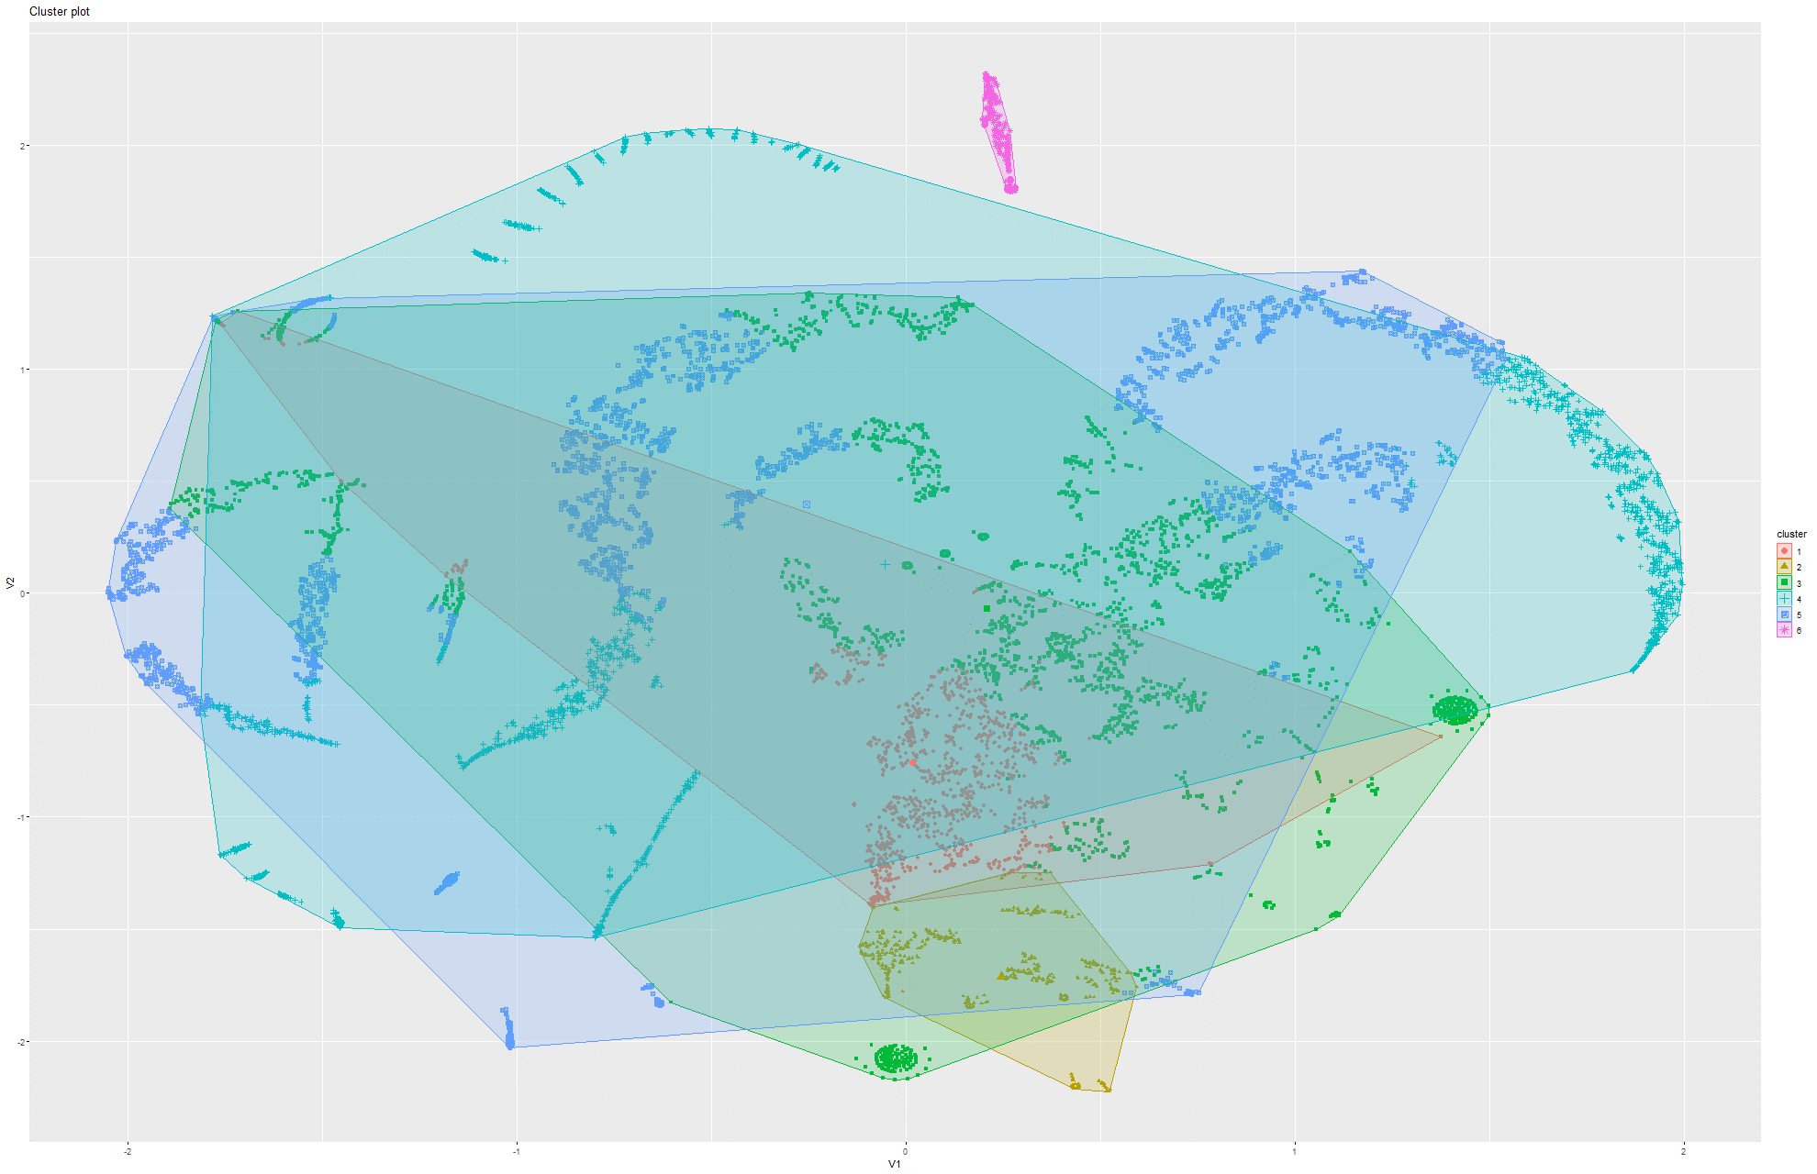Figure 216&217 k-Means on t-SNE Model 6

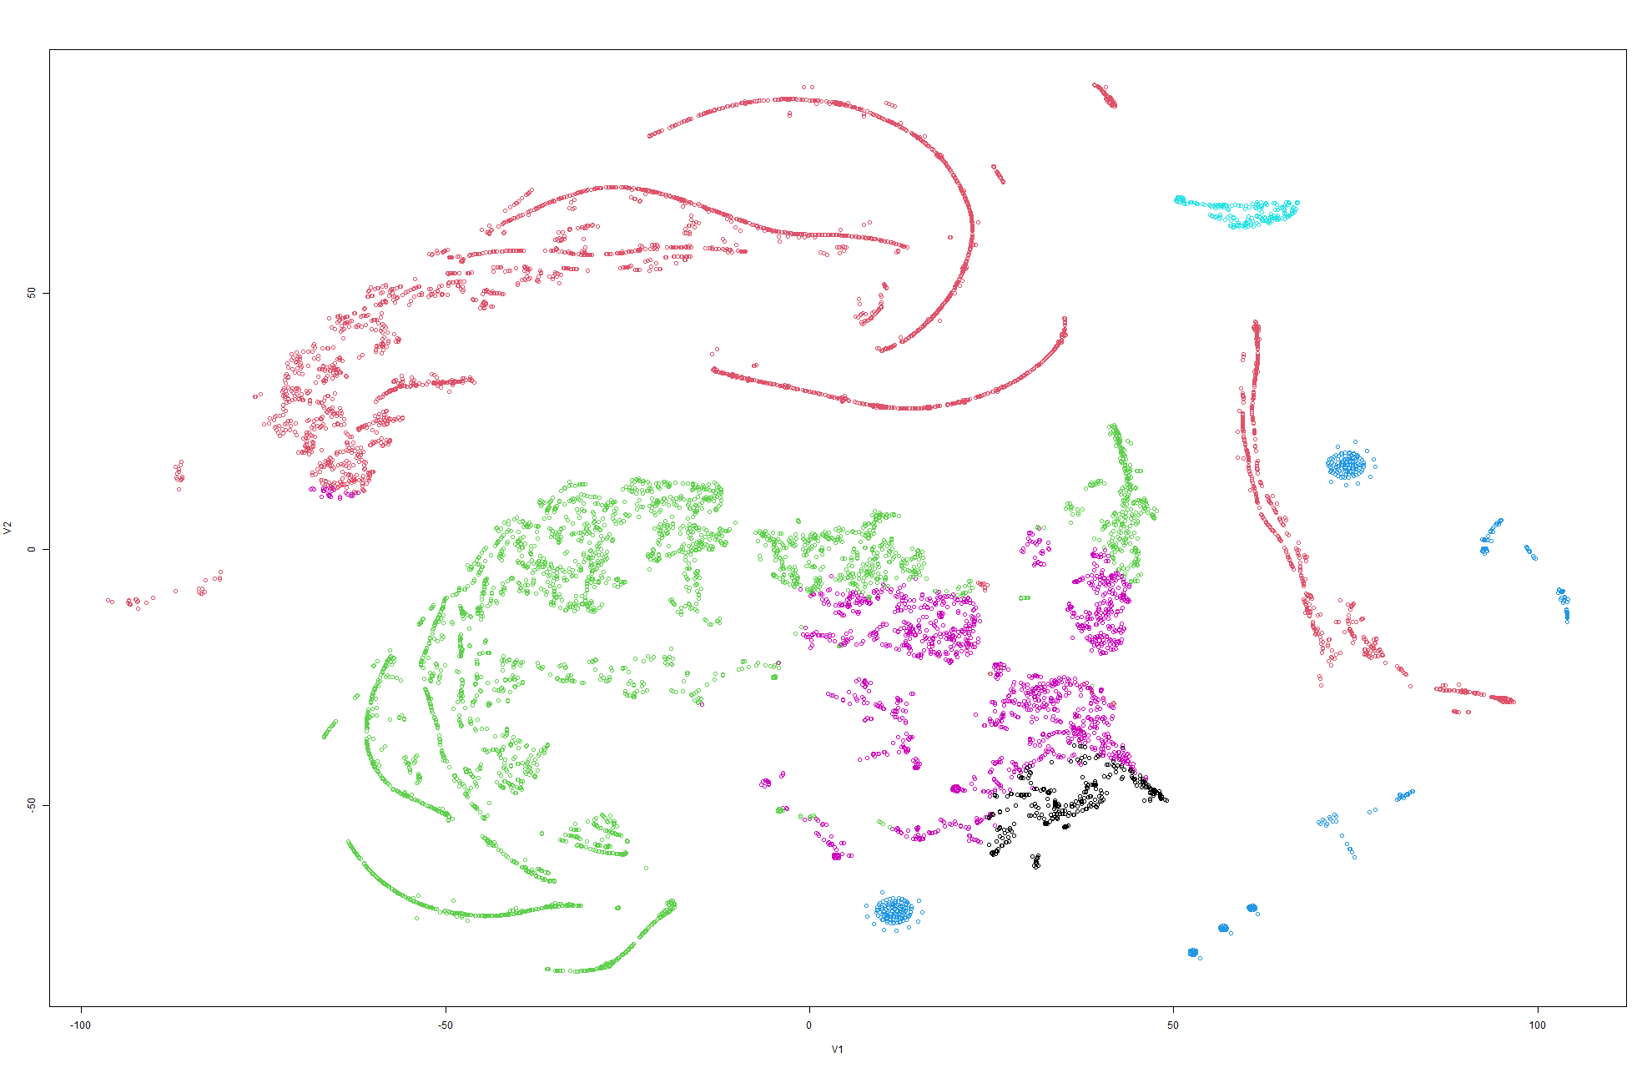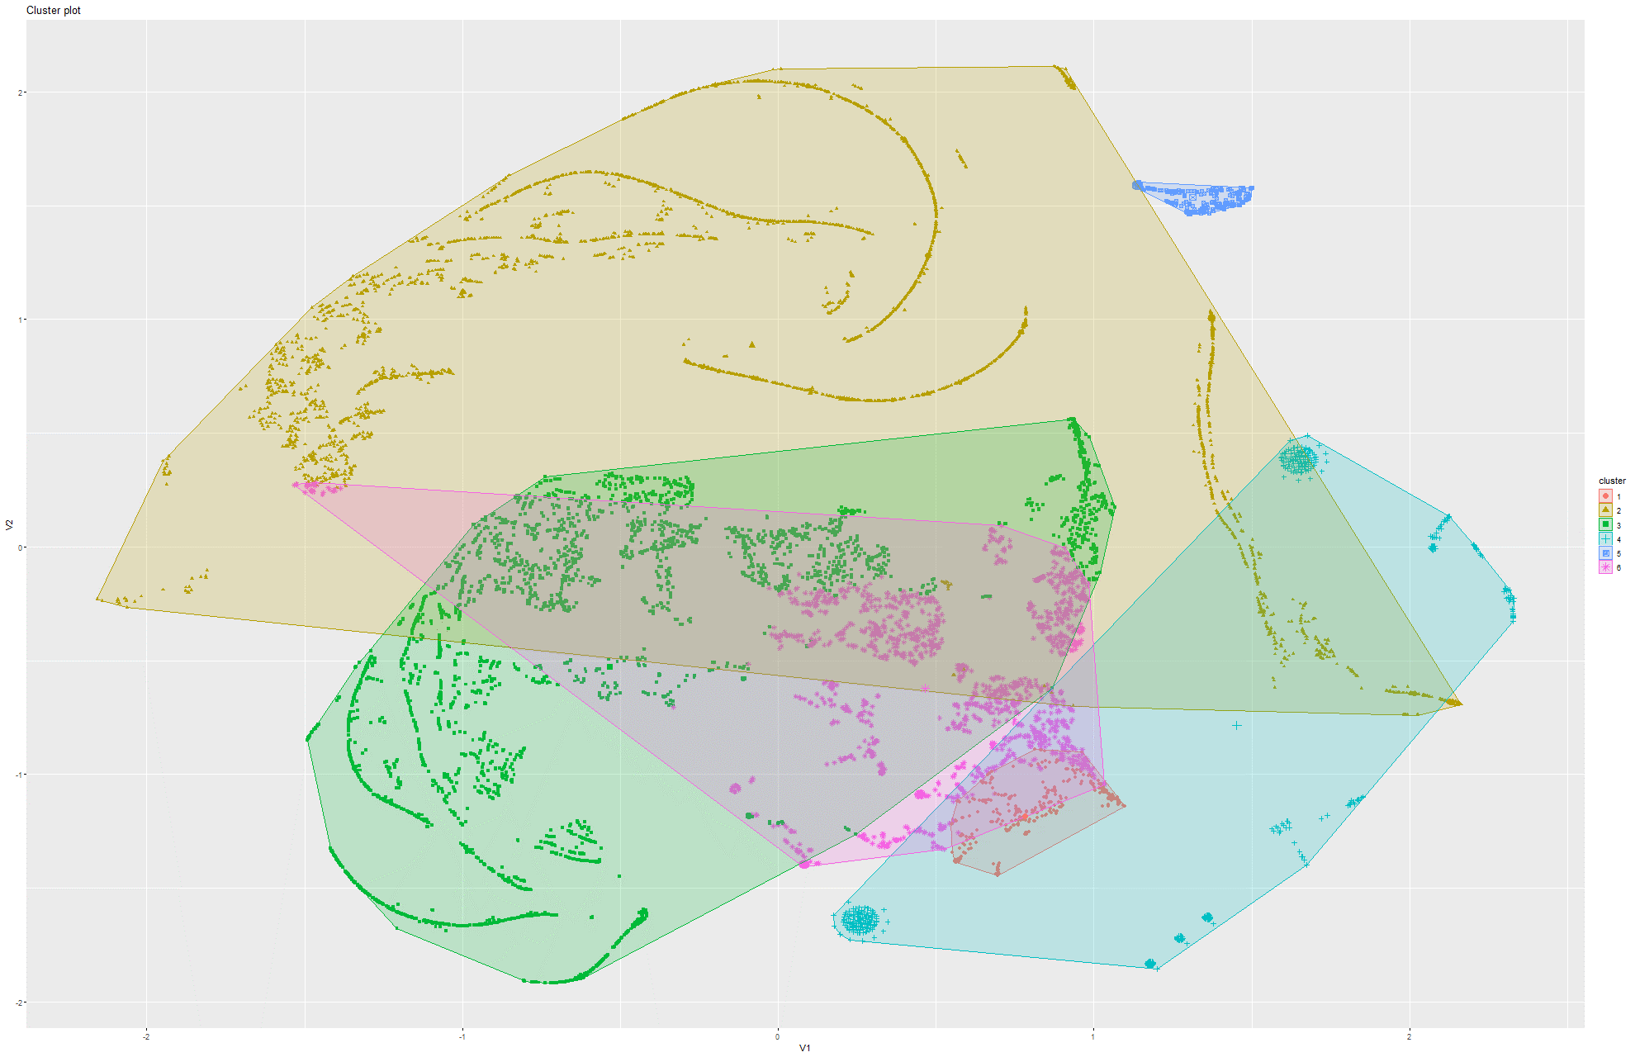Figure 218&219 k-Means on t-SNE Model 7

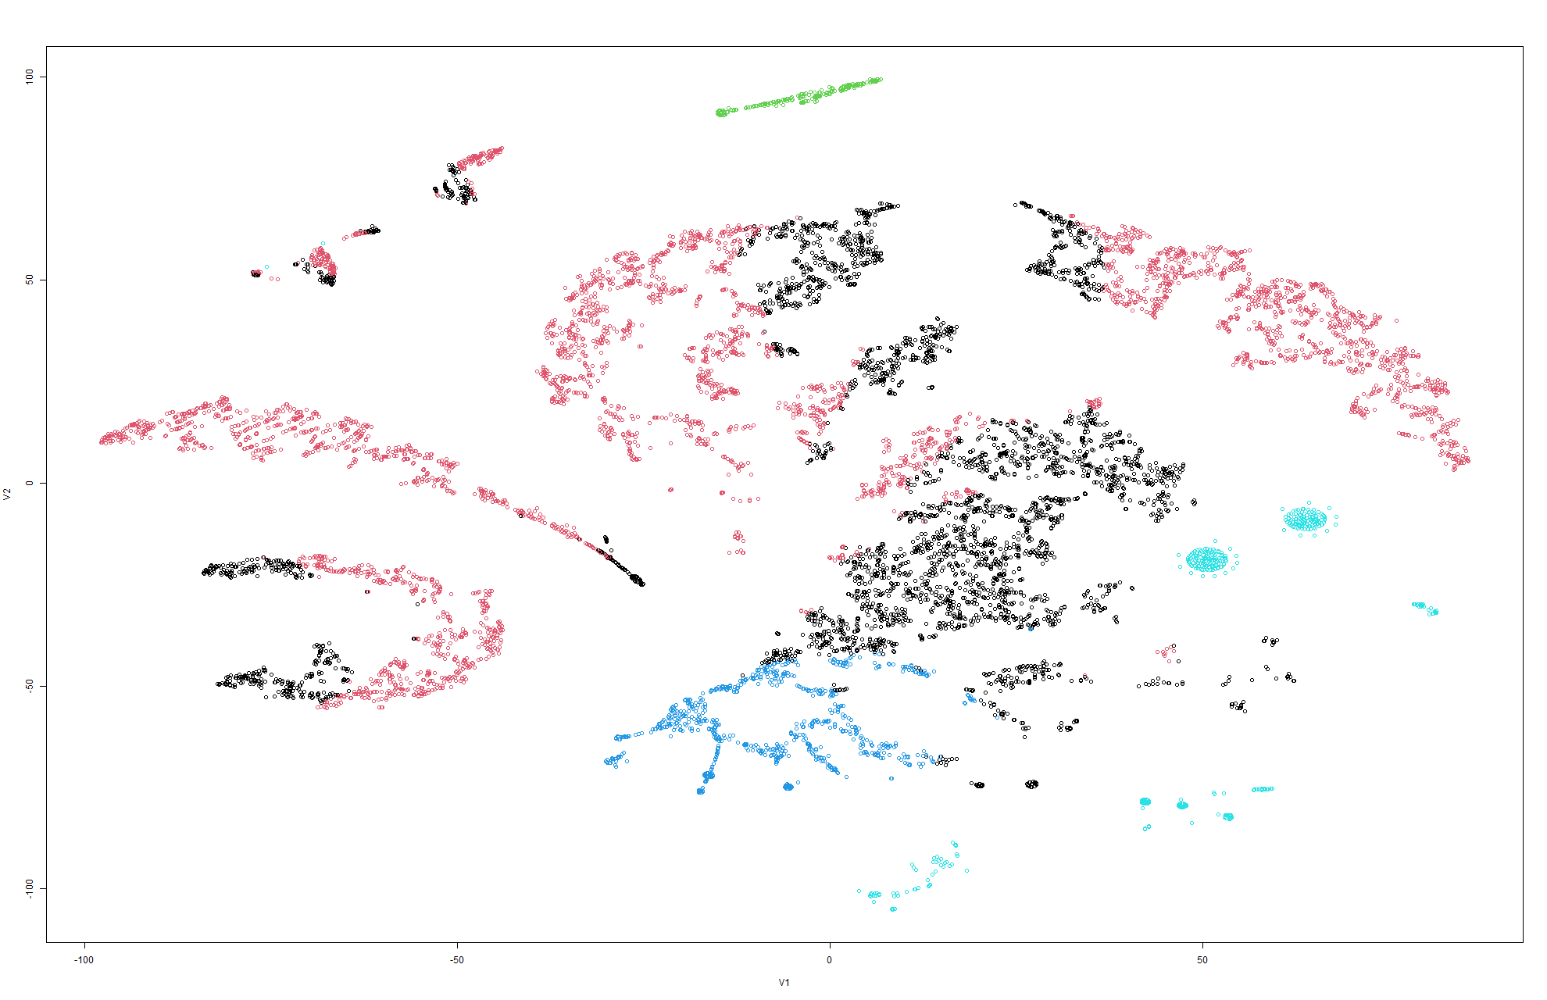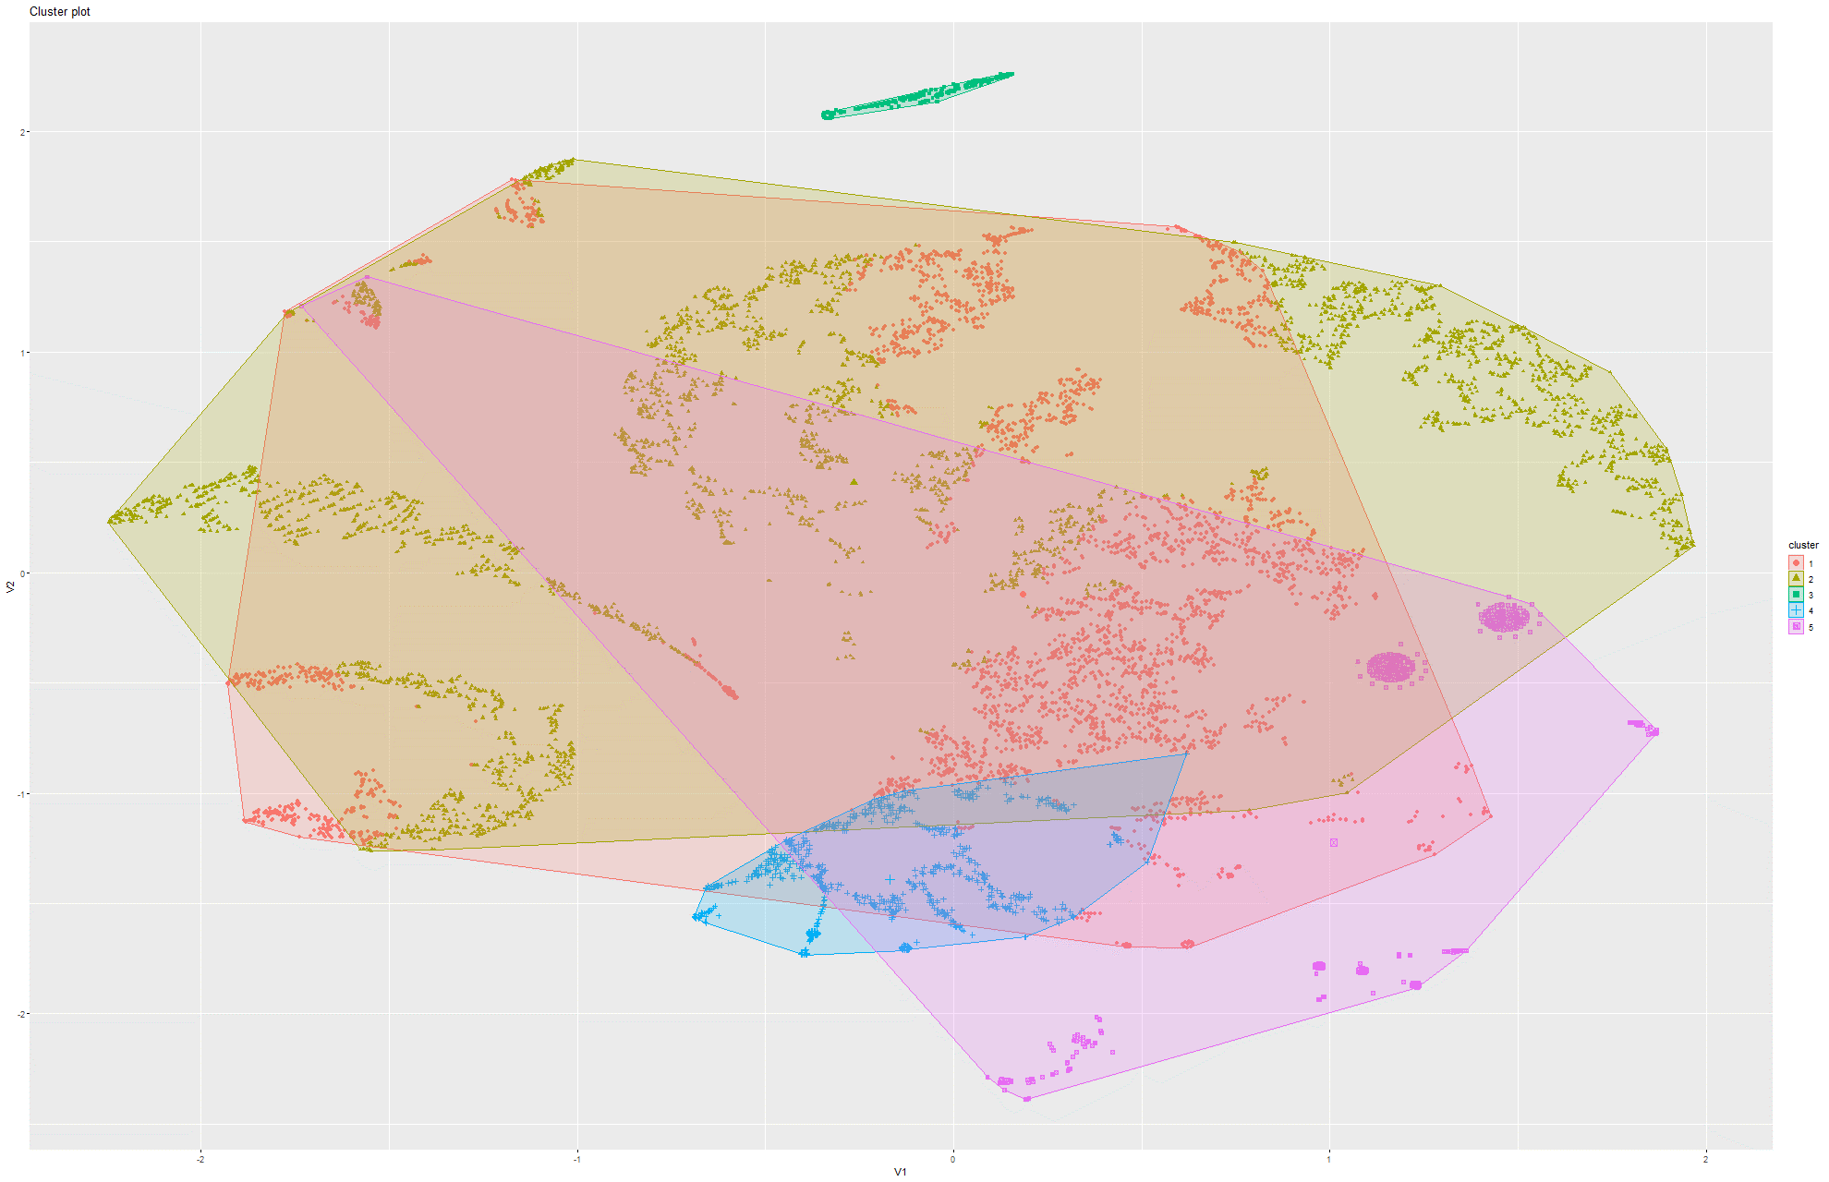Figure 220&221 k-Means on t-SNE Model 8

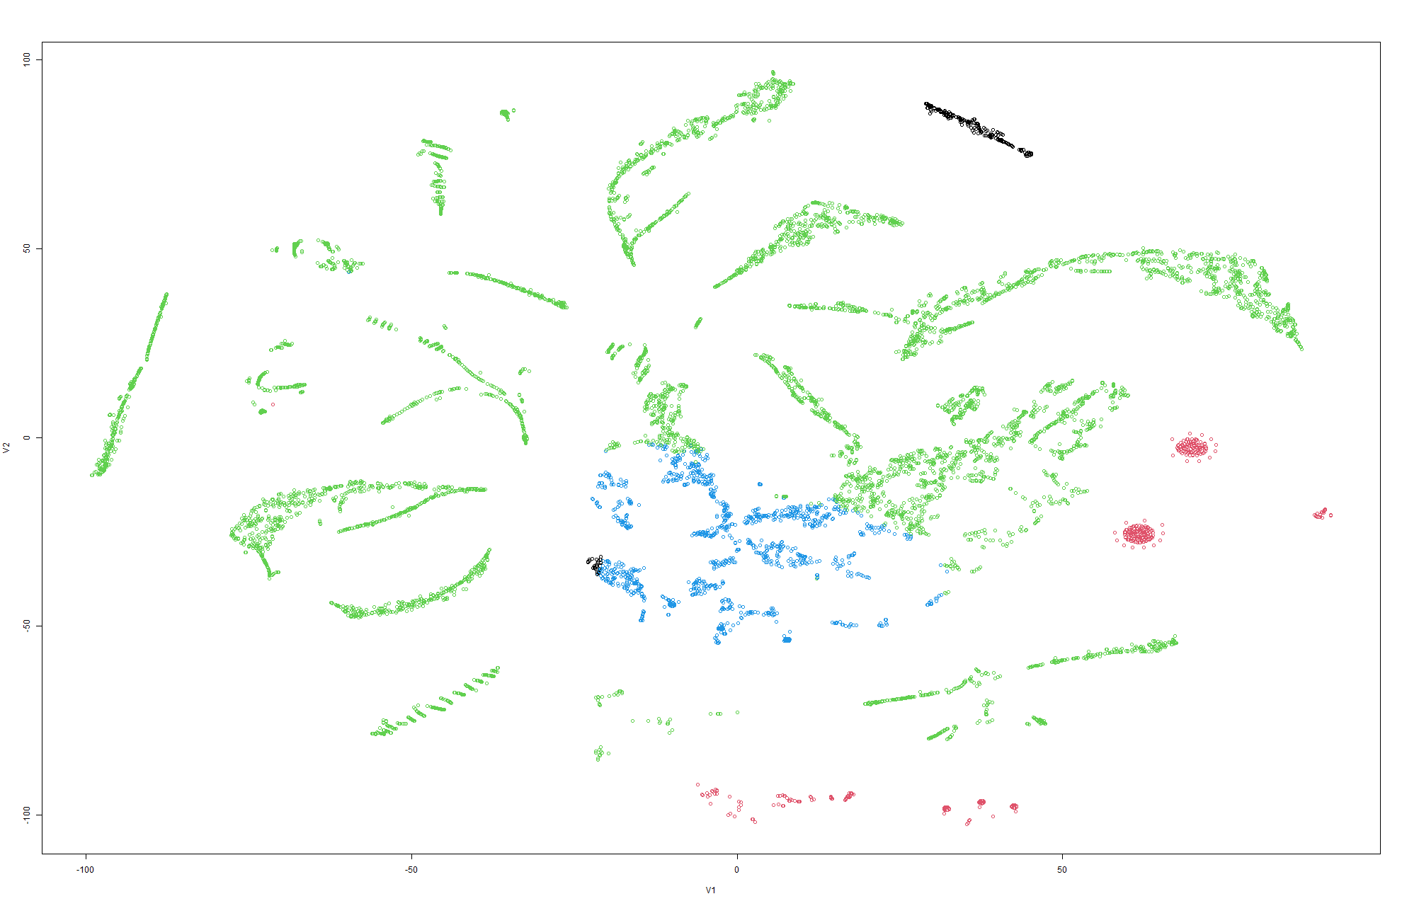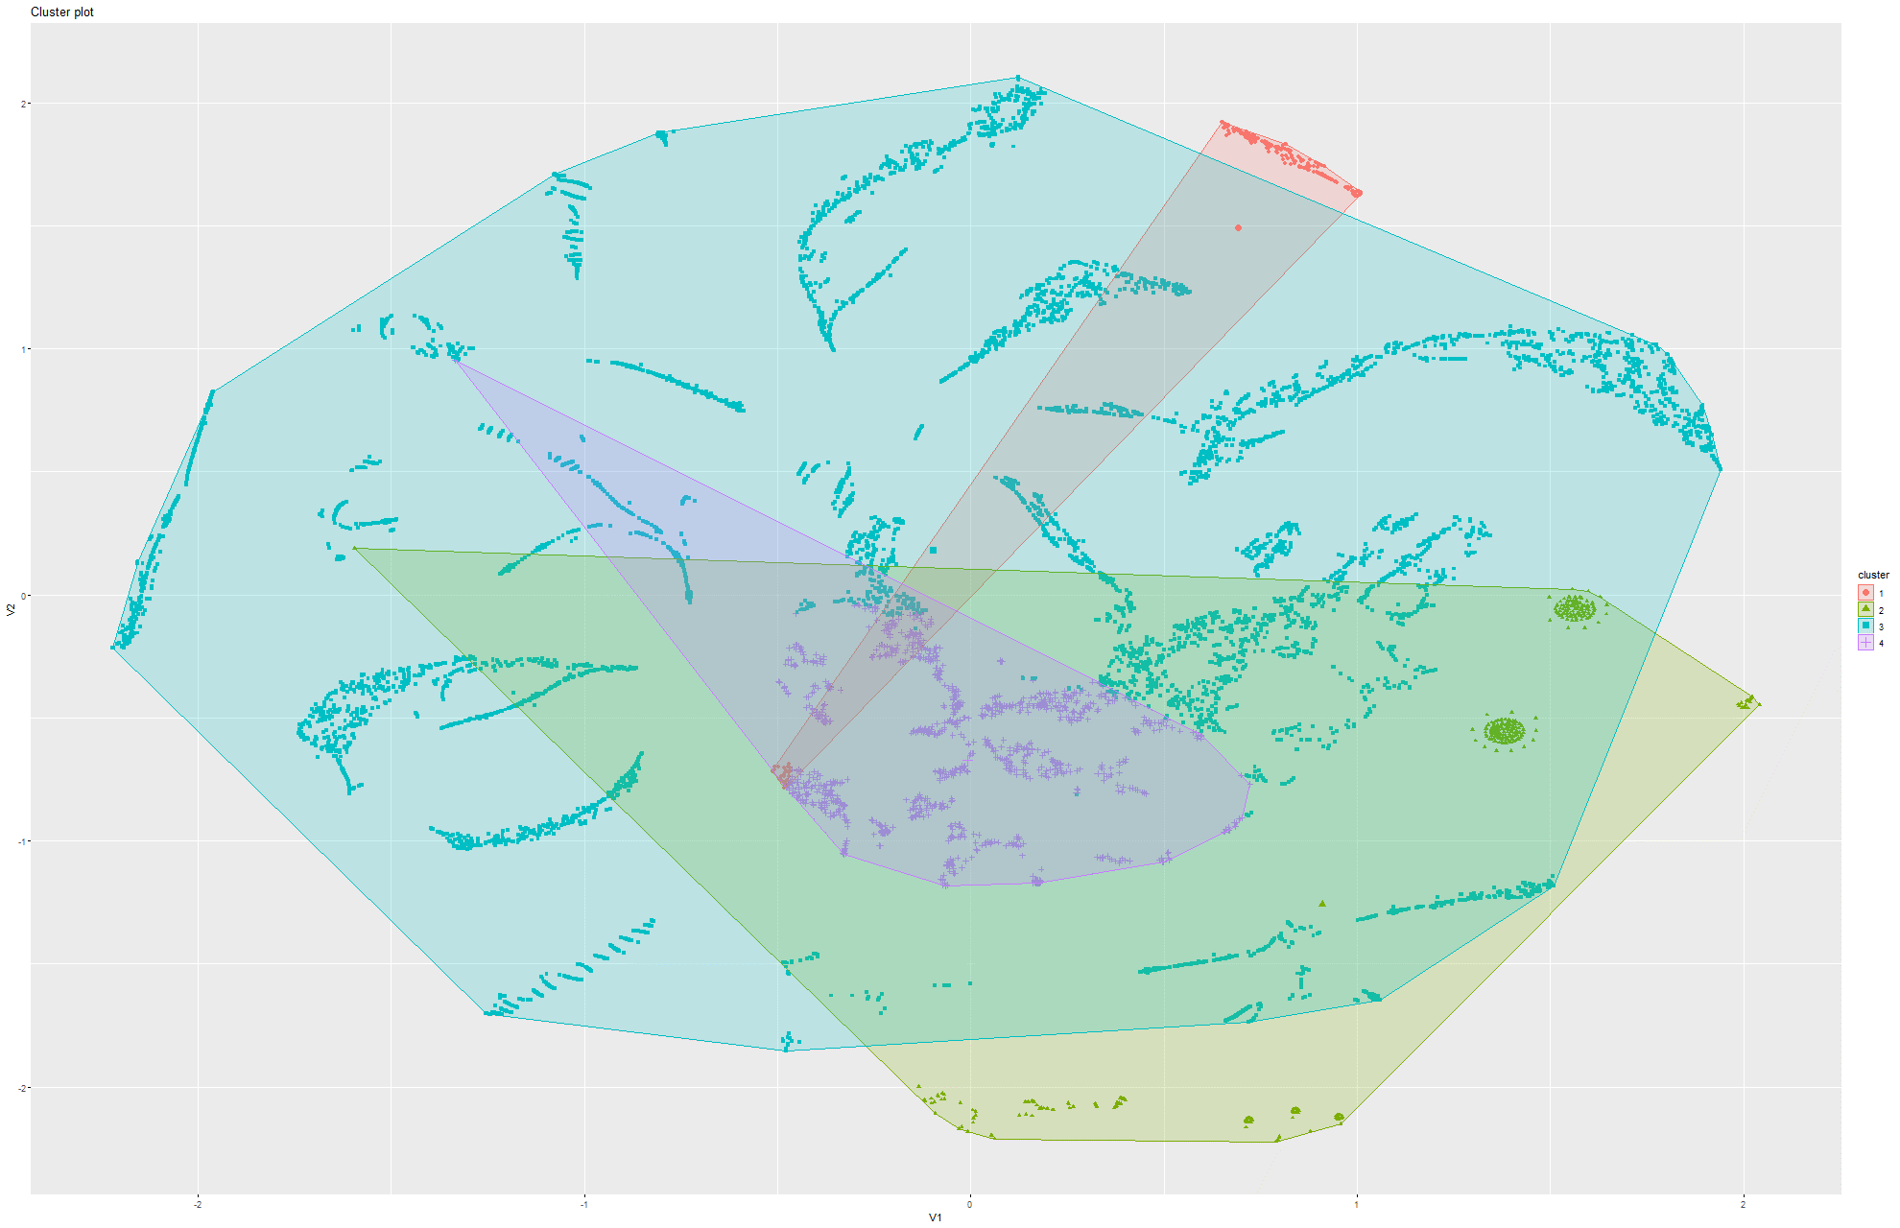Figure 222&223 k-Means on t-SNE Model 9

Model 2:

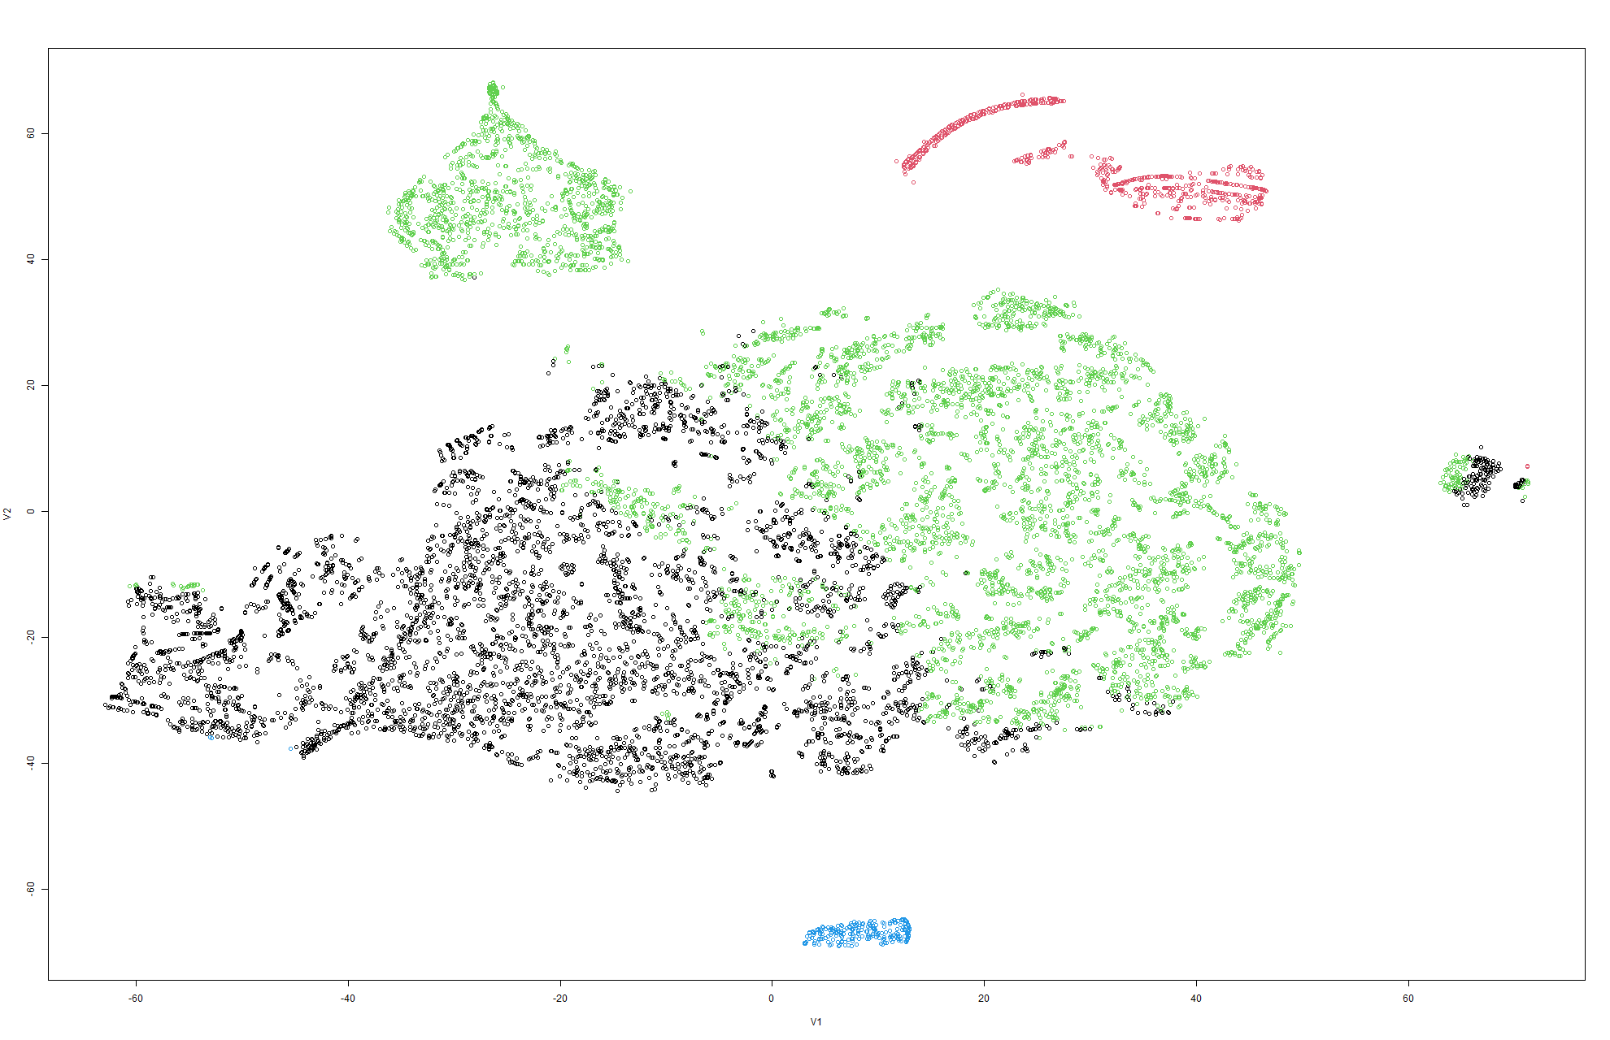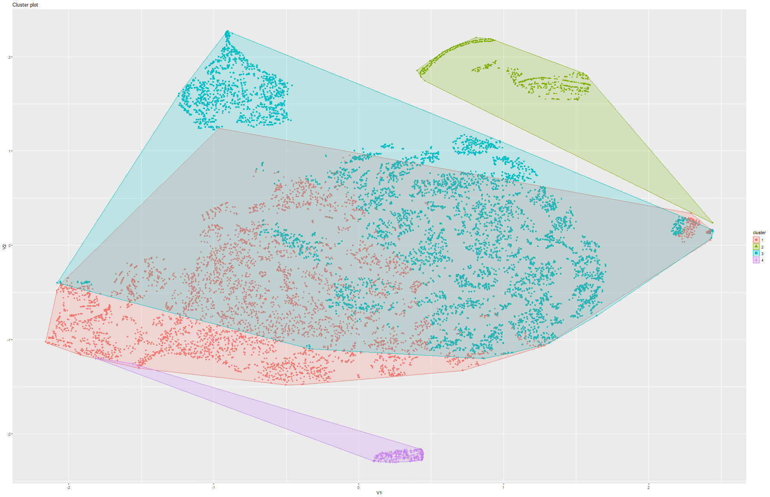Figure 224&225 k-Means on t-SNE Model 1

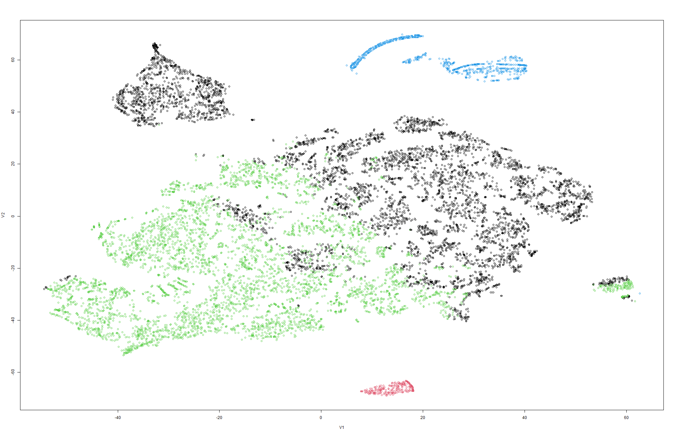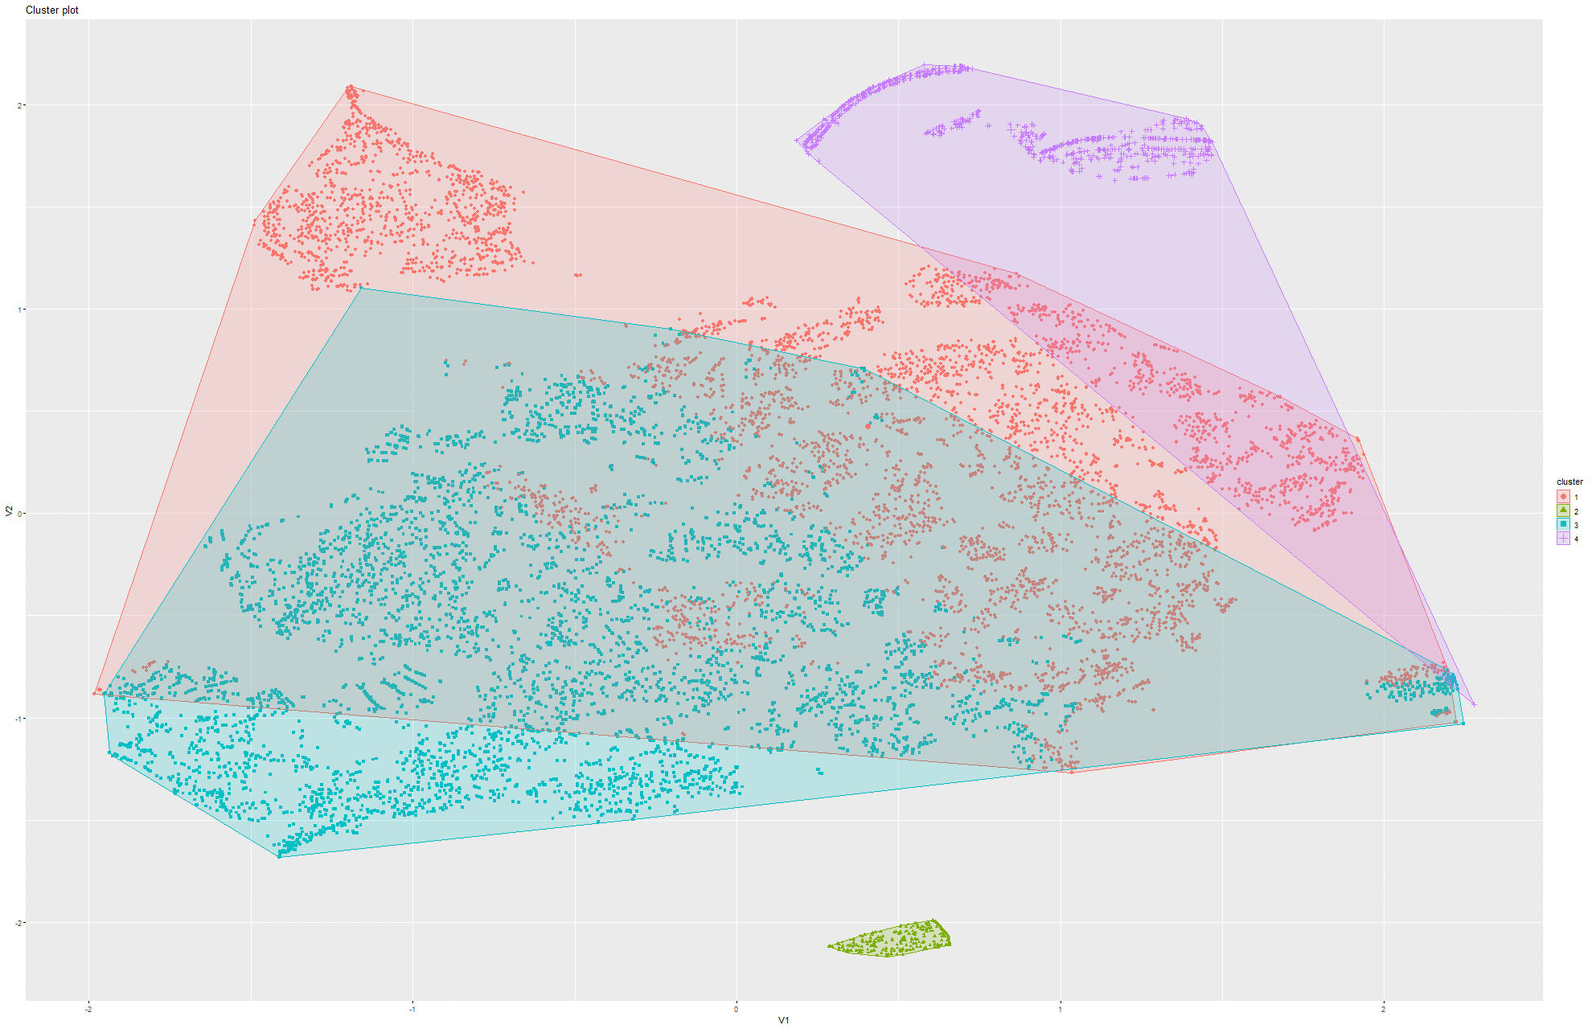Figure 226&227 k-Means on t-SNE Model 2

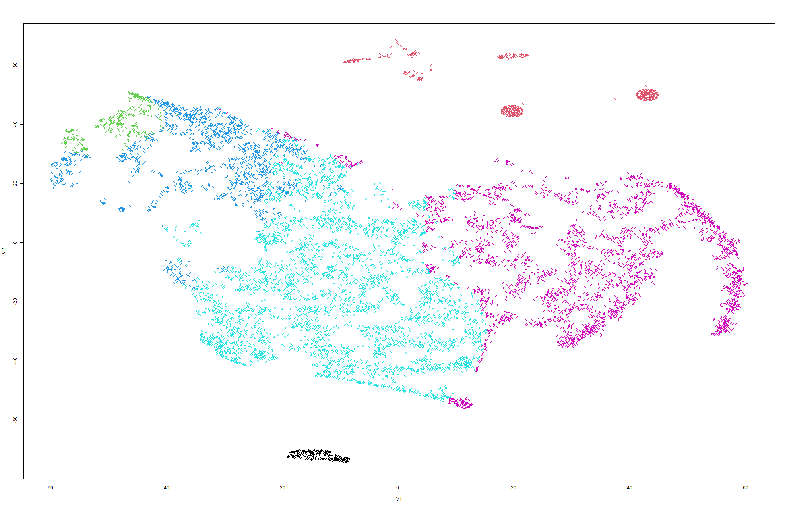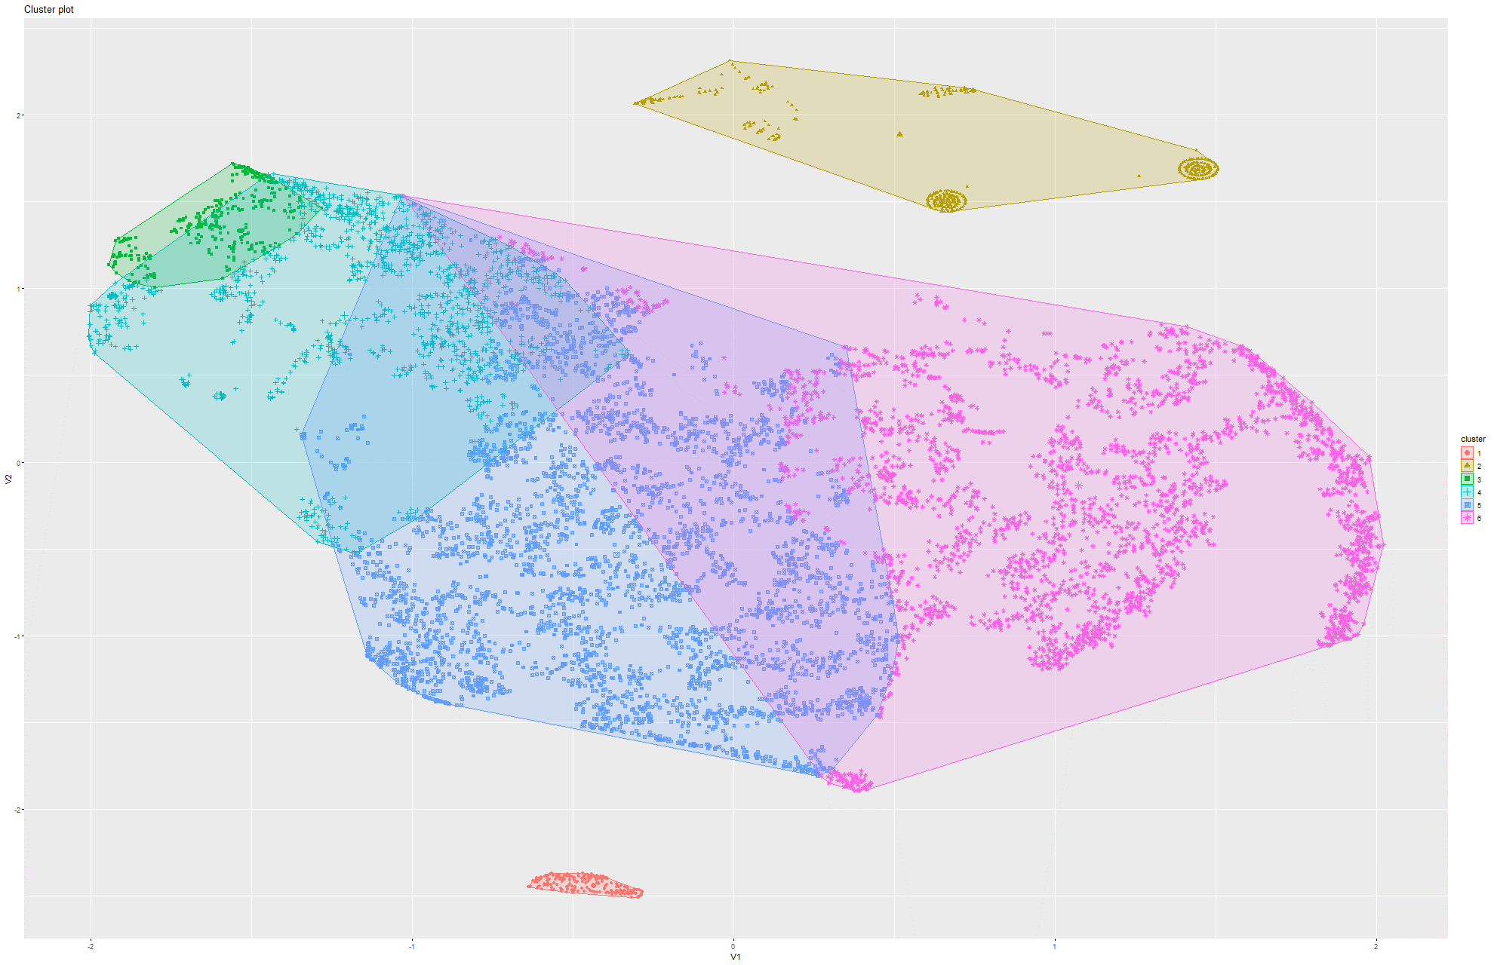Figure 228&229 k-Means on t-SNE Model 3

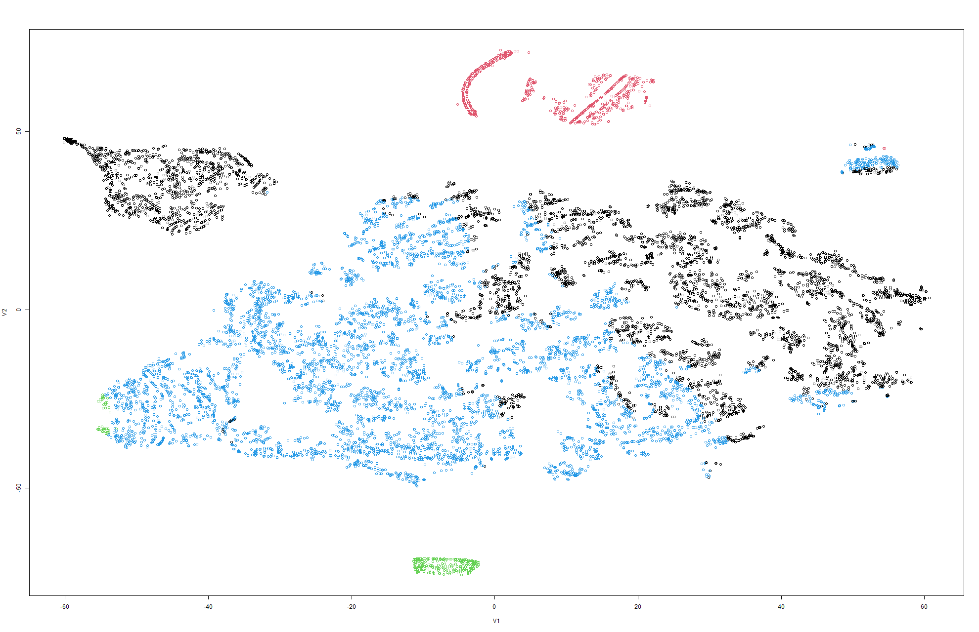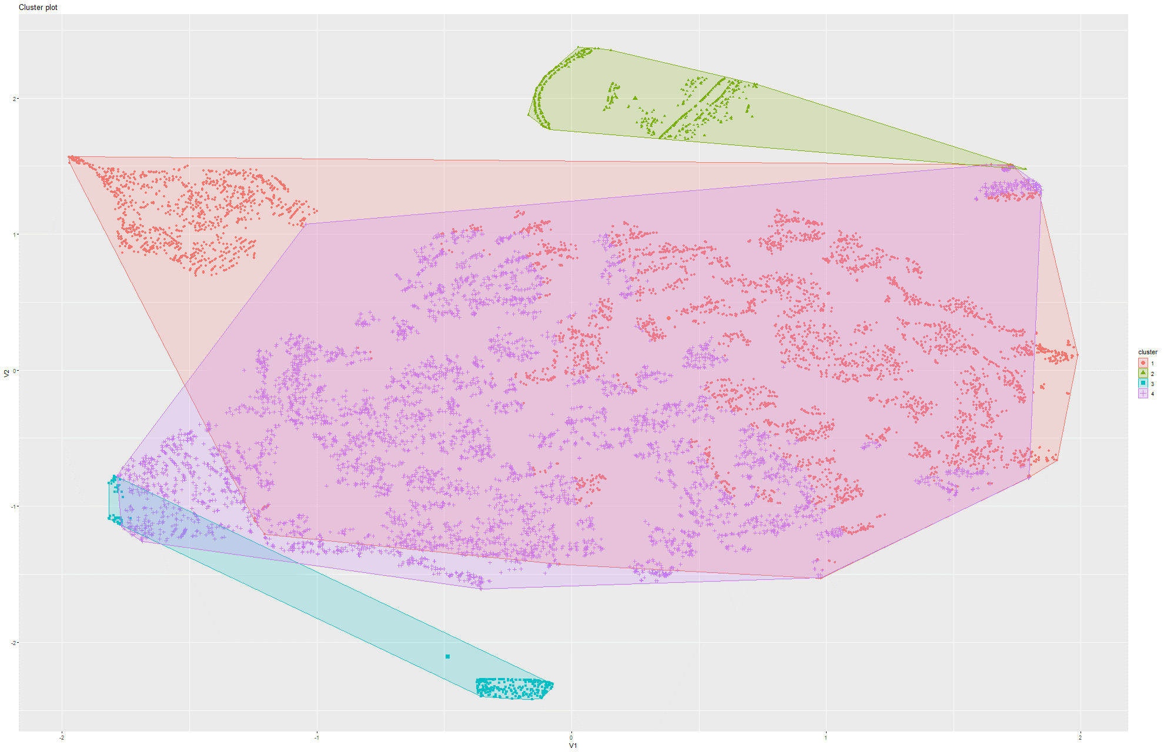Figure 230&231 k-Means on t-SNE Model 4

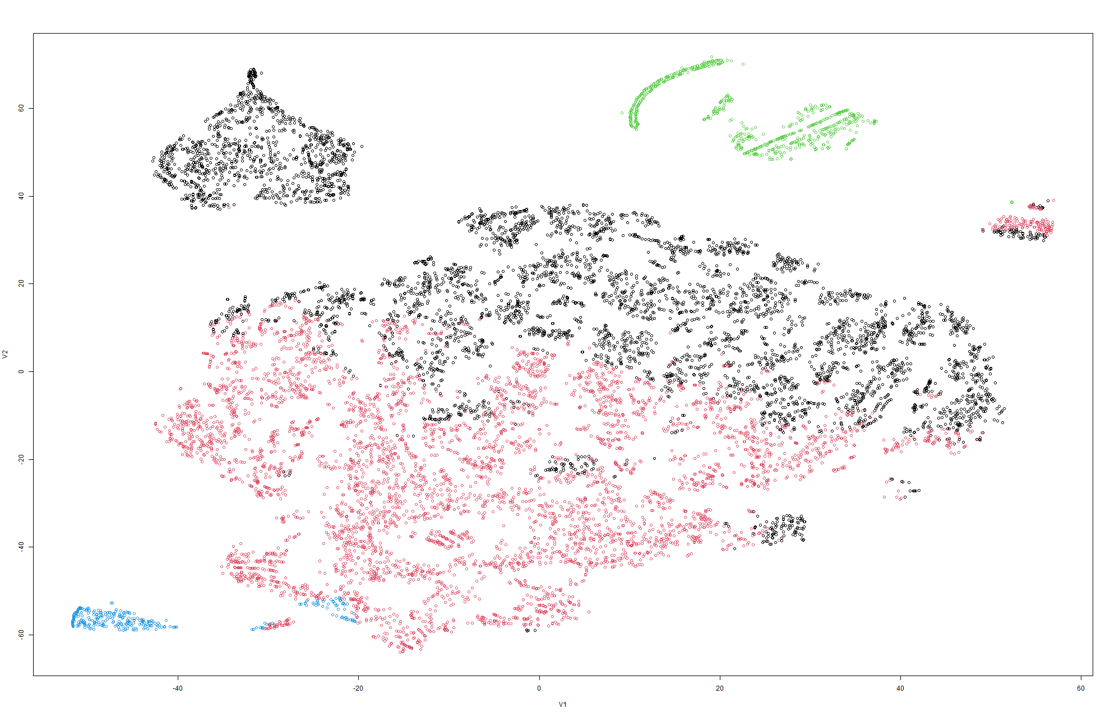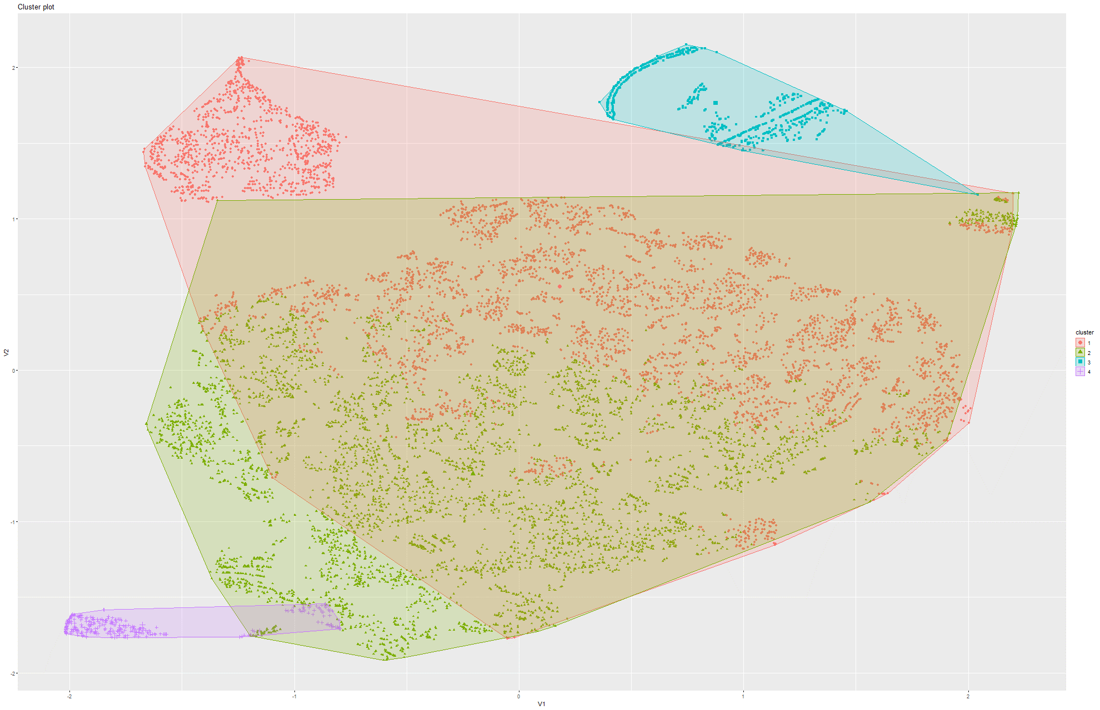Figure 232&233 k-Means on t-SNE Model 5

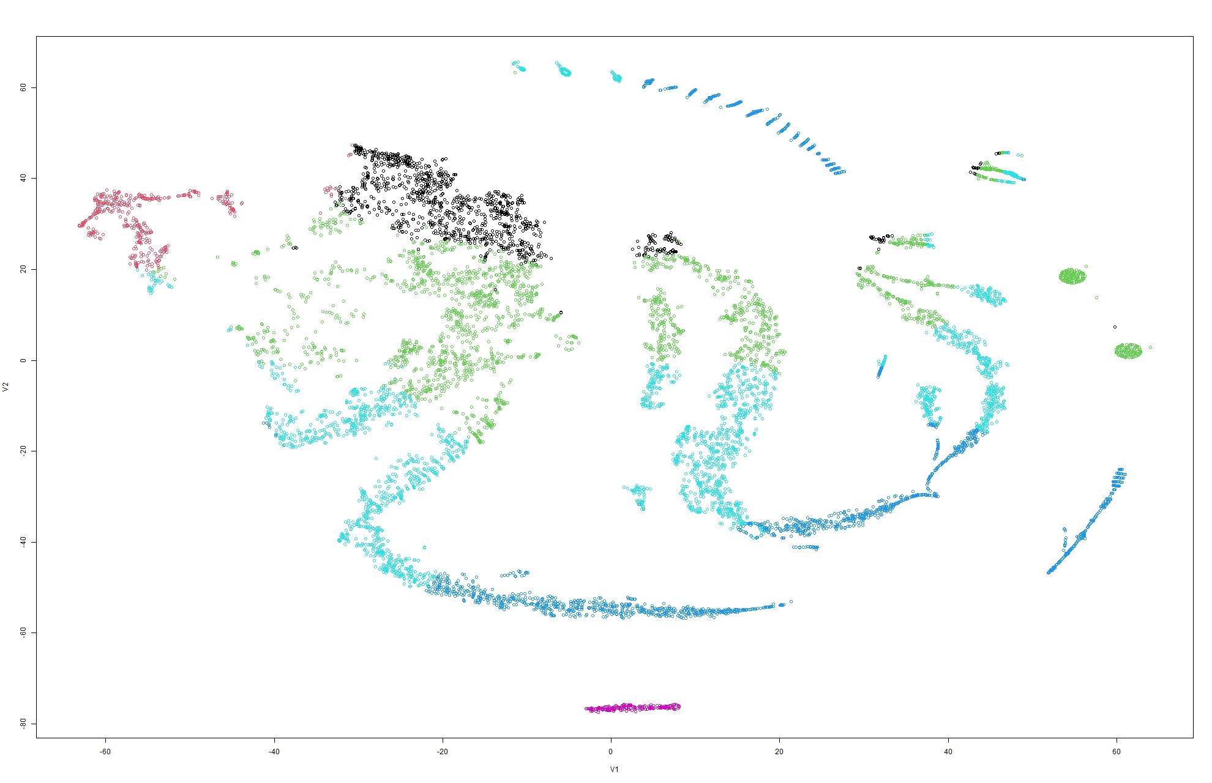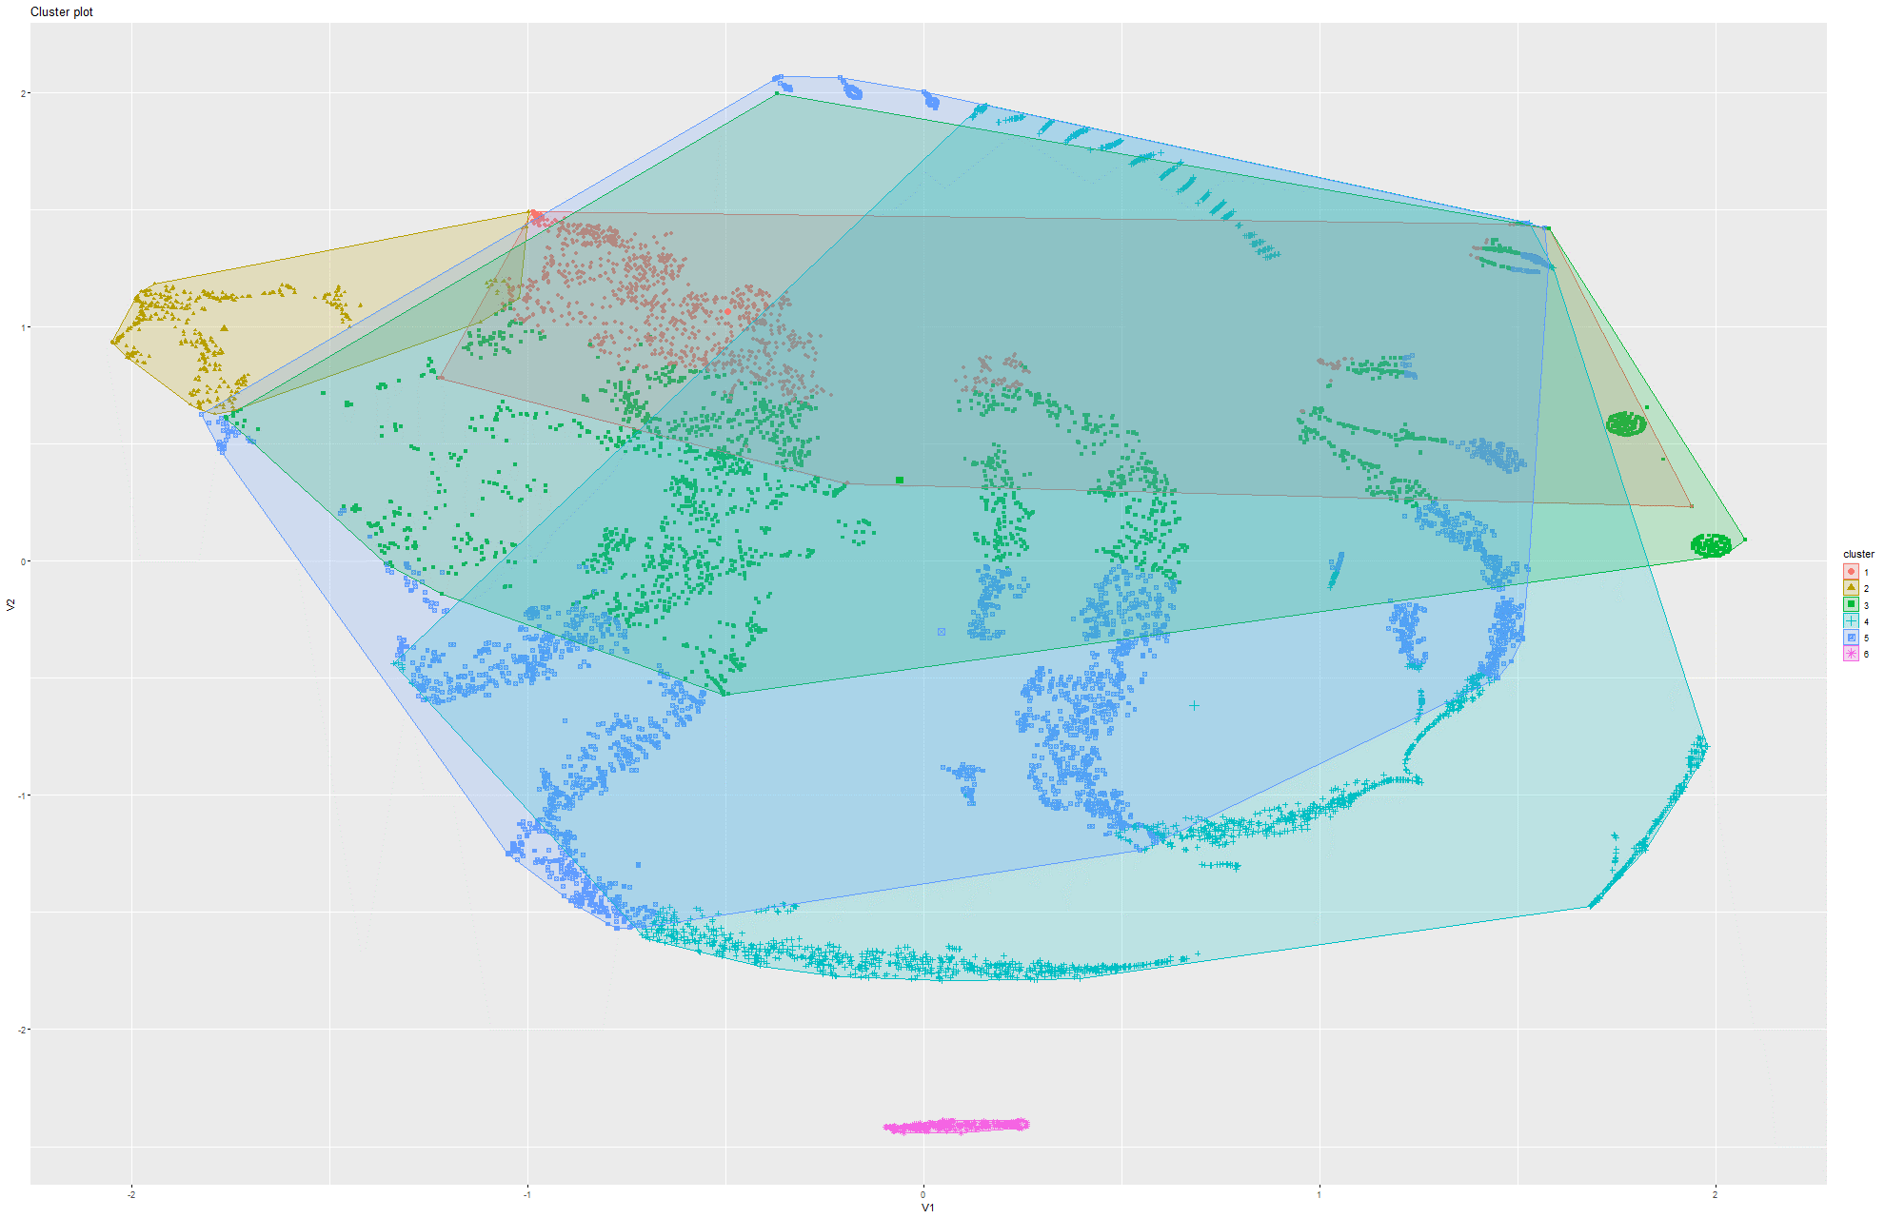Figure 234&235 k-Means on t-SNE Model 6

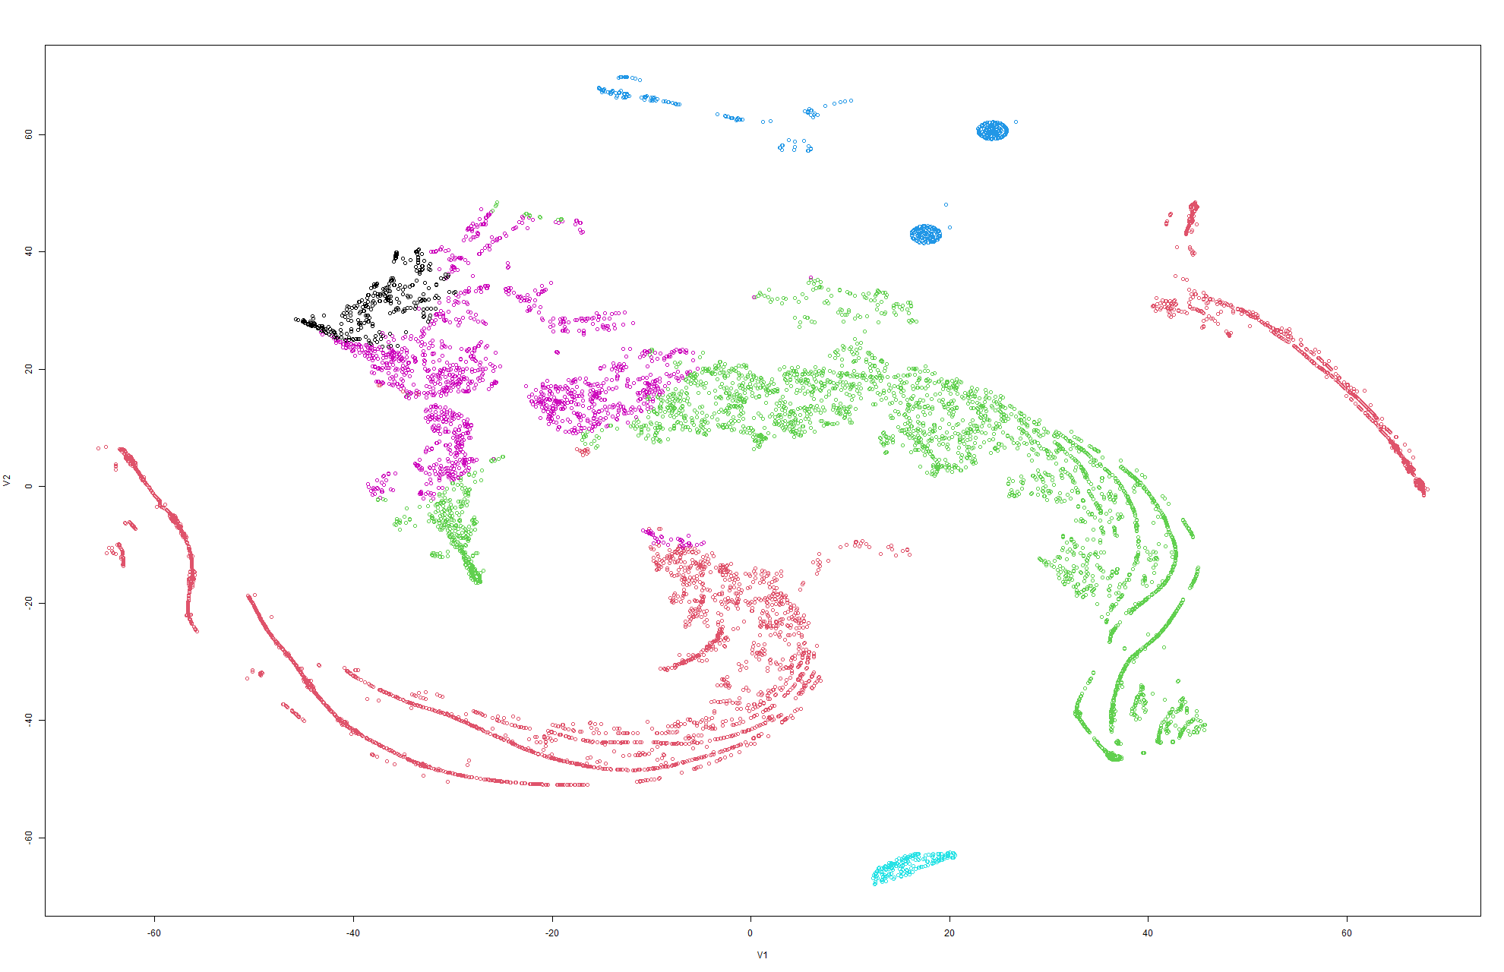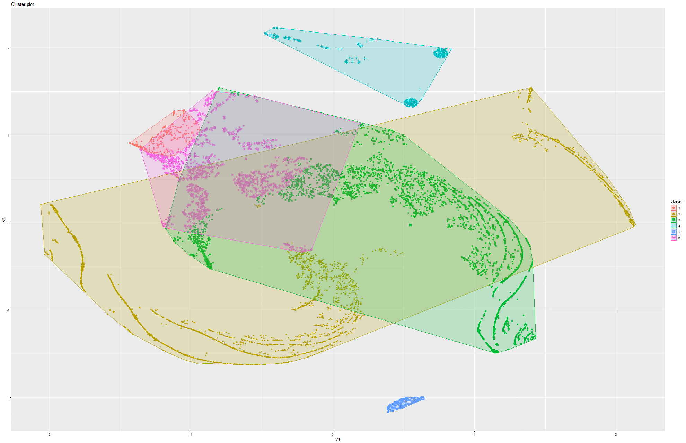Figure 236&237 k-Means on t-SNE Model 7

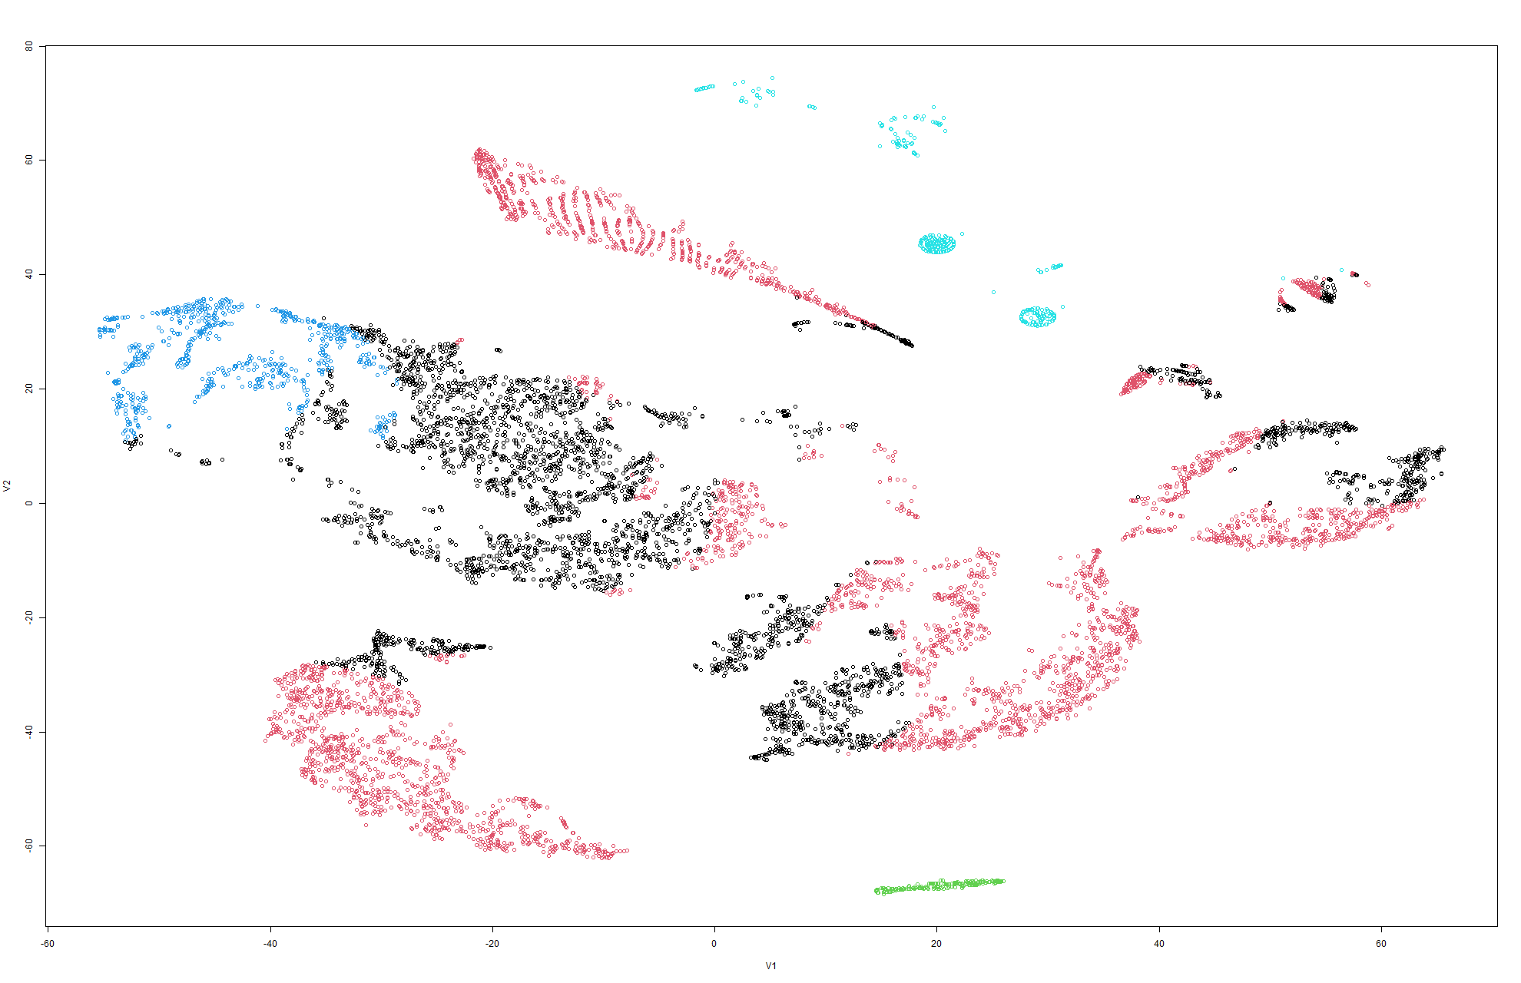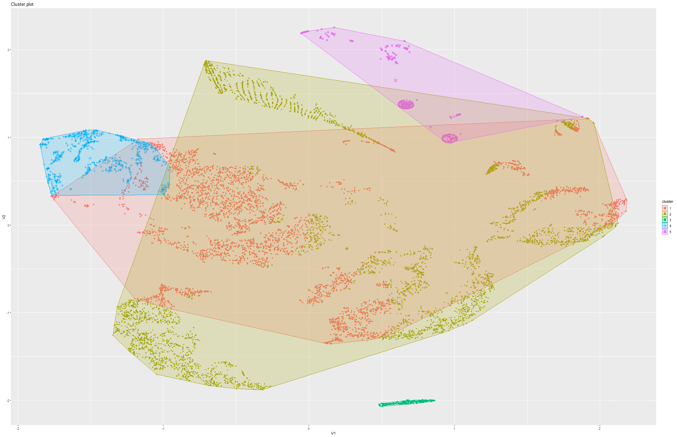Figure 238&239 k-Means on t-SNE Model 8

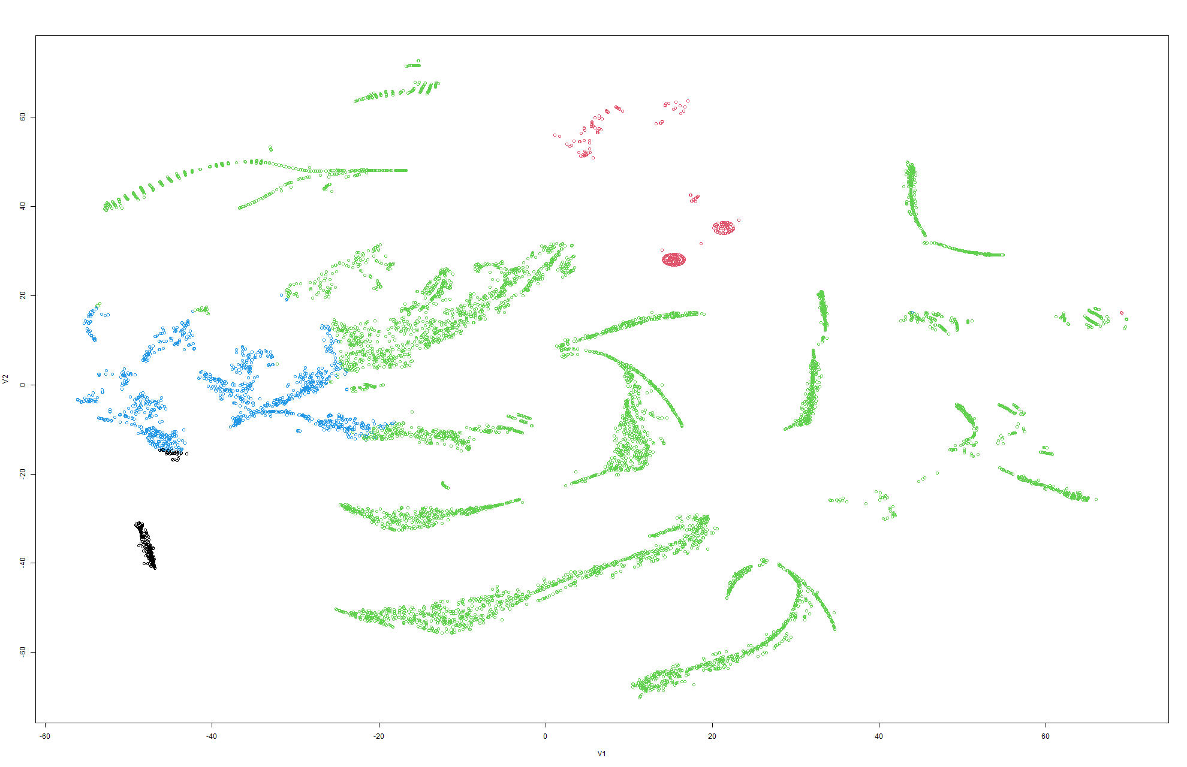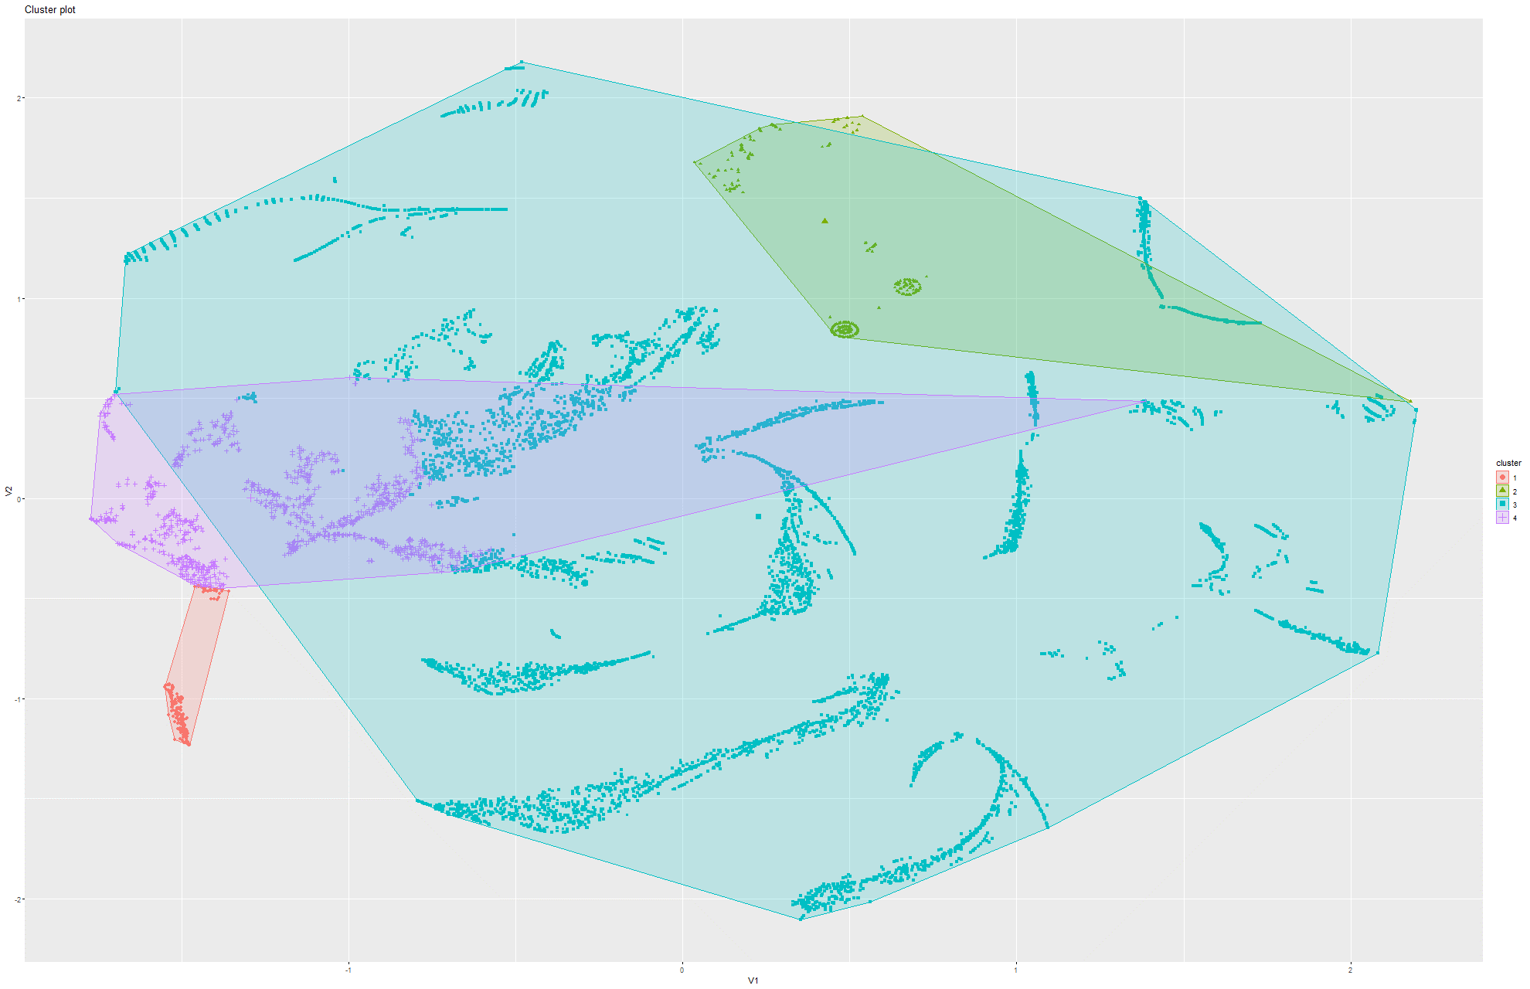Figure 240&241 k-Means on t-SNE Model 9

Model 3:

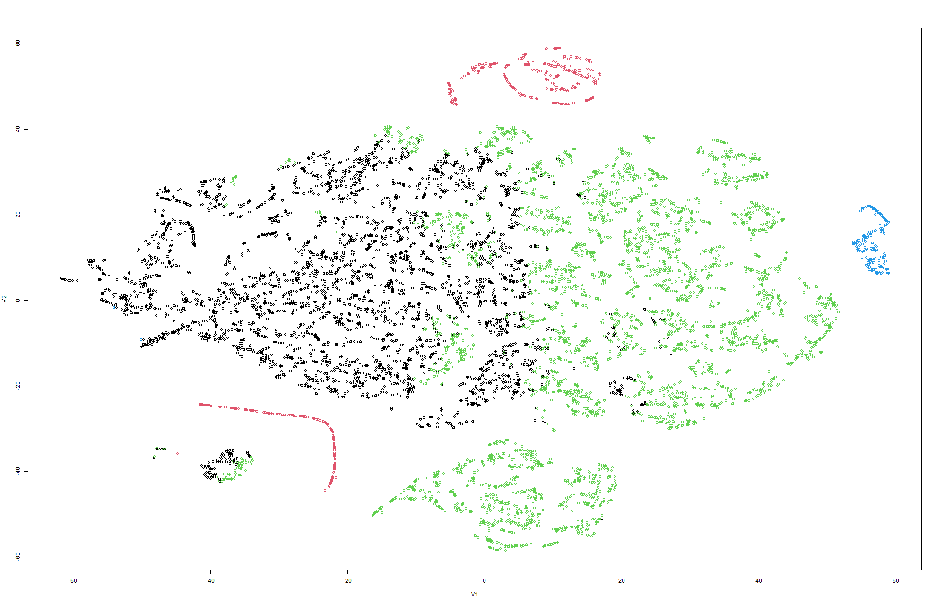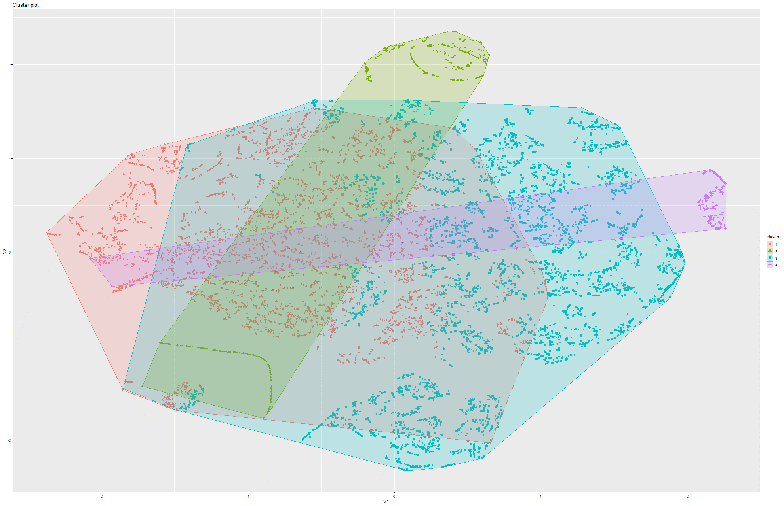Figure 242&243 k-Means on t-SNE Model 1

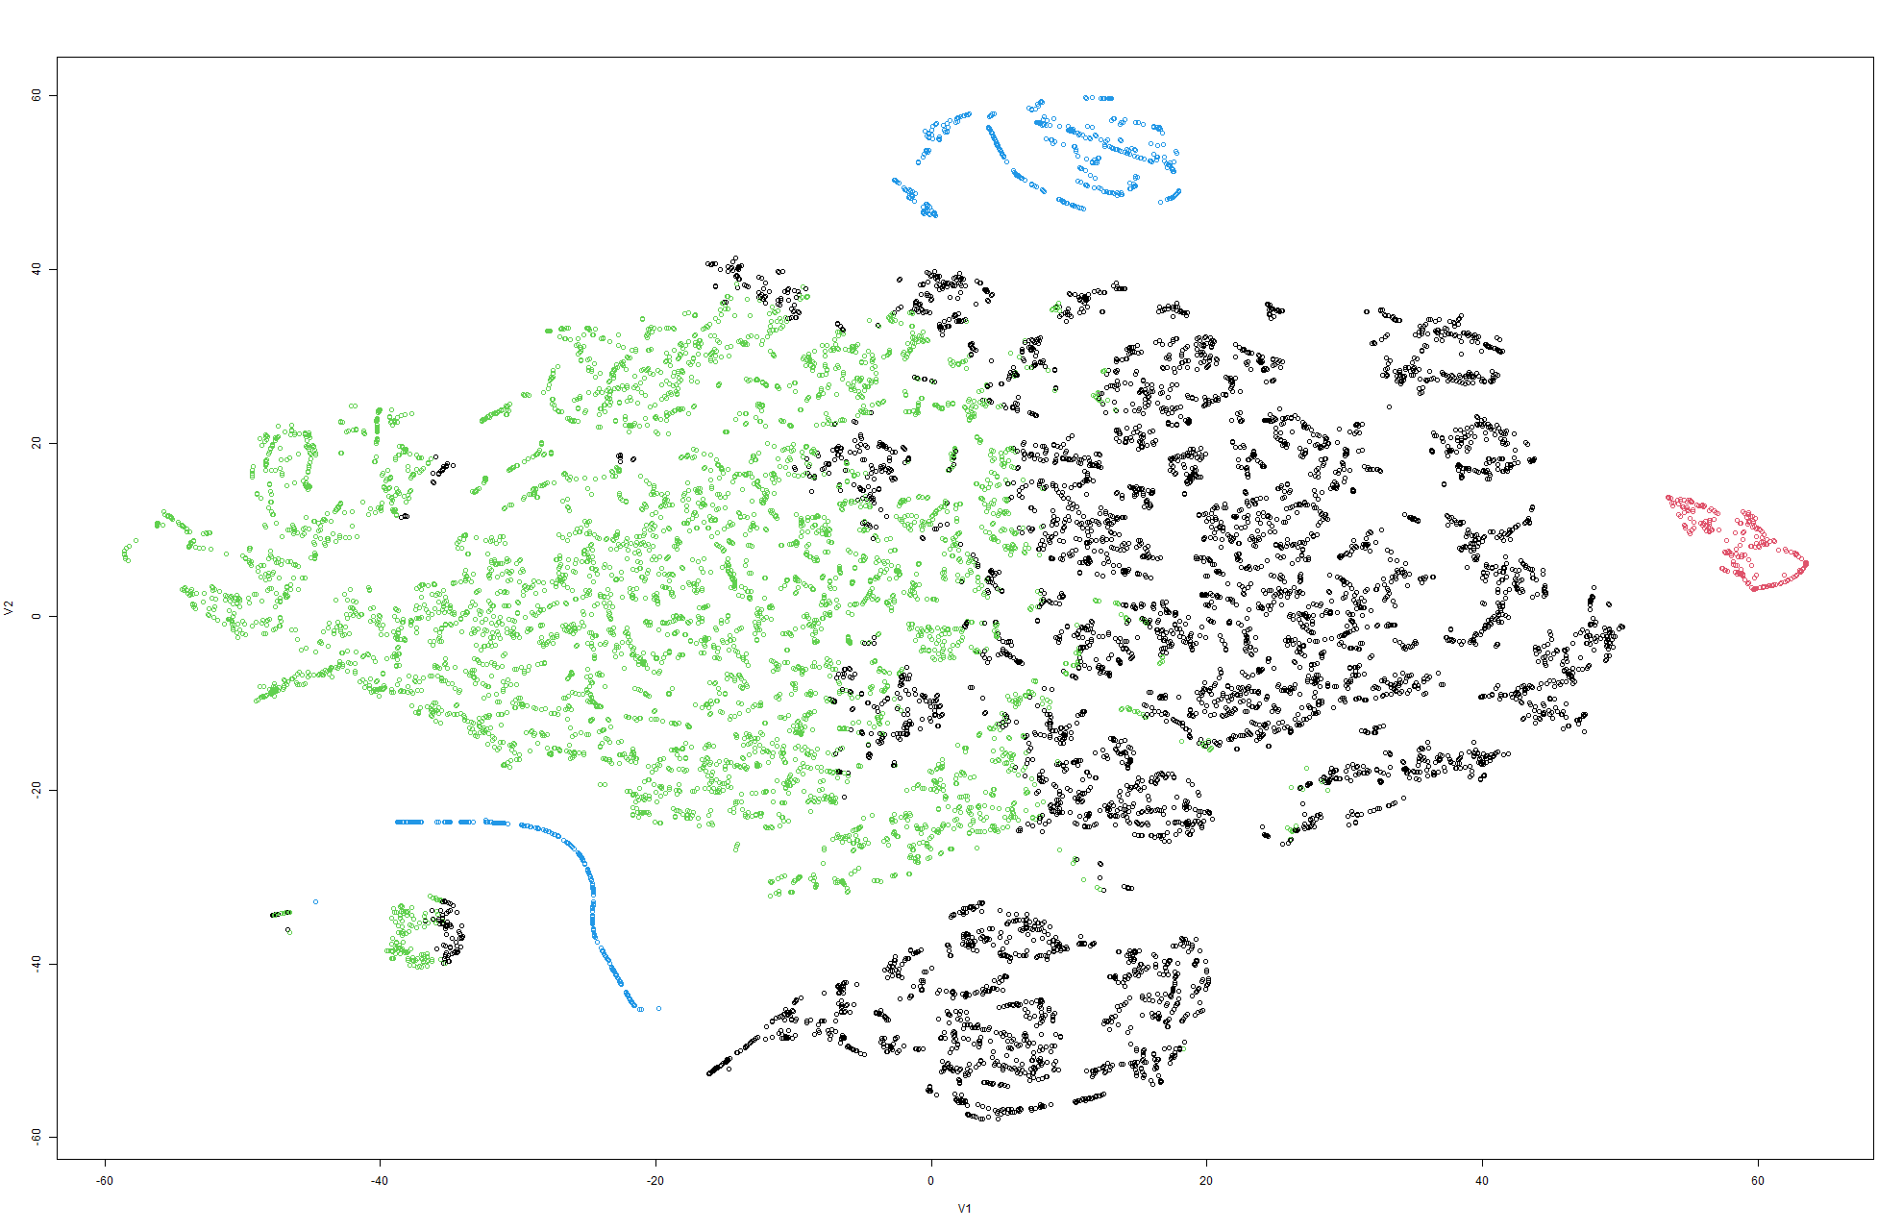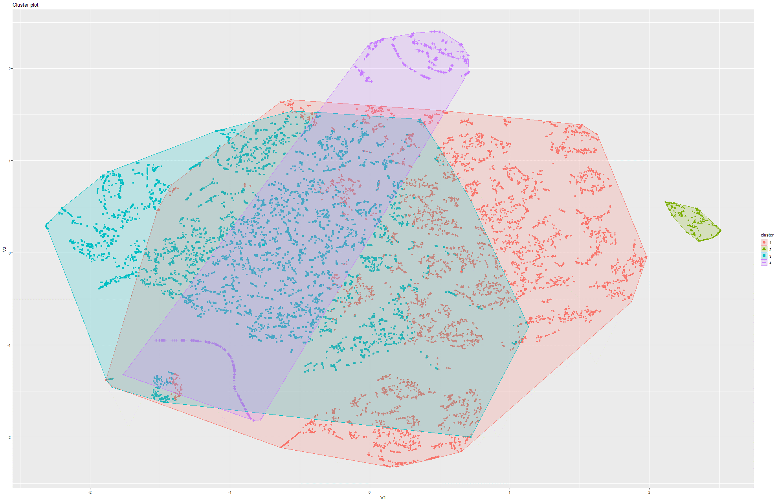Figure 244&245 k-Means on t-SNE Model 2

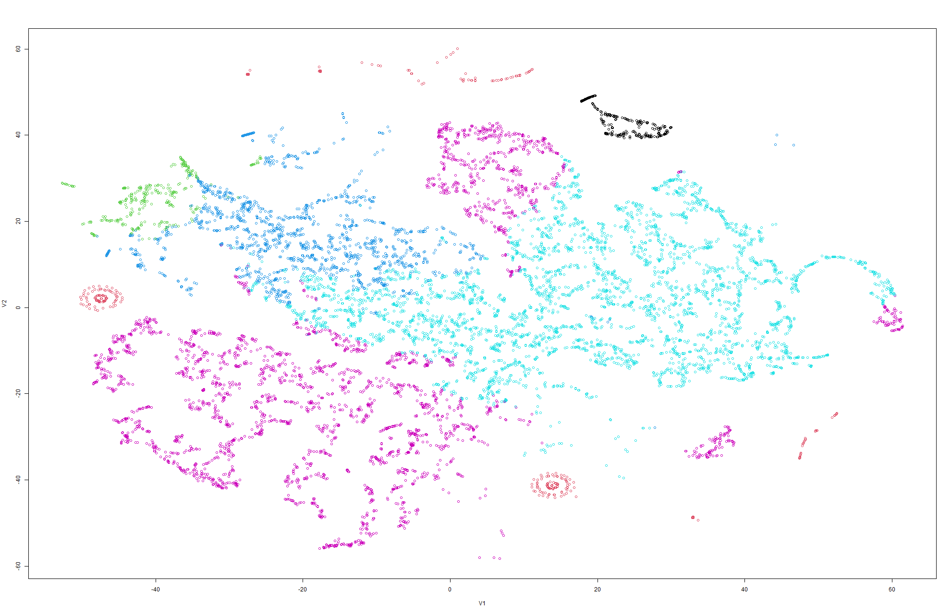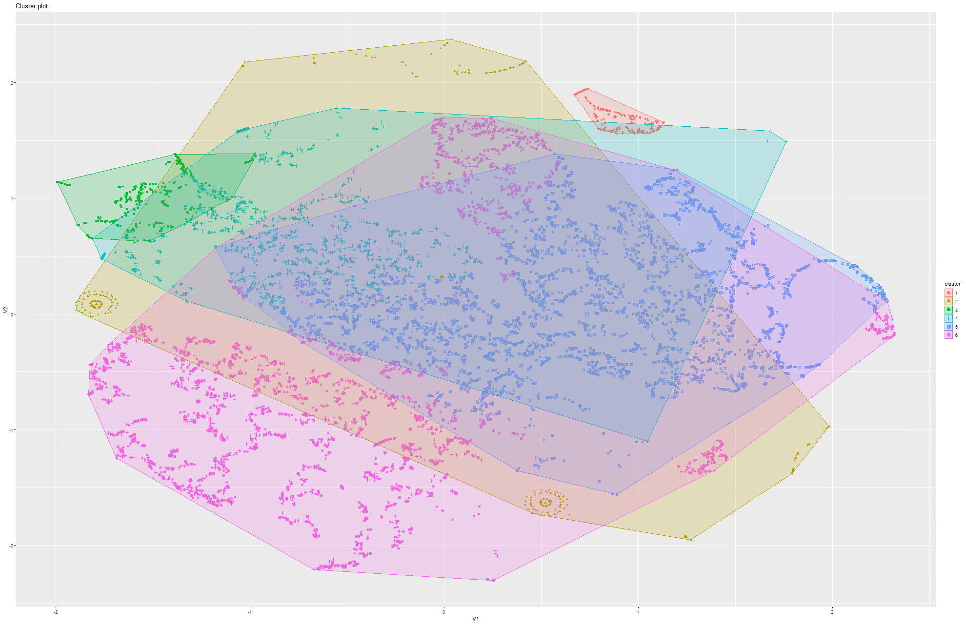Figure 246&247 k-Means on t-SNE Model 3

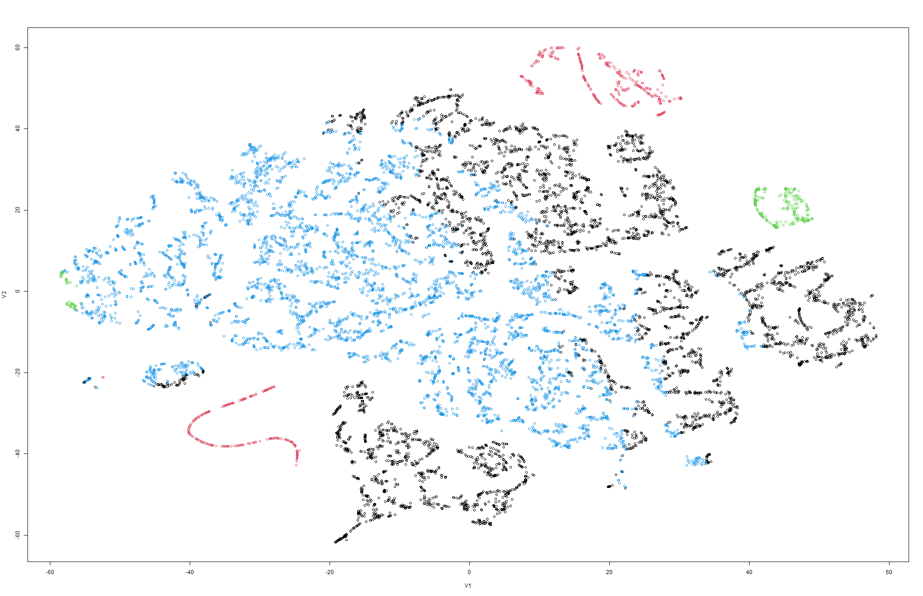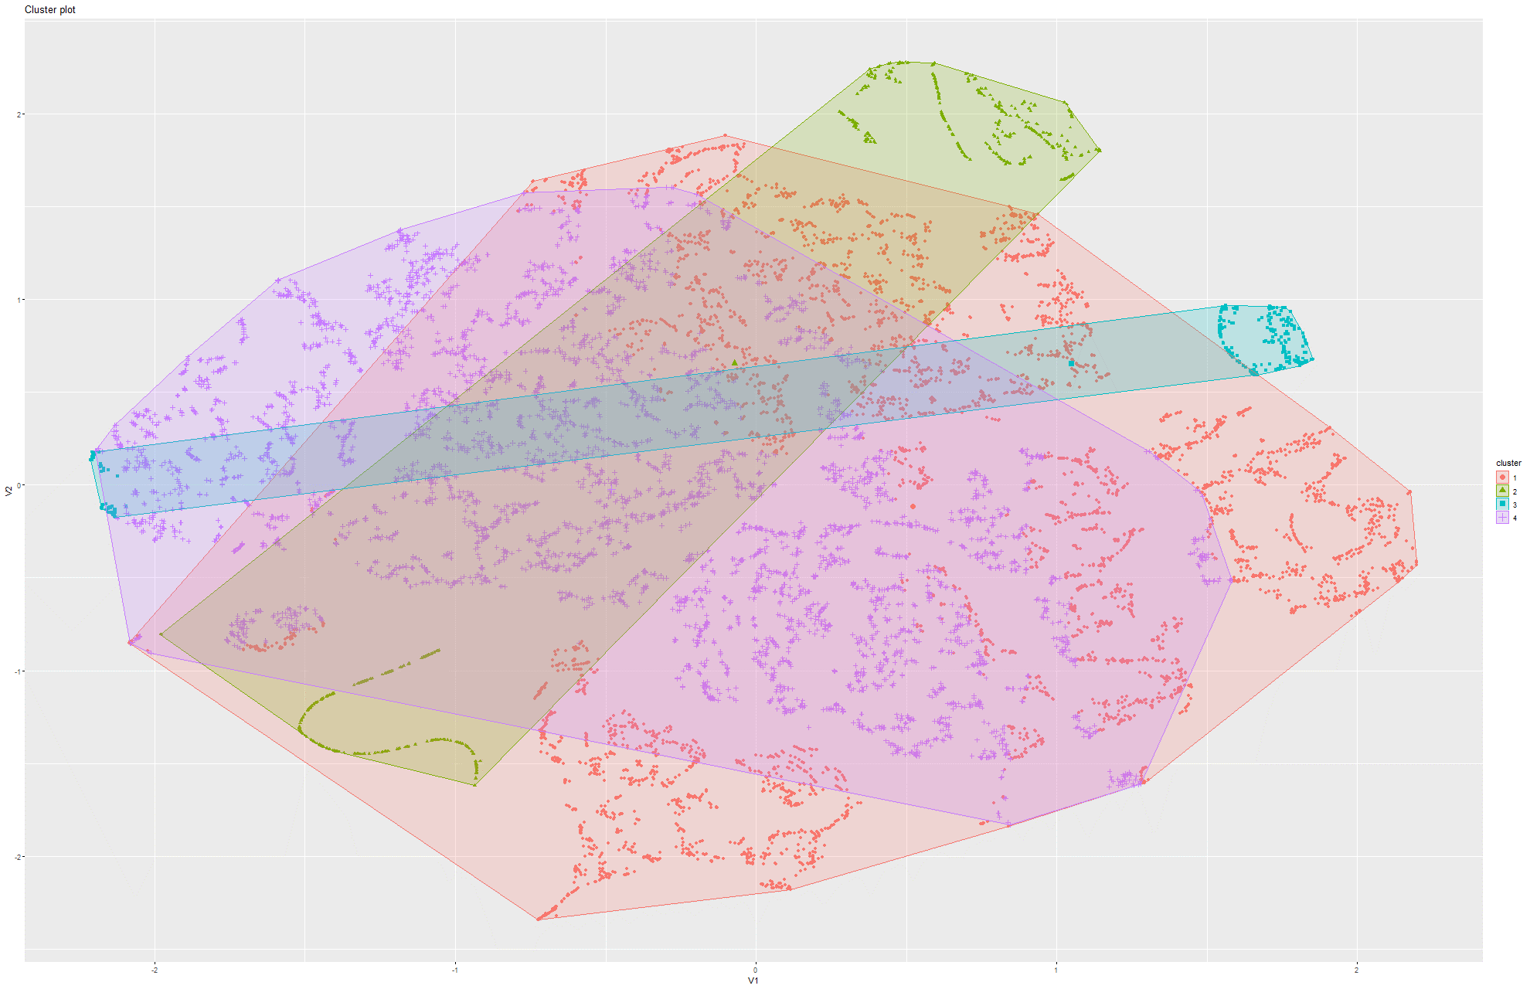Figure 248&249 k-Means on t-SNE Model 4

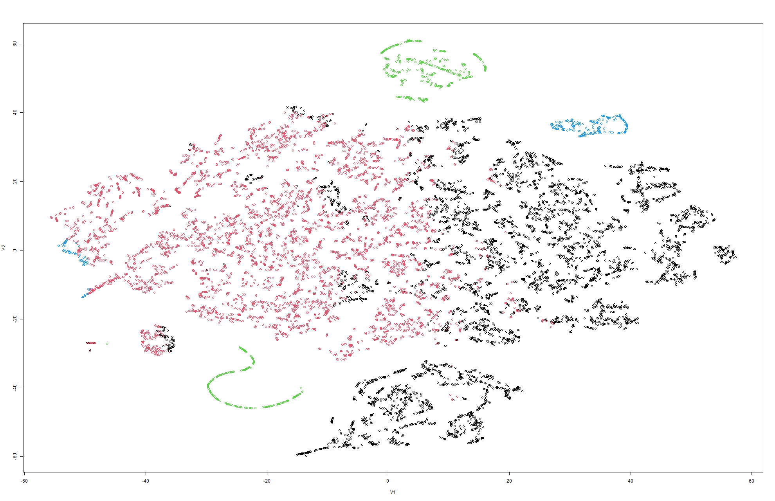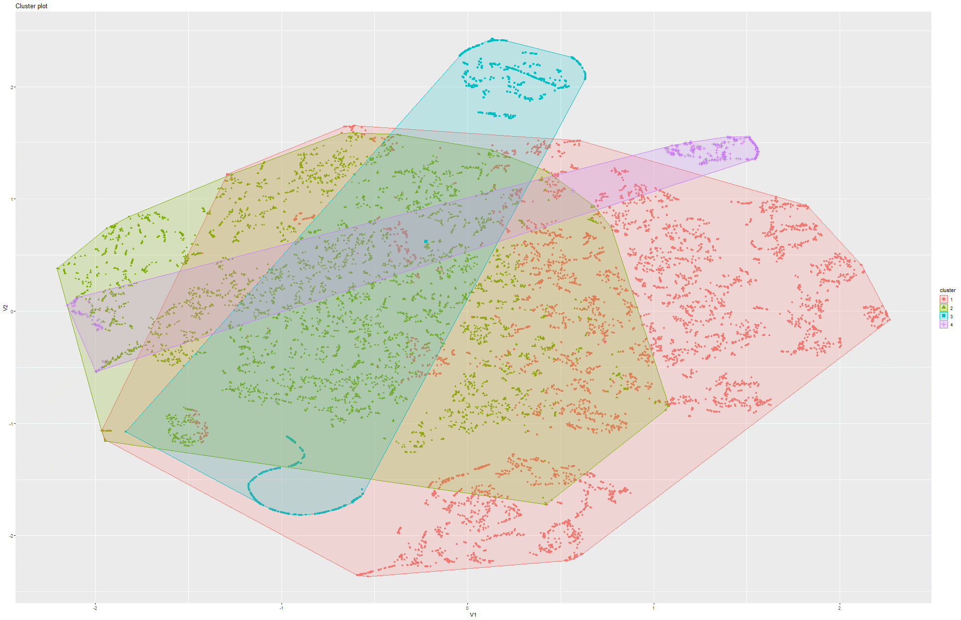Figure 250&251 k-Means on t-SNE Model 5

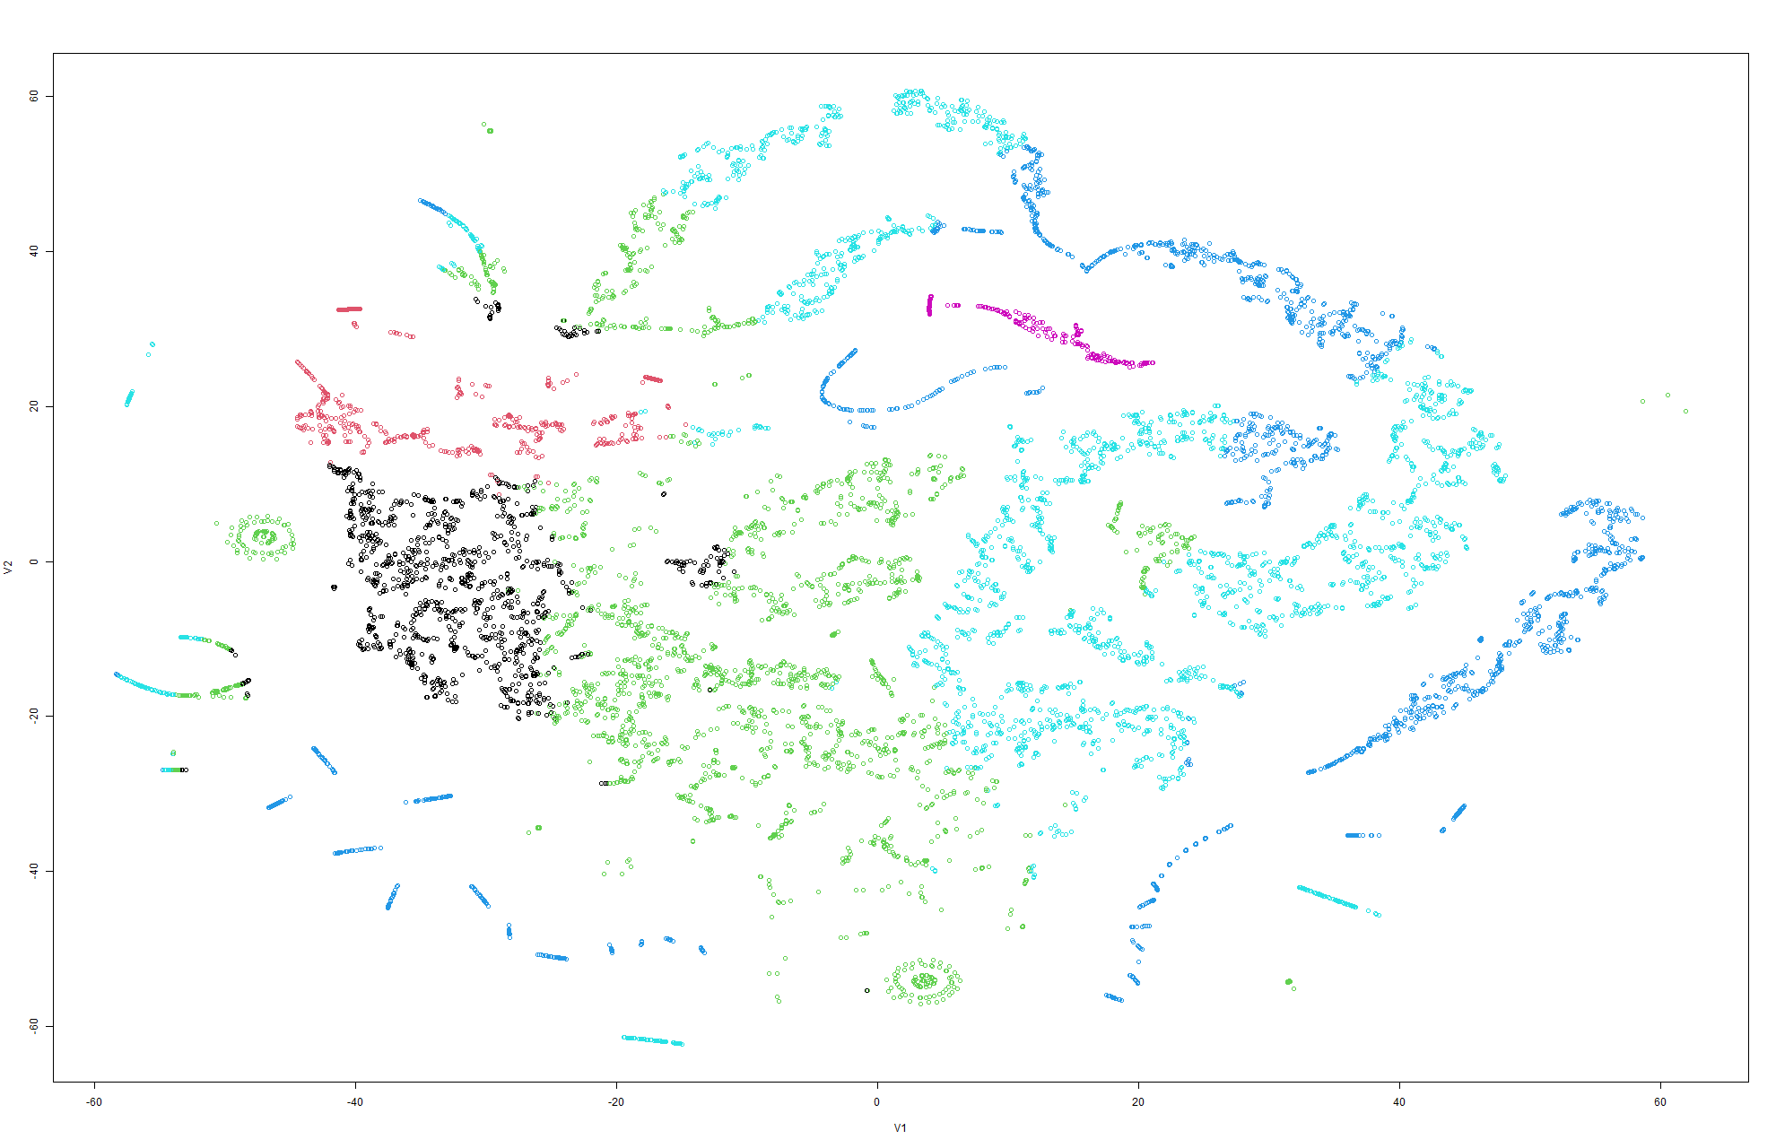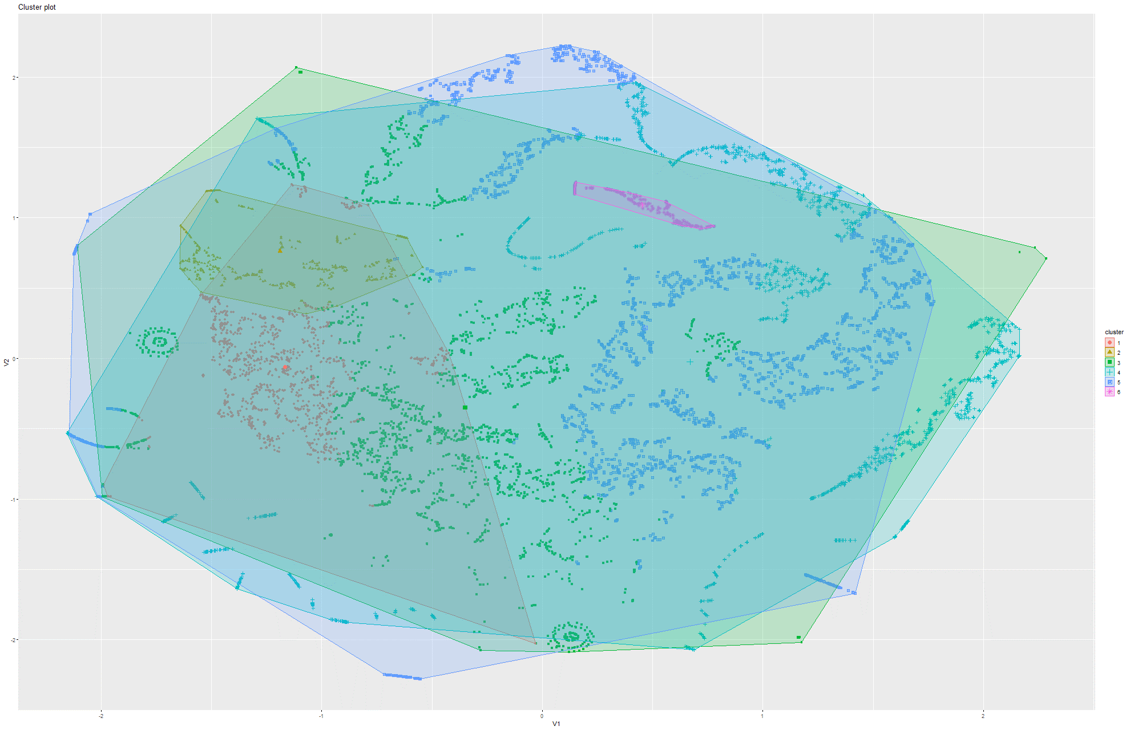Figure 252&253 k-Means on t-SNE Model 6

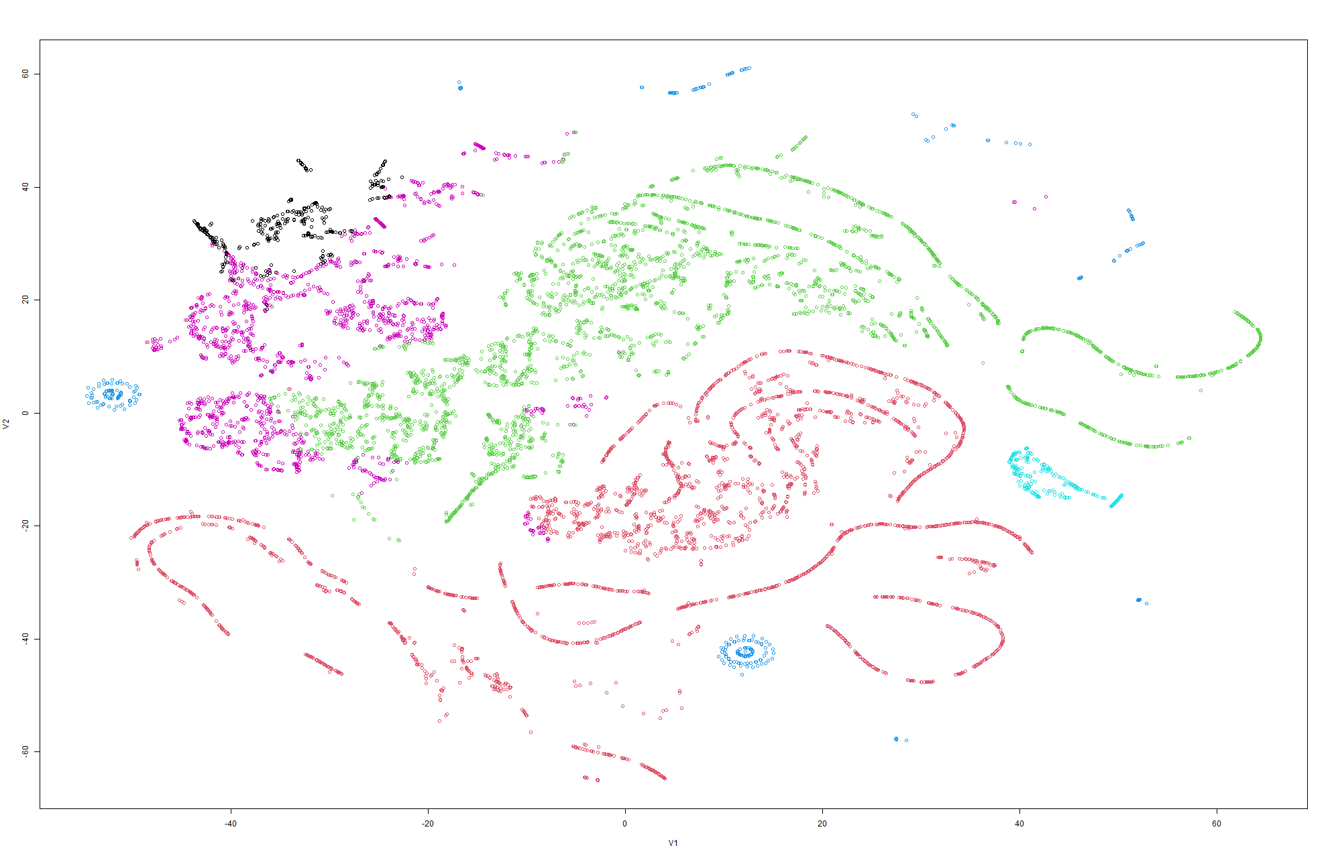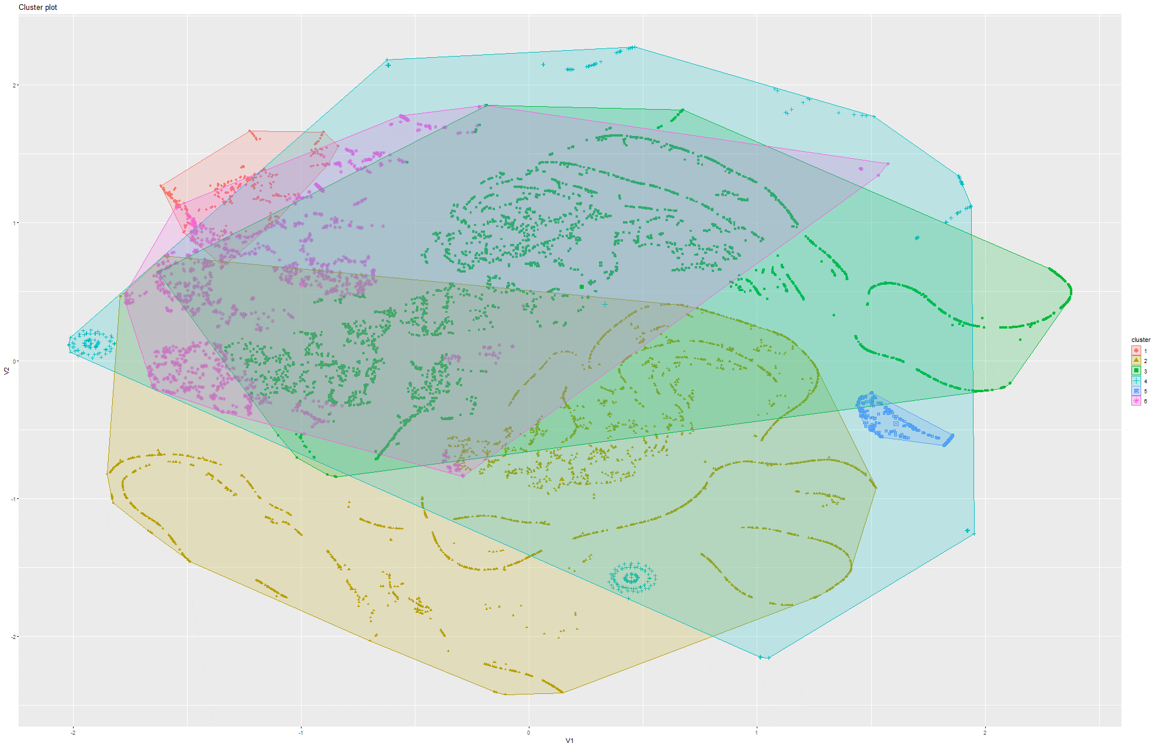Figure 254&255 k-Means on t-SNE Model 7

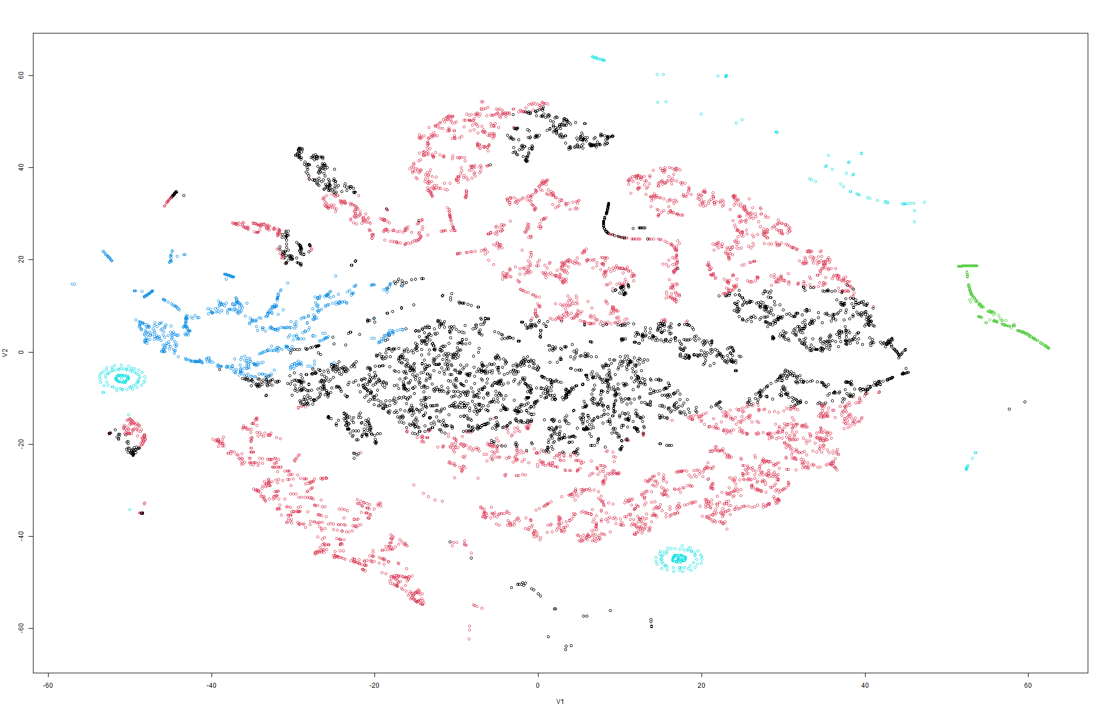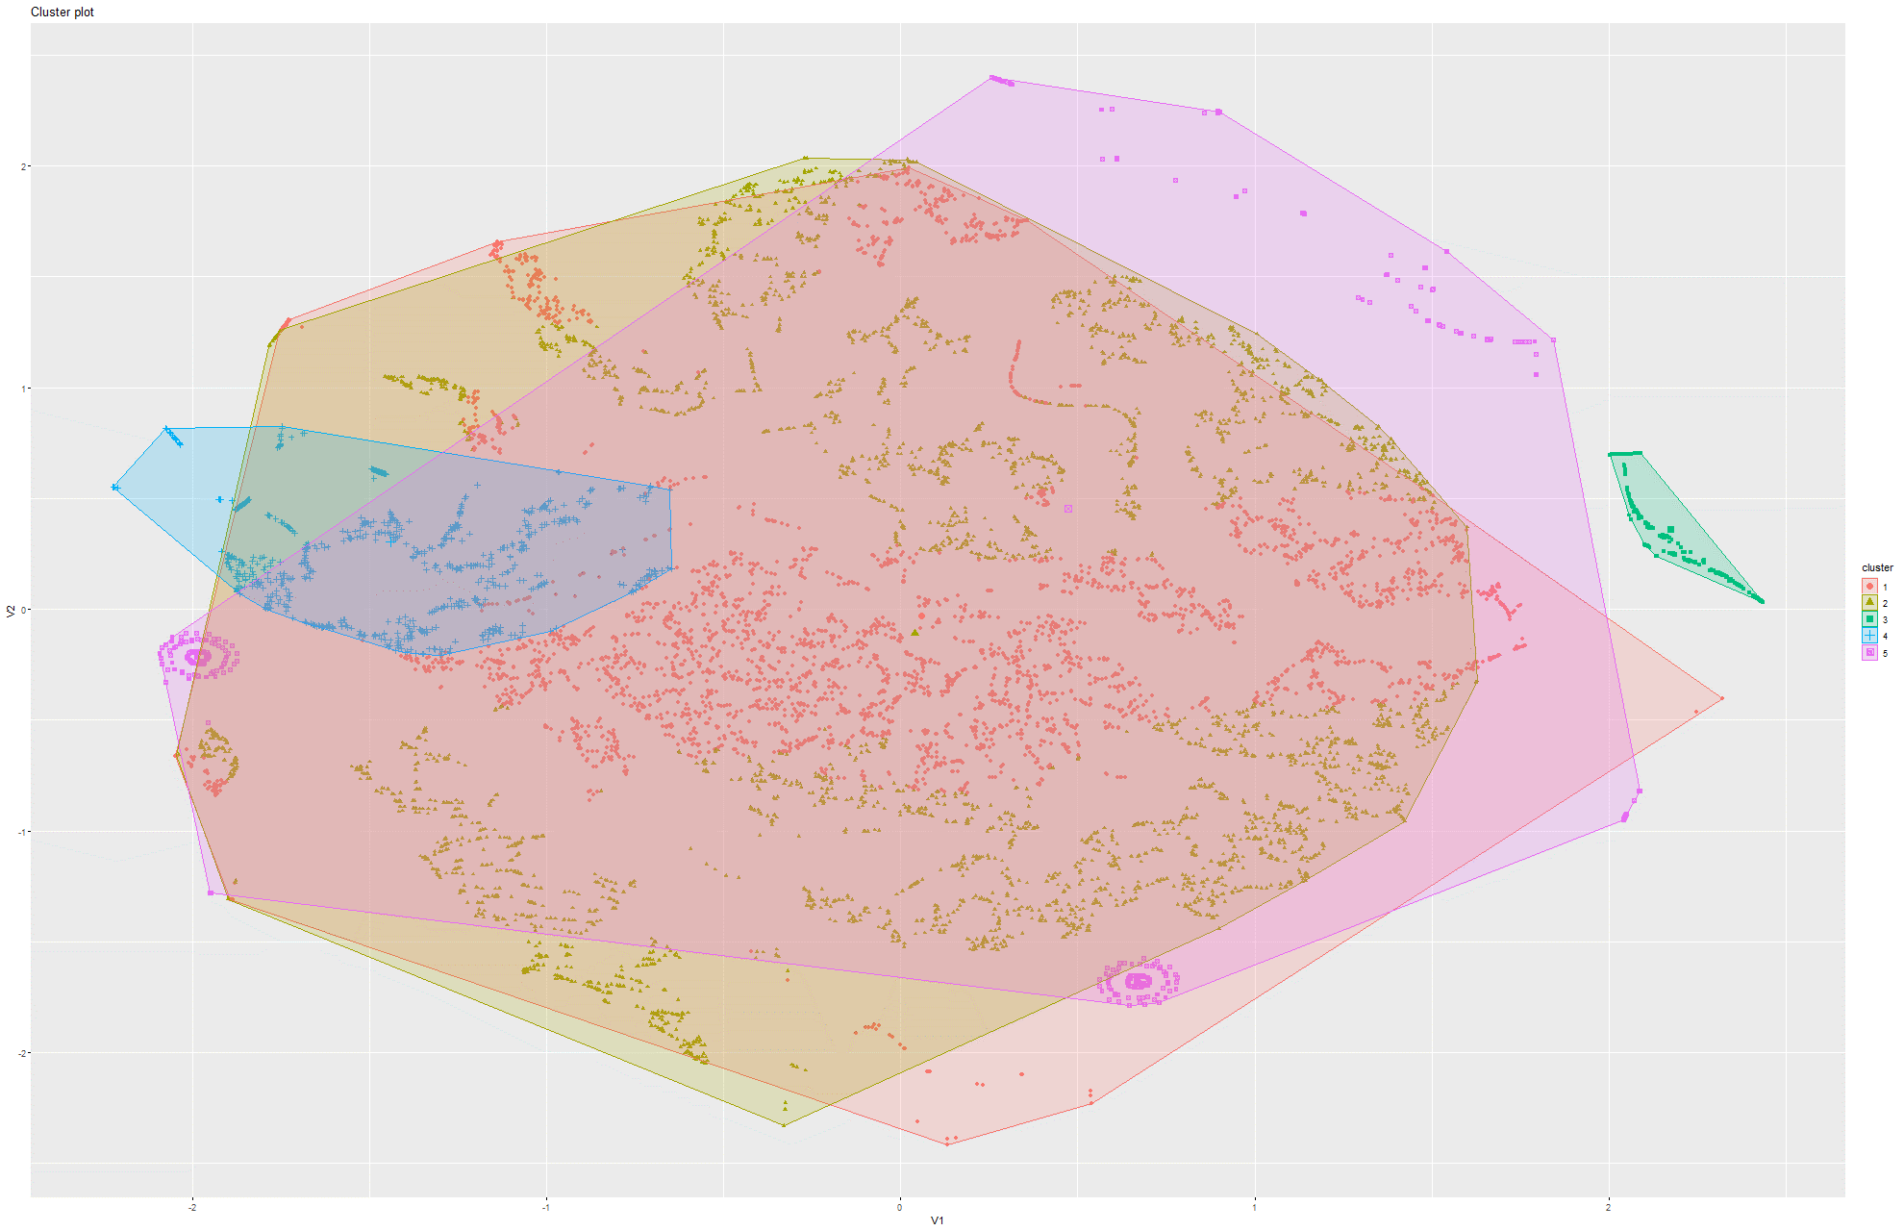Figure 256&257 k-Means on t-SNE Model 8

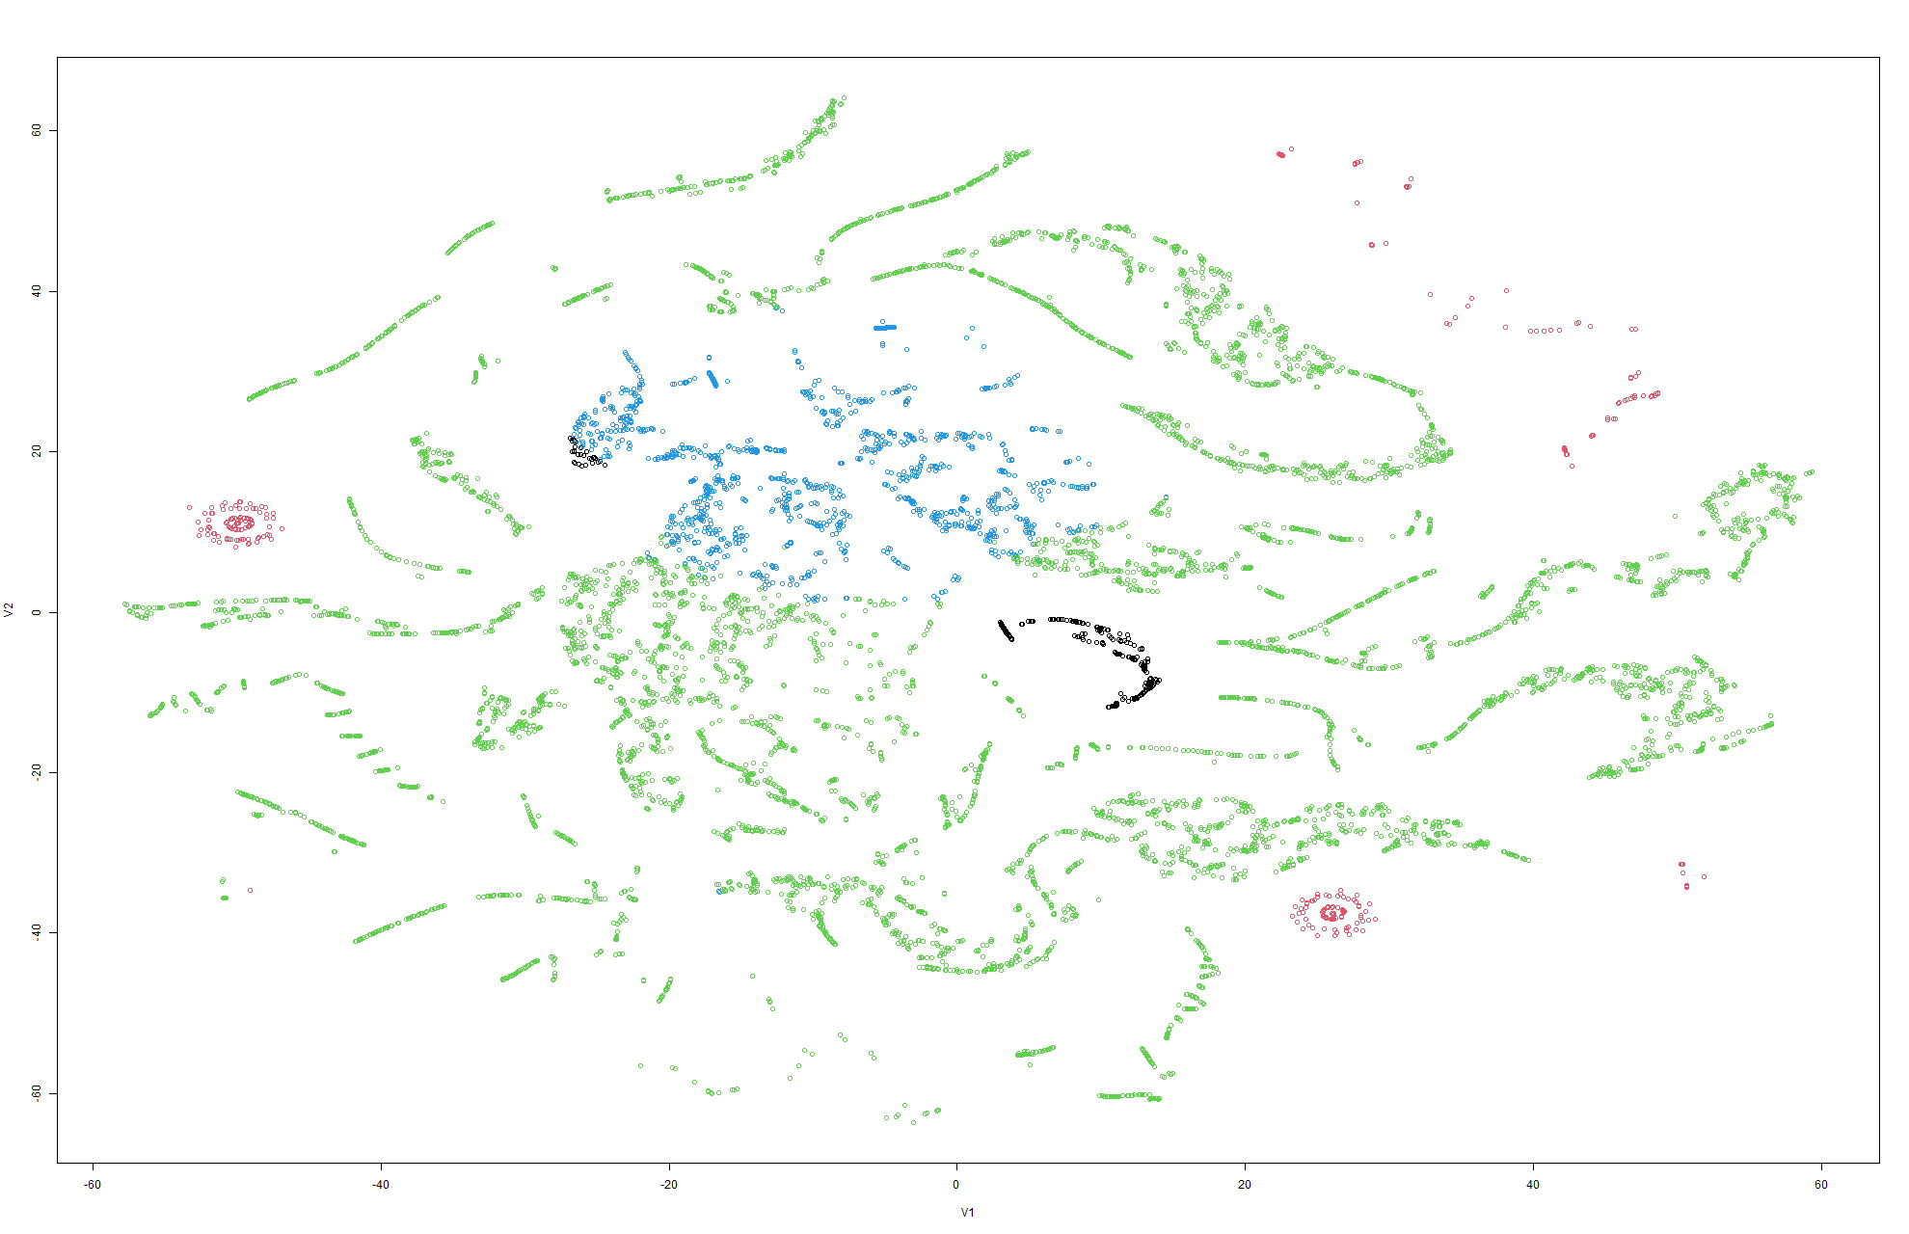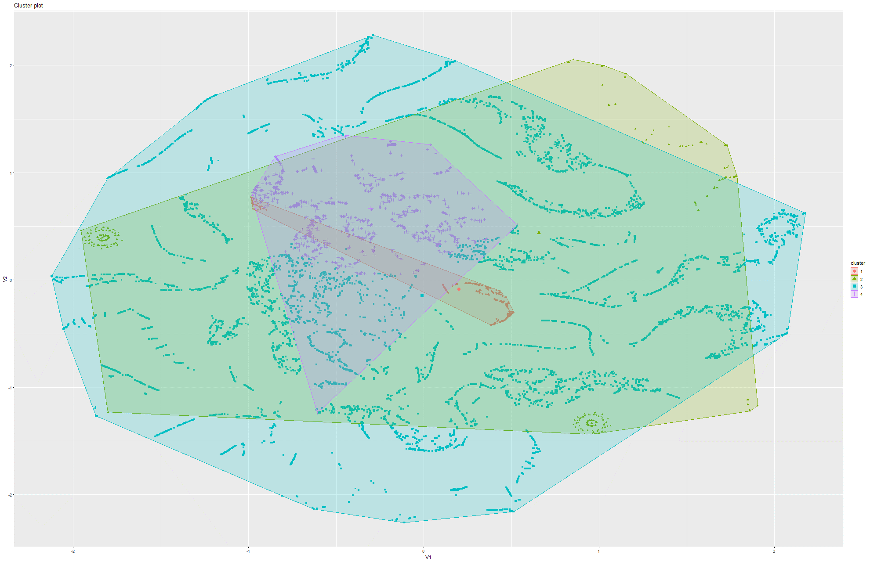Figure 258&259 k-Means on t-SNE Model 9

Model 4:

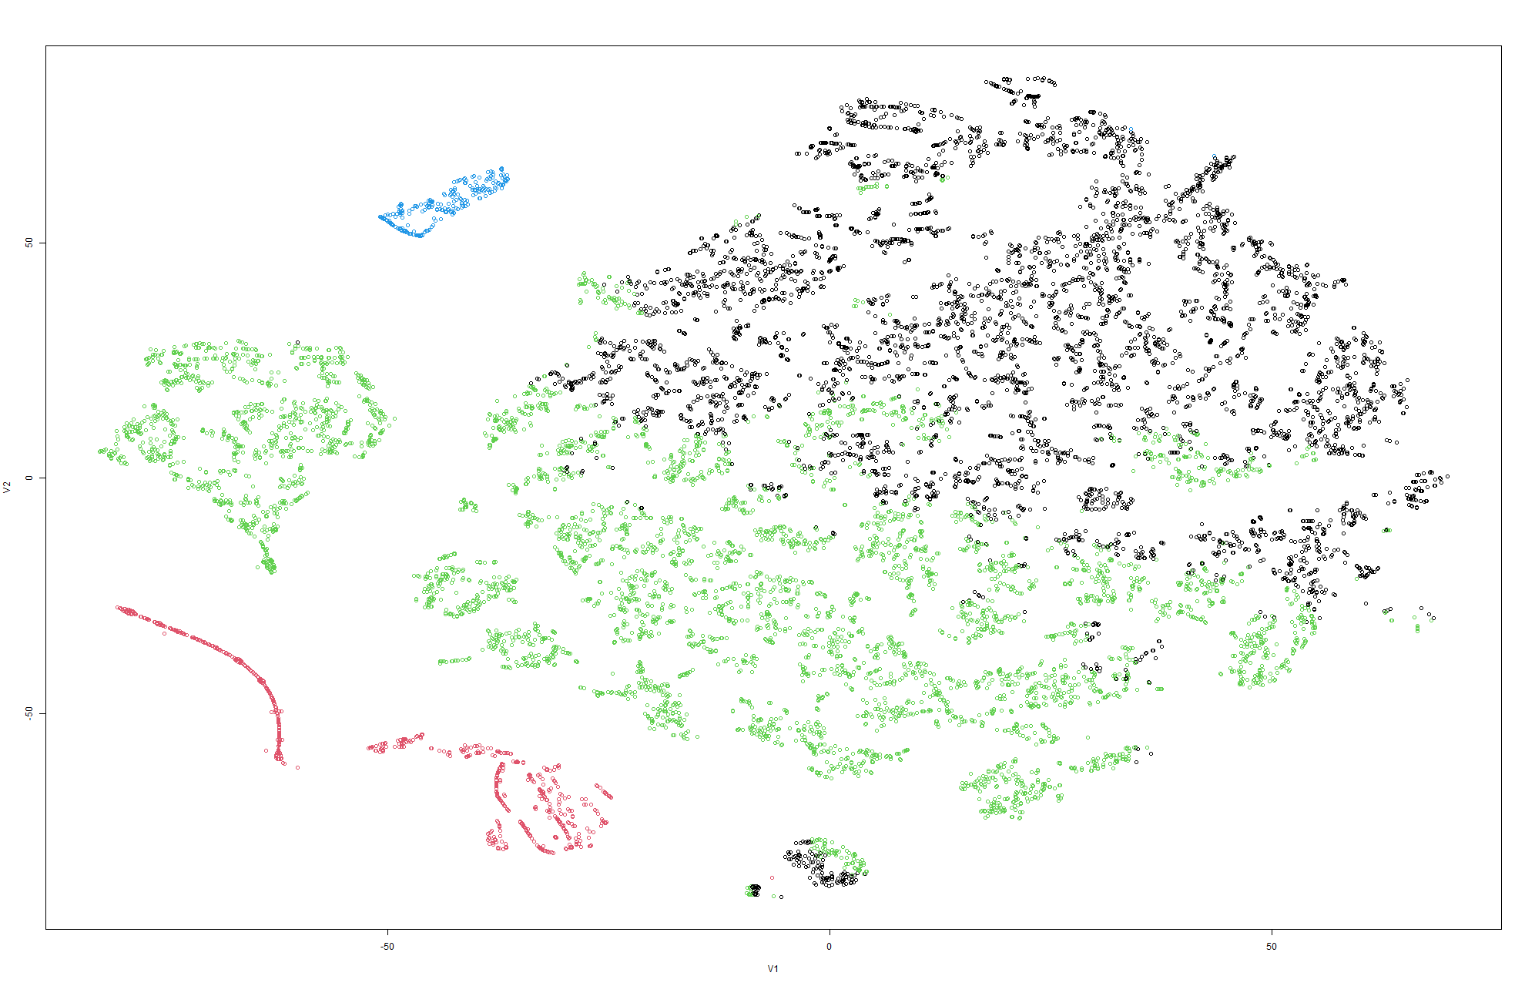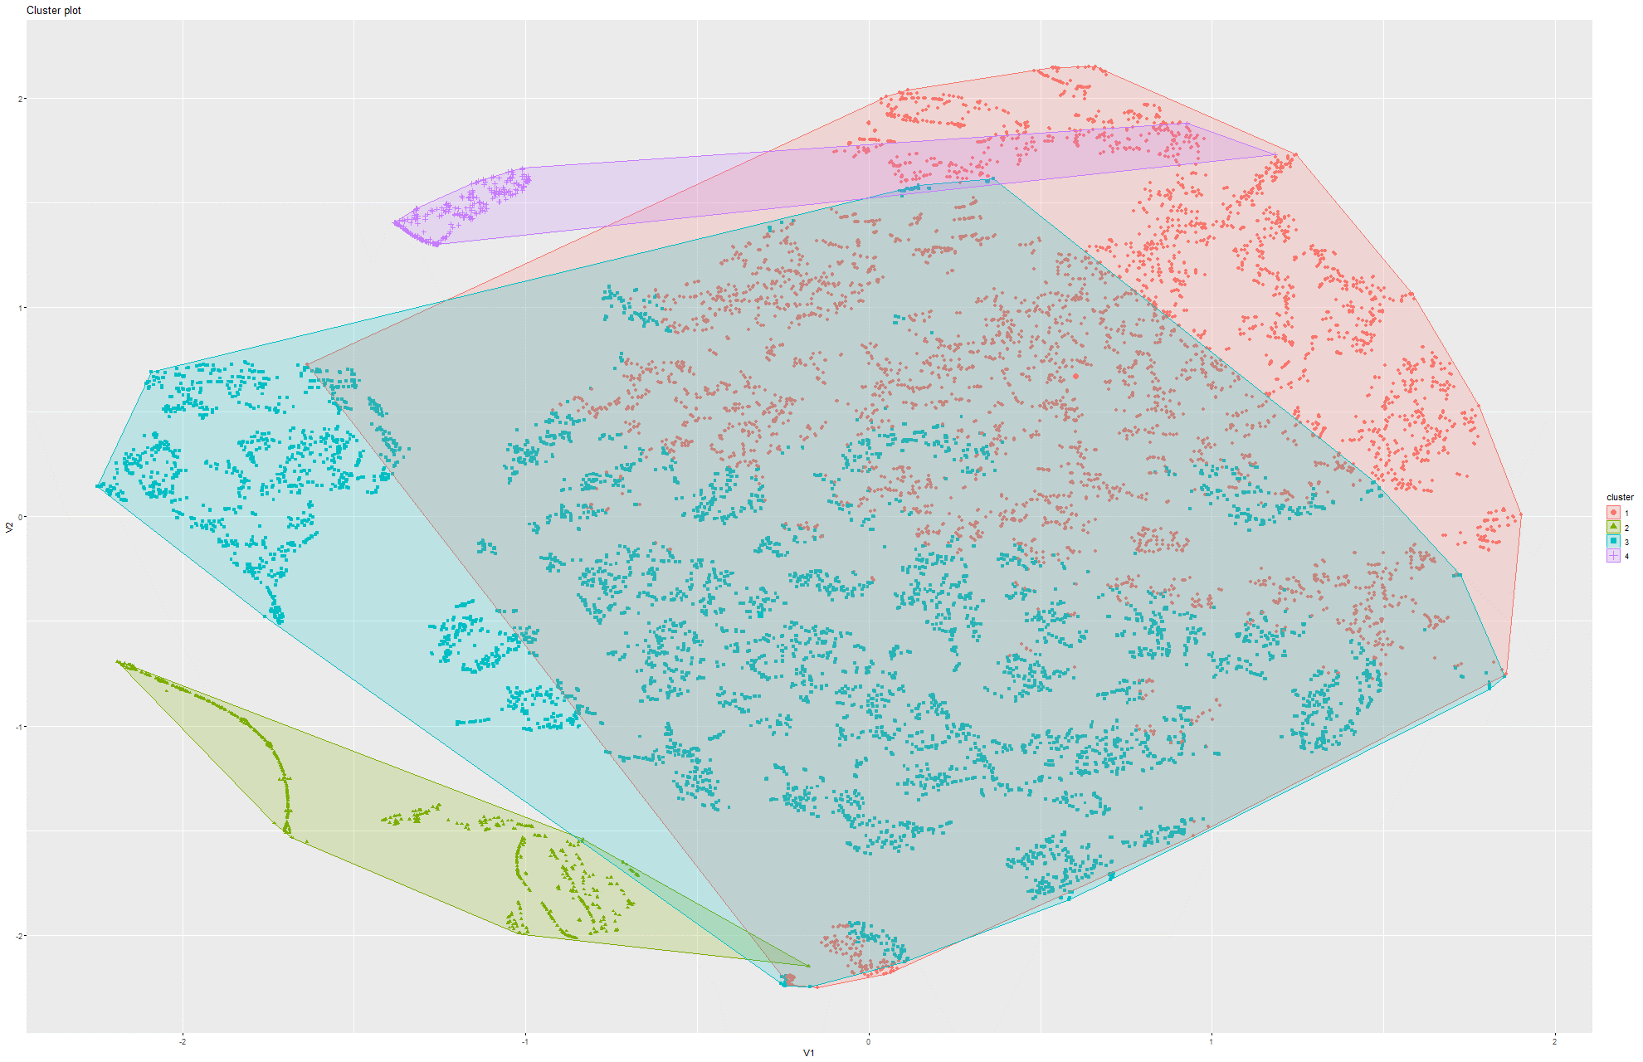Figure 260&261 k-Means on t-SNE Model 1

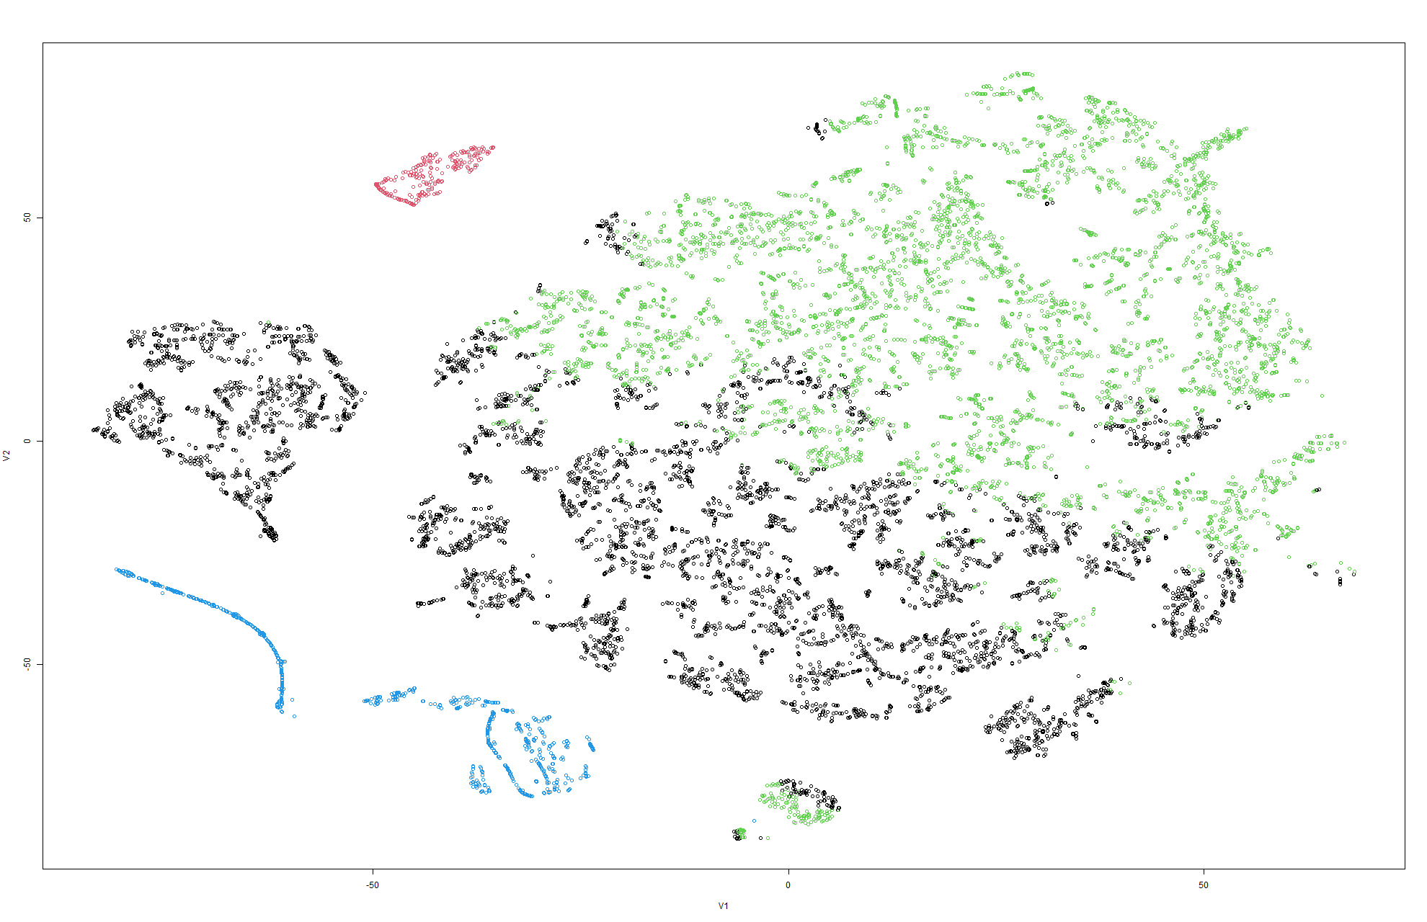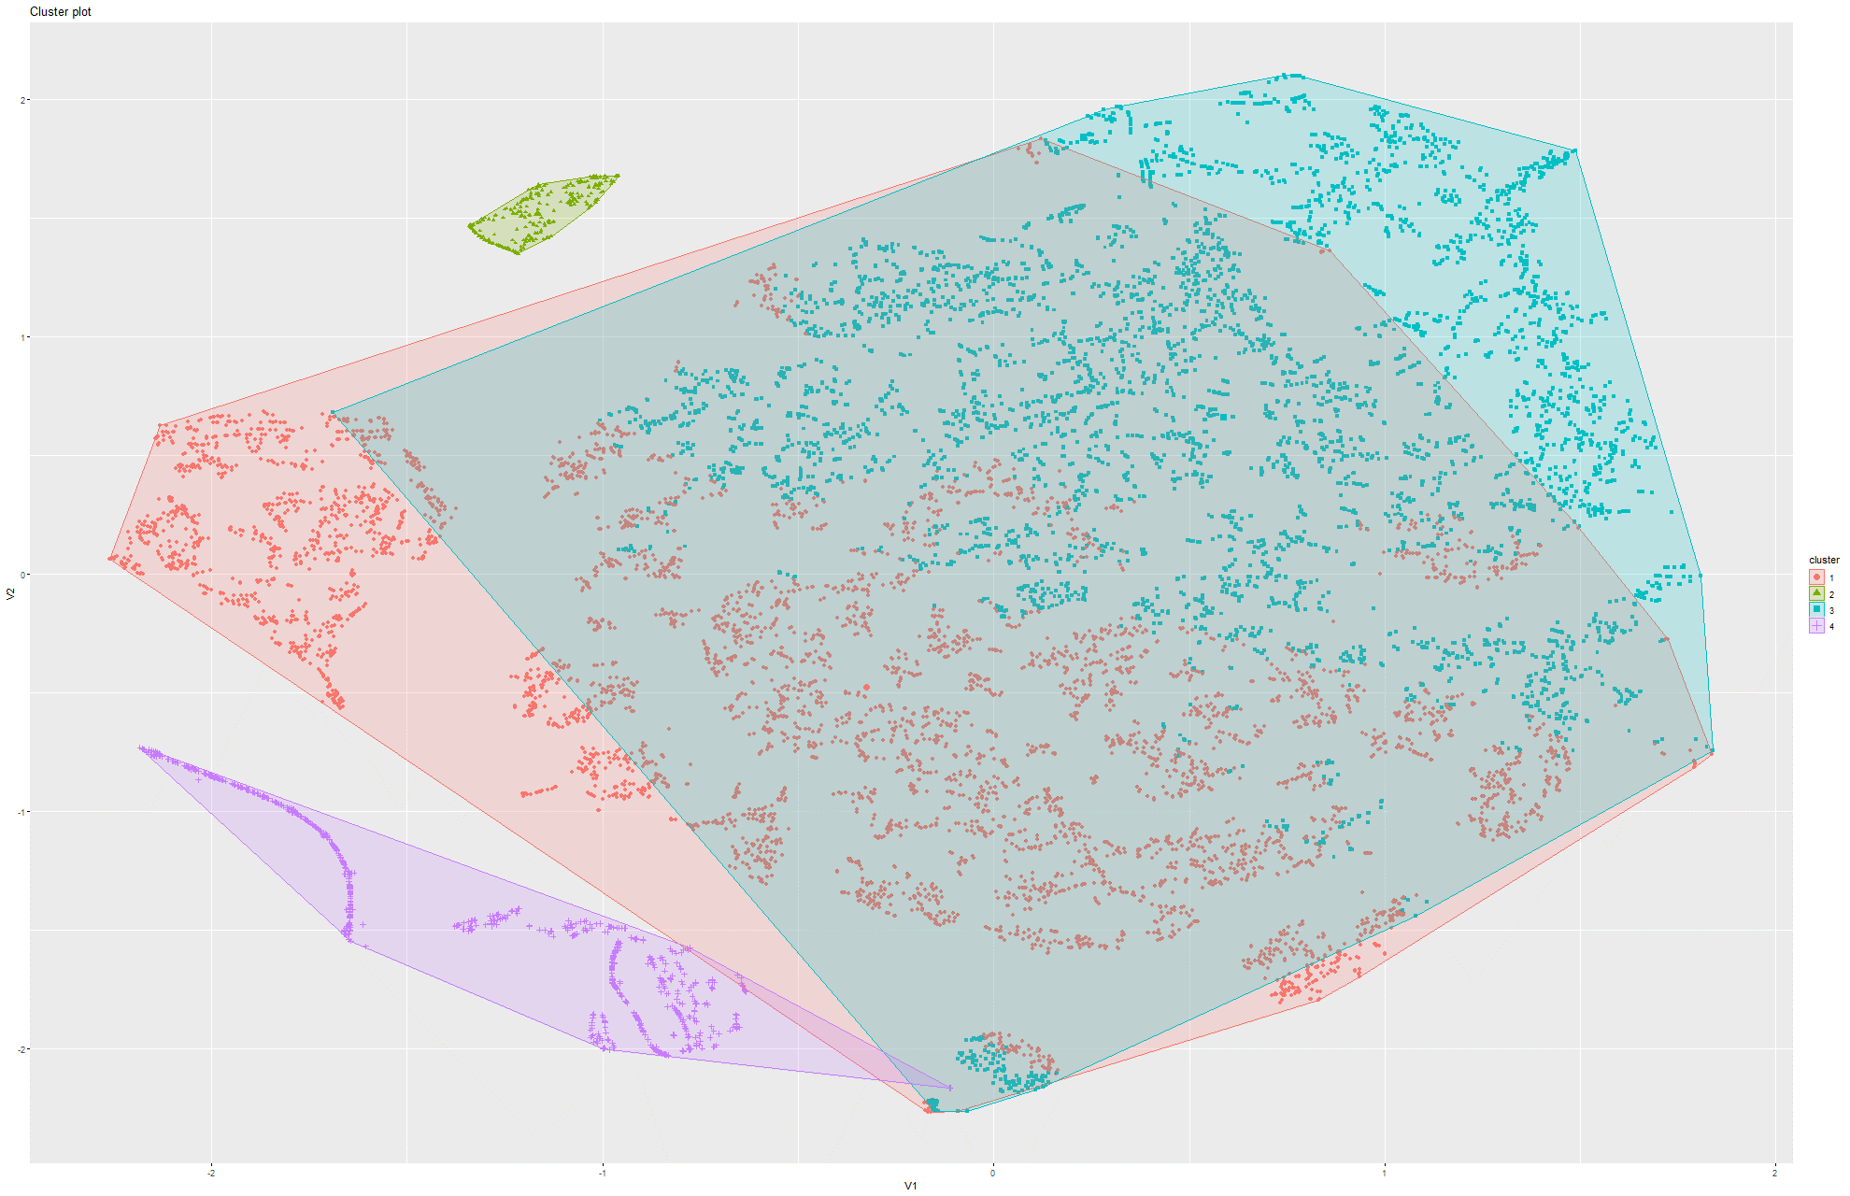Figure 262&263 k-Means on t-SNE Model 2

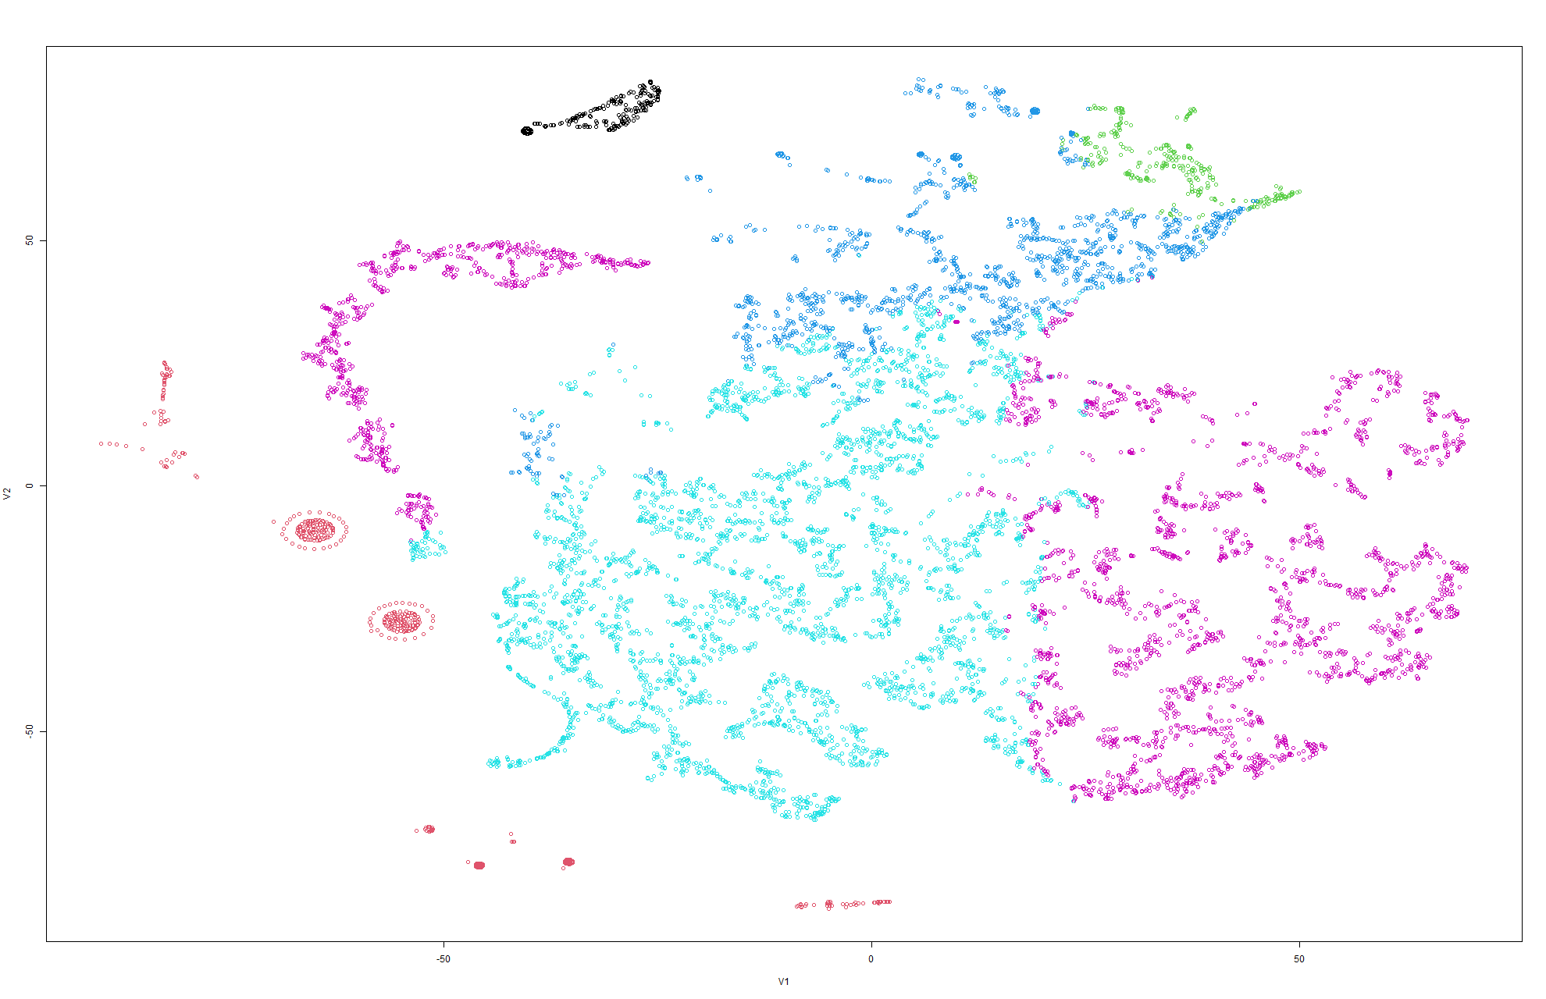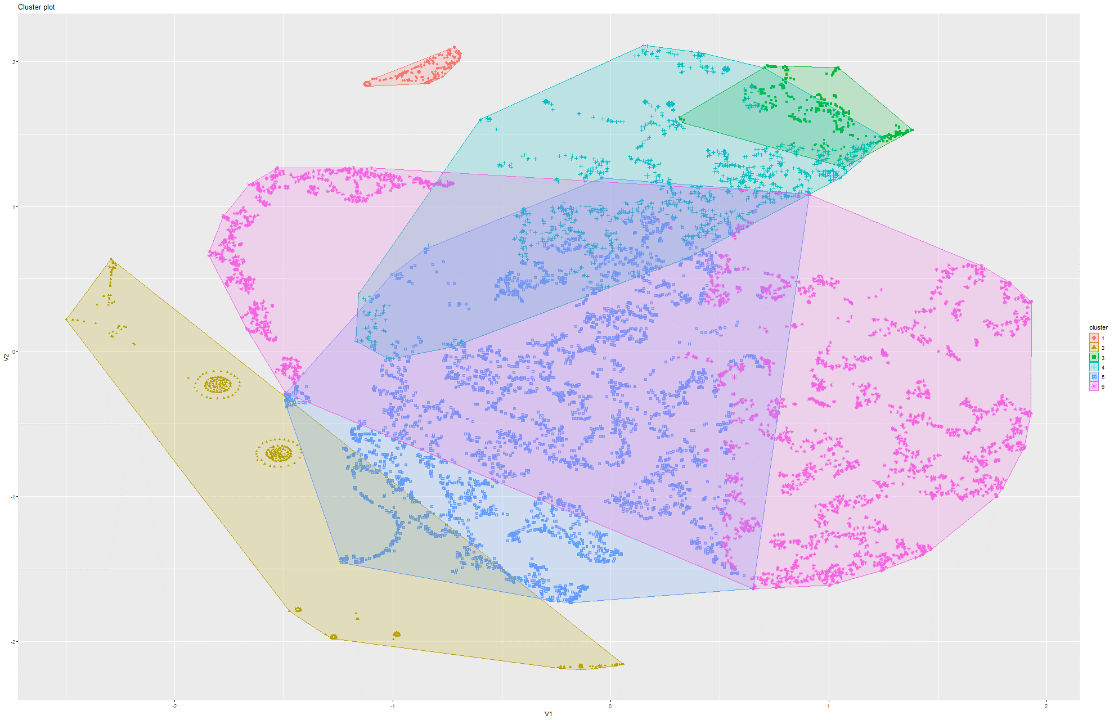Figure 264&265 k-Means on t-SNE Model 3

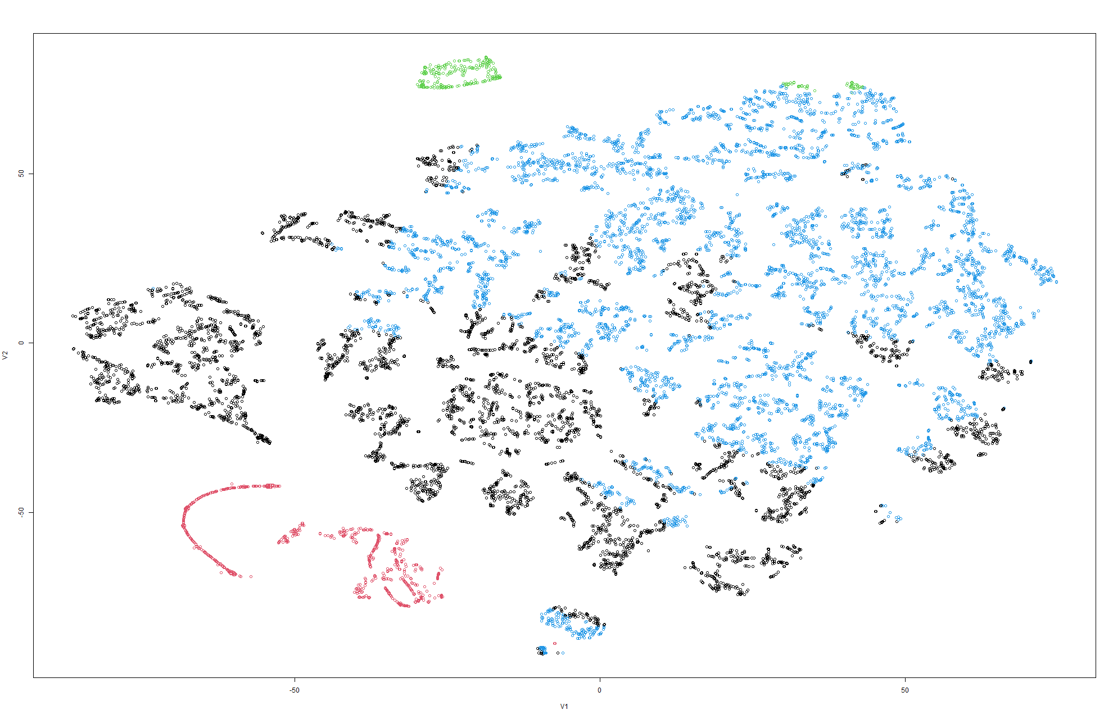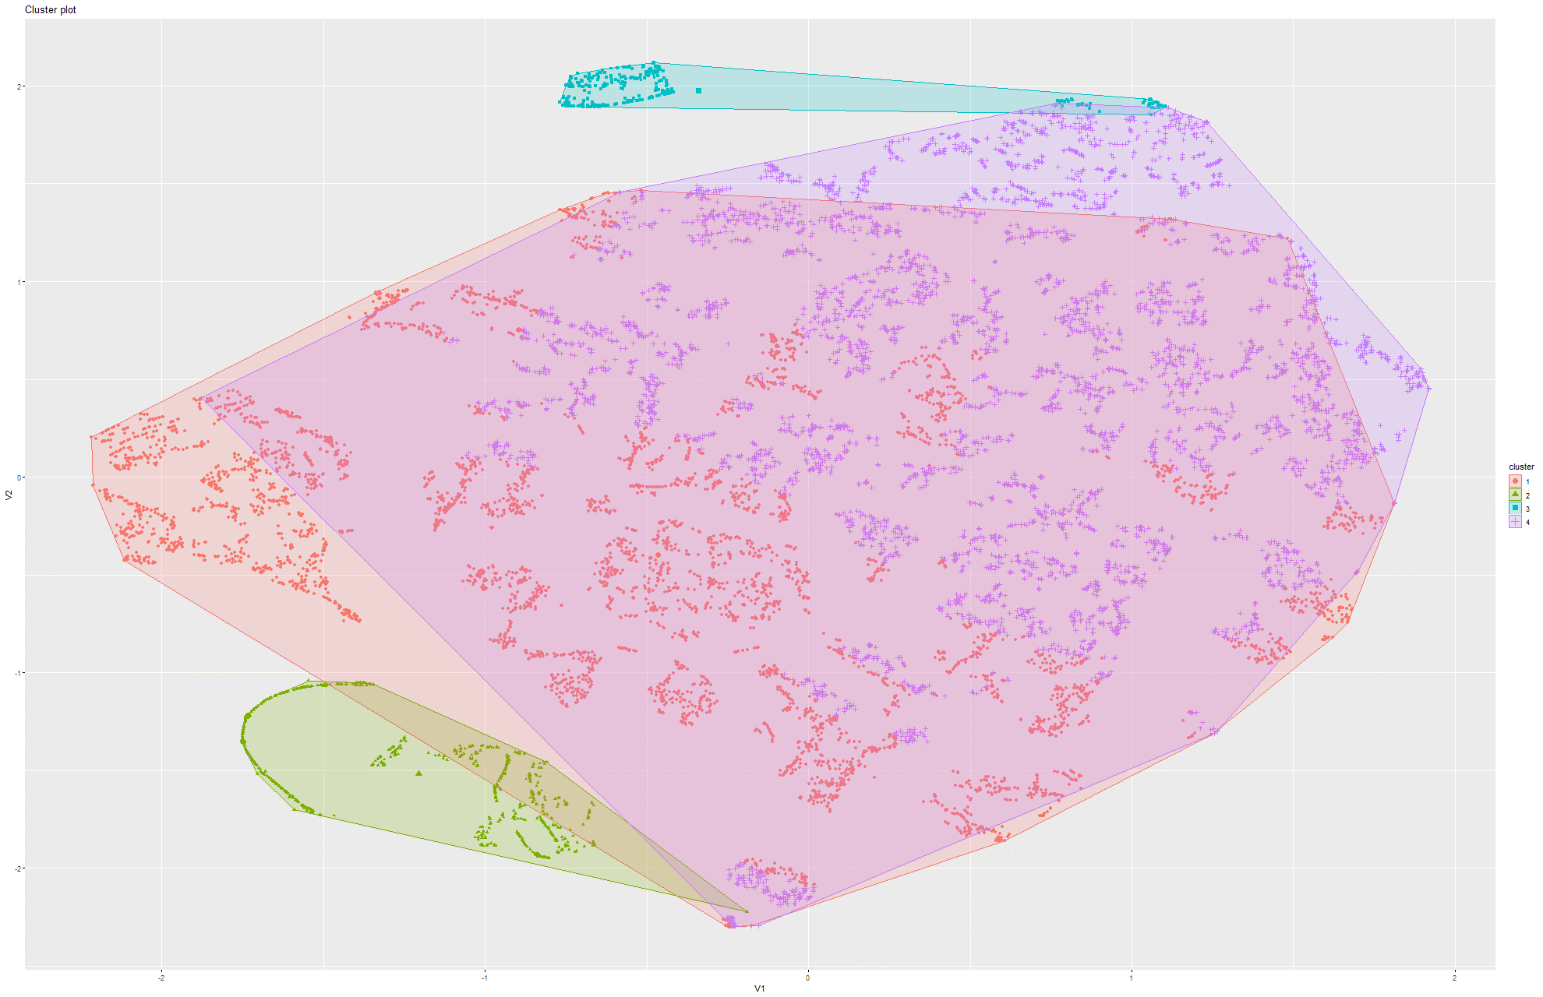Figure 266&267 k-Means on t-SNE Model 4

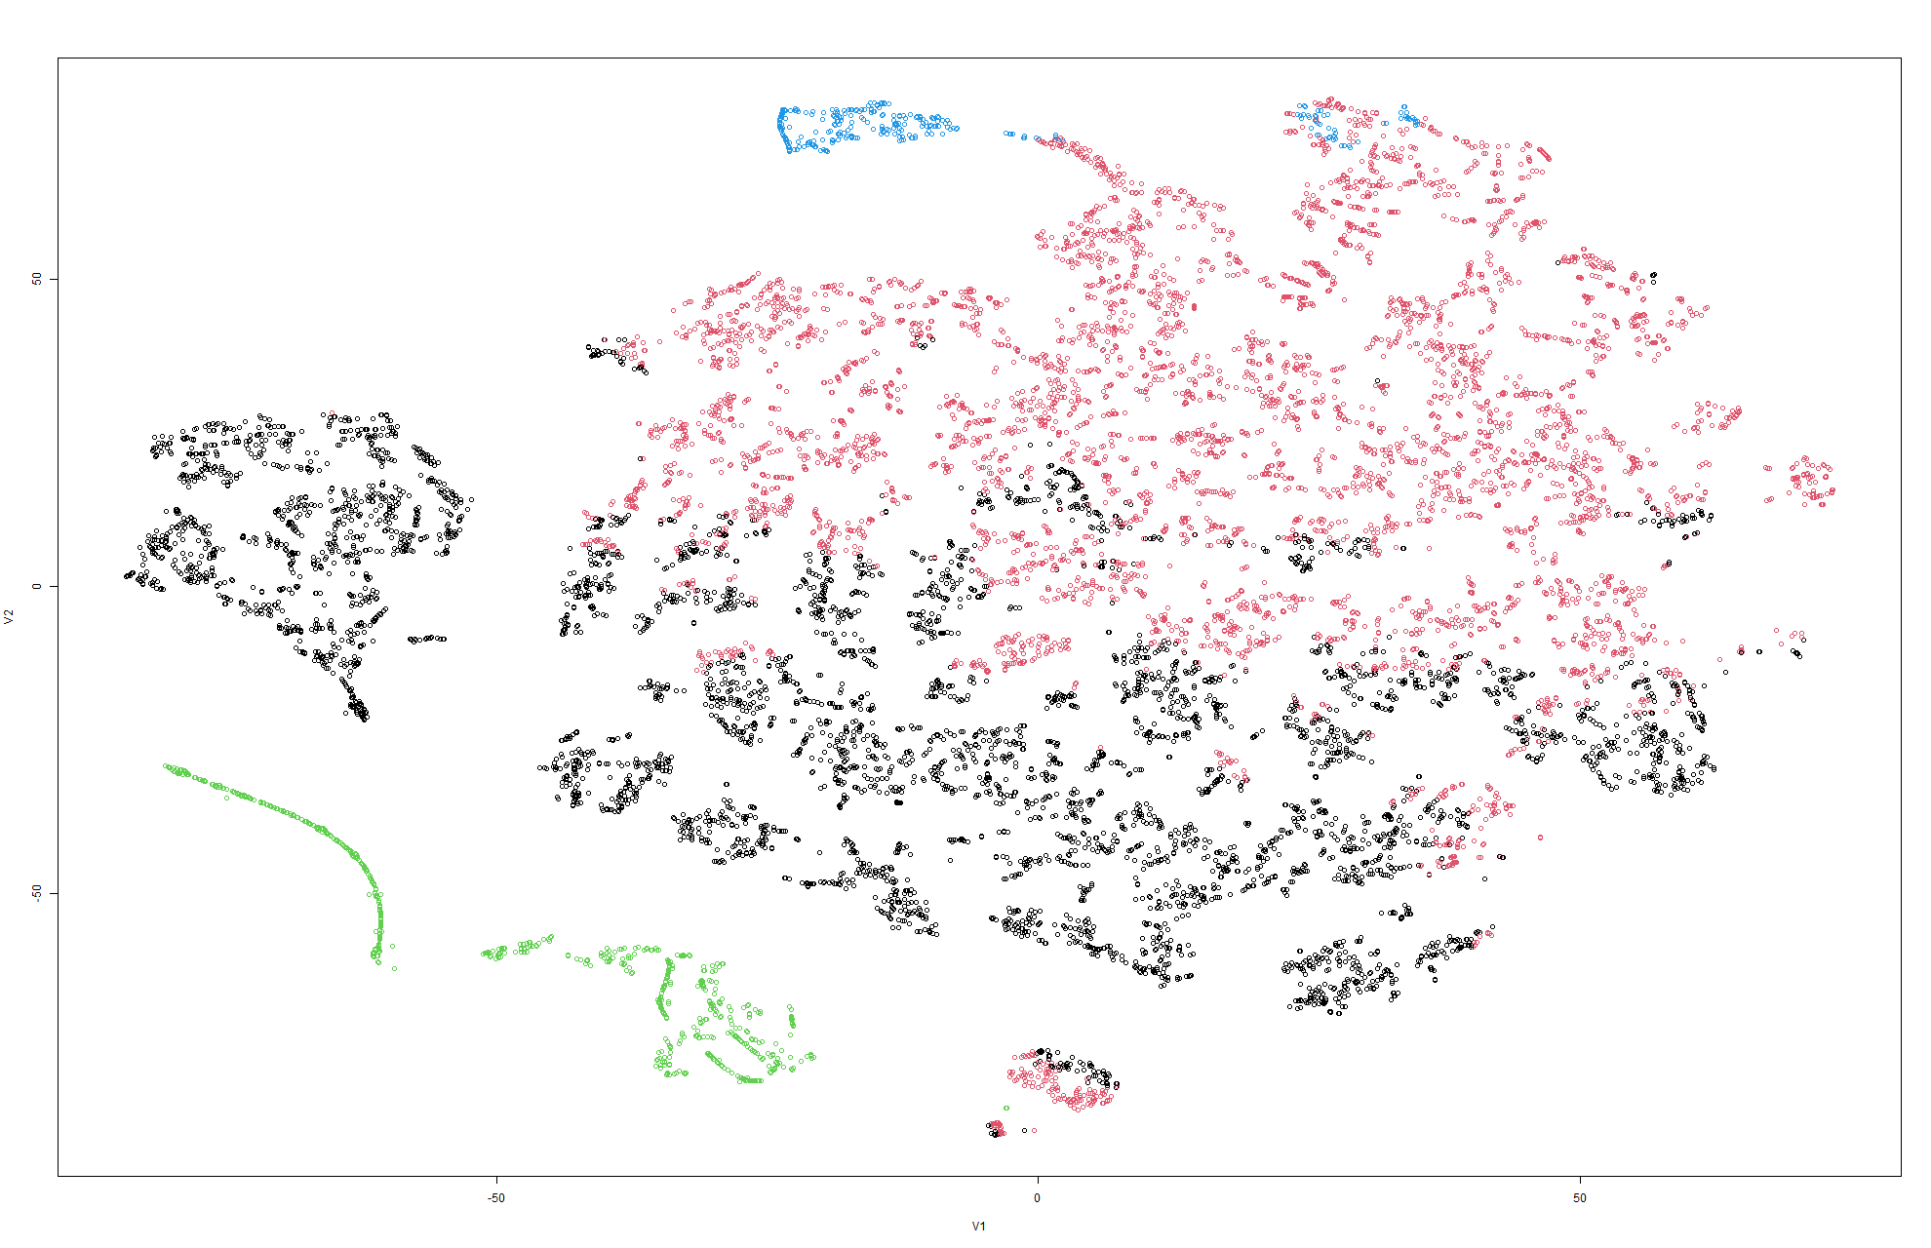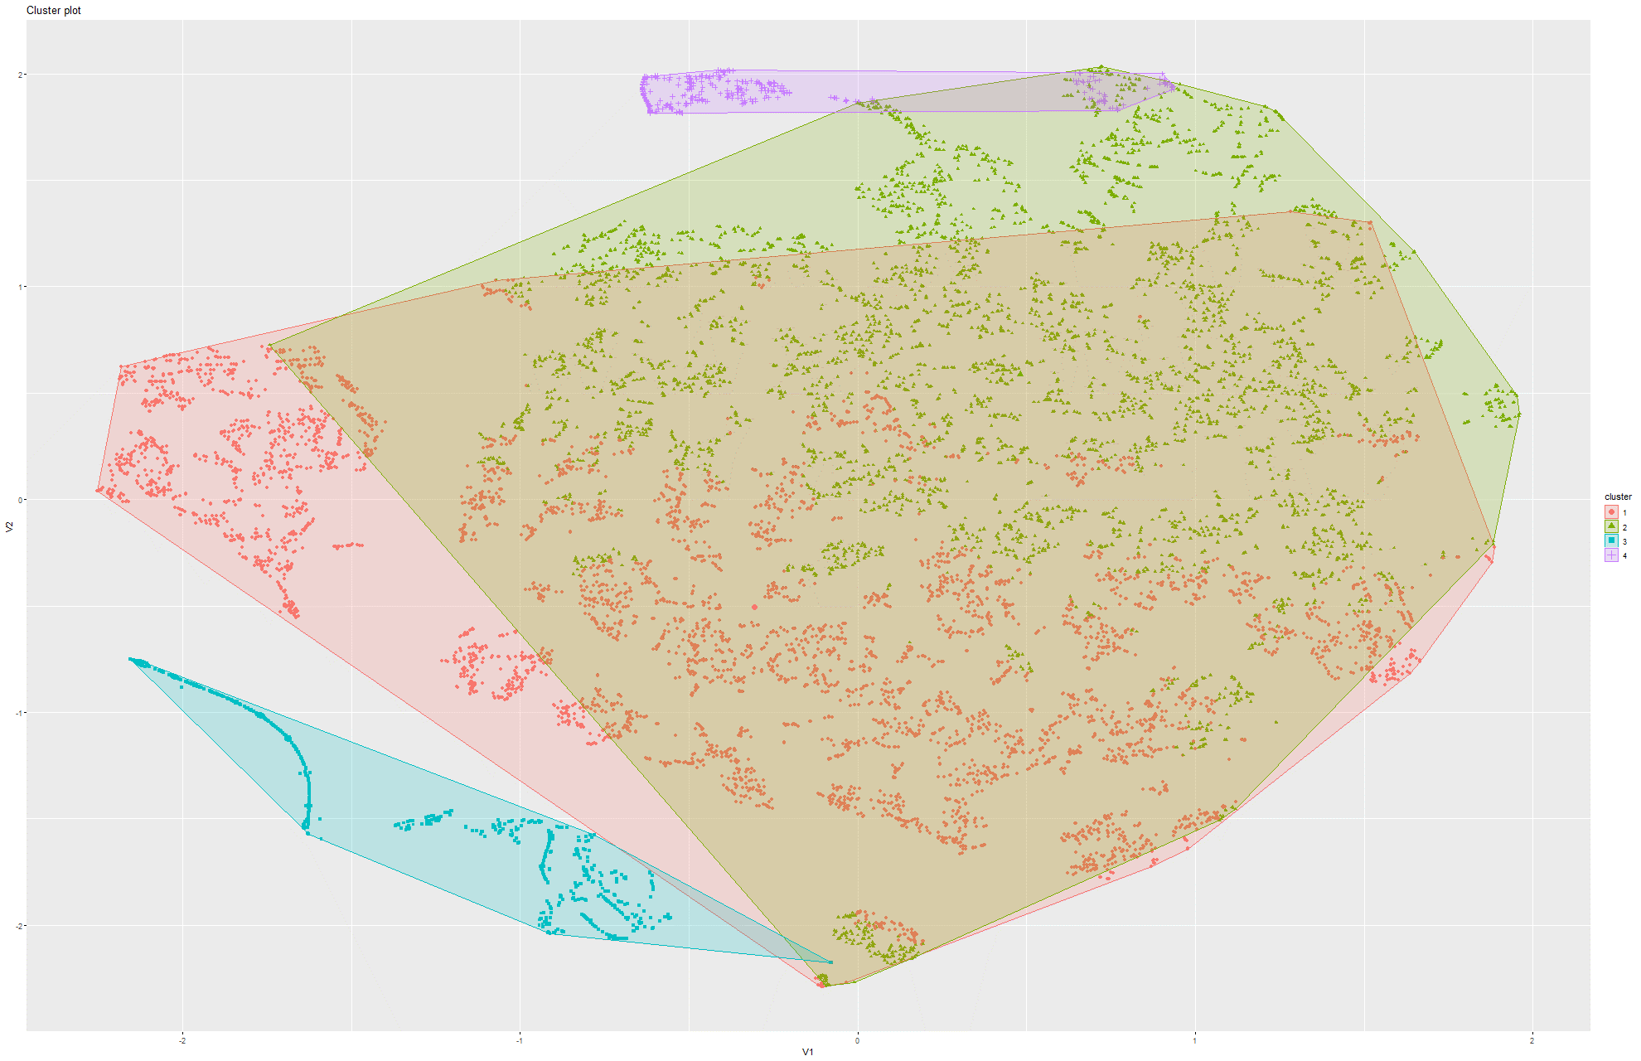Figure 268&269 k-Means on t-SNE Model 5

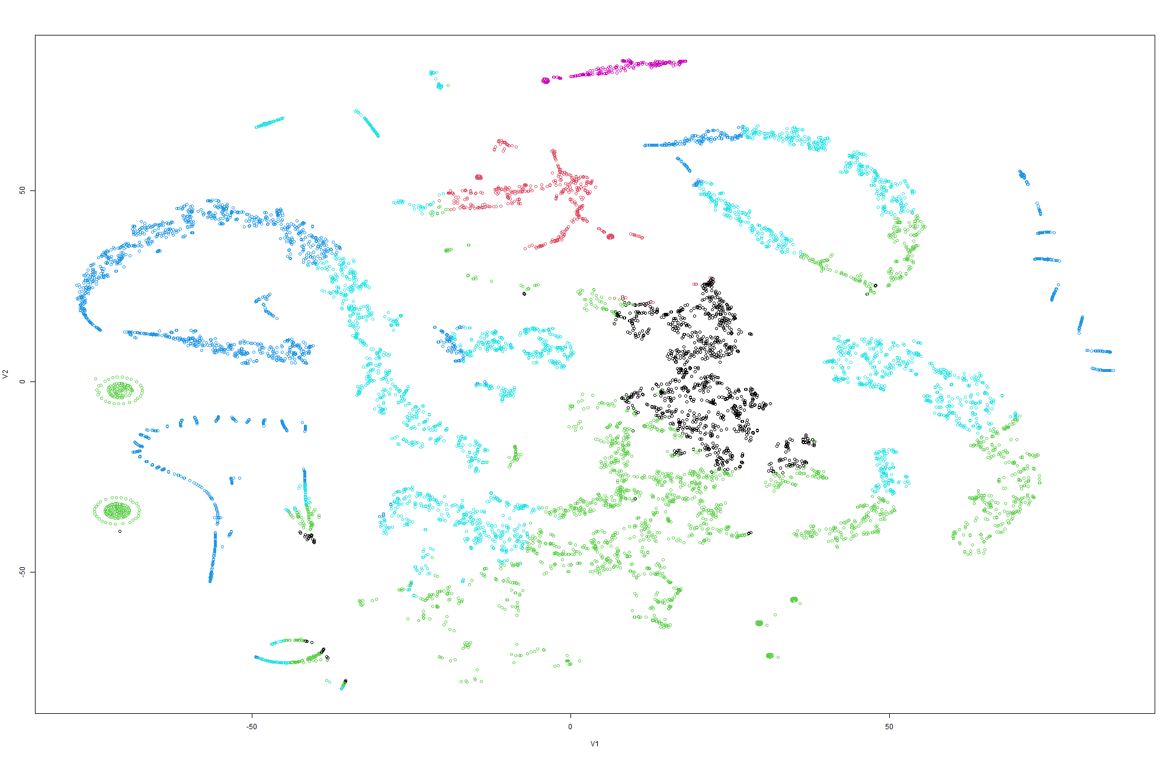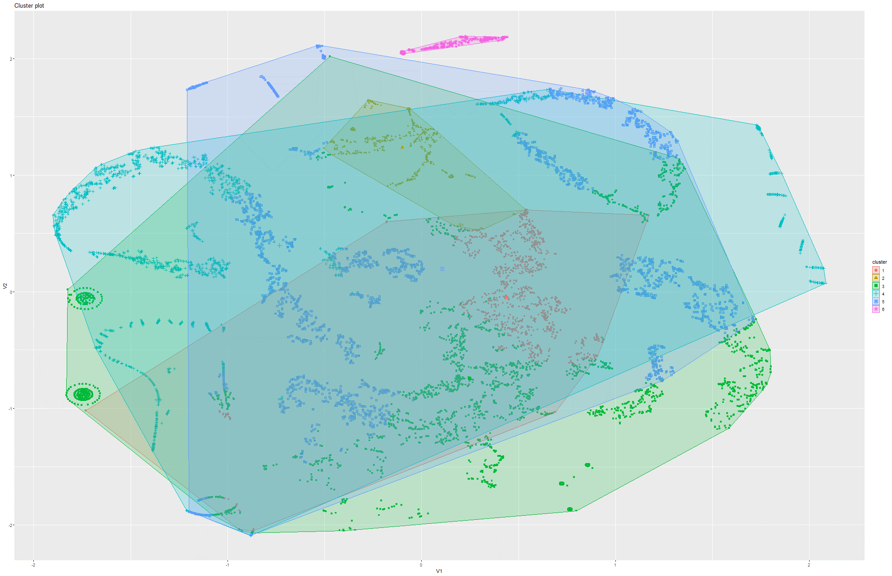Figure 270&271 k-Means on t-SNE Model 6

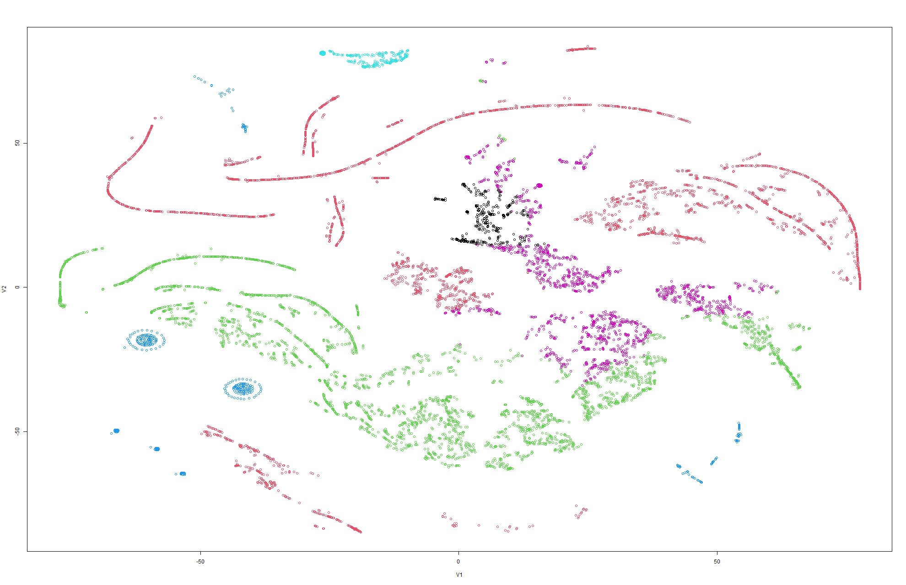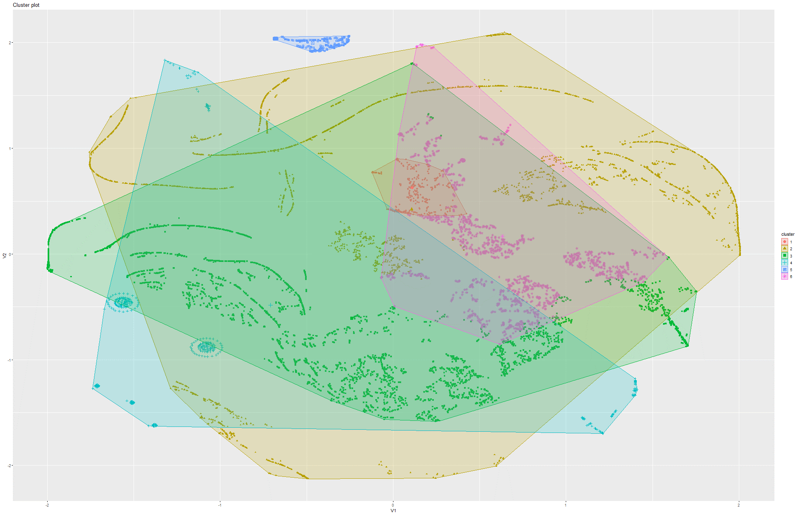Figure 272&273 k-Means on t-SNE Model 7

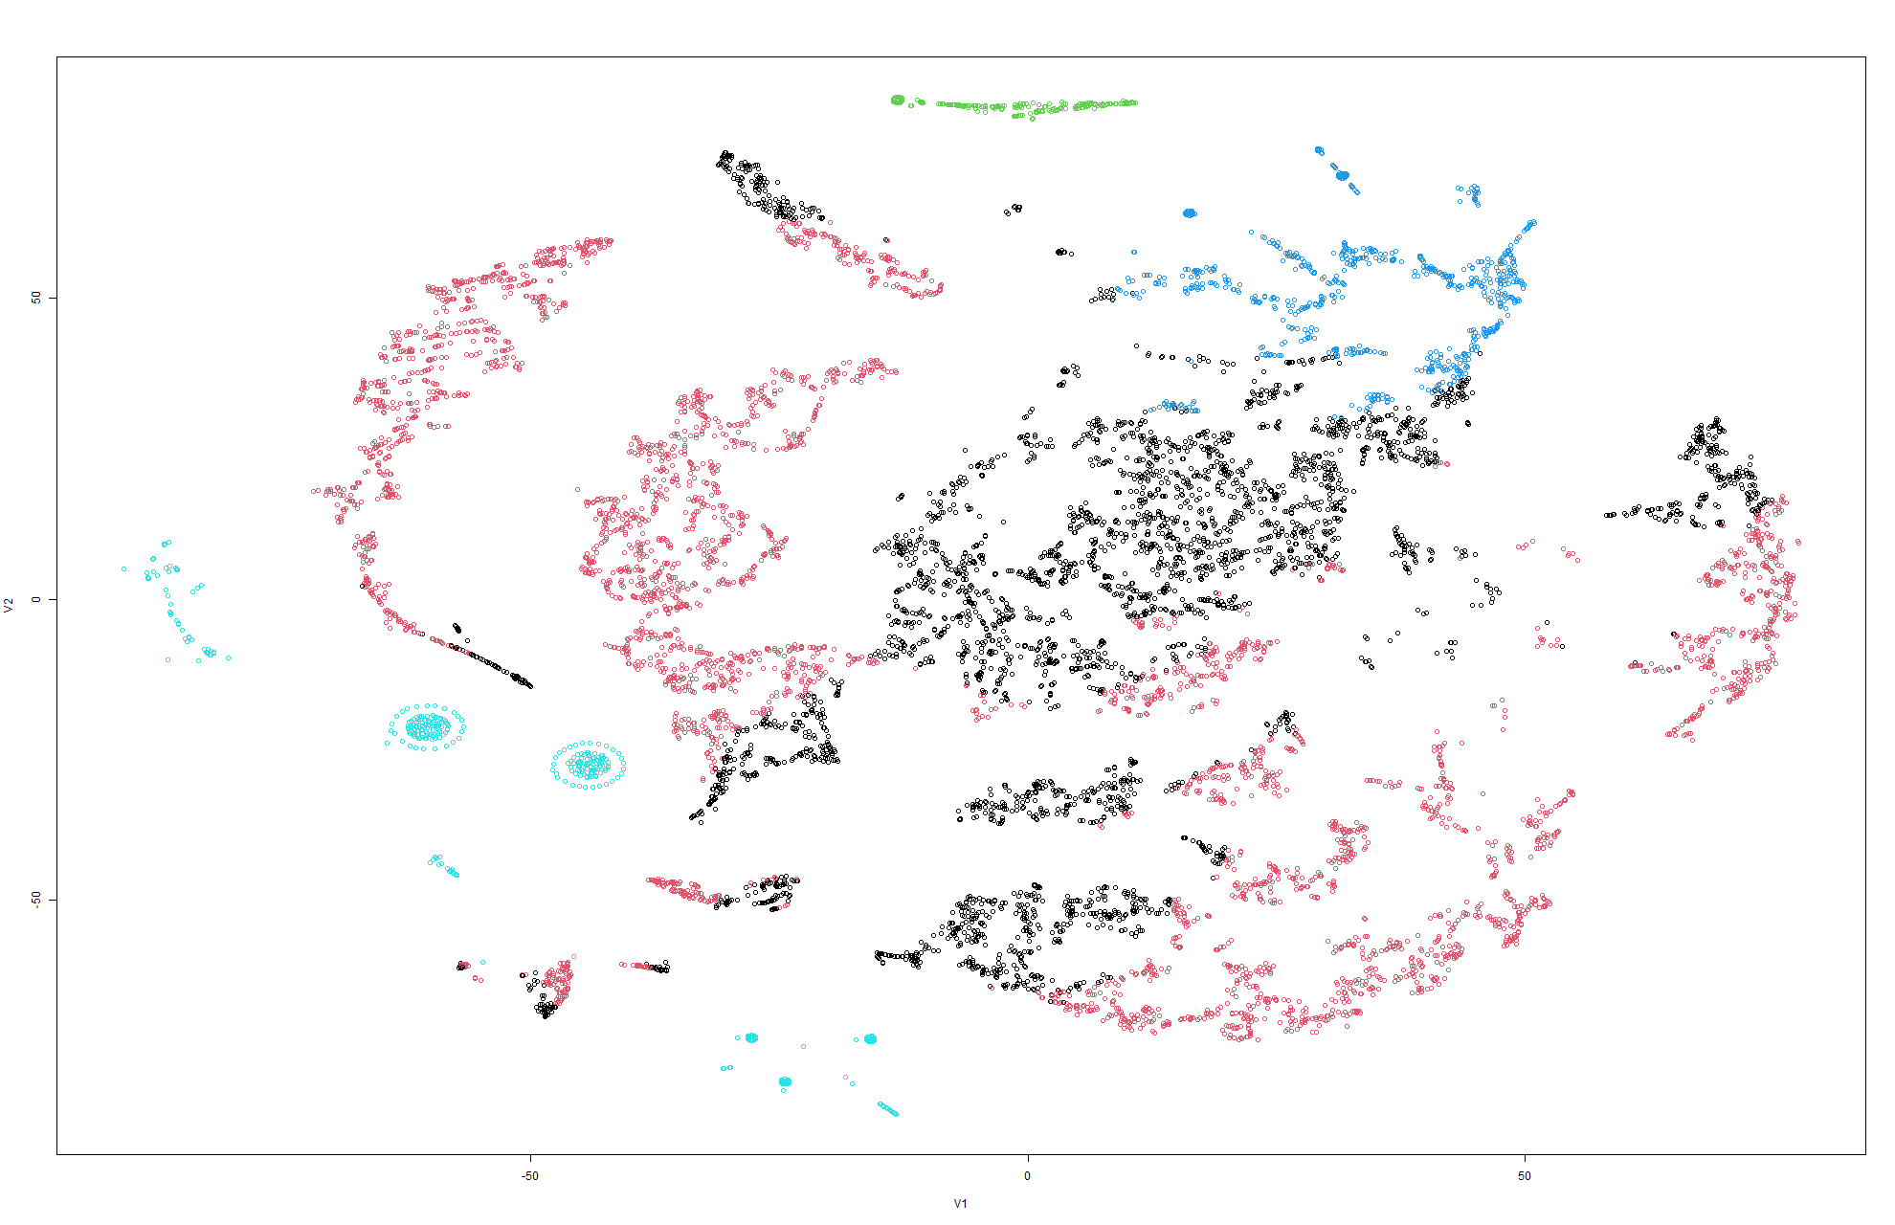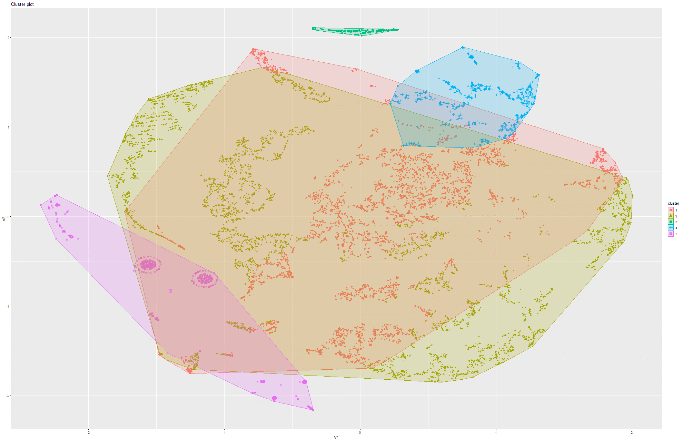Figure 274&275 k-Means on t-SNE Model 8

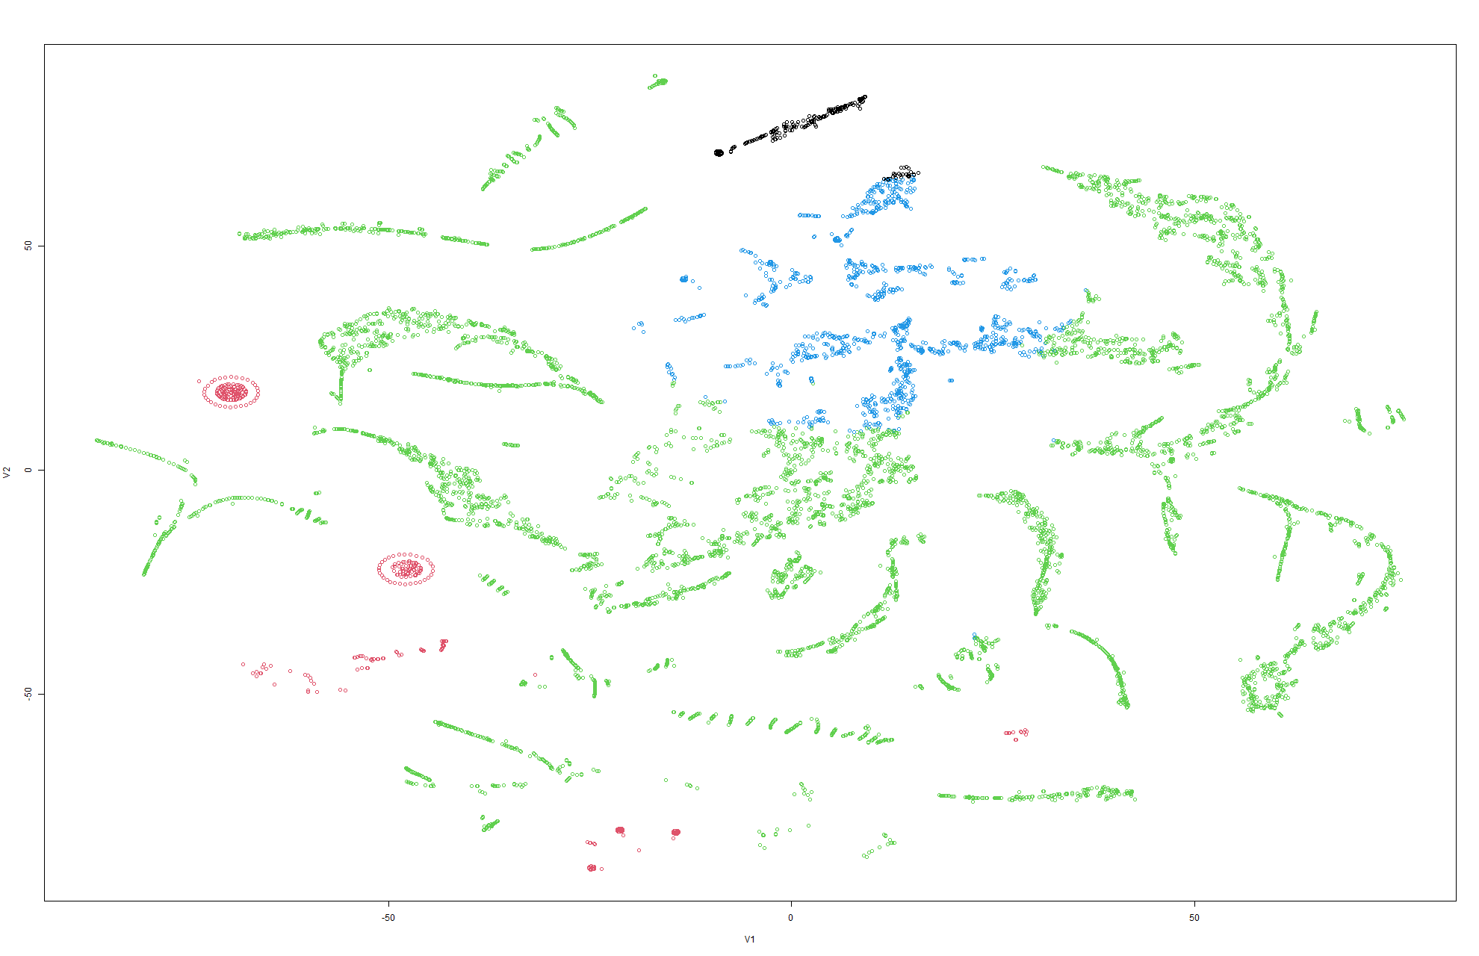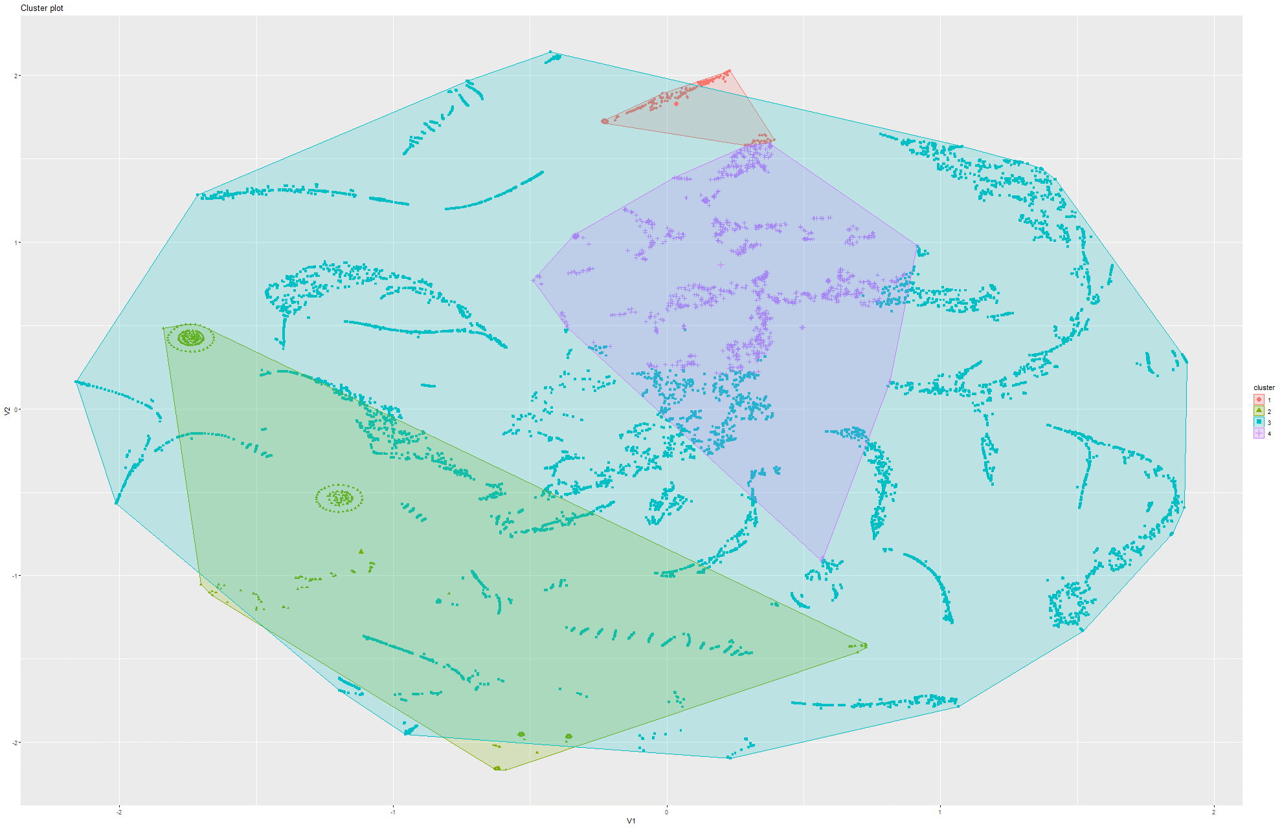Figure 276&277 k-Means on t-SNE Model 9

### 6.2.4 K-means on PCA

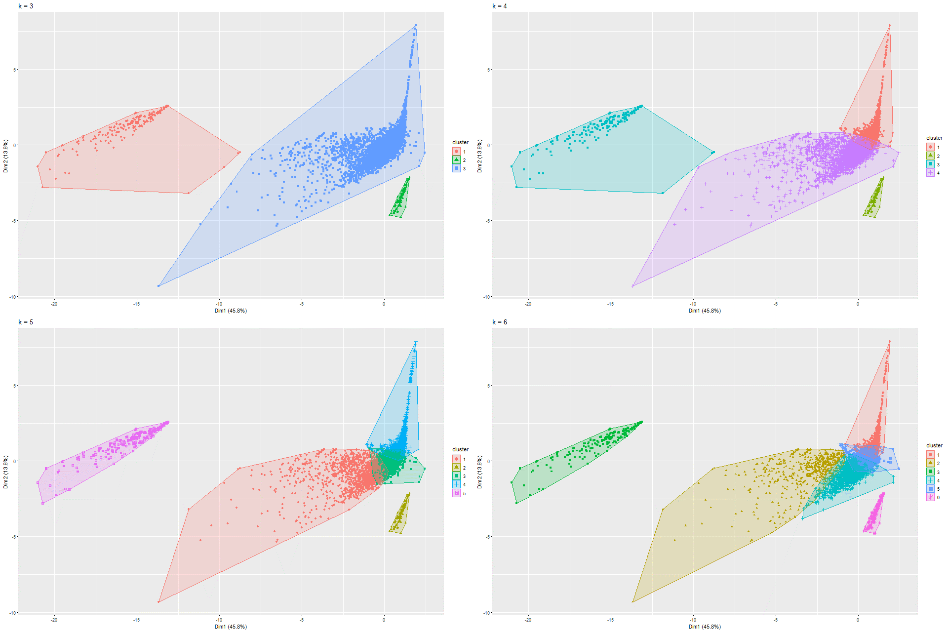

Figure 278 k-Means on PCA Model 1

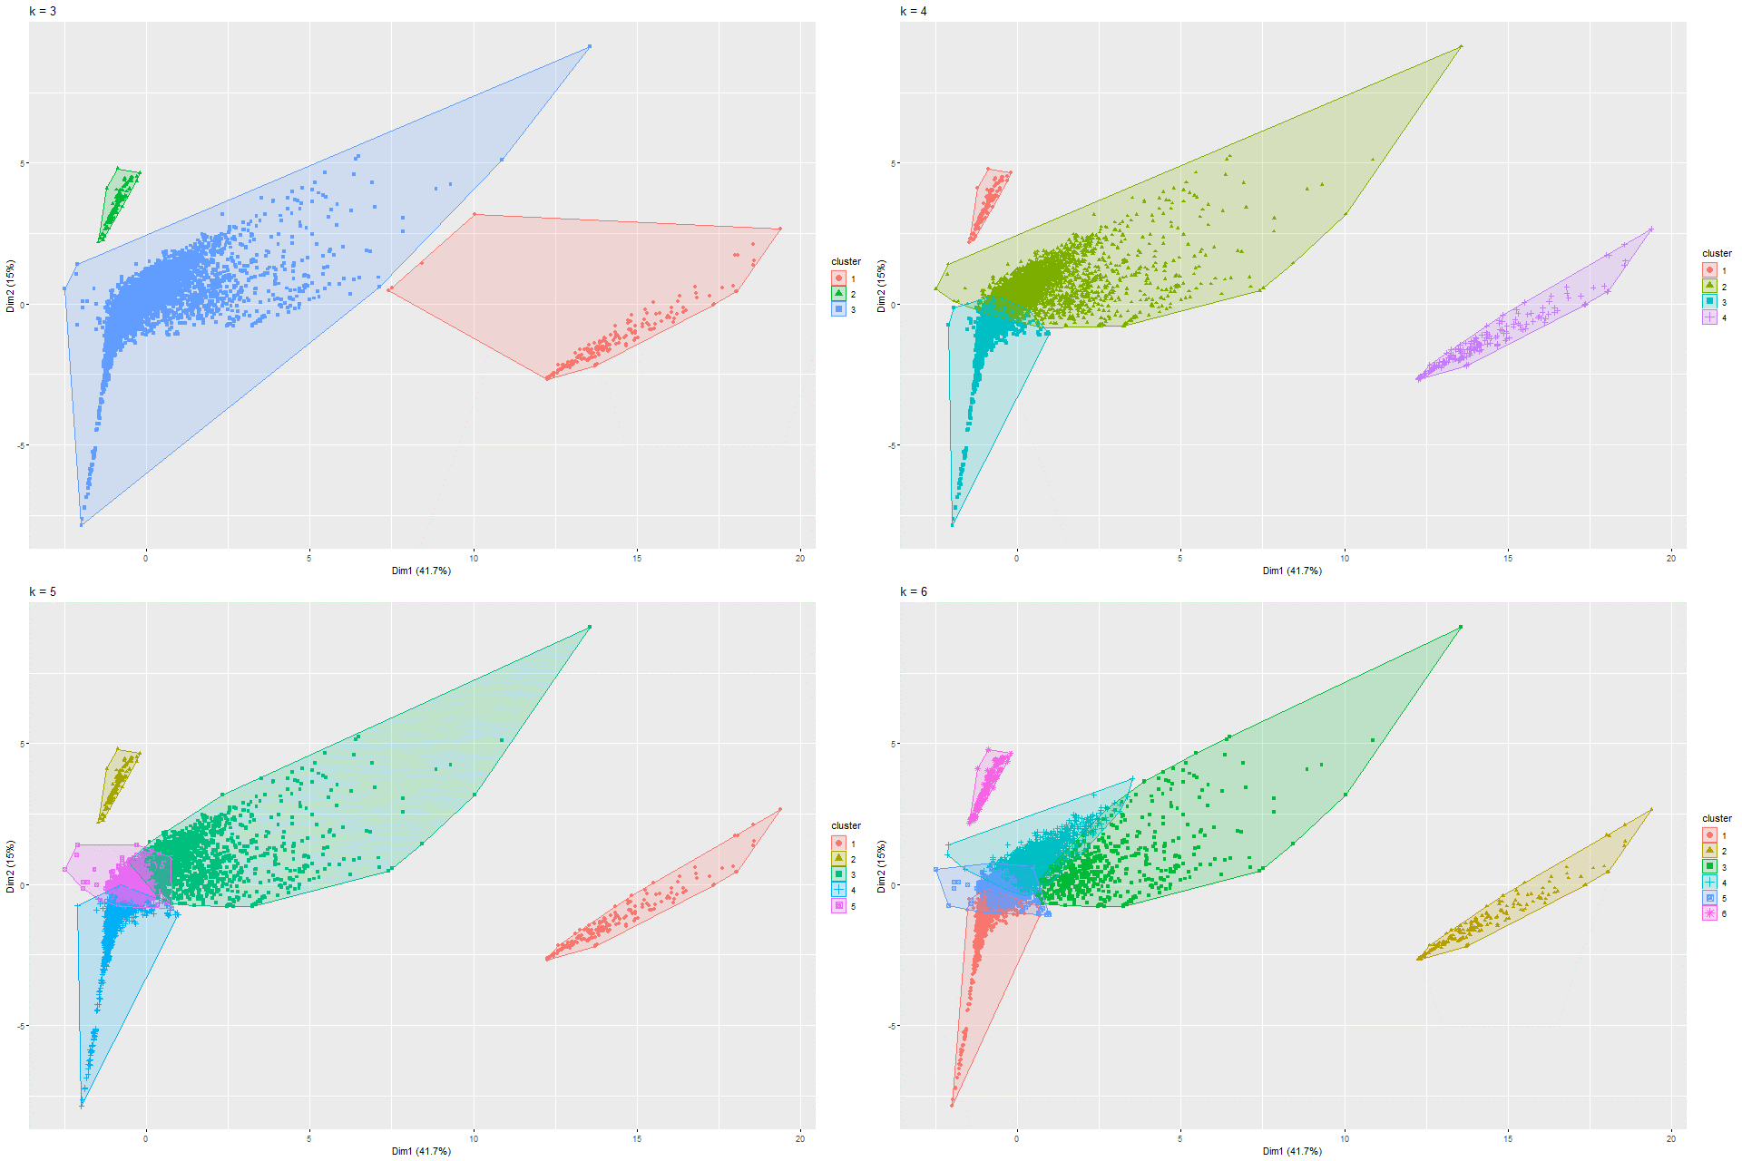

Figure 279 k-Means on PCA Model 2

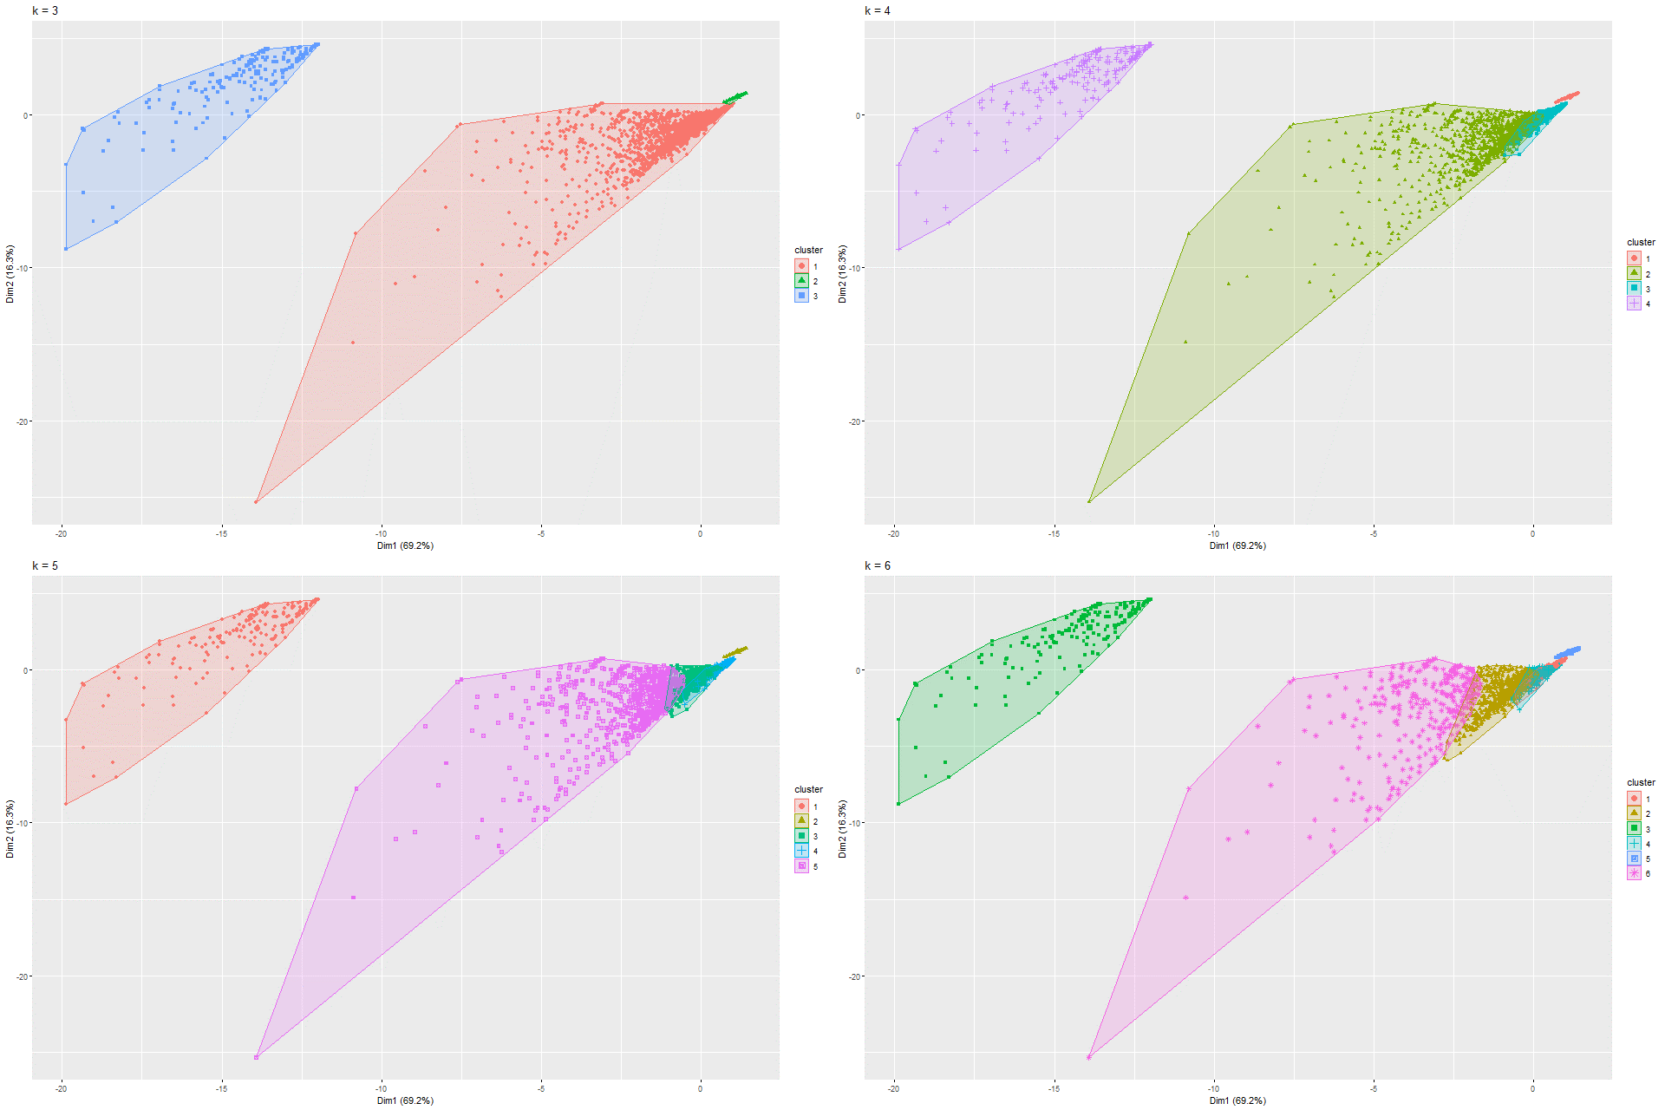

Figure 280 k-Means on PCA Model 3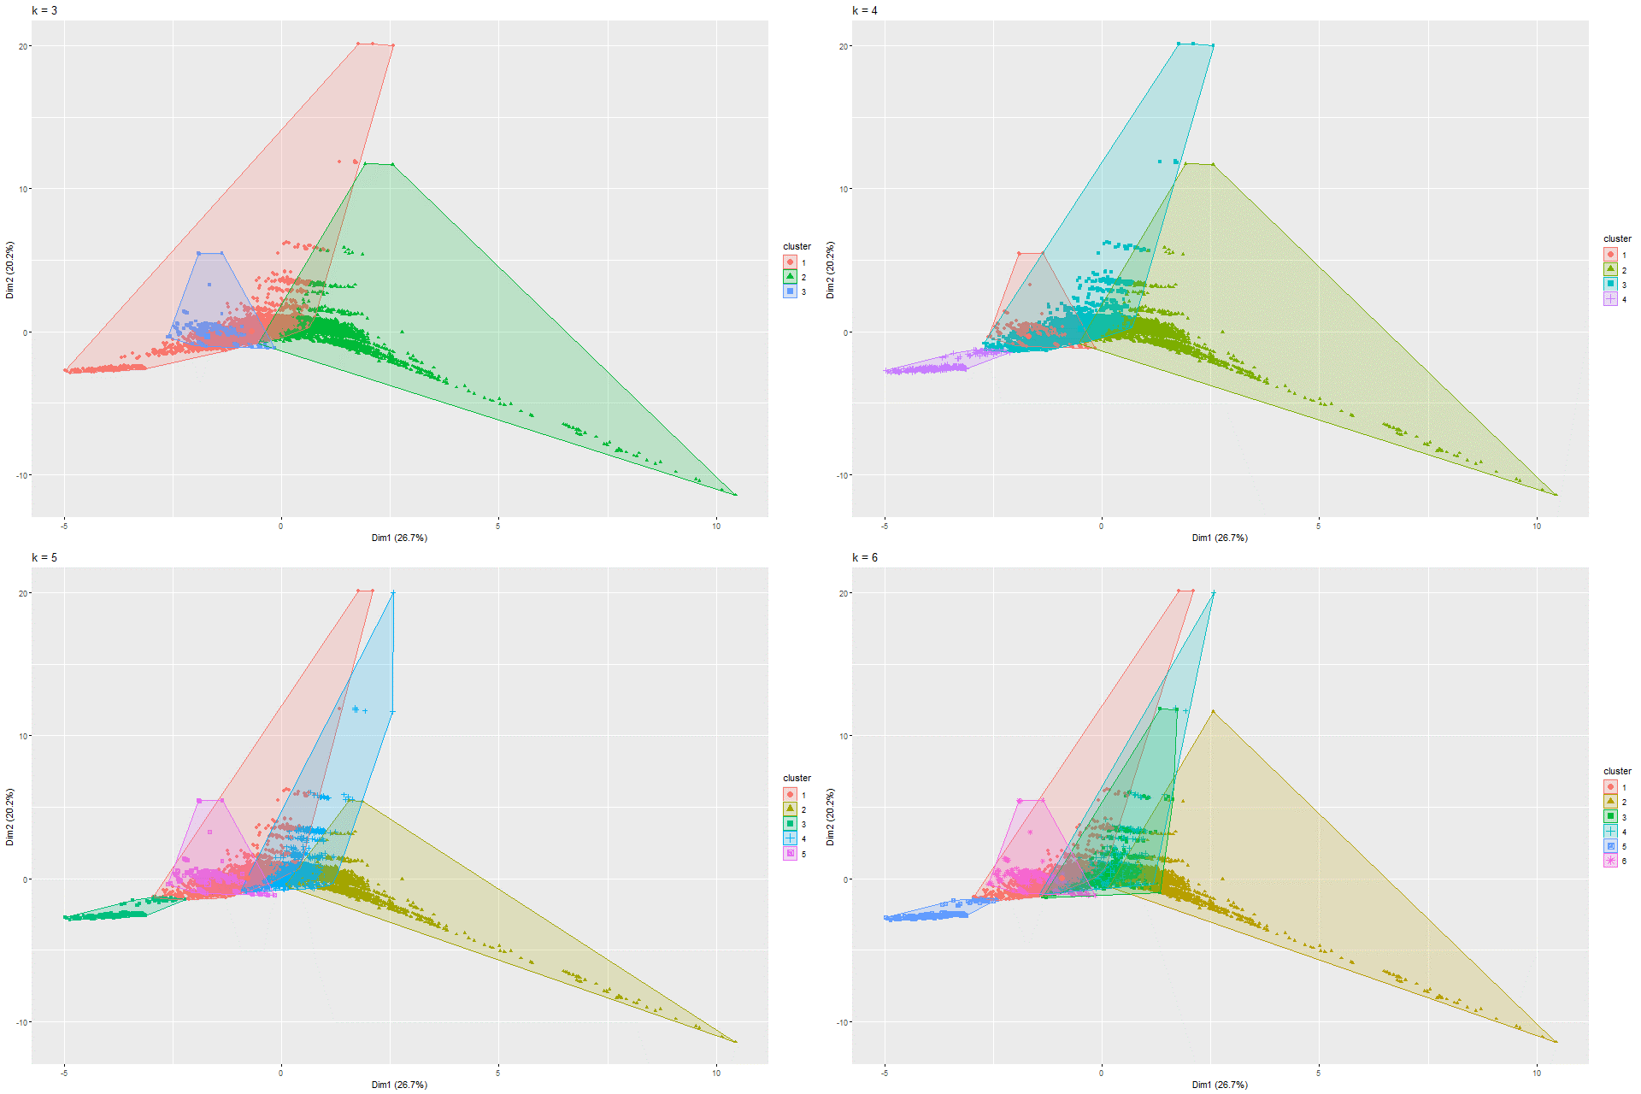

Figure 281 k-Means on PCA Model 4

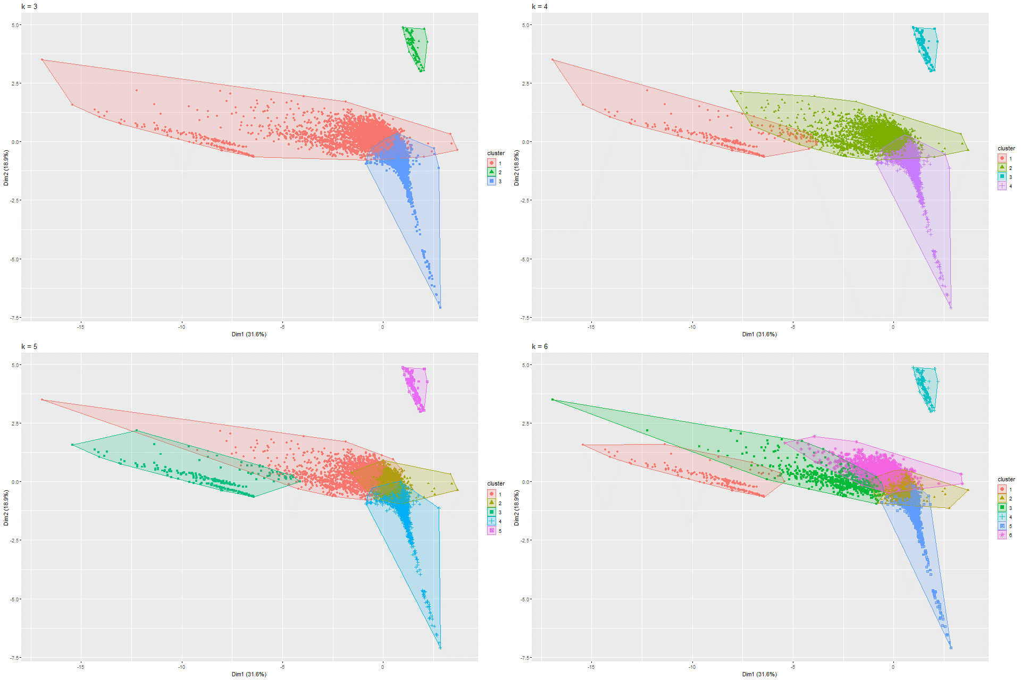

Figure 282 k-Means on PCA Model 5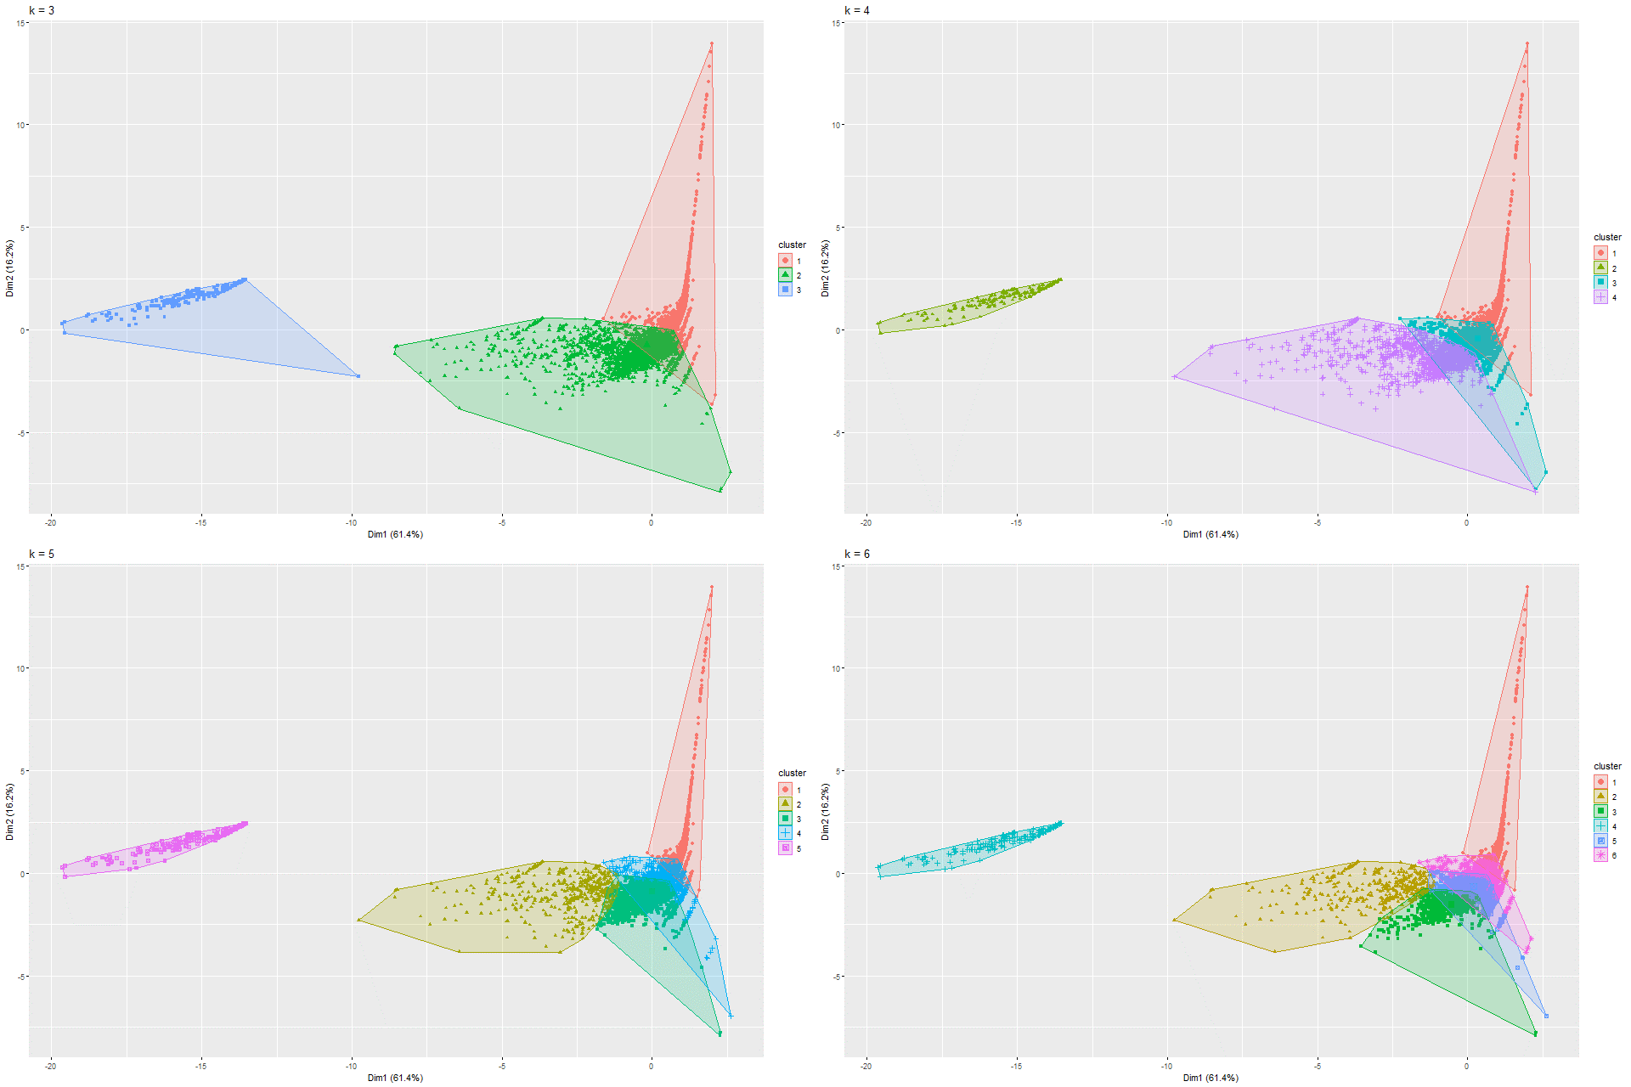

Figure 283 k-Means on PCA Model 6

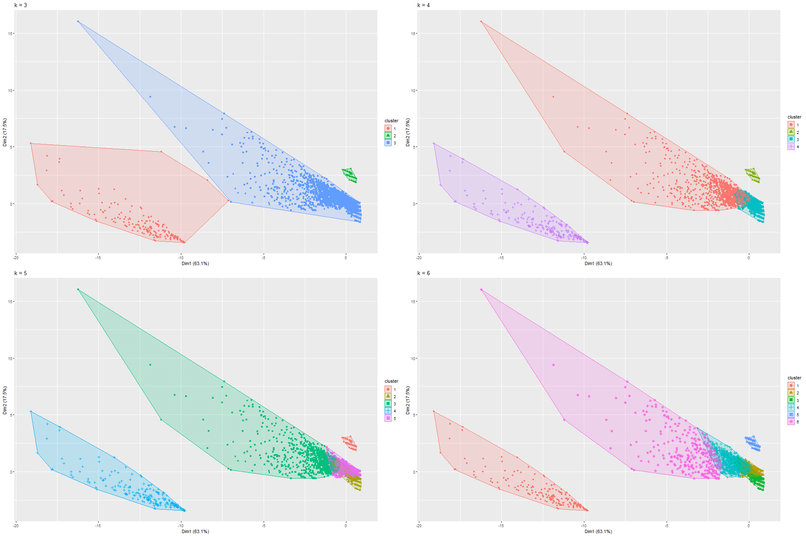

Figure 284 k-Means on PCA Model 7

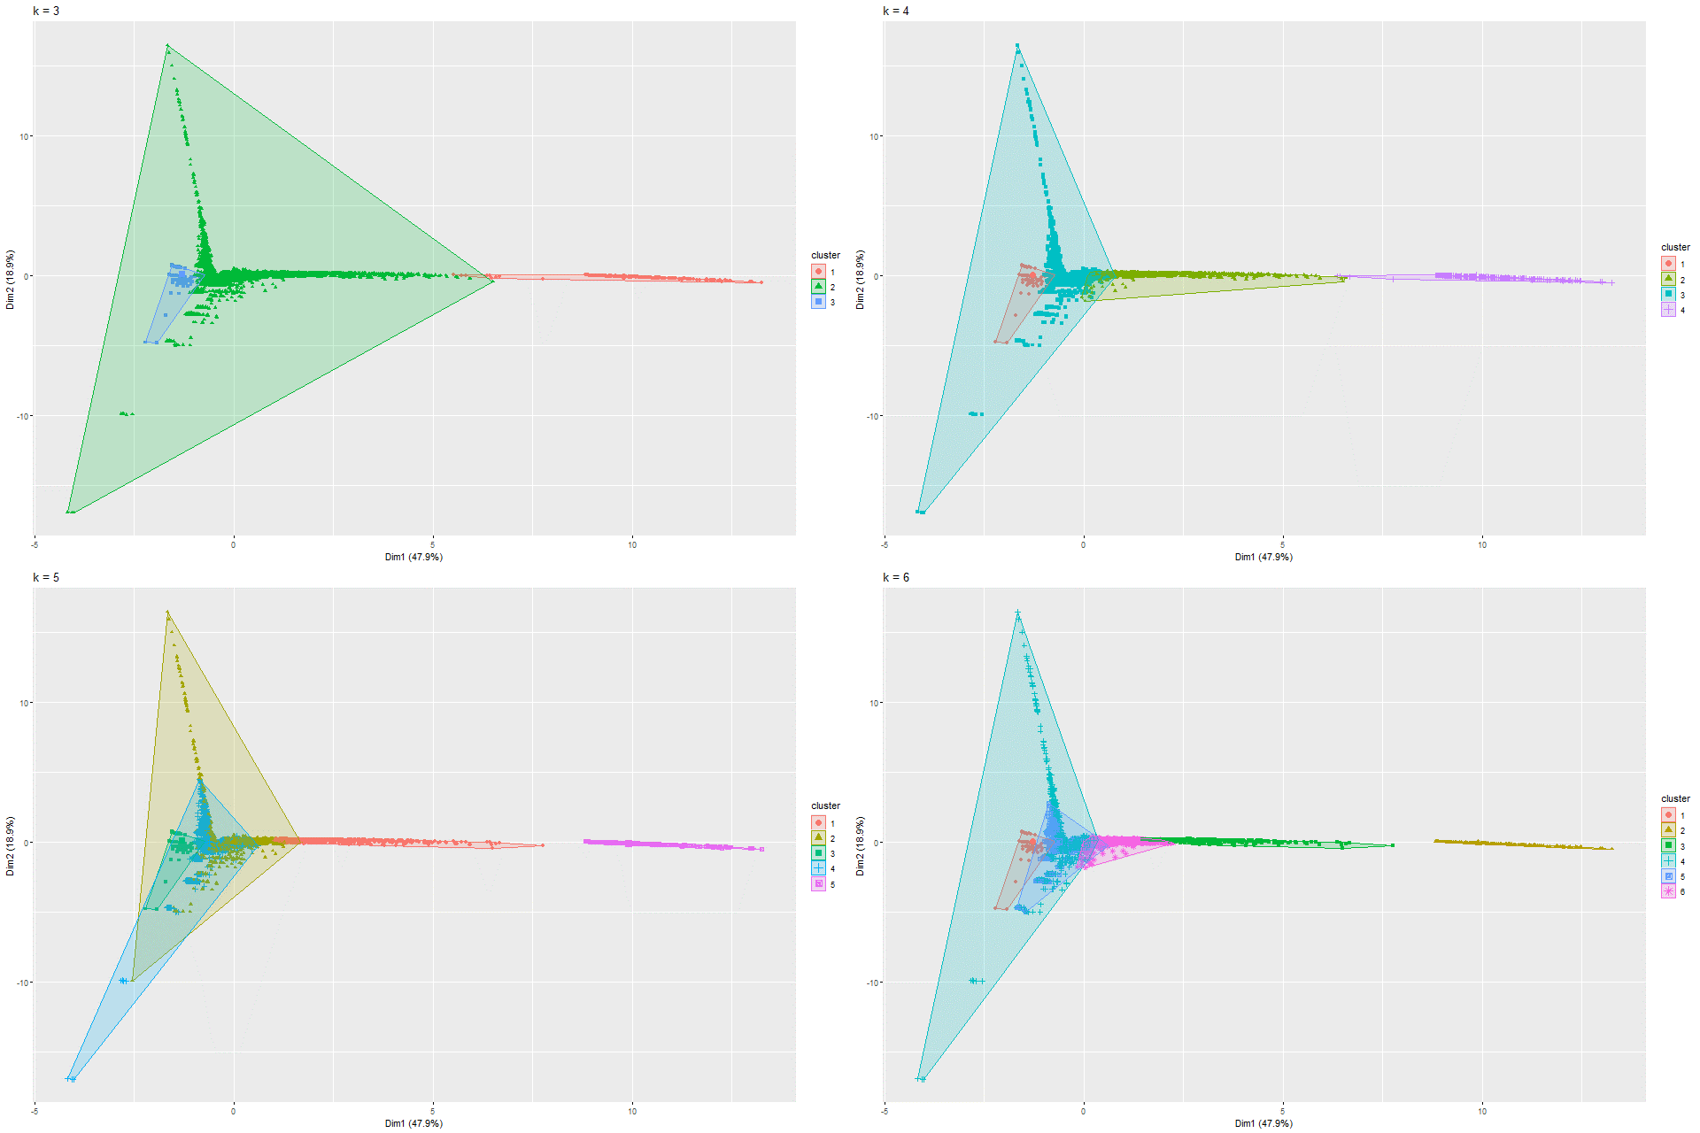

Figure 285 k-Means on PCA Model 8

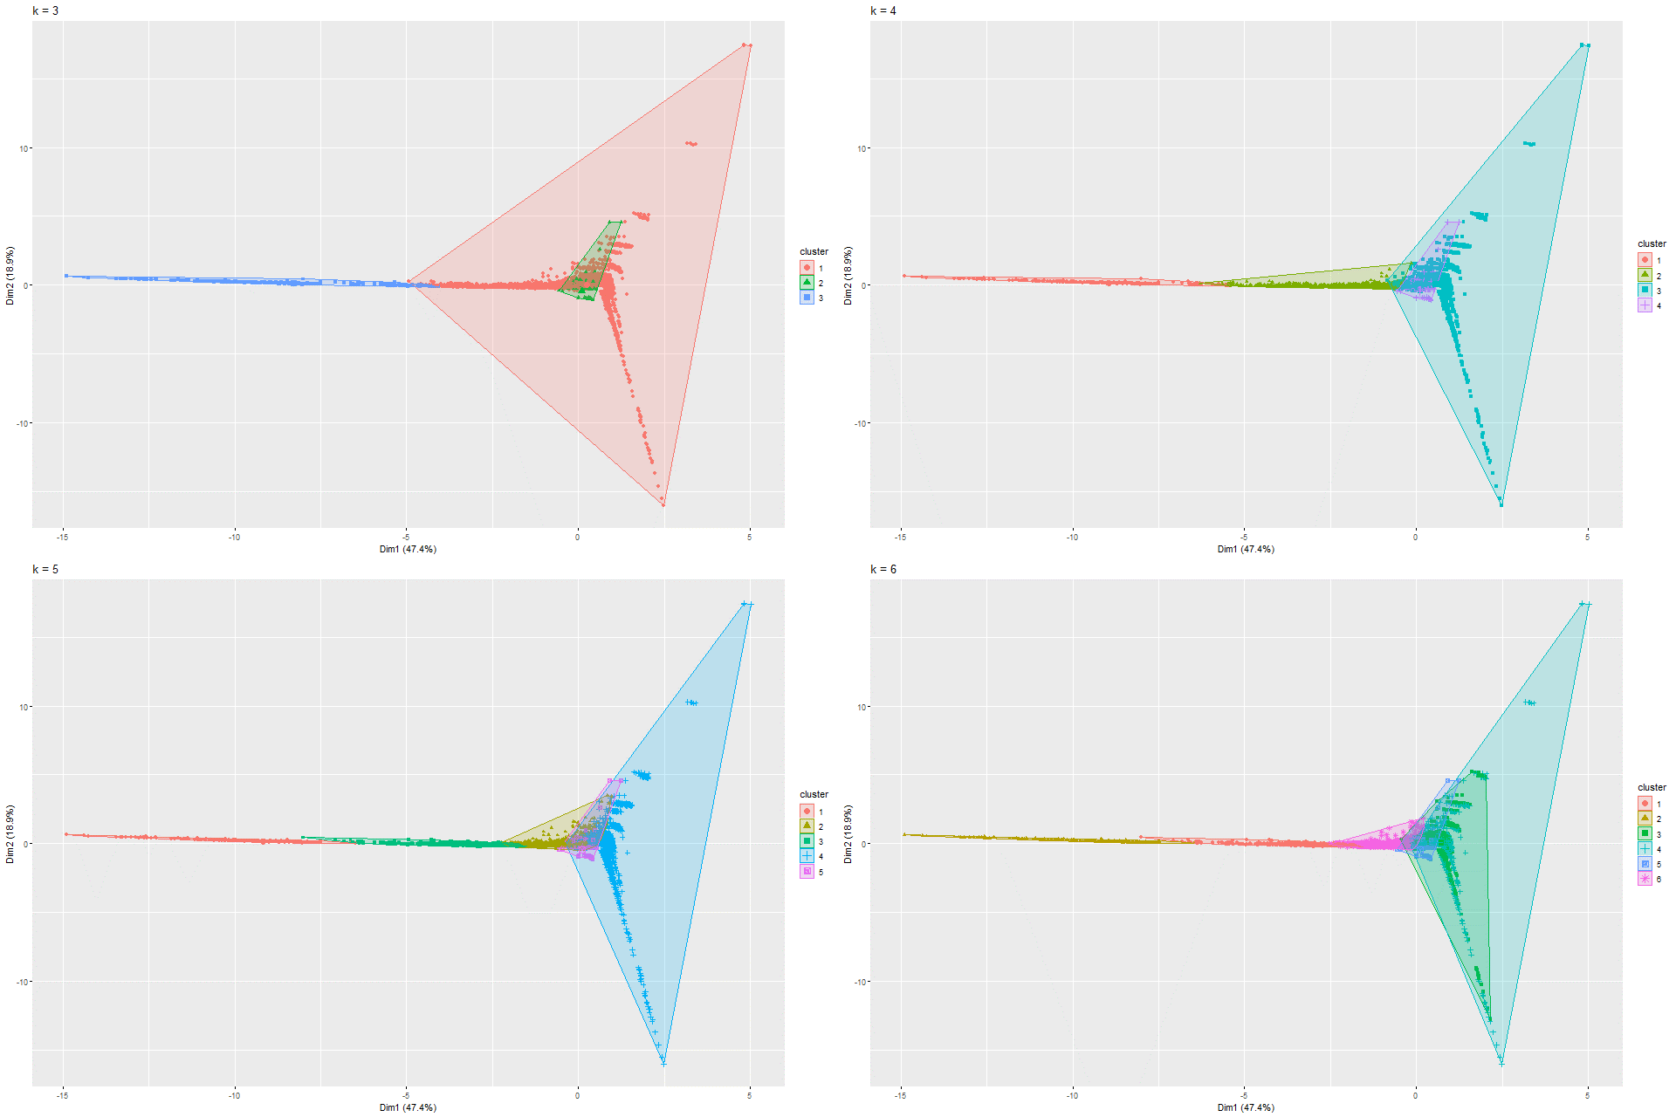

Figure 286 k-Means on PCA Model 9

### 6.2.5 UMAP and K-means on UMAP

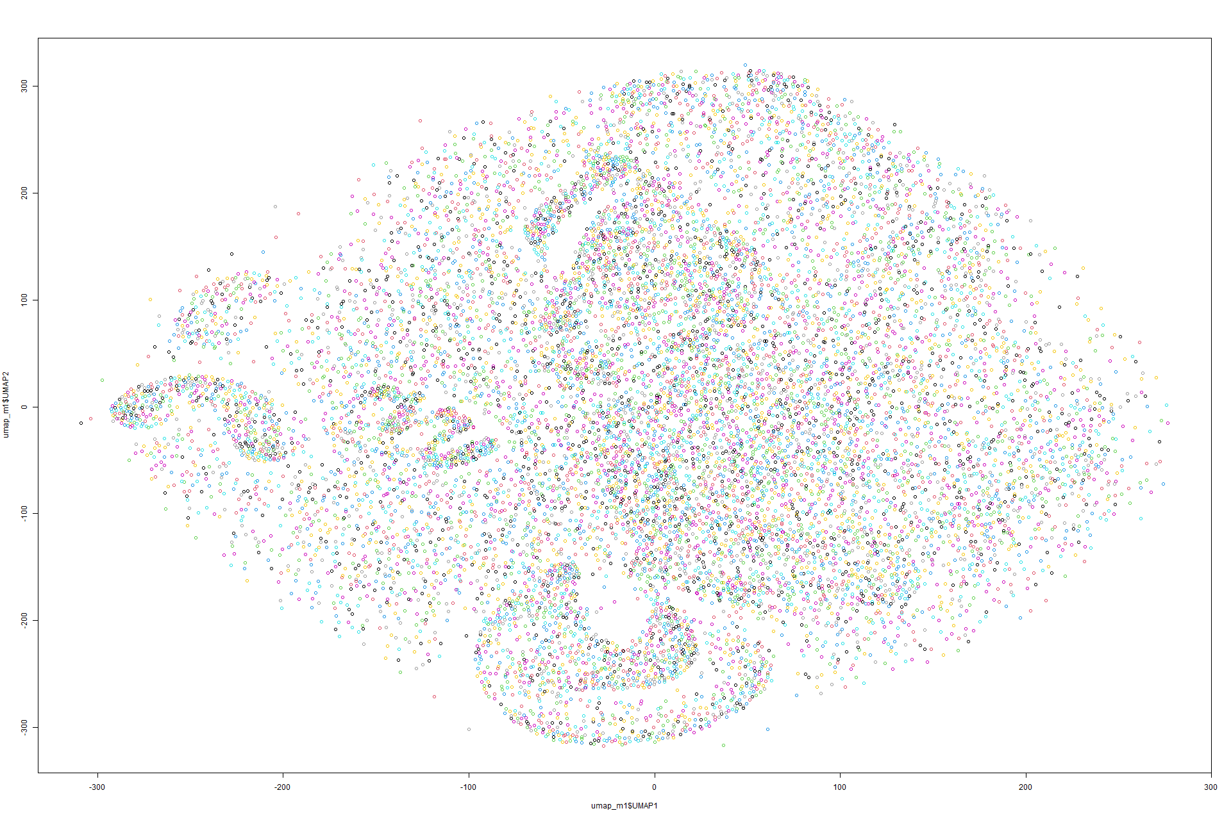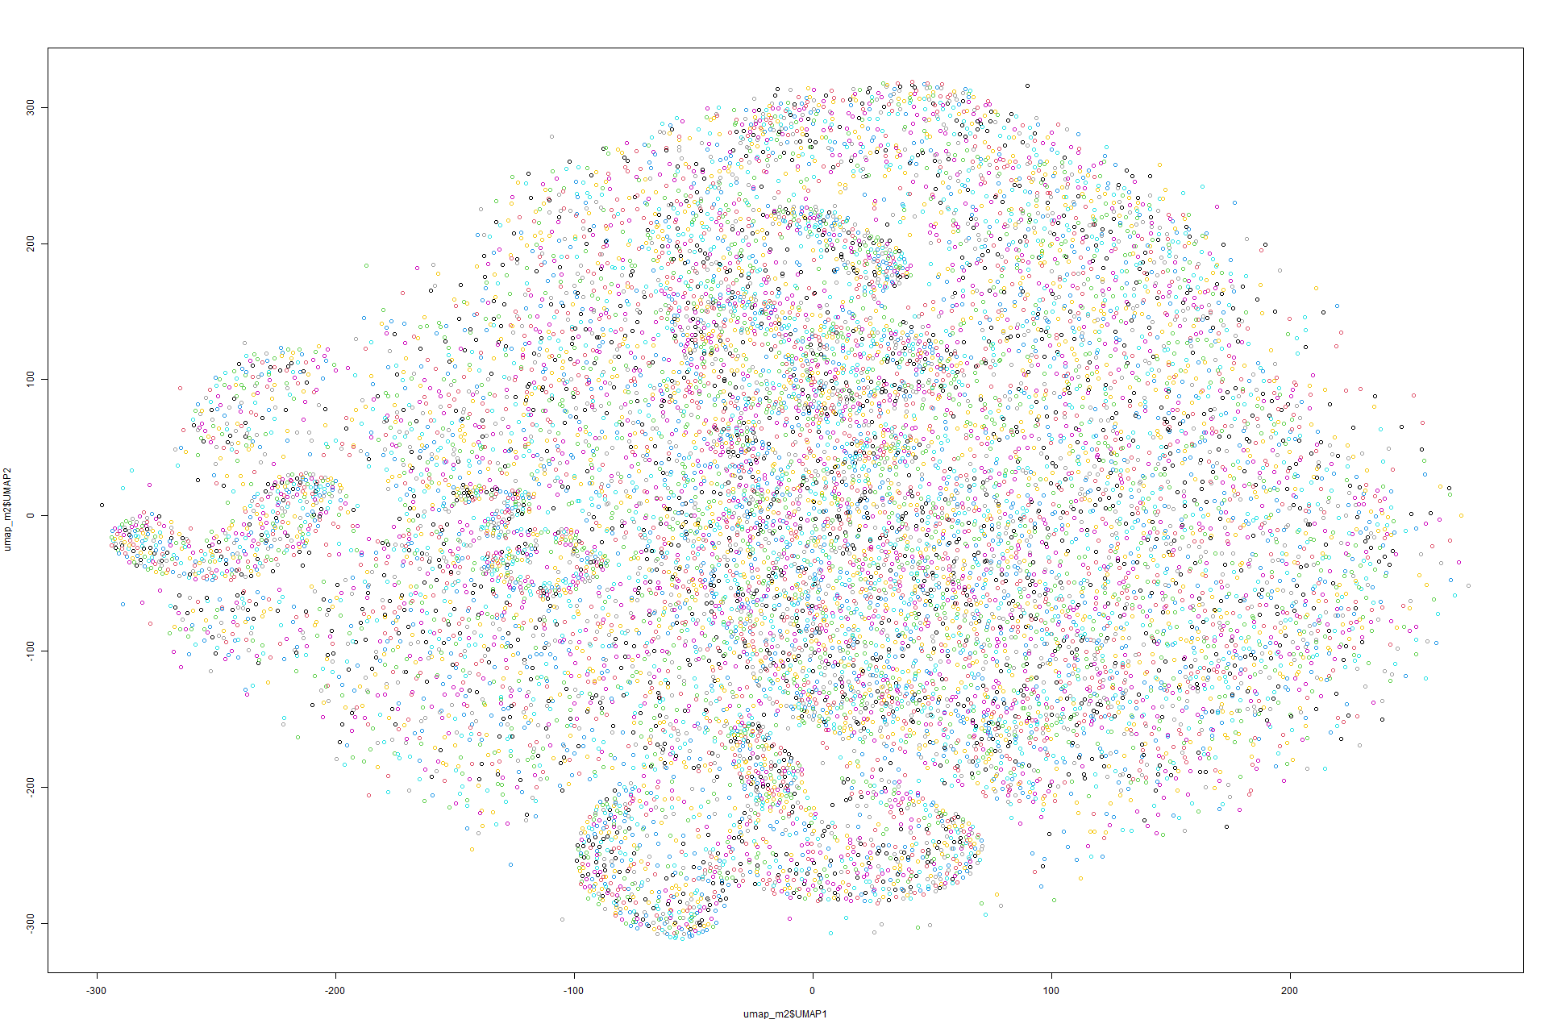Figure 287 UMAP on Model 1 Figure 288 UMAP on Model 2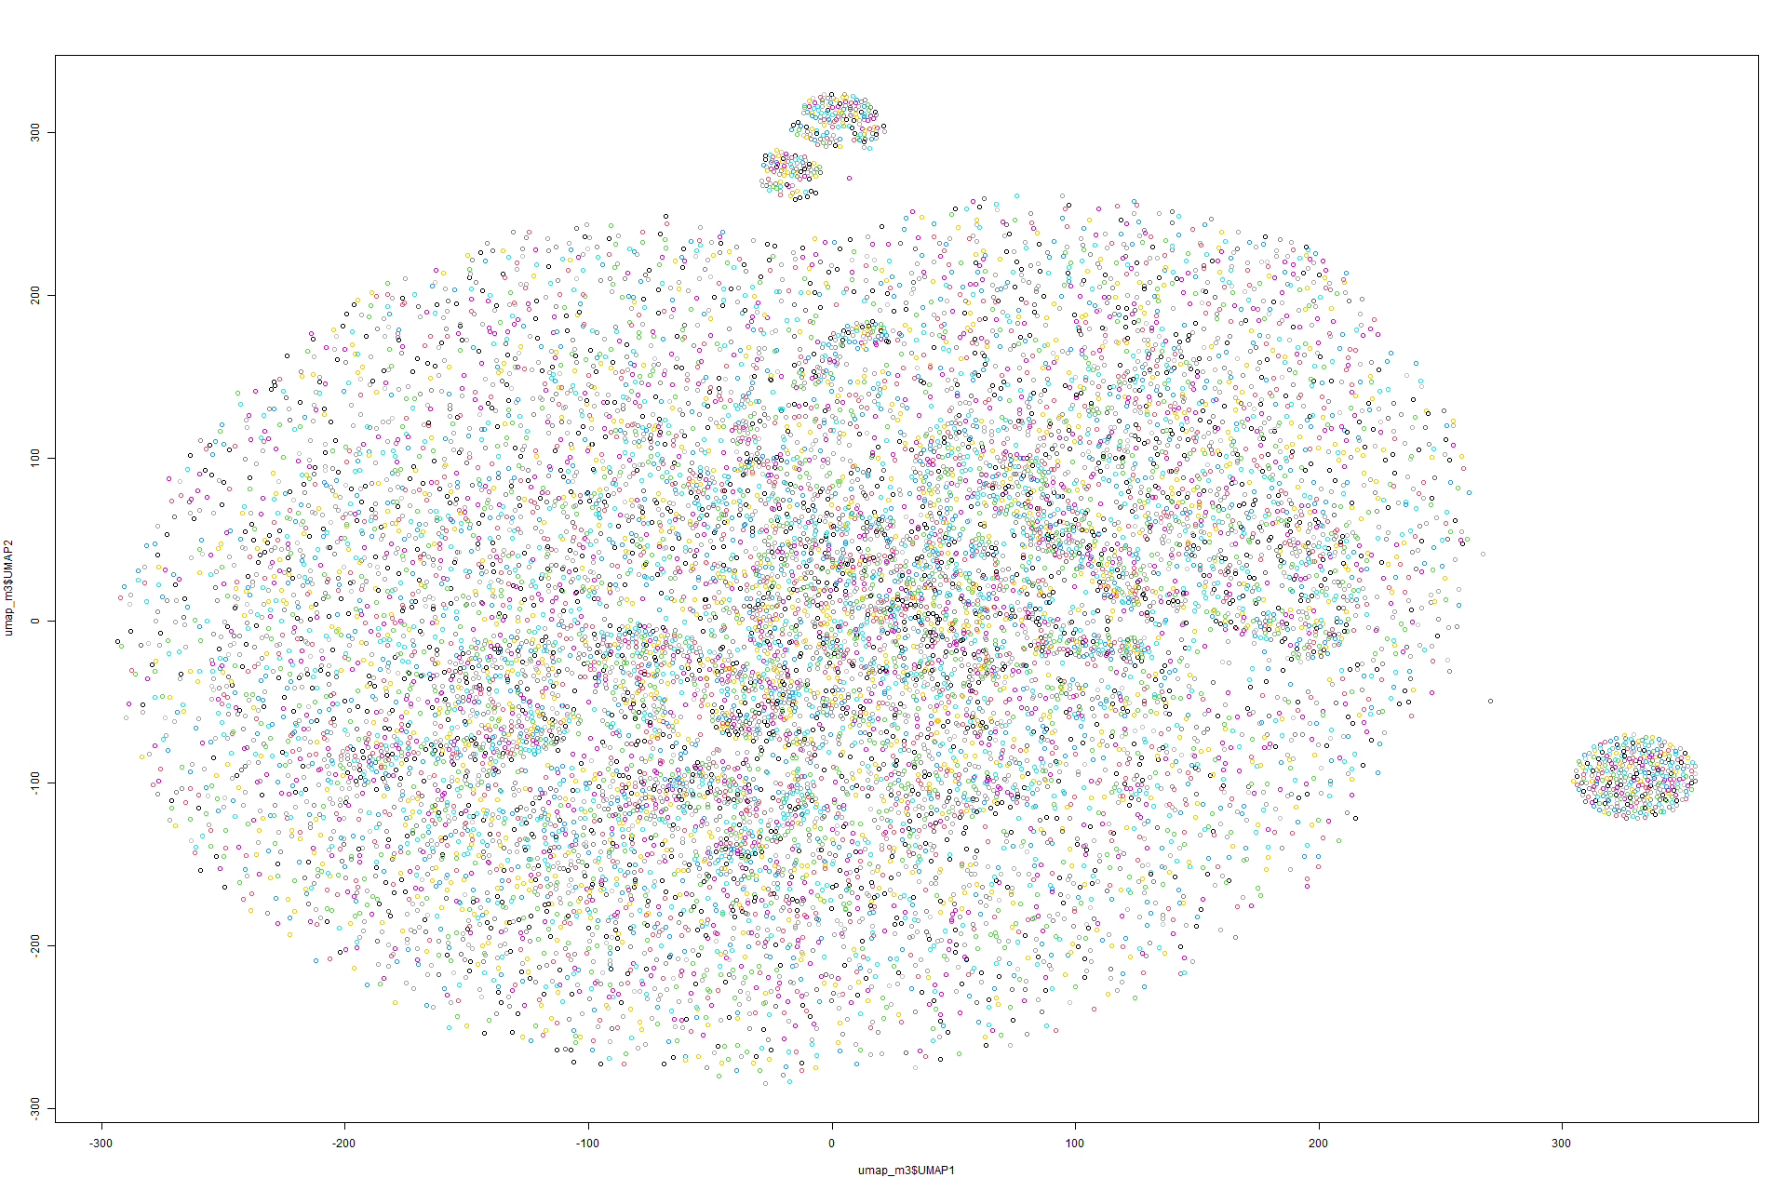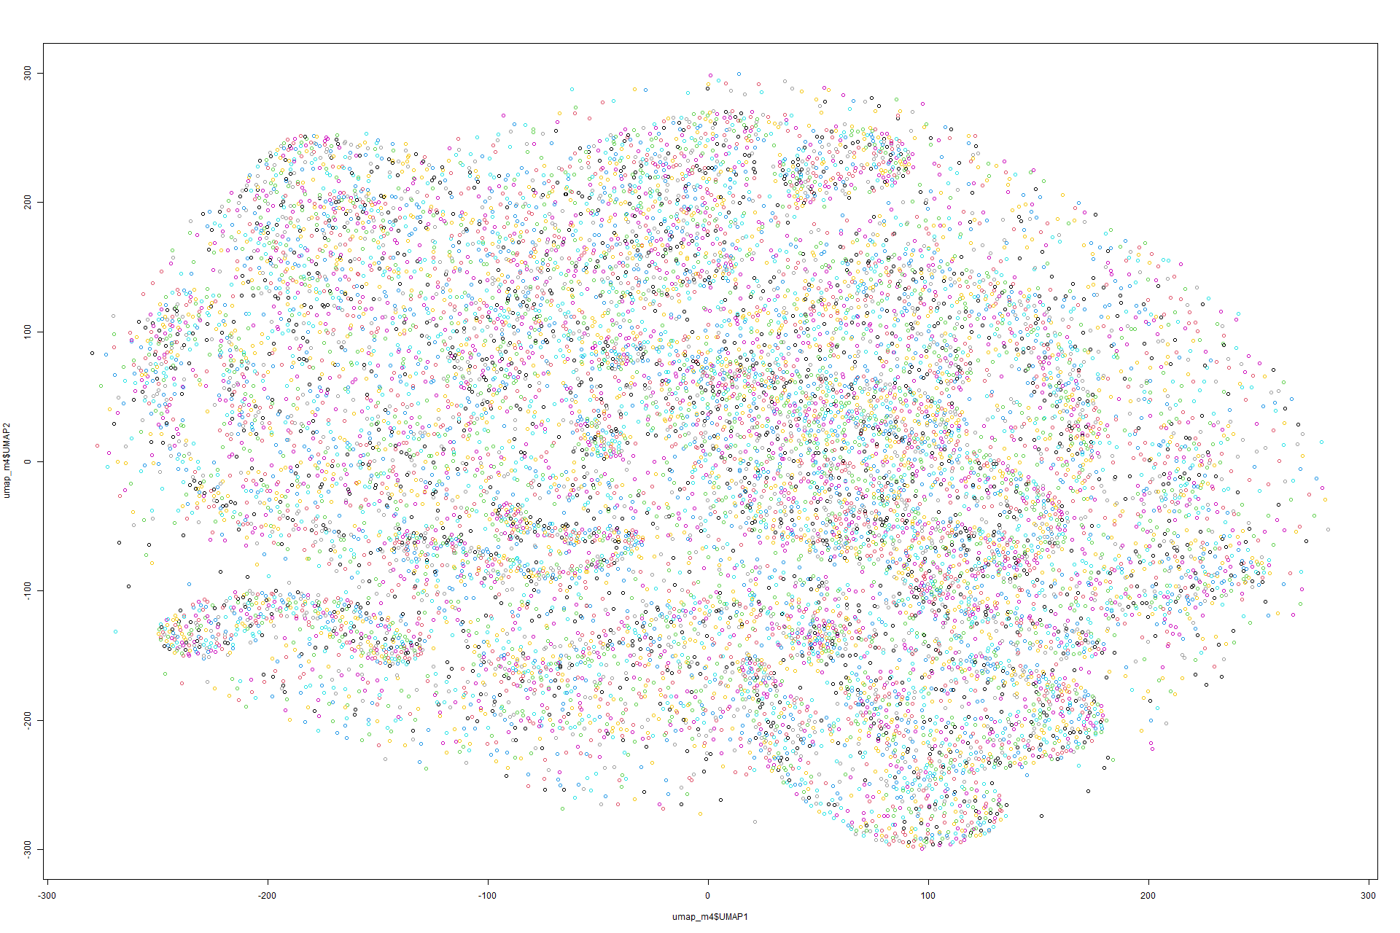 Figure 289 UMAP on Model 3 Figure 290 UMAP on Model 4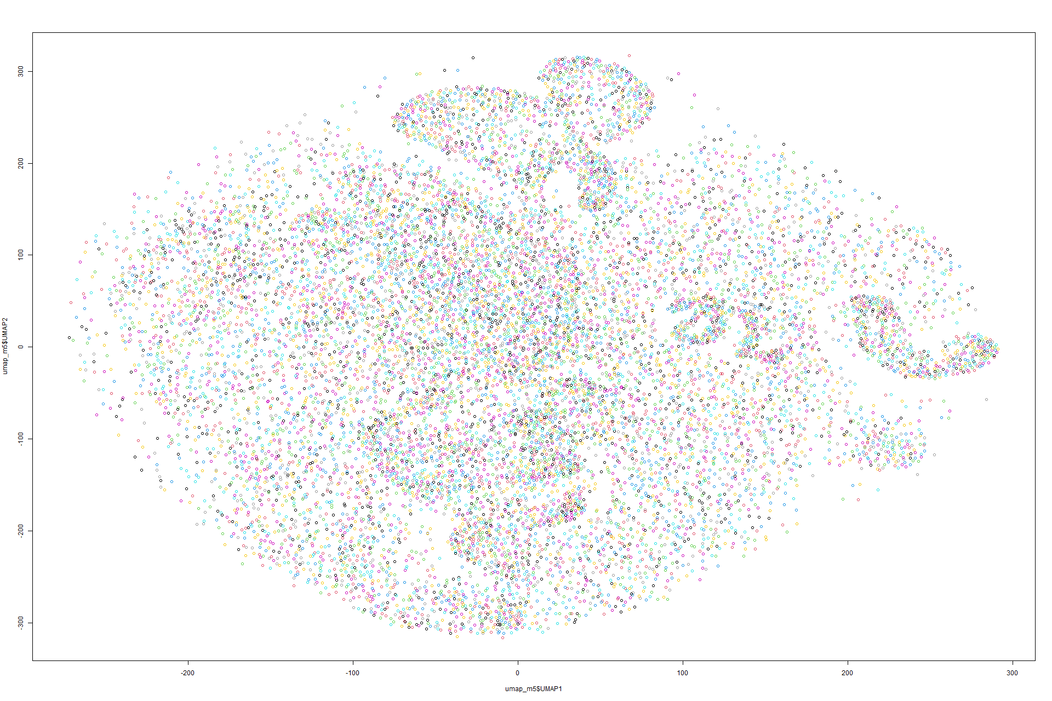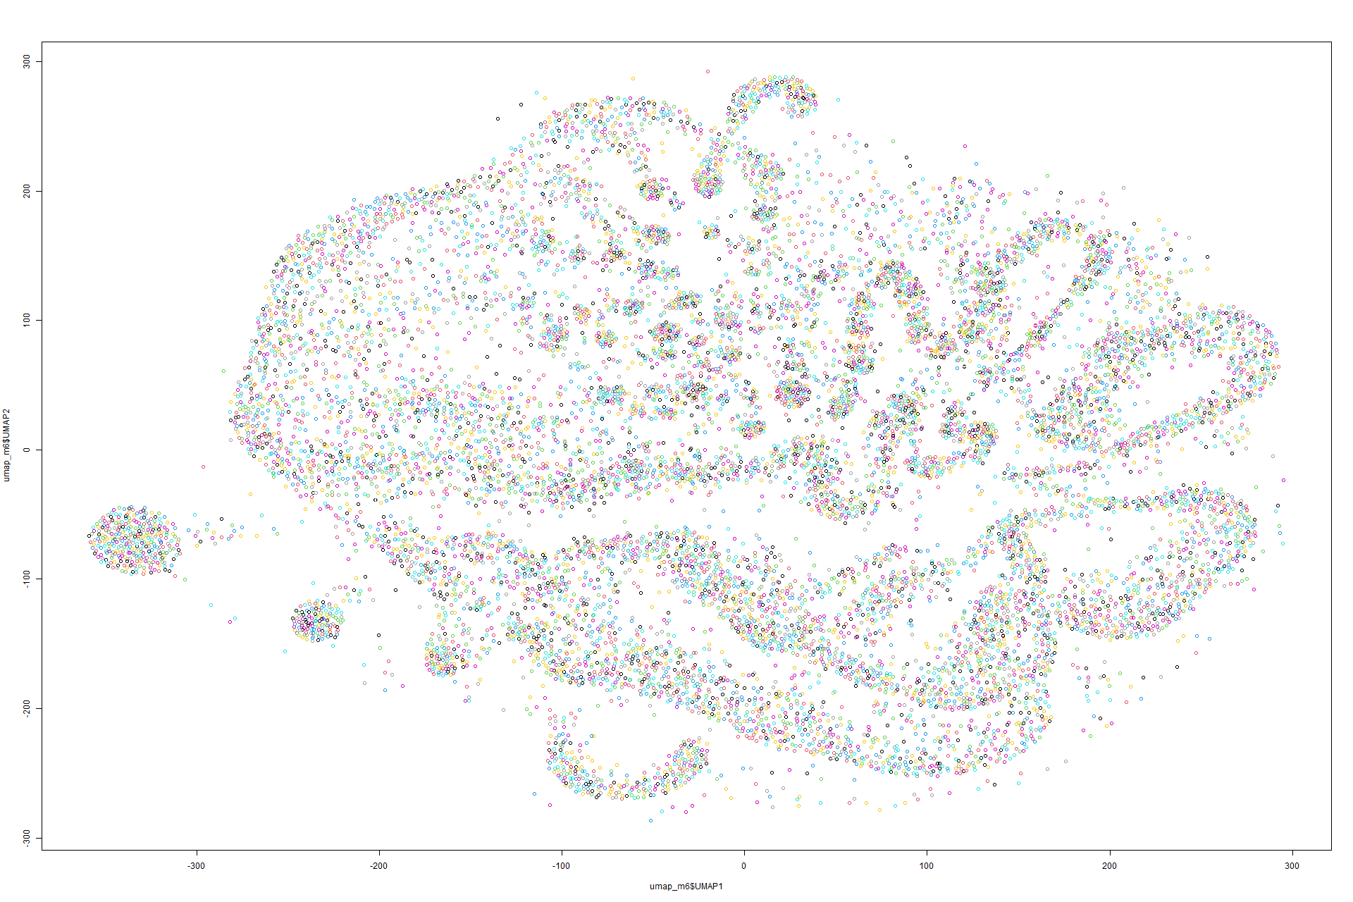 Figure 291 UMAP on Model 5 Figure 292 UMAP on Model 6

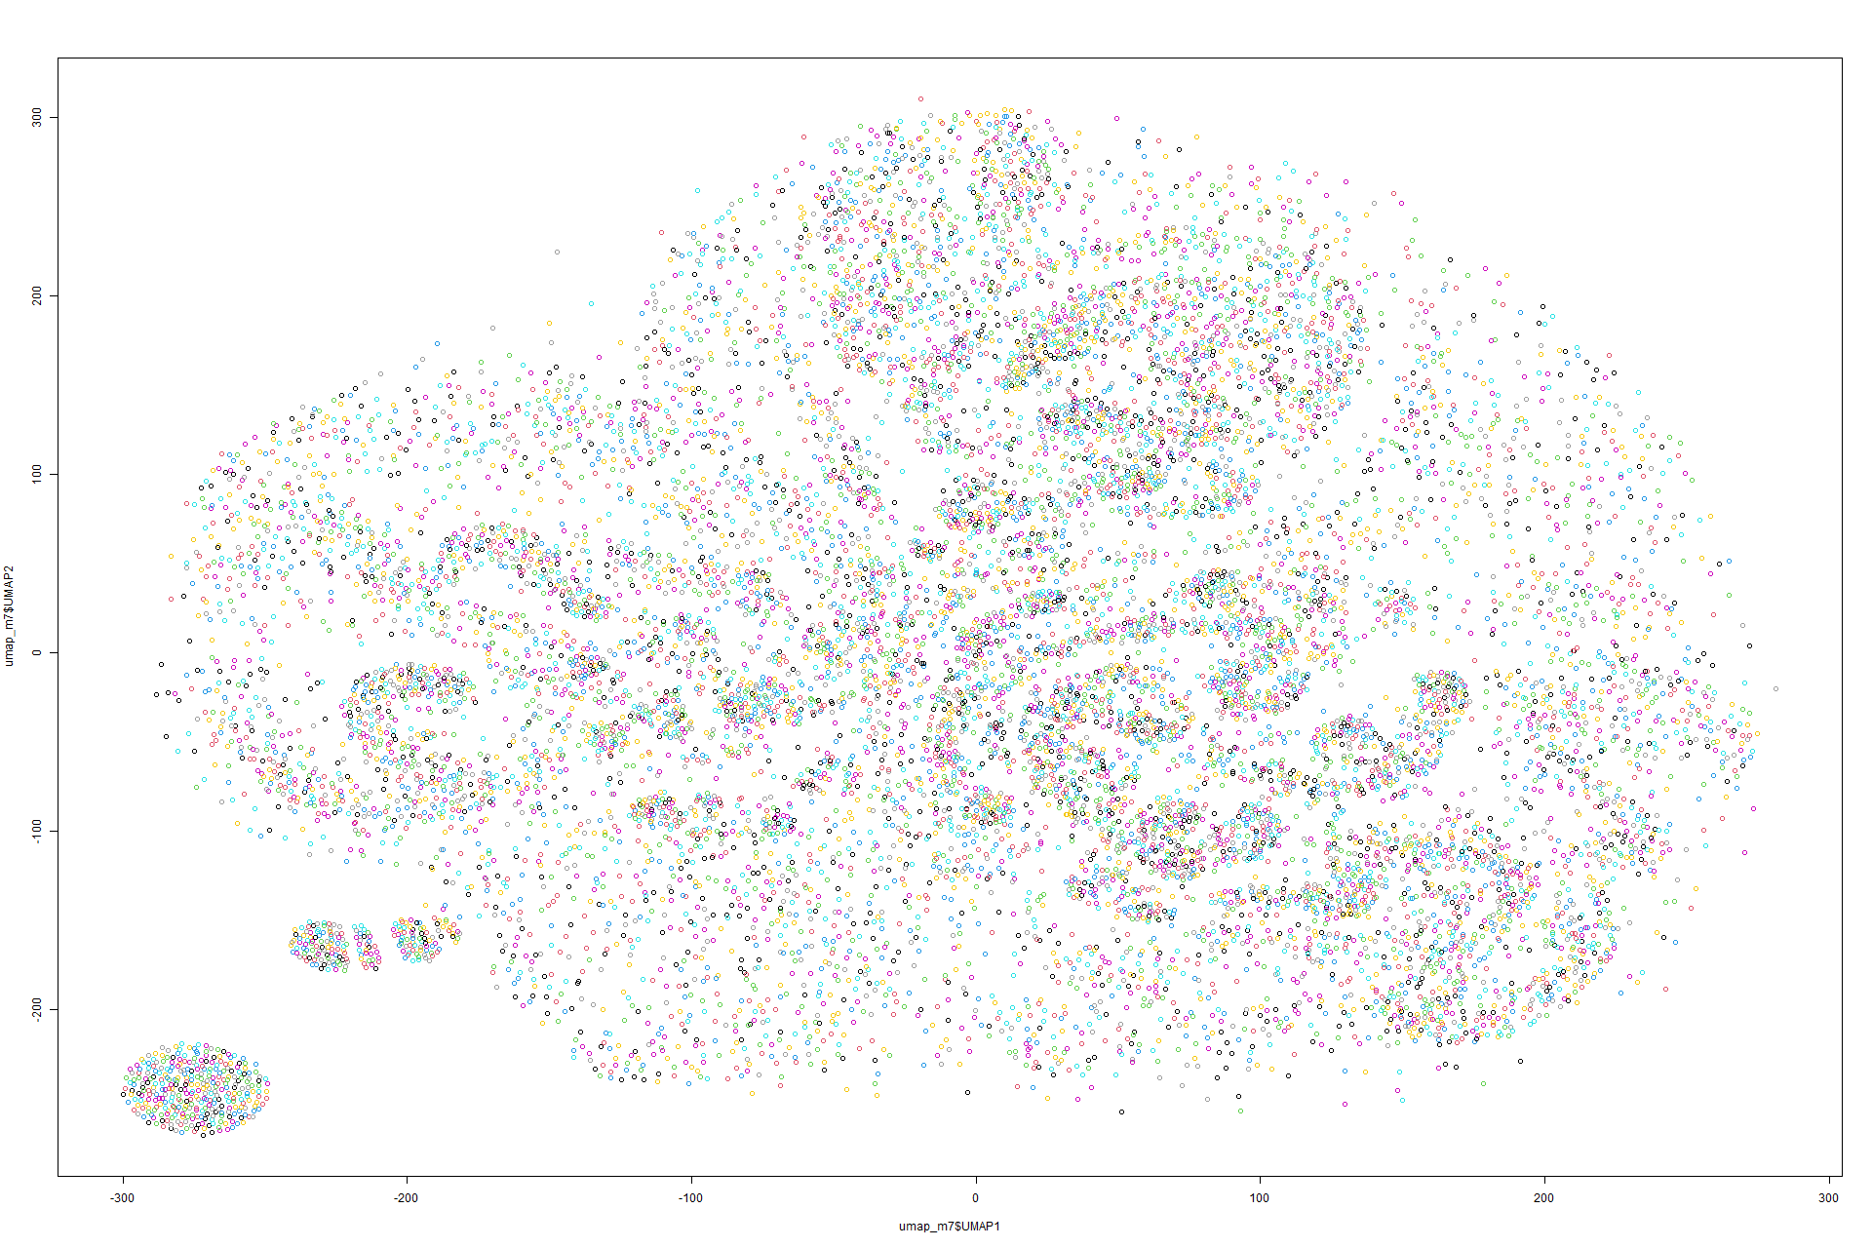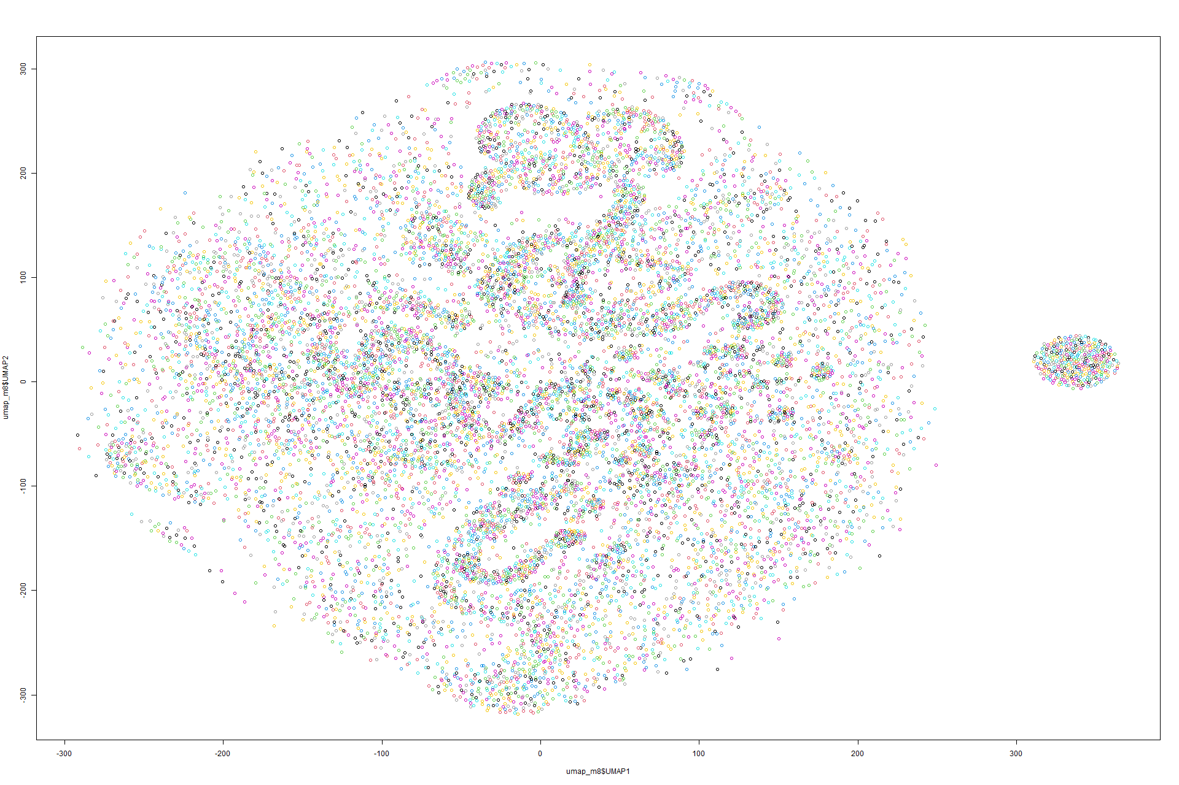Figure 293 UMAP on Model 7 Figure 294 UMAP on Model 8

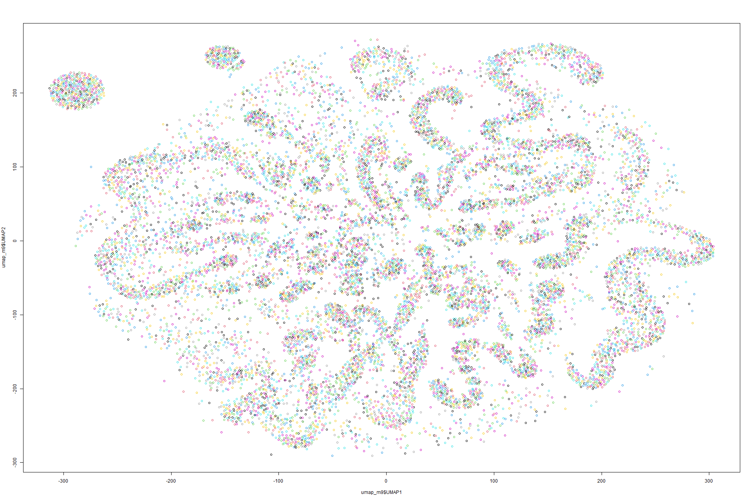

Figure 295 UMAP on Model 9

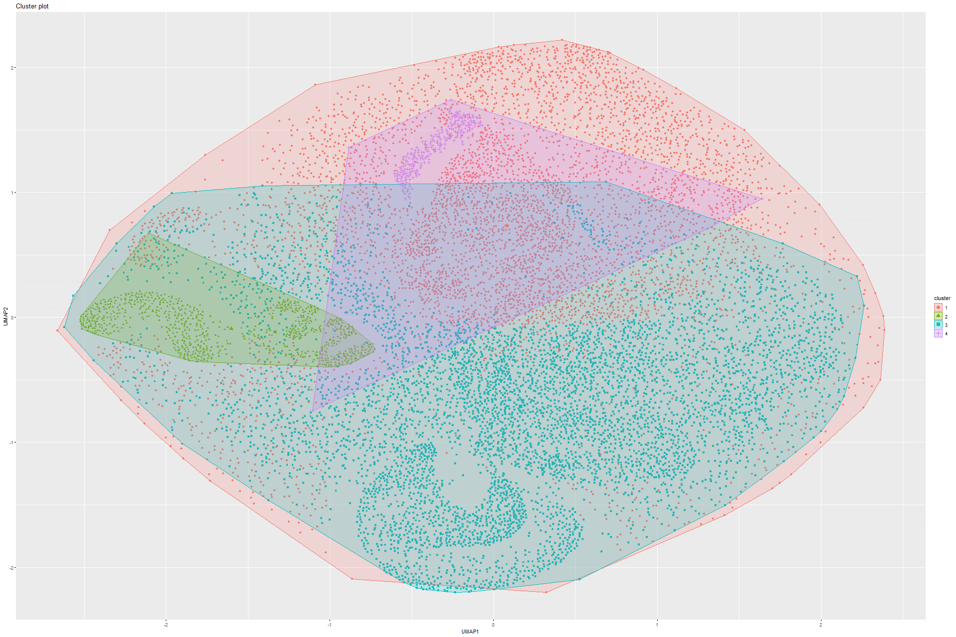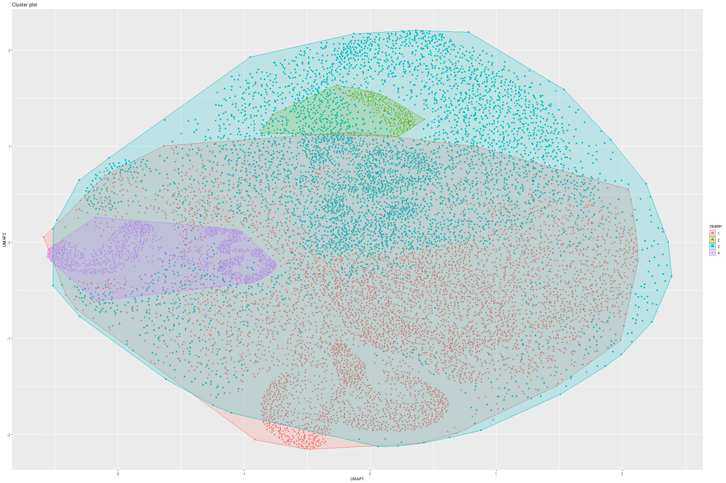Figure 296 K-means on UMAP on Model 1 Figure 297 K-means on UMAP on Model 2

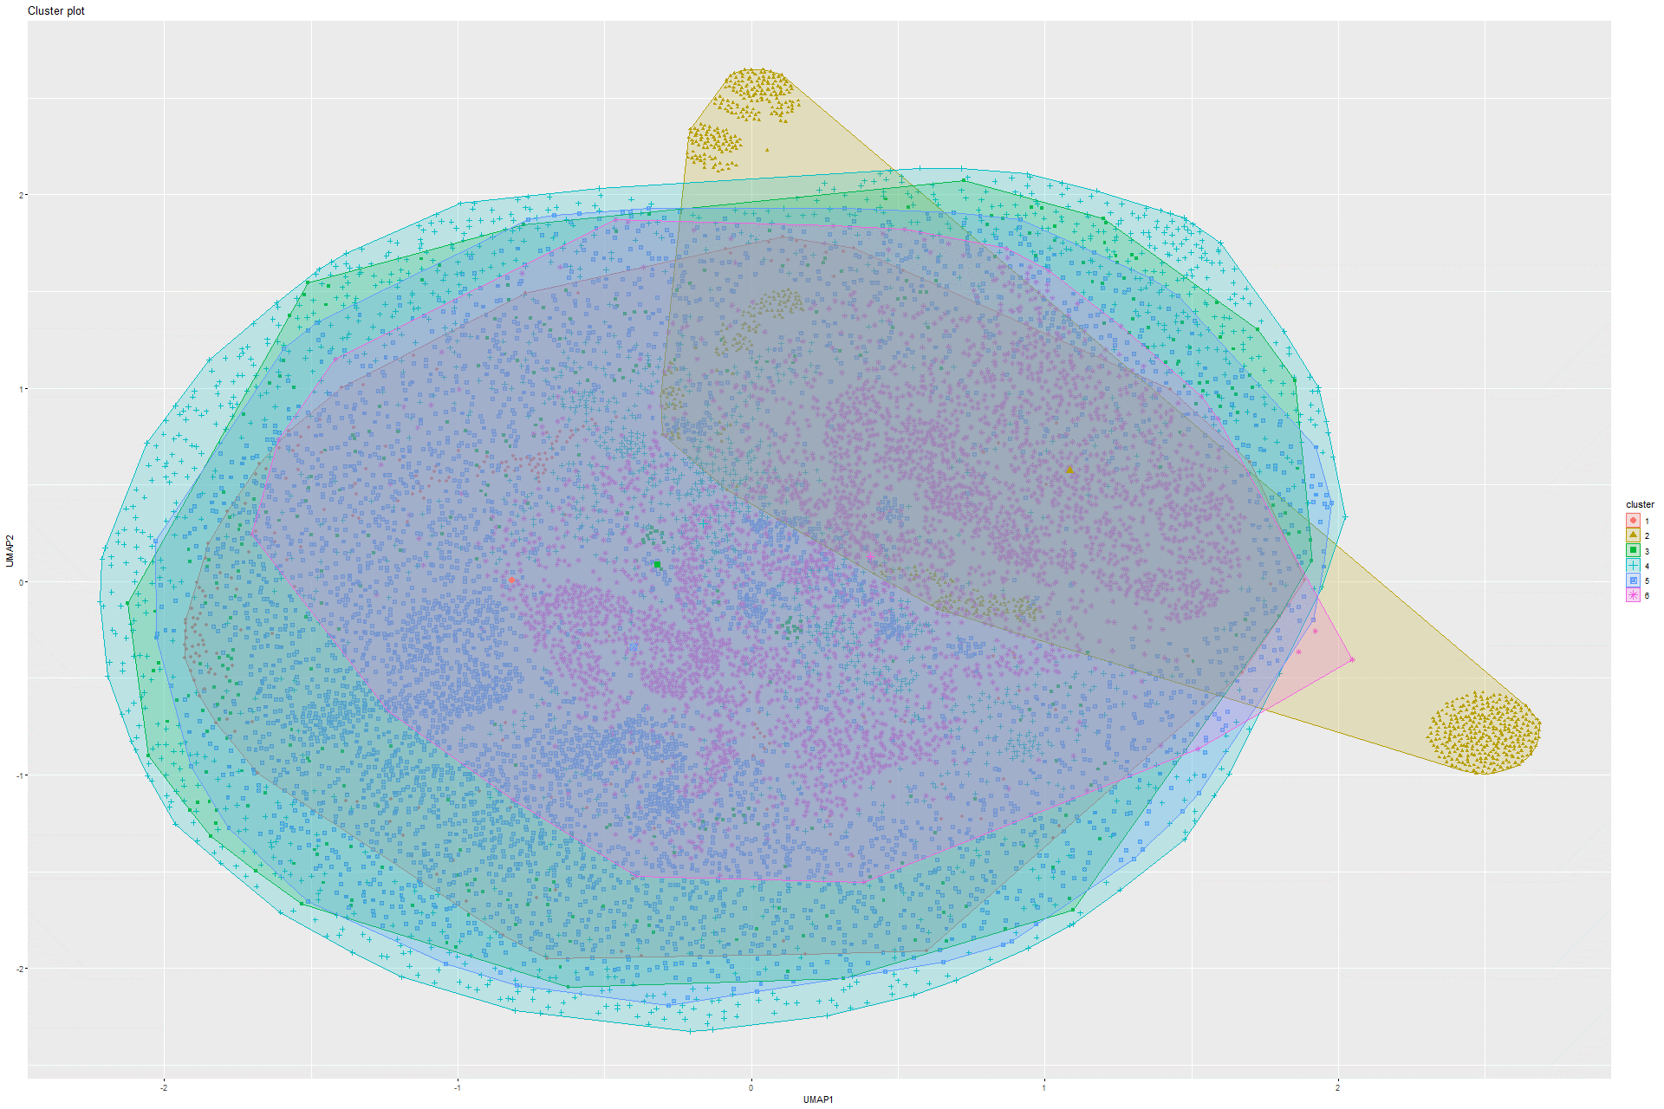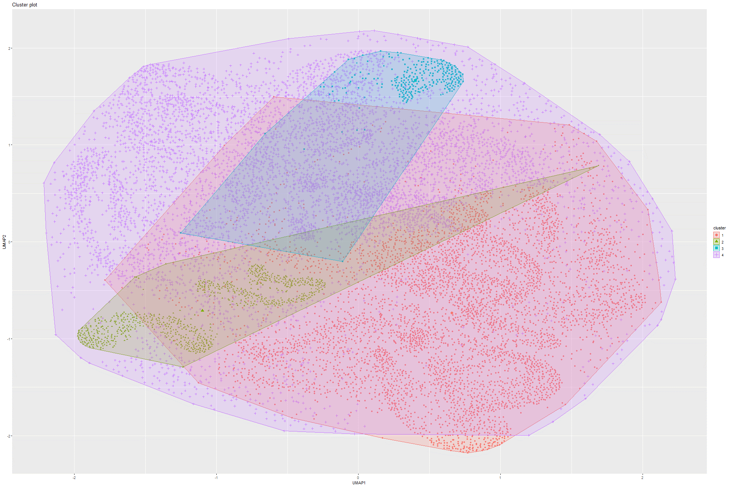Figure 298 K-means on UMAP on Model 3 Figure 299 K-means on UMAP on Model 4

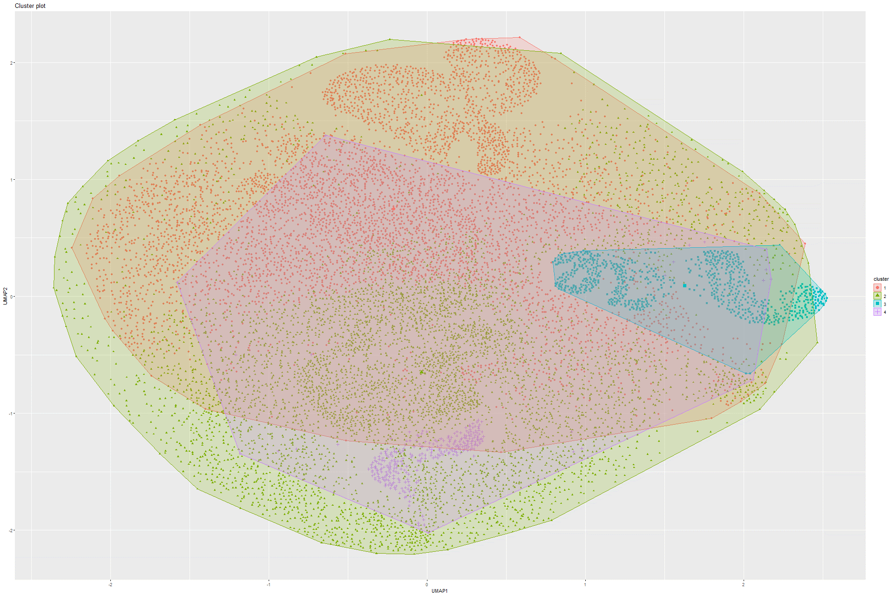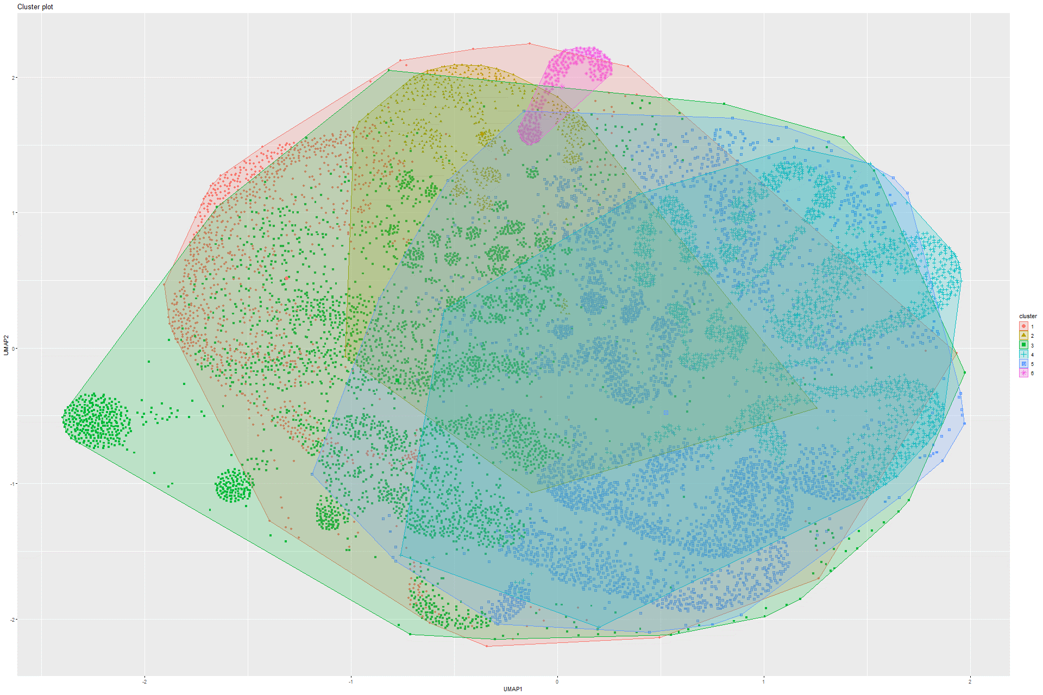Figure 300 K-means on UMAP on Model 5 Figure 301 K-means on UMAP on Model 6

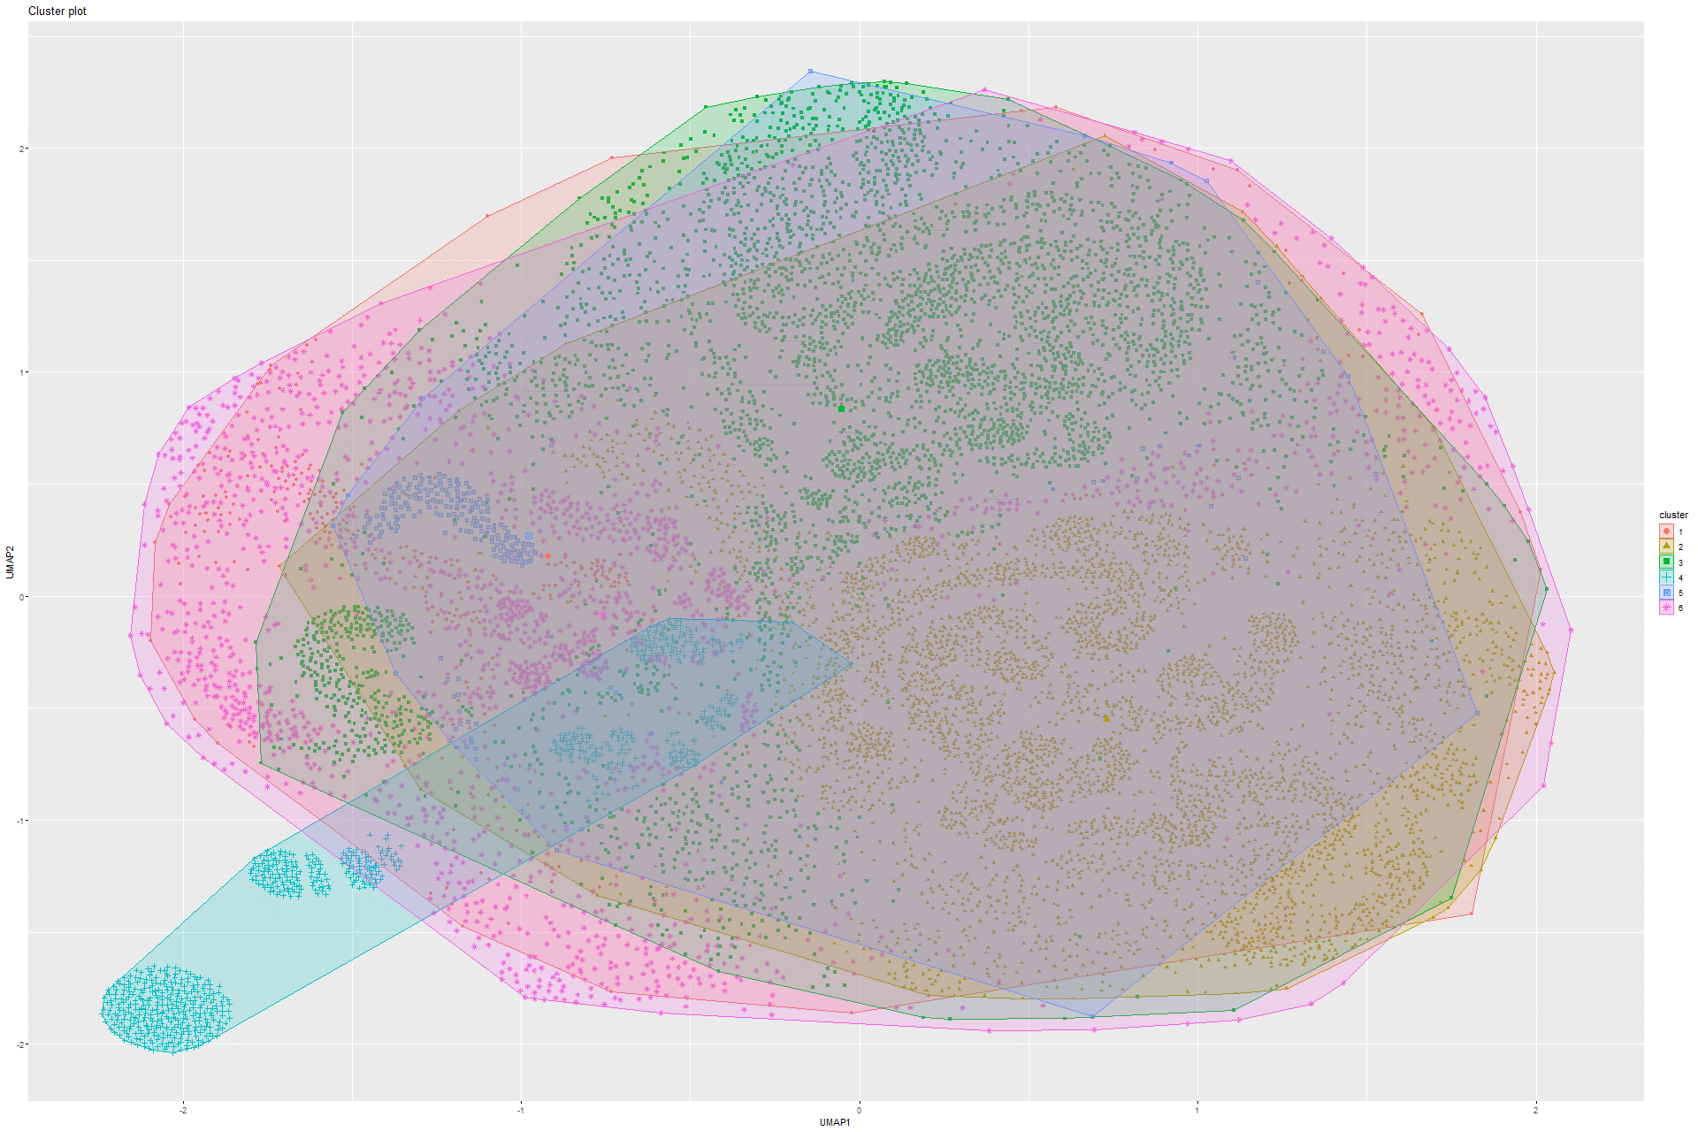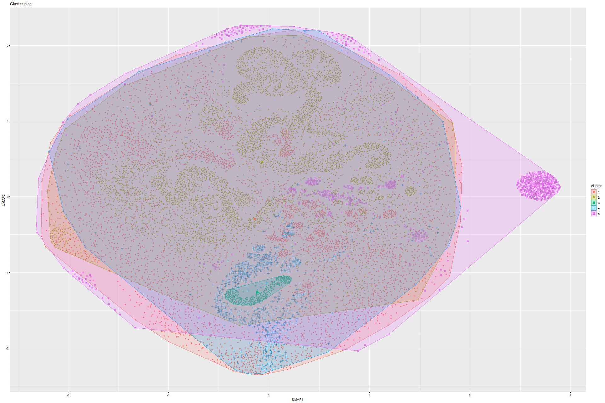Figure 302 K-means on UMAP on Model 7 Figure 303 K-means on UMAP on Model 8

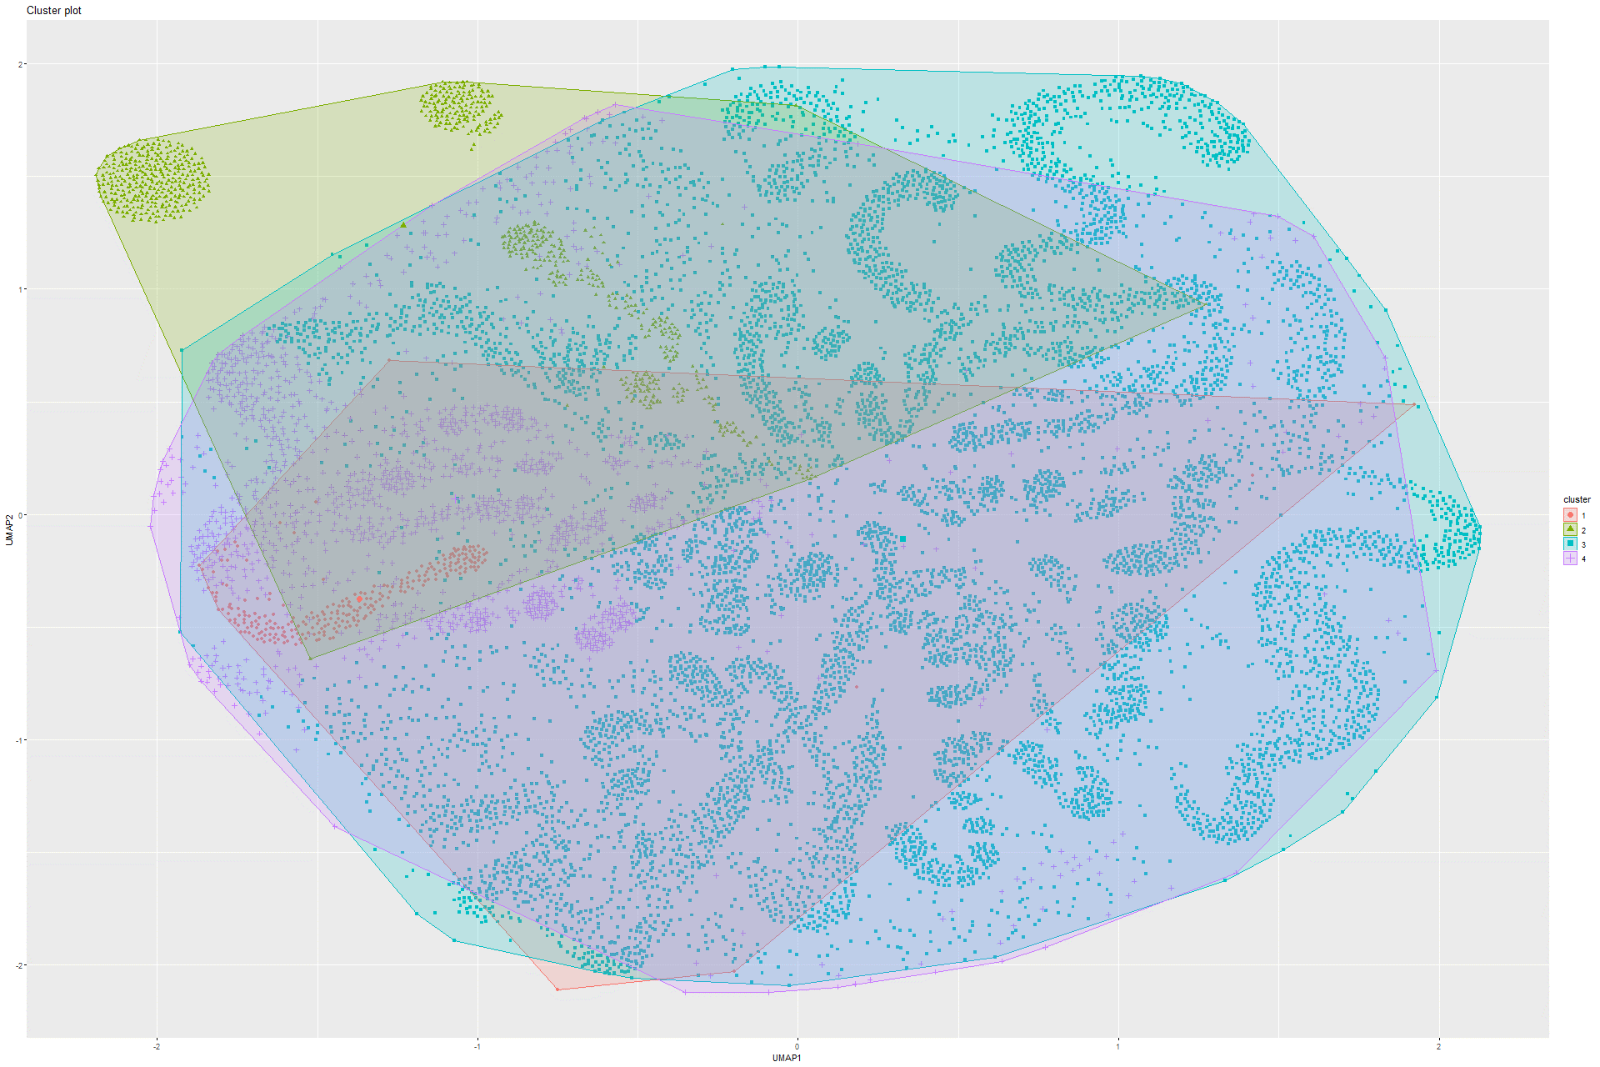

Figure 304 K-means on UMAP on Model 9

### 6.2.6 Sammon’s mapping

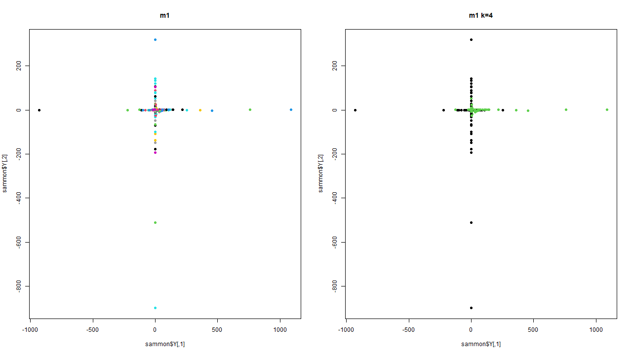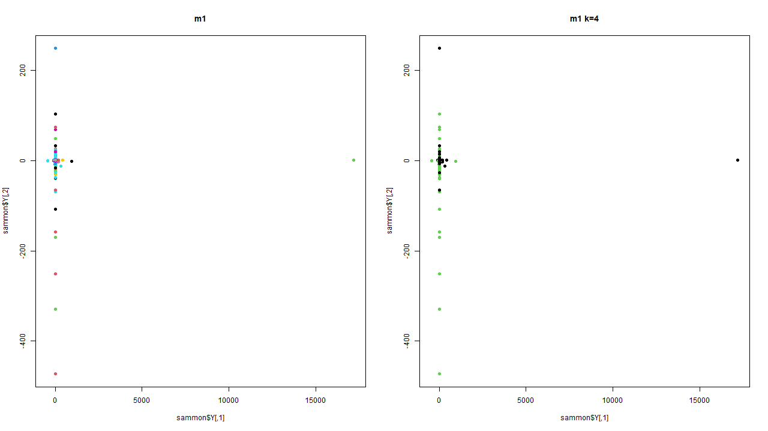Figure 305 Sammon’s mapping on Model 1 Figure 306 Sammon’s mapping on Model 2

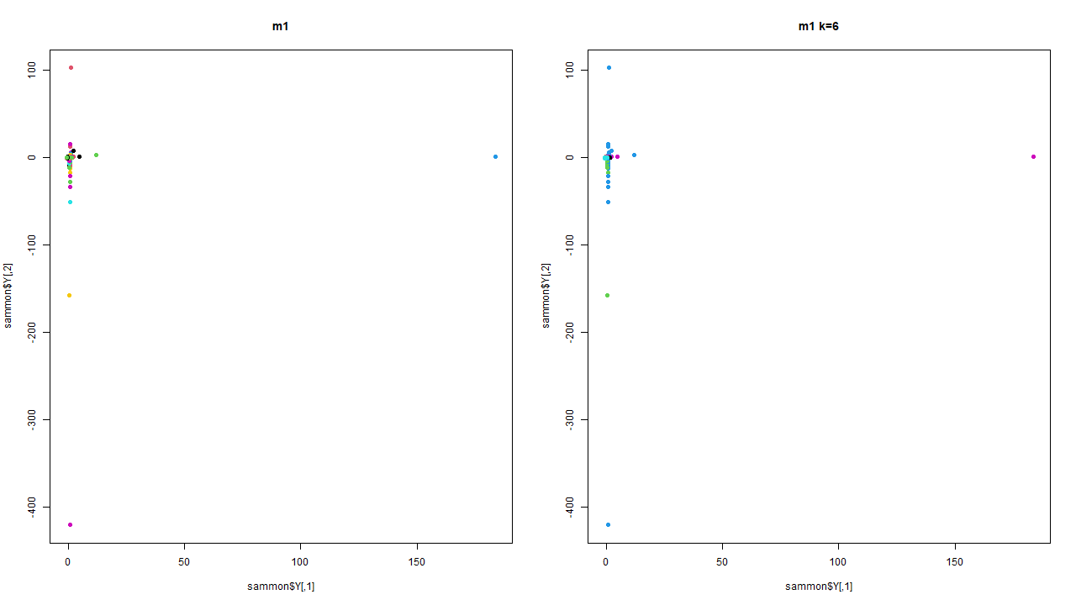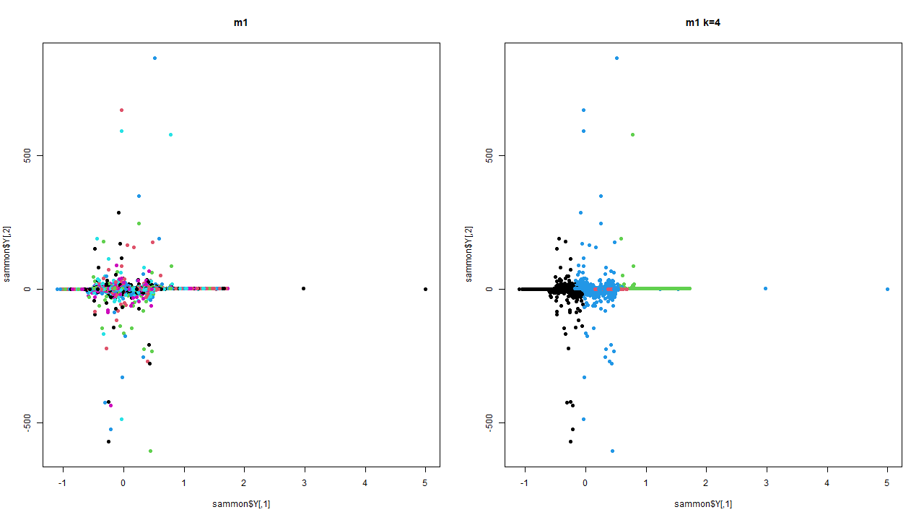

Figure 307 Sammon’s mapping on Model 3 Figure 308 Sammon’s mapping on Model 4

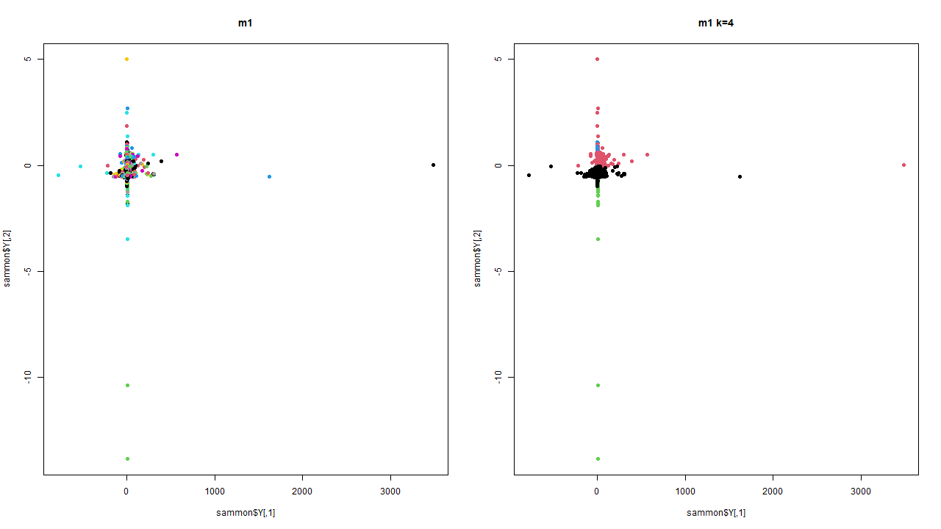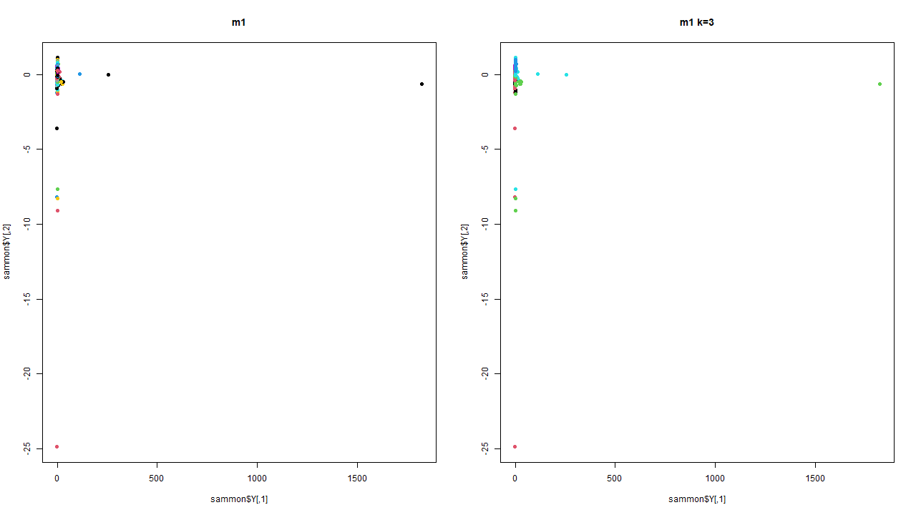Figure 309 Sammon’s mapping on Model 5 Figure 310 Sammon’s mapping on Model 6

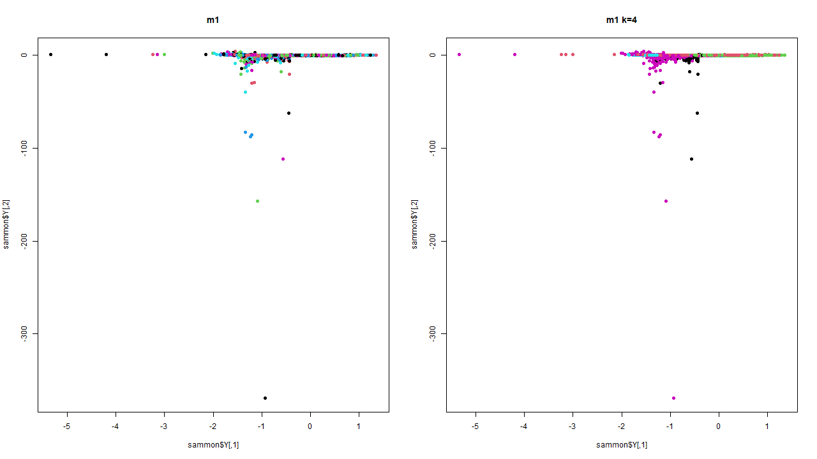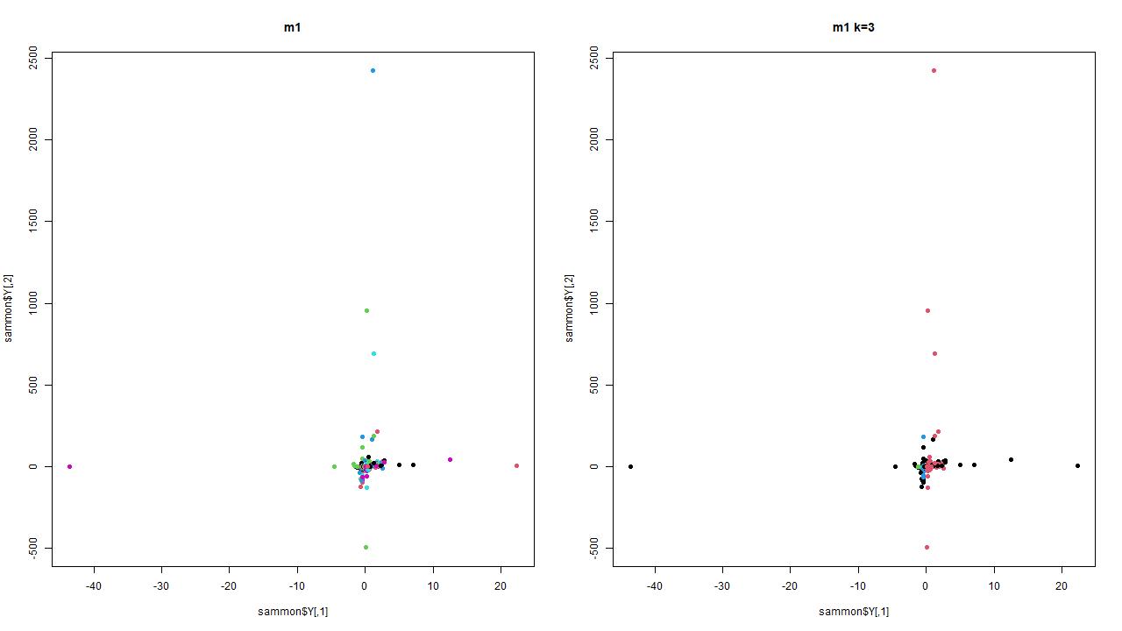

Figure 311 Sammon’s mapping on Model 7 Figure 312 Sammon’s mapping on Model 8

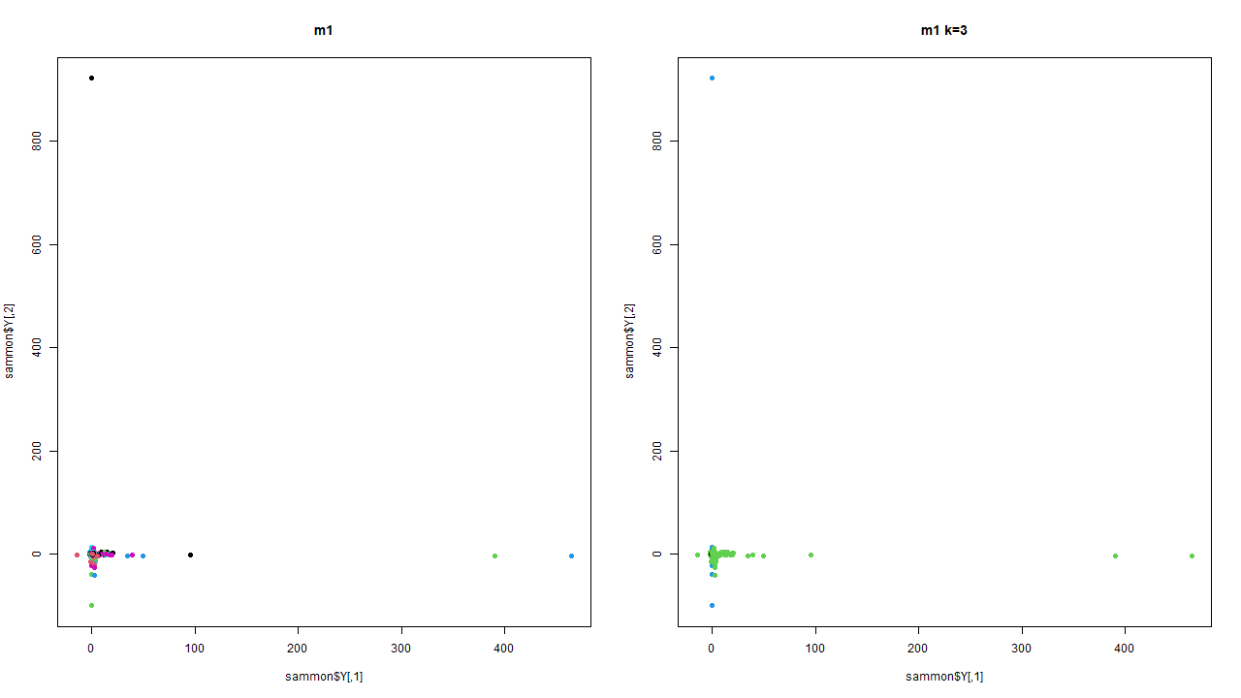

Figure 313 Sammon’s mapping on Model 9

### 6.2.7 DBSCAN

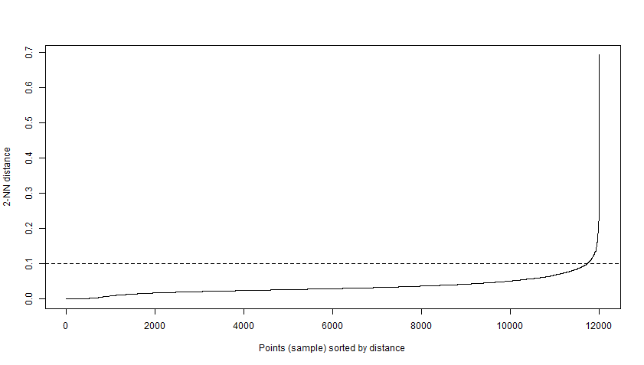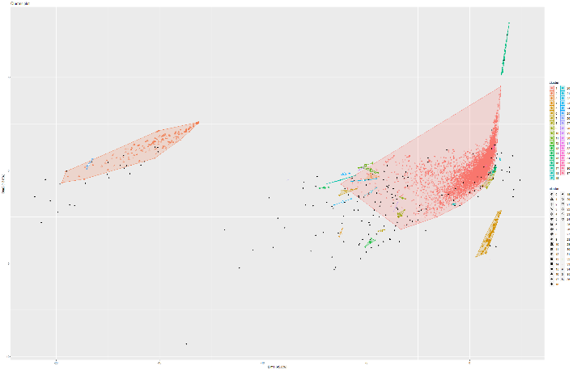Figure 314 & 315 Knee plot and DBSCAN on Model 1

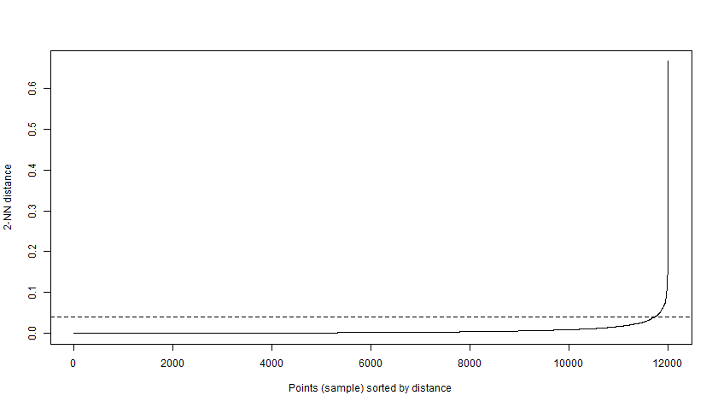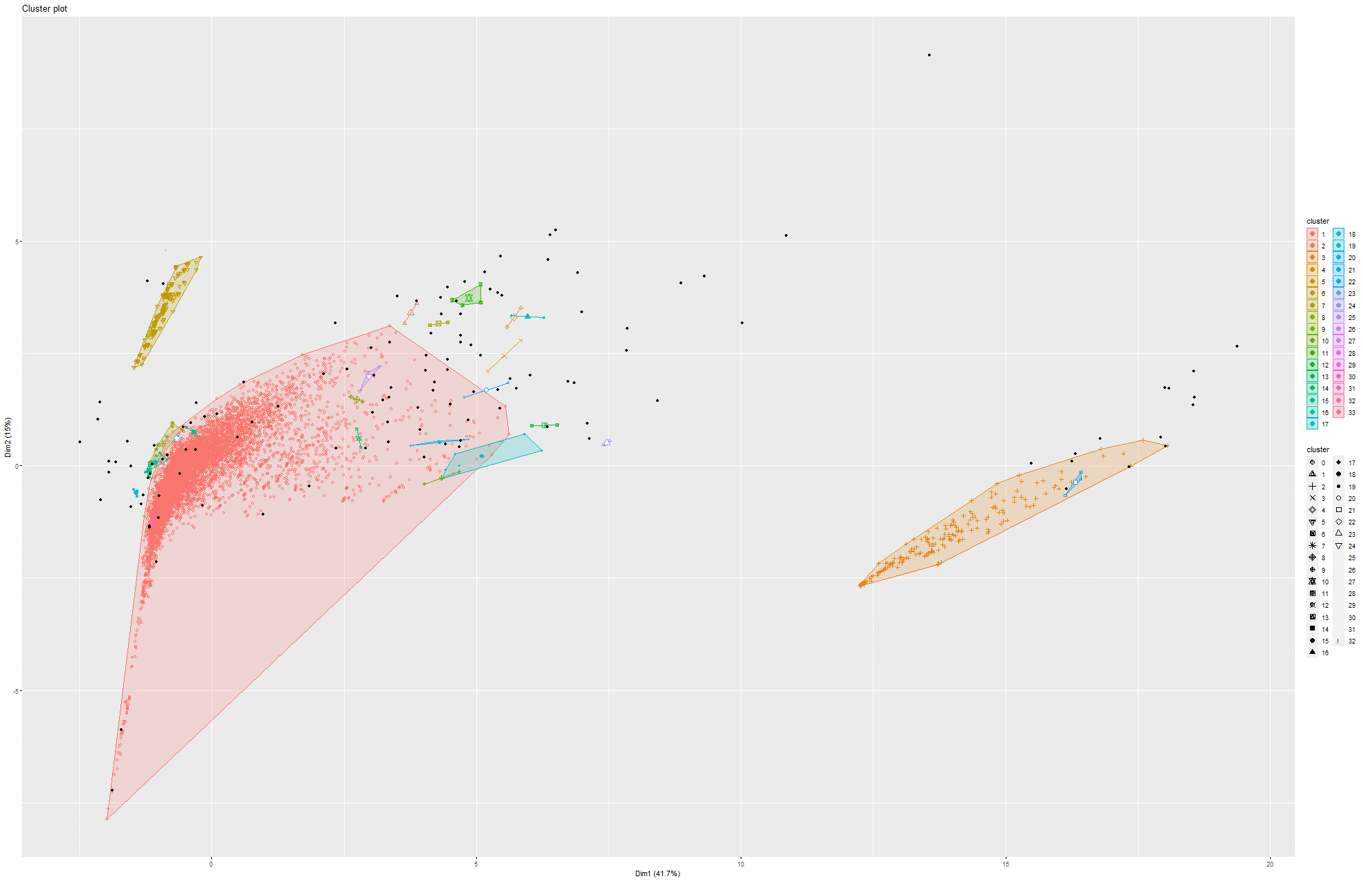Figure 316 & 317 Knee plot and DBSCAN on Model 2

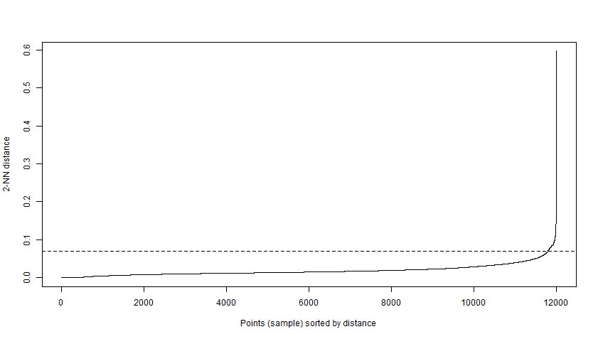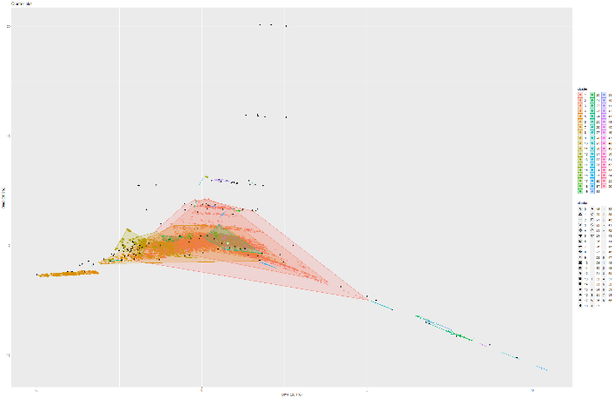Figure 318 & 319 Knee plot and DBSCAN on Model 4

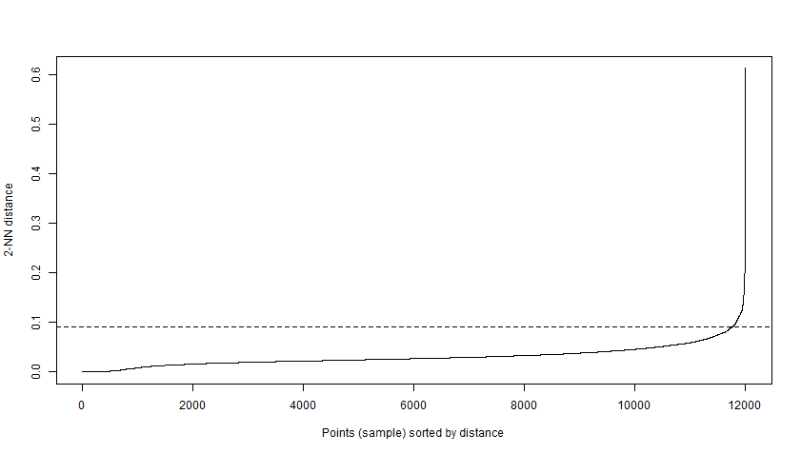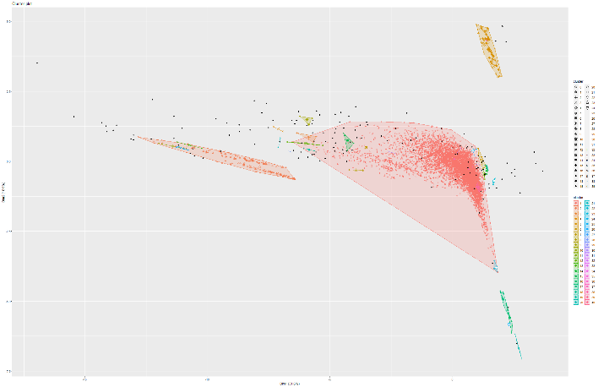Figure 320 & 321 Knee plot and DBSCAN on Model 5

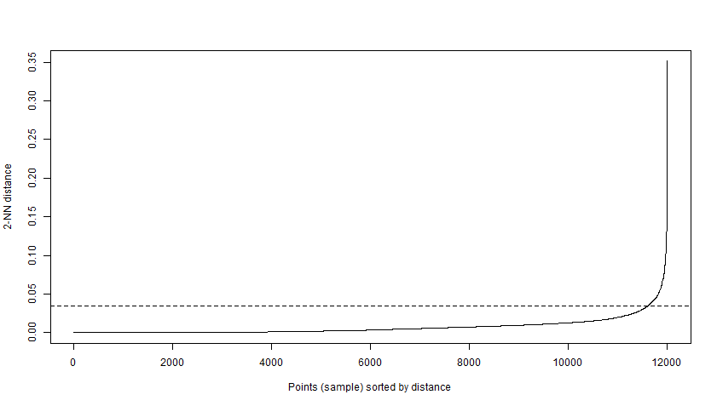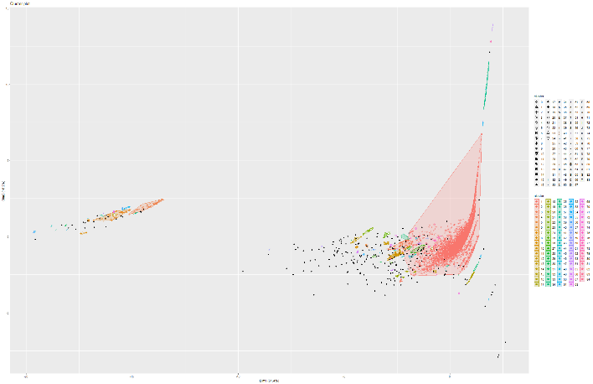Figure 322 & 323 Knee plot and DBSCAN on Model 6

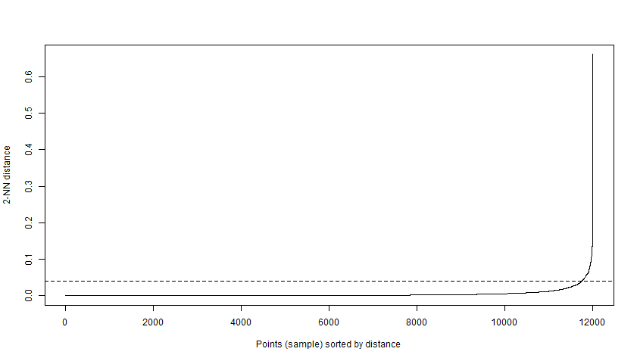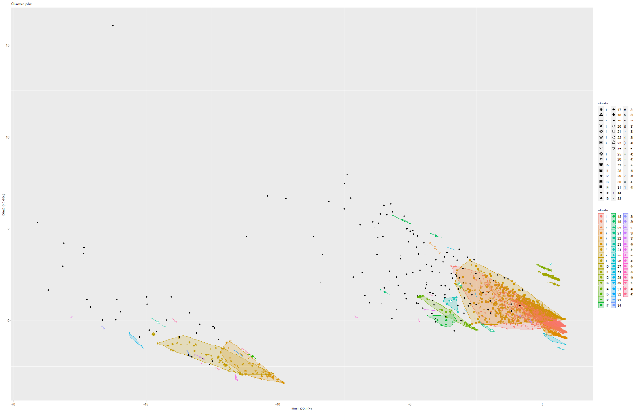Figure 324 & 325 Knee plot and DBSCAN on Model 7

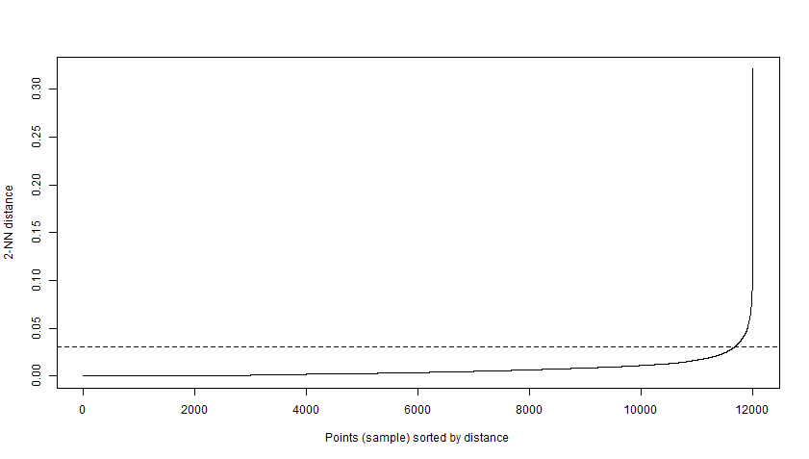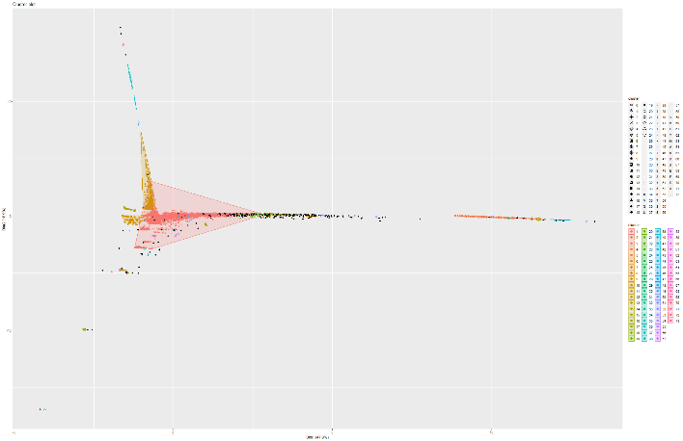Figure 326 & 327 Knee plot and DBSCAN on Model 8

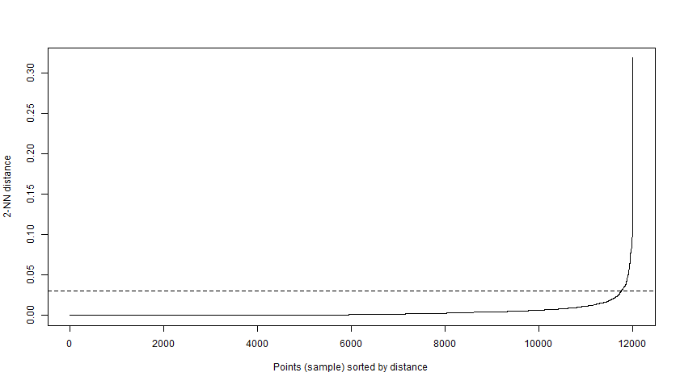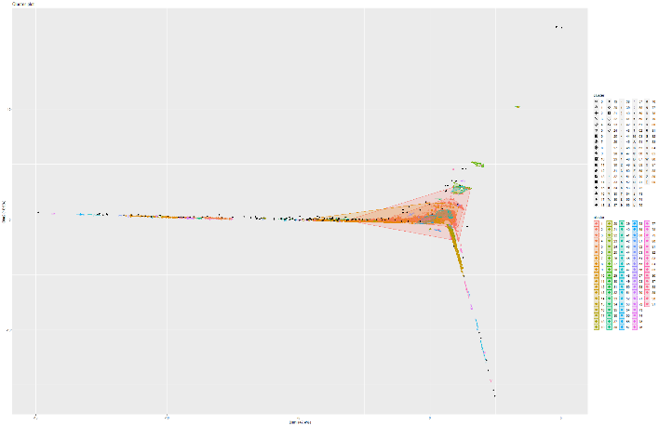

Figure 328 & 329 Knee plot and DBSCAN on Model 9

# CHAPTER 5: CONCLUSION AND FUTURE WORK

# REFERENCES

Bell, D. C., Atkinson, J. S., & Carlson, J. W. (1999). Centrality measures for disease transmission networks. Social Networks, 21(1), 1–21. https://doi.org/10.1016/S0378-8733(98)00010-0

Bródka, P., Skibicki, K., Kazienko, P., & Musiał, K. (2011). A degree centrality in multi-layered social network. Proceedings of the 2011 International Conference on Computational Aspects of Social Networks, CASoN’11, 237–242. https://doi.org/10.1109/CASON.2011.6085951

Chen, H., Yin, H., Chen, T., Viet, Q., Nguyen, H., & Xue, W. P. (2019). Exploiting Centrality Information with Graph Convolutions for Network Representation Learning. 2019 IEEE 35th International Conference on Data Engineering (ICDE), 590–601. https://doi.org/10.1109/ICDE.2019.00059

Chiu, C. C., Balkunid, P., & Weinberg, F. (2016). When managers become leaders : The role of manager network centralities , social power , and followers ’ perception of leadership. The Leadership Quarterly. https://doi.org/10.1016/j.leaqua.2016.05.004

Cohn, A. M., Amato, M. S., Zhao, K., Wang, X., Cha, S., Pearson, J. L., Papandonatos, G. D., & Graham, A. L. (2019). Discussions of Alcohol Use in an Online Social Network for Smoking Cessation: Analysis of Topics, Sentiment, and Social Network Centrality. Alcoholism: Clinical and Experimental Research, 43(1), 108–114. https://doi.org/10.1111/acer.13906

Cordella, L. P., Foggia, P., Sansone, C., & Vento, M. (2004). A (sub)graph isomorphism algorithm for matching large graphs. IEEE Transactions on Pattern Analysis and Machine Intelligence, 26(10), 1367–1372. https://doi.org/10.1109/TPAMI.2004.75

Crucitti, P., Latora, V., & Porta, S. (2006). Centrality in networks of urban streets. Chaos, 16(1). https://doi.org/10.1063/1.2150162

Culotta, A., & Cutler, J. (2016). Predicting Twitter User Demographics using Distant Supervision from Website Traffic Data. 55, 389–408.

Hussain, J., & Islam, M. A. (2016). Evaluation of graph centrality measures for tweet classification. 2016 International Conference on Computing, Electronic and Electrical Engineering, ICE Cube 2016 - Proceedings, 126–137. https://doi.org/10.1109/ICECUBE.2016.7495209

Joyce, K. E., Laurienti, P. J., Burdette, J. H., & Hayasaka, S. (2010). A new measure of centrality for brain networks. PLoS ONE, 5(8). https://doi.org/10.1371/journal.pone.0012200

Landherr, A., Friedl, B., & Heidemann, J. (2010). A Critical Review of Centrality Measures in Social Networks. Business & Information Systems Engineering, 2(6), 371–385. https://doi.org/10.1007/s12599-010-0127-3

Lee, S. H., Choi, J. Y., Yoo, S. H., & Oh, Y. G. (2013). Evaluating spatial centrality for integrated tourism management in rural areas using GIS and network analysis. Tourism Management, 34, 14–24. https://doi.org/10.1016/j.tourman.2012.03.005

Mccallum, A. (2007). Topic and Role Discovery in Social Networks with Experiments on Enron and Academic Email. 30, 249–272.

Miller, P. R., Bobkowski, P. S., Maliniak, D., & Rapoport, R. B. (2015). Talking Politics on Facebook : Network Centrality and Political Discussion Practices in Social Media. https://doi.org/10.1177/1065912915580135

Narayanan, S. (2005). The Betweenness Centrality Of Biological Networks A Study of Betweenness Centrality.

Newman, M. (2010). Networks: An Introduction. In Networks: An Introduction. https://doi.org/10.1093/acprof:oso/9780199206650.001.0001

Park, K., & Kim, D. (2009). Localized network centrality and essentiality in the yeast – protein interaction network. 5143–5154. https://doi.org/10.1002/pmic.200900357

Rossman, G., Esparza, N., & Bonacich, P. (2010). I’d like to thank the academy, team spillovers, and network centrality. American Sociological Review, 75(1), 31–51. https://doi.org/10.1177/0003122409359164

Williamson, S. A., & Tec, M. (2019). Random clique covers for graphs with local density and global sparsity. 35th Conference on Uncertainty in Artificial Intelligence, UAI 2019.

Yang, B., & Liu, J. (2008). Discovering global network communities based on local centralities. ACM Transactions on the Web, 2(1). https://doi.org/10.1145/1326561.1326570

Zhang, Y., Wang, X., Zeng, P., & Chen, X. (2011). Centrality characteristics of road network patterns of traffic analysis zones. Transportation Research Record, 2256, 16–24. https://doi.org/10.3141/2256-03